Stepper driver
It is possible to mount a Pololu 1201 stepper motor driver or a non-isolated or isolated stepper signal interface.
This interface connects to external stepper motor driver.
For example:

Connectors

All connectors (except specified otherwise): 3.5MM plug

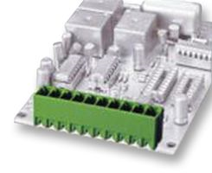
Fabrikant: IMO PRECISION CONTROLS
Farnell: Ordercode: 1761552
Fabrikantnummer: 20.155MV/4

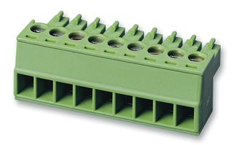
Counter part:
Fabrikant: IMO PRECISION CONTROLS
Farnell: Ordercode: 1761534
Fabrikantnummer: 20.1550M/4

Vertical:
2 PIN: Board: 20.155MV/2 and connector 20.1550M/2
4 PIN: Board: 20.155MV/4 and connector 20.1550M/4
6 PIN: Board: 20.155MV/6 and connector 20.1550M/6
8 PIN: Board: 20.155MV/8 and connector 20.1550M/8
10 PIN: Board: 20.155MV/10 and connector 20.1550M/10

Horizontal:
2 PIN: Board: 20.155MH/2 and connector 20.1550M/2
4 PIN: Board: 20.155MH/4 and connector 20.1550M/4
6 PIN: Board: 20.155MH/6 and connector 20.1550M/6
8 PIN: Board: 20.155MH/8 and connector 20.1550M/8
10 PIN: Board: 20.155MH/10 and connector 20.1550M/10
Opto-couplers:
TLP504A (dual) TLP504A−2 (quad)
DIP (place in IC socket)

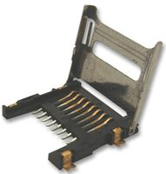
SD Card

MULTICOMP
Farnell Ordercode: 1686452
Fabrikantnummer: 460DE08C3

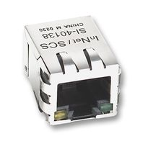
Ethernet
Fabrikant: STEWART CONNECTOR
Farnell Ordercode: 1137983
Fabrikantnummer: SI-60062-F

Pololu
mounted on SIL header (female)

MBED
Mounted on 2x 2x40 header (female) (similar to mbed workshop board)

USB
USB-A connector for USB-stick (flat)

Solder Joints
2.54 mm pitch holes (should be able to place jumper)

I2C / ANALOG / CAN (P7/P8)
Can be 2.54 mm holes

LIMIT SENSORS
ZLIMITS and XY limits can be combined on 8pin connector (3.5mm pitch) or 10 pin connector (combined with Vsensor)

LASER & OUTPUT
Can be combined on 8 pin connector (3.5mm pitch)

