ADAN8888 — Applied Analytics Project
Week 9: Select the Winning Model
BTS T-100 Domestic Segment | Next-Month Passenger Demand

1. Objective and Evaluation Design
In Week 9 we compare all nine configurations from Weeks 6, 7 and 8, choose a model based on the same validation data as before and then evaluate the previously fitted selected model on the reserved test data. The goal is to predict the next-month passenger count for a directional domestic carrier-route. We support comparability by staying with the same Week 3 target, the same PC1/PC2 inputs from Week 5, the same chronological partitions and passenger-scale regression metrics.
MAE is used as the primary selection criterion because an absolute error in passenger numbers is easily interpretable. Validation RMSE is used as the first exact-tie criterion, followed by nominal model complexity as the final tie-breaker. Training scores are used to diagnose the fit of the model but not to decide on the winner. The test scores are not used before the model has been selected and its validation results have been checked for reproducibility.

2. Nine-Model Validation Comparison
Table 1 reproduces actual Week 6–8 model scores, calculated on the same validation design. The Week 6 entries were displayed to three decimals in the executed notebook; Week 7 and Week 8 values are taken from their full-precision CSV files. The sorted order below is illustrative of increasing nominal capacity within each family, not an exact cross-family complexity ranking.
Model | Train MAE | Valid MAE | Train RMSE | Valid RMSE | Valid R²
Ridge_C | 3,395.14 | 3,418.39 | 5,985.65 | 6,163.44 | 0.422
Ridge_B | 3,332.43 | 3,259.03 | 5,789.18 | 5,890.28 | 0.473
Ridge_A | 3,331.96 | 3,257.18 | 5,787.13 | 5,887.10 | 0.473
HGB_A | 1,180.22 | 1,179.31 | 2,263.18 | 2,060.22 | 0.935
HGB_B | 1,164.08 | 1,163.47 | 2,254.86 | 2,050.41 | 0.936
HGB_C | 1,159.02 | 1,161.07 | 2,247.90 | 2,051.79 | 0.936
MLP_A | 1,171.37 | 1,171.51 | 2,236.71 | 2,019.43 | 0.938
MLP_B | 1,161.63 | 1,143.20 | 2,236.20 | 1,988.78 | 0.940
MLP_C | 1,159.01 | 1,149.90 | 2,230.23 | 1,999.78 | 0.939
The best overall validation result is MLP_B (64, 32), with MAE 1,143.20 passengers and RMSE 1,988.78 passengers. Its validation MAE is 17.87 passengers (1.54%) lower than Week 7 HGB_C (1,161.07), and 2,113.98 passengers lower than the Week 6 Ridge_A baseline (3,257.18). This indicates that nonlinear modeling substantially improves this two-component representation relative to Ridge, while the difference between the two strongest nonlinear approaches is comparatively small.

3. Bias–Variance Tradeoff and Model Complexity
Bias–variance diagnostic plots are provided for the nine models’ training and validation mean squared error (MSE) expressed in millions of passengers squared. The model order within a model family increases with flexibility: moving from stronger to weaker regularisation in the Ridge models, more boosting iterations and larger numbers of leaf nodes in the HGB models, and increased layer size and depth in the MLP models. The order of complexity of the models across the different families is not based on a rigorous complexity measure and thus is mostly descriptive.
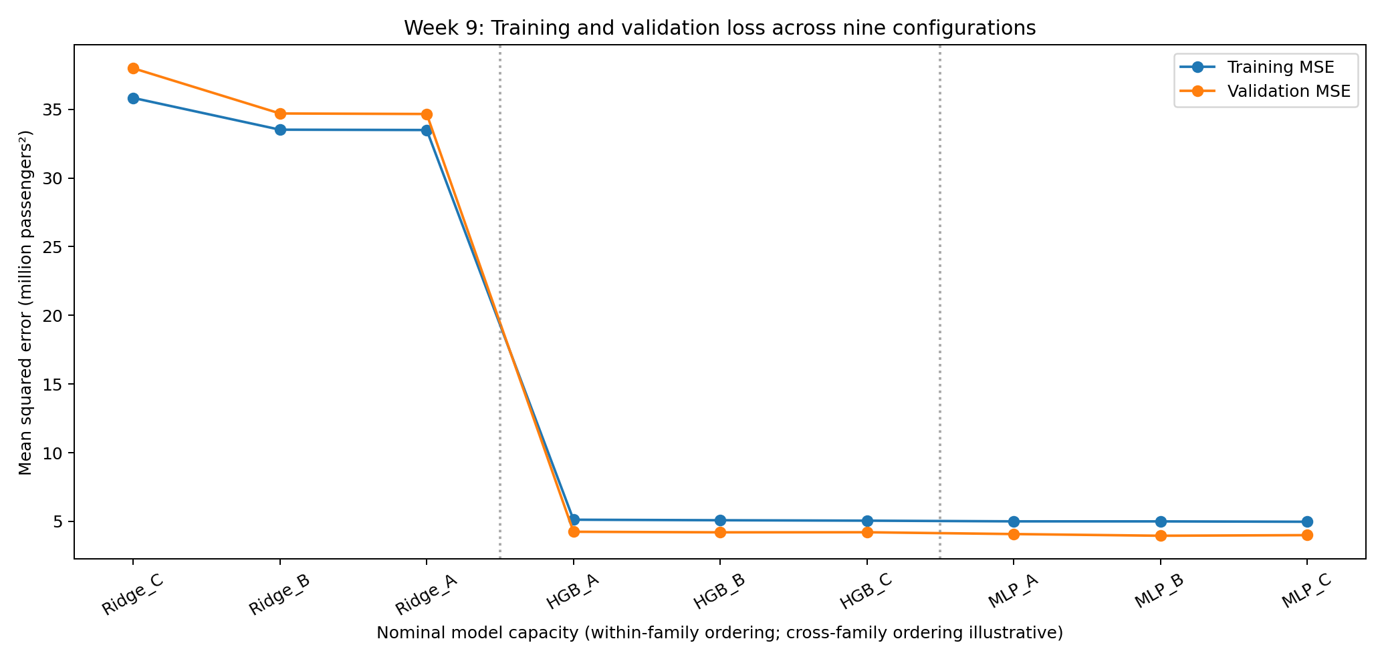
Figure 1. Training and validation MSE across nine candidate models, with approximate cross-family complexity ordering.
The training and validation MSE for the Ridge models is substantially higher than for the trees and neural networks and thus is consistent with greater underfitting for the linear models. Training MSE generally decreases with increasing flexibility in the trees and neural networks; however, the gains from additional flexibility are slight and not always associated with lower validation MSE. Moreover, the validation MSE of the larger MLP_C is even worse than that of the smaller MLP_B, while for the trees the validation MAE for HGB_C is only slightly lower than for HGB_B, although its RMSE and MSE are marginally higher. The differences between training and validation errors may also be caused by changes in demand or in the route network over the calendar periods in which the data were generated. However, the plot itself does not allow a formal decomposition of prediction error into bias and variance across independently generated training datasets.
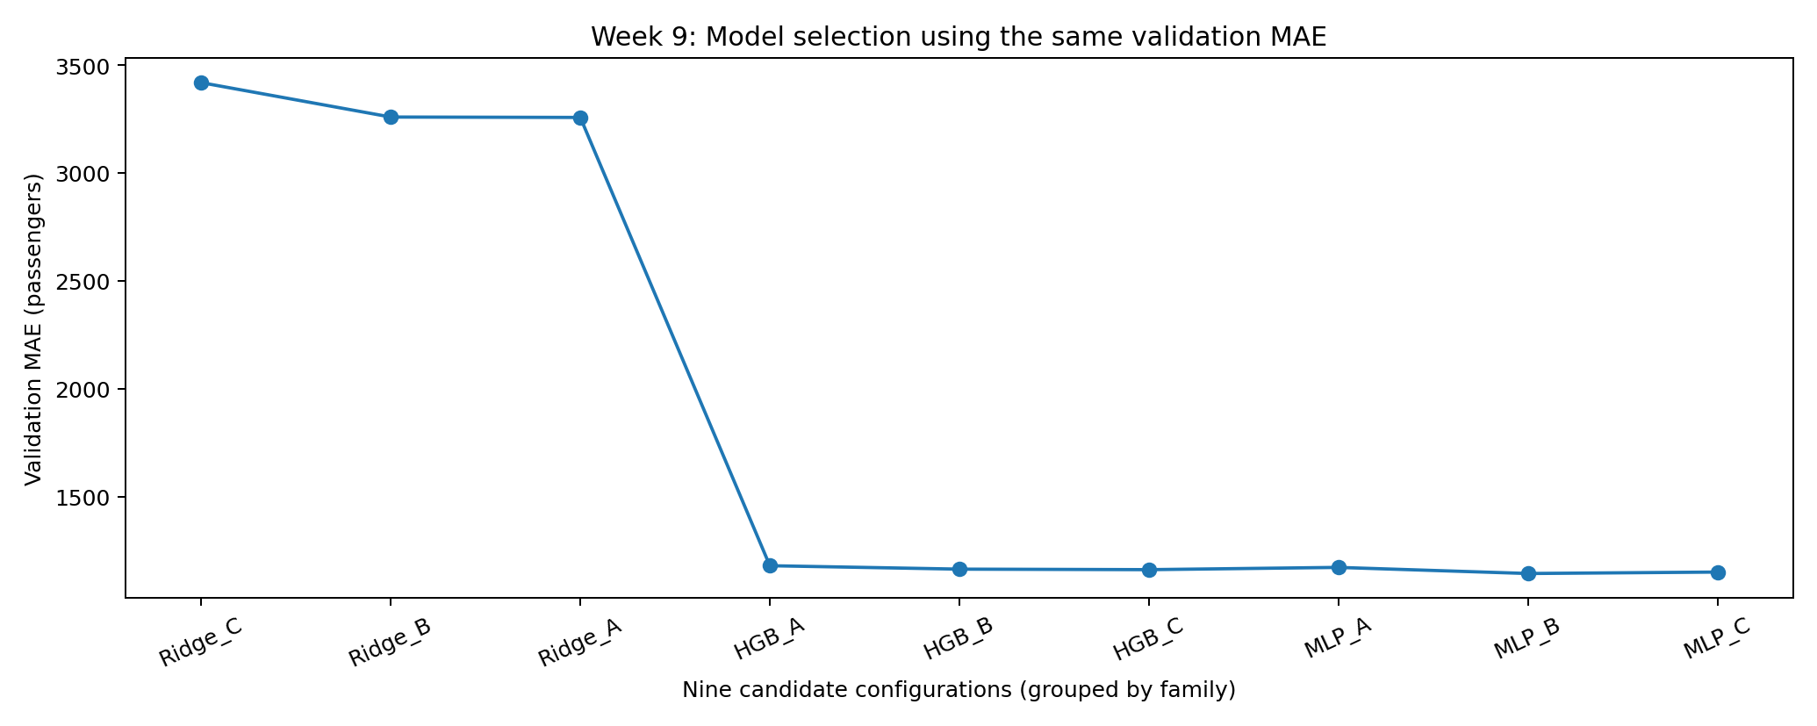
Figure 2. Validation MAE (passengers) across the full nine-model set.

4. Final Selected Model and Rationale
The final validation-selected model is MLP_B, a feedforward multilayer perceptron with two hidden layers of 64 and 32 units (2,305 trainable parameters). It uses the same training-fitted PC1/PC2 input features as Weeks 6 and 7, with feature and target StandardScaler transformations fitted only on training data. Its neural architecture models nonlinear functions of the two input components without the additional depth of MLP_C. Among these nine predefined choices, its validation MAE and RMSE are both the lowest.
HGB_C remains a defensible alternative given the narrow MLP_B–HGB_C validation MAE difference. Week 9 nevertheless follows the pre-established MAE rule and does not choose models or change hyperparameters after examining the final test data. A saved MLP_B estimator from Week 8 is used to preserve the training-only fit during the final evaluation.

5. Final Held-Out Test Evaluation
The selected MLP_B model was locked using the previous nine validation results. The executed Week 9 notebook then verified that the saved Week 8 model reproduced its prior validation MAE and RMSE before final test scoring. The original training-fitted preprocessing was retained, and the frozen MLP_B estimator was evaluated on 264,291 target-eligible observations across 21 forecast months from September 2024 through May 2026. The model was not refitted on validation or test records, and test outcomes were not used for selection.
Partition | Rows | MAE (pass.) | RMSE (pass.) | R²
Training | 1,062,603 | 1,161.63 | 2,236.20 | 0.9169
Validation | 239,395 | 1,143.20 | 1,988.78 | 0.9399
Test | 264,291 | 1,122.50 | 1,935.24 | 0.9390
Test MAE was 1,122.50 passengers, 20.69 (1.81%) lower than validation MAE. Test RMSE was 1,935.24 passengers, 53.54 (2.69%) lower than validation RMSE. Test R² was 0.9390, slightly below the validation R² of 0.9399 by 0.0008. Thus, absolute errors did not deteriorate on the later historical period, but R² did not increase. Differences across partitions may reflect changes in demand, carrier-route composition, and the distribution of passenger counts; no causal explanation can be established from aggregate metrics alone.
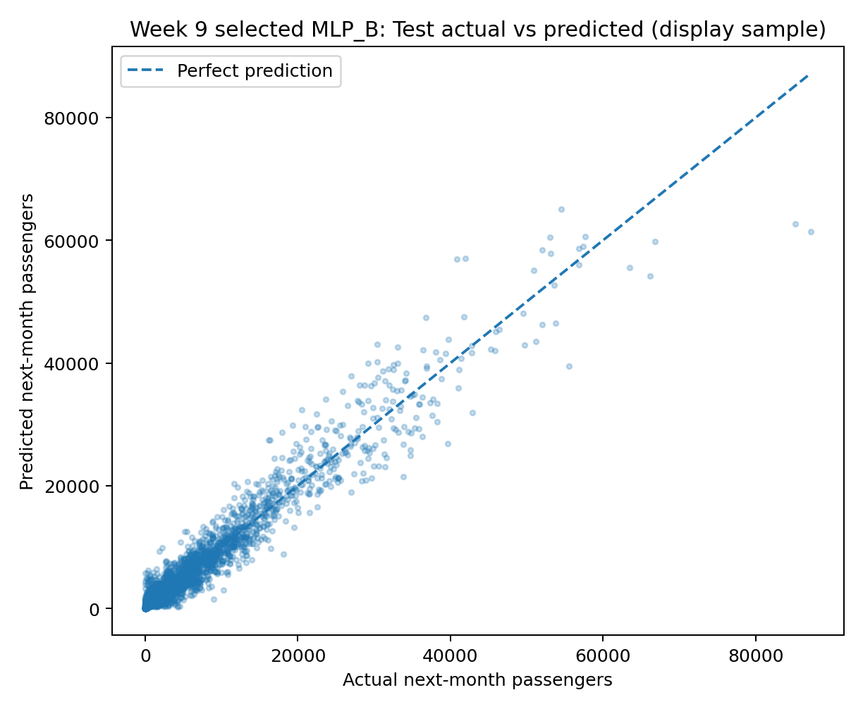
Figure 3. Actual versus predicted passengers for MLP_B on a fixed 4,000-observation test display sample.
The sample tracks the equality line for lower-volume observations but shows wider error dispersion and several underpredictions at high passenger counts. This figure is a visualization sample only; MAE, RMSE and R² use the entire held-out test set.
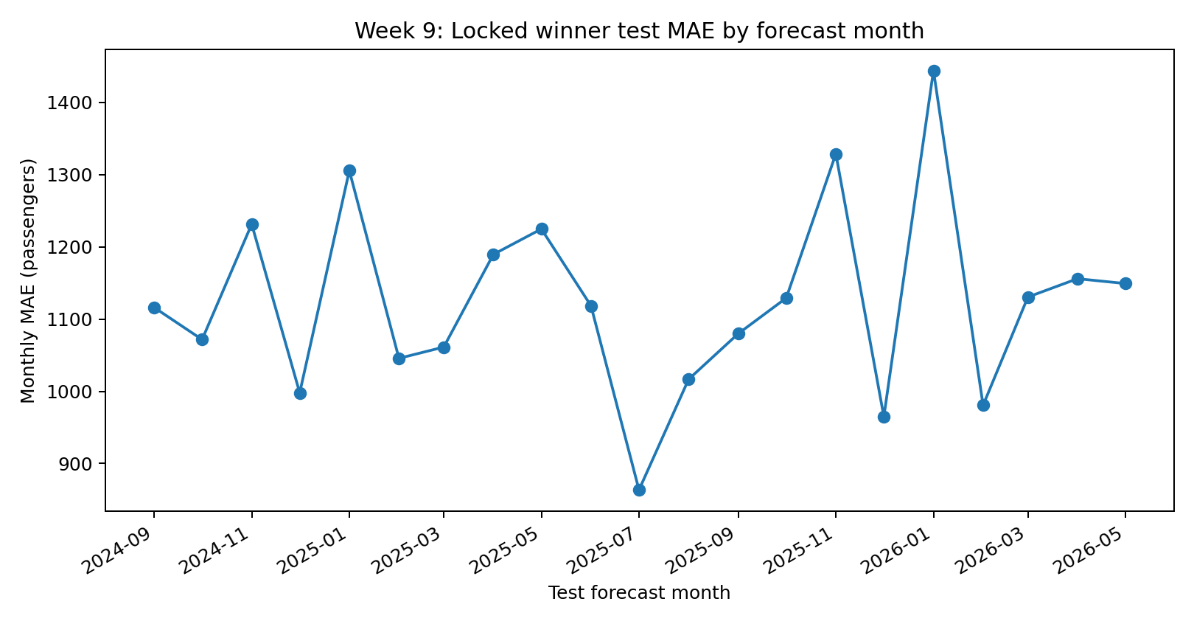
Figure 4. Monthly held-out test MAE for the selected MLP_B model (all 21 forecast months).
Monthly test MAE ranges from 863.52 passengers in July 2025 to 1,444.21 in January 2026. Variation across months suggests that aggregate test accuracy should be complemented by month-level and carrier-route-volume diagnostics.

6. Is This Model Good Enough for Production?
The final holdout results are decent. On average the forecasts are off by 1,122.50 passengers (MAE of 1,122.50), with an RMSE of 1,935.24, which places a higher penalty on large errors, and R² of 0.9390. These numbers are sufficient as a historical out-of-period forecasting benchmark for a course but not necessarily for a real-life operational setting. In particular we still need (i) a passenger-count tolerance as a function of the route volume; (ii) a comparison with a planning baseline and with a seasonal-naïve baseline; (iii) an assessment of the cost of errors at the airline level. Also note that the BTS reference-month inputs needed for prediction may not be available at the time the next-month forecast would be required because of publication delays. Thus, the current evaluation is retrospective rather than a verified real-time operational forecasting analysis.
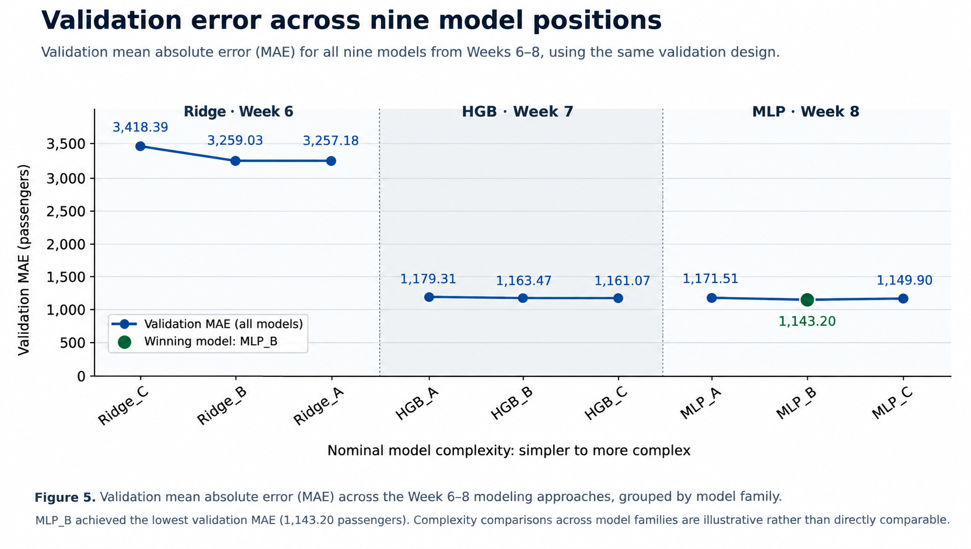
Figure 5. Validation mean absolute error (MAE) across the Week 6–8 modeling approaches, grouped by model family and ordered by nominal within-family complexity. MLP_B achieved the lowest validation MAE (1,143.20 passengers). Complexity comparisons across model families are illustrative rather than directly comparable.

7. Reproducibility, Limitations, and Next Steps
The source compares the validation scores from Weeks 6 through 8, locks the best model for later test scoring and reconstructs the Week 5 PCA transformations using training data only. These training-fitted transformations are then applied to the validation and test data without refitting them on either partition. Using the saved copy of the Week 8 model, MLP_B, the source reproduces the historical validation MAE/RMSE within the “compatibility gate” before scoring the test data. The test scores and associated figures are then saved to file, and subsequent runs of this notebook will simply read the previously saved test scores for the model instead of re-scoring it. The selection digest and final test scores are saved in separate JSON files, with an additional final model manifest.
Outputs included nine-model validation/ranking tables, training/validation MSE chart, training/validation metrics, 21 monthly test MAE rows, two test figures, selection lock, executed notebook PDF. Week 9 source also generates a final model manifest for the single unchanged model (Week 8 estimator). PCA inputs are limited to two, no explicit carrier and/or airport identifier features are included in the model, there is potential for temporal demand shifts not captured by the model, and BTS reporting latencies are not addressed for operational deployment. Further work could consider a) route-segment-level analysis, b) operational feature availability, c) business thresholds for what to monitor, and d) more in-depth monitoring of the selected model. The test set must NOT be used for model selection.

References
Bureau of Transportation Statistics. T-100 Domestic Segment (All Carriers). https://www.transtats.bts.gov/
Scikit-learn developers. Model evaluation and scoring. https://scikit-learn.org/stable/modules/model_evaluation.html
Scikit-learn developers. Validation curves and complexity diagnostics. https://scikit-learn.org/stable/modules/learning_curve.html
Scikit-learn developers. Common pitfalls and data leakage. https://scikit-learn.org/stable/common_pitfalls.html

