Airline Passenger Demand Forecasting
Week 1: Identify the Problem Statement and Dataset
ADAN8888 — Applied Analytics Project
Tyler Miller | Jason Pinales | Emma Portanova
September 11, 2026

Executive Summary
Project Objective: The objective of this project is to develop a supervised regression model which forecasts the passenger demand for a particular carrier-route for a particular origin-destination pair for the following month. The analytical unit for this purpose is defined to be carrier × origin airport × destination airport × month. This unit keeps the airline-specific decision-making aspect intact while mapping to the BTS data structure for the BTS T-100 Domestic Segment (All Carriers) data.
Decision Use: This forecasting project is to support decisions with respect to capacity, flight frequency, network, staffing and gates (i.e. resources), and to validate these predictions in chronological order and to measure the size of errors in such forecasts in order to understand the operation of the system that generated the data rather than ‘splitting’ data at random between a ‘training set’ and a ‘test set’.
Data: Public source data for this project will come from the Bureau of Transportation Statistics (BTS), part of the U.S. Department of Transportation’s TranStats data system. Specifically, we’ll be using the BTS T-100 Domestic Segment (All Carriers) data for the main body of the project, which is reported by U.S. and foreign airlines on a monthly basis for domestic non-stop segments and includes data on passengers, seats, departures, distance, carrier, origin airport, destination airport, aircraft, and class of service. The data for this table goes back to 1990, and for the most recent uniform month reported by all carriers for the main body of the work, that would be May 2026 (the latest date as of September 2026 when this was written).

1. Problem Statement and Modeling Intent
Business Problem: As airlines commit airline capacity well in advance of the time that actual passenger demand will materialize, the problem of under-forecasting demand and resulting from capacity constraints and lost revenue opportunities and that of over-forecasting demand and resulting from avoidable high operating costs due to excess capacity can be mitigated by having a good, repeatable forecast at the route level before capacity and schedule decisions are set in stone..
Modeling Problem: We predict the number of passengers that will be transported in month t+1 for each scheduled-passenger carrier-route-month. Information considered for the prediction would have been available at the end of month t. So primary target variable here is next-month passengers. We will consider several candidate predictors like lagged passengers, lagged seats, lagged departures performed/scheduled and many others like route distance, carrier, origin/destination, calendar seasonality, rolling demand statistics and several trend variables engineered to explain the past trends in passengers.
Research question. How well can historical T-100 data from scheduled passenger air services be used to forecast the number of passengers that will actually be carried on U.S. domestic scheduled passenger services a month in advance? And, compared to simple models that include time-of-year, historical passengers, and the number of seats available on a particular route, does any value added by more complex models support their added complexity?
The models will be evaluated using a chronological holdout set of data. Performance will be reported using average absolute error (MAE) and root mean squared error (RMSE) as primary metrics. Maximum absolute percentage error (MAPE) or weighted average absolute percentage error (WAPE) will be used as an alternative if denominators are sufficiently stable. Performance will also be presented by route volume tier and carrier to reveal potential operational inconsistencies that may not be obvious in aggregate results.
Success Criterion: Evaluate the performance of the model on a simple chronological holdout to measure the absolute error MAE and RMSE. Because of the volatility in the MAPE and WAPE, only use these measures when the denominator is sufficiently stable. In addition, evaluate performance by route volume tier and by carrier to uncover systematic errors that would hide in aggregate measures..

2. Articulation of Value
The value created by the model’s historical traffic and capacity can be used to make forward looking estimates that airlines can incorporate into their on-going planning processes. Airlines can use this model to make better decisions about expected demand and capacity that they have. In particular, the model can support airlines in doing an earlier assessment of routes that may be structurally under-supplied or over-supplied. For routes that are found to be under-supplied or over-supplied, the model can support more disciplined decisions about issues such as aircraft-gauge and frequency. In addition, the model can help the analyst function to be more focused. In addition to value for airlines, the model will also be of value to airport and other operations folks for staff planning and for allocating gates and other resources.
Again, note that any benefits to passengers will be tertiary to airlines and generally will result only in more appropriate airline schedules being published and fewer instances of capacity mismatches. The forecast itself will not reveal any promise of lower fares or new routes, as the latter will depend on a variety of factors, including relevant airline competition and their associated costs.
The value of such decision support lies in the way it enables airlines to create better schedules, which in turn allow for better passenger services. It helps stakeholders in airports and other operation-related functions as well, to plan better for staffing and for gates and other resources.

3. Potential Economic Value
Week 1 does not yet contain data to support an empirical dollar benefit. A simply assumptions-based value model will be built in Week 1 that can be updated in subsequent weeks using actual data to track improved forecast performance, as well as assessing specific costs and revenues to various stakeholders. The simple base case that follows estimates the gross value of decisions regarding capacity improved by just being aligned better with demand.
Base-Case Calculation
Component | Assumption | Calculation | Result
Monthly seats in decision portfolio | 2,000,000 seats¹ | — | 2,000,000
Forecast-error improvement | 2 percentage points² | 2,000,000 × 0.02 | 40,000 seats/month
Share operationally actionable | 25%³ | 40,000 × 0.25 | 10,000 seats/month
Average value per actionable seat | $35⁴ | 10,000 × $35 | $350,000/month
Annual gross economic value | 12 months | $350,000 × 12 | $4,200,000/year
Annual program/process cost | $350,000⁵ | $4,200,000 − $350,000 | $3,850,000 net/year

Interpretation. Under the base assumptions, a two-percentage-point reduction in forecast error creates approximately $4.2 million in gross annual decision value and $3.85 million after an illustrative annual analytics/process cost. This is a planning estimate, not a claimed realized profit. It is designed to answer the instructor’s question: what is the maximum economic rationale for investing in the modeling workflow, given transparent assumptions?
Assumption footnotes
¹ Illustrative airline portfolio scope, not a BTS fact. Replace with the actual seats represented by the final analytical sample.
² Illustrative improvement over the eventual Week 6 baseline. Replace with observed out-of-time improvement after model comparison.
³ Only part of lower forecast error can change a schedule because of fleet, crew, slot, gate, maintenance, and commercial constraints.
⁴ Illustrative weighted value per better-aligned seat combining incremental contribution opportunity and avoidable excess-capacity cost. It is deliberately not treated as average ticket fare or accounting profit.
⁵ Illustrative recurring cost covering analytics, data engineering, model operations, and planning-process integration. It should be replaced with sponsor-specific costs if available.
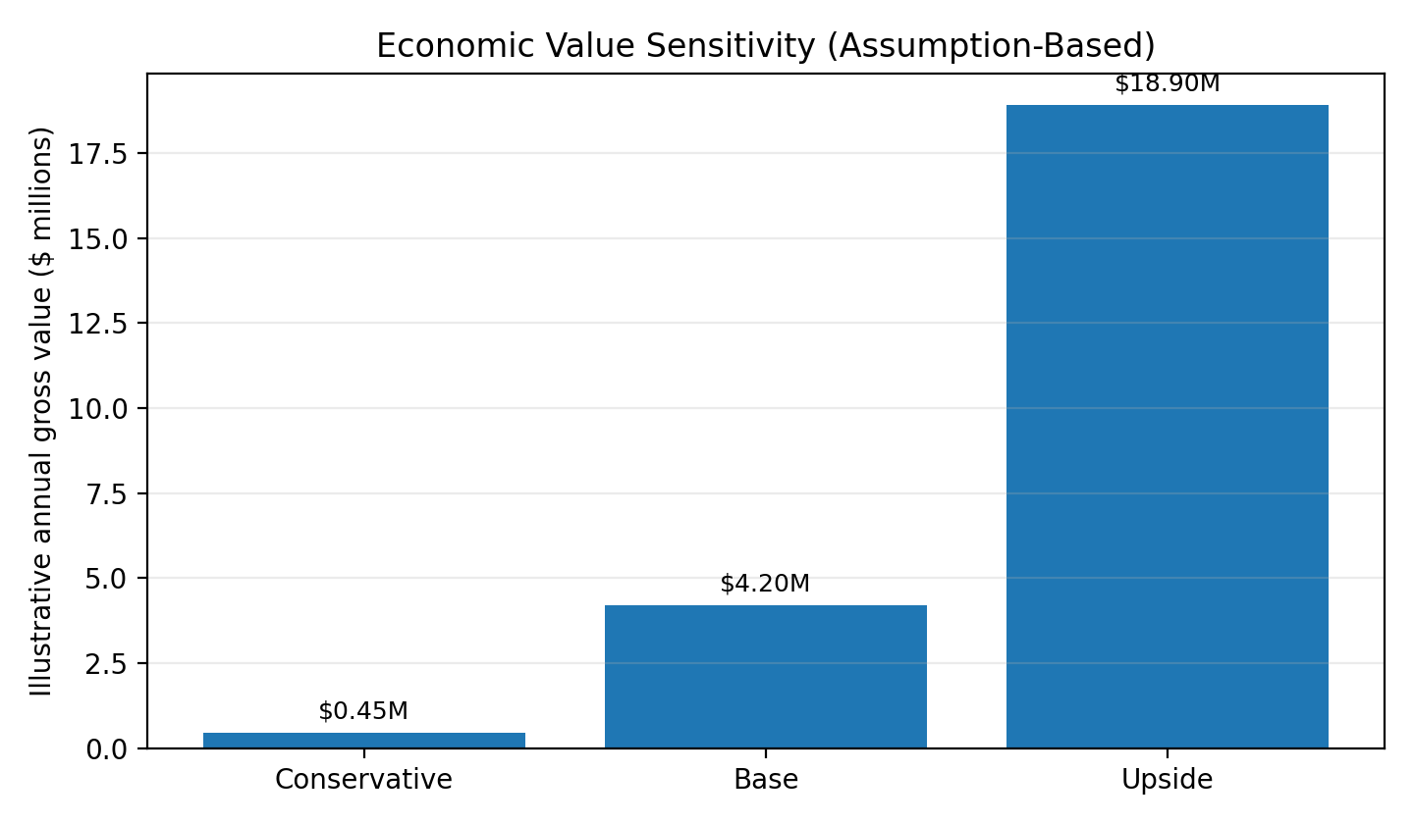
Figure 1. Sensitivity of gross annual value to alternative assumption sets. These are business-case scenarios, not observed model outcomes.

4. Dataset and Analytical Design
Source and Scope: The project will use BTS TranStats, T-100 Domestic Segment (All Carriers). The core table for this data is the domestic non-stop segment data reported by U.S. and foreign air carriers for movements in which origin and destination are within the United States and its territories. There are a large number of fields in this table. They include carrier information and route information, and for each service class on each route for each day, passenger traffic and available capacity, and the scheduled and performed number of departures, and the distance for each direction on each route. The data is provided on a monthly basis.
Initial Data: Download Jan 2015 to current and created uniform month data table with the following fields: Year, Quarter, Month, UniqueCarrier/AirlineID, OriginAirportID/Origin, DestAirportID/Dest, Class, AircraftType, AircraftConfig, Passengers, Seats, DepScheduled, DepPerformed, Distance and LoadFactor (which can be recalculated from the number of passengers and number of seats). Use only Service Class F = Scheduled Passenger/Cargo Service for model. Then aggregate up from individual aircraft to unique carrier, origin airport, destination airport and month after data has been validated.
Why this dataset fits: This dataset fits well for a number of reasons: 1) the target variable Passengers is directly observable; 2) the same table contains variables Time, Route, Carrier, Capacity, and Frequency which can be used as independent variables in a time series forecast model to account for lagged values, seasonal values, etc; 3) data for nonstop directional service is collected as separate records (as opposed to itineraries with multiple connections). Therefore, the core forecast model can be built around nonstop flights between origin/destination pairs.
Important limitation: T-100 is reported historical data. Thus, for the purpose of a course project, students must recreate a t+1 forecast using only information available at t (i.e. lagged data). Do not use same-month historical realized seats or departures as a predictor for same-month realization (since that information would not have been available at the time the forecast was made). Target leakage ruins operational credibility.
Field(s) | Planned role | Rationale
Passengers | Target before shifting to t+1 | Non-stop segment passengers transported
Seats | Lagged capacity predictor | Available seats
DepScheduled | Lagged schedule intensity | Scheduled departures
DepPerformed | Lagged realized frequency | Departures performed
Distance | Static route feature | Distance between airports
UniqueCarrier / AirlineID | Carrier identity | Stable airline identifiers
Origin / Dest + airport IDs | Route identity | Directional origin and destination
Year / Month / Quarter | Seasonality and trend | Monthly time index
Class | Scope filter | Use F for scheduled passenger/cargo service
AircraftType / AircraftConfig | Aggregation / optional features | Aircraft mix and configuration

5. Modeling Type
Since each historical observation has an observed value for the t+1 time period, the problem is supervised. The value to be predicted for a given observation is a single value (a passenger count) so it is not a categorization problem. A simple lag/seasonal model will be developed as a starting point and then the project will explore the use of a number of more complex regression models. All of these models will be compared using chronological validation. Candidate models to examine include regularized linear regression models, tree-based models (e.g. random forest), and even a time-based count regression model if diagnostics support its use. An ARIMA-type model will also be developed as a route-level benchmark model.
Later in the course, candidate model families to consider for more sophisticated regression analysis are: regularized linear regression models, tree-based models (e.g. random forest, gradient boosting), and time-aware models for count or regression analysis, depending on results of distributional diagnostics. ARIMA-type models are candidates to be used as route-level benchmarks.

6. Thirteen-Week Project Plan
The plan below follows the course model-development sequence rather than creating a separate timeline. This keeps each project milestone aligned with the required weekly deliverable.
Week | Phase | Work | Primary deliverable
1 | Problem definition & business case | Finalize target, unit of analysis, stakeholders, economic-value logic, dataset, repo and environment. | Week 1 report; structured private GitHub repo.
2 | Ingest & explore data | Download/ingest T-100; validate schema, field types, row counts, date coverage, target and candidate predictors. | Notebook, code output, data dictionary, Week 2 report.
3 | Exploratory data analysis | Create chronological train/validation/test design; examine distributions, seasonality, route volume, missingness, outliers, and COVID-era shifts. | EDA figures/tables and preprocessing findings.
4 | Make data model-ready | Filter scheduled passenger service; aggregate to carrier-route-month; address missing/invalid values; implement leakage-safe preprocessing. | Clean analytical pipeline and model-ready base table.
5 | Feature engineering | Create passenger/capacity/departure lags, rolling means, seasonal terms, trend, route/carrier encodings; finalize chronological datasets. | Feature-engineered modeling datasets.
6 | Model approach 1: baseline | Build naive lag and seasonal benchmarks plus simple linear/regularized regression; tune minimally and define evaluation metrics. | Baseline models and error benchmark.
7 | Model approach 2: more complex | Train/tune a nonlinear ensemble (e.g., random forest) and compare bias/variance and route-level errors. | Second-model results and comparison.
8 | Model approach 3: more complex | Train/tune gradient boosting or another justified approach; compare against prior models using identical folds. | Third-model results and comparison.
9 | Select winning model | Evaluate finalists on untouched chronological test data; select based on MAE/RMSE plus stability by route/carrier. | Winning model and final test metrics.
10 | Data-centric AI | Improve data/labels/features rather than only model complexity; revisit anomalous periods, sparse routes, aggregation, and feature quality. | Data-centric iteration and measured impact.
11 | Explainability, risk, bias & ethics | Analyze feature importance/prediction behavior; assess error disparities by carrier, route size, geography, and disruption periods; document misuse risks. | Explainability and risk/bias analysis.
12 | Package & monitoring | Serialize model/pipeline; specify inference inputs, drift checks, target/feature monitoring, alert thresholds, retraining triggers, and ownership. | Packaged model and monitoring plan.
13 | Bring it together | Re-run end-to-end pipeline; reconcile figures/tables; update business case with observed forecast lift; finalize report, notebook, outputs, and repo. | Final end-to-end project package.

7. GitHub Repository Structure and Week 1 Artifacts
The GitHub repository for the Week 1 assignment will be graded separately from the written report. The course Git/GitHub instructions for this project must utilize the data, models, notebooks, reports, and src folders from the project template, not the Cookiecutter docs and references folders. The README.md file must provide sufficient information for navigation and description of the project. The requirements.txt file lists the libraries that need to be downloaded.
ADAN8888-Airline-Demand-Forecasting/
├── README.md
├── requirements.txt
├── data/
│ ├── raw/ # immutable BTS source files + source notes
│ └── processed/ # later cleaned/model-ready datasets
├── models/ # serialized model objects in later weeks
├── notebooks/ # weekly Jupyter notebooks
├── reports/ # weekly reports + report-supporting artifacts
│ └── week1_report_figures/
└── src/ # Python source code

8. Scope, Risks, and Week 2 Validation Checks
• Granularity: T-100 contains multiple rows per carrier-route-month because aircraft type and service class can vary. Aggregation must occur only after filtering and reconciliation.
• Directionality: ATL→MCO and MCO→ATL are distinct segment directions; do not silently collapse them unless the business question is redefined.
• Leakage: Use only information available at forecast origin. Realized t+1 seats/departures cannot be predictors of t+1 passengers.
• Reporting lag: T-100 supports historical forecasting and strategic analysis but is not a real-time schedule feed.
• Structural breaks: COVID-19 creates an extreme demand regime. It should be flagged, analyzed, and handled transparently rather than automatically deleted.
• Sparse routes: Very low-frequency carrier-route series may make MAPE unstable and may need minimum-history criteria or pooled modeling.
• Economic attribution: Forecast accuracy does not equal profit. The Week 1 valuation is a decision-value model and must be updated with measured lift and real planning constraints.

References
Boston College, ADAN8888 Applied Analytics Project. Week 1 Assignment: “Identify the Problem Statement and Dataset,” 2026.
U.S. Department of Transportation, Bureau of Transportation Statistics. “T-100 Domestic Segment (All Carriers),” TranStats Table Profile, accessed September 11, 2026.
U.S. Department of Transportation, Bureau of Transportation Statistics. “T-100 Domestic Segment (All Carriers) Fields,” TranStats, accessed September 11, 2026.
U.S. Department of Transportation, Bureau of Transportation Statistics. T-100 Traffic Reporting Guide. Service Class F = Scheduled Passenger/Cargo Service.
Boston College, ADAN8888 Applied Analytics Project. “Getting Started with Git and GitHub,” course repository-structure and collaborator instructions, 2026.

