ADAN8888 - Applied Analytics Project
Week 3: Perform Exploratory Data Analysis
Airline Passenger Demand Forecasting - BTS T-100 Domestic Segment

1. Purpose and Analytical Scope
Week 3 uses the carrier-route-month data of Week 2 to set up a leakage-resistant model for forecasting next-month’s passenger volumes. After splitting the data into a training set, a validation set and a test set, the exploratory data analysis is restricted to the training data. The data-quality issues as well as the modeling issues are to be discovered and to be translated into preprocessing steps for the subsequent weeks to be able to use the best possible input for the modeling weeks. The target is the next-month’s passenger volume for the same carrier and on the same route.

2. Dataset Partition Strategy
The unique forecast months in the dataset were split chronologically into a 70%/15%/15% split into training, validation, and testing partitions. Earlier months were used for model fitting, subsequent months were reserved for model comparison and tuning, and the most recent months were left untouched for final evaluation.
There are 95 forecast months in the training data covering the periods from 2015-02 until 2022-12. The validation data consists of 20 months from 2023-01 until 2024-08 and the test data consists of 21 months from 2024-09 until 2026-05. In total, there are 1,566,289 model-eligible observations. The distribution of rows to the different data sets is approximately 67.84% to training, 15.28% to validation and 16.87% to the test data. Due to varying numbers of carrier-route-observations over time, the percentages of rows and months deviate slightly.
Split | Rows | RowPercent | ForecastMonths | MonthPercent | FirstForecastMonth | LastForecastMonth
Training | 1062603 | 67.84% | 95 | 69.85% | 2015-02 | 2022-12
Validation | 239395 | 15.28% | 20 | 14.71% | 2023-01 | 2024-08
Test | 264291 | 16.87% | 21 | 15.44% | 2024-09 | 2026-05

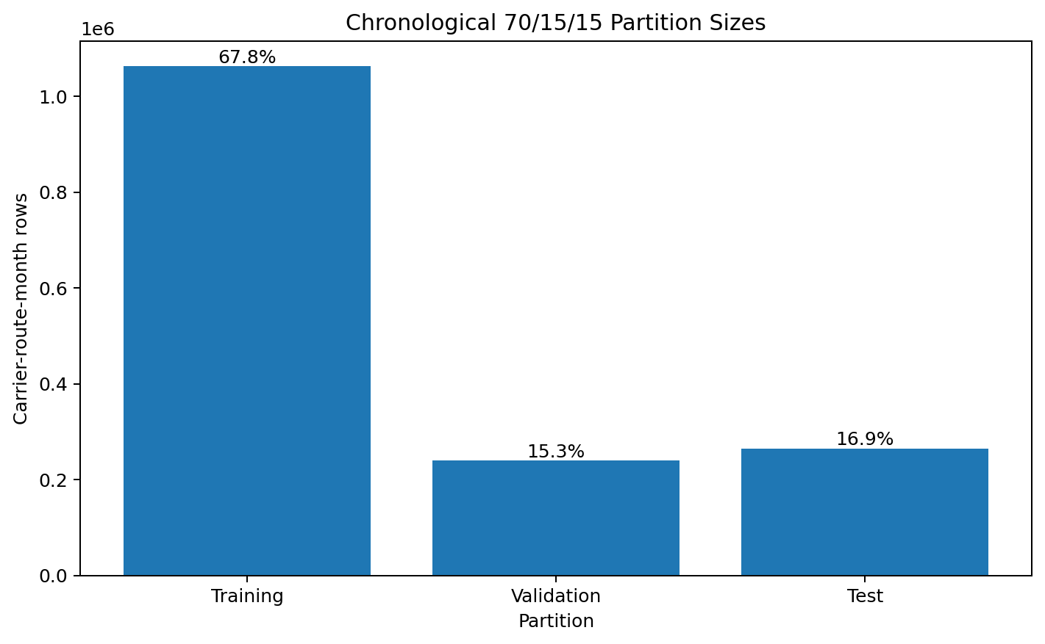
Figure 1. Chronological partition sizes.

3. EDA Methodology
All exploratory data analysis was done on the training data after the full dataset had been chronologically split into training, validation, and test partitions. The validation and test data were not used for any of the following: choosing transformations, investigating the distribution of predictors, picking rules for cleaning missing values. The exploratory data analysis that was done consisted of a structural overview, a missing value analysis, a logical value analysis, a duplicate carrier-route-month key analysis, a panel-continuity analysis, descriptive statistics, an analysis of the target variable’s distribution, a skewness/kurtosis analysis of numeric candidate predictors, correlations of the numeric candidate predictors with the target variable, a calendar-month seasonality analysis, a time-trend analysis, and a categorical-cardinality analysis. The logical checks consisted of searching for invalid negative values in the target, passenger, seat, scheduled/performed departure-count, and distance variables. The checks also searched for unusual load-factors. The numeric candidate predictors were analyzed using summary statistics and their correlations with next-month’s passenger demand. The categorical fields were analyzed by their frequency and the cardinality of the categorical field.
The total number of carrier-route-month observations without an exact observed next-month target was 316,490, representing 16.81% of all carrier-route-month rows. Because the supervised outcome is unknown for those observations, the target was not imputed; instead, those rows were excluded from the model-eligible sample. The full model-eligible dataset contains 1,566,289 observations. The training partition contains 1,062,603 carrier-route-month observations spanning 137 carriers, 14,095 unique directional routes, and 35,388 carrier-route series.

4. EDA Results and Insights

4.1 Target Distribution
The distribution of next-month passenger demand in the training partition is strongly asymmetric and right-skewed. The target has a mean of 5,048.63 passengers and a median of 2,479.00 passengers, while the target skewness is 3.46. The large difference between the mean and median, together with the positive skewness, confirms a substantial upper tail of high-volume carrier-route-month observations. These observations should not automatically be treated as errors or removed as outliers because many may represent legitimate high-volume markets. Later modeling should therefore consider approaches that can accommodate this asymmetry, such as a log1p transformation of the target, robust loss functions, or tree-based models.
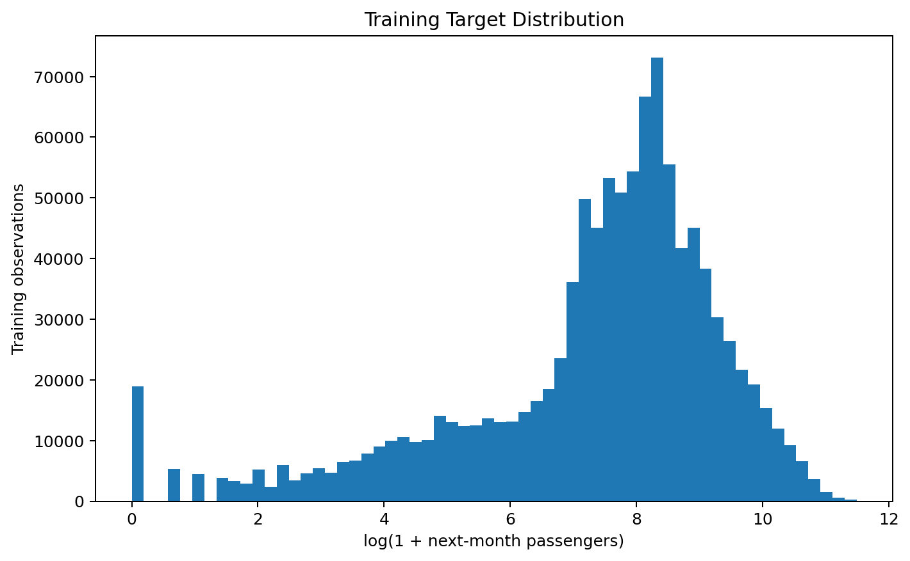
Figure 2. Training target distribution on a log(1 + passengers) scale.

4.2 Time Pattern and Regime Variation
The training time series for the aggregate passenger demand shows a high degree of non-stationarity. In addition to the seasonal patterns, there are also long-term trends in the data. The largest disruption to the regimes, however, is the impact of the COVID-19 crisis. The lowest aggregate training demand for the forecast model was for April 2020, with 2,858,797 target passengers for training. Therefore, the time series cannot be treated as if the individual observations were Independent and Identically Distributed (i.i.d.). Therefore, the model evaluation as well as the feature engineering has to preserve the time-ordering of the data and in addition, it has to be capable to model possible structural changes in the regimes.
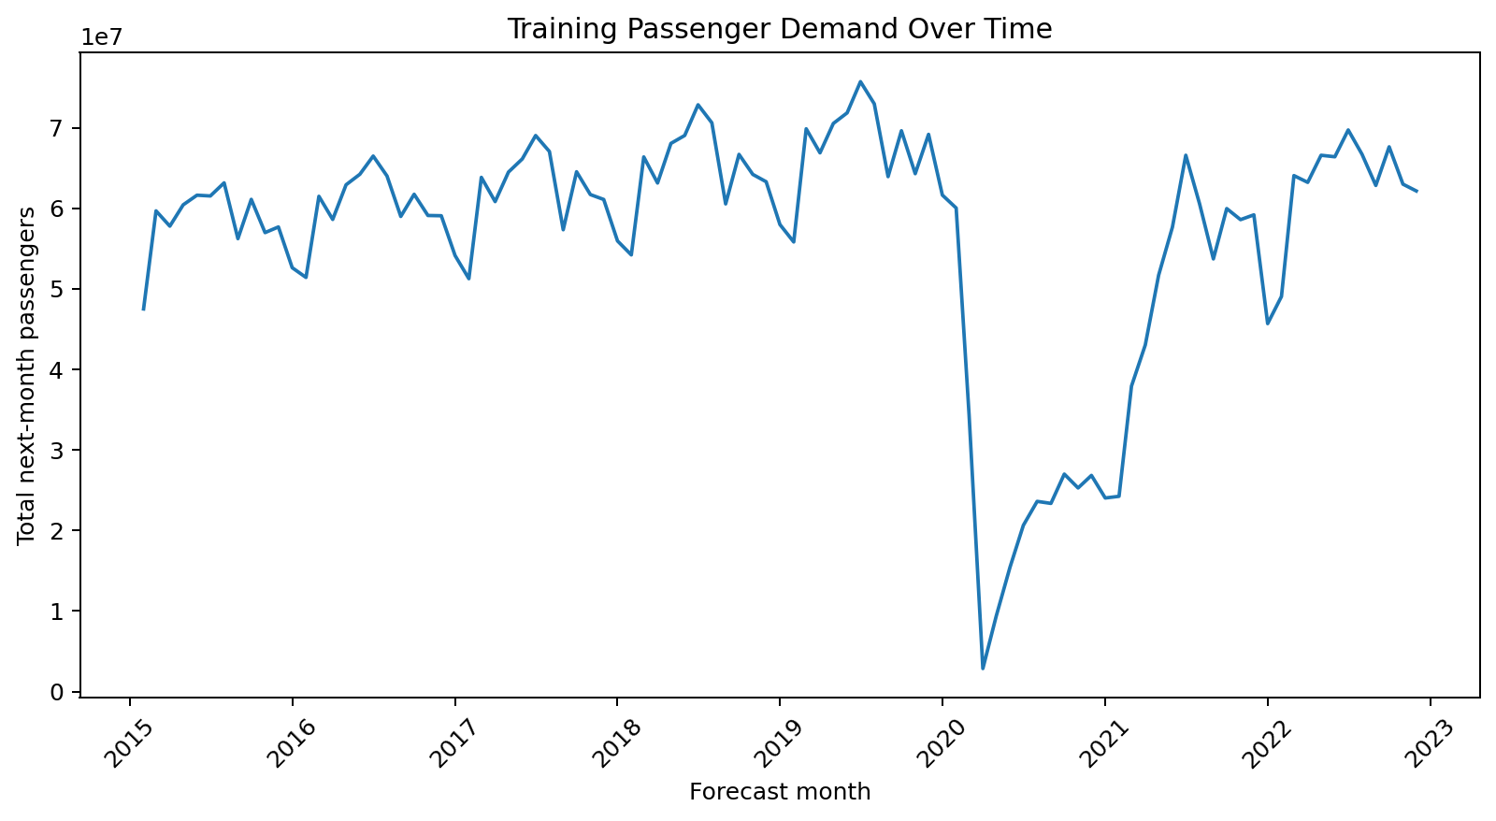
Figure 3. Aggregate next-month passenger demand over the training period.

4.3 Seasonality
Average next-month passenger demand over the training period varies on average by calendar month with October on average recording 5,538.9 passengers per carrier-route observation followed by July with 5,448.6 on average. January on average recorded the least amount of passengers for the next month with 4,303.1 passengers on average. Retaining the information for the calendar month would support evaluating of cyclical features, like trigonometric functions or Fourier features on the training data. Subsequently, the same features would need to be evaluated on the validation data before being applied unchanged to the test data.
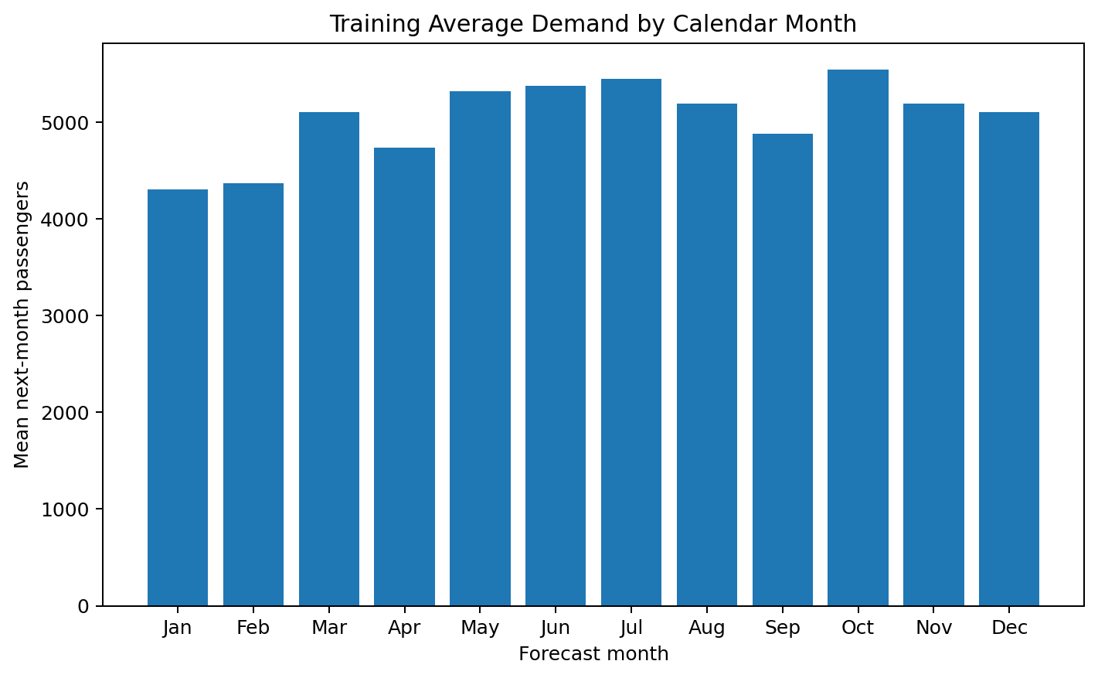
Figure 4. Mean training demand by forecast calendar month.

4.4 Numeric Relationships With the Target
Of the numeric candidate features, Passengers has the largest absolute correlation with next-month’s passenger demand (0.977), followed by Seats (0.964). Correlation of performed and scheduled departures with target passenger demand also indicates persistence between current-period service intensity and next-month passenger demand. Again, however, correlation need not translate into useful out-of-sample prediction and must be verified on the validation partition.
Predictor | PearsonCorrelationWithTarget
Passengers | 0.977
Seats | 0.964
DepPerformed | 0.822
DepScheduled | 0.794
LoadFactor | 0.290
Distance | 0.194

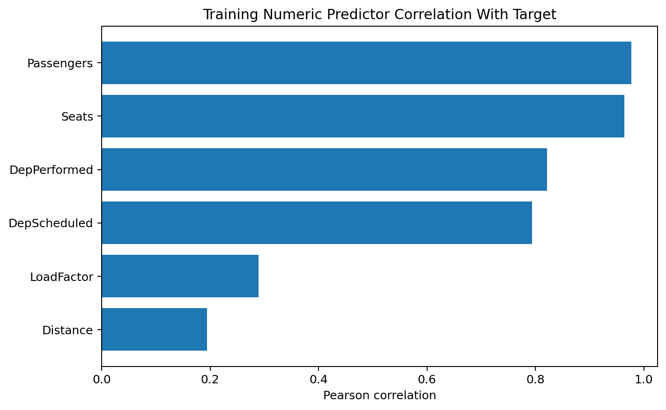
Figure 5. Training-set Pearson correlations between numeric predictors and the target.

5. Data Problems Identified
It is very important to distinguish between problems with integrity that need to be fixed in data prior to modeling, and problems with data that need to be addressed in modeling. So, for example, there were no duplicate keys for carrier-route-months in the data. Furthermore, the values for the target, passenger, seat, departure and distance all were strictly non-negative. However, there were a number of problems found with data that need to be addressed in modeling, and are summarized below.
Issue | Count | PercentOfTrainingRows | Interpretation
Load factor above 1 | 38 | 0.004% | Potential aggregation/reporting inconsistency
Rows that follow a gap of more than one month within a carrier-route series | 55165 | 5.191% | Unbalanced-panel continuity issue affecting 19,240 training series
Rows with at least one missing candidate predictor | 1433 | 0.135% | Missing-feature issue

An important, but complex, structure of the data is the unbalanced carrier-route panel. 55,165 training rows (5.191%) follow a gap of more than one month within their carrier-route series. This affects 19,240 carrier-route series (~54.4%) of 35,388 carrier-route series in the training partition. When we use lag or rolling-window features on these training series, we must check for exact calendar-continuity of the carrier-route in the rows before these rows are used for the feature value. Note that there are 1,433 rows (0.135%) with at least one missing candidate predictor and 38 rows (0.004%) with load factor greater than 1. These must be checked and possibly removed rather than to be cleaned or removed automatically.

6. Implications for the Week 1 Problem Statement
The EDA findings suggest that predicting carrier-route passenger demand for next month is feasible and should be modeled as a temporally ordered panel (carrier-route observations over time) since current measures of passenger volume, seats, and departures for the current month strongly predict next-month’s demand. Furthermore, an analysis of the calendar information (seasonality) over the training period reveals meaningful patterns that can help include additional information for modeling. However, since the target variable for prediction is strongly right-skewed, and there are an unbalanced number of carrier-routes by time, and some predictors are missing, and there are large demand-regime shifts in time, for purposes of out-of-sample generalization, care must be taken in splitting observations into a training set and a validation/ testing set, as well as in the construction of lagged features and rolling features that preserve temporal order, do not bridge missing months, and do not use information from future forecast periods.

7. Recommended Preprocessing for Subsequent Weeks
- Preserve chronological month-based split and never randomly shuffle observations across time. Project predicts future demand; temporal leakage would inflate validation/test performance.
- Do not impute missing target values; exclude rows for which exact next-month outcome is unavailable. Supervised outcome is unknown, not merely a missing predictor.
- Fit all predictor imputation, encoding, scaling, and transformation rules on training data only. Using validation/test distributions to design preprocessing leaks information from future periods.
- Represent carrier/origin/destination categorical information with a modeling-appropriate encoding learned from training data. These are high-cardinality identifiers and cannot be passed as raw strings to most regression estimators.
- Consider log1p target modeling, robust losses, or tree-based models rather than deleting legitimate high-volume routes as outliers. Route-month passenger demand is expected to be strongly right-skewed and operational extremes may be genuine rather than errors.
- Engineer lags/rolling features only from information available at or before forecast origin, with explicit gap handling. Carrier-route panel is unbalanced; naive shift/rolling operations can silently bridge missing months.
- Consider calendar seasonality and a pandemic/regime indicator during feature engineering/model comparison. Time series spans materially different demand regimes and seasonal patterns.

8. Conclusion
This week we created a chronological training/validation/test design and kept the exploratory data analysis within the training data. We found several important properties of the data: target-availability constraints, strong distributional asymmetry, temporal and seasonal effects, highly informative current-period demand and capacity values and last but not least continuity gaps for the carrier-route panel. The findings from this analysis can now be used for subsequent model-development steps, while the validation and test data remain reserved for unbiased future evaluation.

