ADAN8888 — Applied Analytics Project
Week 8: Develop Third Modeling Approach
BTS T-100 Domestic Segment | Next-Month Passenger-Demand Forecasting
EMPIRICAL RESULTS REPORT — actual Week 8 BTS modeling outputs

1. Prediction Task and Third Modeling Approach
Week 8 introduces a third supervised regression model for predicting TargetPassengersNextMonth, the number of passengers in the following month for each directional U.S. domestic carrier–route. Previous weeks compared a regularized linear Ridge model (Week 6) and a nonlinear Histogram Gradient Boosting Regressor (Week 7). This week evaluates a feedforward multilayer perceptron (MLP) neural network, a distinct model family that learns a nonlinear mapping from the same two PCA inputs, PC1 and PC2, to next-month passenger demand.
A multilayer perceptron comprises several connected layers whose weights are adjusted through backpropagation. Nonlinear ReLU activations can represent flexible smooth and piecewise-linear relationships beyond Ridge regression, while the optimization of many connected weights provides a different inductive bias from the successive threshold splits of histogram boosting. Neural networks have non-convex training objectives and may not outperform the Week 7 model; increased flexibility is tested empirically, not assumed beneficial.

2. Dataset, Chronological Validation, and Scaling
The full chronological partition contains 1,062,603 training rows across 95 forecast months (February 2015–December 2022), 239,395 validation rows across 20 months (January 2023–August 2024), and 264,291 reserved test rows across 21 months (September 2024–May 2026). The Week 8 output verifies these unchanged partitions using the full BTS-derived data, not prior-week preview samples. Models fit to training only, with validation used for model selection; the test partition was not evaluated.
The nine original and engineered numeric inputs were log-transformed, imputed, standardized, and projected onto PC1 and PC2 through the existing Week 5 training-fitted transformation. Week 8 adds a training-fitted StandardScaler for these two coordinates and a separately training-fitted StandardScaler for the passenger target, which stabilizes neural-network optimization. The fitted target transformation is automatically inverted for predictions and for passenger-scale metrics. No information from validation or test periods is used to estimate scaling parameters, PCA loadings, or neural-network weights. Negative predictions are clipped to zero only after inverse transformation, using the same policy for every model.

3. Model Complexity and Hyperparameters
Three preset neural-network architectures were evaluated: MLP_A (32, 16), MLP_B (64, 32), and MLP_C (64, 32, 16). All use ReLU activation, the Adam solver, alpha=0.001 for L2 regularization, learning_rate_init=0.001, batch_size=4096, random_state=42, and a maximum of 45 training epochs. Automatic early stopping was disabled to avoid creating a randomly sampled internal validation set; training-loss convergence stopping remained enabled. The real BTS runs terminated after 20 epochs (MLP_A) and 17 epochs (MLP_B and MLP_C), each with the code reporting convergence. Stopping before 45 epochs does not prove a global optimum.
Model | Hidden layers | Contrast with earlier variation
MLP_A | 32, 16 | Compact network; two hidden layers
MLP_B | 64, 32 | Wider two-layer network than A
MLP_C | 64, 32, 16 | Third nonlinear layer beyond B
Moving from MLP_A to MLP_B tests whether additional hidden units improve fit; MLP_B to MLP_C tests the contribution of added depth. These variations change hidden_layer_sizes while holding training optimization and regularization settings constant. Because architecture, neural weight count, and optimization behavior are jointly relevant, a more complex network can overfit or converge poorly even if its training MAE decreases.

4. Performance Metrics and Winner Selection
We use MAE as our primary selection metric, average absolute error in passengers, which is most relevant for airline capacity decisions. RMSE puts a higher penalty on individual large errors, while R² measures fit against a constant-mean prediction in each partition. All training and validation metrics are reported. We use the pre-established selection rule of lowest MAE on validation followed by lowest RMSE on validation, and fewest trainable neural-network weights in case of an exact tie. The metrics that we use to measure fit (the training metrics) do not determine the winner, and we do not score on the test partition.

5. Three-Model Training and Validation Results
Table 2 presents the complete results from week8_three_model_comparison.csv after execution on the original BTS-derived training and validation partitions. MAE and RMSE are measured in passengers; R² is unitless. All models use the same nonnegative prediction floor after inversion of the training-fitted target scaler.
Model | Train MAE | Val MAE | Train RMSE | Val RMSE | Train R² | Val R²
MLP_A | 1,171.37 | 1,171.51 | 2,236.71 | 2,019.43 | 0.9169 | 0.9380
MLP_B | 1,161.63 | 1,143.20 | 2,236.20 | 1,988.78 | 0.9169 | 0.9399
MLP_C | 1,159.01 | 1,149.90 | 2,230.23 | 1,999.78 | 0.9174 | 0.9392
MLP_B provides the lowest validation MAE (1,143.20), validation RMSE (1,988.78), and highest validation R² (0.9399) of the three configurations. These statistics use all 239,395 validation records; no synthetic smoke-test results were used.

6. Training–Validation Comparison and Overfitting Analysis
Increasing network width from MLP_A to MLP_B reduced validation MAE by 28.32 passengers (2.42%) and validation RMSE from 2,019.43 to 1,988.78. In contrast, adding a third hidden layer (MLP_C) decreased training MAE from 1,161.63 to 1,159.01, but validation MAE increased from 1,143.20 to 1,149.90, and validation RMSE increased from 1,988.78 to 1,999.78. This suggests the added depth did not improve validation generalization in this experiment; it is not sufficient by itself to establish statistically significant overfitting. Each model had different training optimization outcomes despite a common maximum of 45 epochs.
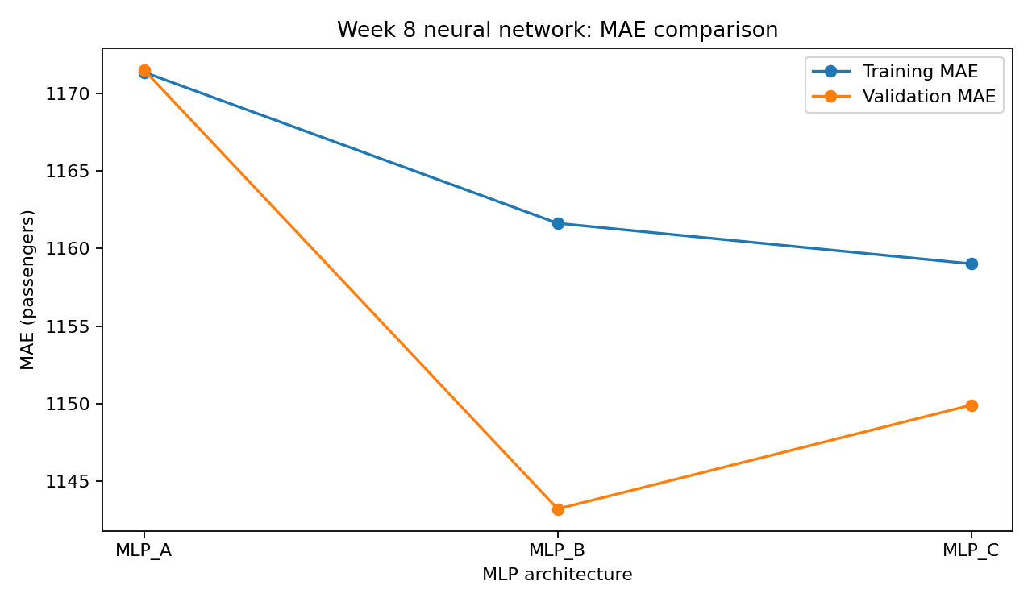
Figure 1. Training versus validation MAE for the three Week 8 neural-network architectures.
MLP_B achieves the lowest validation MAE (1,143.20 passengers); MLP_C has the lowest training MAE (1,159.01) but does not generalize as well as MLP_B on validation.
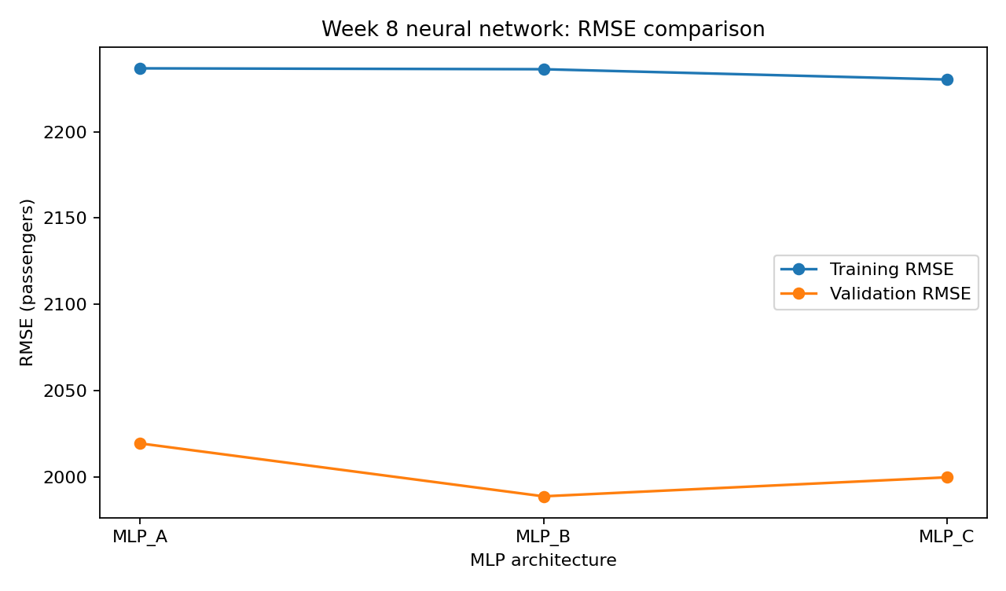
Figure 2. Training versus validation RMSE, with lower error preferred.
MLP_B also minimizes validation RMSE (1,988.78 passengers), confirming its advantage is not confined to the primary MAE selection metric.
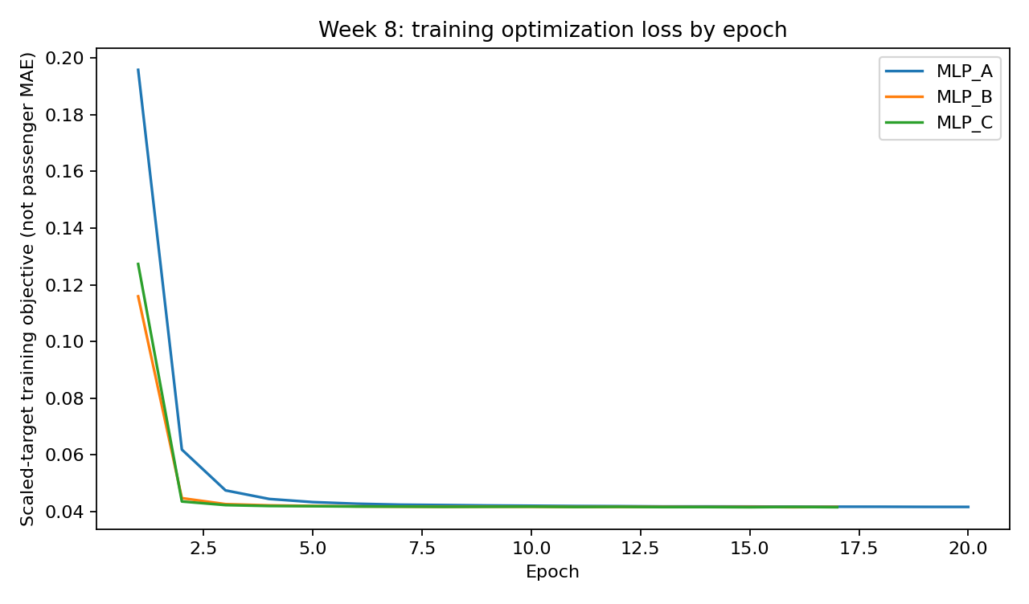
Figure 3. Training optimization loss by epoch, measured on the standardized target scale.
Training losses decrease rapidly and then flatten; their values are not MAE in passengers. The curves describe training optimization rather than held-out validation quality or proof of global convergence.

7. Provisional Winner and Week 7 Benchmark
The provisional Week 8 winner is MLP_B, with two hidden layers of (64, 32) and 2,305 trainable parameters. Its validation MAE is 1,143.20 passengers, RMSE is 1,988.78 passengers, and R² is 0.9399; training MAE is 1,161.63 passengers. The validation MAE improves on Week 7 HGB_C’s 1,161.07 passengers by 17.87 (1.54%). This modest validation-set improvement is not a final test-set result and does not determine the overall project winner. The final test partition remains reserved for later unbiased evaluation, after cross-model selection is completed.
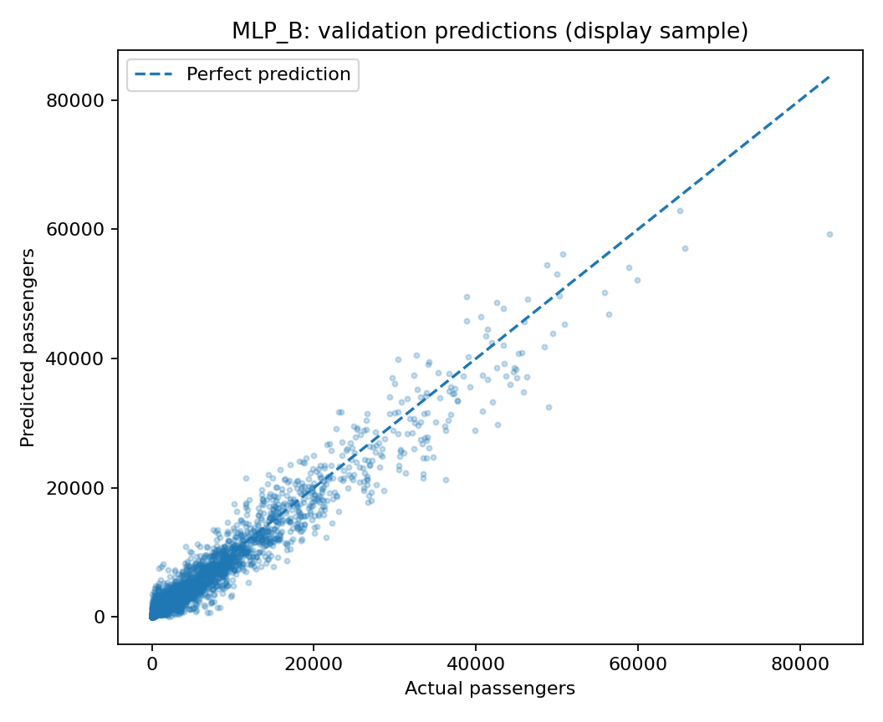
Figure 4. Actual versus MLP_B predictions for a reproducible visualization sample of validation rows.
The sample clusters near the reference line for smaller passenger counts, with larger dispersion and several underpredictions for high-demand segments. The reported scores use all validation rows; only the scatterplot is sampled.
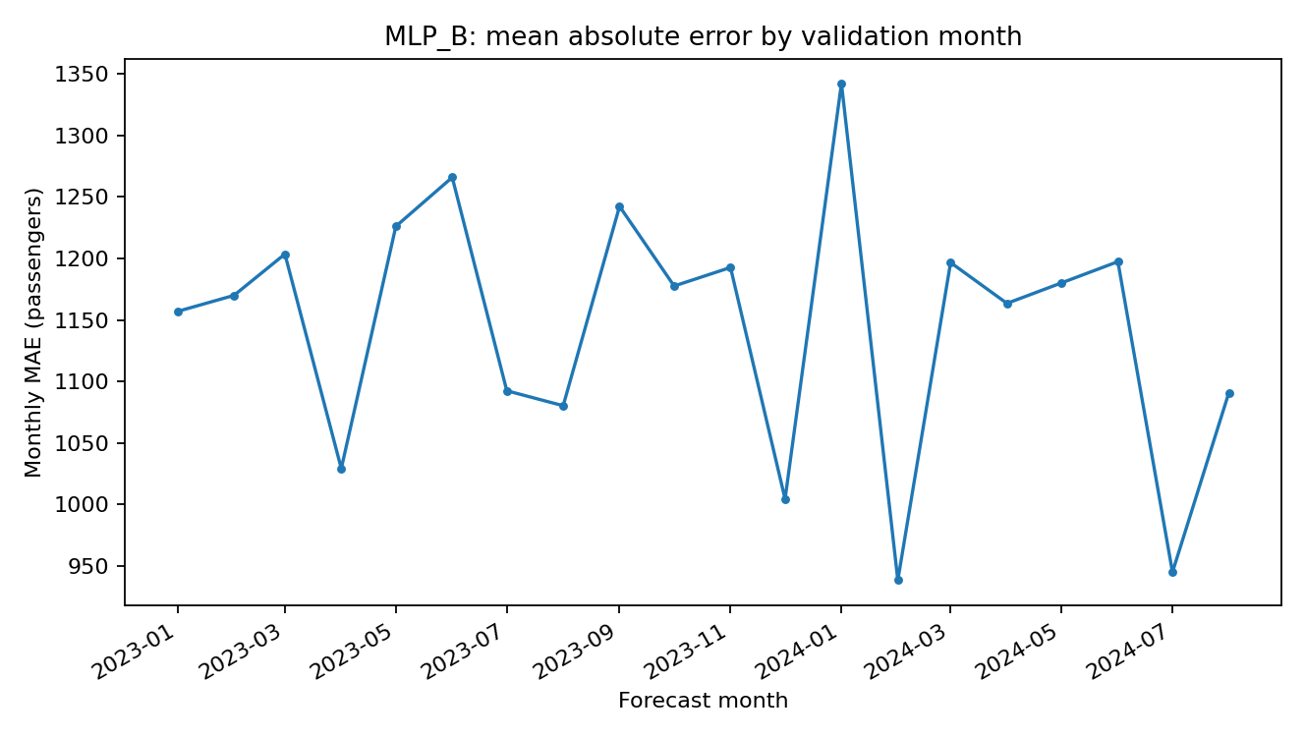
Figure 5. MLP_B validation MAE by forecast month using the complete validation partition.
Calendar-month MAE ranges from 938.36 passengers in February 2024 to 1,342.22 passengers in January 2024. The variation can reflect demand, route mix, record counts, and time-specific conditions rather than seasonality alone.

8. Limitations, Reproducibility, and Next Steps
This new reusable source code for MLP (nonlinear model with more weights than Ridge for two features) is different from the source code for histogram boosting for two features. The difference in the observed MLP_B validation performance relative to Week 7’s performance could be due to many factors including the different modeling approaches, random initialization, the fixed architecture, and the number of training iterations used in the MLP model. Also note that training MAE and validation MAE are not identical, and the respective periods may have different demand levels and route mixes. Furthermore, by using only two features PC1 and PC2, we are discarding possible carrier, airport-specific and other features of demand that could be very valuable. Further checks should also examine the model’s performance under different random seeds, alternative chronological validation periods, and different route-volume segments.
The source that can be reused is located in `Src/week8_src_mlp_neural_network.py` and in the notebook `Notebooks/week8_notebook_mlp_model_training_tuning.ipynb`. The supplied outputs comprise a three-model comparison, six partition-level metric rows, validation ranking, monthly validation MAE, and five diagnostic figures. The selected estimator is saved with its Week 8 feature and target scalers; inference from raw BTS records additionally requires the same training-fitted Week 5 feature definitions and PCA transformation. The winner manifest explicitly marks `EvaluatedTestSet=false`. Cross-week model selection must take place before a single reserved test-set evaluation.

References
Bureau of Transportation Statistics. T-100 Domestic Segment (All Carriers). https://www.transtats.bts.gov/
Scikit-learn. Neural network models (supervised). https://scikit-learn.org/stable/modules/neural_networks_supervised.html
Scikit-learn. MLPRegressor API. https://scikit-learn.org/stable/modules/generated/sklearn.neural_network.MLPRegressor.html
Scikit-learn. TransformedTargetRegressor API. https://scikit-learn.org/stable/modules/generated/sklearn.compose.TransformedTargetRegressor.html
Scikit-learn. Metrics and scoring. https://scikit-learn.org/stable/modules/model_evaluation.html

