ADAN8888 — Applied Analytics Project
Week 5: Engineer Features and Reduce Dimensionality
BTS T-100 Domestic Segment (All Carriers) | Next-Month Passenger Demand

1. Purpose and Analytical Scope
The Week 5 objective is to extend the existing supervised regression dataset with domain-relevant cross-field predictors and reduce numeric input dimensionality without compromising the time-ordered forecasting design. The observation unit is a directional UniqueCarrier × Origin × Dest × reference-month segment; the target is the following calendar month’s passengers for the same carrier-route series. The current month’s data are presumed available before a prediction for the following month is issued. The work focuses on feature representation rather than fitting or evaluating the final forecasting model.
This implementation builds on the Week 2 BTS ingestion and Week 3 chronological splitting code. The five numeric source fields used for the Week 5 experiment are Passengers, Seats, DepScheduled, DepPerformed, and Distance. The source fields and four engineered variables form nine numeric PCA candidate predictors.

2. Preservation of the Chronological Partition
Week 3 chronological allocation is reused, with the earliest forecast months in training, the next period in validation, and the most recent period in test. The percentages are based on whole forecast months, so the proportions of observations need not exactly equal 70%/15%/15%. Future observations never contribute to fitting the numeric imputer, standardizer, or PCA decomposition.
Partition | Rows | Forecast months | Forecast-month window
Training | 1,062,603 | 95 | 2015-02 through 2022-12
Validation | 239,395 | 20 | 2023-01 through 2024-08
Test | 264,291 | 21 | 2024-09 through 2026-05

The above partition counts come from the saved Week 3 results, not from a new Week 5 run. Rows with unknown next-month target values had already been excluded from the eligible supervised sample; missing targets weren’t imputed.

3. Feature Engineering
Four current-month features combine pairs of existing variables to provide operationally interpretable signals about aircraft capacity, passenger intensity, spare capacity, and travel exposure. Each feature uses only observed reference-month values, so the following-month target cannot influence its construction.
Engineered predictor | Calculation | Potential business signal
SeatsPerFlight | Seats / DepPerformed | Average offered seats per performed departure
PassengersPerFlight | Passengers / DepPerformed | Average transported passengers per performed departure
UnusedSeats | Seats − Passengers | Unused reported monthly seat capacity
PassengerMiles | Passengers × Distance | Passenger-mile exposure across the directional segment

A ratio is undefined when/if the number of performed departures is zero; these records are represented as missing values rather than assigning an arbitrary ratio. Negative numeric counts are treated as invalid/missing. When reported passenger counts exceed available seats, the negative UnusedSeats value is treated as an invalid feature rather than interpreted as genuine unused capacity. All resulting missing numeric values are imputed using the corresponding training-only medians after log1p transformation.

4. Dimensionality Reduction Method
The nine candidate numeric predictors are transformed using log1p to reduce differences in scale caused by highly right-skewed count variables. Any remaining missing values are filled using training-partition medians; variables constant in training are excluded. Next, StandardScaler estimates each selected predictor’s training mean and standard deviation. PCA is then fitted only on the standardized training predictor matrix, with PC1 and PC2 providing a two-column compressed representation. Validation and test observations are projected with these frozen training-fitted parameters.
PCA components are orthogonal linear combinations of standardized source variables. The algorithm seeks directions of high input variance; it does not directly optimize passenger-demand forecasting accuracy. The next-month passenger target, route identifiers, categorical carrier codes, and date fields are excluded from the PCA fitting matrix. They are retained only as audit metadata or modeling outcomes. The experiment also calculates, using training data only, how many components would be necessary to retain at least 95% of standardized input variance.
Dimension stage | Number of numeric predictors
Original numeric fields plus engineered fields | 9
After removing training-constant predictors | 9
Final compressed representation (PC1, PC2) | 2

PC1 and PC2 explain 91.56% of standardized training-set predictor variance (73.75% and 17.81%, respectively). Three components explain 94.90%; 4 components are needed to exceed the 95% variance threshold (97.60% cumulative variance). The two-component representation therefore reduces nine nonconstant numeric inputs to two, but variance retention alone does not demonstrate improved forecasting accuracy.

5. Synthetic Augmentation Decision
No synthetic training rows were generated. The historical BTS dataset already includes more than 1.5 million observations with known next-month outcomes, so adding fabricated route-month records is not necessary to satisfy this assignment. Artificially constructed passengers, routes, or demand periods could distort seasonality, panel gaps, capacity constraints, or pandemic-era regime changes. If synthetic augmentation were reconsidered for a later experiment, it would need to be evaluated for realism and forecasting utility and generated strictly within the training period. Week 5 therefore uses the feature-engineering option explicitly permitted by the assignment and independently satisfies the dimensionality-reduction requirement.

6. Leakage Controls and Verification
Data splitting takes place by forecast month. Feature arithmetic uses only the current reference month. Learned medians, constant-column decisions, feature scaling, and PCA loadings are estimated exclusively from the training partition. They are reused unchanged on validation and test data; no validation/test outcome is consulted during feature creation, preprocessing fitting, or selection of two components. The notebook asserts strict split boundaries, unchanged split row counts, finite PCA features, and the successful creation of output artifacts.
The result is a model-ready, two-component representation for later regression evaluation. The Week 4 predictors and the nine-input Week 5 feature set remain available as alternatives: dimensionality reduction can make inputs more compact while losing predictive information or interpretability. Subsequent modeling will establish whether PCA improves real out-of-sample forecasting performance.

7. Outputs and Reproducibility
The reusable implementation is Src/week5_src_features_dimensionality.py and the executed workflow is Notebooks/week5_notebook_features_dimensionality.ipynb. After execution, Reports/week5/week5_tables contains component variance, feature definitions, PCA loadings, split quality checks, and the exact training-fitted transform metadata. Reports/week5/week5_figures contains the PCA explained-variance chart, loadings visualization, and dimension comparison. Data/processed/week5 contains representative reduced training/validation/test samples, with full output reproducible from the annual BTS ZIP archives.
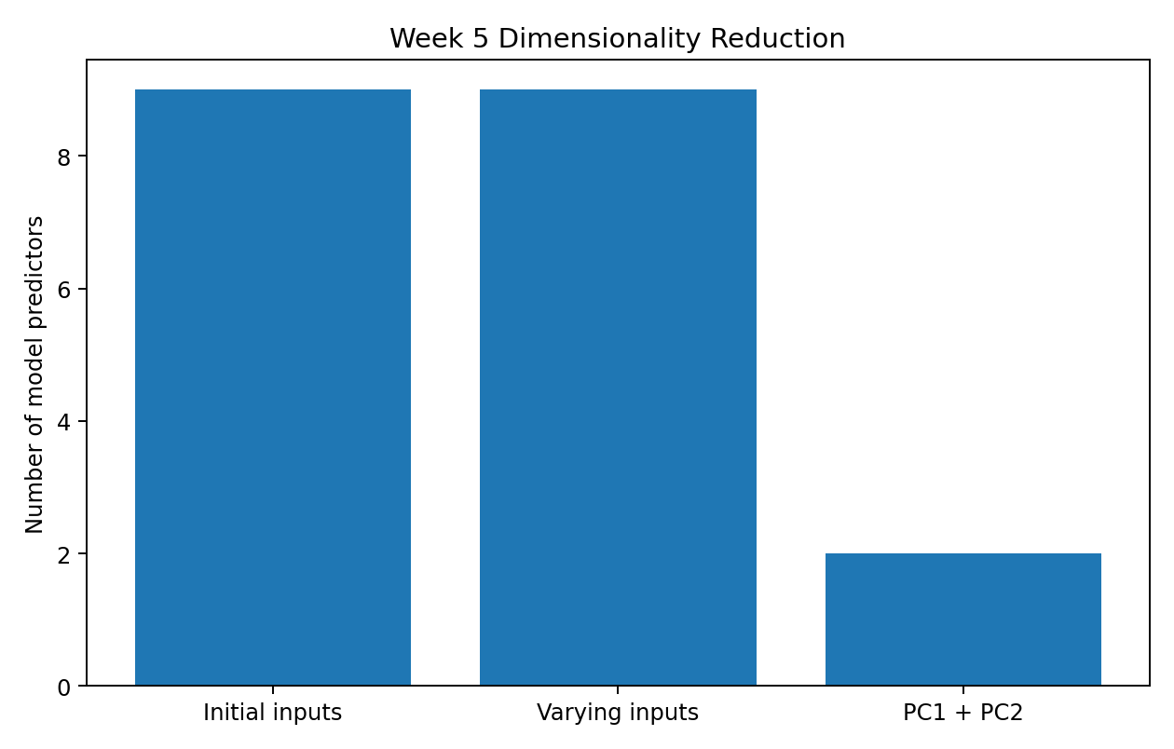
Figure 1. Reduction from nine numeric predictors to two PCA components.
All nine original and engineered numeric candidates varied in training. PCA projects these nine standardized inputs onto PC1 and PC2, reducing the numeric representation to two columns.
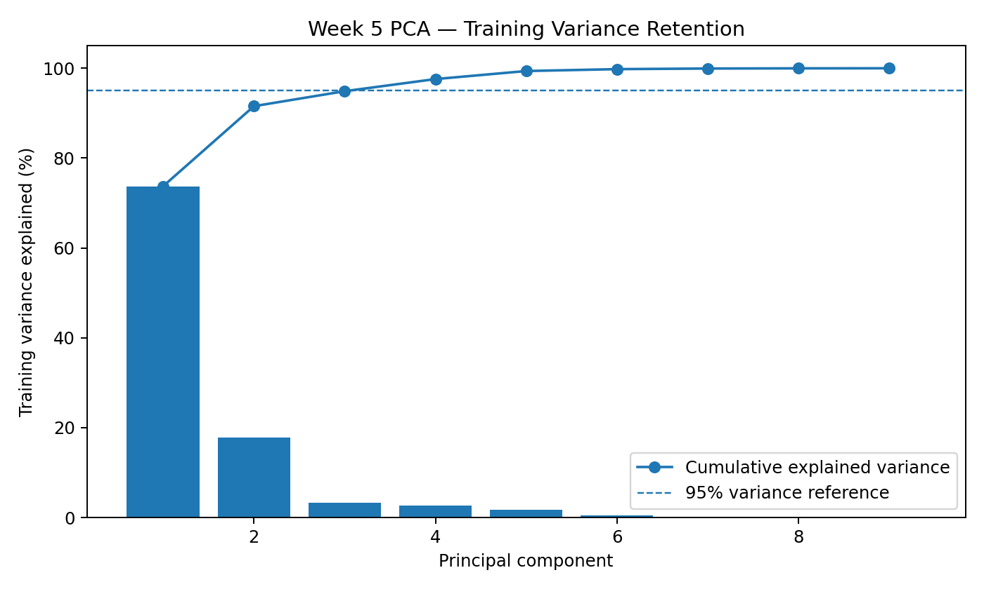
Figure 2. Individual and cumulative explained training variance by principal component.
PC1 and PC2 collectively retain 91.56% of standardized training variance. Three components retain 94.90%, just below the 95% reference; four retain 97.60%. This measures input variance, not forecasting accuracy.
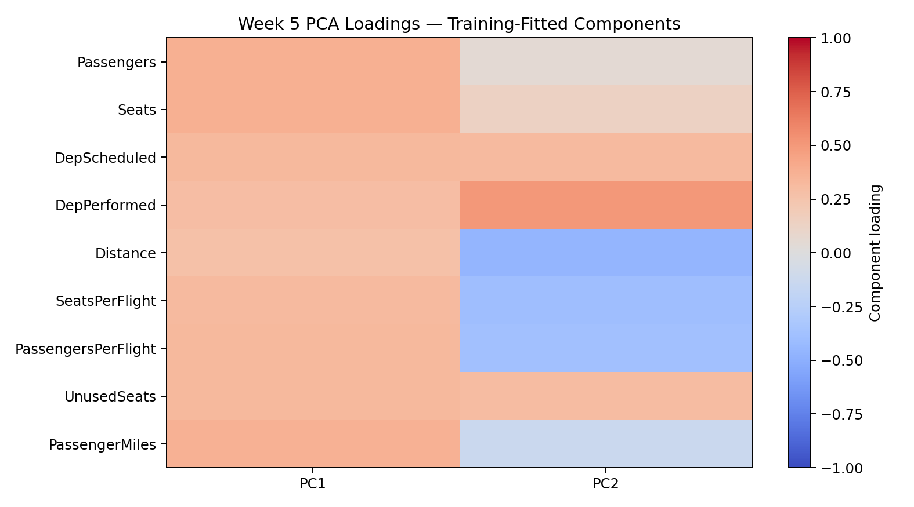
Figure 3. Training-fitted loadings of the nine predictors on PC1 and PC2.
PC1 has positive loadings across all nine predictors, whereas PC2 contrasts service-intensity measures such as performed departures against distance and passengers per flight. Loadings describe the PCA directions and do not imply causal or predictive importance.

8. Conclusion
Week 5 introduces four transparent, airline-specific cross-field features and demonstrates a training-only PCA reduction from nine candidate numeric predictors to two principal components. Missing or invalid arithmetic results are handled systematically; data augmentation is intentionally omitted; and the historical forecast-month split remains unchanged. The resulting artifacts provide a documented, reproducible lower-dimensional feature representation for comparison with the original model-ready predictors in the subsequent forecasting-model development phase.

References
Bureau of Transportation Statistics. T-100 Domestic Segment (All Carriers), annual extracts (2015–2026). https://www.transtats.bts.gov/
scikit-learn developers. Principal Component Analysis (PCA), decomposition user guide. https://scikit-learn.org/stable/modules/decomposition.html
Analytics Vidhya. Getting Started with Feature Engineering (2020). https://www.analyticsvidhya.com/blog/2020/10/getting-started-with-feature-engineering/

