ADAN8888 — Applied Analytics Project
Week 7: Develop Second Modeling Approach
BTS T-100 Domestic Segment | Next-Month Passenger-Demand Forecasting
Tyler Miller, Jason Pinales, and Emma Portanova

1. Purpose and Rationale
This assignment develops a second, more complex supervised regression approach to predict next-month U.S. domestic airline passenger demand for the same carrier, origin, and destination. The response variable is TargetPassengersNextMonth. Week 6 established Ridge regression, a linear model of Week 5 principal components PC1 and PC2; Week 7 instead evaluates Histogram Gradient Boosting Regression on those same components. This comparison tests whether additional nonlinear modeling capacity improves performance on subsequent forecast months.
Histogram gradient boosting builds an ensemble of decision trees in successive correction stages. Its bin-based splitting strategy makes training computationally practical for a large BTS carrier-route-month panel. Relative to Ridge regression, the boosted-tree ensemble can represent nonlinear thresholds and interactions in PC1 and PC2, but greater capacity creates a stronger need to evaluate overfitting and temporal generalization.

2. Dataset, Feature Representation, and Leakage Controls
The earlier pipeline reconstructs the full official BTS T-100 observations, applies the Week 5 log transformations, median imputation, standardization, and PCA learned from training data only, and projects the validation records using those same fitted transformations. Exactly two transformed numeric predictors are used: PC1 and PC2. The 500-row Week 5 preview samples were not used for modeling.
Partition | Forecast-month coverage | Rows | Forecast months
Training | Feb 2015–Dec 2022 | 1,062,603 | 95
Validation | Jan 2023–Aug 2024 | 239,395 | 20
Test (reserved) | Sep 2024–May 2026 | 264,291 | 21
The chronological forecast-month split remains unchanged from Week 3. Models fit on the training partition only; validation outcomes determine model selection. The held-out test set is not evaluated or used to tune any configuration. This preserves the intended distinction between exploratory model selection and later final evaluation.

3. Complexity and Hyperparameters
Three controlled hyperparameter configurations were fitted. The A-to-B comparison raises the number of boosting rounds while holding tree capacity constant; the B-to-C comparison increases maximum leaves per tree with the number of boosting rounds fixed. The learning rate remains 0.05 so the changes are easier to interpret.
Configuration | Learning rate | Boosting iterations | Maximum leaf nodes
HGB_A | 0.05 | 100 | 15
HGB_B | 0.05 | 250 | 15
HGB_C | 0.05 | 250 | 31
Across all configurations, loss="squared_error", min_samples_leaf=50, l2_regularization=1.0, and random_state=42 are fixed. Automatic early stopping was disabled to avoid an additional random internal holdout unrelated to the chronological split. Larger max_iter values can reduce bias by allowing more corrective updates; a larger max_leaf_nodes setting increases individual tree flexibility, potentially improving fit while increasing overfitting risk.

4. Performance Metrics and Selection Rule
The three metrics used for model evaluation are Mean absolute error (MAE) as the average absolute deviation between predicted and observed passenger counts, Root mean squared error (RMSE) with a higher penalty for large errors, and R² as fit relative to an intercept-only mean prediction in each partition. Metrics were calculated and stored for the full training data as well as for the full validation data. Before calculating these metrics, the same zero-floor for negative predictions was applied to all models.
The pre-established winner rule is lowest validation MAE; in case of exact ties, validation RMSE will be the tie-breaker, followed by the complexity of the model for remaining ties, favoring the simpler configuration. Training statistics will be used for model diagnosis but will not override the validation winner. The held-out test data will not be used for model selection.

5. Complete Training and Validation Results
Table 3 contains the measured results from the executed Week 7 notebook and the supplied three-model CSV, with MAE and RMSE stated in passengers. Every one of the three configurations completed all intended boosting iterations.
Model | Train  MAE | Validation  MAE | Train  RMSE | Validation  RMSE | Train  R² | Validation  R²
HGB_A | 1,180.22 | 1,179.31 | 2,263.18 | 2,060.22 | 0.9149 | 0.9355
HGB_B | 1,164.08 | 1,163.47 | 2,254.86 | 2,050.41 | 0.9155 | 0.9361
HGB_C | 1,159.02 | 1,161.07 | 2,247.90 | 2,051.79 | 0.9160 | 0.9360
HGB_C achieves the lowest validation MAE, 1,161.07 passengers; HGB_B follows at 1,163.47 and HGB_A at 1,179.31. The winning-model manifest, rank-order CSV, and executed notebook agree on this selection. Validation R² values for all three configurations are approximately 0.935–0.936.

6. Training-versus-Validation Analysis
Increasing boosting iterations from 100 (HGB_A) to 250 (HGB_B) lowers validation MAE by 15.84 passengers (1.34%) and validation RMSE from 2,060.22 to 2,050.41 passengers. Training MAE also decreases from 1,180.22 to 1,164.08. Thus, additional boosting improves both fitted and subsequent-period accuracy within this tested range.
Increasing maximum leaf nodes from 15 (HGB_B) to 31 (HGB_C) further lowers validation MAE by 2.40 passengers (0.21%) and training MAE by 5.07 passengers. However, HGB_C has slightly higher validation RMSE than HGB_B (2,051.79 versus 2,050.41) and a marginally lower validation R² (0.9360 versus 0.9361). HGB_C is the MAE-based winner, not the winner on every metric; the 2.40-passenger MAE advantage over HGB_B is small and should not be presented as evidence of a statistically significant gain.
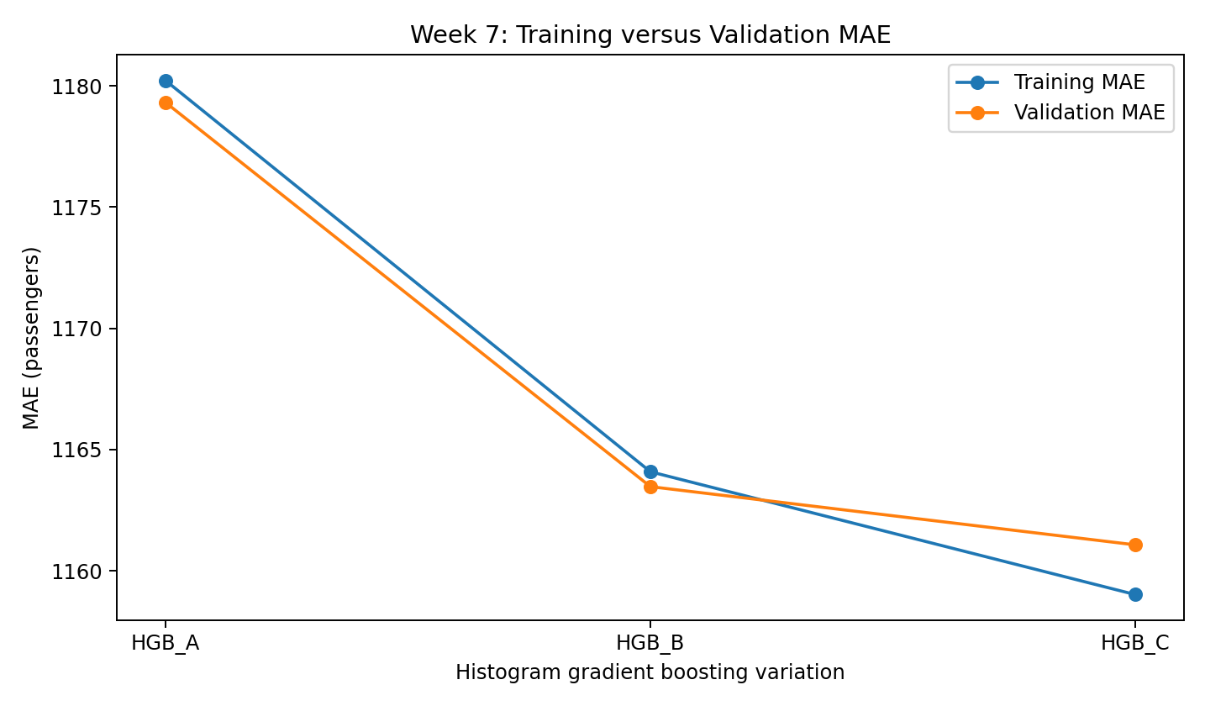
Figure 1. Training and validation MAE for the three histogram-boosting configurations.
Training and validation MAEs are close for each variation: their differences (validation minus training) are −0.90, −0.61, and +2.05 passengers for HGB_A, HGB_B, and HGB_C, respectively. This does not indicate a substantial MAE generalization gap in the tested configurations. However, error differences alone cannot establish the absence of overfitting because the chronological partitions may differ in passenger-demand distribution and route composition.
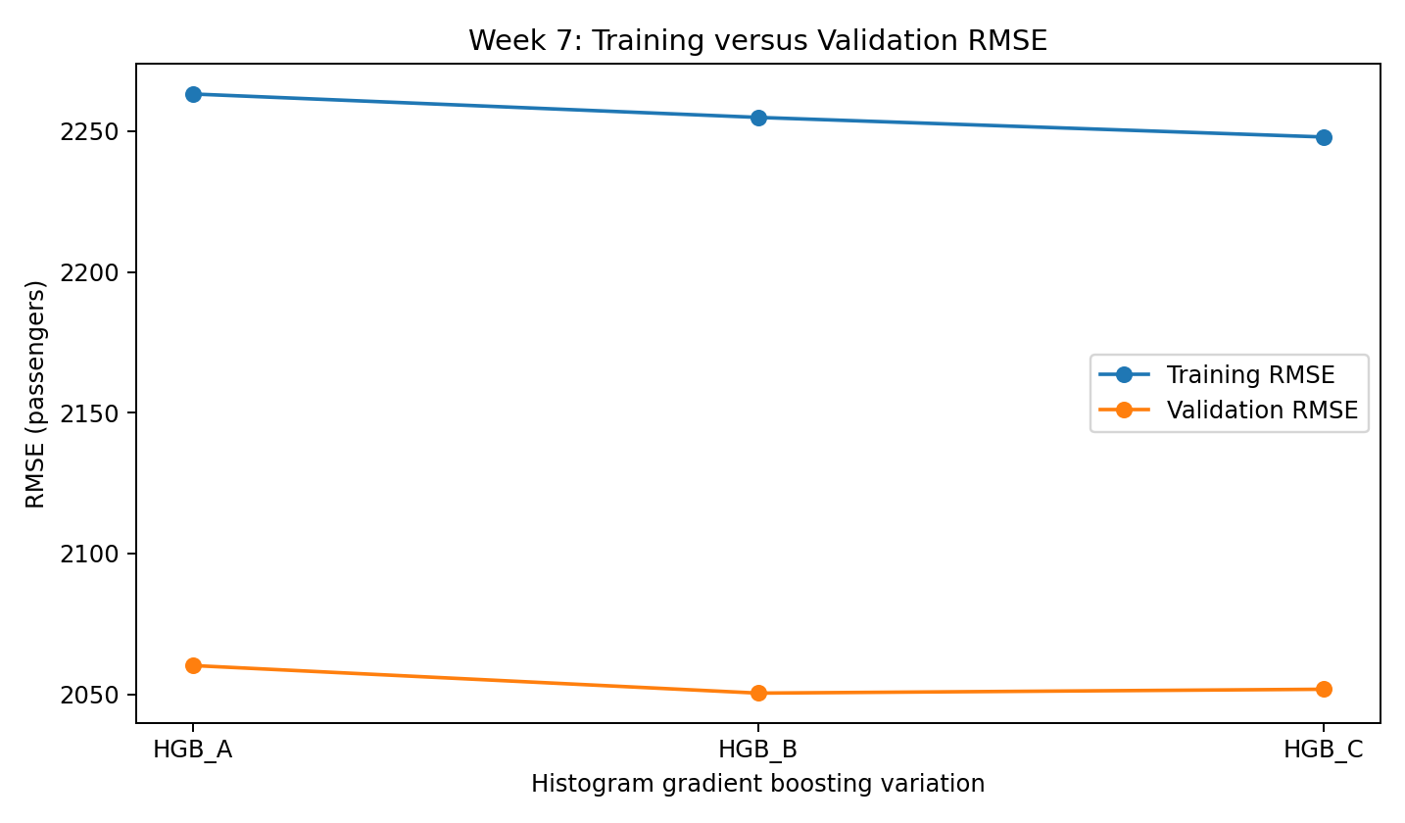
Figure 2. Training and validation RMSE; HGB_B has the lowest validation RMSE.
RMSE on validation is lower than on training for all three candidates despite their chronological separation. This is compatible with a shift in the prevalence of large passenger-count observations or unusually large errors across periods; it should not be interpreted as validation data being intrinsically easier without further segment-level analysis.

7. Selected Model, Diagnostics, and Prior-Week Benchmark
Selected Week 7 model: HGB_C, with learning_rate=0.05, max_iter=250, and max_leaf_nodes=31. Its validation MAE is 1,161.07 passengers, validation RMSE is 2,051.79 passengers, and validation R² is 0.9360. Training MAE is 1,159.02 passengers. HGB_C is selected strictly on the predefined validation MAE criterion; HGB_B remains a reasonable alternative if large-error sensitivity or marginal complexity is prioritized in a future, separately defined decision rule.
Week 6’s validation-selected Ridge_A achieved a validation MAE of 3,257.18 passengers. On the same target definition and chronological validation partition, HGB_C reduces that MAE by 2,096.11 passengers (64.35%) in this comparison. This sizeable reduction supports the predictive value of nonlinear modeling on PC1/PC2; it is a validation finding rather than an unbiased final test-set estimate.
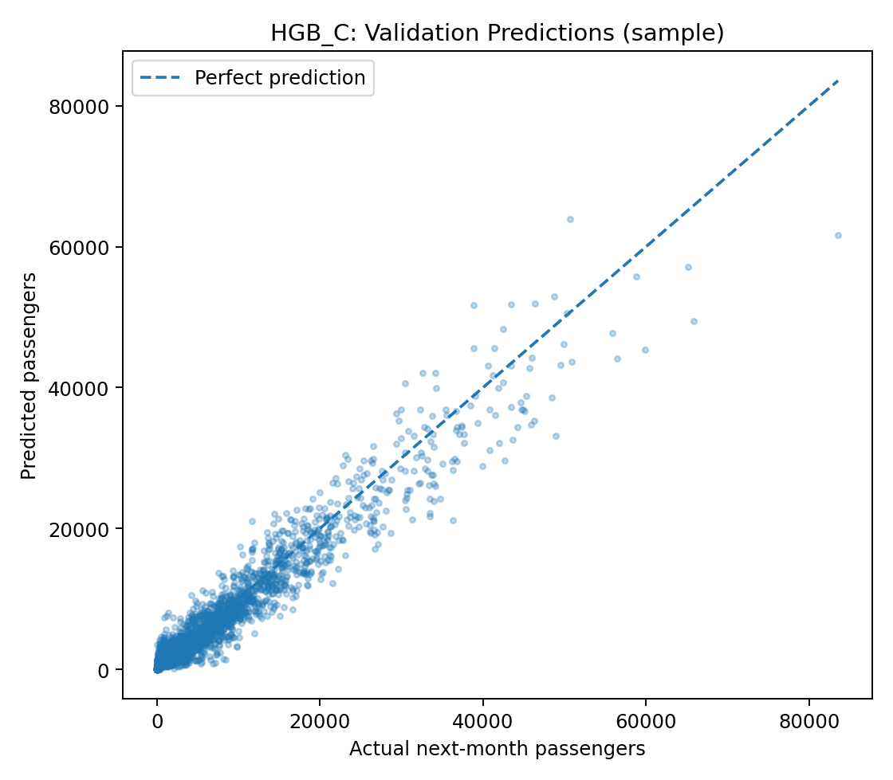
Figure 3. Selected HGB_C predictions against actual validation demand (4,000-point display sample).
The observed-versus-predicted sample clusters around the equality line for lower-volume cases, with visibly wider spread at higher passenger counts. Several high-volume observations are underpredicted, suggesting that route-volume stratification and extreme-error analysis would be valuable follow-up diagnostics. The scatter uses a fixed visual sample only; the reported MAE, RMSE, and R² use the complete validation partition.
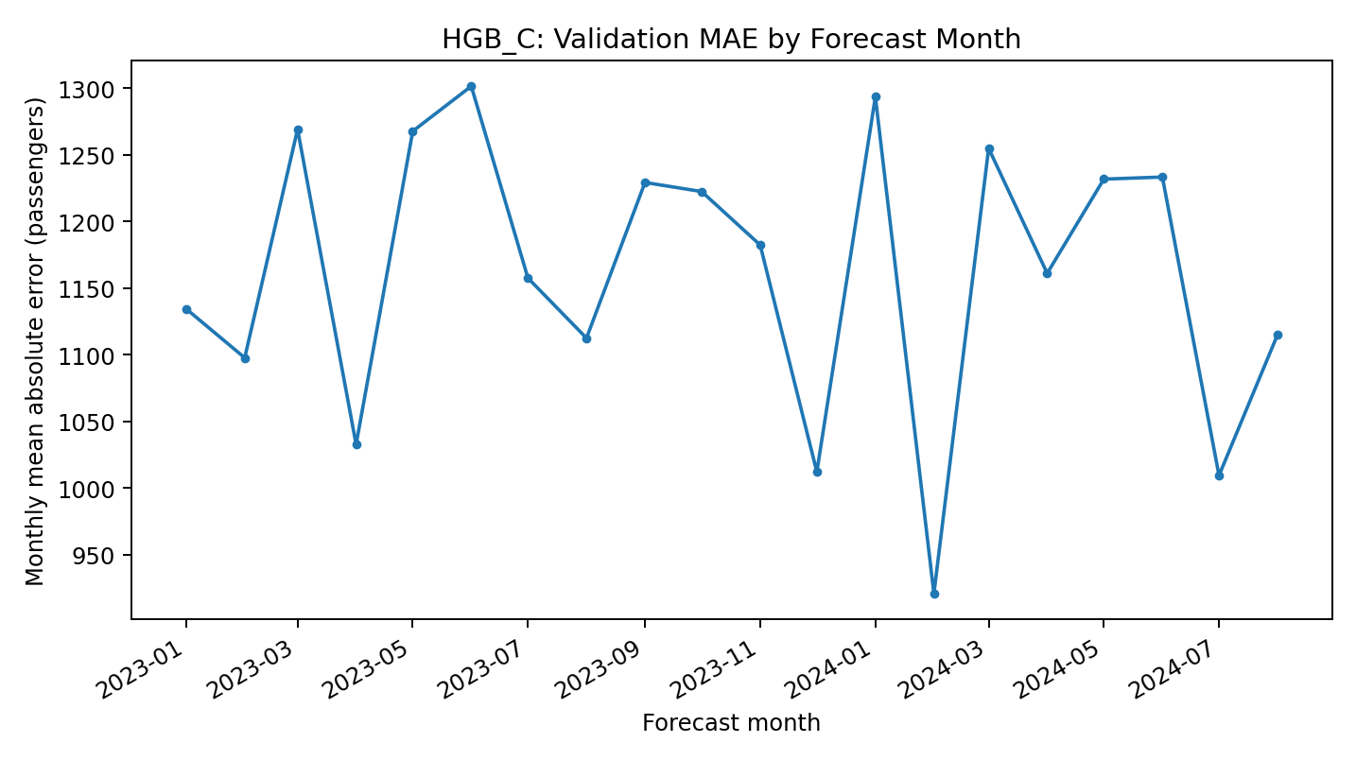
Figure 4. HGB_C average absolute validation error by forecast month (full validation observations).
Monthly validation MAE ranges from 920.83 passengers (February 2024) to 1,301.50 (June 2023). Differences warrant investigation but may reflect changing route mix, traffic, and sample counts rather than seasonality alone.

8. Limitations, Reproducibility, and Next Steps
The two models for Week 6 and Week 7 use only 2 PCA coordinates. These two coordinates retain 91.56% of the total variance across the standardized Week 5 numeric inputs in the training data, but this does not necessarily translate into retaining 91.56% of the predictive information in the data. Furthermore, the information in the direct carrier, airport, and some of the time information in the BTS data may add value to a future model. Also, the actual availability of the reference month’s BTS inputs for operational use will depend on publication delays and so needs to be verified for use on a particular date for forecast deployment.
The Week 7 executable source code and notebook are located at Src/week7_src_hist_gradient_boosting.py and Notebooks/week7_notebook_model_training_tuning.ipynb. The outputs are shown in the three-model comparison, in the six rows containing training and validation metrics, in the validation ranking, in the file containing the monthly errors, in the four figures, and in the selected model and manifest in Models/week7. The final checks in the notebook all pass. The manifest is marked with EvaluatedTestSet=false. The estimator (serialized as the booster) cannot be used to predict on raw BTS input: it requires the same Week 5 transformations fitted on the training data.
HGB_C can, for the time being, be considered the provisional Week 7 winner based on validation MAE. The potential errors for high-volume passenger routes and regime-specific issues should be investigated. In addition, the models’ stability over time should be compared, and based on the validation results, a decision should be made on the final modeling approach before using the reserved test set for a single final evaluation.

References
Bureau of Transportation Statistics. T-100 Domestic Segment (All Carriers). https://www.transtats.bts.gov/
Scikit-learn developers. HistGradientBoostingRegressor documentation. https://scikit-learn.org/stable/modules/generated/sklearn.ensemble.HistGradientBoostingRegressor.html
Scikit-learn developers. Model evaluation: quantifying prediction quality. https://scikit-learn.org/stable/modules/model_evaluation.html
IBM. What is overfitting? https://www.ibm.com/think/topics/overfitting

