Airline Passenger Demand Forecasting
Week 1: Identify the Problem Statement and Dataset
ADAN8888 — Applied Analytics Project
Tyler Miller | Jason Pinales | Emma Portanova | Matt T
September 11, 2026

Executive Summary
Project objective. Develop a supervised regression system that forecasts next-month passenger demand for a directional U.S. domestic nonstop carrier-route. The unit of analysis will be carrier × origin airport × destination airport × month. This refinement preserves airline-specific decision relevance while matching the structure of the BTS T-100 Domestic Segment (All Carriers) data.
Decision use. The forecast is intended to support capacity planning, flight-frequency planning, network review, staffing, and gate/resource planning. The project will prioritize chronological validation and operationally interpretable errors rather than random train/test splitting.
Data. The selected public source is the U.S. Department of Transportation Bureau of Transportation Statistics (BTS) TranStats T-100 Domestic Segment (All Carriers) table. BTS describes it as monthly domestic non-stop segment data reported by U.S. and foreign carriers with passengers, seats, departures, distance, carrier, origin, destination, aircraft, and service-class information. The table begins in 1990; as of September 2026, the latest uniform All-Carriers month shown by BTS is May 2026.

1. Problem Statement and Modeling Intent
Business problem. Airline capacity is committed before realized passenger demand is fully known. Persistent under-forecasting can contribute to constrained capacity and missed revenue opportunities, while persistent over-forecasting can leave excess capacity and increase avoidable operating cost. A repeatable route-level forecast can improve the information available to planners before capacity and schedule decisions are finalized.
Modeling problem. For each scheduled-passenger carrier-route-month, estimate the number of passengers that will be transported in month t+1 using information that would have been available by the end of month t. The primary target is next-month passengers. Candidate predictors include lagged passengers, lagged seats, lagged departures performed/scheduled, route distance, carrier, origin/destination, calendar seasonality, rolling demand statistics, and carefully engineered trend variables.
Research question. How accurately can historical T-100 segment information predict next-month passenger volume for U.S. domestic scheduled passenger service, and does a more complex supervised model materially improve forecast accuracy over simple seasonal and lag-based benchmarks?
Success criterion. Model performance will be assessed on a chronological holdout using MAE and RMSE as primary metrics, with MAPE or WAPE used only where denominators are sufficiently stable. Performance will also be reviewed by route-volume tier and carrier so aggregate accuracy does not conceal systematic operational errors.

2. Articulation of Value
The project creates value by converting historical traffic and capacity records into a forward-looking estimate that can be incorporated into recurring planning. For airlines, the most direct value is improved alignment between expected demand and planned capacity. Better alignment may support earlier review of routes that appear structurally under-supplied or over-supplied, more disciplined aircraft-gauge and frequency decisions, and more focused use of analyst time. For airport and operations stakeholders, a more reliable demand outlook can also inform staffing and gate/resource planning.
Passenger benefits are secondary and should be stated cautiously: if a forecast contributes to better capacity alignment, passengers may experience more appropriate schedule availability and fewer capacity mismatches. The model itself does not establish that fares will fall or that new routes will be opened; those outcomes depend on competition, costs, network strategy, and other constraints outside T-100.
The value proposition is therefore decision support rather than autonomous scheduling. The forecast will be one input to a planning process in which network, revenue-management, fleet, crew, airport, and commercial constraints remain authoritative.

3. Potential Economic Value
Because Week 1 precedes model development, an empirically observed dollar benefit is not yet available. The appropriate Week 1 business case is an assumption-based value model that can be updated in later weeks with measured forecast improvement and stakeholder-specific cost/revenue parameters. The base case below estimates the annual gross value of capacity decisions that become more accurately aligned with demand.
Base-case calculation
Component | Assumption | Calculation | Result
Monthly seats in decision portfolio | 2,000,000 seats¹ | — | 2,000,000
Forecast-error improvement | 2 percentage points² | 2,000,000 × 0.02 | 40,000 seats/month
Share operationally actionable | 25%³ | 40,000 × 0.25 | 10,000 seats/month
Average value per actionable seat | $35⁴ | 10,000 × $35 | $350,000/month
Annual gross economic value | 12 months | $350,000 × 12 | $4,200,000/year
Annual program/process cost | $350,000⁵ | $4,200,000 − $350,000 | $3,850,000 net/year
Interpretation. Under the base assumptions, a two-percentage-point reduction in forecast error creates approximately $4.2 million in gross annual decision value and $3.85 million after an illustrative annual analytics/process cost. This is a planning estimate, not a claimed realized profit. It is designed to answer the instructor’s question: what is the maximum economic rationale for investing in the modeling workflow, given transparent assumptions?
Assumption footnotes
¹ Illustrative airline portfolio scope, not a BTS fact. Replace with the actual seats represented by the final analytical sample.
² Illustrative improvement over the eventual Week 6 baseline. Replace with observed out-of-time improvement after model comparison.
³ Only part of lower forecast error can change a schedule because of fleet, crew, slot, gate, maintenance, and commercial constraints.
⁴ Illustrative weighted value per better-aligned seat combining incremental contribution opportunity and avoidable excess-capacity cost. It is deliberately not treated as average ticket fare or accounting profit.
⁵ Illustrative recurring cost covering analytics, data engineering, model operations, and planning-process integration. It should be replaced with sponsor-specific costs if available.
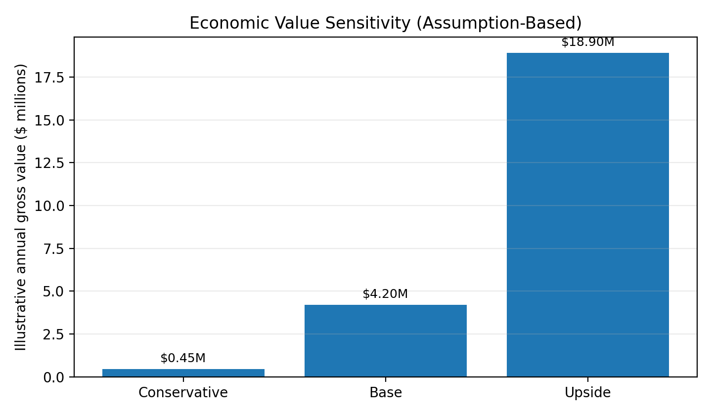
Figure 1. Sensitivity of gross annual value to alternative assumption sets. These are business-case scenarios, not observed model outcomes.

4. Dataset and Analytical Design
Source and scope. The project will use BTS TranStats, T-100 Domestic Segment (All Carriers). BTS defines the table as domestic non-stop segment data reported by both U.S. and foreign air carriers for movements in which origin and destination are within the United States and its territories. The table is monthly and contains carrier, route, aircraft/service class, passenger traffic, available capacity, scheduled and performed departures, distance, and related fields.
Recommended initial extract. Download January 2015 through the latest uniform month available at extraction time, retaining at minimum: Year, Quarter, Month, UniqueCarrier/AirlineID, OriginAirportID/Origin, DestAirportID/Dest, Class, AircraftType, AircraftConfig, Passengers, Seats, DepScheduled, DepPerformed, Distance, and LoadFactor (or recompute load factor from passengers and seats). Filter to Service Class F (Scheduled Passenger/Cargo Service) for the core analysis. Aggregate aircraft-level records to carrier × origin × destination × month after validation.
Why this dataset fits. The target variable is directly observed (Passengers), while the same table provides time, route, carrier, capacity, and frequency variables that can support lags, seasonal terms, and route-level features. Because the data are reported at the segment level, the model can be designed around nonstop directional service without inferring itineraries or connections.
Important limitation. T-100 is a reported historical data source rather than a live forward schedule. Therefore, the course project should simulate a t+1 forecast using only lagged information unless a genuinely forward-looking schedule source is later added. Same-month realized seats or departures must not be used as predictors if they would not have been known at forecast time. This avoids target leakage and keeps the evaluation operationally credible.
Field(s) | Planned role | Rationale
Passengers | Target before shifting to t+1 | Non-stop segment passengers transported
Seats | Lagged capacity predictor | Available seats
DepScheduled | Lagged schedule intensity | Scheduled departures
DepPerformed | Lagged realized frequency | Departures performed
Distance | Static route feature | Distance between airports
UniqueCarrier / AirlineID | Carrier identity | Stable airline identifiers
Origin / Dest + airport IDs | Route identity | Directional origin and destination
Year / Month / Quarter | Seasonality and trend | Monthly time index
Class | Scope filter | Use F for scheduled passenger/cargo service
AircraftType / AircraftConfig | Aggregation / optional features | Aircraft mix and configuration

5. Modeling Type
This is a supervised regression problem. It is supervised because each historical observation has an observed numeric outcome that can be shifted forward to create a labeled t+1 target. It is regression because the dependent variable is a passenger count rather than a category. The project will compare multiple approaches rather than assume one model family in advance. A simple lag/seasonal benchmark will be followed by increasingly flexible regression methods, with all comparisons performed using chronological validation.
Candidate model families for later weeks include regularized linear regression, tree-based ensembles such as random forest or gradient boosting, and a time-aware count/regression formulation if distributional diagnostics support it. ARIMA-type methods may be useful as a route-level benchmark, but they are not required to define the Week 1 problem.

6. Thirteen-Week Project Plan
The plan below follows the course model-development sequence rather than creating a separate timeline. This keeps each project milestone aligned with the required weekly deliverable.
Week | Phase | Work | Primary deliverable
1 | Problem definition & business case | Finalize target, unit of analysis, stakeholders, economic-value logic, dataset, repo and environment. | Week 1 report; structured private GitHub repo.
2 | Ingest & explore data | Download/ingest T-100; validate schema, field types, row counts, date coverage, target and candidate predictors. | Notebook, code output, data dictionary, Week 2 report.
3 | Exploratory data analysis | Create chronological train/validation/test design; examine distributions, seasonality, route volume, missingness, outliers, and COVID-era shifts. | EDA figures/tables and preprocessing findings.
4 | Make data model-ready | Filter scheduled passenger service; aggregate to carrier-route-month; address missing/invalid values; implement leakage-safe preprocessing. | Clean analytical pipeline and model-ready base table.
5 | Feature engineering | Create passenger/capacity/departure lags, rolling means, seasonal terms, trend, route/carrier encodings; finalize chronological datasets. | Feature-engineered modeling datasets.
6 | Model approach 1: baseline | Build naive lag and seasonal benchmarks plus simple linear/regularized regression; tune minimally and define evaluation metrics. | Baseline models and error benchmark.
7 | Model approach 2: more complex | Train/tune a nonlinear ensemble (e.g., random forest) and compare bias/variance and route-level errors. | Second-model results and comparison.
8 | Model approach 3: more complex | Train/tune gradient boosting or another justified approach; compare against prior models using identical folds. | Third-model results and comparison.
9 | Select winning model | Evaluate finalists on untouched chronological test data; select based on MAE/RMSE plus stability by route/carrier. | Winning model and final test metrics.
10 | Data-centric AI | Improve data/labels/features rather than only model complexity; revisit anomalous periods, sparse routes, aggregation, and feature quality. | Data-centric iteration and measured impact.
11 | Explainability, risk, bias & ethics | Analyze feature importance/prediction behavior; assess error disparities by carrier, route size, geography, and disruption periods; document misuse risks. | Explainability and risk/bias analysis.
12 | Package & monitoring | Serialize model/pipeline; specify inference inputs, drift checks, target/feature monitoring, alert thresholds, retraining triggers, and ownership. | Packaged model and monitoring plan.
13 | Bring it together | Re-run end-to-end pipeline; reconcile figures/tables; update business case with observed forecast lift; finalize report, notebook, outputs, and repo. | Final end-to-end project package.

7. GitHub Repository Structure and Week 1 Artifacts
The assignment rubric separately awards the GitHub repository and specifically expects major folders such as data, documents, model, and notebook. The repository should remain private and the instructor should be granted access. The recommended structure is:
Boston-College-Practicum-in-Analytics-Miller/
├── README.md
├── data/
│ ├── raw/ # original BTS extract + source README
│ └── processed/ # later cleaned/model-ready data
├── documents/
│ └── week_01/ # Week 1 PDF/DOCX report
├── notebooks/ # Weeks 2–13 notebooks
├── models/ # serialized candidate/final models
├── src/ # reusable Python modules
└── outputs/
└── figures/ # charts used in reports
For Week 1, the required repository content is the written report, the raw T-100 extract placed in data/raw, the structured project folders, and the repository link. The JupyterHub environment must be confirmed, but the assignment page states that no separate environment submission is required for this task.

8. Scope, Risks, and Week 2 Validation Checks
• Granularity: T-100 contains multiple rows per carrier-route-month because aircraft type and service class can vary. Aggregation must occur only after filtering and reconciliation.
• Directionality: ATL→MCO and MCO→ATL are distinct segment directions; do not silently collapse them unless the business question is redefined.
• Leakage: Use only information available at forecast origin. Realized t+1 seats/departures cannot be predictors of t+1 passengers.
• Reporting lag: T-100 supports historical forecasting and strategic analysis but is not a real-time schedule feed.
• Structural breaks: COVID-19 creates an extreme demand regime. It should be flagged, analyzed, and handled transparently rather than automatically deleted.
• Sparse routes: Very low-frequency carrier-route series may make MAPE unstable and may need minimum-history criteria or pooled modeling.
• Economic attribution: Forecast accuracy does not equal profit. The Week 1 valuation is a decision-value model and must be updated with measured lift and real planning constraints.

References
Boston College, ADAN8888 Applied Analytics Project. Week 1 Assignment: “Identify the Problem Statement and Dataset,” 2026.
U.S. Department of Transportation, Bureau of Transportation Statistics. “T-100 Domestic Segment (All Carriers),” TranStats Table Profile, accessed September 11, 2026.
U.S. Department of Transportation, Bureau of Transportation Statistics. “T-100 Domestic Segment (All Carriers) Fields,” TranStats, accessed September 11, 2026.
U.S. Department of Transportation, Bureau of Transportation Statistics. T-100 Traffic Reporting Guide. Service Class F = Scheduled Passenger/Cargo Service.

