ADAN8888 — Applied Analytics Project
Week 6: Develop First Modeling Approach
BTS T-100 Domestic Segment | Next-Month Passenger Demand

1. Purpose, Prediction Task, and Scope
This week introduces a first supervised regression model for forecasting next-month passengers for the same U.S. domestic directional carrier-route. The observations represent unique carrier × origin × destination × reference-month combinations; the numerical target is TargetPassengersNextMonth. Consistent with Weeks 3–5, all model choices and hyperparameters are evaluated using the training and subsequent validation months only. The final test period remains reserved for a later unbiased evaluation.
The Week 6 assignment calls for one modeling method trained under three different hyperparameter settings, quantitative evaluation for training and validation, and a winner selected exclusively from validation metrics. The implementation satisfies that design using Ridge regression on the two training-fitted principal components constructed in Week 5.

2. Dataset and Chronological Evaluation Design
The model keeps the target-eligible partition boundaries from Week 3. The two PCA features (PC1 and PC2) were derived from five original current-month numeric inputs and four engineered features during Week 5. Medians, standardization parameters, and PCA loadings are estimated only on the chronological training partition, and the frozen transformation is applied to validation data. The reported metrics are calculated on the full training and validation partitions, not 500-row representative samples.
Partition | Forecast-month window | Rows | Purpose
Training | 2015-02–2022-12 | 1,062,603 | Estimate coefficients and compute training error
Validation | 2023-01–2024-08 | 239,395 | Compare alphas and select provisional winner
Test — not evaluated | 2024-09–2026-05 | 264,291 | Reserved for later final assessment

These counts originate from verified prior-week partitions and were confirmed unchanged by the executed Week 6 notebook. The Week 5 reduction retained 91.56% of standardized training predictor variance in PC1 and PC2. Explained input variance is not itself a measure of demand-forecast accuracy.

3. Model Choice and Complexity
Ridge regression is a linear least-squares model with L2 penalty for the coefficients. It is the first model to start with because outcome variable is continuous, the Week 5 PCA representation of the inputs is numeric and of low dimensions. A simple model like this one will make for an efficient and reproducible baseline model that other, more complex models can then be compared against. With PC1 and PC2 as its only predictors, this Ridge model does not explicitly capture nonlinear relationships or carrier- and airport-specific interactions.
For training inputs X = [PC1, PC2] and passenger outcome y, the Ridge model tries to find the best coefficients by minimizing the sum of squared errors plus α * ||coefficients||^2 (the intercept is not subject to this penalty). The α parameter determines the strength of regularization: Small values of α allow for larger coefficients, while higher values of α make the coefficients shrink towards zero. This in turn can decrease variance but increase bias. All variations use the same features, data splits, target, and evaluation metric; only the value of α is changed.
Variant | Ridge alpha (α) | Interpretation
Ridge_A | 1 | Weak regularization, close to unpenalized fit
Ridge_B | 10,000 | Intermediate coefficient shrinkage
Ridge_C | 1,000,000 | Strong shrinkage; underfitting becomes more plausible

The alpha values intentionally span several orders of magnitude because the training dataset contains over one million observations. They are predefined rather than tuned on the test period. This is a controlled three-point hyperparameter comparison, not a claim that the globally optimal Ridge regularization has been found.

4. Evaluation Metrics and Model Selection
The primary metric for selecting the best regression variation is mean absolute error (MAE), measured in passengers, because it expresses average absolute forecast error in units relevant to demand and capacity planning. Root mean squared error (RMSE) penalizes larger prediction errors more heavily. R² measures model fit relative to predicting the mean outcome within each partition and can be negative on holdout data.
We report mean absolute error, root mean squared error, and R-squared for both training and validation data after applying a non-negative prediction floor of zero to all models. Among the three Ridge variations, the winner has the lowest validation MAE; exact ties are broken using validation RMSE and then the smaller value of α. Selection uses validation performance only: training metrics are reported for comparison, and the test partition is not used.

5. Results — Training and Validation
Table 3 reports the measured training and validation results from the executed Week 6 notebook. All metrics use the full training (1,062,603 rows) and validation (239,395 rows) partitions; no 500-row preview samples were used. MAE and RMSE are in passengers, and predictions were floored at zero before evaluation.
Model (α) | Train MAE | Valid MAE | Train RMSE | Valid RMSE | Train R² | Valid R²
Ridge_A (1) | 3,331.96 | 3,257.18 | 5,787.13 | 5,887.10 | 0.444 | 0.473
Ridge_B (10,000) | 3,332.43 | 3,259.03 | 5,789.18 | 5,890.28 | 0.443 | 0.473
Ridge_C (1,000,000) | 3,395.14 | 3,418.39 | 5,985.65 | 6,163.44 | 0.405 | 0.422

6. Training-versus-Validation Analysis
Increasing α from 1 (Ridge_A) to 10,000 (Ridge_B) barely changes the errors: validation MAE rises from 3,257.18 to 3,259.03 passengers (an increase of 1.86 passengers, about 0.06%). Raising α to 1,000,000 (Ridge_C) increases validation MAE to 3,418.39 and validation RMSE to 6,163.44, consistent with excess coefficient shrinkage and a deterioration in model fit. Training MAE similarly increases from 3,331.96 for Ridge_A to 3,395.14 for Ridge_C. For Ridge_A and Ridge_B, validation MAE is slightly lower than training MAE despite validation RMSE being higher; this is not by itself evidence that the model generalizes better or that overfitting is absent. Differences in demand distribution, route mix, and large-error cases across the chronological periods could contribute. The narrow Ridge_A–Ridge_B difference should not be interpreted as proof of practical superiority.
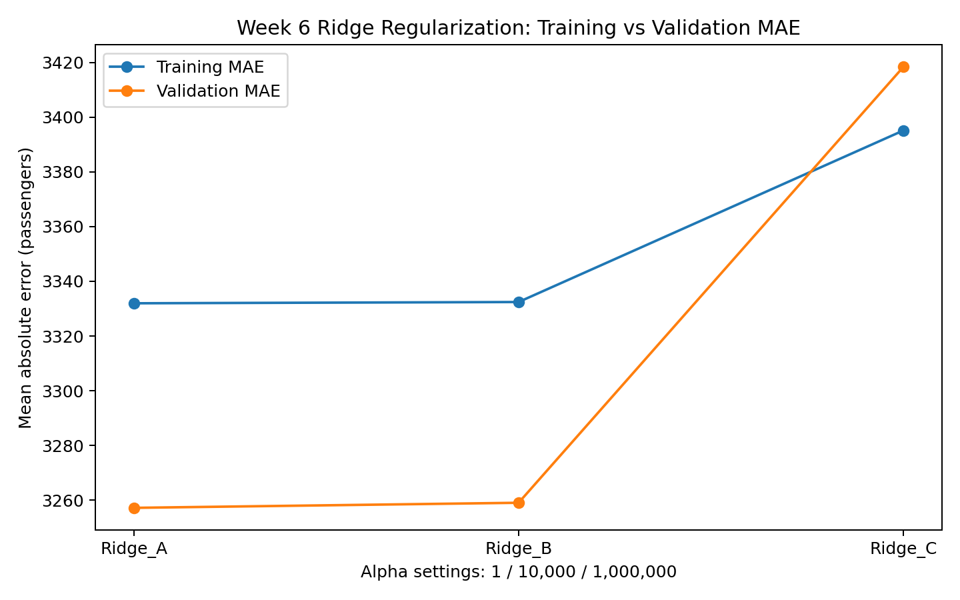
Figure 1. Training and validation MAE under the three Ridge regularization settings.
Ridge_A has the lowest validation MAE (3,257.18 passengers); Ridge_B is nearly identical, while Ridge_C shows a materially larger error.
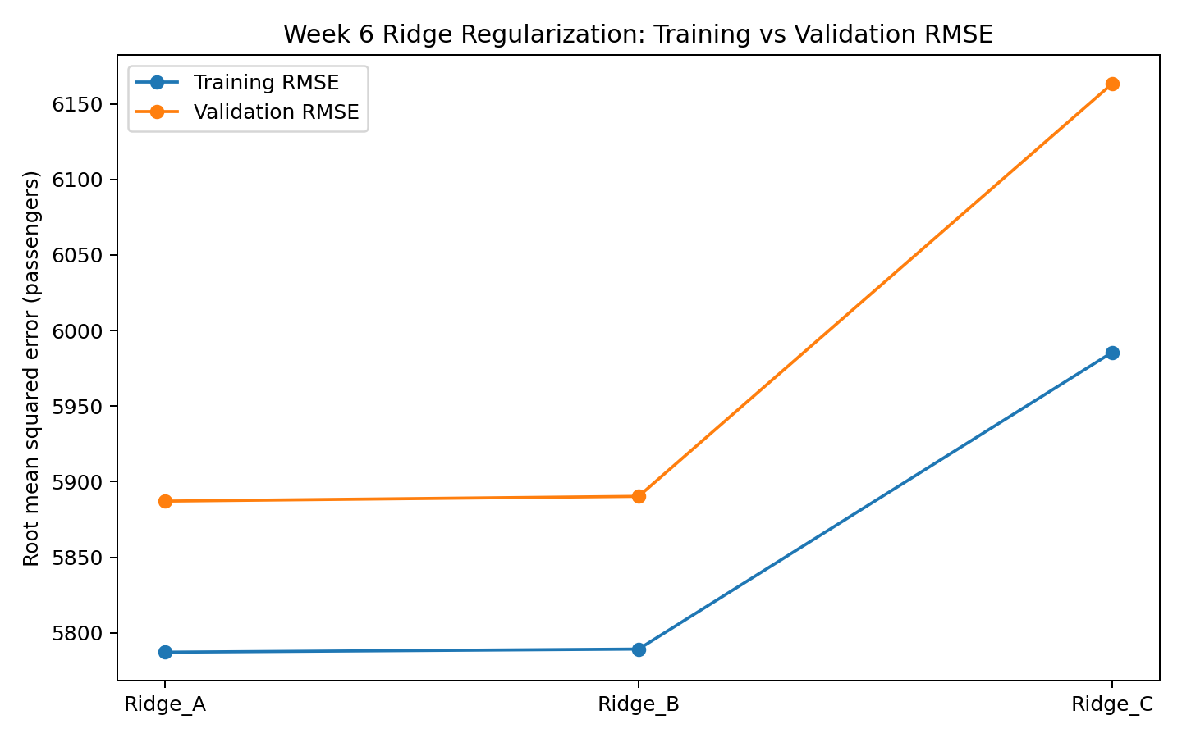
Figure 2. Training and validation RMSE under the three Ridge regularization settings.
RMSE is higher in validation than in training for all three settings. Ridge_C produces the largest validation RMSE (6,163.44 passengers), reinforcing the preference for weaker regularization in this experiment.

7. Winning Week 6 Model
Selected Ridge variation: Ridge_A. Hyperparameter α: 1. Validation MAE: 3,257.18 passengers; validation RMSE: 5,887.10 passengers; validation R²: approximately 0.473. Ridge_A is selected solely because it yields the lowest validation MAE among the three evaluated configurations. It improves validation MAE over Ridge_B by approximately 1.86 passengers and over Ridge_C by approximately 161.22 passengers. The selected estimator is saved under Models/week6 with a JSON manifest and requires the matching Week 5 PCA transformation for inference.
This remains a provisional validation-selected benchmark. It must not be described as the best overall forecasting model without comparisons to later modeling approaches and a final assessment on the untouched test partition. In particular, two principal components may omit predictive information retained by the richer Week 4 feature set.
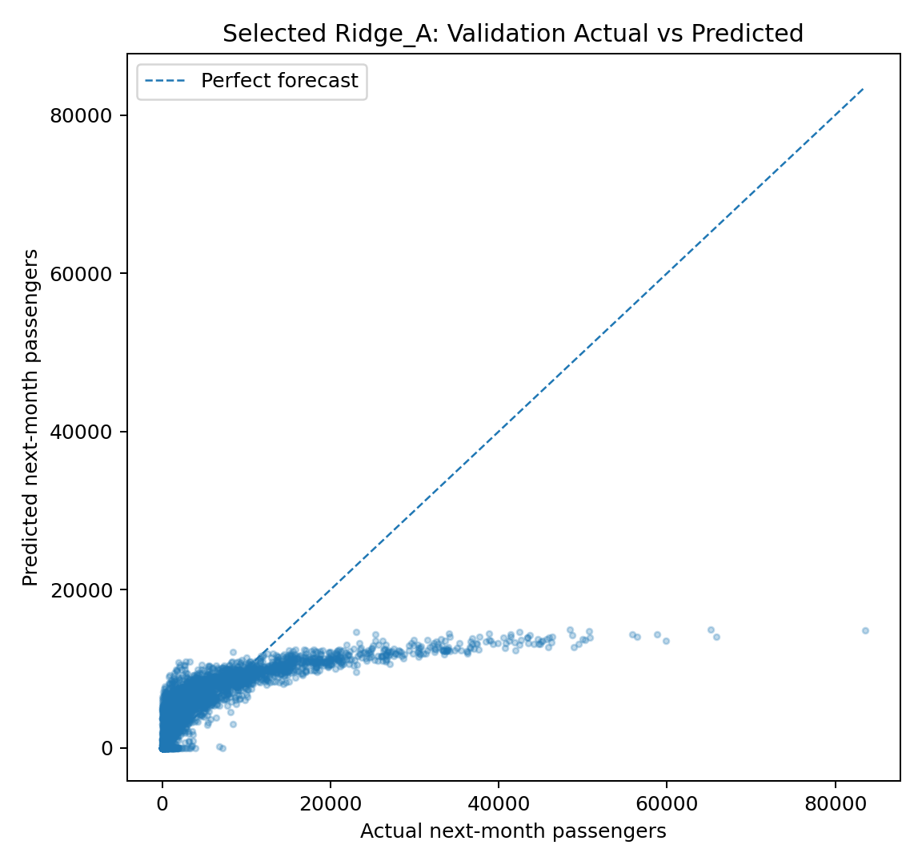
Figure 3. Actual versus predicted next-month passengers in a sample of validation observations for the selected Ridge_A model.
The scatterplot indicates compression of predictions for high-volume observations: the model frequently underpredicts the largest actual passenger counts. This diagnostic is sampled for visual display; the reported evaluation metrics use all validation rows.

8. Reproducibility, Limitations, and Next Steps
The notebook and standalone Python source code reuse Week 2 ingestion, the Week 3 chronological split, and Week 5 training-fitted PCA. The pipeline exports six training/validation metric rows, a three-model comparison table, the validation ranking, metadata for the winning model, and the serialized Ridge estimator. Three report figures are also exported. The model has two PCA input features. Future inference requires the same Week 5 feature definitions, training imputation statistics, scaling parameters, and PCA transformation. No test-set metrics or large raw prediction files are exported.
For this first model, we assume that the monthly BTS aggregates are available before the month to be predicted. As the publication of the aggregates most likely is delayed in real life, the model would not be used for real time prediction in this setup. Reducing the numeric predictors to two PCA components simplifies the input representation but may reduce interpretability and discard useful predictive information. The current linear model cannot capture nonlinear relationships without appropriate feature transformations; a more flexible model provides another option. Subsequent weeks: compare to a more flexible model, also investigate the errors in more detail for different route sizes and demand scenarios, and then evaluate the chosen model in the way it was evaluated for the validation data, once on the reserved test data.

References
Bureau of Transportation Statistics. T-100 Domestic Segment (All Carriers), official annual extracts. https://www.transtats.bts.gov/
scikit-learn developers. Linear models: Ridge regression. https://scikit-learn.org/stable/modules/linear_model.html
scikit-learn developers. Model evaluation and scoring. https://scikit-learn.org/stable/modules/model_evaluation.html
scikit-learn developers. Cross-validation and time-series data. https://scikit-learn.org/stable/modules/cross_validation.html

