**NAME: LAPIERRE Yohan et TRONTIN Pauline**

**Installation and User Instructions**

**Raspberry Pi 3**

**Model B+**

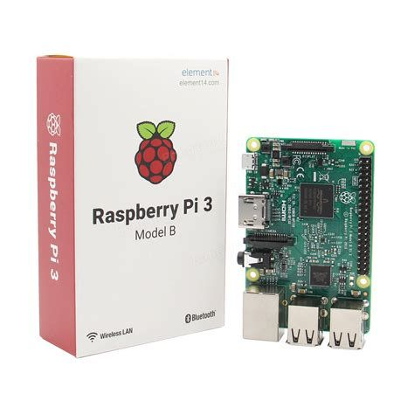



October 2021  
**SAE 1.03**

**Approvals**

This document requires following approvals:

|  |  |
| --- | --- |
| Name | Title |
| FARRUGIA Jean-Philippe | Architecture teacher |
| POZET Lionel | System teacher |
|  |  |
|  |  |

# Distribution

This document has been distributed to:

|  |  |
| --- | --- |
| Name | Title |
| FARRUGIA Jean-Philippe | Architecture teacher |
| POZET Lionel | System teacher |
| DAUMAS Anne | English teacher |
|  |  |

# Table of Contents

1 PREFACE 5

1.1 Description of the User 5

1.2 Conventions Used in This Manual 5

2 DESCRIPTION OF THE PRODUCT 6

2.1 Purpose of the Product 6

2.2 Key features of the product 6

• USB 2.0 ports 7

2.3 Accessories 7

2.4 Product elements 8

2.5 Understanding the user interface and operating panels 9

3 SAFETY INSTRUCTIONS 10

3.1 How to Use the Product Safely 10

4 INSTALLATION / PACKAGES 11

4.1 STEP 1 11

4.1.1 Procedures for set-up the mini computer 11

4.2 STEP 2 12

4.2.1 The booting 12

5 OPERATION/USE 14

5.1 How to Use the Product 14

5.1.1 Operational environment 14

5.1.2 Working on Python 14

5.1.3 Execute a program 14

After the start of Thonny. 14

5.1.4 Save a program 15

5.1.5 Debug a program 15

5.1.6 Add or uninstall packages 15

5.1.7 Stopping the product’s operation 16

5.2 What to Do in Emergency and Exceptional Situations 16

6 TROUBLESHOOTING AND REPAIR 17

6.1 How to Identify and Solve Problems 17

7 GLOSSARY 18

8 RELATED DOCUMENTATION 19

Raspberry Pi 3 19

# PREFACE

## Description of the User

This manual is intended for anyone wanting to install a raspberry PI. You can install the hardware without having any special skills. You just have to be extremely careful and be delicate. The raspberry is a very fragile component. Moreover, you can set it up yourself without the help of other people.

However, this raspberry has been configured and fitted out with tools compatible with Python. In more, some packages have been added like Scipy, Pandas and Numpy. So you need some basics.

## Conventions Used in This Manual

The following style conventions are used in this document:

**Bold**Names of product elements, commands, options, programs, processes, services, and utilities Names of interface elements (such windows, dialog boxes, buttons, fields, and menus)  
Interface elements the user selects, clicks, presses, or types

*Italic*Publication titles referenced in text  
Emphasis (for example a new term)  
Variables

Courier  
System output, such as an error message or script  
URLs, complete paths, filenames, prompts, and syntax

User input variables  
< > Angle brackets surround user-supplied values  
[ ] Square brackets surround optional items  
| Vertical bar indicates alternate selections - the bar means “or”

# DESCRIPTION OF THE PRODUCT

## Purpose of the Product

Project: For this project you will be using a Raspberry Pi3. This will replace your computer (mini "pocket" computer). This raspberry is mainly dedicated to development and big data in Python. The Raspberry Pi is what is called a nano-computer. The size of a credit card, it is equipped with the bare essentials:

* **An ARM microprocessor**
* **RAM memory**
* **A video card**
* **An ethernet card**
* **Wi-fi**
* **Bluetooth**

The main goal in the creation of the Raspberry Pi was to create a very accessible tool to allow all students to learn computer development and programming more effectively. There are two development environments:

* + Scratch
  + Python

For this project, it is Python that interests us the most. It is a relatively accessible programming language (compared to C or C ++ which are much more complex languages ​​for a beginner) but which remains very powerful and whose possibilities are enormous.

## Key features of the product

The characteristics of the raspberry pi:

* **Processor: 64-bit Quad-core ARMv8 Cortex A-53 clocked at 1.2 GHz**
* **1 GB RAM**
* **Built-in 802.11 b / g / n Wi-Fi LAN, up to 70 Mb / s**
* **Integrated Bluetooth 4.1 LE**
* **HDMI 1.3a port**
* **10/100 Ethernet port**
* **3.5 headphone jack and composite video**
* **Power supply: 5V, 2.5A**

# USB 2.0 ports

* **1 micro USB port**
* **Storage: microSD (8GB)**
* **The RBPi embeds a real operating system**

## Accessories

The accessories are :

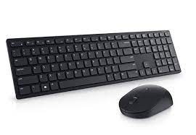

* A mouse and a keyboard
* Screen or tv monitor

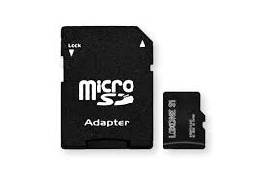

* SD card / adapter
* Power cable

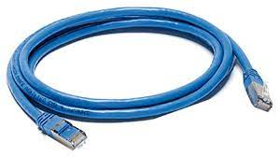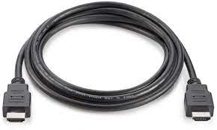

* Ethernet cable
* HDMI cable

Optional extras :





* headphones or speakers

## Product elements

1. **Monitor** : HDMI port (for the screen)
2. **Network** : Ethernet cable
3. **Power** : power supply
4. **Keyboard & mouse :** USB mouse port and USB keyboard port
5. You can install a **camera** and a **sound** **system**

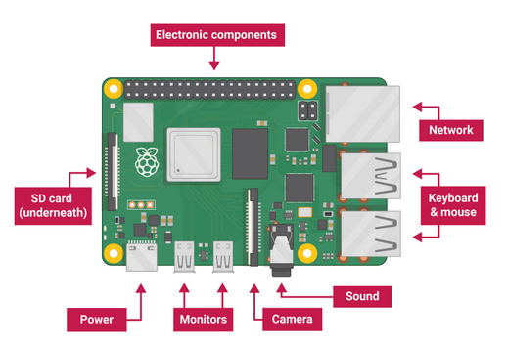

## Understanding the user interface and operating panels

After launching the **RPI**, you arrive at the user interface. It is thanks to this interface that you will interact. This interface is divided into three parts. You can find there in the center "the office". This is where the most important shortcuts are placed. That is to say, **Python**, internet or even the **terminal**. On the banner at the bottom right, called the dashboard, we find the date, time, **Wi**-**Fi** settings, sounds or even **Bluetooth**. Still on the banner at the bottom left is the most important part. There is the application menu. Thanks to this menu you can control all the applications, access the parameters and turn off the **Raspberry Pi**.

The interface has been configured as a **Windows** interface so as not to disturb the user.

You can change anything you want and create an **interface** you like. Also remember to change the **password** in the **settings**.

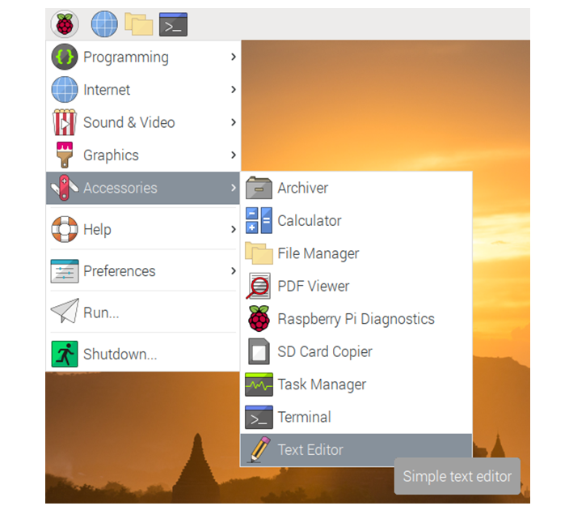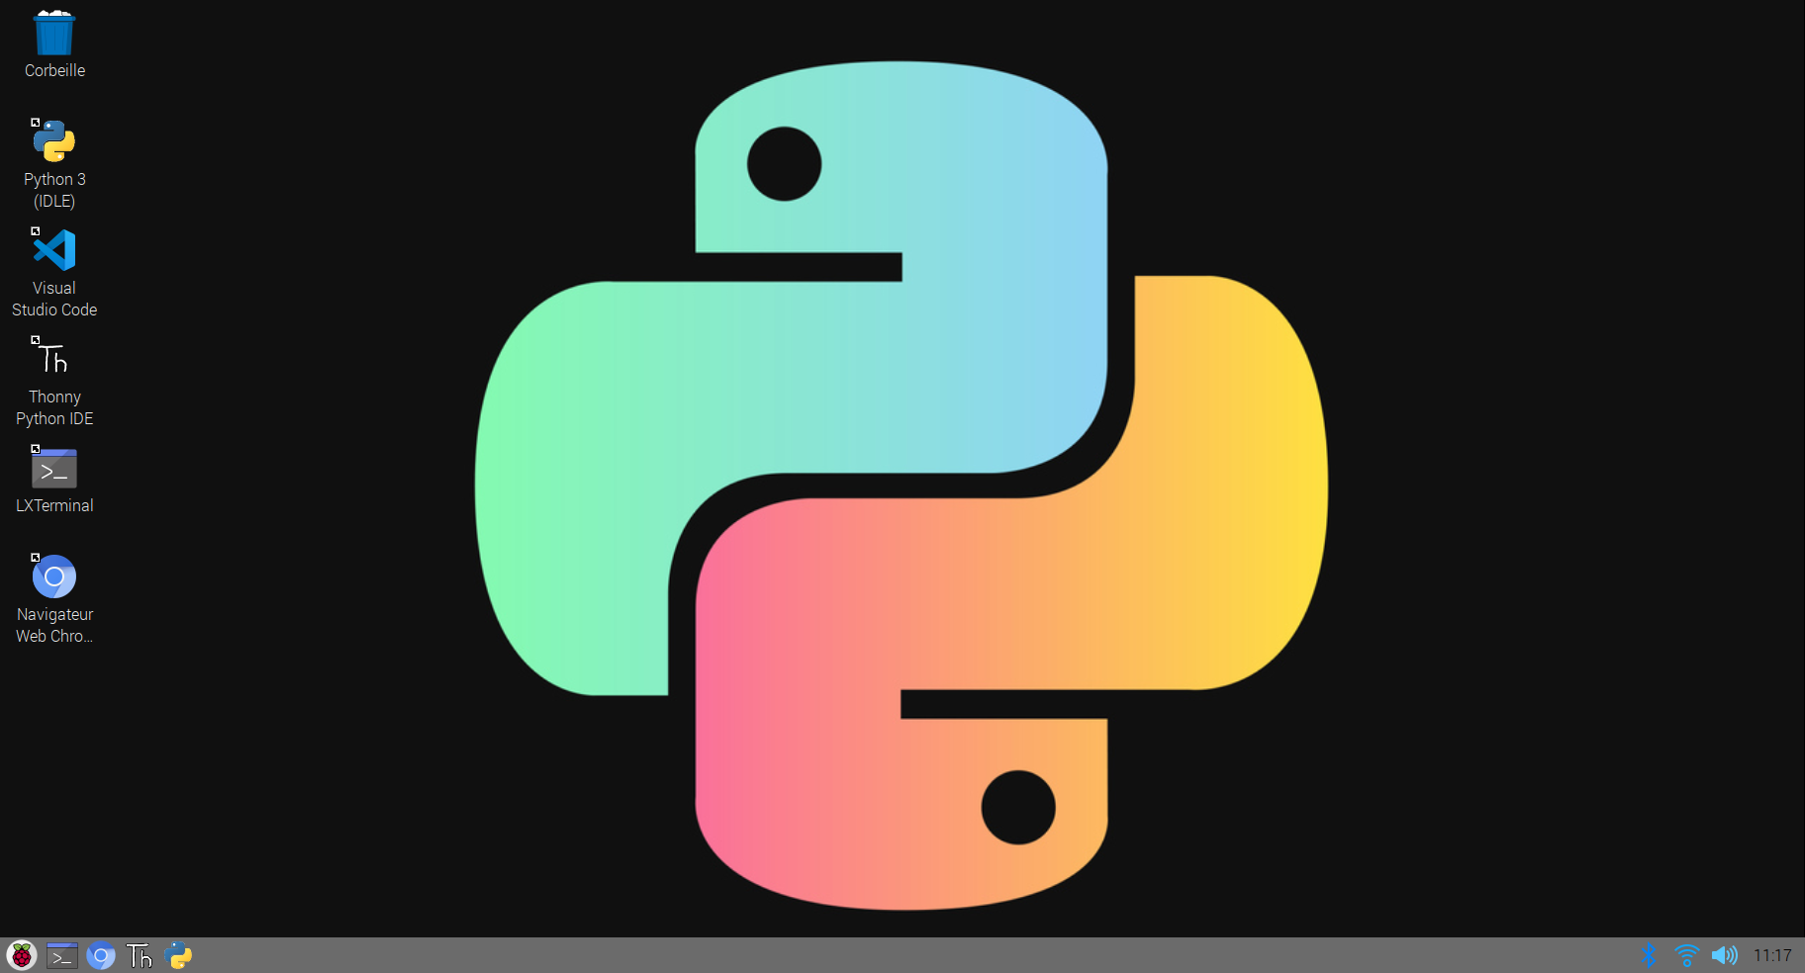

# SAFETY INSTRUCTIONS

**WARNING!**

## How to Use the Product Safely

The Raspberry Pi is very fragile so it must be protected:  
Open the box correctly, your component is packed in an anti-static bag, because current components are really VERY sensitive to static electricity!  
Use serious protective measures (bracelet, mat, etc.) to remove this electricity.  
  
In addition, choose your system wisely: install your **Raspbian** system on a "clean" card. If necessary, reformat it completely. Carefully configure the options of the **raspy-config** program and make backups as often as possible.

Some instructions to the Product:

- Do not expose the product to water or to humidify it. Nor in the heat

- Do not place it on a conductive surface while it is live (risk of electrocution)

- The box must not be covered (at the risk of overheating)

- Install the **Raspberry** in a ventilated place

# INSTALLATION / PACKAGES

## STEP 1

We will see how to turn on your **Raspberry.**

### Procedures for set-up the mini computer

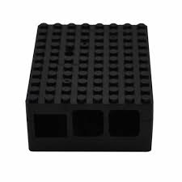Installation of the various peripherals of the **raspberry Pi 3**.

**To install :**

1. put the raspberry in its protective case
2. insert the SD card

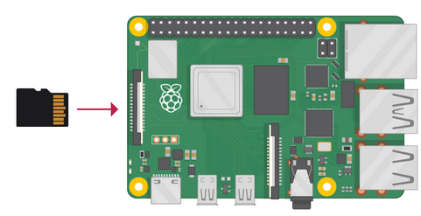

1. connect the HDMI port of your screen to the Raspberry
2. 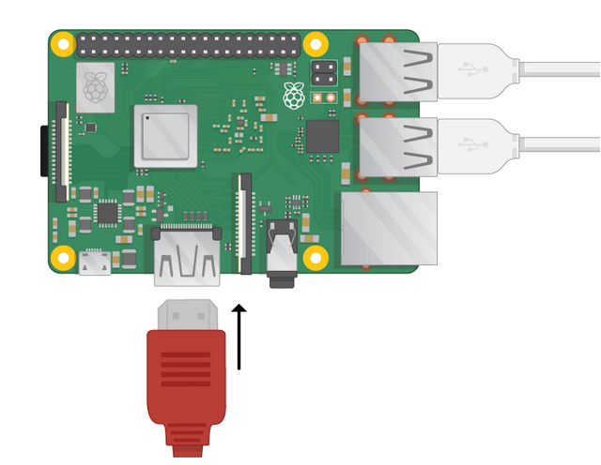plug in the mouse's USB port

4.

1. connect the keyboard's USB port

5.

3.

1. 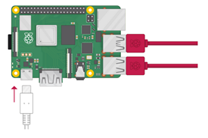connect your Raspberry to a mains socket.

## STEP 2

Proceed to display your Raspberry on your screen.

### The booting

We will see how to "prepare" your Raspberry for optimal use.

**To install :**

1. Change your screen mode to HDMI



1. Set the Wi-Fi of your choice (with the icon at the bottom right)

,or with the Ethernet cable

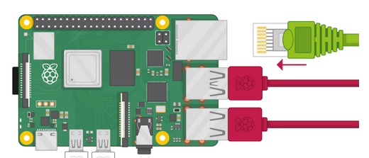



OR

1. Open the terminal (shortcut on the desktop)

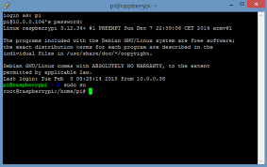

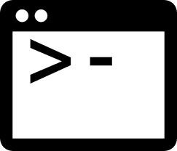

Icône

1. Change the date with the command :



Now everything is ready. you can work.

# OPERATION/USE

## How to Use the Product

### Operational environment

First of all, you need to choose your app. For our project, we have the choice between the **Thonny Python IDE or Python 3 (IDLE)** application. For this notice, we have chosen Thonny.

To work on Python, you need to know all the commands.

### Working on Python

1. Double click on the application named **Thonny Python IDE** (place on desktop).
2. Let the app launch
3. Sometimes you need to do some update, so click accept.

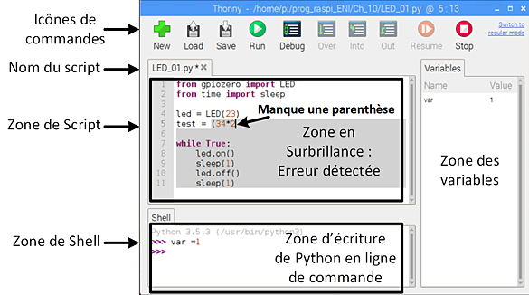

### Execute a program

### After the start of Thonny.

1. You can write your program in the white frame. (If a script is already present, delete it or re-create a page with this button  or add another  ).
2. Then press this button  to run the program.
3. Look in the lower part of the screen titled "shell" to verify debugging and execution..

### Save a program

Once your program is correct you can save it.

1. To do this, press "File" at the top left.
2. Select "Save as ..." and save it wherever you like.
3. If you modify your script after that, save with this button  or by doing "CTRL + S".

### Debug a program

If you have a problem with your program you can use the debugging button.

1. You can use step-by-step debugging using the buttons below:

### Add or uninstall packages

If you want to use other non-existent packages.

1. Select "Tool" then "manage packages ..."

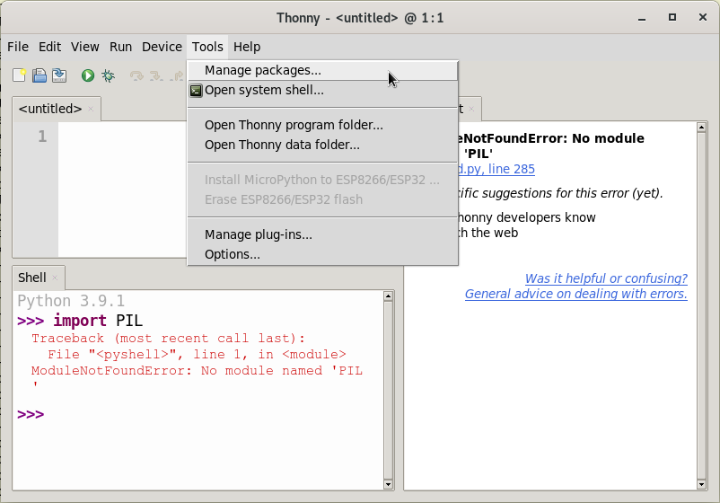

1. Then click on "Find package from PyPI
2. Finally, install or uninstall your package

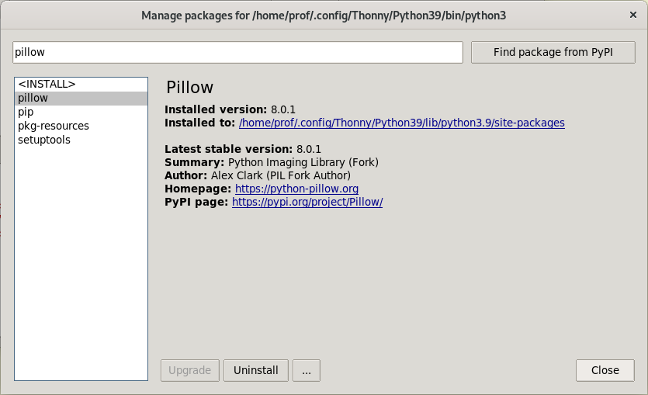

### Stopping the product’s operation

When you are done using Python.

1. If a program is running press this button to stop it .
2. Don't forget to save your work.
3. Close the application by pressing the cross at the top right.

If you want to stop working with the raspberry pi.

1. Check that no applications are running
2. Once back on the desk press the "Raspberry" logo at the bottom left.
3. Click on "disconnection" then "shutdown" to completely shut down the Raspberry otherwise press "reboot" to restart.

## What to Do in Emergency and Exceptional Situations

**In case of an emergency:**

1. You can close all programs.
2. Reboot your Raspberry
3. If the problem persists, unplug and reinstall your SD Card.

# TROUBLESHOOTING AND REPAIR

## How to Identify and Solve Problems

**WARNING:**

|  |  |  |
| --- | --- | --- |
| Error | Cause | Solution |
| You cannot use the internet when starting the **Raspberry** | At each start, the date and time are reset | To do this, type the command again:  *sudo date -s "YYYY-MM-DD HH-MM-SS"* |
| The Wi-Fi turns off regularly | If you are connected to a 4G network or a Wi-Fi sharing | It is preferable to connect with an Ethernet cable or to be on a private network |
| If you are doing large projects, or **updating** several at the same time. | The device tends to overheat | Make poses, and especially ventilate the Raspberry and especially not cover it. |
| If you are on the terminal and you cannot execute a command | You do not have the rights | Switch to "**root**" or use the command:  *chmod 777* |
| Product lights up displays a black screen | HDMI port | Exchange HDMI port outputs on the back of the screen |

# GLOSSARY

|  |  |
| --- | --- |
| Term | Meaning |
| **Raspbian** | Raspberry Pi OS (formerly named Raspbian1) is a free Debian-based open source operating system optimized to run on various Raspberry Pi. |
| **Nano-computer** | A nanocomputer is a computer having a size smaller than a microcomputer, itself smaller than a minicomputer; the mini-computer is said to be "mini" because it is much smaller than the original computers |
| **Port HDMI** | High-Definition Multimedia Interface (HDMI) is a fully digital audio / video standard and interface for transmitting encrypted streams consisting of uncompressed video data and compressible audio data. It is intended for the general public market. |
| **Numpy** | NumPy is a library for the Python programming language, intended to handle multidimensional matrices or arrays as well as mathematical functions operating on these arrays. |
| **Pandas** | Pandas is a library written for the Python programming language for data manipulation and analysis. In particular, it offers data structures and operations for manipulating numerical tables and time series. |
| **Big-Data** | The definition of Big Data is as follows: more varied data, arriving in increasingly large volumes and at a higher speed. |
| **Scipy** | SciPy is a project aimed at unifying and federating a set of Python libraries for scientific use. Scipy uses the arrays and matrices of the NumPy module |

# RELATED DOCUMENTATION

|  |  |  |  |  |
| --- | --- | --- | --- | --- |
| # | Document Title | Version # | Location | Author |
|  | Set up your Raspberry Pi and see what it can do! | internet | https://projects.raspberrypi.org/en/pathways/getting-started-with-raspberry-pi | [Raspberry Pi Foundation](https://www.raspberrypi.org) |
|  | Raspberry Pi 3 | internet | https://www.papergeek.fr/raspberry-pi-3-tout-savoir-mini-pc-2327 | PAPER GEEK |