**Final task**

**Task 5**

1. Log into dlab using **EPAM SSO** <https://ssn.trainings.dlabanalytics.com/>
2. Click button “Create NEW” to create own env

1. Run env when it needs. Stop after working with it

1. bucket where all source data is stored:

NOT i**skldl02-projectby-local-bucket**

1. I used gsutil commands to copy data for the task .

<https://cloud.google.com/storage/docs/gsutil/commands/ls>

* ‘raw’ –contains target data

* ‘source’ containing 3 source files required for processing data

6 new notebook was created in my environment

7 Create functions for check:

* Airports: Completeness by sum (for numeric columns)
* Flights: Validity by Time Range for ArrTime and ArrDepTime
* Carrier: Uniqueness by PK
* Flights: Consistency check for CancellationCode

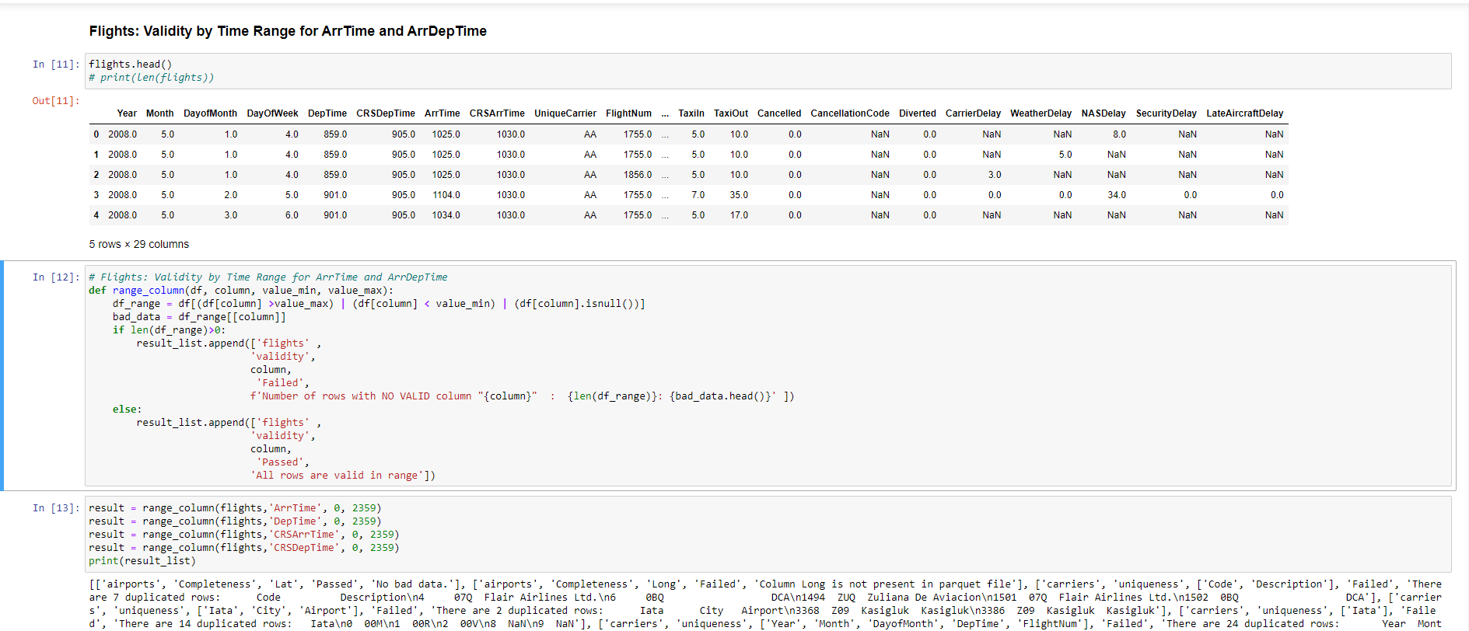

8. Create HTML REPORT

8. Create csv file REPORT

**Task 6**

9. Create python script for running Jupyter Notebook automatically using Selenium

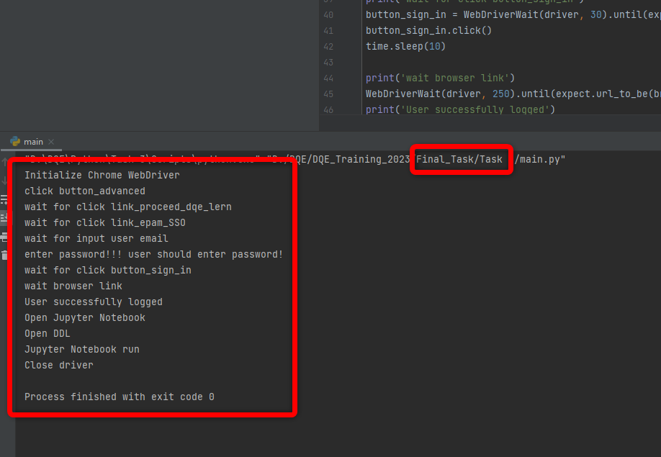

**Links :**

GIT

<https://github.com/LapitskayaN/DQE-Mentoring-Program-/tree/main/Final_task>

Link to notebook:

https://dqelearn.trainings.dlabanalytics.com/nllapitskaya/notebooks/Final_task.ipynb