OpenBCI 开发环境配置
1、下载安装 VSCode；
2、下载Processing；
3、添加环境变量到 PATH E:\Software\processing-3.5.3；
4、下载OpenBCI源代码；
5、打开VSCode；
6、VSCode -> 打开文件夹, 选择OpenBCI_GUI目录；
7、拷贝OpenBCI Libraries到Progressing Libraries；
比如：从E:\OpenBCI_GUI\OpenBCI_GUI\libraries 到 d:\Documents\Processing\libraries
8、安装Processing Extension
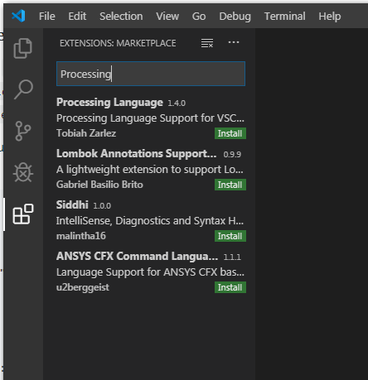
安装Processing Language Extension
9、重启VS Code
10、设置tasks.json文件 (Ctrl + Shift + P)
---------------------------------------------------------------
{
"version": "2.0.0",
"tasks": [
{
"label": "Run Sketch",
"type": "shell",
"group": {
"kind": "build",
"isDefault": true
},
"command": "${config:processing.path}",
"presentation": {
"echo": true,
"reveal": "always",
"focus": false,
"panel": "dedicated"
},
"args": [
"--force",
"--sketch=${workspaceRoot}/OpenBCI_GUI",
"--output=${workspaceRoot}/OpenBCI_GUI/build",
"--run"
],
"windows": {
"args": [
"--force",
"--sketch=\"${workspaceRoot}\\OpenBCI_GUI\"",
"--output=${workspaceRoot}\\OpenBCI_GUI\\build",
"--run"
]
}
}
]
}-------------------------------------------------
11、Ctrl + Shift + B 运行
enjoy！

