Level of Attributes Assignment

Name: Rasolosoa Jimmy

Create a “level of attributes” diagram for a **car rental**. Include its core benefit, expected attributes, and add-on attributes. Have any of these attributes changed over the past 10 years?

**Core attribute car rental:** Low Cost and Affordability, the cars proposed are functioning and not too old, the car rental has experience in this field, and the car proposed are reliable.

**Expected attributes:** fuel in the vehicle tank, various types of cars proposed, and not too much administrative work to use the car. The cars proposed are comfortable, and there are also consumer services.

**Add-on attributes** Fidelity rewards, and percentage discounts according to the number of consumers who have used kilometers, Mobile friendly (A good website), Car photos are published and there are a lot of descriptions for the car.

I don’t think that these attributes have changed very much over the past 10 years. However, as cars have become more comfortable and more technological, the adds-on attributes have increased with new widgets, and eventually, these widgets have become expected attributes. The core attribute remains the same which is mainly to have a low cost and affordable prices.

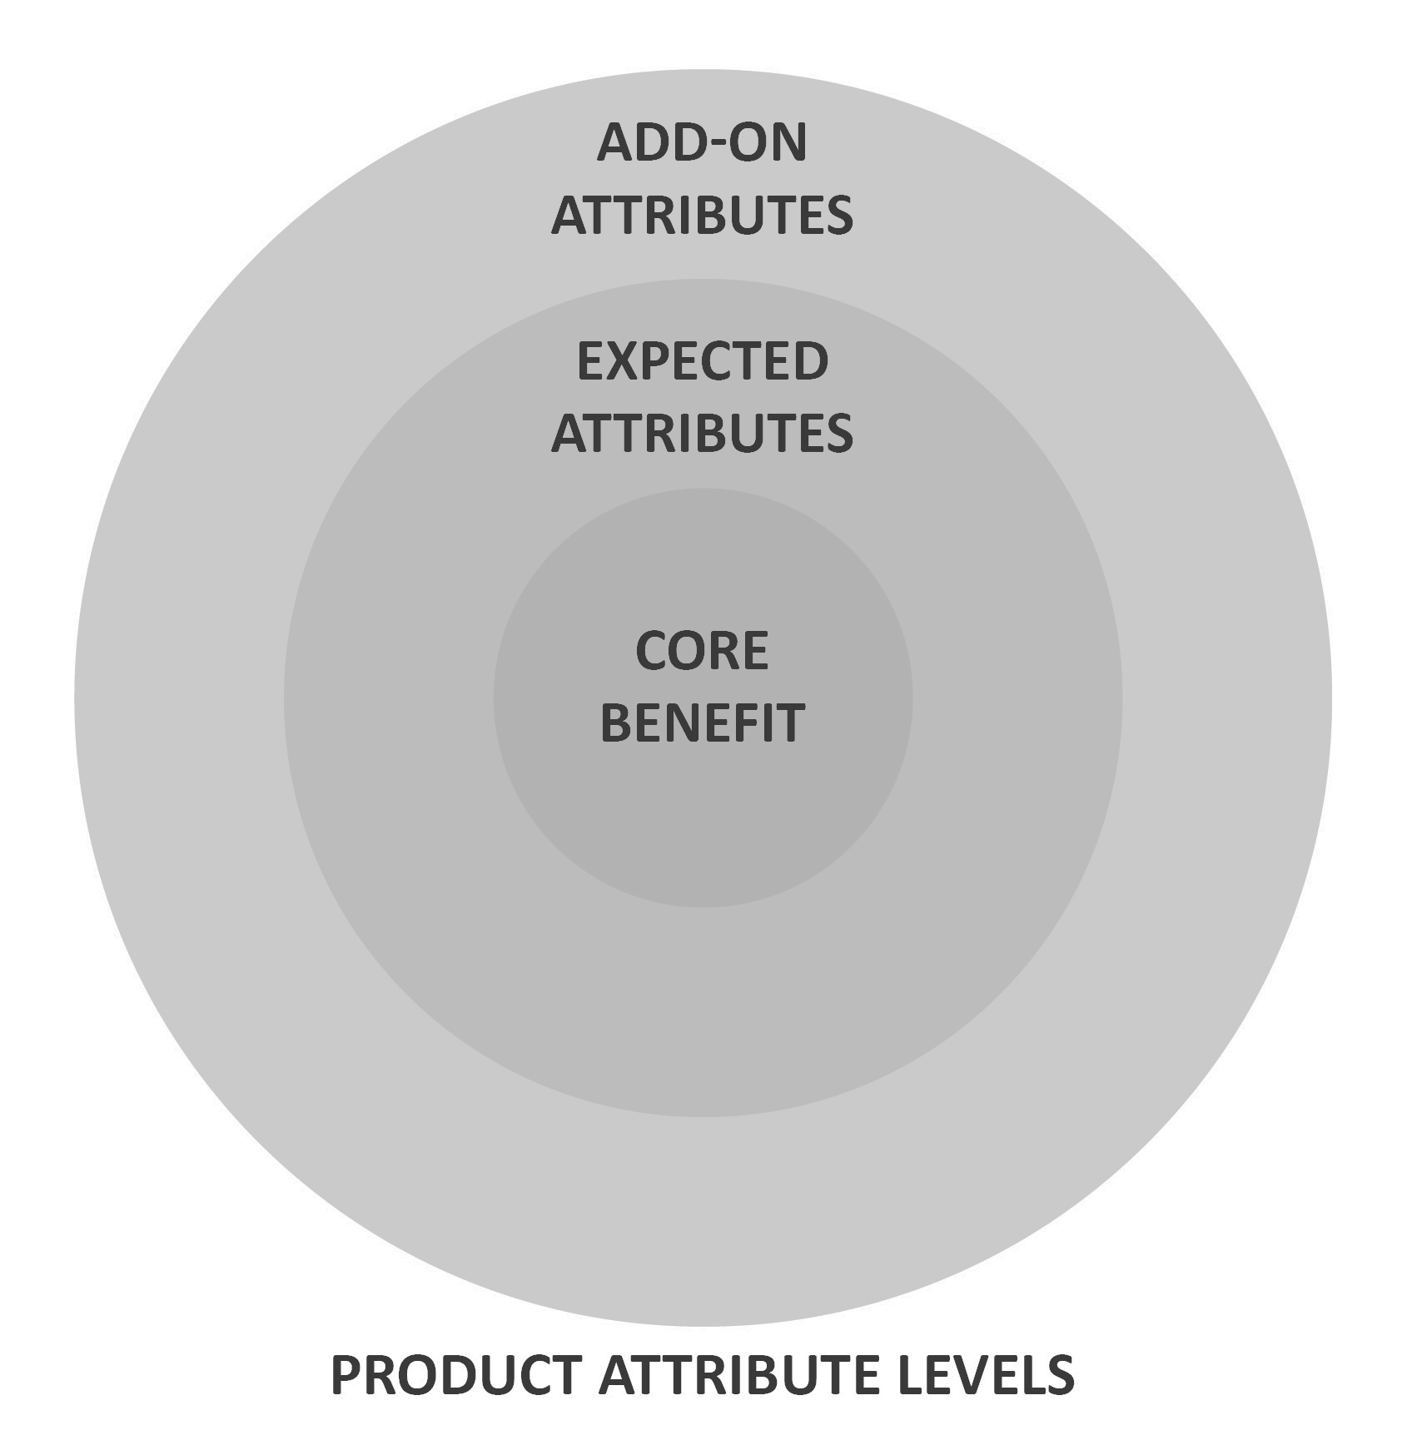

Create a “level of attributes” diagram for a **product of your choice**. Include its core benefit, expected attributes, and add-on attributes. Have any of these attributes changed over the past 10 years?

Product: Computer

**Core Benefit:** Browsing on the web, using software for work, playing games, being efficient and quick.

**Expected attributes:** Bluetooth, Wi-Fi, A lot of space stockage, easy to use, good volume, and good quality of the image.

**Add-ons:** Keyboard light, Fingerprint recognition, Face recognition, Vocal recognition.

There are a lot of things that have changed with this object. Before, computers used to have DVD players, however, as technology has improved these Add-ons have disappeared to let the place of USB and HDMI ports. I believe that it will change again as new technology will emerge, there might be a function to do the online payment directly through your fingerprint or something like that.

