1. **on branch develop create a file food.txt, add some text to it and do 1 commit**

Created food.txt file and committed it on develop branch.

1. **from branch develop create a new branch (with name - test),**

* **do 2 commits on it,**

* **then switch to develop and do one more commit**

* **merge branch test to develop**



* **git log**

I made 2 commits on test branch, 1 on develop, merged test into develop branch, and the history of commits can be viewed with “git log”, where is also visible the merge.

1. **checkout on the first commit of the branch master**

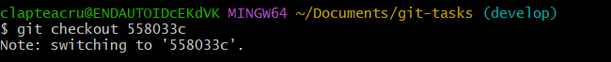

* **create a new branch (firstBr) from this commit**

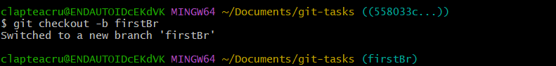

* **do 2 more commits on this branch**

* **rebase it with branch test**

* **git log**

* **reset hard last 2 commits**

* **git log**

* **What happens with commit history?**

The last two commits were removed from the branch through command “reset –hard”. So, they no longer appear in firstBr branch.

1. **search the commits that have been reset**

* **create a new branch (lost) from one of them**

* **git log**

--

* **do some changes and then commit amend**

* **git log**

**What happens with commit history?**

The last commit was replaced by a new one created from the staged snapshot. The old commit dropped out of the branch history but remains reachable via git reflog.

“-- amend” replaces the most recent commit with a new one built from what’s currently staged, effectively rewriting the last commit’s history.

**5. checkout on the develop branch,**

* **add new content in food.txt file, then commit them,**

* **add some new content to the same file, (don't make a commit) and git status**

* **now switch to test branch**

* **git status**

* **What can you see at this moment? Why does it happen? Solve the problem!**

Checkout was blocked because uncommitted edits to food.txt on develop branch would be overwritten by test branch. It can be solved by committing the changes of food.txt.

**6. switch to the branch firstBr**

* **create a new file (color.txt), do commit**

* **add content to this new file, (don't make a commit) and switch to master**

* **What happened? Why?**

It was blocked for the same reason, uncommitted changes in the working tree, here color.txt file would be overwritten by files from main branch. Solution: commit or stash the changes.