Data Structure and Algorithm

Laboratory Activity No. 2

Algorithm Analysis and Flowchart

|  |  |
| --- | --- |
| *Submitted by:* | *Instructor:* |
| LAPUT, MARK DANIELLE E. | Engr. Maria Rizette H. Sayo |

8, 2, 2025

# Objectives

Introduction

Data structure is a systematic way of organizing and accessing data, and an algorithm is a step-by-step procedure for performing some task in a finite amount of time. These concepts are central to computing, but to be able to classify some data structures and algorithms as “good,” we must have precise ways of analyzing them.

This laboratory activity aims to implement the principles and techniques in:

* Writing a well-structured procedure in programming
* Writing algorithm that best suits to solve computing problems to improve the efficiency of computers
* Convert algorithms into flowcharting symbols

# Methods

* 1. Explain algorithm and flowchart

-x, x<0

x, x ≥ 0

* 1. Write algorithm to find the result of equation: f (x) = and draw its flowchart
  2. Write a short recursive Python function that finds the minimum and maximum values in a sequence without using any loops

# Results

### A. Explain algorithm and flowchart

**Algorithm** and **flowchart** are programming tools. A Programmer uses various programming languages to create programs. But before actually writing a program in a programming language, a programmer first needs to find a procedure for solving the problem which is known as planning the program. The program written without proper pre-planning have higher chances of errors. The tools that are used to plan or design the problem are known as programming tools. Algorithm and flowchart are widely used programming tools.  
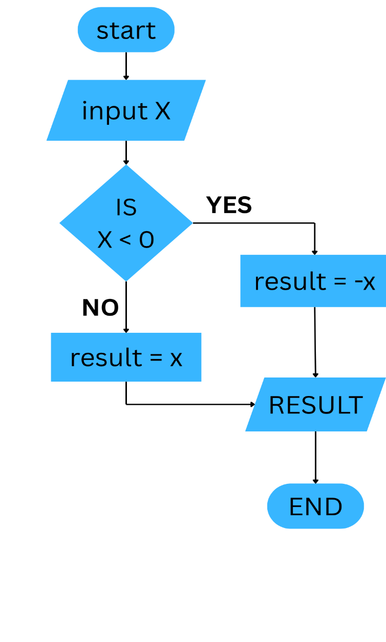B.  
C.

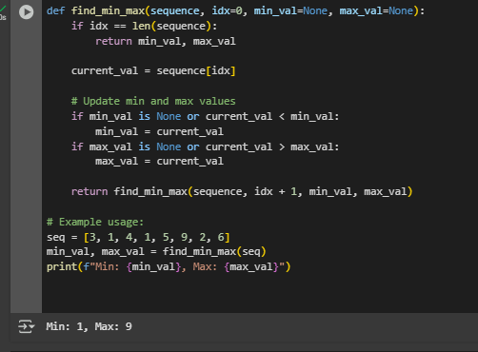

# Conclusion

In this activity, we learned about algorithms, flowcharts, and recursion through illustrating an easy conditional algorithm for $f(x)$, converting it to a flowchart, and writing a recursive Python function to determine the minimum and maximum values within a sequence using no loops, illustrating how various programming methodologies can effectively solve actual problems.

**References**

[1] Co Arthur O.. “University of Caloocan City Computer Engineering Department Honor Code,” UCC-CpE Departmental Policies, 2020.