Data Structure and Algorithm

Laboratory Activity No. 3

Translating Algorithm to Program

|  |  |
| --- | --- |
| *Submitted by:* | *Instructor:* |
| LAPUT, MARK DANIELLE E. | Engr. Maria Rizette H. Sayo |

8, 11, 2025

# Objectives

Introduction

Data structure is a systematic way of organizing and accessing data, and an algorithm is a step-by-step procedure for performing some tasks in a finite amount of time. These concepts are central to computing, but to be able to classify some data structures and algorithms as “good,” we must have precise ways of analyzing them.

This laboratory activity aims to implement the principles and techniques in:

* Writing a well-structured procedure in programming
* Writing algorithm that best suits to solve computing problems
* Writing an efficient Python program from translated algorithms

# Methods

• Design an algorithm and the corresponding flowchart (Note: You may use LucidChart or any application) for adding the test scores as given below if the number is even: 26,49,98,87,62,75

• Translate the algorithm to a Python program (using Google Colab)

• Save your source codes to GitHub

# Results

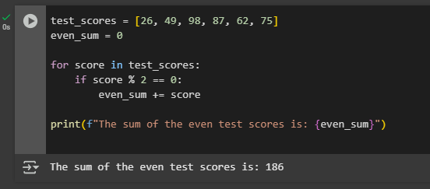

# Conclusion

In this exercise, we created an algorithm to add even test scores from a list, and wrote it out as a flowchart and Python program. The algorithm iterates over the test scores, verifies whether or not each score is even, and adds it to a cumulative total. The Python program executes this reasoning effectively using a loop and a condition to detect even numbers. Lastly, the total of all even test scores is displayed as output. This step demonstrates how simple algorithms and programming principles are utilized to solve common data manipulation problems efficiently.

**References**

[1] Co Arthur O.. “University of Caloocan City Computer Engineering Department Honor Code,” UCC-CpE Departmental Policies, 2020.