Data Structure and Algorithm

Laboratory Activity No. 6

Singly Linked Lists

|  |  |
| --- | --- |
| *Submitted by:* | *Instructor:* |
| LAPUT, MARK DANIELLE E. | Engr. Maria Rizette H. Sayo |

08, 23, 2025

# Objectives

Introduction

A linked list is an organization of a list where each item in the list is in a separate node. Linked lists look like the links in a chain. Each link is attached to the next link by a reference that points to the next link in the chain. When working with a linked list, each link in the chain is called a Node. Each node consists of two pieces of information, an item, which is the data associated with the node, and a link to the next node in the linked list, often called next.

This laboratory activity aims to implement the principles and techniques in:

* Writing algorithms using Linked list
* Writing a python program that will perform the common operations in a singly linked list

# Methods

* Write a Python program to create a singly linked list of prime numbers less than 20. By iterating through the list, display all the prime numbers, the head, and the tail of the list. (using Google Colab)
* Save your source codes to GitHub

# Results

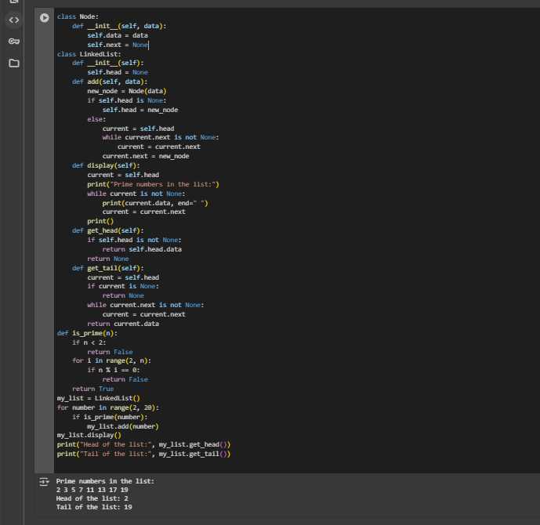

# Conclusion

This Python program creates a singly linked list that holds all prime numbers under 20. It defines custom Node and LinkedList classes to manage the list. It also uses a function to find prime numbers and adds each one to the list. The program then shows all the prime numbers in the list and prints the values at the head and tail. This helps beginners learn the basics of object-oriented programming, how linked lists work, and how to use loops and conditionals in Python.

1. **References**
2. [1] Co Arthur O.. “University of Caloocan City Computer Engineering Department Honor Code,” UCC-CpE Departmental Policies, 2020.