Data Structure and Algorithm
Laboratory Activity No. 11

Implementation of Graphs

Submitted by: | Instructor:
LAPUT, MARK DANIELLE E. | Engr. Maria Rizette H. Sayo

October, 18, 2025

Objectives
Introduction
A graph is a visual representation of a collection of things where some object pairs are linked together. Vertices are the points used to depict the interconnected items, while edges are the connections between them. In this course, we go into great detail on the many words and functions related to graphs.
An undirected graph, or simply a graph, is a set of points with lines connecting some of the points. The points are called nodes or vertices, and the lines are called edges.

A graph can be easily presented using the python dictionary data types. We represent the vertices as the keys of the dictionary and the connection between the vertices also called edges as the values in the dictionary.
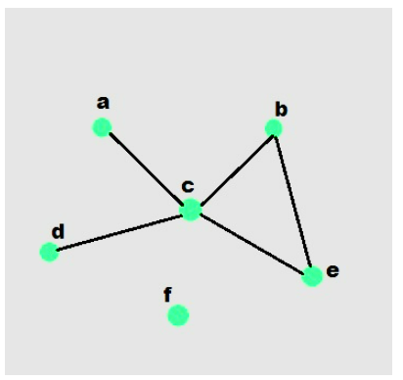

Figure 1. Sample graph with vertices and edges

This laboratory activity aims to implement the principles and techniques in:
- To introduce the Non-linear data structure – Graphs
- To implement graphs using Python programming language
- To apply the concepts of Breadth First Search and Depth First Search

Methods
  - Copy and run the Python source codes.
  - If there is an algorithm error/s, debug the source codes.
  - Save these source codes to your GitHub.

from collections import deque

class Graph:
def __init__(self):
self.graph = {}

def add_edge(self, u, v):
"""Add an edge between u and v"""
if u not in self.graph:
self.graph[u] = []
if v not in self.graph:
self.graph[v] = []

self.graph[u].append(v)
self.graph[v].append(u) # For undirected graph

def bfs(self, start):
"""Breadth-First Search traversal"""
visited = set()
queue = deque([start])
result = []

while queue:
vertex = queue.popleft()
if vertex not in visited:
visited.add(vertex)
result.append(vertex)
# Add all unvisited neighbors
for neighbor in self.graph.get(vertex, []):
if neighbor not in visited:
queue.append(neighbor)
return result

def dfs(self, start):
"""Depth-First Search traversal"""
visited = set()
result = []

def dfs_util(vertex):
visited.add(vertex)
result.append(vertex)
for neighbor in self.graph.get(vertex, []):
if neighbor not in visited:
dfs_util(neighbor)

dfs_util(start)
return result

def display(self):
"""Display the graph"""
for vertex in self.graph:
print(f"{vertex}: {self.graph[vertex]}")

# Example usage
if __name__ == "__main__":
# Create a graph
g = Graph()

# Add edges
g.add_edge(0, 1)
g.add_edge(0, 2)
g.add_edge(1, 2)
g.add_edge(2, 3)
g.add_edge(3, 4)

# Display the graph
print("Graph structure:")
g.display()

# Traversal examples
print(f"\nBFS starting from 0: {g.bfs(0)}")
print(f"DFS starting from 0: {g.dfs(0)}")

# Add more edges and show
g.add_edge(4, 5)
g.add_edge(1, 4)

print(f"\nAfter adding more edges:")
print(f"BFS starting from 0: {g.bfs(0)}")
print(f"DFS starting from 0: {g.dfs(0)}")

Questions:
    - What will be the output of the following codes?
    - Explain the key differences between the BFS and DFS implementations in the provided graph code. Discuss their data structures, traversal patterns, and time complexity. How does the recursive nature of DFS contrast with the iterative approach of BFS, and what are the potential advantages and disadvantages of each implementation strategy?
    - The provided graph implementation uses an adjacency list representation with a dictionary. Compare this approach with alternative representations like adjacency matrices or edge lists.
    - The graph in the code is implemented as undirected. Analyze the implications of this design choice on the add_edge method and the overall graph structure. How would you modify the code to support directed graphs? Discuss the changes needed in edge addition, traversal algorithms, and how these modifications would affect the graph's behavior and use cases.
    - Choose two real-world problems that can be modeled using graphs and explain how you would use the provided graph implementation to solve them. What extensions or modifications would be necessary to make the code suitable for these applications? Discuss how the BFS and DFS algorithms would be particularly useful in solving these problems and what additional algorithms you might need to implement.

Results
1.
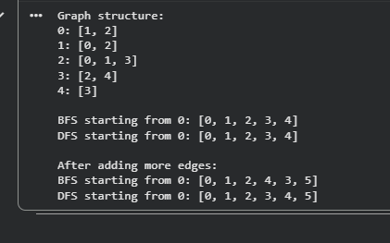
2. • Data Structures Used:
- BFS (Breadth-First Search) uses a queue (deque) to explore nodes level by level.
- DFS (Depth-First Search) uses recursion (implicitly a stack) to go as deep as possible before backtracking.
• Traversal Pattern:
- BFS visits all neighbors of a node before moving to the next level (ideal for shortest paths in unweighted graphs).
- DFS goes deep into one branch before visiting siblings (ideal for path existence and cycle detection).
• Time Complexity:
Both have O(V + E) complexity, where V = number of vertices and E = number of edges.
• Recursive vs. Iterative Approach:
- DFS uses recursion, making it simpler but prone to stack overflow on large graphs.
- BFS is iterative, using a queue, more memory-efficient for deep but sparse graphs.
• Advantages:
- BFS: Finds the shortest path in unweighted graphs.
- DFS: Requires less memory in shallow graphs and can detect cycles.

3.
• Adjacency List (used in code):
- Efficient in terms of space for sparse graphs.
- Easy to add or remove nodes and edges.
- Traversal time proportional to connected edges.
• Adjacency Matrix:
- Uses a 2D array (V×V).
- Fast edge lookup (O(1)), but consumes large memory (O(V²)).
- Suitable for dense graphs.
• Edge List:
- Stores only pairs of connected nodes.
- Space-efficient but slower for traversal or neighbor lookup (O(E)).
4. • Current Design (Undirected):
Each edge is stored twice — once for each connected vertex (u → v and v → u).
This ensures traversal works in both directions.
• To Make It Directed:
- Modify add_edge method:
def add_edge(self, u, v):
if u not in self.graph:
self.graph[u] = []
self.graph[u].append(v) # Remove v→u
• Traversal algorithms (BFS/DFS): No major change needed. They’ll naturally follow direction of edges.
• Effect:
- Directional relationships (e.g., follower/following) can be modeled.
- May require additional algorithms (like topological sort or strongly connected components).
5. a. Social Network Analysis:
- Nodes: People; Edges: Friendships.
- Use Case: Finding shortest connection paths (BFS) or exploring mutual groups (DFS).
- Extension: Add weights (e.g., strength of relationships).
b. Route Planning in Maps:
- Nodes: Locations; Edges: Roads (with distances).
- Use Case: BFS can find shortest path in unweighted grids; DFS helps in exploring all possible routes.
- Extension: Add edge weights and implement Dijkstra’s algorithm for shortest paths.
BFS helps in finding minimum steps (shortest route), while DFS is good for exploring connectivity or detecting unreachable zones. For practical applications, algorithms like Dijkstra’s or A* would further enhance functionality.

Conclusion
In summary, the above implementation of the graph effectively illustrates main graph traversal methods such as BFS and DFS employing an adjacency list representation. Whereas BFS is best suited to level-wise traversal and computing shortest paths, DFS is best for deep traversals and solving problems such as connected components. The adjacency list provides an efficient and flexible means of storing sparse graphs, but in certain applications other options such as adjacency matrices or edge lists might be more appropriate. Knowledge of how directed graphs differ from undirected graphs and how to choose the traversal algorithm is required in order to apply graph theory to problems such as web crawls and social network analysis.

References
[1] Sedgewick, R., & Wayne, K. "Algorithms," 4th ed., Addison-Wesley, 2011. https://algs4.cs.princeton.edu/
[2] "Graph Algorithms," GeeksforGeeks. https://www.geeksforgeeks.org/graph-data-structure-and-algorithms/

