Data Structure and Algorithm
Laboratory Activity No. 12

Graph Searching Algorithm

Submitted by: | Instructor:
LAPUT, MARK DANIELLE E. | Engr. Maria Rizette H. Sayo

10, 25, 2025

Objectives
Introduction
Depth-First Search (DFS)
- Explores as far as possible along each branch before backtracking
- Uses stack data structure (either explicitly or via recursion)
- Time Complexity: O(V + E)
- Space Complexity: O(V)
Breadth-First Search (BFS)
- Explores all neighbors at current depth before moving deeper
- Uses queue data structure
- Time Complexity: O(V + E)
- Space Complexity: O(V)

This laboratory activity aims to implement the principles and techniques in:
- Understand and implement Depth-First Search (DFS) and Breadth-First Search (BFS) algorithms
- Compare the traversal order and behavior of both algorithms
- Analyze time and space complexity differences

Methods
  - Copy and run the Python source codes.
  - If there is an algorithm error/s, debug the source codes.
  - Save these source codes to your GitHub.
  - Show the output

    - Graph Implementation

from collections import deque
import time

class Graph:
def __init__(self):
self.adj_list = {}

def add_vertex(self, vertex):
if vertex not in self.adj_list:
self.adj_list[vertex] = []

def add_edge(self, vertex1, vertex2, directed=False):
self.add_vertex(vertex1)
self.add_vertex(vertex2)

self.adj_list[vertex1].append(vertex2)
if not directed:
self.adj_list[vertex2].append(vertex1)

def display(self):
for vertex, neighbors in self.adj_list.items():
print(f"{vertex}: {neighbors}")

2. DFS Implementation

def dfs_recursive(graph, start, visited=None, path=None):
if visited is None:
visited = set()
if path is None:
path = []

visited.add(start)
path.append(start)
print(f"Visiting: {start}")

for neighbor in graph.adj_list[start]:
if neighbor not in visited:
dfs_recursive(graph, neighbor, visited, path)

return path

def dfs_iterative(graph, start):
visited = set()
stack = [start]
path = []

print("DFS Iterative Traversal:")
while stack:
vertex = stack.pop()
if vertex not in visited:
visited.add(vertex)
path.append(vertex)
print(f"Visiting: {vertex}")

# Add neighbors in reverse order for same behavior as recursive
for neighbor in reversed(graph.adj_list[vertex]):
if neighbor not in visited:
stack.append(neighbor)
return path

- BFS Implementation

def bfs(graph, start):
visited = set()
queue = deque([start])
path = []

print("BFS Traversal:")
while queue:
vertex = queue.popleft()
if vertex not in visited:
visited.add(vertex)
path.append(vertex)
print(f"Visiting: {vertex}")

for neighbor in graph.adj_list[vertex]:
if neighbor not in visited:
queue.append(neighbor)

return path

Questions:
- When would you prefer DFS over BFS and vice versa?
- What is the space complexity difference between DFS and BFS?
- How does the traversal order differ between DFS and BFS?
- When does DFS recursive fail compared to DFS iterative?

Results
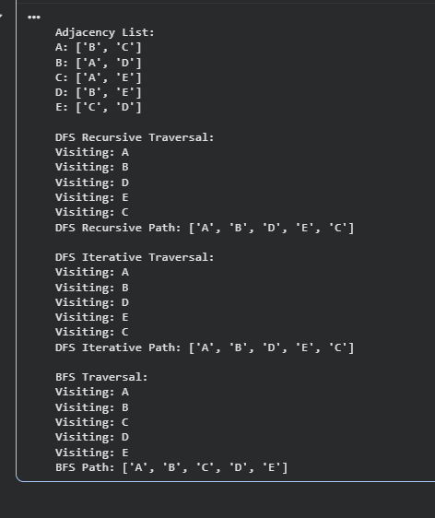
1. I would prefer DFS (Depth-First Search) when I need to explore a graph deeply before backtracking, such as when finding a specific path, checking for cycles, or performing topological sorting. On the other hand, I would use BFS (Breadth-First Search) when I need the shortest path in an unweighted graph or when I want to visit nodes level by level, like in maze-solving or network traversal.
2. In my understanding, DFS usually takes O(h) space, where h is the depth of the recursion or stack. BFS, however, can take O(V) space since it needs to store all nodes at a particular level in the queue. This means that in large or wide graphs, BFS can use much more memory than DFS.
3. When I use DFS, it explores as deep as possible along one branch before backtracking, so the traversal feels like going down a single path first. In contrast, BFS explores all the neighbors of a node before moving deeper, meaning it visits nodes level by level. So, DFS goes deep first, while BFS goes wide first.
4. From my experience, recursive DFS can fail when the graph is very large or has deep nesting because it might exceed the recursion limit and cause a stack overflow. Iterative DFS avoids this problem since it uses its own stack, making it safer and more efficient for large-scale graphs.

Conclusion
In conclusion, both DFS (Depth-First Search) and BFS (Breadth-First Search) are essential graph traversal algorithms, each suited for different situations. I’ve learned that DFS is better when I need to go deep into a structure, such as when searching paths or detecting cycles, while BFS is ideal for finding the shortest path and exploring all nodes at the same depth. Their main difference lies in traversal strategy and memory usage—DFS is more space-efficient, while BFS provides level-wise exploration. Understanding when to use each one helps me apply the right algorithm depending on the problem I face.

References
[1] GeeksforGeeks. (2023). Difference between BFS and DFS. Retrieved from https://www.geeksforgeeks.org/difference-between-bfs-and-dfs/

