Data Structure and Algorithm
Laboratory Activity No. 10

Intro to Graphs

Submitted by: | Instructor:
LAPUT, MARK DANIELLE E. | Engr. Maria Rizette H. Sayo

10, 11, 2025

Objectives
Introduction
A graph is a visual representation of a collection of things where some object pairs are linked together. Vertices are the points used to depict the interconnected items, while edges are the connections between them. In this course, we go into great detail on the many words and functions related to graphs.
An undirected graph, or simply a graph, is a set of points with lines connecting some of the points. The points are called nodes or vertices, and the lines are called edges.

A graph can be easily presented using the python dictionary data types. We represent the vertices as the keys of the dictionary and the connection between the vertices also called edges as the values in the dictionary.
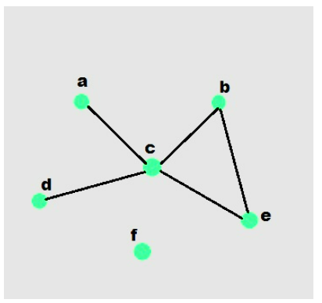

Figure 1. Sample graph with vertices and edges

This laboratory activity aims to implement the principles and techniques in:
- To introduce the Non-linear data structure – Graphs
- To discuss the importance of Graphs in programming

Methods
  - Discuss the following terms related to graphs:
    - Undirected graph
    - Directed graph
    - Nodes
    - Vertex
    - Degree
    - Indegree
    - Outdegree
    - Path
    - Cycle
    - Simple Cycle

Results
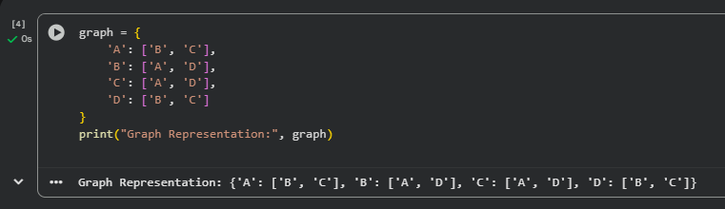
This output shows that each vertex and its connections can be clearly represented using a Python dictionary. Vertices A, B, C, and D are interconnected, forming a simple undirected graph.
Graphs like this can represent real-world systems such as social networks, transportation routes, and data linkages in computing.

Conclusion
In this laboratory activity, we explored the fundamental concepts of graphs as a non-linear data structure. Through practical examples and Python implementations, we learned how to represent graphs using dictionaries, where vertices serve as keys and edges define their connections. We also differentiated between directed and undirected graphs and discussed essential terminologies such as nodes, degrees, indegree, outdegree, paths, and cycles. Understanding graphs is vital in computer engineering as they are widely used in networking, data organization, and algorithm design. This activity enhanced our comprehension of how data relationships can be efficiently modeled and visualized using graph structures in programming.

References
[1] Co, Arthur O., “University of Caloocan City Computer Engineering Department Honor Code,” UCC-CpE Departmental Policies, 2020.
[2] W3Schools, “Python Graphs (Dictionary Implementation),” W3Schools Online Python Tutorials, 2024. [Online]. Available: https://www.w3schools.com/python/python_graphs.asp
[3] GeeksforGeeks, “Introduction to Graphs – Data Structure and Algorithms,” GeeksforGeeks, 2024. [Online]. Available: https://www.geeksforgeeks.org/graph-data-structure-and-algorithms/

