Data Structure and Algorithm
Laboratory Activity No. 14

Tree Structure Analysis

Submitted by: | Instructor:
LAPUT, MARK DANIELLE E.. | Engr. Maria Rizette H. Sayo

11, 9, 2025

Objectives
Introduction
An abstract non-linear data type with a hierarchy-based structure is a tree. It is made up of links connecting nodes (where the data is kept). The root node of a tree data structure is where all other nodes and subtrees are connected to the root.

This laboratory activity aims to implement the principles and techniques in:
- To introduce Tree as Non-linear data structure
- To implement pre-order, in-order, and post-order of a binary tree
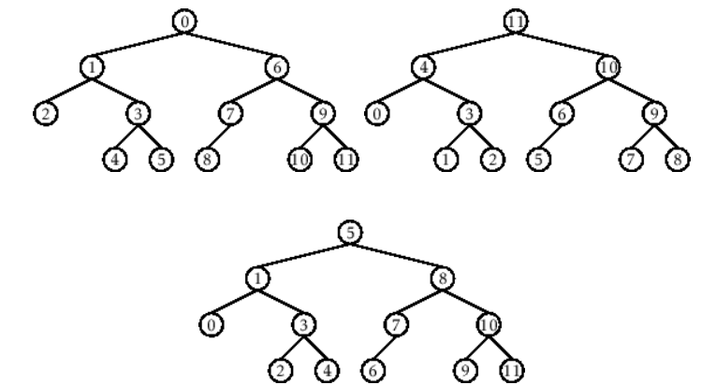

- Figure 1. Pre-order, In-order, and Post-order numberings of a binary tree

Methods
  - Copy and run the Python source codes.
  - If there is an algorithm error/s, debug the source codes.
  - Save these source codes to your GitHub.
  - Show the output

    - Tree Implementation

class TreeNode:
def __init__(self, value):
self.value = value
self.children = []

def add_child(self, child_node):
self.children.append(child_node)

def remove_child(self, child_node):
self.children = [child for child in self.children if child != child_node]

def traverse(self):
nodes = [self]
while nodes:
current_node = nodes.pop()
print(current_node.value)
nodes.extend(current_node.children)

def __str__(self, level=0):
ret = " " * level + str(self.value) + "\n"
for child in self.children:
ret += child.__str__(level + 1)
return ret

# Create a tree
root = TreeNode("Root")
child1 = TreeNode("Child 1")
child2 = TreeNode("Child 2")
grandchild1 = TreeNode("Grandchild 1")
grandchild2 = TreeNode("Grandchild 2")

root.add_child(child1)
root.add_child(child2)
child1.add_child(grandchild1)
child2.add_child(grandchild2)

print("Tree structure:")
print(root)

print("\nTraversal:")
root.traverse()

Questions:
- What is the main difference between a binary tree and a general tree?
- In a Binary Search Tree, where would you find the minimum value? Where would you find the maximum value?
- How does a complete binary tree differ from a full binary tree?
- What tree traversal method would you use to delete a tree properly? Modify the source codes.

Results
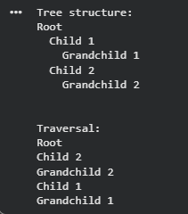
1. The main difference between a binary tree and a general tree
A binary tree allows each node to have at most two children, commonly known as the left and right child. In contrast, a general tree can have any number of child nodes, allowing for more flexible structures but more complex traversal and manipulation.
2. In a Binary Search Tree, where would you find the minimum and maximum values?
In a Binary Search Tree (BST), the minimum value is found by following the leftmost child from the root node until there are no more left children. Conversely, the maximum value is found by following the rightmost child from the root node until there are no more right children.
3. How does a complete binary tree differ from a full binary tree?
A complete binary tree has all levels completely filled except possibly the last, which is filled from left to right. A full binary tree, on the other hand, requires that every node has either 0 or 2 children—no node can have only one child.
4. What tree traversal method would you use to delete a tree properly? Modify the source codes.
To delete a tree properly, we use post-order traversal because it deletes the child nodes first before their parent, preventing orphan references.
Modified Code Example:
def delete_tree(node):
if node:
for child in node.children:
delete_tree(child)
print(f"Deleting node: {node.value}")
del node
Usage:
delete_tree(root)

Conclusion
Through this activity, I have learned how to implement and visualize tree structures using Python. I understood the hierarchical relationships among nodes and how different tree types, such as binary and general trees, operate. Moreover, I gained insight into traversal techniques like pre-order, in-order, post-order, and how these are applied in operations such as deletion and searching. Overall, this laboratory activity strengthened my understanding of trees as fundamental non-linear data structures that organize and process data efficiently.

References
[1] GeeksforGeeks, “Difference Between General Tree and Binary Tree,” GeeksforGeeks Data Structures Tutorial, 2025. Available: https://www.geeksforgeeks.org/difference-between-general-tree-and-binary-tree/
[2] TutorialsPoint, “Tree Traversal Techniques in Data Structures,” TutorialsPoint Computer Science Resources, 2024. Available: https://www.tutorialspoint.com/data_structures_algorithms/tree_traversal.htm

