#AhsokaTop
YARN: Sport weight (#2 fine); 1117 (1211, 1257, 1349, 1443, 1543, 1640, 1734, 1831) yd [1022 (1108, 1150, 1234, 1320, 1411, 1500,1586, 1675) m] ; shown: Anzula Luxury Yarns, Ava, (80% merino wool 10% cashmere goat 10% nylon; 330 yd [302 m]/4.02 oz [114 gm]) in cornflower; 4 (4, 4, 5, 5, 5, 6, 6, 6) skeins
Other yarns to try:
Lion Brand Yarn, Beautiful You 100% acrylic; 326 yards [298 m], 3.53 oz [100 g] – great stitch definition with a nice sheen, friendly on the wallet
Red Heart, It’s a wrap! 55% acrylic 45% cotton; 623 yards [570 m], 5.29 oz [150 g] – if you are a fan of self striping and/or ombre style, this fairly new yarn by Red Heart comes in giant cakes that are also small on price.
HOOK: G [4/4.25mm]
NOTIONS: Tapestry needle, locking stitch markers (4)
GAUGE: 19 sts and 11 rows = 4″ [10 cm] in double crochet
FINISHED MEASUREMENTS: Circumference at hip- 32 (36, 40, 44, 48, 52, 56, 60, 64)” [81 (91.5, 101.5, 112, 122, 132, 142, 152.5, 162.5) cm] after blocking.
Sample shown is Size Medium, model is 5’ 8”, pear shape with 34“ [85 cm] bust, 38”[95 cm] full hip. Intended to be worn form fitting or with about 1-2” [5-10 cm] positive ease at the hip.
SIZES: XS (S, M, L, 1X, 2X, 3X, 4X, 5X); to fit hip 32 (36, 40, 44, 48, 52, 56, 60, 64) [81 (91.5, 101.5, 112, 122, 132, 142, 152.5, 162.5) cm]
PROJECT LEVEL: Easy +
TECHNIQUES USED: foundation single crochet – chain – double crochet – back post – front post – front loop only – together – slip stitch – stacked double crochet [see Special Stitches] – seaming

ABBREVIATIONS:
Bpdc- back post double crochet
Ch – chain
Dc- double crochet
Dc3tog – double crochet 3 together [see special stitches]
Ea- each
Flo- front loop only
Fpdc – front post double crochet
Fsc – foundation single crochet [see special stitches]
PM- place marker
Rep- repeat
RS- right side
Sc – single crochet
Sk – skip
Sl st- slip stitch
Sp(s) – space(s)
St(s)- stitch(es)
WS- wrong side
Yo – yarn over (hook)

NOTES:
- Top is worked in 3 pieces, Upper Front / Back are stitched individually from bottom up then seamed at shoulders and underarms, the Lower Body is then worked perpendicular to the Upper portion, attaching as the rows are created.
- Take time to save time. Stitch, wash, and block a gauge swatch in the same manner you will be using for your garment to ensure proper measurements. This lace fabric will need “help” opening up. It is recommended to thoroughly soak/wash, then lay flat to dry, using rust-proof pins to shape the pieces to measurements.
- Choose sizing from largest of bust or full hip measurement.
- Read through each line before beginning to avoid any confusion during stitching.
- Remember, if needed, stitch diagram(s), schematic, and customization instruction are available through my Etsy store and at LoveCrochet.
SPECIAL STITCHES:
Dc3togA (double crochet 3 together A): (Yo, insert hook into next dc, pull up a loop, yo, draw through 2 loops on hook) twice, yo, insert hook into ch-3 sp, pull up a loop, yo, draw through 2 loops on hook, yo, draw through remaining 4 loops on hook.
Dc3togB (double crochet 3 together B): Yo, insert hook into ch-3 sp, pull up a loop, draw through 2 loops on hook, (yo, insert hook into next dc, pull up a loop, yo, draw through 2 loops on hook) twice, yo, draw through remaining 4 loops on hook.
Fsc (foundation single crochet): Ch 2, yo, insert hook in 2nd ch from hook, yo, pull up a loop, yo and draw through 1 loop (1 chain made), yo and draw through 2 loops on hook (1stfoundation single crochet made), *Yo, insert hook under the 2 bottommost horizontal bars of the chain portion of fsc just made, yo, pull up a loop, yo and draw through 1 loop (1 chain made), yo and draw through 2 loops on hook (sc made); repeat from * for indicated number of foundation sts.
PM (place marker): Place a marker in stitch just made, or otherwise indicated within pattern.
Stacked dc (stacked double crochet): Sc in indicated st, insert hook behind leftmostvertical bar of sc just made and pull up a loop, yo and draw through 2 loops on hook. Replace this with a traditional ch-3 if desired.
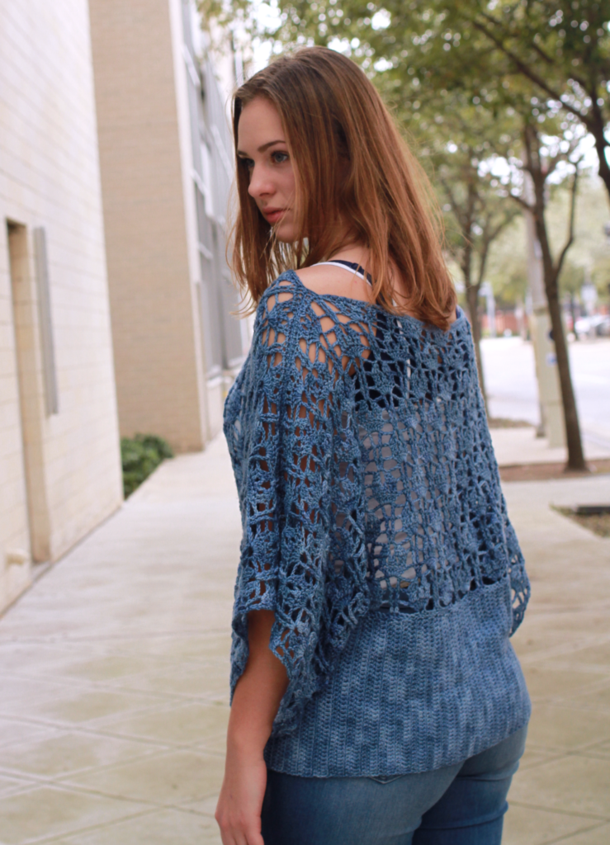
Top
Upper Front / Back (make 2)
Set up: Fsc 156 (156, 167, 167, 167, 189, 189, 189, 189), PM in fsc 46 (40, 40, 40, 35, 40, 35, 33, 29) to mark for sleeve seam.
Row 1 (RS): Stacked dc in first fsc, dc in next fsc, *ch 2, sk 4 fsc, 6 dc in next fsc, ch 2, sk 4 fsc, dc in next 2 fsc; rep from * across to end, turn.
Row 2: Stacked dc in first dc, *bpdc in next dc, ch 2, dc in next 2 dc, ch 3, sc in next 2 dc, ch 3, dc in next 2 dc, ch 2, bpdc in next dc; rep from * across, dc in last dc, turn.
Row 3: Stacked dc in first dc, ch 2, *fpdc in next dc, ch 3, dc3togA (see special stitches), ch 1, dc3togB (see special stitches), ch 3, fpdc in next dc, ch 2; rep from * across, dc in last dc, turn.
Row 4: Stacked dc in first dc, 3 dc in ch-2 sp, ch 2, 2 dc in ch-1 sp, ch 2, sk ch 3, *6 dc in ch-2 sp, ch 2, 2 dc in ch-1 sp, ch 2; rep from * across, 3 dc in ch-2 sp, dc in last dc, turn.
Row 5: Sc in first dc, *sc in next dc, ch 3, dc in next 2 dc, ch 2, fpdc in next 2 dc, ch 2, 2 dc in next 2 dc, ch 3, sc in next dc*; rep from * to across, sc in last dc, turn.
Row 6: Stacked dc in first sc, ch 1, *dc3togB, ch 3, bpdc in next dc, ch 2, bpdc in next dc, ch 3, dc3togA, ch 1; rep from * across, dc in last sc, turn.
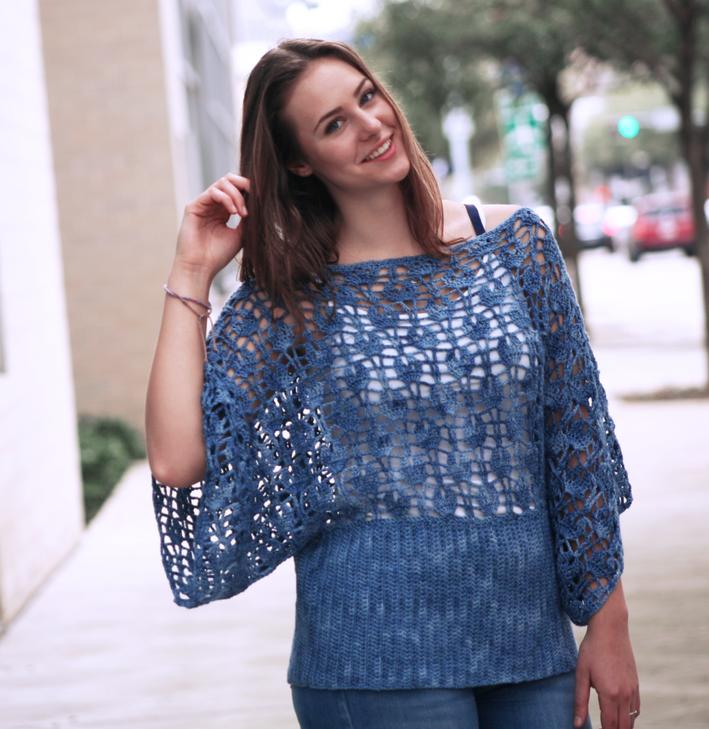
Row 1 (RS): Fdc 79 (79, 79, 83, 83, 83, 83, 87, 87), turn.
Row 7: Stacked dc in first dc, dc in ch-1 sp, ch 2, sk ch 3, 6 dc in ch-2 sp, ch 2, *2 dc in ch-1 sp, ch 2, sk ch 3, 6 dc in ch-2 sp, ch 2; rep from * across, dc in ch-1 sp, dc in last dc, turn.
Size XS (S, 1X) only
Row 8: Stacked dc in first dc, *bpdc in next dc, ch 2, dc in next 2 dc, ch 3, sc in next 2 dc, ch 3, dc in next 2 dc, ch 2, bpdc in next dc**; rep from * to ** 4 (4, 4) times, PM in dc just made for neck/shoulder placement, move marker up with each corresponding repeat row; rep from * to ** across, dc in last dc, turn.
Size M (L, 2X, 3X, 4X, 5X) only
Row 8: Stacked dc in first dc, bpdc in next dc, ch 2, dc in next 2 dc, ch 3, sc in next 2 dc, ch 3, *dc in next 2 dc, ch 2, bpdc in next 2 dc, ch 2, dc in next 2 dc, ch 3, sc in next 2 dc, ch 3**; rep from * to ** 4 (4, 5, 5, 5, 5) times, PM in ch-3 sp just made for neck/shoulder placement, move marker up with each corresponding repeat row; rep from * to ** across, dc in next 2 dc, ch 2, bpdc in next dc, dc in last dc, turn.
All Sizes
Row 9: Stacked dc in first dc, ch 2, *fpdc in next dc, ch 3, dc3togA, ch 1, dc3togB, ch 3, fpdc in next dc, ch 2; rep from * across, dc in last dc, turn.
Row 10: Stacked dc in first dc, 3 dc in ch-2 sp, ch 2, 2 dc in ch-1 sp, ch 2, sk ch 3, *6 dc in ch-2 sp, ch 2, 2 dc in ch-1 sp, ch 2; rep from * across, 3 dc in ch-2 sp, dc in last dc, turn.
Row 11: Sc in first dc, *sc in next dc, ch 3, dc in next 2 dc, ch 2, fpdc in next 2 dc, ch 2, 2 dc in next 2 dc, ch 3, sc in next dc; rep from * across, sc in last dc, turn.
Row 12: Stacked dc in first sc, ch 1, *dc3togB, ch 3, bpdc in next dc, ch 2, bpdc in next dc, ch 3, dc3togA, ch 1; rep from * across, dc in last sc, turn.
Rows 13-24 (24, 24, 24, 30, 30, 30, 36, 36): Rep Rows 7-12.
Rows 25 (25, 25, 25, 31, 31, 31, 37, 37) -26 (26, 26, 26, 32, 32, 32, 38, 38): Rep Rows 7-8.
Row 27 (27, 27, 27, 33, 33, 33, 39, 39): Sc in first dc, sc in next dc, *sc in ch-2 sp, sc in next 2 dc, sc in ch-3 sp, ch 1, sc in ch-3 sp, sc in next 2 dc, sc in ch-2 sp, sc in next 2 dc; rep from * to end, turn.
Row 28 (28, 28, 28, 34, 34, 34, 40, 40): Sc in first sc, *sc in ea sc to ch, sc in ch-1 sp; rep from * across, sc in ea sc to end, turn, leaving a tail approximately 3X width of shoulder for seaming (see schematic), fasten off.
Move neck/shoulder placement marker, to corresponding sc of row just made.
- For best results, block finished Front and Back pieces to measurements before proceeding.
Shoulders / Neck
Thread long tail through yarn needle, with RS together, using mattress stitch, seam across shoulder from edge to marker.
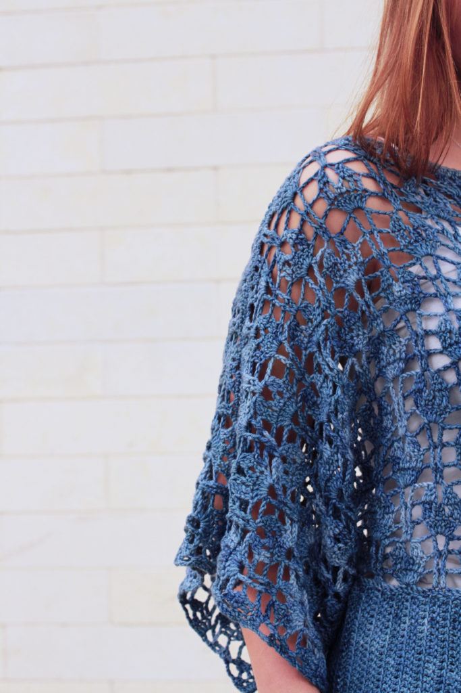
Repeat for second shoulder.

Sleeves
Using a length of yarn approximately 3X length of sleeve underarm (see schematic) thread yarn needle, with RS together, using mattress stitch, seam across underarm from edge to marker.
Repeat for second sleeve.
Lower body
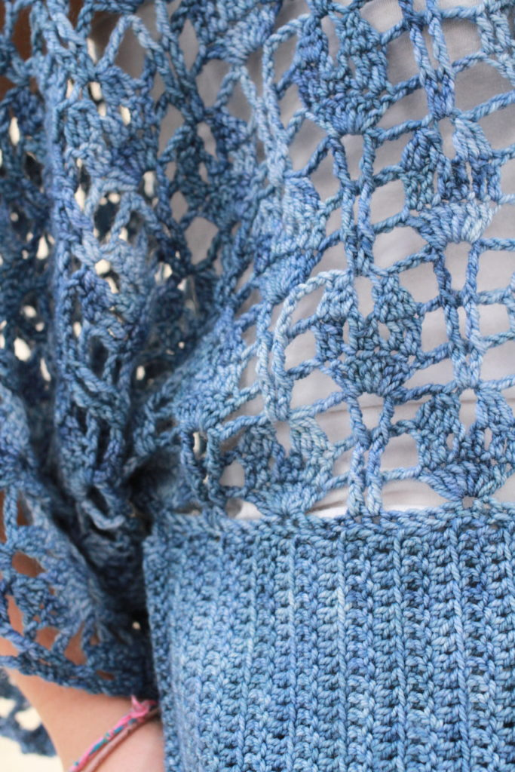
Row 1: With RS facing, join yarn at either underarm seam, ch 38, stacked dc in first ch from hook, dc in ea ch across, sk next fsc of upper body, sl st in next 2 fsc, turn.
Row 2: Dc in flo of ea dc across, turn.
Row 3: Stacked dc in first dc, dc in ea dc across, sk next fsc, sl st in next 2 fsc, turn.
Rep Rows 2-3 across front and back until stitching reaches beginning foundation row of Lower Body, leaving a tail of approximately 3X length of row, fasten off.
Finishing
Turn top inside-out, thread long tail through yarn needle, with RS together, using mattress stitch, sew side seam.
Weave in all ends, remove all markers.
Lightly wet block or steam Lower Body, edges and seams for best results.
