PRACTICAL FILE

Keshav Mahavidyalaya
University of Delhi

Q1: Using SHA256, obtain the message digest of string “Blockchain Developer”.
#include <iostream>
#include <openssl/sha.h>
#include <iomanip>
#include <sstream>
using namespace std;
int main() {
string message = " Blockchain Developer"; // leading space included
unsigned char hash[SHA256_DIGEST_LENGTH];
SHA256((unsigned char*)message.c_str(), message.length(), hash);
cout << "Message: \"" << message << "\"" << endl;
cout << "SHA-256 Digest: ";
for (int i = 0; i < SHA256_DIGEST_LENGTH; i++) {
cout << hex << setw(2) << setfill('0') << (int)hash[i];
}
cout << endl;
return 0;
}

Q2 Write a program to encrypt and decrypt the message “Hello World” using SHA256.

#include <iostream>
#include <openssl/sha.h>
#include <iomanip>
using namespace std;
int main() {
string msg = "Hello World";
unsigned char hash[SHA256_DIGEST_LENGTH];
SHA256((unsigned char*)msg.c_str(), msg.length(), hash);
cout << "Message : " << msg << endl;
cout << "SHA256 : ";
for (int i = 0; i < SHA256_DIGEST_LENGTH; i++)
cout << hex << setw(2) << setfill('0') << (int)hash[i];
cout << endl;
cout << "Decryption : Not possible (SHA256 is one-way)" << endl;
return 0;
}

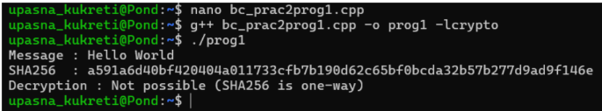
Q3 Implement RSA cryptographic algorithm.
p = 17
q = 11
e = 11
M = 12

n = p * q
phi = (p - 1) * (q - 1)

def mod_inverse(e, phi):
for d in range(1, phi):
if (e * d) % phi == 1:
return d

d = mod_inverse(e, phi)

C = pow(M, e, n)

M_decrypted = pow(C, d, n)

print("---------------------RSA---------------------\n\n")
print("GIVEN:-")
print("Value of M:", M)
print("Value of e:", e)
print("Value of p:", p)
print("Value of q:", q)
print("-----------------------------------------------------------------------------\n")
print("Value of n:", n)
print("Value of phi(n):", phi)
print("Private key d:", d)
print("Ciphertext:", C)
print("Decrypted message:", M_decrypted)
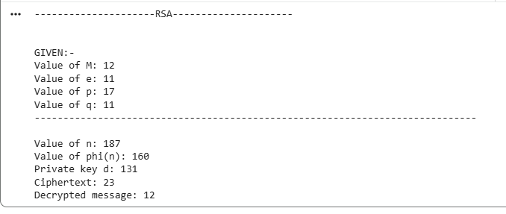
Q4 Create a simple blockchain using Proof of Work (PoW).
import hashlib

class Block:
def __init__(self, index, data, previous_hash):
self.index = index
self.data = data
self.previous_hash = previous_hash
self.nonce = 0
self.hash = self.mine_block()

def calculate_hash(self):
value = str(self.index) + self.data + self.previous_hash + str(self.nonce)
return hashlib.sha256(value.encode()).hexdigest()

def mine_block(self):
hash_value = self.calculate_hash()
while not hash_value.startswith("00"):
self.nonce += 1
hash_value = self.calculate_hash()
return hash_value

class Blockchain:
def __init__(self):
self.chain = []

def add_block(self, data):
if len(self.chain) == 0:
previous_hash = "0"
else:
previous_hash = self.chain[-1].hash

block = Block(len(self.chain), data, previous_hash)
self.chain.append(block)

def print_chain(self):
for block in self.chain:
print("Index:", block.index)
print("Data:", block.data)
print("Hash:", block.hash)
print("Previous Hash:", block.previous_hash)
print("Nonce:", block.nonce)
print("-" * 40)

my_blockchain = Blockchain()

my_blockchain.add_block("A -> B")
my_blockchain.add_block("B -> C")
my_blockchain.add_block("C -> D")

my_blockchain.print_chain()

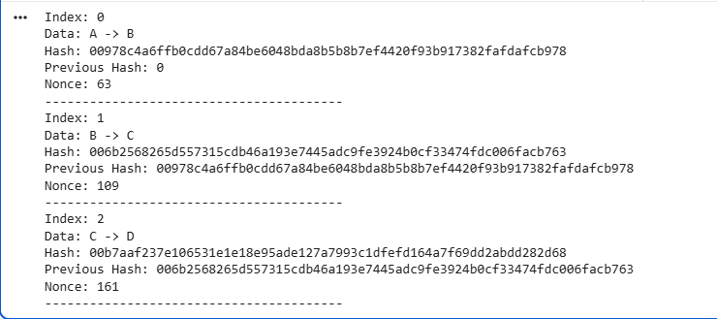
Q5 Demonstrate sending of a digitally signed document.
from cryptography.hazmat.primitives.asymmetric import rsa, padding
from cryptography.hazmat.primitives import hashes

private_key = rsa.generate_private_key(
public_exponent=65537,
key_size=2048
)

public_key = private_key.public_key()

document = b"This is a digitally signed document"

print("Original Document:", document.decode())

signature = private_key.sign(
document,
padding.PKCS1v15(),
hashes.SHA256()
)

print("Document signed successfully")

public_key.verify(
signature,
document,
padding.PKCS1v15(),
hashes.SHA256()
)

print("Signature verified successfully")
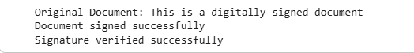
Q6 Create a blockchain block containing block hash, transaction history, time of creation.
import hashlib
import datetime

class Block:
def __init__(self, index, timestamp, data, previous_hash):
self.index = index
self.timestamp = timestamp
self.data = data
self.previous_hash = previous_hash
self.hash = self.calculate_hash()

def calculate_hash(self):

block_string = str(self.index) + str(self.timestamp) + str(self.data) + str(self.previous_hash)
return hashlib.sha256(block_string.encode()).hexdigest()

class Blockchain:
def __init__(self):
self.chain = [self.create_genesis_block()]

def create_genesis_block(self):
return Block(0, datetime.datetime.now(), "Genesis Block", "0")

@property
def last_block(self):
return self.chain[-1]

def add_block(self, new_block):
new_block.previous_hash = self.last_block.hash
new_block.hash = new_block.calculate_hash()
self.chain.append(new_block)
my_blockchain = Blockchain()
print("Blockchain created with Genesis Block.")
print("Adding blocks...")
my_blockchain.add_block(
Block(1, datetime.datetime.now(), {
"sender": "Alice",
"recipient": "Bob",
"amount": 10.0
}, "")
)
print("Block 1 added.")
my_blockchain.add_block(
Block(2, datetime.datetime.now(), {
"sender": "Bob",
"recipient": "Charlie",
"amount": 5.0
}, "")
)
print("Block 2 added.")
my_blockchain.add_block(
Block(3, datetime.datetime.now(), {
"sender": "Charlie",
"recipient": "Alice",
"amount": 3.5
}, "")
)
print("Block 3 added.")

print("\n--- Blockchain Content ---")
for block in my_blockchain.chain:
print(f"\nBlock Index: {block.index}")
print(f"Timestamp: {block.timestamp}")
print(f"Data (Transactions): {block.data}")
print(f"Previous Hash: {block.previous_hash}")
print(f"Block Hash: {block.hash}")

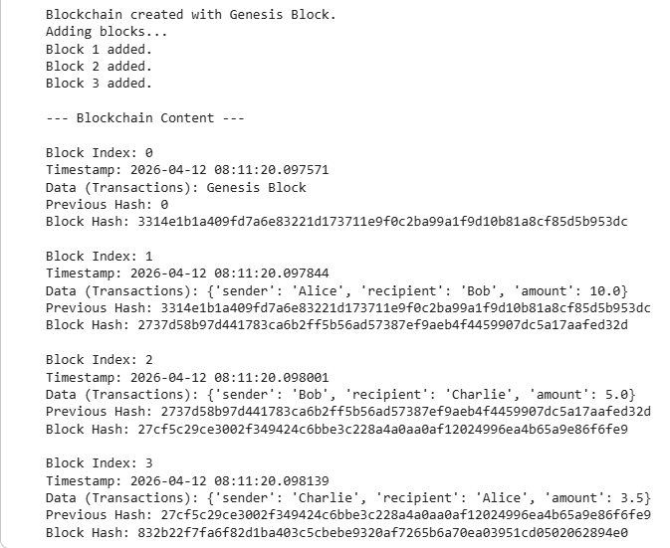
Q7 Create a blockchain having 5 nodes and print the hash values of each block.
import hashlib
import datetime

class Block:
def __init__(self, index, data, previous_hash):
self.index = index
self.timestamp = str(datetime.datetime.now())
self.data = data
self.previous_hash = previous_hash
self.hash = self.calculate_hash()

def calculate_hash(self):
value = str(self.index) + self.timestamp + self.data + self.previous_hash
return hashlib.sha256(value.encode()).hexdigest()

class Blockchain:
def __init__(self):
self.chain = [self.create_genesis_block()]

def create_genesis_block(self):
return Block(0, "Genesis Block", "0")

def add_block(self, data):
last_block = self.chain[-1]
new_block = Block(len(self.chain), data, last_block.hash)
self.chain.append(new_block)

def print_chain(self):
for block in self.chain:
print("Block", block.index)
print("Data:", block.data)
print("Hash:", block.hash)
print("Previous Hash:", block.previous_hash)
print("------------------------")

def is_valid(self):
for i in range(1, len(self.chain)):
current = self.chain[i]
previous = self.chain[i-1]

if current.hash != current.calculate_hash():
return False

if current.previous_hash != previous.hash:
return False

return True

blockchain = Blockchain()

blockchain.add_block("A -> B")
blockchain.add_block("B -> C")
blockchain.add_block("C -> D")
blockchain.add_block("D -> E")

print("Blockchain with 5 blocks:")
blockchain.print_chain()

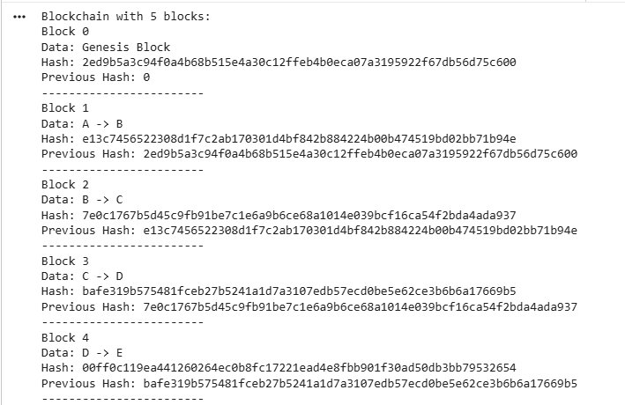

Q8 Create a blockchain having 5 nodes and check its validity.
import hashlib
import datetime

class Block:
def __init__(self, index, data, previous_hash):
self.index = index
self.timestamp = str(datetime.datetime.now())
self.data = data
self.previous_hash = previous_hash
self.hash = self.calculate_hash()

def calculate_hash(self):
value = str(self.index) + self.timestamp + self.data + self.previous_hash
return hashlib.sha256(value.encode()).hexdigest()

class Blockchain:
def __init__(self):
self.chain = [self.create_genesis_block()]

def create_genesis_block(self):
return Block(0, "Genesis Block", "0")

def add_block(self, data):
last_block = self.chain[-1]
new_block = Block(len(self.chain), data, last_block.hash)
self.chain.append(new_block)

def print_chain(self):
for block in self.chain:
print("Block", block.index)
print("Data:", block.data)
print("Hash:", block.hash)
print("Previous Hash:", block.previous_hash)
print("------------------------")

def is_valid(self):
for i in range(1, len(self.chain)):
current = self.chain[i]
previous = self.chain[i-1]

if current.hash != current.calculate_hash():
return False

if current.previous_hash != previous.hash:
return False

return True

blockchain = Blockchain()

blockchain.add_block("A -> B")
blockchain.add_block("B -> C")
blockchain.add_block("C -> D")
blockchain.add_block("D -> E")

print("Blockchain with 5 blocks:")
blockchain.print_chain()

print("Is blockchain valid?", blockchain.is_valid())

# Tamper with 3rd block
print("\nTampering with Block 3...\n")

blockchain.chain[2].data = "Tampered Data"

print("Is blockchain valid after tampering?", blockchain.is_valid())

print("\nCreating blockchain network with 5 nodes...\n")

nodes = []

for i in range(5):
node_blockchain = Blockchain()
node_blockchain.add_block("A -> B")
node_blockchain.add_block("B -> C")
node_blockchain.add_block("C -> D")
node_blockchain.add_block("D -> E")
nodes.append(node_blockchain)

# Checking validity of each node
for i in range(5):
print("Node", i+1, "Blockchain valid?", nodes[i].is_valid())
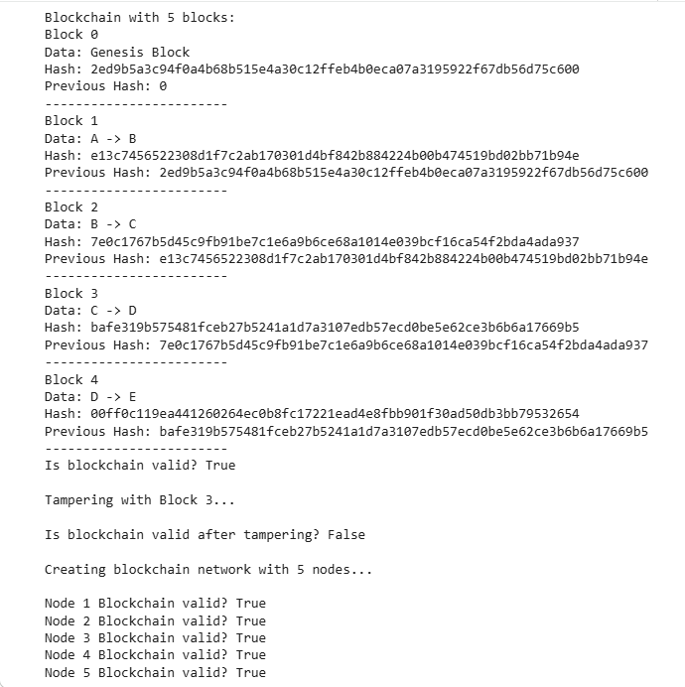
Q9 Implement a smart contract using Solidity programming language.
!pip install py-solc-x web3 eth-tester
from solcx import install_solc
install_solc('0.8.0')

from solcx import compile_source, set_solc_version
set_solc_version('0.8.0')
contract_code = '''
pragma solidity ^0.8.0;
contract SimpleStorage {
uint public data;

function setData(uint _data) public {
data = _data;
}

function getData() public view returns(uint) {
return data;
}
}
'''
compiled = compile_source(contract_code)
compiled
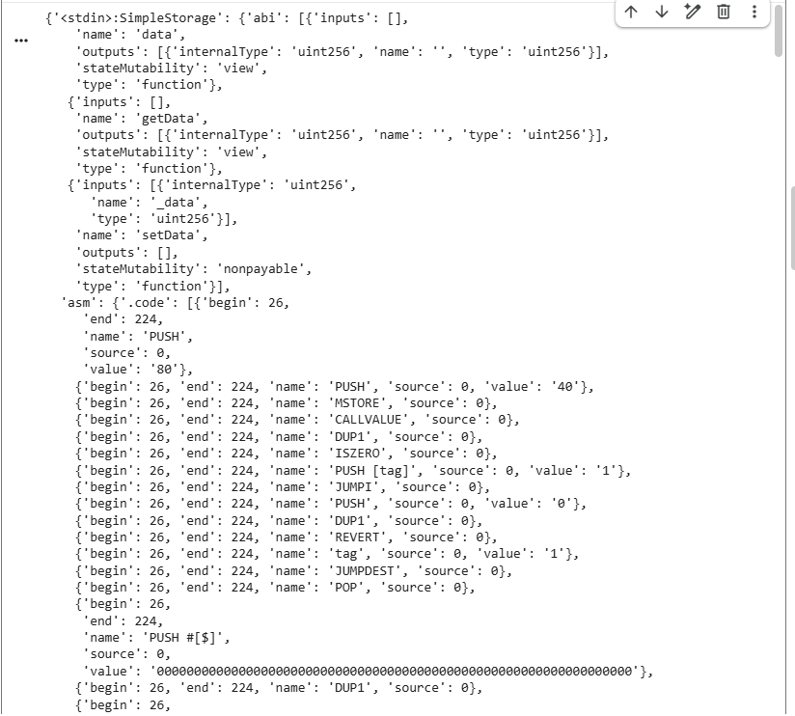
student_contract = '''
pragma solidity ^0.8.0;

contract Student {

string public name;
uint public age;

function setStudent(string memory _name, uint _age) public {
name = _name;
age = _age;
}

function getStudent() public view returns(string memory, uint) {
return (name, age);
}
}
'''

compiled_student = compile_source(student_contract)
compiled_student
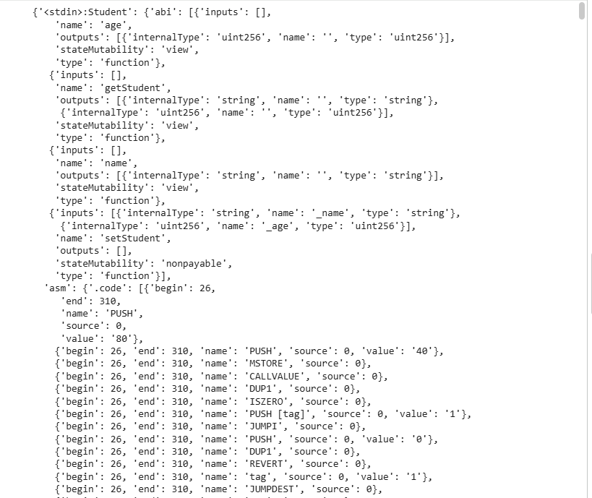
fund_contract = '''
pragma solidity ^0.8.0;

contract FundTransfer {

address payable public receiver;

constructor(address payable _receiver) {
receiver = _receiver;
}

function transferFunds() public payable {
receiver.transfer(msg.value);
}

}
'''

compiled_fund = compile_source(fund_contract)
compiled_fund
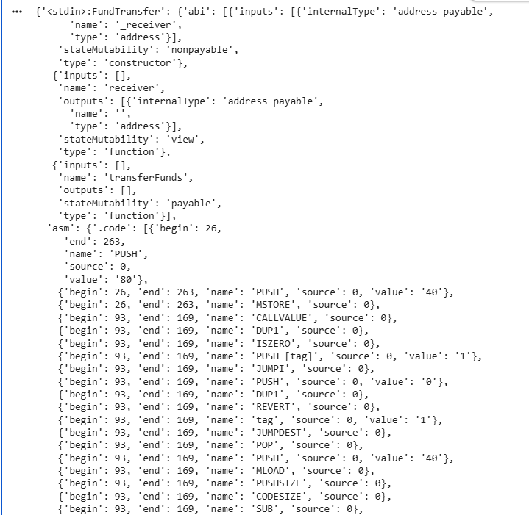
Q10 Create a simple permissioned blockchain using Hyperledger Fabric.

./network.sh up
./network.sh createChannel
./network.sh deployCC -ccn basic -ccp ../asset-transfer-basic/chaincode-go -ccl go
docker ps
