Linear Regression Project Summary
Simple LR • Sklearn Simple LR • Multiple LR

1. Project Overview
These three notebooks show a progression from understanding Simple Linear Regression from scratch, to implementing the same problem with scikit-learn, and then extending the idea to Multiple Linear Regression with 10 input features.

2. simple_LR.ipynb — Simple Linear Regression From Scratch
The notebook uses Study_Hours as the single input feature and Grade as the target. A custom class, my_simple_lr, calculates the slope and intercept directly from the training data and uses them to predict test values.
Model equation: Grade = m × Study_Hours + b
Completed model equation: Grade ≈ 7.0354 × Study_Hours + 25.7090
Main concepts practiced:
- Loading the student CSV
- Selecting one feature and one target
- 80/20 train-test split with random_state=42
- Calculating slope and intercept manually
- Prediction with the learned equation
- MAE, MSE, RMSE and R² evaluation
- Regression-line and Actual-vs-Predicted visualizations
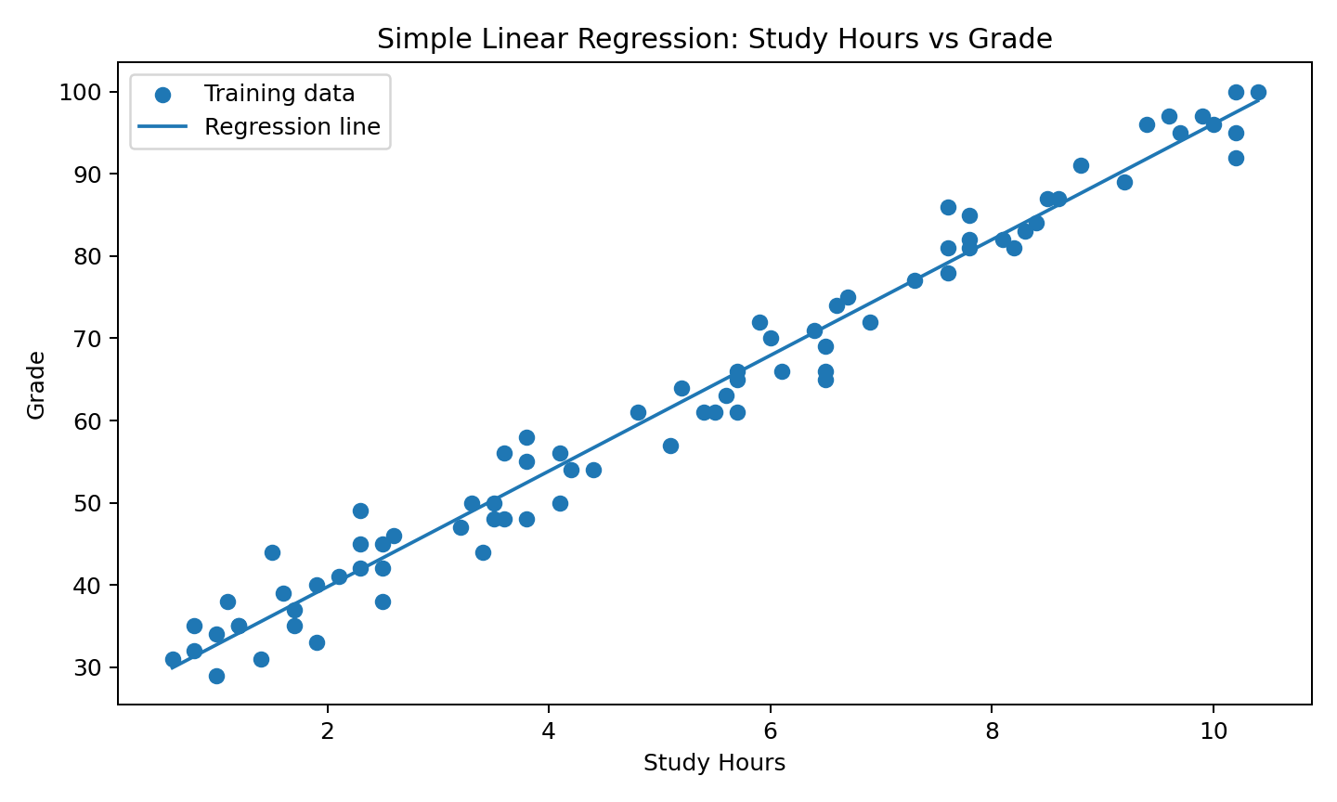
Visual: fitted regression line for Study Hours → Grade.

3. simple_lr_sklearn.ipynb — Simple Linear Regression With Sklearn
This notebook uses the same student dataset and target relationship, but the model is created with sklearn.linear_model.LinearRegression. The feature is represented in 2-D form for sklearn.
Workflow:
- Load the dataset and select Study_Hours / Grade
- Split into training and test sets
- Reshape X for sklearn
- Fit LinearRegression()
- Predict the test set
- Calculate MAE, MSE, RMSE and R²
- Plot the regression line and Actual vs Predicted values
- Display the final regression equation

Evaluation values from the completed sklearn workflow
Metric | Value
MAE | 2.014381
MSE | 7.621016
RMSE | 2.760619
R² | 0.984612
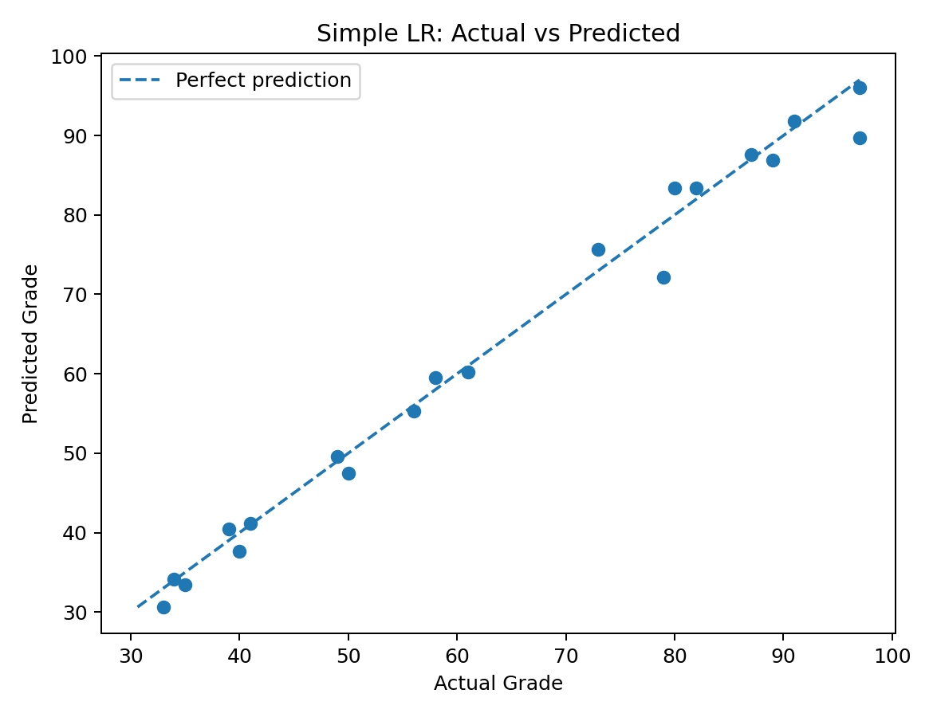
Visual: Actual vs Predicted Grade; the dashed diagonal represents perfect prediction.

4. multiple_LR.ipynb — Multiple Linear Regression
This notebook uses sklearn's diabetes dataset. The notebook shows X with shape (442, 10) and y with shape (442,). After an 80/20 split, the training data has 353 rows and the test data has 89 rows.
Two approaches are demonstrated: sklearn's LinearRegression and a custom my_LR class. The custom class adds a column of ones for the intercept and calculates coefficients using matrix operations based on the normal equation.
The custom prediction uses the learned coefficients and intercept to calculate the target value.
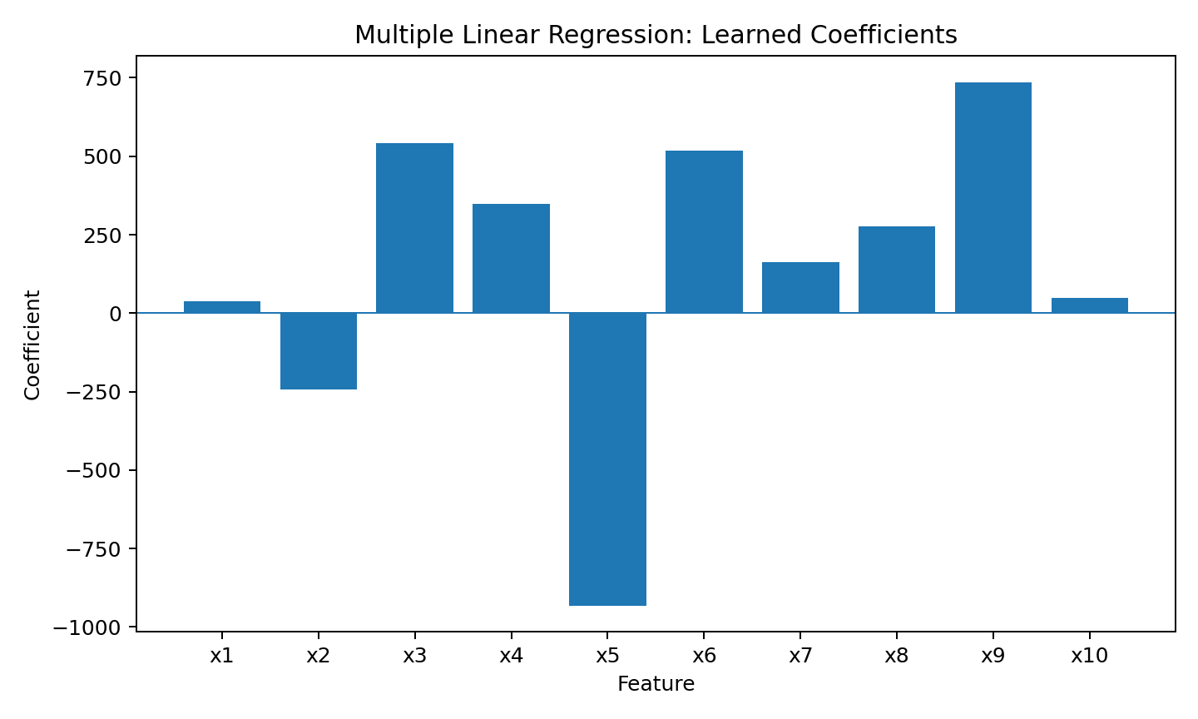
Visual: coefficients learned for the ten input features.

Multiple LR Results
Result | Value
Sklearn R² | 0.4526027630
Custom-model R² | 0.4526027630
Intercept | 151.345605
The notebook's sklearn and custom implementations produce essentially identical R² values and matching coefficients/intercept to numerical precision, demonstrating that the custom multiple-regression calculation reproduces the sklearn result.

5. Overall Learning Summary
Area | What you practiced
Data handling | CSV loading, feature/target selection, sklearn dataset loading
Splitting | 80/20 train-test split with random_state=42
From scratch | Slope/intercept calculation and matrix-based multiple regression
Sklearn | LinearRegression().fit() and .predict()
Evaluation | MAE, MSE, RMSE and R²
Visualization | Regression line, Actual-vs-Predicted plot, coefficient visualization

6. Final Takeaway
The three notebooks build the same regression concept step by step: Simple Linear Regression explains the mathematics with one feature, the sklearn notebook shows how the same model is implemented with a library, and Multiple Linear Regression extends the idea to several features. The custom multiple-regression model closely matches sklearn.

