|  |  |
| --- | --- |
|  | **[Year]** |
|  | home  ismail - [2010] |

|  |
| --- |
| **[Type the document title]** |
| [Type the abstract of the document here. The abstract is typically a short summary of the contents of the document. Type the abstract of the document here. The abstract is typically a short summary of the contents of the document.] |

Table of Contents

1. Introduction 2

1.1. Human Brain 2

1.1.1. Parts of Brain 2

1.1.2. Brain Commands 2

1.2. Movement of Objects through Brain 2

1.2.1. Controlling Movement of Objects through Brain 3

1.2.2. Usage of Controlling Objects through Brain 3

1.3. Communication with Human Brain 3

1.4. Research Problem 3

1.5. Proposed Solution 3

2. Literature Review 4

2.1. Brain Computer Interface 4

2.1.1. BCI Functions 4

2.1.2. BCI Applications 4

2.2. EEG Based Brain Computer Interfaces 4

2.2.1. EEG 4

2.2.2. BCI Based on EEG 5

2.3. Brain Computer Interfaces for Movement of Objects 5

2.3.1. Automated Wheel Chair 5

2.3.2. Cursor Control 6

2.3.3. Mind Controlled Robotic Arm 6

2.3.4. Mind Controlled Robot 7

2.3.5. Semi-Autonomous Car 7

2.3.6. Brain Drone Race 7

3. Requirements and Analysis 9

4. Prototype Description 9

5. Conclusion 9

Bibliography 9

# Introduction

## Human Brain

Human brain is always an interesting subject of research for a very long time. How it works? How it sends commands and controls all other organs? These types of questions always grab interest of humans towards this subject. We all know that this part of humans controls all the working of human body.

### Parts of Brain

(Bailey, 2013)Brain is mainly composed of three parts (Figure 1 )

* **Cerebrum** this part of the brain controls touch, hearing, vision, speech, reasoning, learning and voluntary movements of the body.
* **Cerebellum** this part of the brain controls muscular movement, posture and balance.
* **Brainstem** this part of the brain controls involuntary movements.

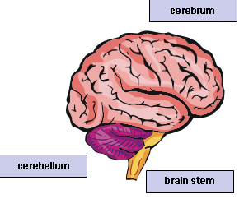

Figure 1 Parts of Brain (The Human Brain | Parts of the Brain | The Nervous System | Brain Disorders, no date)

### Brain Commands

When brain receives some message from body or sends any message to the body, it is sent through a network of cells (neurons) in form of electric current. Voltage of this electric current is so small that cannot be felt but can be detected.

## Movement of Objects through Brain

As discussed earlier different parts of brain are responsible for different functions in which cerebrum controls movement. “Different parts of the cerebrum are responsible for moving different body parts. The left side of the brain controls the movements of the right side of the body, and the right side of the brain controls the movements of the left side of the body.”(Brain and Nervous System, no date) As movement of organs is controlled by brain we can also control movement of different mechanical objects through brain commands using waves or signals generated by cells of brain.

## Controlling Movement of Objects through Brain

Beside other research topics “Controlling movement of objects through brain commands” is also a vast topic for research. A lot of research has been done and is going on as well in this regard. (Ferreira *et al.*, 2007) A robotic wheel chair was moved using HMI (Human Machine Interface). At Florida University people flew drones while controlling them with brain.(Mind-controlled drones race to the future - Powering the New Engineer, no date). Similarly a hex bug was controlled with brain waves.(EEG Hacker: Controlling a Hex Bug with my Brain Waves, no date)

## Usage of Controlling Objects through Brain

Handicapped people are those who are paralyzed or have movement disorders. These people face difficulty in doing simple tasks in their daily life. They need alternate ways for movement and control in order to perform daily life duties. To help these people a lot of work has been done. “Brain Computer Interface” is this type of work.

## Communication with Human Brain

We know that a brain sends messages or receive message in form of electric current then how we can communicate with the brain if we want to send any message or receive any message.

One way of communication with human brain is through EEG devices. EEG device is consists of electrodes which record brain signals from scalp in form of electric current. “EEG activity recorded at the scalp consists of voltage changes of tens of microvolts at frequencies ranging from below 1 Hz to about 50 Hz.”(Wolpaw, McFarland and Vaughan, 2000)

## Research Problem

Previously a single object is moved by brain commands. This includes (Mind-controlled drones race to the future - Powering the New Engineer, no date) world’s first race between mind controlled drones in university of Florida. (Ferreira *et al.*, 2007)A robotic wheel chair was moved through brain signals and some other.

If a single object can be moved through EEG devices why not multiple objects? What if a person who is handicapped is alone at home and needs to operate different things in the house? Will he use that many headsets as many things are there in the house? Can we control different objects through one EEG headset?

If a person is playing a strategy game can he control all the players through one EEG head set?

## Proposed Solution

Different Objects can be moved through one EEG headset if we can differentiate between those objects. As we already know how to control movements of an object through brain commands using EEG technology. Based on this previous knowledge we can build an “EEG Based Multiple Object Controller”. Obstacle in this is how we can differentiate multiple objects just by looking at them? i.e. if a person is wearing the headset and controlling the objects and the device gets a command of moving left, how will it differentiate that this command was for which object?

# Literature Review

## Brain Computer Interface

BCI (Abdulkader, Atia and Mostafa, 2015) Brain computer interface is a powerful tool for communication with human brain. This tool is used for getting signals from brain through the activity going in the neurons. (Abdulkader, Atia and Mostafa, 2015)Research in brain computer interfaces was initially developed for biomedical applications like restoring movement ability of physically challenged people. Those people who have movement disorders, physically challenged or has lost their ability faces a lot of problems in daily life. This tool was developed to facilitate those people. But later on this research was widened to nonmedical applications as well.

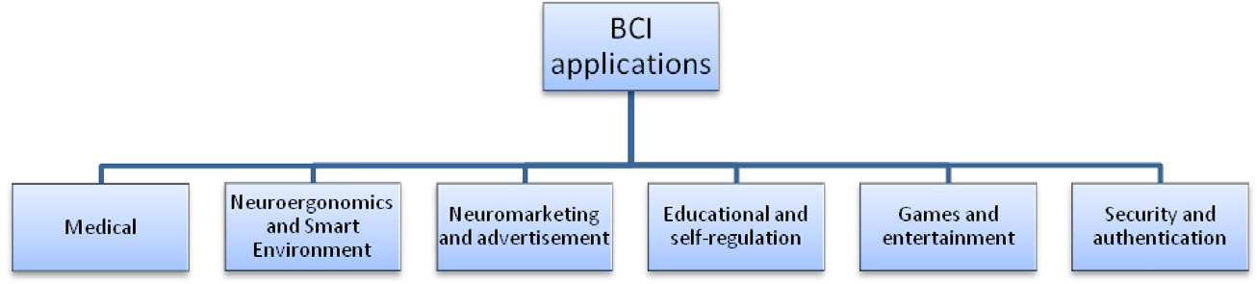

Figure 2 BCI Applications (Abdulkader, Atia and Mostafa, 2015)

### BCI Functions

Brain computer interface captures signals from brain going in single neuron activity and send them to the computer for processing. These signals are not only processed to facilitate physically challenged people but also works as tool that gets and uses information about one’s emotional and cognitive state.

### BCI Applications

As mentioned earlier, firstly BCI was developed only for medical application but later on it did not remained to medical applications but it also has applications in neuro-ergonomics, neuro-marketing, education, games, entertainment and security. (Figure 2) (Abdulkader, Atia and Mostafa, 2015) There are variety of applications of BCI in medical like prevention, detection, diagnosis, rehabilitation and restoration. BCI has also impact on smart houses, workplaces and transportation, referring to neuro-ergonomics. Similarly marketing has also interest in BCI becoming neuro-marketing. “Neuro-feedback is a promising approach for enhancing brain performance via targeting human brain activity modulation”(Abdulkader, Atia and Mostafa, 2015) Like all above fields entertainment, gaming and security has also developed interest in BCI.

## EEG Based Brain Computer Interfaces

### EEG

EEG stands for electroencephalography. (EEG (Electroencephalogram): Purpose, Procedure, and Risks, no date)It is a test that records electric signals of the brain. EEG records brain waves through small metallic discs called electrodes. These electrodes capture electric impulse and send these signals to computer.

### BCI Based on EEG

(Saddique and Siddiqui, 2009)A brain computer interface was developed, which get brain signals through EEG electrodes process them and gets results from them.

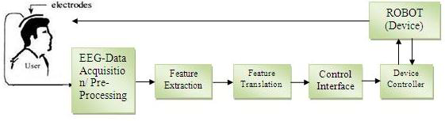

Figure 3 EEG Based BCI

## Brain Computer Interfaces for Movement of Objects

(Saddique and Siddiqui, 2009)“Mind control” generally regarded scary but recent achievements in the field of “Brain Machine Interfacing” redefined its meaning. Need of BMI was strongly felt for those people, who cannot communicate to the outside world because of their disabilities but later this also widened to those people as well who are not physically challenged.

Some achievements in the field of “moving objects through BCI” are:

* Automated wheel chair
* Cursor control
* Mind controlled robotic arm
* Mind controlled robot
* Semi-autonomous car
* Brain drone race

### Automated Wheel Chair

(Brain-Controlled Wheelchair: 10 Steps (with Pictures), no date; Galán *et al.*, 2008)Handicapped people cannot move like normal people because of this they are unable to do even small things in daily life. What could be better than a wheel chair controlled by brain? A person with mobility disorders moving without any attendant. To facilitate these people, many others are working on brain computer interfaces to develop brain controlled wheel chair. These sorts of wheel chairs are developed by BCI using wheel chairs, EEG electrodes, Arduino and computers. (Figure 4)

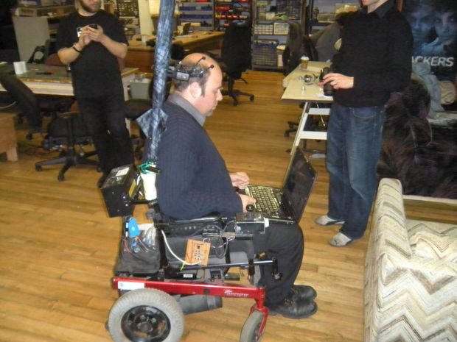

Figure 4

### Cursor Control

Mind controlled cursor had made it easier for disabled persons to type and click much easier. “[A new method being tested by Stanford researchers](http://news.stanford.edu/news/2015/july/brain-control-prosthesis-073115.html) taps directly into the brain, allowing a cursor to be controlled on a screen without moving a single muscle”(Mind-Controlled Cursor Could Allow Disabled to Type and Click With Ease - NBC News, no date)

### Mind Controlled Robotic Arm

“A variety of BCI systems have been described in the literature mostly differing in the requested mental strategy and in the type of brain signal used for classiﬁcation.”(Hazrati and Erfanian, 2010) One of which is robotic arm. Some research regarding a robotic arm has also been done. “The hand, developed by US scientists, was surgically wired directly to Copeland’s brain, providing him with a two-way electrical feedback. Despite the signals coming from a robotic hand, Copeland said the sensation of having his fingers touched was “almost natural”.(Flesher *et al.*, 2016) (Figure 5)

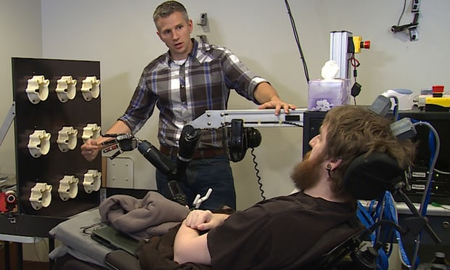

Figure 5

### Mind Controlled Robot

(Ramesh, Krishna and Nakirekanti, 2014)Work on moving a robot through brain commands has also been done. “A team from MIT’s Computer Science and Artificial Intelligence Laboratory (CSAIL) and Boston University is working on this problem, creating a feedback system that lets people correct robot mistakes instantly with nothing more than their brains.” (Brain-controlled robots | MIT News, no date) (Figure 6)

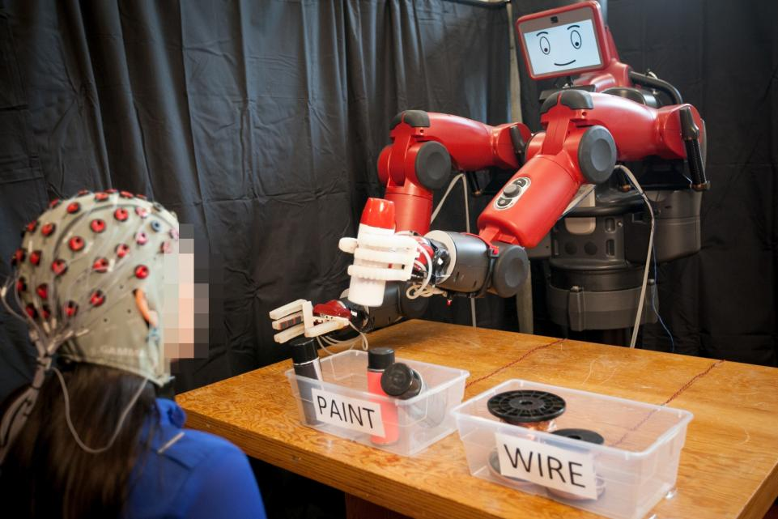

Figure 6

### Semi-Autonomous Car

A car not driven by driver manually but controlled by driver’s brain is not a dream but a reality because of the brain computer interfaces this idea got a life. Many people trying to automate a car by using BCI. Know “human controls a car just by using brain signals, i.e., without need for any physical interaction with the car.”(Göhring *et al.*, 2013) Similarly in China “Chinese engineers from [Nankai University in Tianjin](http://english.nankai.edu.cn/) have developed a system that can read brain signals and control a car accordingly.”(Mind-controlled car unveiled in China - Telegraph, no date)

### Brain Drone Race

(Mind-controlled drones race to the future - Powering the New Engineer, no date)At university of Florida world’s first brain controlled drone race was held where 16 pilots drove drones through 10 yards basketball court with their will power.(Figure 7)

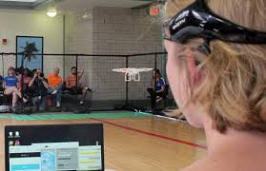

Figure 7

# Requirements and Analysis

# Prototype Description

Prototype consists of an interface with objects (more than one). These objects could be any shape.

# Conclusion

# Bibliography

Abdulkader, S. N., Atia, A. and Mostafa, M. S. M. (2015) ‘Brain computer interfacing: Applications and challenges’, *Egyptian Informatics Journal*. Ministry of Higher Education and Scientific Research, 16(2), pp. 213–230. doi: 10.1016/j.eij.2015.06.002.

Bailey, R. (2013) ‘Anatomy of the Brain - Cerebrum’, *About.com*, pp. 1–6. doi: 10.1288/00005537-191506000-00025.

*Brain-controlled robots | MIT News* (no date). Available at: http://news.mit.edu/2017/brain-controlled-robots-0306 (Accessed: 29 December 2017).

*Brain-Controlled Wheelchair: 10 Steps (with Pictures)* (no date). Available at: http://www.instructables.com/id/Brain-Controlled-Wheelchair/ (Accessed: 29 December 2017).

*Brain and Nervous System* (no date). Available at: http://kidshealth.org/en/teens/brain-nervous-system.html# (Accessed: 28 December 2017).

*EEG (Electroencephalogram): Purpose, Procedure, and Risks* (no date). Available at: https://www.healthline.com/health/eeg (Accessed: 29 December 2017).

*EEG Hacker: Controlling a Hex Bug with my Brain Waves* (no date). Available at: http://eeghacker.blogspot.com/2014/06/controlling-hex-bug-with-my-brain-waves.html (Accessed: 28 December 2017).

Ferreira, A. *et al.* (2007) ‘Human-machine interface based on muscular and brain signals applied to a robotic wheelchair’, *Journal of Physics: Conference Series*, 90(1). doi: 10.1088/1742-6596/90/1/012094.

Flesher, S. N. *et al.* (2016) ‘Intracortical microstimulation of human somatosensory cortex’, *Science Translational Medicine*, 8(361), p. 361ra141-361ra141. doi: 10.1126/scitranslmed.aaf8083.

Galán, F. *et al.* (2008) ‘A brain-actuated wheelchair: Asynchronous and non-invasive Brain-computer interfaces for continuous control of robots’, *Clinical Neurophysiology*, 119(9), pp. 2159–2169. doi: 10.1016/j.clinph.2008.06.001.

Göhring, D. *et al.* (2013) ‘Semi-autonomous Car Control Using Brain Computer Interfaces’, *Intelligent Autonomous Systems …*. Available at: http://link.springer.com/chapter/10.1007/978-3-642-33932-5_37.

Hazrati, M. K. and Erfanian, A. (2010) ‘An online EEG-based brain-computer interface for controlling hand grasp using an adaptive probabilistic neural network’, *Medical Engineering and Physics*. Institute of Physics and Engineering in Medicine, 32(7), pp. 730–739. doi: 10.1016/j.medengphy.2010.04.016.

*Mind-controlled car unveiled in China - Telegraph* (no date). Available at: http://www.telegraph.co.uk/technology/news/12040216/Mind-controlled-cars-unveiled-in-China.html (Accessed: 29 December 2017).

*Mind-Controlled Cursor Could Allow Disabled to Type and Click With Ease - NBC News* (no date). Available at: https://www.nbcnews.com/tech/innovation/mind-controlled-cursor-could-allow-disabled-type-click-ease-n401911 (Accessed: 29 December 2017).

*Mind-controlled drones race to the future - Powering the New Engineer* (no date). Available at: https://www.eng.ufl.edu/newengineer/news/mind-controlled-drones-race-to-the-future/ (Accessed: 28 December 2017).

Ramesh, S., Krishna, M. G. and Nakirekanti, M. (2014) ‘Brain Computer Interface System for Mind Controlled Robot using Bluetooth’, *International Journa of Computer Application*, 104(15), pp. 20–23.

Saddique, S. M. and Siddiqui, L. H. (2009) ‘EEG based brain computer interface’, *Journal of Software*, 4(6), pp. 550–554. doi: 10.4304/jsw.4.6.550-554.

*The Human Brain | Parts of the Brain | The Nervous System | Brain Disorders* (no date). Available at: http://www.english-online.at/biology/human-brain/parts-and-functions-of-the-brain.htm (Accessed: 29 December 2017).

Wolpaw, J. R., McFarland, D. J. and Vaughan, T. M. (2000) ‘Brain-computer interface research at the Wadsworth Center’, *IEEE Transactions on Rehabilitation Engineering*, 8(2), pp. 222–226. doi: 10.1109/86.847823.