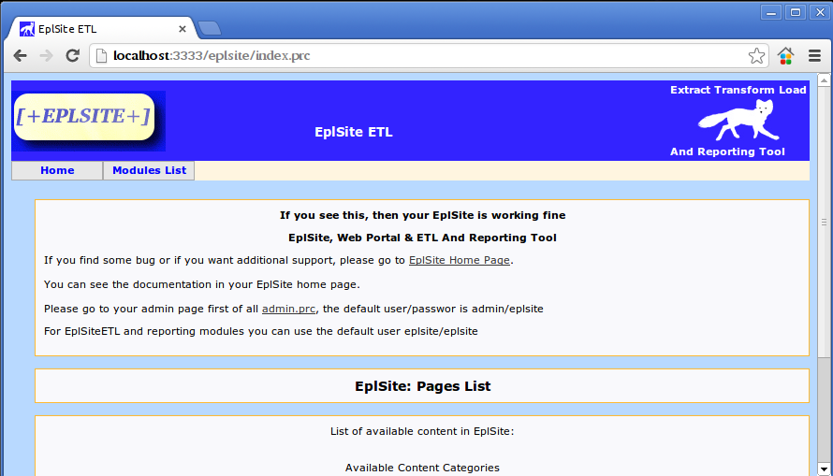
Creating a data a basic transformation step by step:
From the main screen go to admin page clicking on

Enter user and password admin/eplsite and click Login:
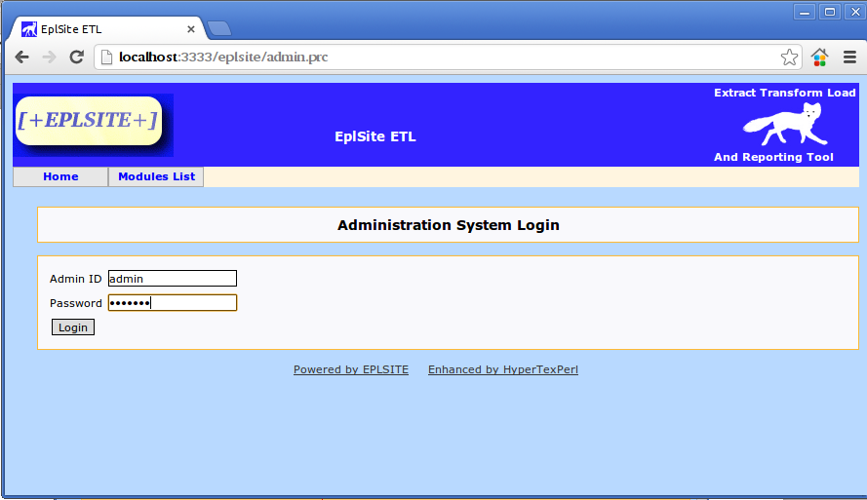
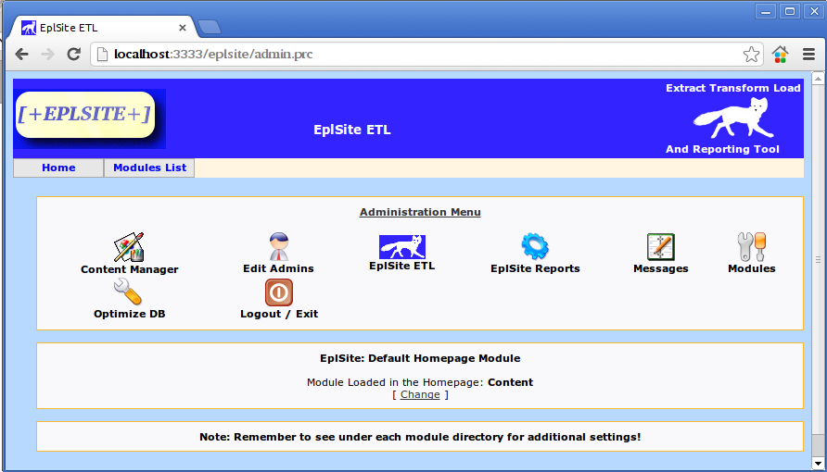
Click on EplSite ETL to go to administration screen of EplSite ETL.

Click on Database Connections

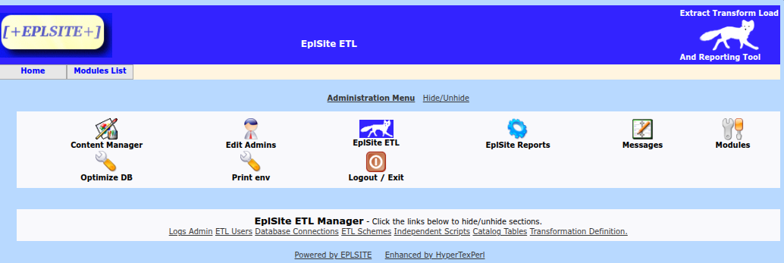

Create your database connections for source and target dbs, remember that the subroutine name must be the same than the connection name.
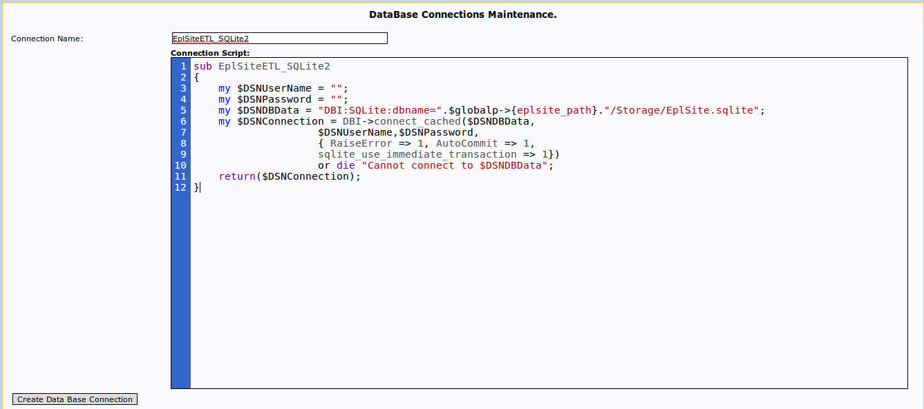
Note. After creating your Database connection, you can test it, by selecting the Database Connection, then entering a table name that exists in the Database, then click “Test DB Connection” button.
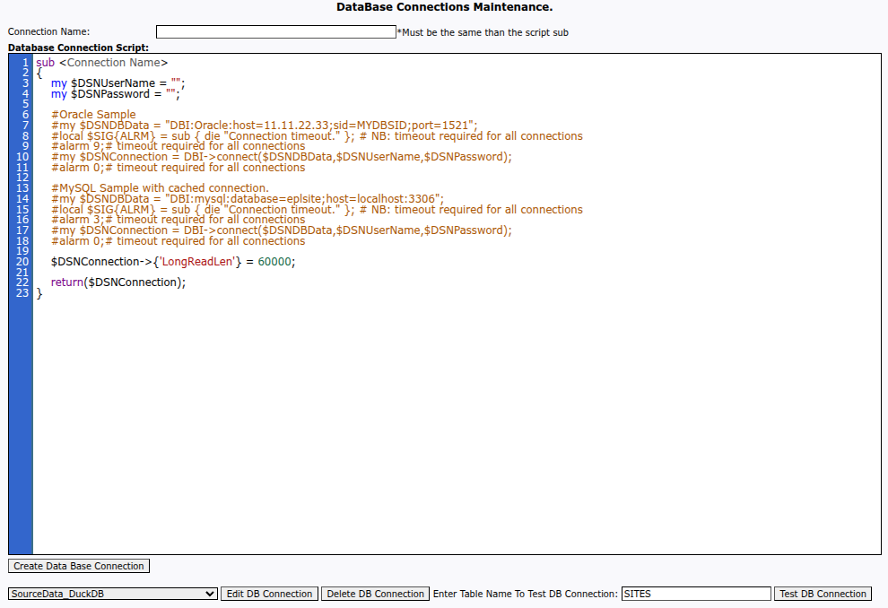

Additionally, to test your Database connection, you can go to “ EplSite ETL Module” => EplSite SQL Query Tool(it is recommended to open a new tab or window):
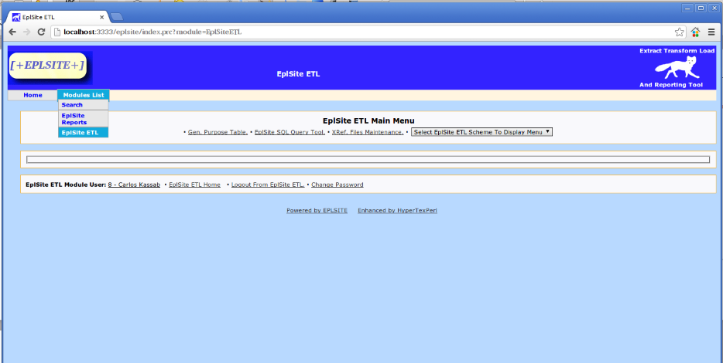

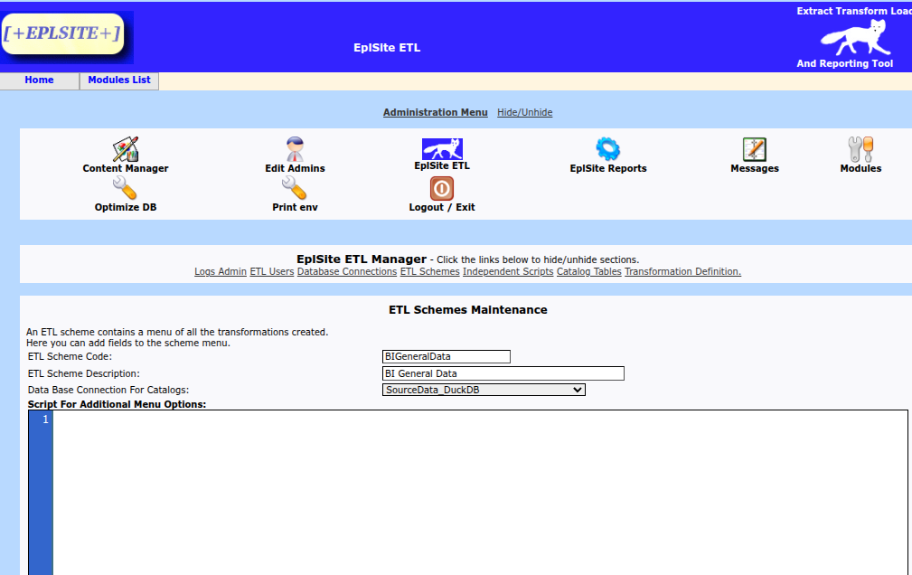
Next step to create the transformation: Click on “ETL Schemes” on the admin menu.
An ETL Scheme is like a container for ETL scripts.
In the sample above you can see the container for BI General Data.

Enter the Scheme Code and description, select the database connection where your catalogs for validation will be, here we will use the same database connection we just created.
You can delete the Script For Additional Menu Option if not using any additional variable in your menu.
=> For testing purpose, it is recommended to delete the field “Script For Additional Menu Options” , and “Script For Additional Menu Validation When Executing Layouts”, click “Add ETL Scheme” button

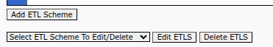
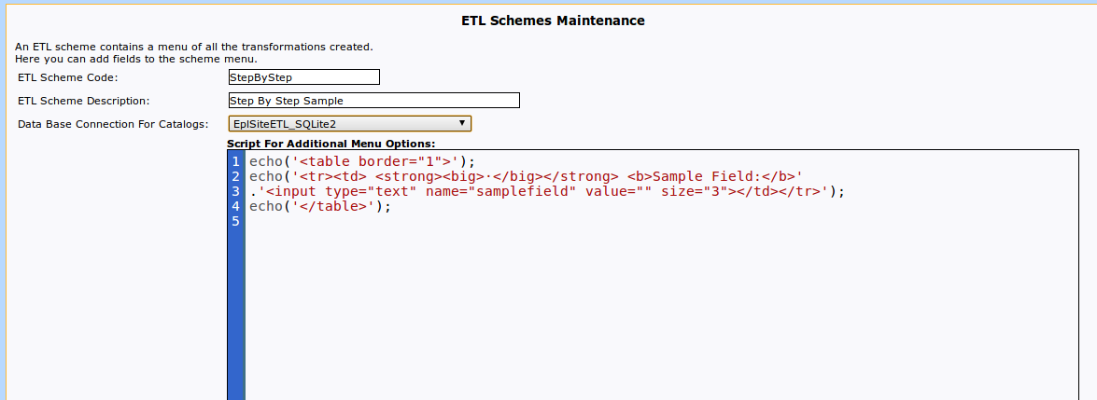
Click on add etl scheme and you will have a new etl scheme, it is like a container for scripts.

We are using sqlite so if we run this query(select * from sqlite_master) on the new connection EplSiteETL_SQLite2 we will have all the tables in our database:
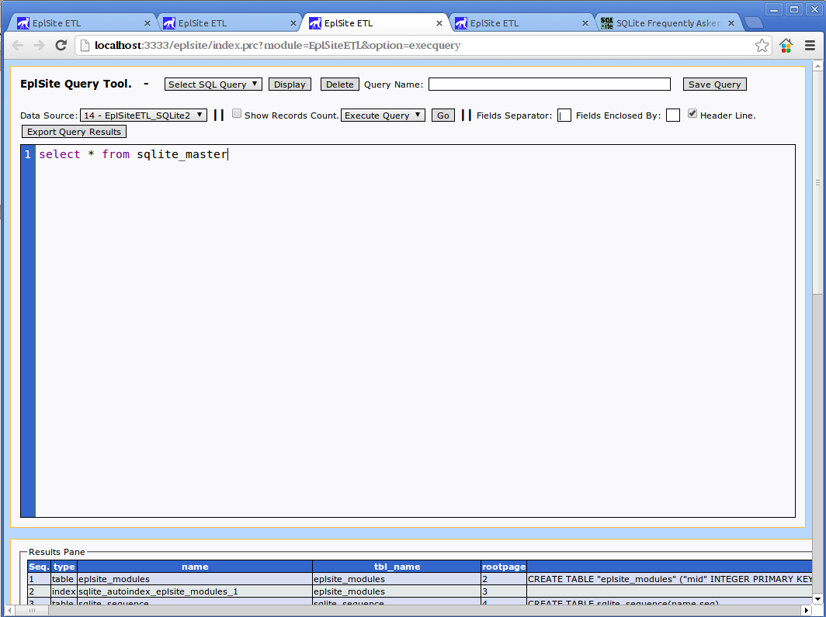
we can see we have eplsite_modules table, we are going to extract data from this table and export it to a file, we could import it into GENERAL_DATA table, this general_data table is a table included in eplsite etl which contains 100 fields so, it can be used to import almost any kind of data and if you do not have too much data, it will be very useful for your data transformations.

So, going back to the admin panel, we must scroll down until Data Transformation Definitions Maintenance. And continue the process:

Enter the main data in the form:

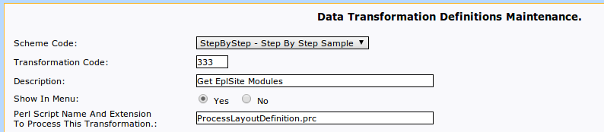
Now go down until field: Perl Script To Build The Query For The Layout, this is the query to get the data:

and enter the script to get the data:

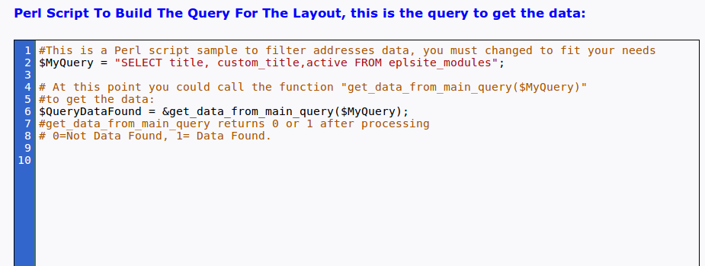

Now in the next field(Script Before Process Transformation To The Data From Query), leave as showed:
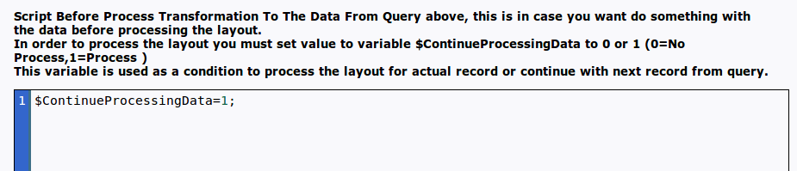
Scroll down until the button <<Create Data Transformation Definition>> and click on it.

Now go to EplSite ETL menu, we need to set where each field will go in output:
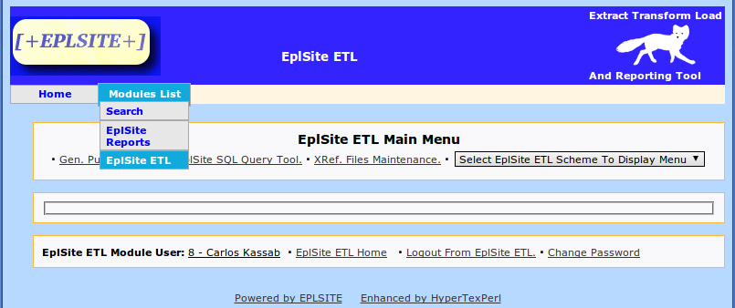
From the main menu, select your new etl scheme from the combo box and you will see the screen below:

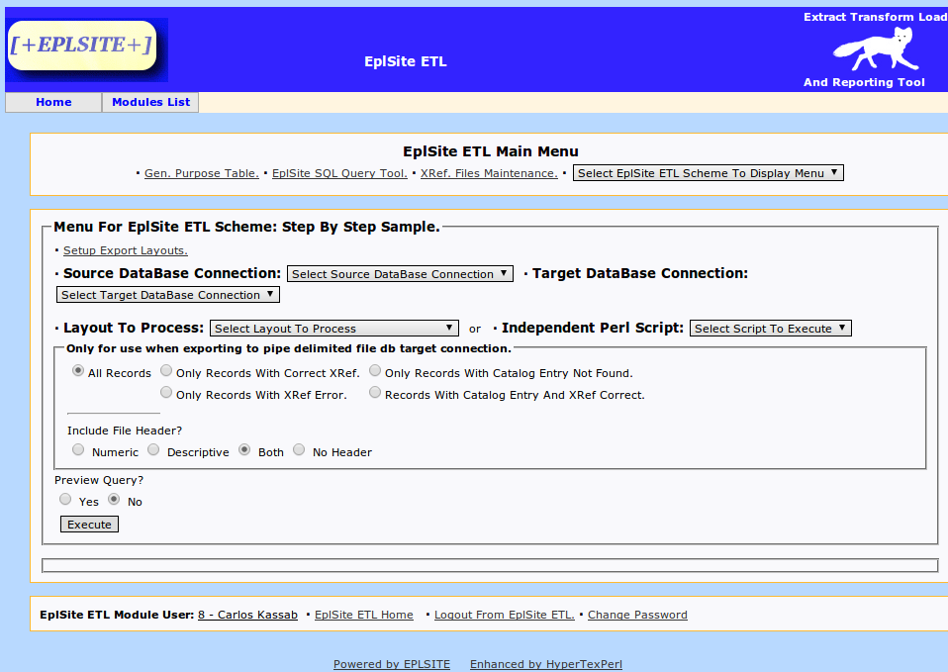
Now click on Setup Export Layouts and you will see the next screen:
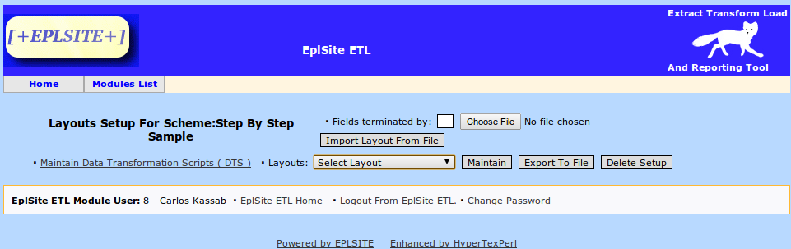
Now select your new layout from the combo box, click on maintain and create your layout:
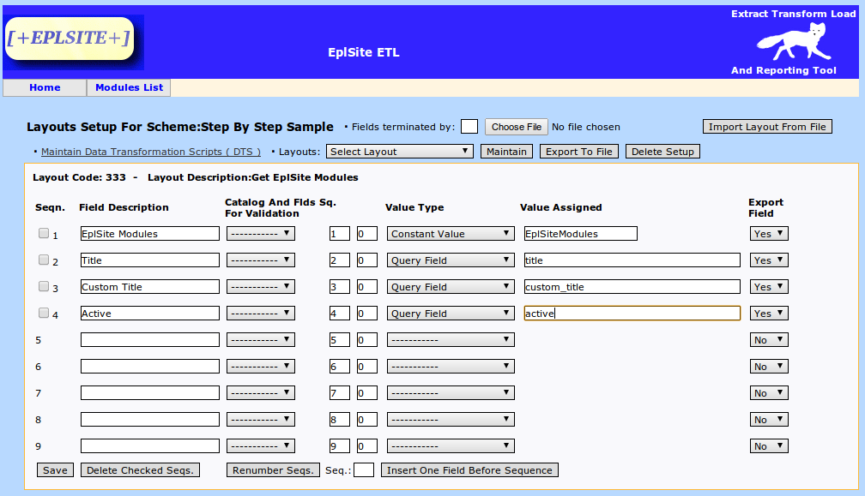
Note, you can see that we are using Query Field, this is the name of the query variable or the alias if you are using “as” in your query.

Now just click Save and that's it, we are done with our first data transformation.

Go back to the main menu of your scheme and reload it selecting it again from the combo box to run the data transformation recently created:

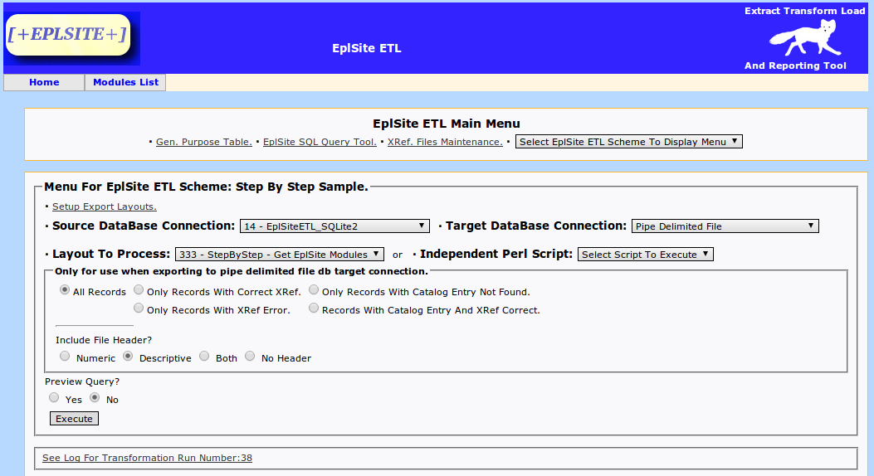
Now, select the next field:
Source database connection, that we just created
Target database connection, select pipe delimited file
Layout to process, select the layout code we just created.
For the other form fields, just leave them as shown in the screen above.

Click Execute Button.

The transformation will be executed, here is a screen shot:
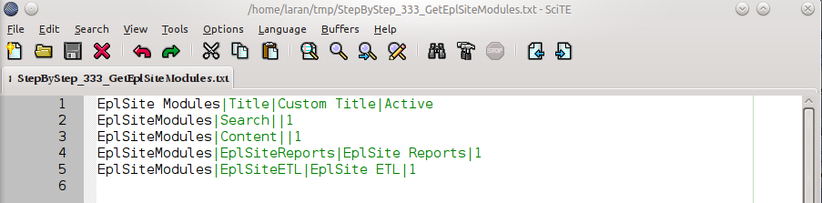

You also can see the transformation log if you click on the link showed below:

