Open Reporting System.

What is it?.

It is an easy way to get your own good looking reports with output comming directly from ERP LN report sessions as file downloads in Excel xlsx or PDF format.

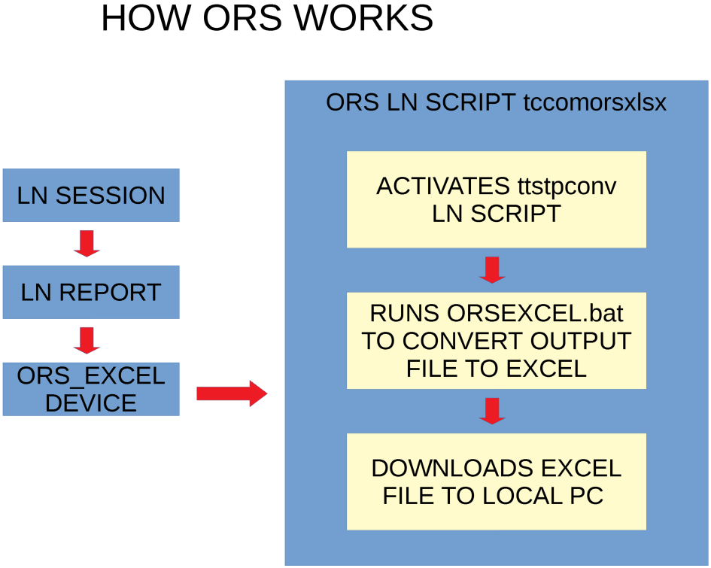

ORS INSTALL

Prerequisites:

- PowerShell( https://docs.microsoft.com/en-us/powershell/ )
- ERP LN Windows Server
- VisualStudio Code IDE ( https://code.visualstudio.com ), For development machine.
- wkhtmltopdf ( https://wkhtmltopdf.org/index.html )

Notes:
- Powershell must be at least version 5.
- Check PowerShell on the server and the development machine are the same versions.
To check Powershell version open a PowerShell console and run: $PSVersionTable.PSVersion

Reports with Excel Output:

Install PowerShell ImportExcel Module:

- Open PowerShell Console as administrator
- Run this command: Find-Module ImportExcel | Install-Module

If when running this command, PowerShell asks to install nuget provider, answer yes → Y
It also may say that you are installing from untrusted repositories, answer yes to install the module.

Download OpenReportingSystem as a zip file from github: https://github.com/LaranIkal/OpenReportingSystem

Whe opening the zip file, there is a main folder: OpenReportingSystem-master

Open OpenReportingSystem-master folder and copy folder OpenReportingSystem to your root c:\

Now you have installed Open Reporting System. Follow the next steps.

For any help, you can reach me at my email in the header of this document or in baan board:

Login to LN, navigate to Tools→Application Development → Program Scripts / Libraries, start session Program Scripts / Libraries and create the next library:
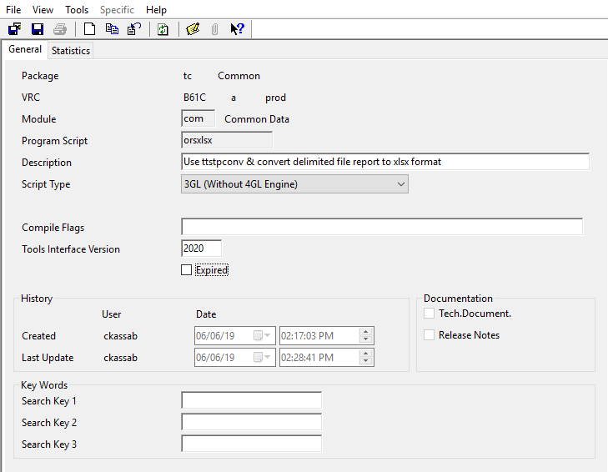
Tools interface version depends on your tools version.

Copy the below the script source code, save and compile your library:

|******************************************************************************
|* Title : tccomorsxlsx - ttstpconv report output delimited file to xlsx Excel format
|* Author : Carlos Kassab
|* Date : June,06,2019
|******************************************************************************
|* Script Type : 3GL
|****************************** DECLARATION SECTION ***************************

extern domain tcmcs.str132 program_name
extern domain tcmcs.str132 prog_arguments
string tmp.file1(1024), tmp.xlsx.file1(1024) | Temporary file names.
string tmp.file_r(1024)
string local.path(1024) | Client Location for report.
string file_to_email(1024)
string start(1024) | Start command
string application(132) | Application to start.
long app_id | Application id.
string device.parameters(50)

extern domain tcmcs.long retval
extern domain tcmcs.long fileid1
extern domain tcmcs.long err
extern string monthnum(2),daynum(2) |Actual date
extern long utc.func.ret, ret
extern long _yearno, _monthno, _month_dayno, _hours, _minutes, _seconds

#pragma used dll ottdllbw
#pragma used dll ottdllhtml
#include <bic_desktop>

function main()
{
|For development and testing, use temporary file tmp.file1 on development machine.
tmp.file1 = creat.tmp.file$( bse.tmp.dir$() )
tmp.xlsx.file1 = tmp.file1 & ".xlsx" | This will be the final converted file name.

| Arguments description
|message("argument1:" & argv$(1)) | tmp file created from report output
|message("argument2:" & argv$(2)) | path to file in device setup
|message("argument3:" & argv$(3)) | arguments parameter in device setup
|message("argument4:" & argv$(4)) | This is wt value, still waiting to know description.
|message("argument5:" & argv$(5)) | at this time this value is comming empty

wait.and.activate( "ttstpconv", argv$(1), tmp.file1, argv$(3), argv$(4) )

| Running script to convert delimited file to xlsx format, file name in variable tmp.xlsx.file1
program_name = "/OpenReportingSystem/ExcelOutput/ORSEXCEL.bat"
prog_arguments = tmp.file1 & " " & tmp.xlsx.file1 & " " & spool.report
retval = run.prog( program_name, prog_arguments, RP_WAIT )

if job.process then
utc.func.ret = utc.to.date(utc.num(), _yearno, _monthno, _month_dayno, _hours, _minutes, _seconds)
monthnum = str$(_monthno)
if _monthno < 10 then
monthnum = "0" & str$(_monthno)
endif

daynum = str$(_month_dayno)

if _month_dayno < 10 then
daynum = "0" & str$(_month_dayno)
endif

file_to_email = bse.tmp.dir$() & "/" & spool.report & "_" & monthnum & daynum & str$(_yearno) & ".xlsx"
file.cp( tmp.xlsx.file1, file_to_email )

else

if tc.is.html.ui() then

client.download.file( tmp.xlsx.file1 )

else

local.path = "${BSE_TMP}/" & str$(utc.num()) & ".xlsx"

err = server2client( tmp.xlsx.file1, local.path, false, false,false )

if (err) then
message("Could not copy file to client")
else
application = "excel.exe"
start = application & " " & get.local.filename()
app_id = start.application.local(start,0,err)
endif

endif

endif

retval = seq.unlink(tmp.file1) |For development and testing, comment this line to avoid file deletion.
}

Create your printing device, login to LN and navigate to:
Tools → Device Management → Device Data run Device Data Session and add this device:

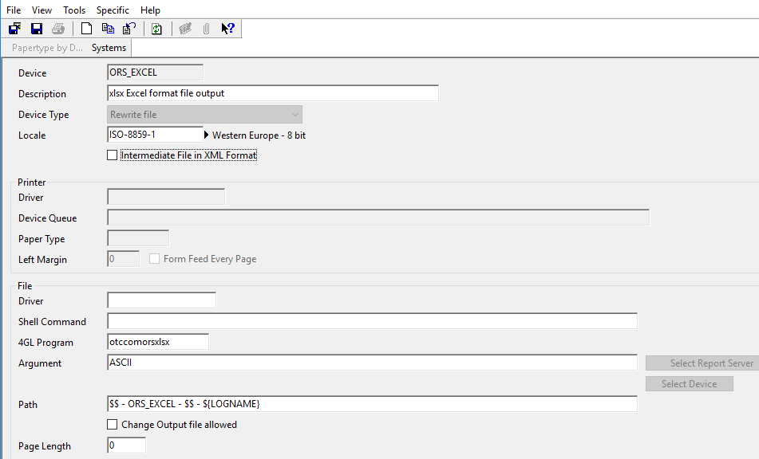

To test your new reporting system, create a query, name it tcsqlorssales with the next sql code:

select
tdsls400.orno, | Sales Order
tdsls400.odat, | Order Date
tdsls400.hdst, | Sales Order Status
tdsls400.ddat | Planned Delivery Date
from
tdsls400 | Sales Orders
where
tdsls400.hdst = tdsls.hdst.in.process

Once the report has been generated,go to maintain reports and find your new query report:
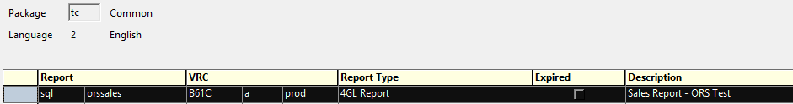

Right click on the report name and edit the layout header, it should be like this:
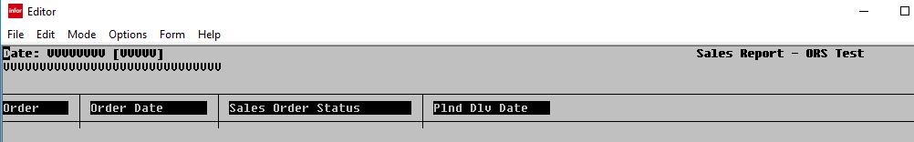

Delete all header lines but keep header column descriptions, it must be like this after your deletion:
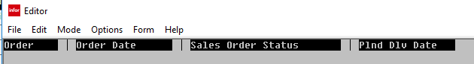
Note. You must also resize the header to keep just the column descriptions line.

If you edit Header and Detail layouts, they must look like this:
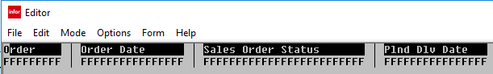

Here we are creating the header and detail for our delimited file.
Save, exit and compile your report.
Run your sql query and use the new device: ORS_EXCEL, you must have an output like this:
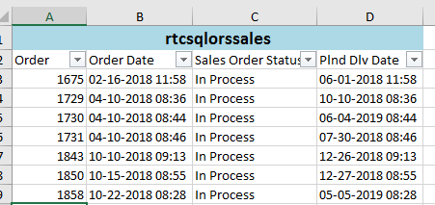

All sources and documentation can be found on github: https://github.com/LaranIkal/OpenReportingSystem

