ANALYTICS REQUIREMENT DEFINITION

Revision | Author | Date | Comments
1.0 | Carlos Kassab | 2018-04-19
1.1

Requirement Subject: | BitCoin Crypto Market Prediction For Next 3 Days

Contents
1Project Introduction. 2
1.1Brief Description. 2
1.2Project Scope. 2
1.3Company Benefits. 2
2Input Data Description 2
2.1Input Data Grid Sample. 2
2.2How to Get Input Data 2
2.3Variables Description 2
3Deliverables Description 2
4Special Considerations. 2

Project Introduction.

Brief Description.
Predict Bitcoin crypto market numbers( open, high, low, close, volume, market, close_ratio, spread ) for next 3 days.

Project Scope.
Functional area: Finance
- Global

Company Benefits.
We will be able to plan our investment in Bitcoins.

Input Data Description

Input Data Grid Sample.

How to Get Input Data
Go to this link: https://www.kaggle.com/vivekchamp/bitcoin/data

And download the csv file.

Variables Description

Deliverables Description
- Chart showing daily predicted quantities for the next 3 days.
- See sample chart in the next page.

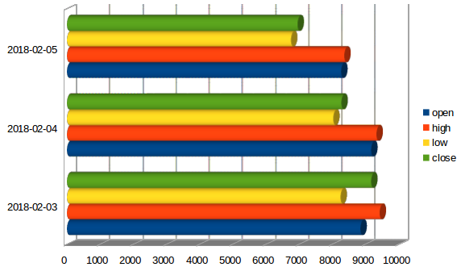

Special Considerations.
- Prediction Script execution frequency: daily basis at 03:00 AM
- Data to keep: 5 years of data.

