**NAME:LAREB**

**ROLL NO: ARI-F23-0097 LAB 10 (LEET CODE)**

**TASK 1:** Given the root of a binary tree check whether it is a mirror of itself (ie. symmetric around its centre)

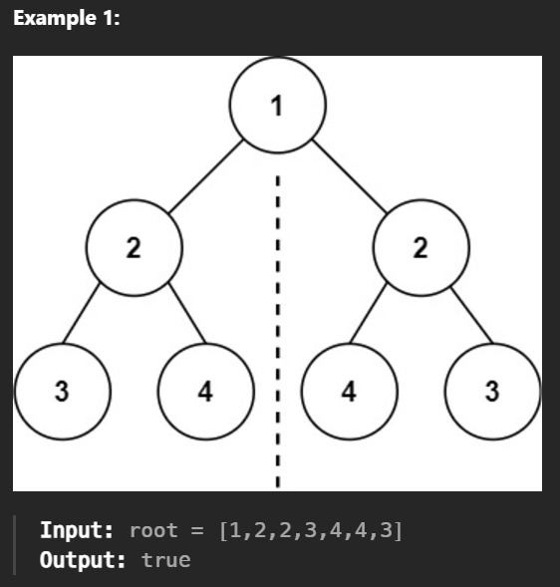

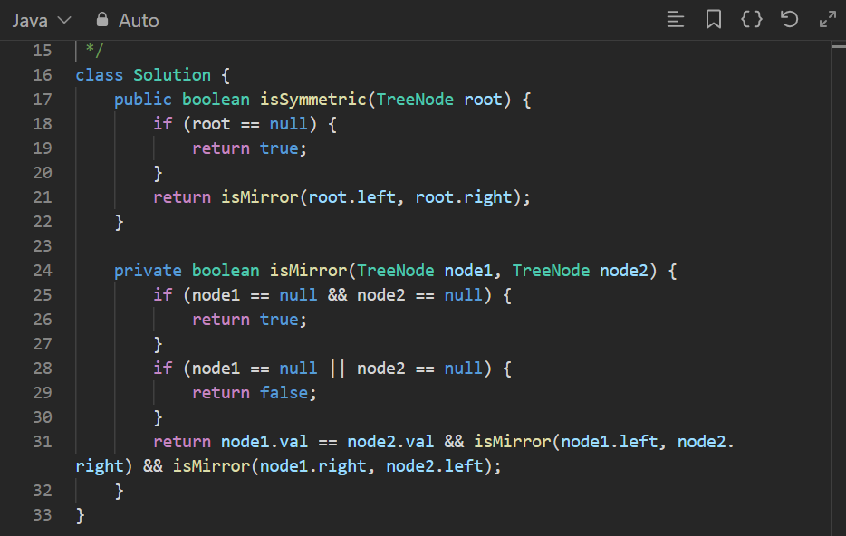

**OUTPUT:**

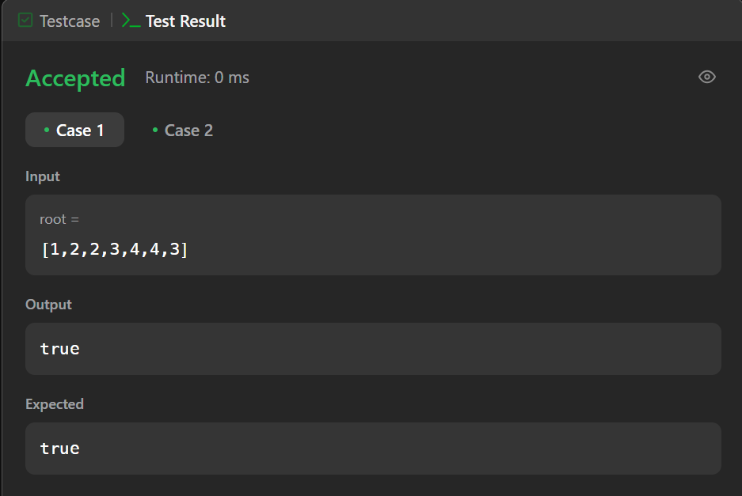

**TASK 2:** Given the root of a binary tree return its maximum depth

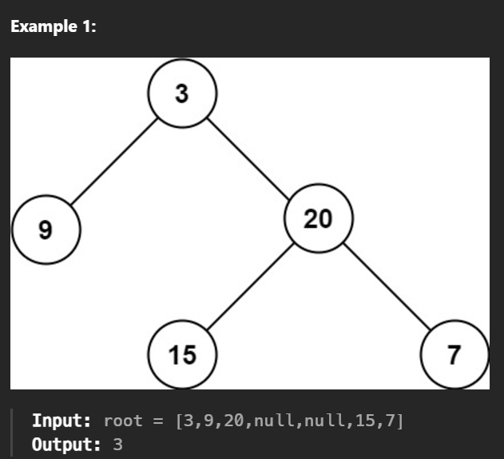

**CODE:**

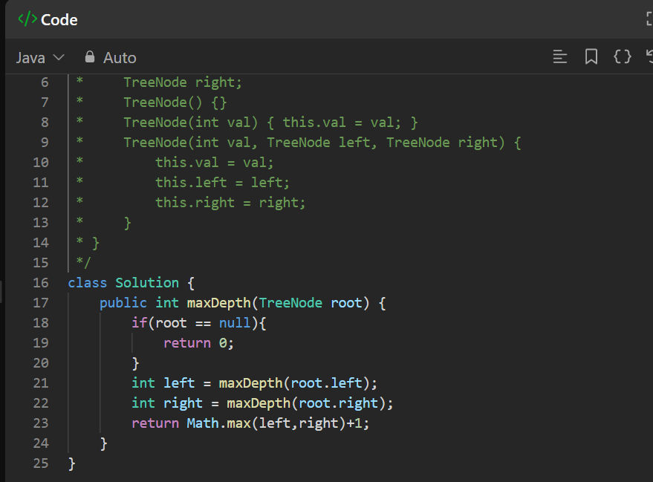

**OUTPUT:**

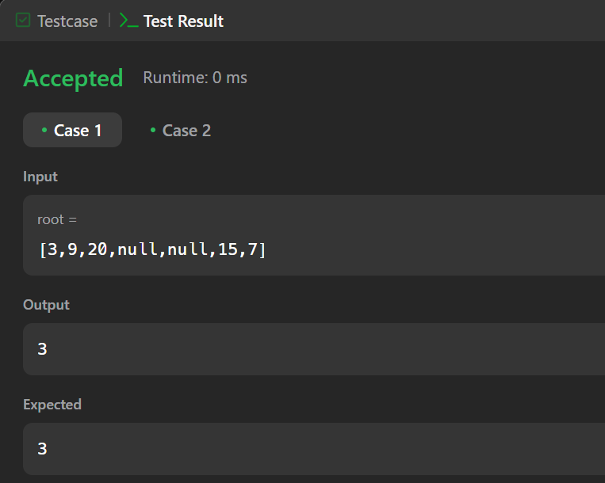

**TASK 3:** Given the root of a binary tree and an integer targetSum, return true if the tree has a root-to-leaf path such that adding up all the values along the path equals targetSum.

EXAMPLE:

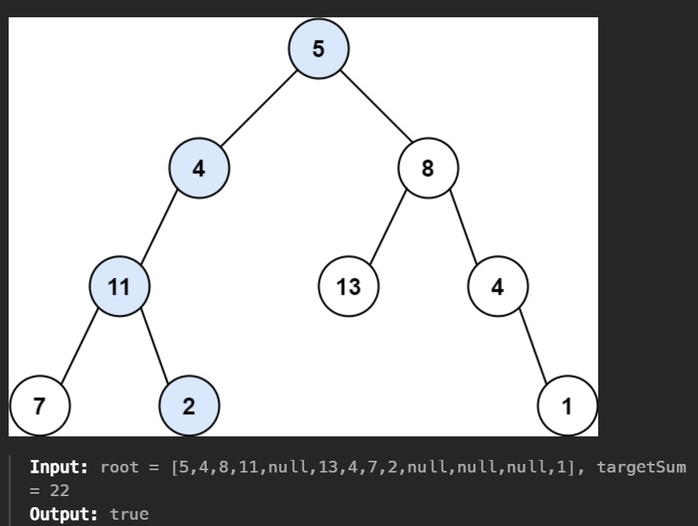

**CODE:**

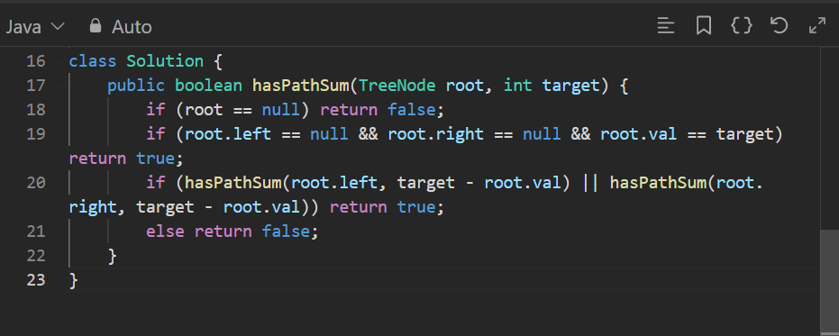

**OUTPUT:**

