- EdgeShard: Efficient LLM Inference via Collaborative Edge Computing
https://arxiv.org/html/2405.14371v1
Profiling: Analyze device computing power, model layer memory requirements, and network bandwidth.
Task scheduling optimization: Dynamic programming algorithm optimizes device selection and model sharding strategy.
Online collaborative reasoning: Supports sequential inference (low latency) and pipeline parallel inference (high throughput).
sharing activation values instead of KV-cache
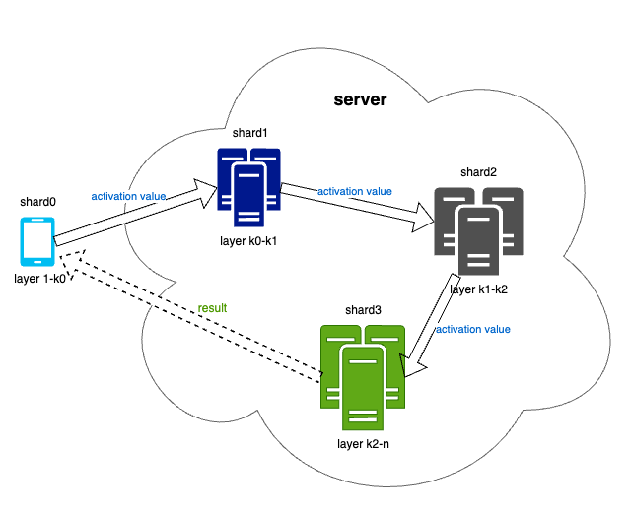
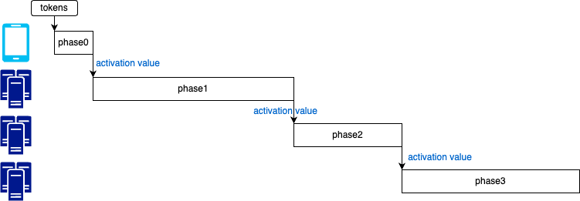

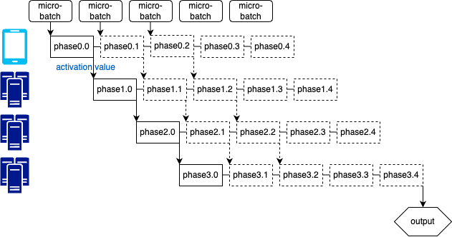
Reduce latency, increase throughput

- PRESERVE: Prefetching Model Weights and KV-Cache in Distributed LLM Serving
https://arxiv.org/abs/2501.08192
 | PRESERVE | EdgeShard
Sharding | Tensor, Attention Head | Layer-wise
KV Cache | Share | Local
Communication overhead | High | Low
Applicable scenarios | Strong homogeneity, complex single-layer calculation | Strong heterogeneity, large differences in computing load between layers
- Model Tells You Where to Merge: Adaptive KV Cache Merging for LLMs on Long-Context Tasks
https://arxiv.org/html/2407.08454v2
Quantization: Reduce storage through low-precision representation, but may introduce precision loss.
Eviction: Select important tokens based on attention scores and eliminate unimportant information, but may cause loss of key information in long-context tasks.
Merging: Merge multiple KV states into one, compressing memory while retaining as much information as possible.
KVMerger
Merging Set Identification: Treats KV cache merging as a ​constrained clustering problem. It identifies consecutive tokens with high cosine similarity (threshold ≥0.75) through ​backward traversal while preserving critical attention.
Gaussian Kernel Merging: Selects the token with the ​highest attention score in each merging set as the pivotal state. Merging is performed using Gaussian kernel-weighted aggregation (adaptive σ) to retain local semantic structures.
​Performance Advantages
​Long-Context Tasks: Under a 50% KV cache budget, KVMerger achieves average scores of ​35.02 (Llama2-7B) and ​35.79 (Mistral-7B), outperforming H2O and CaM
Retrieval Capability: Maintains >90% accuracy for contexts up to 4.5k tokens, significantly surpassing baseline methods
Robustness: Near-full-cache performance in multi-document QA tasks (e.g., triviaQA: 84.16 vs. 83.89 full cache)
Ablation Insights: Adaptive σ (σ=5) and attention-based pivotal state selection improve LongBench scores by ​2.08 points
- LLM as a System Service on Mobile Devices
https://arxiv.org/abs/2403.11805

