Cosgun Murat
Quentinsousaz Gatien



University of Franche-Comté

Licence 3 computer science

Web Project

2018-2019

Report of web project

DEZAIN PROJECT



Encadré par : Gros Jean-Philippe

Summary

1.Introduction
2.Diagram of features
3.Diagrams of classes
1.Introduction

The goal for this Advanced Web project is a multiplayer drawing game. The different players in a game must, in turn, make a drawing whose meaning must be guessed by the other players. The drawings to guess will be kanas (hiraganas or katakanas). Players will have to guess the corresponding syllable, as soon as possible. The syllable to be drawn, as well as the alphabet to be used, will be randomly selected by the application. The configuration of a part will allow to define the usable syllables as well as the maximum allowable response time and the number of rounds of play that will be included in a part. A score system will be calculated according to the speed of players to recognize the kanas offered. The player who draws will score points based on the number of correct answers that have been recorded for their drawing round.

2.Diagram of features

3,Diagrams of classes
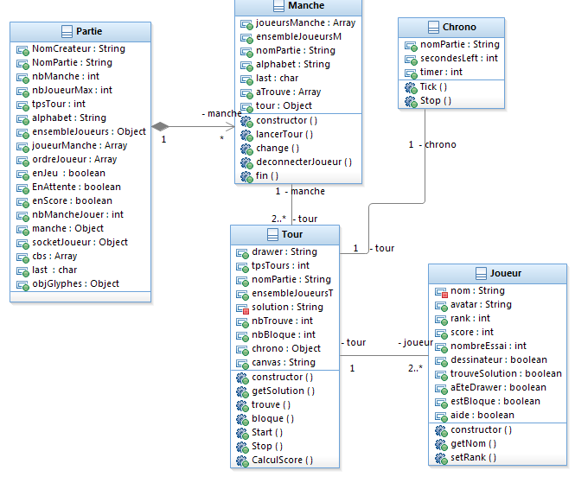Diagrams of classes of the DezainProject
First of all, the constructor of the class “Partie” takes for arguments “nomJoueur, nomPartie, nbManche, nbJoueurs, tpsTours, alphabet, css”, this constructor is initialized when a player choose to create a game that is normal because all this information are checked before a game start. But when a game is created we initialized the other value for example null value for “manche”,an empty array for “ensembleJoueurs” or a false value to “enJeu” because we are waiting for others players.

Secondly the function “ajoutJoueur()” is activated when a player join the actual created game, the variable nbJoueur is incremented and we add a new “Joueur” class to our set “EnsembleJoueur”. When a player disconnect we delete his class “Joueur” of our set “EnsembleJoueur” with the function “deconnecterJoueur”. “Jeu()” make the value of “EnJeu” true, “FinJeu()” make this value false. “EnJeu()” is a getter for “enJeu” and “getJoueursManche” as is name indicate it's for the value “joueursManche”. The getters are to simplify coding for us. “lancerManche()” increment the value of “nbMancheJouer” and start the round.

For the class “Manche” the constructor create a new round which initialized all the value in the class and start the function “lancerTour()” this function choose a drawer and this drawer have is variable “aEteDrawer” turned to true and now this drawer can't be drawer in the actual round. And in this function we call “change()” to choose three syllable with a defined alphabet with the options before the game start they are put in “aTrouve” array.

The function “deconnecterJoueur” manage the deconexion in the lap for not crash the game so the lap end and an another lap start. “fin” mark the end of the rounds and an another begin in 5 secondes if all the rounds aren't played yet.

In the class Tour, the constructor arguments it's the name of the game the drawer of the game and the array of syllables, the constructor initialized the timer, the canvas, the number of players which have found the answer and the player which used their three chance. Then the drawer choose a syllable that's display on the screen and the timer start.”trouve()” and “bloque” increment the value of “nbTrouve” and “nbBloque”. “Start()” start the lap with the chosen solution and start the timer.

“Stop” is called when the timer is finished and he calculating with the function “calculScore” the score and display this then restarts a new lap.

The function “CalculScore()” is calculating the score, // a finir

The constructor of the class “chrono” initialize the timer with the given option when the party was created. “Tick()” display the number of the seconds left and “stop()” stop the timer and restart it.
Last but not least the class player, the constructor initialize all the attributes, the boolean attributes to false the “NombreEssai” value as 3 and we keep his name and his avatar. The getter and setter are here too simplify coding.

Finally, we have chosen for one game you can have 0 or more round because if we create a game we don't have to create a round. For a round we must have two rounds because we need two peoples to play the game. And a lap can launch when two players are in the game and the timer is bind to the lap and each new lap we create new timer.

