USER MANUAL

Home
Here is a screenshot of the home screen. Users can access different pages through the navigation bar at the top.

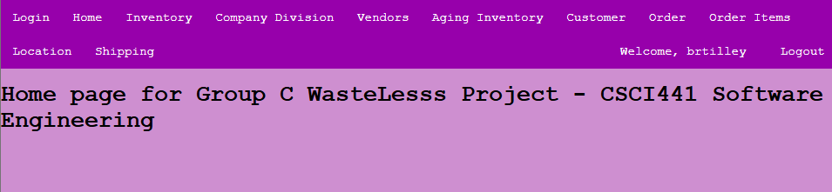

Navigation Bar
The navigation bar features multiple clickable pages for users.

Inventory
The inventory button in the navigation bar directs users to the inventory page.
On the inventory page, users can retrieve, create, update, and delete data from the inventory database. They can also receive and clear alerts. After inputting data into the Manage Inventory table, users can retrieve data by clicking Get Inventory, add data by clicking Add Product, update data by clicking Update Product, and delete data by clicking Delete Product. The data in the Manage Inventory table interacts with the API in the background to generate alerts. Users can view alerts by clicking Get Alerts, and they can clear the alerts by clicking Clear All Alerts.

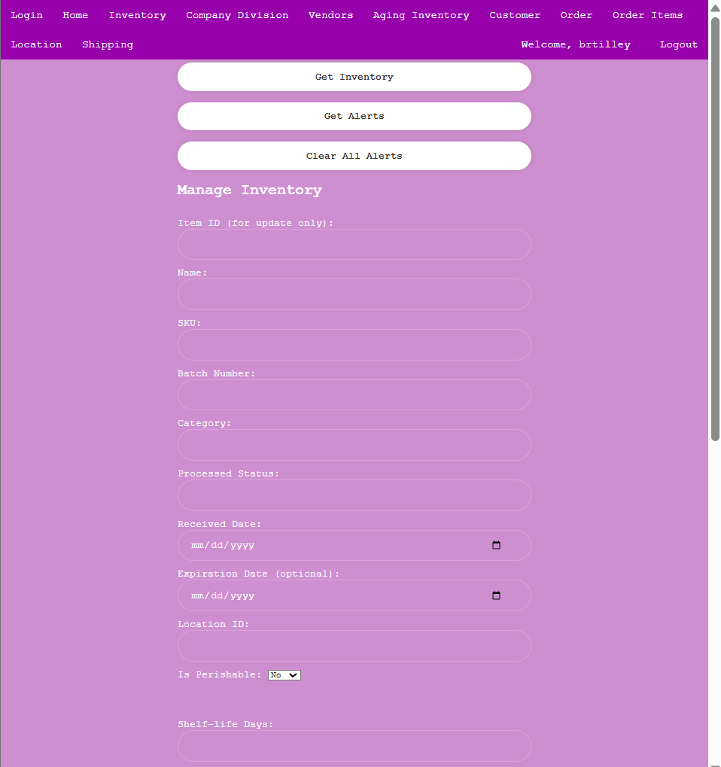
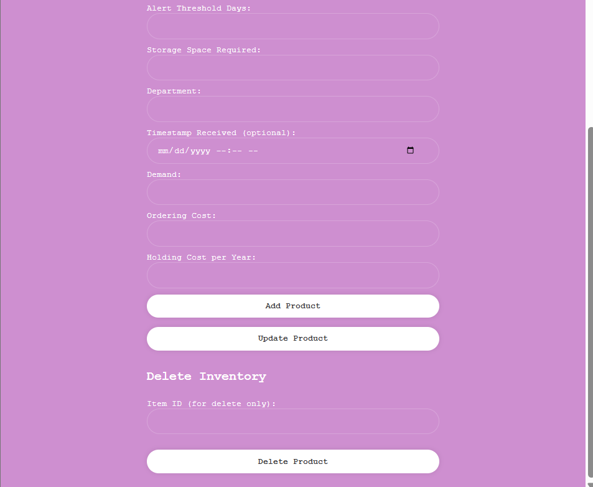

Company Division
The Company Division button in the navigation bar directs users to the company division page.
The company division page showcases the Company Divisions table, which contains comprehensive details about the divisions. Users can retrieve, create, update, and delete table entries. After entering data, users can access it by clicking Get Company Division, add new entries with Add Company Division, update existing information using Update Company Division, and remove entries by selecting Delete Company Division.

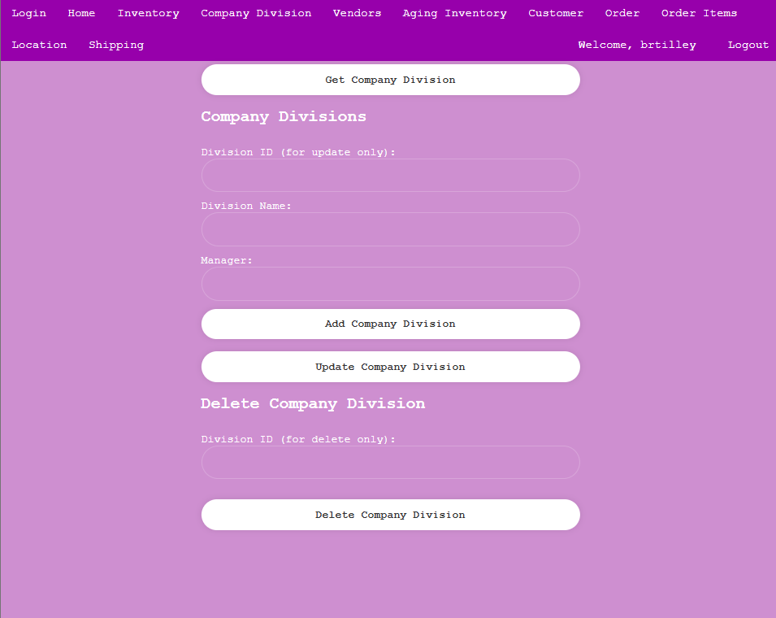

Vendors
The Vendors button in the navigation bar directs users to the vendors page.
The vendors page features the Manage Vendors table, which displays all available information about the vendors. Users can retrieve, create, update, and delete entries within the Manage Vendors table. After inputting data into the table, users can retrieve it by clicking Get Vendors, add new entries with Add Vendor, update existing data using Update Vendor, and remove entries by clicking Delete Vendor.
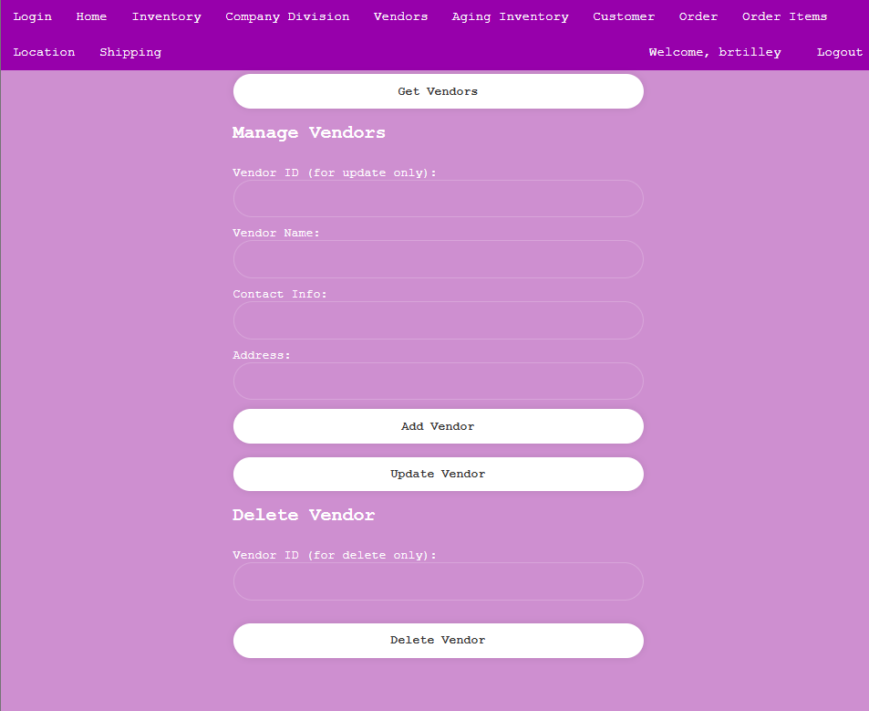

Aging Inventory
The Aging Inventory button in the navigation bar directs users to the aging inventory page.
The aging inventory page features the aging inventory table, which displays all available information about aged inventory. Users can retrieve, create, update, and delete entries within the aging inventory table. After inputting data into the table, users can retrieve it by clicking Get Aging Inventory, add new entries with Add Aging Inventory, update existing data using Update Aging Inventory, and remove entries by clicking Delete Aging Inventory.
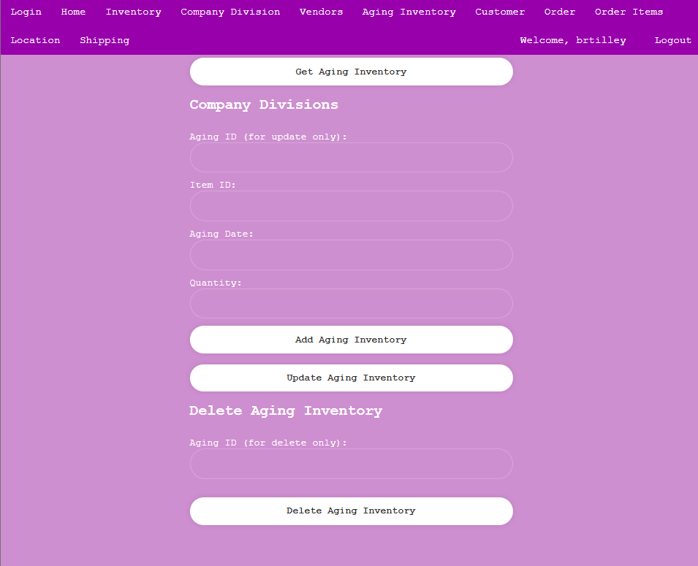
Customer
The Customer button in the navigation bar directs users to the customer page.
The customer page features the customer table, which displays all available information about customers. Users can retrieve, create, update, and delete entries within the customers table. After inputting data into the table, users can retrieve it by clicking Get Customer, add new entries with Add Customer, update existing data using Update Customer, and remove entries by clicking Delete Customer.
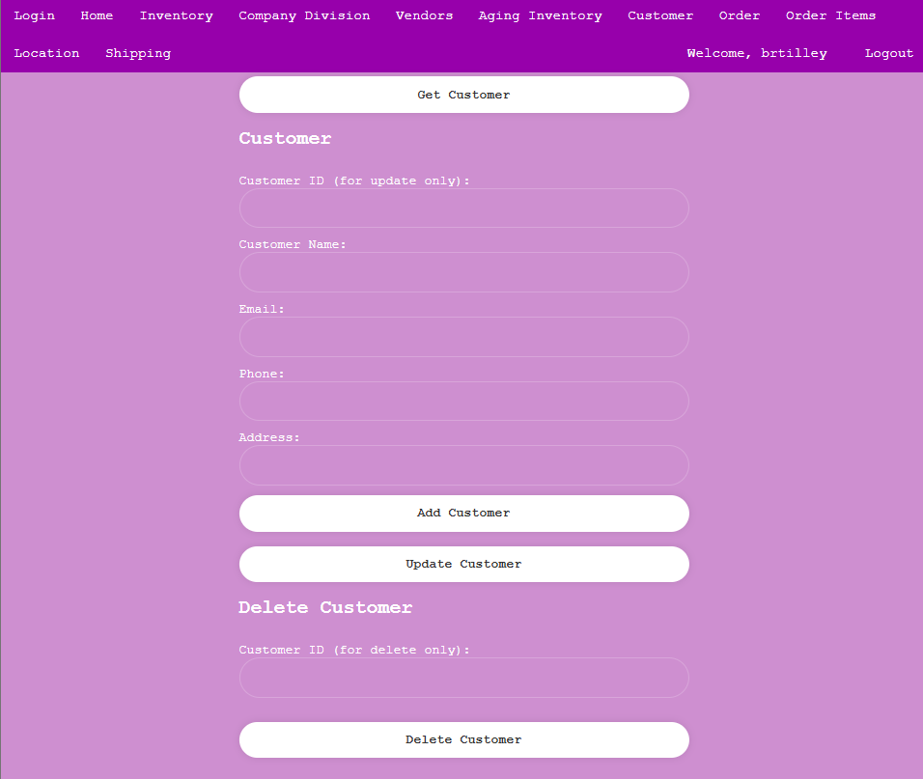
Order
The Order button in the navigation bar directs users to the order page.
The order page features the order table, which displays all available information about orders. Users can retrieve, create, update, and delete entries within the orders table. After inputting data into the table, users can retrieve it by clicking Get Order, add new entries with Add Order, update existing data using Update Order, and remove entries by clicking Delete Order.
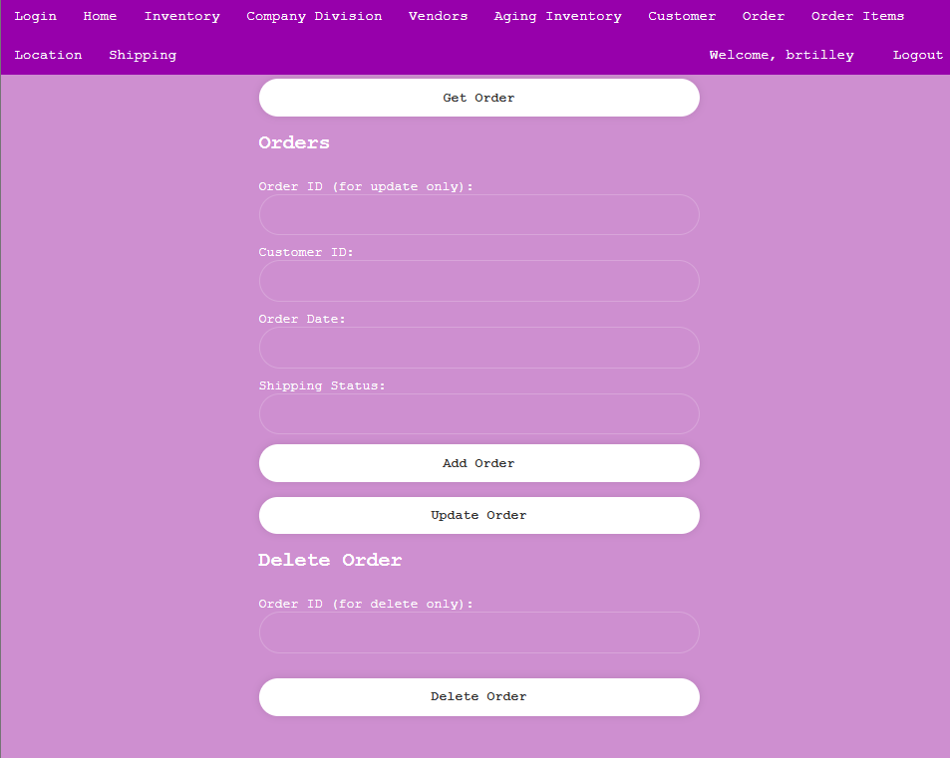
Order Items
The Order Items button in the navigation bar directs users to the order item page.
The order item page features the order item table, which displays all available information about order items. Users can retrieve, create, update, and delete entries within the order items table. After inputting data into the table, users can retrieve it by clicking Get Order Item, add new entries with Add Order Item, update existing data using Update Order Item, and remove entries by clicking Delete Order Item.
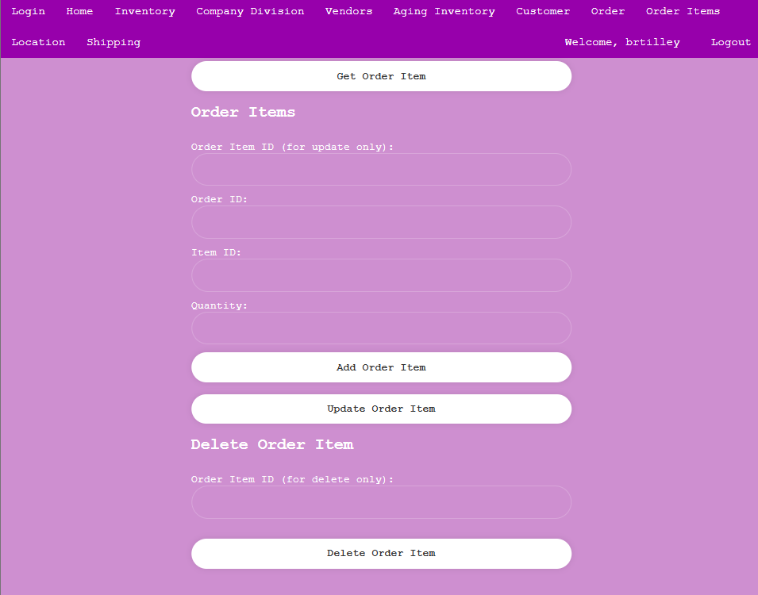
Location
The Location button in the navigation bar directs users to the location page.
The location page features the location table, which displays all available information about locations. Users can retrieve, create, update, and delete entries within the locations table. After inputting data into the table, users can retrieve it by clicking Get Location, add new entries with Add Location, update existing data using Update Location, and remove entries by clicking Delete Location.
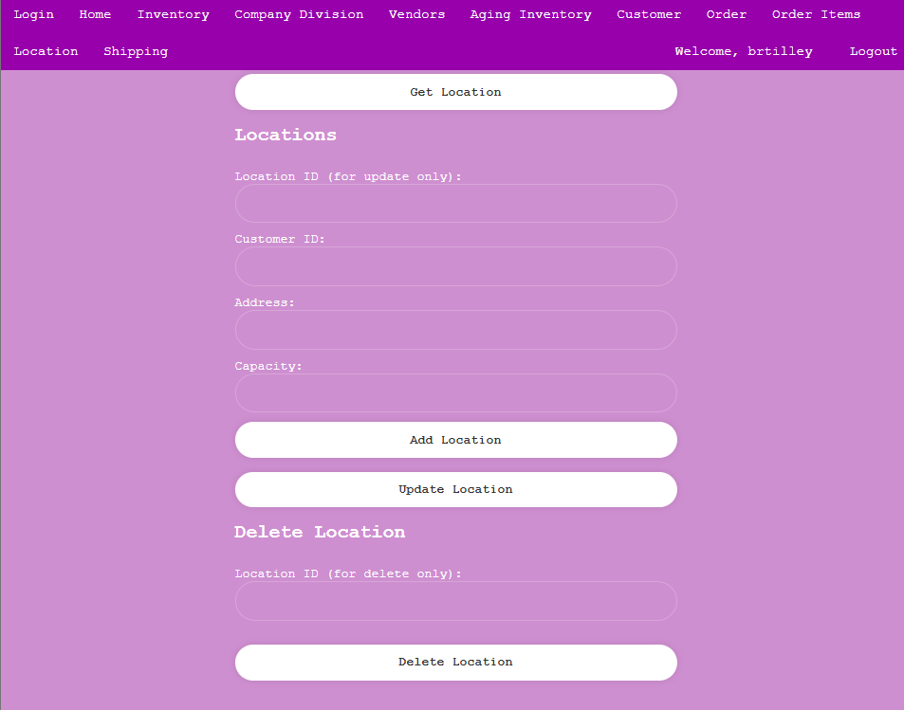
Shipping
The Shipping button in the navigation bar directs users to the shipping page.
The shipping page features the shipping table, which displays all available information about shippers. Users can retrieve, create, update, and delete entries within the shippers table. After inputting data into the table, users can retrieve it by clicking Get Shippers, add new entries with Add Shipper, update existing data using Update Shipper, and remove entries by clicking Delete Shipper.
