BOOKS WRITERS PUBLISHERS BLOG CONTACT

All about literature

Bookworm

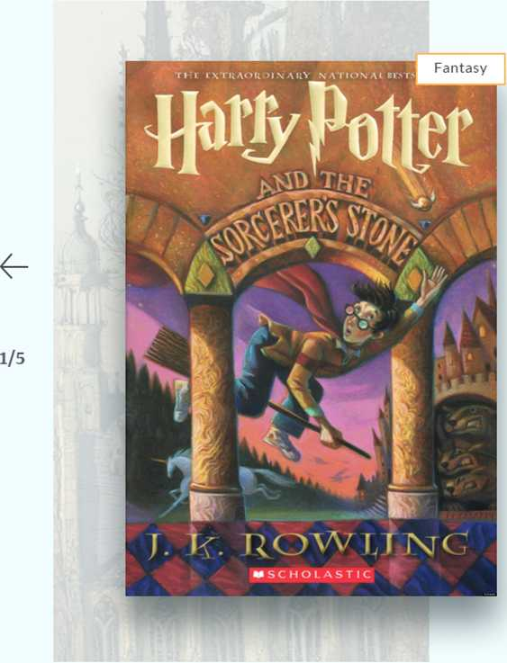

The Da Vinci Code

**Dan Brown 5 ★**

Harry Potter And The Sorcerer's Stone

By Joan Rowling I 5 ^

Vestibulum rutrum quam vitae fringilla tincidunt. Suspendisse nec tortor urna. Ut laoreet sodales nisi, quis iaculis nulla iacu- lis vitae.

$100

THE

Da Vinci

CODE



A major update in the Detective section



Shopfront

ItrClfcc[1]

WWW

VMM

Hlflw

WWW

Art & Photography

Popular v»

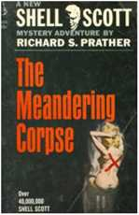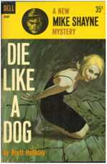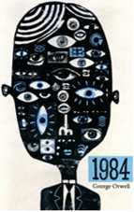

J R R

#### TOLKIEN

LORD

RINGS

|  |  |  |  |  |
| --- | --- | --- | --- | --- |
| Opaque Region | The Meandering | English Detective | Die Like a Dog | 1984 |
| Carlos Fuentes | Corpse | Stories | Brett Halliday | Georf |

**The Lord of the Rings**

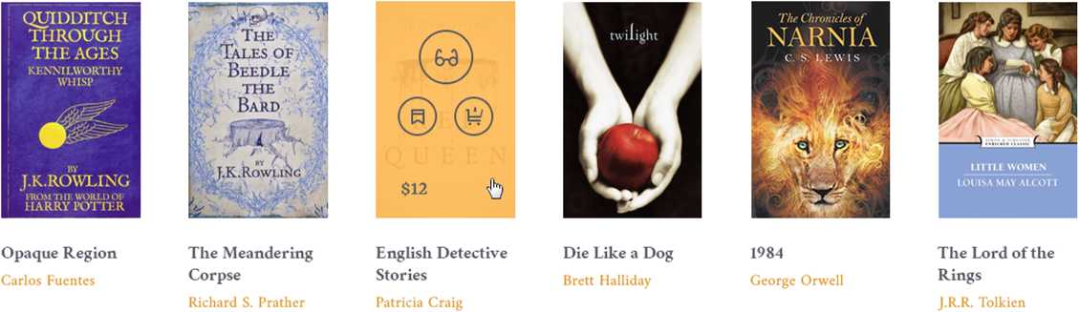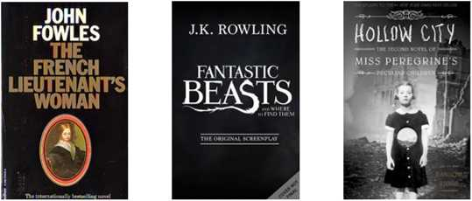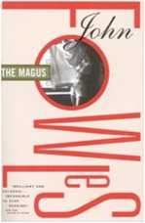

|  |  |  |  |  |
| --- | --- | --- | --- | --- |
| The french | Fantastic beasts | Hollow city | The collector | The magus |
| lieutenants woman | J.K. Rowling |  | John Fowles | John Fowles |

**Everything I Never Told You**

All books

**Popular writers**

John Fowles

John Fowles

31 March 1926

Leigh-on-Sea, Essex, ® ^  
England

55

You are right. He did not. But millions of Germans did betray their selves. That was the tragedy. Not that one man had the courage to be evil. But that millions had not the courage.



**About**

In hac habitasse platea dictumst. Vivamus adipiscing fermentum quam volutpat aliquam. Integer et elit eget elit facilisis tristique. Nam vel iaculis mauris. Sed ulla- mcorper tellus erat, non ultrices sem...

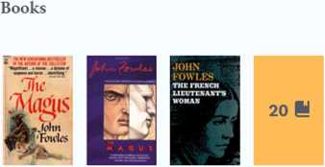

To writer page

Literature news



How literature can help people cope with mental health problems

Sales of 'Harry Potter and the Cursed Child' script book hit more than 2 million within 48 hours of its release in US

Marvel introduces character Riri Williams, a woman who takes over as new Iron Man

**Edmonton bookseller, publisher and activist Mel Hurtig dies at 84 - CBC**

**BBC to produce Les MisGrables as 6-part TV special - The Guardian**

Association of Former Agents of the United States Secret Ser­vice denounces anti- Clinton tell-all book - Politico

5 Britons, 5 Americans, 2 Canadians and South African on short list for English liter­ature's Man Booker Prize



**' \**

Steven Rowley

piMtgrtic ... A wondsifull, mining; —GARTH STKIN. of The Ael nf lleeing in the Rein



All news

and the

## Octopus

**Lily and the octopus**

Steven Rowley I 5 ^

In hac habitasse platea dictumst. Vivamus adipiscing fermentum quam volutpat aliquam. Integer et elit eget elit facilisis tristique. Nam vel iaculis mauris.

To the writer page 2$

Popular series

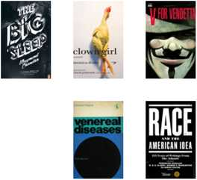

**Discount for novel**

In hac habitasse platea dictumst.  
Vivamus adipiscing fermentum quam  
volutpat aliquam.

INVISIBLE „ MAN

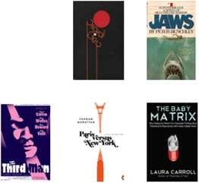

Thinking. Fait ond Slow

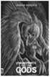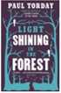

Slavoj

2izck

Trouble

tiool Um

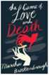

All books

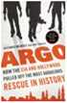

Paradise

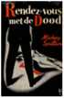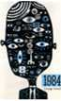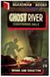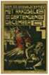

THE

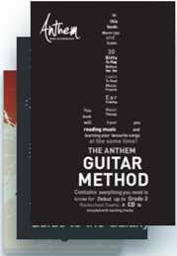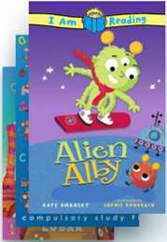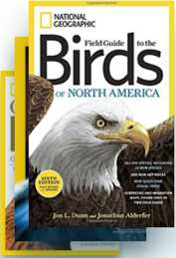

Da Vinci

[ CODE

DAN BROWN

LZiaTIVl Tint

Intellectual bestseller 20 0

Hobbies 85 0

Childrens literature 54 0

National geographic 21 0

• o o o o

|  |  |  |  |  |  |
| --- | --- | --- | --- | --- | --- |
| Publishers |  | C|.  international 1 DA publishers IrM association | gIo  SANCTUM  BOOKS | MACMILLAN  Pan Macmillan Australia | Q Penguin |
| In hac habitasse platea dictumst. Vi­vamus adipiscing fermentum quam vo­lutpat aliquam. | | ©©  LITTLE,  BROWN | Vintage Books ♦ ♦♦ | ^<3>  tx3>  FARRAR  STRAUS  GIROUX | U  Andrews McMeel Publishing |
| Full list |  |  |  | Europa  editions | -pt |
|  |  | Ssl  QUIRK | Saraband HI | 7*  8LOOMS8URY |

SITEMAP HELP DELIVERY PRIVACY POLICY ACCESSIBILITY

About

Stay in touch

I Subscribe B

Cras quis nulla commodo, aliquam lectus sed, blandit augue. Cras ullam- corper bibendum bibendum. Duis tincidunt urna non pretium porta. Nam condimentum vitae ligula vel ornare. Phasellus at semper turpis.

Follow us

o o © ©

**Ade books**

Rare Books & Textbooks

**Junglee**

Shop Online in India

**DpReview**

Digital Photography

**Look**

Kids’ Clothing & Shoes

**Audible**

Download Audio Books

**MYHABIT**

Private Fashion Designer Sales

© 2016 Bookworm. All rights reserved

1. O O