VEYVIO
Vehicle Ecosystem, Yard Visibility and Intelligent Operations
COMBINED BLUEPRINT
Product Blueprint · Enterprise Extensions · Technical Implementation Specification
Combined edition — one file, living document, version-controlled
Combined version | 1.0, 24 July 2026
Status | Living document — keep adding to this file as the platform evolves
Classification | Confidential product planning document
What's in This File
Six documents merged into one. Each part keeps its own internal section numbering and table of contents — use Word's navigation pane (headings) to jump between parts.
Part | Contents | Read it for
A | Master Product & Technical Blueprint | Product strategy, vision, principles, application portfolio, roles, workflows
B | Platform Principles | The 10 non-negotiable principles behind every design decision — read this before changing anything else in this file
C | The Next Level — Strategic Platform Vision | Digital Twin, Operational Intelligence, Recommendation Engine, Decision Engine, Knowledge Graph, Governance Engine, Operational Playbooks, Business Continuity, Customer Success Centre
D | Enterprise Capability & Market Positioning Extensions | Integration architecture (incl. tachograph), Driver/Vehicle Compliance Passports, Compliance Readiness Scoring, Audit Management, Sustainability Dashboard, brand and go-to-market positioning
E | Technical Implementation Specification | System architecture diagrams, database schema, API catalogue, event architecture, Configuration Centre, Transport Rules Library, Application Access Control (incl. Permission Matrix), Core Workflows, Capability Matrix
F | Production Readiness Requirements | 17 hard rules and backend changes required before Veyvio is production-ready, plus the recommended implementation order — stop-ship gates, not suggestions
Not included in this file
- Regulatory & Standards Grounding Addendum — real UK transport law/safeguarding/standards mapped onto Part A.
- Companion Application Blueprints (Command, Driver, Yard) — full per-app implementation detail.
- Developer Architecture Guide — how the full document library fits together and build order.
- Say the word and I'll fold any or all of these back in.
VEYVIO
MASTER PRODUCT & TECHNICAL BLUEPRINT
Vehicle Ecosystem, Yard Visibility and Intelligent Operations

Move smarter. Operate safer.
Version 1.0
24 July 2026
Confidential product planning document

Document Purpose
Blueprint decision
Veyvio should not be rebuilt from zero. The current product should be treated as a working domain and interface prototype. Preserve validated workflows, redesign confusing areas, replace mock data and insecure shortcuts, and progressively move each module onto a shared production-grade multi-tenant platform.
This document defines the complete target state for Veyvio as a licensable transport management platform for multiple independent operators. It combines product strategy, application boundaries, workflows, information architecture, data ownership, integration rules, security controls, offline behaviour, operational governance and a practical implementation sequence.

How to Use This Blueprint
- Product and design teams use it to define pages, journeys, terminology and acceptance criteria.
- Engineering teams use it to define domains, services, data models, APIs, tenancy and release boundaries.
- Operational experts use it to confirm that workflows match real transport, yard, driver, maintenance and compliance practice.
- Leadership uses it to control scope, prioritise delivery and decide when a module is production-ready.

Table of Contents
1. Executive Blueprint
2. Product Vision and Principles
3. Platform Operating Model
4. Application Portfolio
5. Roles and Permission Model
6. Information Architecture
7. Core End-to-End Workflows
8. Domain Module Specifications
9. Shared Data Model
10. Technical Architecture
11. Multi-Tenant Security and Isolation
12. Offline, Mobile and Device Architecture
13. Notifications and Communication
14. Reporting, Intelligence and Audit
15. Integrations
16. UX and Design System
17. Non-Functional Requirements
18. Delivery Roadmap
19. Quality Gates and Definition of Done
20. Decisions, Risks and Open Items

1. Executive Blueprint

1.1 The Product
Veyvio is a multi-tenant transport management system designed for passenger transport operators. It connects company administration, bookings, dispatch, drivers, vehicles, depots, yard activity, maintenance, compliance, passengers, communications and reporting in one trusted operational platform.
Element | Definition
Purpose | Help transport teams operate safely, confidently and efficiently.
Mission | Connect every vehicle, person, journey and operational decision in one trusted transport system.
Vision | Every vehicle accounted for, every issue visible, every journey begins with confidence.
Brand promise | Know what is happening. Act on what matters. Move safely.
Commercial model | Licensable software used independently by multiple transport companies, with strict separation of company data.
Primary market | PSV, community transport, school transport, Dial-a-Ride and related managed passenger transport operations.

1.2 Target Outcome
- One company account can operate one or many depots.
- Each company sees only its own people, passengers, vehicles, bookings, documents and reports unless an explicit, audited cross-company relationship is configured.
- Administrators plan and control operations; drivers perform assigned work; yard teams control physical fleet readiness; maintenance teams manage technical work; customers and passengers receive appropriate self-service access.
- Every material operational action produces a timestamped audit event.
- Safety and compliance rules act as real assignment and release gates, not passive reminders.

1.3 Product Boundary
In scope | Out of scope / separate capability
Bookings, jobs, runs, trips, schedules and recurring transport | General accounting ledger and payroll engine
Driver, staff, passenger, customer, school and contract records | Full garage workshop diagnostic platform
Fleet, yard, defects, inspections, maintenance and equipment | Public ride-hailing marketplace unless separately commissioned
Messaging, notifications, reports and audit | Generic CRM unrelated to transport operations
Company setup, licensing, users, roles and integrations | Sharing tenant data by default between connected companies

2. Product Vision and Principles
Principle | Meaning
Safety before convenience | The system blocks unsafe vehicle release, unqualified driver assignment and incomplete mandatory checks.
Tenant isolation by default | Company boundaries are enforced in the database, API, storage, cache, search, notifications and analytics layers.
Operational truth | Live status must come from connected backend records, not placeholder or mock data.
Simple at the surface, rigorous underneath | Users see clear tasks and status while the system maintains full evidence, history and auditability.
Role-specific products | Admin, Driver, Yard, Customer and Maintenance are separate experiences on shared platform services.
Mobile-first frontline work | Driver and Yard workflows must work with weak connectivity and support fast, one-handed use.
Exception-led management | Dashboards should highlight what requires action rather than overwhelm users with static data.
Preserve proven work | Reuse validated components and workflows; redesign only where there is confusion, duplication, security risk or technical debt.

3. Platform Operating Model

3.1 Tenant Hierarchy
Level | Purpose | Example controls
Platform | Veyvio service operator and licensing layer | Tenant provisioning, subscription, global feature flags, support access with approval and audit
Company / Tenant | Independent transport operator | Own users, passengers, fleet, bookings, policies, branding and reports
Depot / Operating Base | Physical or operational location | Vehicle allocation, yard layout, teams, local tasks, stock and shifts
Team / Department | Functional grouping | Operations, yard, maintenance, compliance, finance, customer service
User | Named person with company membership | Role, permissions, depot scope, employment status, MFA and device sessions

3.2 Licensing and Company Onboarding
- Create tenant and immutable tenant identifier.
- Accept legal terms, subscription plan and data-processing terms.
- Configure company name, logo, registered and operating details, timezone, units, service types and required compliance rules.
- Create primary company owner; require MFA and recovery setup.
- Create depots, roles, teams and approval rules.
- Import or create vehicles, drivers, staff, customers, passengers, schools and contracts.
- Complete readiness checklist before live operations are enabled.

4. Application Portfolio
Application | Primary users | Core responsibility | Release boundary
Veyvio Command / Admin | Controllers, schedulers, managers, compliance, customer service, company leadership | Plan, govern and monitor the entire operation | Web-first responsive app; independent release
Veyvio Driver | Drivers and escorts | Receive duties, complete checks, navigate, update job status, communicate and close shifts | Android and iOS native shell; offline capable
Veyvio Yard | Yard managers and depot operatives | Control physical location, readiness, movements, equipment, inspections, damage and VOR status | Standalone mobile-first app; invitation-only; offline capable
Veyvio Maintenance | Fleet engineers, workshops and maintenance coordinators | Plan and execute maintenance, inspections, repairs, parts and return-to-service approvals | Dedicated application or bounded module; independent permissions
Veyvio Customer | Commissioners, schools, organisations and authorised bookers | Request and manage bookings, passengers, documents and communications | Separate portal/app with constrained tenant/customer scope
Platform Console | Veyvio authorised platform staff | Provision and support tenants without normal access to operational data | Strongly segregated internal control plane

Application rule
No frontline app should depend on another frontend. All applications communicate through versioned shared platform APIs and event services.

5. Roles and Permission Model
Role | Default scope
Company Owner | Full company configuration, subscription, senior user administration and approval settings. Cannot bypass immutable audit or tenant controls.
Director / Executive | Read organisation-wide performance and risks; approve defined high-risk actions.
Operations Manager | Control bookings, schedules, dispatch, runs, trips, drivers and live exceptions.
Dispatcher / Controller | Assign work and vehicles, manage live trips, transfers, cancellations and incidents within scope.
Compliance Manager | Manage rules, evidence, expiries, audits, incidents and release gates.
Fleet Manager | Manage vehicles, inspections, maintenance plans, defects, VOR and return-to-road decisions.
Yard Manager | Control depot vehicle locations, readiness, equipment, checks, photos, damage and yard tasks.
Maintenance User | Perform or coordinate technical work and record evidence, costs, parts and sign-off.
Driver | Access own assigned duties, checks, messages, documents and profile only.
Escort / Passenger Assistant | Access assigned duties and passenger support information appropriate to role.
Customer Booker | Create and manage bookings for authorised customer accounts.
Auditor / Read-only | Read defined records and reports without operational modification.

5.1 Permission Design
- Use role-based access control with additional attribute checks for tenant, depot, team, ownership, assignment and record sensitivity.
- High-risk actions require explicit permissions and, where configured, a second approval: vehicle return to road, compliance override, deletion/export, cross-company access and financial changes.
- Driver and passenger safeguarding data must be field-restricted, purpose-limited and logged when viewed.
- Permissions are deny-by-default. UI hiding is not security; every API and database operation rechecks access.

6. Information Architecture

6.1 Veyvio Command Navigation
Navigation group | Pages
Command | Overview; Live Operations; Exceptions; Notifications
Operations | Bookings; Jobs; Dispatch; Runs; Trips; Schedule; Dial-a-Ride; School Routes; Recurring Transport
People and Fleet | Drivers; Staff; Vehicles; Depots
Yard Operations | Yard overview; Vehicle locations; Tasks; Equipment; Bodywork; Movements
Maintenance | Maintenance dashboard; Work orders; Service plans; Inspections; Tyres; Parts; Suppliers
Safety and Compliance | Vehicle Checks; Defects; Inspections; Incidents; Compliance Rules; Documents and Expiries
Customers and Commercial | Customers; Passengers; Schools; Contracts; Pricing; Funding / surplus classification where applicable
Communication | Messages; Announcements; Templates
Intelligence | Reports; Performance; Audit Log
Administration | Company Settings; Users and Roles; Integrations; Data Imports; Subscription

6.2 Booking Terminology Decision
Simplification
“Bookings” is the creation area for general transport work. “Jobs” is the complete operational list of work created through any booking process. Dial-a-Ride and School Routes retain their own specialised booking flows and should not be forced into the general booking wizard.

Object | Meaning
Booking request | The request and commercial/customer context.
Job | One transport task for a passenger/group between locations, with timing and service needs.
Run | A planned collection of jobs operated together, often repeated or route-based.
Trip / Duty | The executable driver and vehicle assignment for a defined period.
Stop | A pickup, drop-off, depot, break or operational waypoint.
Route | Ordered path and timing plan connecting stops.

7. Core End-to-End Workflows

7.1 General Booking to Completion
Stage | Required system behaviour
1. Create request | Select customer, payer, service date/time, passenger/group, pickup/drop-off, accessibility, luggage/equipment, contact and service requirements.
2. Validate | Check addresses, operating area, service eligibility, duplicate request, timing feasibility and required consent.
3. Price / authorise | Apply contract or pricing rule, record funding/surplus classification where required, and obtain approval if outside limits.
4. Create jobs | Generate one or more operational jobs and preserve the source booking relationship.
5. Plan | Group jobs into runs/trips; calculate travel and dwell time; add breaks and depot movements.
6. Assign | Select eligible driver, escort and roadworthy suitable vehicle. Hard gates run before assignment.
7. Publish | Notify frontline users and require acknowledgement when configured.
8. Execute | Driver checks in, completes vehicle check, starts duty, updates arrivals/departures/no-shows and records exceptions.
9. Intervene | Control can transfer jobs, change vehicle/driver, cancel or assist; every change records reason and history.
10. Close | Driver completes end-of-duty checks, records fuel/AdBlue/mileage and parking bay, submits defects/lost property and signs off.
11. Reconcile | Operations reviews exceptions, actual timings, evidence, costs, invoicing/export and service performance.

7.2 Driver Eligibility Gate
Gate | Examples | Outcome when failed
Identity and employment | Active account, right role, employment/engagement status | Cannot be assigned
Driving entitlement | Licence valid, correct category, checks current | Cannot be assigned
Training | Mandatory induction, safeguarding, wheelchair, route/service modules | Cannot be assigned to affected work
Medical / declarations | Required declarations or assessments current | Block or managerial review
Duty time | Rest, working time, overlap and availability rules | Cannot assign or requires authorised override
Equipment / access | Valid device, ID, payment/top-up card or required equipment | Warning or block according to company rule

7.3 Vehicle Readiness Gate
Gate | Source | Outcome
Roadworthiness | Daily checks, open defects, VOR state | Block dispatch when unsafe or VOR
Legal compliance | MOT, tax where relevant, insurance, PSV documents, inspection dates | Block or urgent escalation
Maintenance | Service, safety inspection, recalls, tyre limits, wheel-nut retorque | Block or controlled warning
Suitability | Seats, wheelchair capacity, lift/ramp, emissions/zone, height/weight | Prevent unsuitable assignment
Yard readiness | Known location, keys, charge/fuel, cleanliness, equipment set | Task to yard or assignment warning/block

7.4 Yard Start-to-Finish Workflow
- Receive tasks from operations, maintenance, vehicle onboarding and end-of-shift exceptions.
- Locate vehicle by depot, zone and bay; optionally scan QR/NFC asset code.
- Perform requested check using a guided workflow with photos and pass/fail results.
- Record movements, keys, fuel/charge, cleanliness, equipment and body condition.
- Create linked defect, bodywork report, maintenance work order or VOR action when required.
- Complete task and update the shared vehicle readiness state for Command and Driver.

8. Domain Module Specifications

8.1 Bookings, Jobs and Scheduling
Capability | Blueprint requirement
General booking wizard | Short progressive flow with save-and-resume, repeat passenger, return journey and multi-stop support.
Dial-a-Ride | Dedicated eligibility, membership, flexible windows, recurring requests, mobility and shared-ride logic.
School routes | Dedicated school, term calendar, pupil roster, guardians, safeguarding, pickup points, escort and route versioning.
Recurring transport | Template with recurrence, exceptions, holidays, passenger changes and future instance regeneration.
Scheduling board | Day/week timeline, unassigned work, driver/vehicle lanes, conflicts, travel feasibility and depot awareness.
Transfers | Move job between trips or driver/vehicle assignments with reason, notifications and preserved history.
Cancellation/no-show | Policy, reason, charge decision, passenger notification and reporting.

8.2 Live Operations and Dispatch
- Map and timeline of active duties with freshness indicator for location data.
- Exception queue: late start, missed check, no acknowledgement, route deviation, passenger not ready, breakdown, incident, lost connectivity and overdue completion.
- Controller actions are guided, permissioned and reason-coded.
- Replanning never destroys the original plan; store planned, revised and actual states.
- Passenger-sensitive information is minimised in map labels and notifications.

8.3 Driver App
Area | Required experience
Home | Greeting, current date, next duty countdown, depot, vehicle and location/bay, job count, estimated finish, acknowledgement and pre-duty actions.
Trips | Today and upcoming duties; stop sequence; passenger requirements; navigation; controlled status buttons.
Vehicle Checks | Pre-use, defect, change-of-vehicle and end-of-duty checks with evidence and offline queue.
Messages | Operational threads, announcements, urgent alerts and read receipts.
More | Profile, documents, training, holiday balance, app security, biometrics, accessibility and support.
End shift | Mileage, fuel/charge/AdBlue, defects, cleanliness, lost property, equipment, keys and exact parking bay/location.

8.4 Yard App
Page / module | Required functions
Home | Vehicles requiring action, today’s tasks, alerts, VOR count, vehicles not located and upcoming deadlines.
Vehicles | Search/filter company fleet; state, depot, bay, assignment, fuel/charge and readiness.
Vehicle detail | Known damage, images, inspections, equipment, maintenance, open defects, movements and documents.
Vehicle Check | Configurable yard inspection with all-round body condition capture.
Vehicle Bodywork | Fleet list; known damage map and photos; history; wizard to report new damage and create linked repair work.
Equipment | Assign/unassign movable and fixed items with QR codes, quantities, expiry and condition.
Movements | Move vehicle between depot zones/bays; record who, when, keys and reason.
VOR / Return to Road | Reason, severity, restrictions, evidence, approvals and maintenance linkage.
Upcoming | Safety inspections, MOT, service, tyres, retorque, weekly checks, battery-start tasks for inactive vehicles and other due work.
Messages / Profile | Operational communication, device sync, settings and account security.

8.5 Vehicle Onboarding and Image Baseline
- Admin may create the vehicle record before images exist, but the vehicle remains in “onboarding incomplete” status.
- System automatically creates a yard task to capture required exterior angles, interior, mileage, identifiers and equipment.
- Uploaded baseline images become the authoritative pre-service body condition record and appear in Vehicle Bodywork.
- Future driver or yard damage reports are compared against the baseline and known damage history.
- A vehicle cannot become fully operational until mandatory documents, configuration and baseline tasks are complete, unless an authorised temporary exception is recorded.

8.6 Defects, Bodywork and Incidents
Record type | Use | Linkages
Defect | Mechanical, safety or operational fault | Vehicle check, work order, VOR, inspection, driver and trip
Body damage | Exterior/interior physical damage | Baseline images, annotated vehicle diagram, photos, repair estimate and insurance/incident
Incident | Event involving injury, collision, safeguarding, passenger, property or service risk | Trip, people, vehicle, witnesses, documents, actions and reporting
Lost property | Item reported or found | Trip, vehicle, passenger/customer communication and chain of custody

8.7 Tyre Management
- Track tyre by unique asset/serial where practical, position, size, make/model, fit date, odometer, tread depths, pressure and condition.
- Record reason for fit/removal, puncture/repair, expected mileage, supplier, cost and warranty.
- Maintain position history through rotations and twin-wheel positions.
- Generate replacement and inspection tasks from tread, age, damage, mileage or policy thresholds.

8.8 Maintenance
Capability | Requirement
Plans | Time, mileage, engine hours or condition-based service schedules.
Work orders | Requested, approved, scheduled, in progress, awaiting parts, completed and verified states.
Inspections | Upload third-party certificates and structured results; preserve original file and extracted metadata.
Parts and labour | Parts, quantities, supplier, technician, labour time, cost and warranty.
Return to service | Independent verification where required; closes VOR only with sufficient evidence and permission.
External garage | Controlled portal or secure request/upload link with tenant-scoped access.

8.9 People, Training and Leave
- Driver/staff profile separates identity, contact, employment, permissions, licences, training, documents, availability and emergency details.
- Mandatory training is determined by role, vehicle type, passenger needs and contract/service type.
- Holiday entitlement uses configured contract rules, start/end dates, working pattern, carry-over and approved leave; show earned, taken, booked and remaining balances with calculation explanation.
- Invitation, account activation, password reset, MFA and biometric settings are managed without exposing credentials to administrators.

9. Shared Data Model
Core entity | Purpose
Tenant | Company boundary and configuration root
Depot | Operating location and yard hierarchy
User | Authentication identity
Membership | User-to-tenant role and scope
Person | Driver, staff, passenger, guardian, contact or witness
Customer | Organisation commissioning or paying for transport
Contract | Service and commercial rules
Vehicle | Fleet asset
VehiclePosition | Depot/zone/bay and movement history
EquipmentAsset | Trackable vehicle/depot equipment
Booking | Customer request
Job | Operational transport task
Run | Planned group of jobs
TripDuty | Executable assignment
Stop | Ordered waypoint
Assignment | Driver/vehicle/escort allocation
Check | Structured inspection instance
Defect | Fault record
Damage | Body condition/damage record
Incident | Operational/safety event
WorkOrder | Maintenance action
Document | Tenant-scoped file and metadata
MessageThread | Operational communication
Notification | User delivery record
AuditEvent | Immutable security and business history

9.1 Data Rules
- Every tenant-owned row carries tenant_id and is protected by database-level row security or an equivalent enforced policy.
- Foreign keys include tenant consistency validation; a record cannot reference another tenant’s entity even when identifiers are known.
- Soft deletion is used only where retention and recovery justify it; safety/audit history is never silently removed.
- Files are stored under tenant-scoped paths with signed, short-lived access and malware/type validation.
- Operational state is derived from explicit events and statuses, not overwritten free-text notes.

10. Technical Architecture

10.1 Target Logical Architecture
Layer | Components
Clients | Command web, Driver mobile, Yard mobile, Maintenance, Customer portal, Platform Console
Edge / API | API gateway, authentication, rate limits, request validation, tenant context and versioning
Application services | Booking, scheduling, dispatch, fleet, yard, maintenance, compliance, people, messaging, reporting
Workflow / event layer | Domain events, job queue, scheduled tasks, notification orchestration and audit stream
Data | Relational operational database, object storage, cache, search index and analytics store
Observability | Structured logs, metrics, traces, security events, alerting and support diagnostics
Delivery | Separate CI/CD pipelines, environment configuration, migrations, feature flags and rollback

10.2 Architectural Style
Begin with a modular monolith or a small number of strongly bounded services rather than premature microservices. Each domain owns its rules and API surface. Use asynchronous events for notifications, reporting, integration and cross-domain reactions, while safety-critical commands remain transactional and immediately consistent.

10.3 API Standards
- Versioned REST or well-governed GraphQL for client APIs; idempotency keys for retried mobile commands.
- Schema validation at the boundary and typed client contracts.
- Cursor pagination, server-side filtering, explicit sort and bounded exports.
- Consistent error codes with safe user messages and correlation identifiers.
- Optimistic concurrency for records that may be edited by multiple controllers.

11. Multi-Tenant Security and Isolation
Stop-ship rule
No production release is acceptable while cross-tenant create, read, update, delete, search, file access, notification or analytics tests can fail.

Control plane | Required safeguard
Authentication | No fallback secrets; strong password rules; MFA for privileged roles; secure recovery; revocable sessions.
Authorisation | Tenant membership and permission checked server-side on every action.
Database | Row-level policies plus tenant-safe foreign keys, functions and background jobs.
Storage | Tenant-prefixed paths; signed URLs; content validation; no public operational buckets.
Caching/search | Tenant included in every key, filter and index document; no shared unscoped query.
Notifications | Recipient tenant and membership revalidated at send time.
Support access | Time-bound, approved, purpose-recorded impersonation or read access with banner and audit.
Secrets | Rotate exposed credentials; keep environment secrets outside repositories and archives.
Testing | Automated cross-tenant attack suite in CI for every high-risk endpoint.

11.1 Current Hardening Priorities
- Rotate all potentially exposed Supabase, database, JWT, SMTP, Stripe and related credentials.
- Remove historical archives containing environment files and use a clean-archive process.
- Eliminate default/fallback JWT secret behaviour.
- Complete tenant foreign-key validation and backend integration tests.
- Remove all mock data paths from production builds and seed data from live environments.

12. Offline, Mobile and Device Architecture
Concern | Blueprint approach
Offline read | Cache assigned duties, vehicle records, forms, known damage and essential messages only for the signed-in tenant/user.
Offline write | Queue signed commands with local timestamp, device ID, idempotency key and attachment references.
Conflict | Server decides using version and workflow rules; user sees clear resolution task when automatic merge is unsafe.
Media | Compress, encrypt locally, upload in background and retain until server acknowledgement.
Security | Encrypted device storage, biometric unlock option, remote session revocation, inactivity lock and no secrets in logs.
Screen awake | Driver-controlled or duty-mode wake lock with battery warning and safe automatic release.
Sync status | Always show last successful sync and pending/failed item count.

13. Notifications and Communication
- Use a central notification service supporting in-app, push, email and SMS according to tenant policy and message sensitivity.
- Events include duty published/changed, acknowledgement overdue, vehicle reassigned, check failed, defect escalated, deadline due, passenger update and incident action.
- Templates are tenant-configurable but system-required safety wording can be locked.
- Record delivery, failure, open/read and acknowledgement where relevant.
- Urgent alerts must not expose sensitive passenger details on lock screens.

14. Reporting, Intelligence and Audit
Area | Example measures
Operations | On-time pickup/drop-off, late starts, completion, no-shows, cancellations, utilisation and dead mileage.
Fleet | Availability, VOR time, defect recurrence, maintenance compliance, tyre life, fuel/energy and cost per mile.
Driver | Acknowledgement, check completion, punctuality, training status, incidents and duty utilisation.
Customer/service | Volume, performance against contract, complaints, passenger outcomes and service reliability.
Yard | Task completion, vehicle location accuracy, readiness failures, damage discovered and turnaround.
Compliance | Expired/expiring items, overrides, overdue actions, inspection outcomes and evidence completeness.

14.1 Audit Standard
- Capture actor, tenant, role, action, entity, before/after summary, timestamp, device/IP context, reason and correlation ID.
- Audit records are append-only and accessible through filtered reports according to permission.
- Sensitive field values may be redacted while the event still proves that a change occurred.
- Exports and support access are themselves audited.

15. Integrations
Integration category | Purpose / examples
Identity | Email/password, MFA, optional enterprise SSO
Maps and routing | MapLibre/OpenStreetMap presentation; routing engine such as OSRM or managed alternative; geocoding and traffic where licensed
Communications | Email, SMS and push providers
Payments / billing | Subscription billing and optional customer payment workflows
Vehicle data | Telematics, mileage, location, fuel/energy and diagnostics where available
Compliance | Licence/check services, document verification and external inspection uploads
Finance/export | Invoice, payroll/time, accounting or funding exports rather than replacing those systems
Calendar/import | School terms, public holidays, customer rosters, CSV/API imports

16. UX and Design System

16.1 Brand Foundation
Token | Use
#4A8FA3 | Primary teal: trust, platform identity, headings and key navigation
#7AB82E | Lime: primary action and positive operational state
#8EC63F | Supporting green: onboarding and success emphasis
#173E48 | Deep teal: text, high contrast and professional surfaces
Neutral greys | Backgrounds, borders, disabled states and dense operational data

16.2 Interaction Rules
- Use plain operational language and one dominant action per screen.
- Do not use colour alone for status; pair icon, label and accessible contrast.
- Frontline forms use large touch targets, progress, autosave, camera-first evidence and clear offline status.
- Admin tables support search, filters, saved views, bulk actions and direct links to related records.
- Wizards reveal complexity progressively and explain why information is needed.
- Every blocked action explains the failed gate and the responsible team/action needed to resolve it.

17. Non-Functional Requirements
Quality | Target requirement
Availability | Operational services designed for high availability with graceful degradation and published status.
Performance | Common pages responsive under realistic tenant data volumes; live updates without uncontrolled polling.
Scalability | Tenant and depot growth without rearchitecture; background work isolated from interactive requests.
Accessibility | WCAG 2.2 AA target for user-facing applications.
Privacy | UK GDPR-aligned minimisation, retention, access, export and deletion processes.
Resilience | Backups, point-in-time recovery, restore tests, queue retry/dead-letter handling and offline continuity.
Observability | Actionable monitoring for API errors, sync failures, notification failures and security anomalies.
Maintainability | Typed contracts, modular domains, automated tests, migration discipline and documented ownership.

18. Delivery Roadmap
Phase | Scope | Exit outcome
Phase 0 – Control and discovery | Freeze uncontrolled feature growth; inventory pages, mock data, APIs, schemas, secrets and tenant risks; agree terminology and ownership. | Audited baseline and prioritised backlog
Phase 1 – Production foundation | Credential rotation, tenant isolation, authentication, roles, audit, environment separation, CI gates, observability and file security. | Secure platform foundation
Phase 2 – Core master data | Company, depots, users, people, vehicles, customers, passengers, documents and onboarding workflows. | Trusted shared records
Phase 3 – Operations core | General bookings, jobs, scheduling, runs/trips, assignments, publishing and driver duty flow. | End-to-end operational service
Phase 4 – Yard and fleet readiness | Yard standalone app, vehicle location/bays, tasks, checks, equipment, bodywork, VOR and upcoming work. | Physical fleet control
Phase 5 – Maintenance and compliance | Work orders, service plans, tyres, inspections, incidents, training and hard release gates. | Evidence-based safety system
Phase 6 – Specialist services | Dial-a-Ride, School Routes, recurring patterns and customer portal workflows. | Service-specific depth
Phase 7 – Intelligence and integrations | Advanced reports, telematics, finance exports, automation and optimisation. | Scaled operational intelligence
Phase 8 – SaaS maturity | Self-service onboarding, subscription controls, feature entitlements, support tooling and tenant lifecycle. | Commercially scalable product

18.1 Recommended Build Strategy
Incremental replacement
Use a strangler approach: place shared authentication, tenant context and APIs around the current applications; replace mock-backed pages and risky modules one vertical workflow at a time. Do not perform a single “big bang” rewrite.

19. Quality Gates and Definition of Done
Gate | Must be true before release
Product | User journey, edge cases, permissions, empty/loading/error states and terminology approved.
Data | Schema, tenant constraints, migrations, retention and audit behaviour reviewed.
Security | Threat model completed; cross-tenant tests pass; secrets scanned; access checks verified.
Backend | No mock production path; API contract tested; idempotency and concurrency handled.
Frontend | Responsive, accessible, offline/sync behaviour defined where relevant; no fabricated live data.
Operations | Alerts, support diagnostics, runbook, rollback and ownership in place.
Testing | Unit, integration, end-to-end and permission matrix coverage pass in CI.
Evidence | Screenshots/files retain provenance, timestamps and link to the correct tenant/entity.

19.1 Module Acceptance Checklist
- Happy path and failure path complete.
- Cross-role handoffs work and notify the correct users.
- Historical records remain understandable after reassignment or correction.
- All state transitions are validated on the server.
- No page shows mock, stale or cross-company information as live operational truth.
- Audit and reporting can explain what happened without reading raw database rows.

20. Decisions, Risks and Open Items

20.1 Confirmed Decisions
- Veyvio is a licensable multi-company platform, not an app built only for BCT or one operator.
- Admin, Driver and Yard must all enforce the same company isolation model.
- Yard is a standalone application with shared APIs and independent navigation/release cycle.
- General Bookings, Dial-a-Ride and School Routes use separate creation flows but produce compatible operational jobs.
- The existing product is not discarded; it is hardened and progressively redesigned.
- Vehicle images may follow initial record creation, but a generated yard task and incomplete status remain until baseline capture is finished.

20.2 Principal Risks
Risk | Impact | Mitigation
Legacy mock data or disconnected screens | Users make decisions using false information | Trace every UI field to an API and database source; production fixture ban
Tenant leakage | Severe privacy, contractual and reputational harm | Database policies, scoped services and automated attack tests
Overlapping terminology | Operational confusion and duplicate modules | Adopt glossary and navigation decisions in this blueprint
Big-bang rewrite | Long delay and lost validated work | Incremental vertical slices with compatibility layer
Frontline connectivity | Incomplete checks and missing status | Offline command queue, sync visibility and conflict handling
Safety rules treated as warnings | Unsafe assignment or vehicle release | Server-enforced eligibility and readiness gates
Uncontrolled module expansion | Inconsistent platform and delivery slowdown | Architecture review and phased roadmap

20.3 Open Design Decisions
- Final subscription plans, feature entitlements and usage limits.
- Whether Maintenance launches as a separate app from day one or a bounded Command module first.
- Exact supported transport licensing/service regimes and company-configurable wording.
- Preferred mapping, traffic, telematics, SMS and payment providers for production.
- Data retention periods by record class and customer contract.
- Final platform support model and emergency access approval process.

Appendix A – Status Vocabulary
Domain | Suggested statuses
Booking | Draft; Pending approval; Confirmed; Cancelled; Completed
Job | Unplanned; Planned; Assigned; Published; In progress; Completed; Cancelled; No-show
Trip/Duty | Draft; Ready; Published; Acknowledged; Checked in; Active; Paused; Completed; Closed
Vehicle readiness | Onboarding incomplete; Available; Assigned; Attention required; VOR; In maintenance
Defect | Reported; Triaged; Deferred; Work ordered; Repaired; Verified; Closed
Work order | Requested; Approved; Scheduled; In progress; Awaiting parts; Completed; Verified; Cancelled
Yard task | New; Accepted; In progress; Blocked; Completed; Cancelled

Appendix B – Product Governance
- Every domain has a named product owner and technical owner.
- New features start with problem statement, affected roles, workflow, data ownership, permissions, events, reporting and acceptance criteria.
- Architecture decisions that affect multiple apps are recorded as decision records.
- Design system components are reused; module-specific variants require review.
- Release notes identify tenant-facing changes, migrations, risks and rollback steps.
END OF MASTER BLUEPRINT

Enterprise Architecture & Best Practice Enhancements
This section extends the Veyvio platform blueprint with the enterprise capabilities required to make the product configurable, secure, integration-ready, scalable and suitable for multi-operator deployment. These capabilities should build on the existing Veyvio backend rather than duplicate or replace established business logic.

Business Rules Engine
- Centralise operational rules for driver eligibility, vehicle readiness, booking restrictions, passenger and luggage limits, compliance checks, customer-specific requirements and exception handling.
- All Veyvio applications must call the same rule services; business logic must not be duplicated in the Website, Command, Driver, Yard, Maintenance or Customer applications.
- Rules should be configurable by authorised administrators, versioned, auditable, testable and capable of supporting effective dates, tenant overrides and controlled exceptions.

Workflow Engine
- Provide configurable workflows for incidents, defects, approvals, maintenance, onboarding, complaints, compliance and document review.
- Allow authorised administrators to change stages, assignments, service-level targets, approvals, escalations and notifications without changing application code.
- Every workflow transition must be permission-checked and recorded in the audit log.

Public API Strategy
- Expose a versioned API, beginning with /api/v1, for the Website, Command App, Driver App, Yard App, Maintenance App, Customer Portal and approved third-party systems.
- API endpoints should cover authentication, tenants, users, drivers, vehicles, bookings, jobs, runs, trips, yard operations, maintenance, defects, incidents, documents, notifications, reports and integrations.
- All API requests must use the same underlying Veyvio business rules, validation, permissions and tenant-isolation controls.
- Use OpenAPI documentation, consistent error responses, pagination, filtering, sorting, correlation IDs, idempotency keys for retried commands and clear deprecation policies.

API Keys, Authentication & Secret Management
- Human users should authenticate through secure identity flows such as OpenID Connect or OAuth 2.0, with MFA for privileged roles. API keys should primarily be used for approved server-to-server integrations rather than normal user sign-in.
- Every API credential must belong to a specific tenant and integration, have an owner, purpose, allowed scopes, permitted environments, creation date, expiry or review date and last-used timestamp.
- Keys must be generated with high entropy, displayed only once, stored only as secure hashes where verification is sufficient, and never stored in source code, browser storage, documents, logs or support tickets.
- Provide key creation, naming, scope selection, rotation, revocation, expiry, usage monitoring and emergency disablement through an Integration Management screen.
- Separate development, sandbox, staging and production credentials. Production keys must never work in non-production environments, and sandbox keys must never access production data.
- Support OAuth 2.0 client credentials for higher-trust integrations, signed JWTs where appropriate, short-lived access tokens and refresh-token rotation. Prefer scoped tokens over unrestricted long-lived keys.
- Apply least privilege using scopes such as bookings:read, bookings:write, vehicles:read, trips:update and webhooks:manage. Sensitive scopes should require additional approval.
- Store secrets in a managed secrets vault, rotate them on a defined schedule and immediately after suspected exposure, staff departures or vendor changes.
- Never return secret values through APIs after initial creation. Audit all creation, viewing, rotation, revocation and failed authentication events.

Webhooks & Event Integrations
- Allow approved systems to subscribe to events such as booking.created, booking.updated, job.assigned, trip.started, trip.completed, vehicle.vor, defect.raised and document.expiring.
- Sign webhook payloads using a per-endpoint secret and include timestamps and event IDs so receivers can verify authenticity and prevent replay attacks.
- Use retry policies with exponential backoff, dead-letter handling, idempotent event processing, delivery logs and a manual redelivery option.
- Permit endpoint verification, event filtering, secret rotation and temporary suspension.

Rate Limiting & API Protection
- Apply rate limits by tenant, credential, endpoint and risk level to prevent abuse and protect operational services.
- Return standard rate-limit information and use HTTP 429 for exceeded limits.
- Add request-size limits, schema validation, input sanitisation, IP controls where justified, anomaly detection and protection against replay, brute-force and enumeration attacks.

Developer Platform
- Provide OpenAPI/Swagger documentation, example requests, example responses, SDK guidance, changelogs, integration tutorials and a sandbox containing synthetic data.
- Offer a developer portal where approved customers can create applications, request scopes, manage credentials, configure webhooks, review usage and access support documentation.
- Introduce an API lifecycle covering design review, security review, automated contract tests, versioning, release notes, deprecation notice and retirement.

Integration Framework
- Support Microsoft 365, Google Workspace, council transport systems, accounting, payroll, SMS, email, mapping/GPS providers, payment gateways and approved telematics platforms.
- Use connector-specific configuration, field mapping, validation, retry, reconciliation and health monitoring.
- Keep integration failures isolated from safety-critical operational workflows and surface clear recovery actions to administrators.

Operations Control Centre
- Provide a real-time management dashboard showing active drivers, active vehicles, jobs in progress, compliance alerts, VOR vehicles, incidents, missed actions and live KPIs.
- Allow filtering by tenant, depot, contract, customer, service, route and time period.
- Every alert should link to an actionable record, owner and resolution workflow.

Configurable Forms Engine
- Allow authorised users to build vehicle checks, driver checks, incident forms, risk assessments, customer-specific forms and evidence requests without development.
- Support conditional questions, required fields, photographs, signatures, scoring, validation, versioning, approvals and offline completion.
- Completed forms must retain the exact form version used at submission time.

Enterprise Asset Management
- Add QR codes, barcode support, equipment tracking, assignment history, inspections, maintenance history, audit history and lifecycle management.
- Assets may include vehicles, keys, wheelchair equipment, tablets, radios, fuel cards, safety equipment and depot equipment.
- Every asset should have a unique identifier, status, owner or custodian, location and full event history.

Document Management
- Provide version control, expiry monitoring, approval, digital signatures, document templates, retention rules and secure storage.
- Link documents to drivers, vehicles, tenants, contracts, customers, incidents, maintenance records and training records.
- Access must be permission-controlled and all downloads, replacements, approvals and deletions audited.

Notification Centre
- Support email, SMS, push and in-app notifications with templates, preferences, escalation rules, quiet hours, reminder scheduling and delivery tracking.
- Notifications should be triggered by platform events and workflows rather than duplicated inside individual applications.
- Safety and compliance notifications must support acknowledgement and escalation when unanswered.

AI & Intelligence
- Plan for predictive maintenance, driver performance insights, fleet utilisation, route optimisation, intelligent scheduling, anomaly detection and natural-language reporting.
- AI recommendations must remain explainable, permission-controlled and reviewable by authorised staff.
- AI must not automatically override safety, compliance or safeguarding controls without an explicitly approved governance process.

Offline-First Mobile Architecture
- Support encrypted local storage, automatic synchronisation, conflict resolution, offline inspections, offline defect reporting and resumable uploads.
- Clearly show users what is saved locally, pending synchronisation, synchronised or failed.
- Safety-critical actions must define whether they are permitted offline and how server-side revalidation occurs after reconnection.

Reporting & Analytics
- Provide a custom report builder, scheduled reports, dashboard widgets, KPI library and controlled export to Excel and PDF.
- Use consistent metric definitions, tenant-aware data access, data-quality indicators and an auditable reporting model.
- Operational reporting should be separated from heavy analytical workloads where necessary to protect platform performance.

Security Architecture
- Enforce strict multi-tenant isolation, deny-by-default permissions, MFA, encryption in transit and at rest, secure session handling and comprehensive audit logs.
- Follow OWASP guidance, conduct threat modelling, automate dependency and secret scanning, and test for broken access control and tenant data leakage.
- Implement GDPR-aligned data minimisation, lawful processing, retention, subject-rights handling, breach response and privacy-by-design controls.

DevOps & Infrastructure
- Use CI/CD pipelines, automated tests, infrastructure as code, environment separation, monitoring, alerting, backup, disaster recovery and high-availability planning.
- Protect production deployments with approvals, rollback capability, database migration controls and observable release health.
- Define recovery time objectives, recovery point objectives, backup testing, incident response and business continuity procedures.

Best Practice Research
- Each major blueprint section should cite and adapt recognised guidance, including OWASP, NIST Cybersecurity Framework, Microsoft Azure Architecture Center, Google Cloud Architecture Framework, OpenAPI Specification, REST API guidance, WCAG, ISO 27001, ISO 9001, ITIL, Agile/Scrum and Twelve-Factor App principles.
- Require implementation teams or AI agents to distinguish mandatory requirements, recommended practices and future enhancements.
- External standards must be reviewed periodically because security, privacy, accessibility and technology guidance changes over time.

Future Expansion
- Plan for a marketplace or plugin ecosystem, customer self-service, white-labelling, multi-language support, AI assistants, advanced forecasting, IoT and telematics, digital twins and an enterprise data warehouse.
- Future modules should use the same tenant, identity, permission, audit, workflow, rules and API foundations rather than creating parallel systems.

Enterprise Guiding Principle
Every feature within Veyvio must be configurable before it is customisable. Business rules, workflows, forms, permissions, notifications and integrations should be configuration-driven wherever practical, allowing operators to adapt the platform without requiring unnecessary software development.

Implementation Definition of Done
- No feature is considered complete until its permissions, tenant isolation, audit events, validation, error handling, accessibility, testing, monitoring and documentation have been defined.
- No integration is considered production-ready until credentials, scopes, rate limits, retries, webhook security, logging, rotation, revocation and support ownership have been defined.
- No rule or workflow may be implemented separately in multiple applications when it can be centralised in the Veyvio platform services.

Buildability, Configuration & Application Access Controls
This section converts the product vision into implementation-ready platform requirements and establishes strict application-level access boundaries. It must be treated as a mandatory extension of the Enterprise Architecture & Best Practice Enhancements section.

System Architecture Blueprint
- Produce current-state and target-state architecture diagrams covering web applications, mobile applications, API gateway, backend services, workflow and rules engines, databases, file storage, messaging, integrations, identity, monitoring and deployment environments.
- Show trust boundaries, tenant boundaries, data flows, external dependencies, failure points and offline synchronisation paths.
- Maintain separate logical, deployment, security and integration architecture views so developers and auditors can understand the platform without assumptions.

Database Schema Blueprint
- Define every core entity, primary key, foreign key, tenant key, relationship, lifecycle status, ownership field and audit field.
- Document indexes, uniqueness constraints, soft-delete behaviour, retention rules, encryption requirements and data residency requirements.
- All tenant-owned records must carry an immutable tenant identifier, and tenant isolation must be enforced at query, service and database-policy levels where supported.
- Schema changes must use version-controlled migrations with rollback and production validation procedures.

API Endpoint Catalogue
- Maintain an OpenAPI-based catalogue for every endpoint, including method, route, purpose, request schema, response schema, validation rules, errors, permissions, tenant scope, idempotency behaviour and rate-limit class.
- Provide example requests and responses for bookings, drivers, vehicles, trips, yard, defects, incidents, maintenance, documents, notifications, reports and administration.
- Use explicit API versioning such as /api/v1 and publish a deprecation and backward-compatibility policy.
- API documentation must never expose live API keys, secrets, tokens or customer data.

Event & Webhook Architecture
- Define a canonical event catalogue, including event name, version, producer, consumers, payload, tenant scope, ordering expectations, retry policy and retention period.
- Initial events should include booking.created, booking.updated, trip.assigned, trip.started, trip.completed, driver.compliance_changed, vehicle.readiness_changed, defect.reported, vehicle.vor_changed, incident.created and document.expiring.
- Webhook deliveries must use signed payloads, timestamp validation, replay protection, retry with backoff, dead-letter handling and delivery audit logs.
- Consumers must be idempotent so repeated messages do not create duplicate bookings, incidents, notifications or financial records.

Configuration Centre
- Provide a tenant-scoped administration area for operational rules, forms, workflows, notifications, permissions, integrations, branding and feature flags.
- Configuration changes must be validated, versioned, auditable and reversible, with effective dates and approval controls for high-risk changes.
- Support test or preview mode before a configuration becomes active in production.
- Separate global platform defaults from tenant overrides and customer-contract-specific overrides.

Transport Rules Library
- Create reusable rules for luggage limits, wheelchair capacity, passenger assistance, escort requirements, age restrictions, safeguarding, school-route requirements, driver qualifications, vehicle classes and equipment requirements.
- Rules must be configurable by tenant, contract, customer, service type, route, vehicle type and passenger profile where lawful and appropriate.
- Every decision made by the rules engine must produce an explainable result showing which rule passed, failed or was overridden.
- Overrides must require permission, a reason, an audit record and, where configured, approval.

Application Access Control & Role Separation
- Application access must be enforced by the backend identity and authorisation layer, not merely by hiding navigation items in the user interface.
- Define application scopes such as app.command, app.driver, app.yard, app.maintenance, app.customer and app.platform_admin. A valid login does not automatically grant access to every Veyvio application.
- A Driver-only user must be blocked from Command/Admin, Yard, Maintenance and platform-administration routes, APIs and data, even when manually entering a URL or calling an endpoint directly.
- A Command/Admin user must not automatically receive Driver App access. Driver access should require an explicit driver identity, active employment or assignment status, required app scope and any device or compliance controls configured by the operator.
- Yard, Maintenance and Customer users must receive only the applications and functions required for their duties. Cross-application roles must be explicitly granted and reviewed.
- Platform administrators may manage tenants and licensing but must not automatically gain unrestricted access to tenant operational or personal data. Privileged support access must be time-limited, approved and fully audited.
- Authorisation must be checked on every protected API request using tenant, application scope, role, permission, resource ownership and contextual rules. Frontend checks are usability controls only and are never the security boundary.
- Use deny-by-default access policies. Unknown roles, missing scopes, expired sessions, inactive users and tenant mismatches must be rejected.
- Add automated security tests proving that each role is denied access to every unauthorised application, route, endpoint and tenant. Include horizontal and vertical privilege-escalation tests.
- Record successful and failed logins, application switches, permission changes, impersonation or support access, denied requests and high-risk actions in immutable audit logs.

Authentication, Sessions & API Credentials
- Use modern identity standards such as OpenID Connect and OAuth 2.0 for user and service authentication. Require MFA for privileged roles and support stronger controls for sensitive actions.
- Issue short-lived access tokens with tenant, application scope and permission claims. Refresh tokens must be rotated, revocable and protected against replay.
- API keys are for approved machine-to-machine integrations only. Store only hashed key material where possible, show the secret once, support expiry, rotation, revocation, scopes, IP restrictions and usage audit.
- Never place API keys or secrets in source code, mobile applications, browser bundles, logs, screenshots or documentation. Store secrets in a managed secrets vault.
- Session policies must cover inactivity timeout, absolute lifetime, forced logout, password or credential changes, lost devices and administrator revocation.

Companion Application Blueprints
- Create separate implementation blueprints for Veyvio Command, Driver, Yard, Maintenance, Customer and Platform Administration.
- Each companion blueprint must define personas, navigation, screens, states, permissions, workflows, APIs, offline behaviour, notifications, reports, errors, acceptance criteria and test cases.
- The companion documents must reference this master blueprint as the source of shared rules and must not redefine shared logic inconsistently.

Platform Capability Matrix
- Maintain a matrix mapping every capability to the applications that use it, the owning backend service, API endpoints, data entities, roles and permissions, rules, workflows, events, reports and tests.
- Use the matrix to detect duplicated logic, missing ownership, inconsistent permission checks and incomplete integrations before development begins.
- No capability is considered implementation-ready until its row in the matrix is complete and traceable to acceptance criteria.

Implementation Acceptance Criteria
- Architecture diagrams, database schema, API catalogue, event catalogue, application scopes and permission matrix must be reviewed before production implementation.
- Every protected function must have positive and negative authorisation tests, including attempts to access another application or tenant.
- Configuration changes, rule decisions, overrides, API-key use and privileged access must be fully auditable.
- The Website, Command, Driver, Yard, Maintenance and Customer applications must call the same governed backend services rather than implementing competing copies of business logic.
- Production release is blocked when critical access-control tests, tenant-isolation tests, migration tests, backup-restore tests or API-contract tests fail.
VEYVIO
Vehicle Ecosystem, Yard Visibility and Intelligent Operations
PLATFORM PRINCIPLES
Not technical. Not product. Just principles.
Version 1.0, 24 July 2026 — read this before writing another line of code
Purpose
Every other document in this library describes what Veyvio does and how it's built. This one describes what Veyvio believes, and it's deliberately kept separate from both the product and technical material — because principles that are mixed in with implementation detail get treated as implementation detail, and stop being able to do their job.
Their job is this: when someone building or extending Veyvio asks “how should we implement this?”, the first answer should always be “does it follow the platform principles?” — not “what's fastest”, not “what did the last feature do”. A feature that violates a principle below is wrong even if it works, and should be stopped before it ships, not patched after.
These ten principles are the foundation for every future decision about Veyvio, across every application, every service, and every team working on it — product, engineering, sales, support, and any AI tool building against this specification.
Principles at a Glance
The one-page version. Each is expanded, with reasoning, application guidance and concrete Veyvio examples, in the sections that follow.
# | Principle | In one line
1 | Every Action Is Auditable | Who, what, when and why — permanently, for everything.
2 | Safety Overrides Convenience | Safety wins the conflict, every time, no exceptions.
3 | Configuration Before Customisation | Solve it with a setting before you solve it with a special case.
4 | One Source of Truth | One authoritative answer, everywhere it's asked.
5 | Explain Every Automated Decision | Never a generic block — always the actual reason.
6 | Offline-First Where Operationally Necessary | The physical work never waits for a signal bar.
7 | Deny by Default | Unspecified means refused, not permitted.
8 | Never Duplicate Business Logic | Define it once; call it everywhere.
9 | Multi-Tenant by Design | Isolation is structural, not a filter someone remembered to add.
10 | AI Assists but Does Not Bypass Compliance | AI suggests within the same rules a human would follow — never around them.
1. Every Action Is Auditable
What it means
If Veyvio did it, or let a person do it, there is a permanent, tamper-evident record of who, what, when and why. Auditability is not a feature that gets added to important actions — it is a property every action has by default.
Why this matters
Community and passenger transport operates in a sector where trust is existential: a school, a council commissioner, an insurer or the Traffic Commissioner can ask an operator to prove what happened, sometimes years after the fact. An operator whose software can't answer that isn't just inconvenienced — they can lose a contract, a licence, or a legal case. Veyvio's audit trail is the operator's evidence, not an engineering nicety.
How to apply it
Ask, before building anything that changes state: “if this were questioned in an audit or a dispute in two years, is there a complete record?” If the answer requires “we'd need to check the logs and hope”, it fails this principle.
Signs you're drifting from it
- A feature ships with logging as a follow-up ticket rather than a launch requirement.
- An engineer says “we can add an audit entry later if anyone asks for it.”
- An action's audit entry records that something happened but not why, making it useless for a dispute.
Already true of Veyvio
Every entity carries created_by/updated_by audit fields; the audit_log entity is append-only with no update or delete route; every rule override generates an audit_log entry regardless of who performed it.
What violating it looks like
A feature ships with a “disable logging for performance” flag, or an admin action that bypasses the audit_log because it's “internal only.” There is no internal-only exception to this principle.
2. Safety Overrides Convenience
What it means
When a safety or compliance requirement and a usability shortcut conflict, safety wins, every time, without exception for deadline pressure, a frustrated user, or a commercially important customer.
Why this matters
This is a passenger transport platform; the people affected by a shortcut aren't abstract users, they're a wheelchair user who needs a properly equipped vehicle, or a child on a school run whose escort's DBS check actually matters. A system that can be talked into bending a safety rule “just this once” isn't a safety system — it's a suggestion box. The whole value of the Eligibility and Readiness gates depends on them meaning it every time.
How to apply it
Ask: “if we make this easier, does it become possible to dispatch an unsafe vehicle or assign an unqualified driver?” If yes, the convenience loses, and the correct fix is a better-designed safe path, not a bypass.
Signs you're drifting from it
- A support request for a one-off exception turns into a permanent hidden setting.
- A control appears that lets a user skip a step “just this once” with no audit trail attached.
- “The gate is annoying” becomes the framing, rather than “why is the correct path slower than the unsafe one.”
Already true of Veyvio
The Driver Eligibility Gate and Vehicle Readiness Gate block assignment outright on failure — they do not merely warn — and overrides require permission, a reason, and audit logging, never a silent one-click bypass.
What violating it looks like
A support engineer is given a “force assign anyway” button with no reason field, no audit trail and no permission check, added because a customer complained the gate was “annoying.”
3. Configuration Before Customisation
What it means
When two tenants need different behaviour, the first question is “can this be a configuration option every tenant can set for themselves”, not “can we build a one-off for this customer.” Bespoke code paths per customer are a last resort, not a starting point.
Why this matters
Veyvio's ambition is to be one core engine that a small community transport charity, a large commercial PSV operator and a council-run service can all run — configured differently. Every bespoke, per-customer code path is a small tax on every future release: it has to be remembered, tested separately, and eventually someone forgets it exists and breaks it. Configuration doesn't have that cost; it's just data.
How to apply it
Ask: “will another tenant plausibly want this differently too?” If yes, it belongs in the Configuration Centre as a rule or setting, not as a special case in application code for one tenant.
Signs you're drifting from it
- A pull request contains a tenant ID or tenant name as a literal string anywhere in application code.
- “We'll just hardcode it for now and generalise it later” becomes a recurring justification.
- Two tenants ask for what is really the same underlying flexibility, and it gets built twice, differently.
Already true of Veyvio
Booking rules, compliance rules, notification templates and workflow approval chains all live in tenant-scoped, versioned configuration — a policy change is a configuration change, not a deployment.
What violating it looks like
An engineer adds an if (tenant_id == 'x') branch in application code to satisfy one customer's request instead of exposing it as a configuration option every tenant could use.
4. One Source of Truth
What it means
Any given fact about the operation — is this vehicle roadworthy, is this driver eligible, is this booking confirmed — has exactly one authoritative answer, computed and served from exactly one place. Every application that needs that fact asks the same service and gets the same answer.
Why this matters
Six different applications (Command, Driver, Yard, Maintenance, Customer, Platform Console) all show facts about the same underlying operation. The moment two of them can show a different answer to the same question, trust in the whole platform erodes — a driver who's told a vehicle is ready when Command already knows it isn't will stop trusting the app, and rightly so.
How to apply it
Ask: “if Command and the Driver app both showed this, could they ever disagree?” If the honest answer is “yes, if one of them is out of date”, the design is wrong — both should be reading the same governed source, not maintaining their own copy.
Signs you're drifting from it
- Two apps compute the same status (e.g. “eligible driver”) using slightly different logic “because the mobile app needs it to be faster.”
- A bug report says “Command says one thing, the Driver app says another” and the fix is a manual reconciliation rather than tracing back to a duplicated source.
- A new report is built by querying raw tables directly instead of the same API/service every other consumer uses.
Already true of Veyvio
No frontline app depends on another frontend; all applications call the same versioned platform APIs and event services (Master Blueprint §4; Technical Implementation Specification §1.1).
What violating it looks like
A mobile app caches a “good enough” local copy of vehicle readiness and keeps using it after the backend has changed, because refetching felt slow.
5. Explain Every Automated Decision
What it means
Any time Veyvio blocks, allows, recommends or flags something automatically, it can say why, in specific terms, immediately — not “contact support”, not a generic error code, the actual reason.
Why this matters
Automated decisions that can't explain themselves push work onto the humans around them — someone has to investigate, guess, or escalate. Worse, in a sector this regulated, an unexplained block is indistinguishable from a bug, and an unexplained approval is indistinguishable from a gap in the rules. Explanation is what turns automation from a black box into something a compliance manager can actually rely on and defend to an auditor.
How to apply it
Ask, of any automated block or suggestion: “could the person seeing this act on it without asking someone else what it means?” If not, the explanation isn't good enough yet.
Signs you're drifting from it
- An error message is generic (“action not permitted”) where a specific one was available.
- The fix for a confusing block is a support article explaining what it usually means, rather than the system saying what it actually means this time.
- A recommendation is shown with no visible reasoning, asking the user to just trust it.
Already true of Veyvio
Gate failures name the specific rule and its expiry/deadline (Technical Implementation Specification §3.3); the Decision Engine concept extends this into a full reasoning trail attached to every compliance decision.
What violating it looks like
A rule engine returns “action not permitted” with no further detail, forcing the user to guess or call support to find out which of five possible rules actually failed.
6. Offline-First Where Operationally Necessary
What it means
Where the job genuinely happens away from reliable connectivity — a driver on the road, a yard operative in a depot with poor signal — losing connection must never stop the physical work from being recorded. Where the job is inherently connected — planning, dispatch, configuration — offline support is not the priority.
Why this matters
The physical world doesn't wait for signal: a vehicle check still needs doing, a defect still needs reporting, a trip still needs completing, whether or not a depot's connection is working at that moment. Software that blocks the work itself because of a network gap creates exactly the safety and compliance gaps the rest of this platform exists to close — a missed check because the app wouldn't let a driver proceed offline is a self-inflicted wound.
How to apply it
Ask: “does this role's core task happen somewhere connectivity can't be guaranteed?” If yes, design for queued, idempotent, eventually-synced writes from day one, not as a retrofit.
Signs you're drifting from it
- Offline handling is treated as a “phase two” item for a driver- or yard-facing feature.
- A queued write can silently be lost or duplicated on reconnect because idempotency wasn't designed in from the start.
- Command is asked to “just cache data locally too”, which would let it show stale data as if it were live — violating operational truth to chase offline support it doesn't need.
Already true of Veyvio
Driver and Yard apps queue checks, status updates and defect reports locally and sync with idempotency keys on reconnect; Command deliberately is not offline-capable, because showing stale data as live would violate operational truth.
What violating it looks like
A driver loses signal mid-shift and the app blocks them from completing a vehicle check because it can't reach the server right now.
7. Deny by Default
What it means
Access, both to data and to actions, is granted explicitly and narrowly. The default state of anything unspecified — an unknown role, a missing scope, an expired session, a tenant mismatch — is refusal, not permission.
Why this matters
Every new role, application and integration this platform ever adds is a new opportunity for an access rule to be forgotten. “Deny by default” means a forgotten rule fails safe — it blocks something that should have worked, which is an annoyance to fix. The opposite default means a forgotten rule fails open — it silently exposes something that shouldn't have been visible, which is a breach.
How to apply it
Ask, of any new check: “what happens if this condition is something we didn't anticipate?” The answer must always be “it's rejected”, never “it's allowed because nothing said otherwise.”
Signs you're drifting from it
- A new endpoint is added without an explicit permission check, on the assumption that “no one would call this who shouldn't.”
- A permission or scope check is implemented as a blocklist (deny these) rather than an allowlist (permit only these).
- “We'll tighten this up later” is used to justify shipping a broad grant now.
Already true of Veyvio
A valid login does not automatically grant access to every application; application scopes are explicit grants; every protected request is checked for token validity, tenant match, app scope and permission before anything else happens (Technical Implementation Specification §7.4).
What violating it looks like
A new role is added to the system and, because no explicit permission rule excludes it, it inherits access to a screen or endpoint nobody intended it to reach.
8. Never Duplicate Business Logic
What it means
A rule, calculation or workflow is defined once, in one governed place, and everything that needs it calls that definition — it is never reimplemented, even approximately, in a second place for convenience or speed.
Why this matters
Duplicated logic doesn't stay identical for long. Rules change, edge cases get discovered, regulations shift — and every copy has to be updated in step or the platform starts silently disagreeing with itself. In a system whose whole value is that gates actually mean it, a duplicated-and-drifted copy of the eligibility check is worse than no check at all, because it looks trustworthy while being wrong.
How to apply it
Ask, before writing any logic that decides something (is this driver eligible, is this booking allowed, what does this status mean): “does this already exist somewhere in the platform?” If yes, call it. If a similar-but-not-identical version exists, that's a bug to fix, not a pattern to follow.
Signs you're drifting from it
- A “quick check” is added client-side that approximates a server-side rule, for a faster perceived response.
- Two services independently calculate the same derived value (e.g. a driver's remaining duty hours) and they're allowed to disagree.
- A rule change requires updating logic in more than one codebase or service to take effect everywhere.
Already true of Veyvio
All six applications call the same governed backend services rather than implementing competing copies of business logic (Technical Implementation Specification §9.1); rules live in the Transport Rules Engine as data, not scattered across application code.
What violating it looks like
A mobile app re-implements a simplified version of the eligibility check locally “for speed”, which then quietly drifts out of sync with the real rules engine as rules change.
9. Multi-Tenant by Design
What it means
Tenant isolation is not a filter applied at the edges of a shared system — it is structural, present at the schema, API and service level from the first line of code, and it is never something a developer has to remember to add.
Why this matters
Veyvio's commercial model depends on strangers sharing infrastructure with genuine confidence that their data never reaches another operator — a rival transport company, or a competing council. One tenant-isolation failure, even a small one, is the kind of breach that ends customer trust in the platform permanently, not just for the tenant affected. This has to be a property of how the system is built, not a policy someone promises to follow.
How to apply it
Ask, of any new table, endpoint or service: “if I removed every tenant check, would this still accidentally isolate tenants correctly, or would it leak?” The goal is that it should be nearly impossible to write code that leaks across tenants by mistake.
Signs you're drifting from it
- A new table is created without a tenant_id column, on the assumption “it's platform-level, not tenant data” — worth double-checking, not assuming.
- Tenant filtering is applied only in one layer (e.g. only in the API) rather than defended at multiple layers.
- A performance optimisation queries “all records” and filters afterward instead of scoping the query itself.
Already true of Veyvio
Every tenant-owned row carries an immutable tenant_id; isolation is enforced at query layer, API layer and, where supported, database-policy layer, as defence in depth rather than a single point of failure (Technical Implementation Specification §1.1, §2).
What violating it looks like
A new report endpoint queries across all tenants for a performance shortcut and filters to the caller's tenant only in the application layer, one missed filter away from a data breach.
10. AI Assists but Does Not Bypass Compliance
What it means
Any AI or automated recommendation capability Veyvio builds — a co-pilot, a recommendation engine, a natural-language query over the knowledge graph — operates strictly within the same gates, rules and permissions as a human user. It can suggest; it cannot approve its own suggestion, and it cannot see or act on anything a human in the same role couldn't.
Why this matters
AI capability is genuinely one of Veyvio's biggest future opportunities (see the Next-Level Platform Vision document) — but every one of the first nine principles exists precisely to make sure a decision can be trusted and explained. An AI feature that quietly sidesteps a gate, sees data its human equivalent couldn't, or acts without the same audit trail, doesn't just risk one bad decision — it undermines the credibility of every one of those nine principles at once.
How to apply it
Ask, of any AI-assisted feature: “could this feature cause a non-compliant assignment, a data leak, or an unaudited action, in a way a human using the normal UI couldn't?” If yes, it's not ready.
Signs you're drifting from it
- An AI feature is given a broader data scope or a higher-privilege credential “to do its job properly” than the human role it's assisting.
- An AI recommendation is allowed to auto-apply without the same approval workflow a human override would require.
- A gate or rule check is skipped for AI-initiated actions “because the AI already validated it”, duplicating logic that should be called once (Principle 8) rather than re-implemented inside the AI feature.
Already true of Veyvio
The Recommendation Engine concept is explicitly specified to show its reasoning and require the same workflow approval as a human-initiated override, never to auto-apply a safety-critical change silently.
What violating it looks like
An AI assistant is given a service-level credential that bypasses the Driver Eligibility Gate “because it already knows the answer”, instead of calling the same governed API and gate a human-driven action would.
Worked Example
A concrete walkthrough of how these principles are meant to be used — not as an abstract checklist, but as the actual argument that settles a real design question.
The proposal
“When Maintenance marks a work order complete, automatically clear the vehicle's VOR status and make it available for dispatch — it saves a click, and the work order being complete already tells us the vehicle is fixed.”
Running the test
- 1. Which principles does this touch? Principle 1 (Every Action Is Auditable), Principle 2 (Safety Overrides Convenience), and Principle 5 (Explain Every Automated Decision) most directly.
- 2. Does it strengthen or weaken them? It weakens Principle 2: “work order complete” is a labour record, not a safety confirmation — a technician can mark a work order complete while a return-to-service check still hasn't verified the fix actually worked. Auto-clearing VOR here would let convenience (saving a click) override a safety gate (return-to-service approval) that the Technical Implementation Specification deliberately treats as a separate step from work-order completion.
- 3. Is there a version that doesn't weaken it? Yes: keep work-order completion and return-to-service approval as two distinct actions (already the specified design, Technical Implementation Specification §10.2), and instead spend the “save a click” effort on making the return-to-service approval screen faster to reach and complete — solving the real usability complaint without removing the safety check it was aimed at.
- 4. Is the reasoning written down? Yes — this walkthrough is the record; the same reasoning belongs in the design decision log for whichever backlog item raised the original proposal, so the next person who suggests the same shortcut can see why it was rejected once already.
The outcome: the proposal is rejected as written, and replaced with a smaller, genuinely safe improvement — exactly the kind of decision these principles exist to make quickly and consistently, instead of re-litigating from scratch every time convenience and safety pull in different directions.
Using These Principles
A short, deliberately simple test to run on any new feature, integration or design decision before it's built:
- 1. Which of the ten principles does this touch?
- 2. Does it strengthen that principle, or quietly weaken it?
- 3. If it weakens one, is there a version of this idea that doesn't — and if there genuinely isn't, is this the right feature to build at all?
- 4. Is the reasoning for the decision written down somewhere findable later, the same way the Decision Engine concept (in the Next-Level Platform Vision document) expects every automated decision to explain itself?
These principles don't change often, and shouldn't. If one of them turns out to be wrong, that's a deliberate, documented decision for whoever owns this platform — not something that erodes quietly, one convenient exception at a time.
VEYVIO
Vehicle Ecosystem, Yard Visibility and Intelligent Operations
THE NEXT LEVEL
From Transport Management System to Transport Operating Platform
Version 1.0, 24 July 2026 — strategic direction, to be grounded into the Technical Implementation Specification as each capability is scheduled
Where This Fits
Everything built so far — the gates, the events, the rules engine, the audit trail, the passports — is the foundation. This document is the layer above it: what turns a well-engineered transport management system into a transport operating platform that community transport, commercial PSV operators, councils and contracted services could all run on the same core engine, configured differently for each. None of the ten ideas below require re-architecting what already exists; each is explicitly built as a layer on top of the schema, event bus and rules engine already specified in the Technical Implementation Specification, not a replacement for them.
Sequencing note: build depth and connection into what exists before adding more surface area. Several of these (Digital Twin, Knowledge Graph, Decision Engine) are prerequisites for the others (Operational Intelligence, Recommendation Engine) — the order below is also roughly the build order.
1. Digital Twin
The single biggest opportunity here. Today the platform stores records; a digital twin maintains a live model. Every core object — vehicle, driver, depot, booking, passenger, equipment, contract, route — exists as a continuously current representation of its real-world state and relationships, not just a row that's correct as of its last write.
- This is not a new database. It's a materialised, relationship-aware view layer built on top of the existing tenant-partitioned schema (Technical Implementation Specification §2) and kept current by the same event stream already specified (§4) — the system of record doesn't move; a reasoning layer sits above it.
- Each twin object resolves its current state from the latest relevant events (vehicle.readiness_changed, driver.compliance_changed, trip.assigned, etc.) rather than requiring a fresh query chain across multiple tables every time something needs to know “what is true about this vehicle right now, and what is it connected to.”
- This is the foundation the next four sections depend on: intelligence, recommendations, explainable decisions and graph queries all need a live model to reason over, not a set of tables to join.
2. Operational Intelligence
The difference between reporting a fact and reasoning about its consequence. “5 vehicles are due a service” is a report. “If Vehicle 12 is taken out tomorrow, School Route A will fail because no other accessible vehicle is available” is intelligence — it required knowing the route's vehicle-class requirement, every other vehicle's wheelchair capacity and availability, and running that forward as a what-if.
- Implementation shape: a simulation mode that runs the existing Driver Eligibility Gate and Vehicle Readiness Gate (§7.2–§7.3 of the master blueprint; §3.3 of the Technical Implementation Specification) against a hypothetical future state of the Digital Twin, rather than the current one — the gates already exist and already produce explainable pass/fail results; this reuses them, it doesn't reinvent them.
- Surfaced as proactive alerts (“this will become a problem”) rather than only reactive ones (“this is a problem now”), routed through the existing Notifications service (§4 event consumers).
3. Recommendation Engine
Move from dashboards that flag a problem to a system that proposes the fix: not “Vehicle overdue / Driver expired / Booking conflict” but “I recommend moving Driver John onto Vehicle 24 because his current vehicle's PMI is due and Vehicle 24 has the matching wheelchair configuration and no conflicting duty.” A transport co-pilot, not a warning light.
- Built on the Transport Rules Engine's existing explainability requirement (every evaluation already shows which rule passed, failed or was overridden — Technical Implementation Specification §6) plus a ranking layer over the set of gate-eligible alternatives the Digital Twin already knows about.
- Guardrail, non-negotiable: a recommendation is a suggestion with visible reasoning, never a silent auto-action on a safety-critical decision. Auto-apply is only available where the tenant has explicitly configured it through the existing Workflow Configuration approval chains (Technical Implementation Specification §5.4) — this is the concrete application of “AI assists but does not bypass compliance” (see the Platform Principles document).
4. Decision Engine
Every decision the platform makes — or blocks — should answer “why” completely and immediately. “Vehicle rejected” is not an answer. “Open VOR. PMI expires tomorrow. Lift inspection overdue. Wheelchair restraint missing. Driver not authorised” is an answer, and it's the difference between a system that's trusted during an audit and one that isn't.
- This formalises something already partially built: the gate-failure response shape shown in §3.3 of the Technical Implementation Specification (named failing rules, not generic errors) becomes a first-class, structured decision_record — every rule considered, every input value used, pass/fail per rule, any override and its reason — attached to the compliance_check entity (§2.1) rather than a transient API response.
- This is what makes the Driver and Vehicle Compliance Passports (Enterprise Capability Extensions §1.3–1.4) and Audit Packs (§3) genuinely powerful during an audit: the passport doesn't just say “compliant”, it can show the full reasoning trail behind every decision made about that driver or vehicle.
- Product surface: a “Why?” control available anywhere a status or a block is shown, not just in a back-office report.
5. Knowledge Graph
Almost nobody in this sector builds this. Instead of a set of tables a report has to be written to join, everything is explicitly connected — so a question like “show me every wheelchair vehicle used for schools with more than three defects in the last six months” can be answered directly, without a bespoke report being commissioned for it.
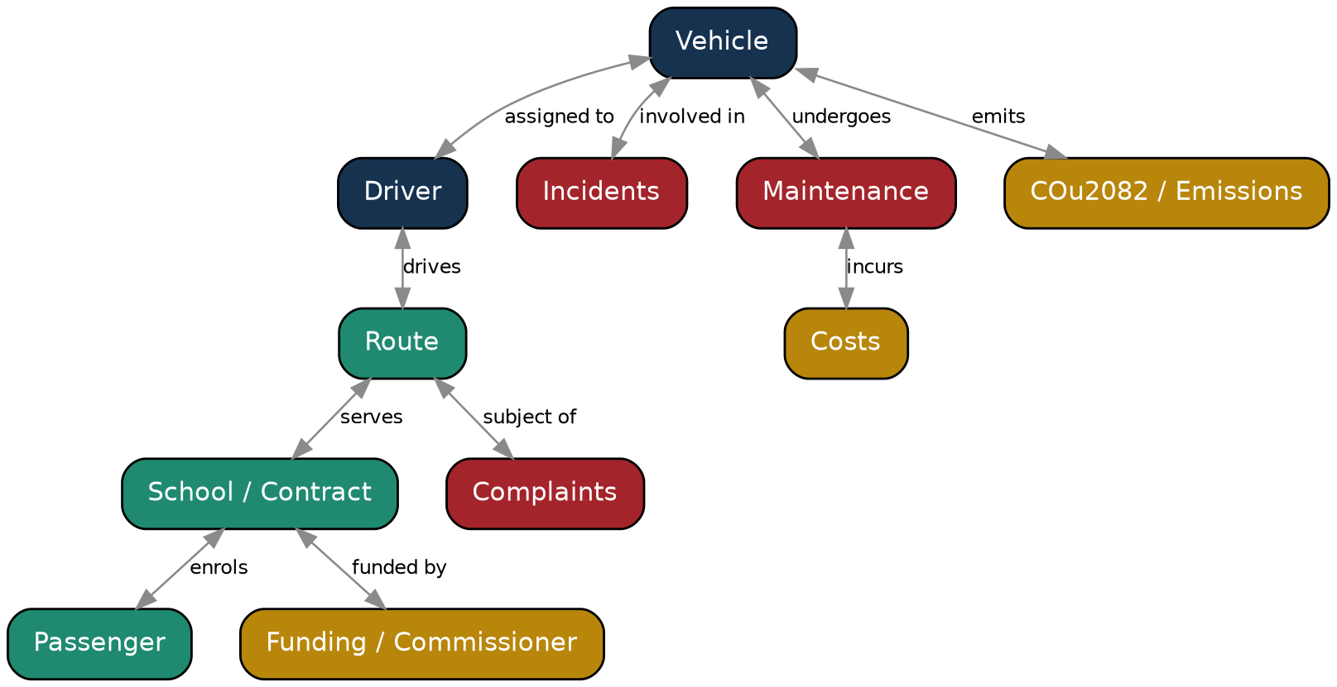
Figure 9. A representative slice of the Veyvio knowledge graph — the same entities already in the schema (Technical Implementation Specification §2), explicitly connected.
- Implementation shape: a graph projection maintained alongside the relational schema, populated from the same event stream as the Digital Twin — not a replacement for the relational system of record, a query layer for the class of cross-entity question relational tables are genuinely bad at answering quickly.
- This is what makes natural-language and AI-assisted querying viable without an explosion of custom reports: the graph is the thing an AI reasons over; the relational schema remains the thing that guarantees correctness and tenant isolation.
What's Still Missing
Five more, less glamorous but exactly what separates enterprise software from a good product.
6. Governance Engine
Not permissions — governance. Every approval, override, policy change, feature flag, API key, workflow and configuration change should answer: who approved it, why, when, when does it expire, and should it be reviewed.
- This elevates and unifies several things already scattered through the spec — rule overrides (Technical Implementation Specification §6.4), configuration versioning (§5), API key issuance (§3.1), privileged support access (§3.8) — into one governed-action model instead of several similar-but-separate mechanisms.
- New entity shape: governance_record (subject_type, subject_id, action, approved_by, reason, approved_at, expires_at, review_due_at, status), which the Compliance Readiness Score and Audit Packs (Enterprise Capability Extensions §2–§3) can then treat as a single, complete evidence source rather than assembling it from five different tables.
7. Operational Playbooks
Click “Vehicle Breakdown” and Veyvio launches the correct sequence, guided, no thinking required: notify passengers, notify control, notify maintenance, arrange a replacement, log evidence, start the insurance process, update ETA, close the incident.
- This extends the Incident Response workflow already specified (Technical Implementation Specification §10.4) from one generic flow into a library of named, configurable playbooks — Vehicle Breakdown, Passenger Incident, Safeguarding Concern, Severe Weather Disruption, and tenant-defined ones.
- A playbook is configuration, not code: an ordered set of steps, each mapped to an API call, event or notification that already exists in the catalogue (§3–§4) — built in the Configuration Centre (§5), not shipped as a release.
8. Business Continuity
What happens when the cloud provider goes down, the database goes down, the internet at a depot goes down, a driver's phone dies, a driver loses signal, or a council API fails — documented and designed for, not discovered live.
Failure | Designed behaviour
Cloud/infrastructure provider outage | Documented RTO/RPO per service tier; Command shows an explicit outage state (§7.3 of the Technical Implementation Specification) — never falls back to mock or cached-as-live data
Database unavailable | Read replicas / failover per the deployment architecture (§1.4); writes queue where the client supports offline (Driver, Yard)
Depot loses internet | Yard and Driver apps continue on local offline queues (already specified, §7 of each companion blueprint) with idempotent sync on reconnect
Driver's device fails or loses signal | Paper/verbal fallback procedure documented per tenant; Command shows the driver's last-known state with an explicit staleness age, never as live
Third-party API failure (council, tachograph provider) | Integration Service degrades to last-known-good data with a visible staleness flag (Enterprise Capability Extensions §1.2) — never silently treated as current
This section is largely making explicit, and completing the coverage of, decisions already implicit elsewhere in the spec — the gap is a single documented reference, not new engineering in most rows above.
9. Customer Success Centre
When a new operator signs up, Veyvio should onboard them, not just provision them: guided wizard, short videos, a task checklist, a health score, usage visibility, training, and a support path — the self-serve layer that makes §3.2 of the master blueprint's onboarding checklist something a new tenant can complete themselves with confidence.
- Health score: reuses the Compliance Readiness Score model (Enterprise Capability Extensions §2) but scored from the onboarding/adoption side — checklist completion, feature usage breadth, time-to-first-live-trip — so Veyvio's own team can see which tenants need help before the tenant has to ask.
- This is the difference between a platform operators buy once and struggle to configure, and one they can actually get live on themselves — directly supporting the “configuration before customisation” principle (Platform Principles document).
The Overall Shape
Keep going in this direction and the destination isn't “another transport management system” — it's a transport operating platform that community transport, commercial PSV operators, councils and contracted services can all run on the same core engine, configured differently for each. That means resisting the pull toward more surface-level features from here and instead making every capability already specified deeper, more connected, and more configurable. That depth and connectedness — not the feature list — is what's genuinely hard for a competitor to replicate.
VEYVIO
Vehicle Ecosystem, Yard Visibility and Intelligent Operations
ENTERPRISE CAPABILITY & MARKET POSITIONING EXTENSIONS
Integration Architecture · Compliance Passports · Readiness Scoring · Audit Management · Sustainability · Brand
Version 1.0, 24 July 2026 — extends the Technical Implementation Specification
1. Integration Architecture
Enterprise strength principle: Veyvio does not talk directly to specialised regulated hardware (tachographs, telematics units, card readers). It integrates with established, already-certified provider platforms via secure APIs. Building and maintaining a hardware reader is a certification and liability burden that adds no product differentiation — the differentiation is what Veyvio does with the data once it arrives.
1.1 Integration Principles
- Every external integration is an adapter behind the Integration Service layer, calling out through the same governed patterns as everything else in §1 of the Technical Implementation Specification — versioned contracts, signed payloads, idempotent consumers, full audit logging.
- Prefer a provider's official API over screen-scraping, file-drop, or reverse-engineered protocols — official APIs carry a support relationship and a stability contract that ad-hoc integrations don't.
- Secrets for every provider integration live in the managed secrets vault (Technical Implementation Specification §3.9 conventions extend to third-party credentials, not just Veyvio's own); no provider credential is ever stored in application code, mobile bundles or logs.
- Every inbound provider feed has an explicit staleness/failure state that is shown to the user, never silently masked by falling back to assumed-good data — the same principle already applied to Command's backend-availability handling (Technical Implementation Specification §7.3).
1.2 Tachograph and Telematics Integration
Veyvio integrates with an existing tachograph/telematics software provider's API rather than reading tachograph or telematics hardware directly. This is both the lower-risk engineering choice (no DVSA type-approval burden on Veyvio itself) and the faster path to reliable data, since remote-download and card-management infrastructure already exists in the market and is what operators are already using.
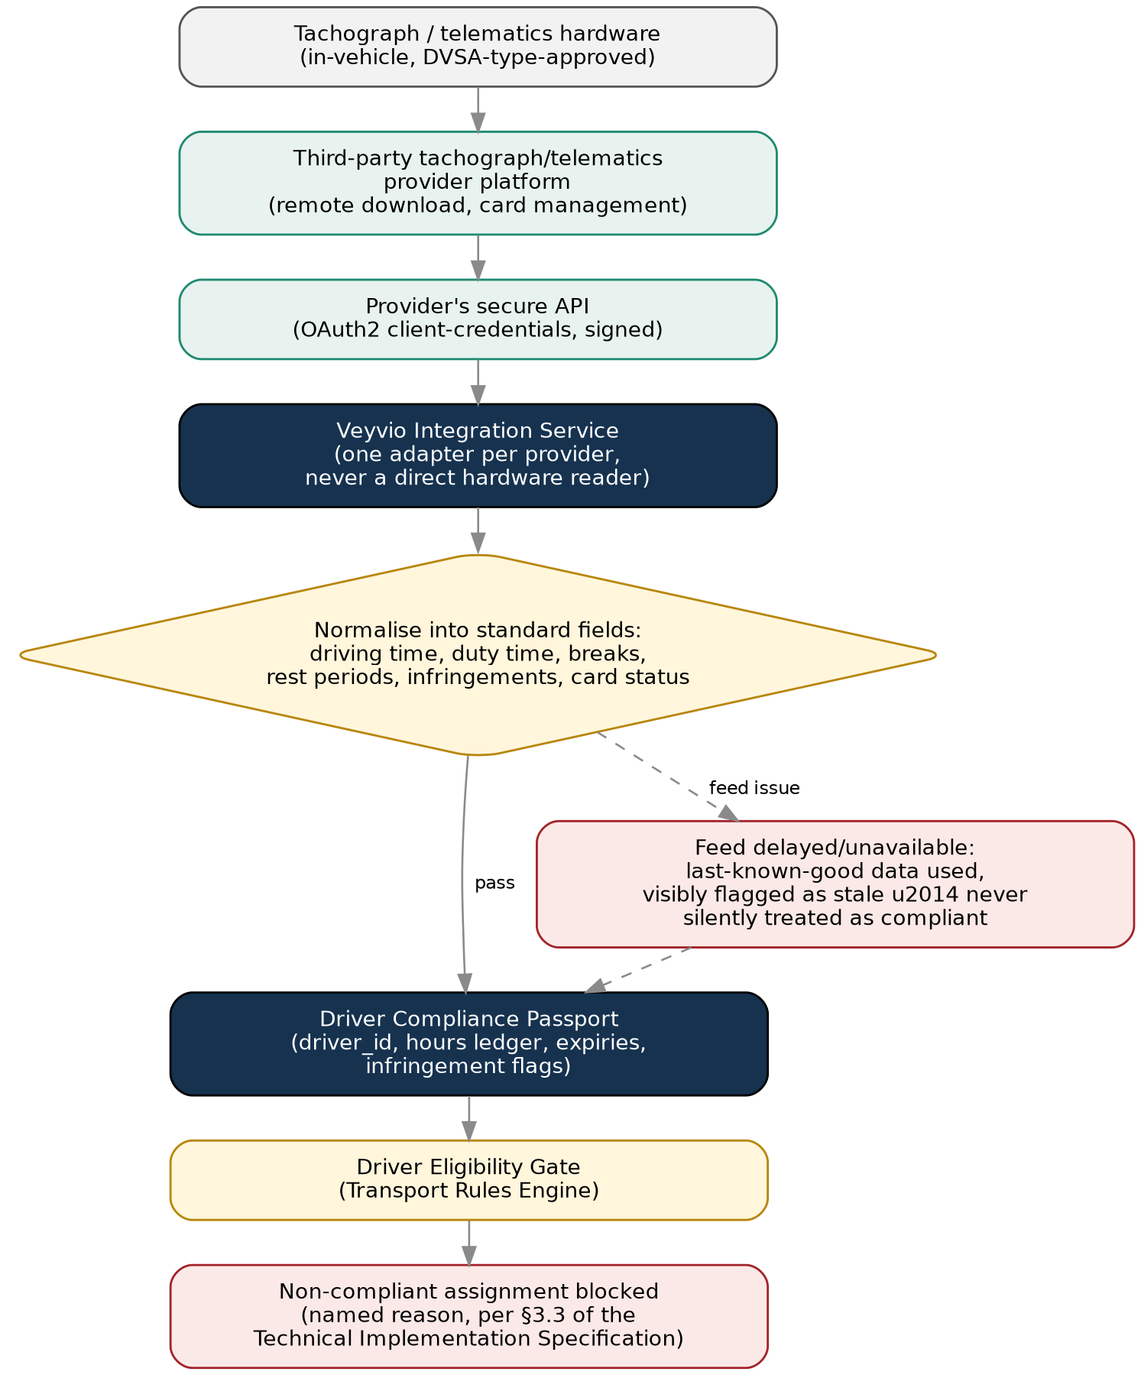
Figure 8. Tachograph data reaches the Driver Eligibility Gate through a provider API and a normalisation step — never through Veyvio talking to hardware directly.
Provider integration contract requirements
- Authentication via OAuth2 client-credentials or a scoped API key per tenant, never a shared platform-wide credential across tenants.
- Either a webhook (preferred, real-time) or a scheduled poll for new remote-download records, driver card events and infringement flags.
- A defined data-processing agreement covering retention, since tachograph records include personal driving-time data.
- Preference for providers offering DVSA-recognised remote download compliant with the digital tachograph regulations, so the same feed can satisfy both Veyvio's internal gate and the operator's separate regulatory download obligation.
Normalised fields consumed
Field | Source | Used by
driving_time_today / this_week | Provider API (tachograph record) | Driver Eligibility Gate duty-time check (Regulatory & Standards Addendum §B)
duty_time_today | Provider API | GB domestic 11-hour daily duty limit check
breaks_taken | Provider API | 5.5-hour continuous-driving break rule check
infringements[] | Provider API (flagged events) | Compliance Manager alerting; Driver Compliance Passport
card_status / card_expiry | Provider API (driver card) | Driver Eligibility Gate identity/entitlement check
feed_last_synced_at | Integration Service (own timestamp) | Staleness flag shown wherever hours data is displayed
1.3 Driver Compliance Passport
A single, always-current, exportable view of one driver's compliance status — the canonical answer to “can this person legally and safely drive right now”, combining every signal the Driver Eligibility Gate already checks plus the tachograph-derived hours ledger, in one place a compliance manager or auditor can read without cross-referencing five screens.
- Contents: licence category and expiry; CPC or MiDAS status (per operating basis); DBS type, expiry and barred-list scope; medical declarations; tachograph-derived hours/breaks/infringements (§1.2); training records; current Eligibility Gate status with reasons for any active block.
- API: GET /api/v1/drivers/{id}/compliance-passport — returns the live JSON view; a PDF export variant feeds the Audit Management module (§3).
- The passport is a read view over existing entities (driver, document, compliance_check, plus the tachograph-derived duty ledger), not a duplicate data store — it is always exactly as current as the underlying records, never a stale snapshot unless explicitly exported.
1.4 Vehicle Compliance Passport
The vehicle equivalent: one view combining everything the Vehicle Readiness Gate checks, for the same reason — a single, exportable source of truth per vehicle.
- Contents: MOT/annual test status and expiry; PSVAR compliance status (Regulatory & Standards Addendum §C); PMI history and next-due date; insurance; open and historical defects; VOR history with reasons; accessibility-equipment inspection status (LOLER/PUWER).
- API: GET /api/v1/vehicles/{id}/compliance-passport, with the same live-view and PDF-export pattern as the driver passport.
2. Compliance Readiness Scoring
A single 0–100 score per tenant (and per depot) that answers “how ready would we be if an auditor walked in today” — recalculated on every relevant event, not on a nightly batch, so it is never stale when it matters.
Signal | Weight | Source
% drivers with a fully compliant Eligibility Gate | 30% | Driver & Compliance service
% vehicles with a fully compliant Readiness Gate | 30% | Fleet & Vehicle Readiness service
Open high-severity defects past their target resolution window | 15% | Yard / Maintenance
Documents expired or expiring within 7 days, unactioned | 15% | Reporting (document.expiring)
Safety-critical rule overrides in the last 30 days | 10% | Audit log (§6.4 of the Technical Implementation Specification)
- Bands: Green ≥ 90 (audit-ready), Amber 70–89 (action needed, not yet blocking), Red < 70 (material compliance risk — surfaced to the Board of Trustees / Director role, not just Operations).
- The score recalculates on the same events already flowing through the platform (driver.compliance_changed, vehicle.readiness_changed, document.expiring, incident.created) — it is a consumer of existing events, not a new source of truth.
- Shown on the Command dashboard (Live Ops overview) and as the executive-summary page of every Audit Pack (§3).
- Scoring weights are tenant-configurable in the Configuration Centre, since a school-transport-heavy operator and a Dial-a-Ride-heavy operator may reasonably weight risk differently.
3. Audit Management Module
Produces exportable, role-scoped evidence packs for the audiences that actually ask for them — DVSA, the Traffic Commissioner, a council commissioner, an insurer — so “prepare for an audit” becomes a workflow instead of a fire drill.
3.1 Entities
Entity | Keys | Purpose
audit_pack | id (PK), tenant_id (FK), requested_by (FK) | One export job: scope, date range, audience type, status
audit_pack_item | id (PK), audit_pack_id (FK), item_type, item_ref | Links a pack to the specific passports/logs/reports it contains
3.2 Role-Based Pack Content
The same underlying evidence, scoped differently by audience — an insurer never receives safeguarding data they have no lawful basis to see, matching the special-category-data access rules in §2.2 of the Technical Implementation Specification.
Audience | Included | Excluded
DVSA / Traffic Commissioner | Vehicle Compliance Passports, PMI history, driver hours ledger, defect/VOR history, Compliance Readiness Score summary | Passenger personal data not relevant to vehicle/driver compliance
Council commissioner (contract audit) | Compliance Readiness Score, service delivery reports, relevant driver/vehicle passports for the contracted routes | Unrelated tenant-wide operational data outside the contract scope
Insurer | Incident log, Vehicle Compliance Passports | Safeguarding flags, DBS results, passenger medical/behavioural notes
Internal Board / Trustees review | Compliance Readiness Score, audit log summary, override log | Raw passenger and safeguarding data (summarised, not itemised)
3.3 Workflow
- Requester selects audience type, scope (tenant-wide or specific depot/contract) and date range.
- System compiles the pack automatically from existing passports, logs and reports — no manual evidence-gathering.
- Compliance Manager reviews and approves before export, for anything beyond a routine internal report.
- Export as PDF (readable pack) and/or structured ZIP (raw records) as required by the requesting audience.
- Every export is itself an audit_log entry — who requested it, for whom, and when — so “who has seen our compliance data” is answerable.
APIs
Method | Route | Purpose
POST | /api/v1/audit-packs | Request a new pack (audience, scope, date range)
GET | /api/v1/audit-packs/{id} | Status and, once approved, download links
POST | /api/v1/audit-packs/{id}/approve | Compliance Manager approval step
4. Sustainability Dashboard
Supports tenant net-zero commitments and, increasingly, the ESG evidence that council and NHS-adjacent commissioners require from suppliers. Built on data the platform already has or already integrates (§1), not a new hardware requirement.
- Fleet composition: proportion of the fleet by fuel type (diesel, hybrid, electric) and its trend over time.
- Estimated CO2e per mile and per trip, calculated from vehicle fuel type and trip mileage — telematics-integrated tenants (same integration pattern as §1, via a provider API) get measured mileage rather than estimated.
- Emissions-zone compliance (ULEZ/CAZ and similar) status per vehicle, cross-referenced against routes that enter a zone.
- Idle-time and eco-driving indicators where the telematics integration provides them.
- Tenant-configurable net-zero target year with interim milestones; the dashboard shows current position against the trajectory needed to hit the target, not just a raw current-state number.
This dashboard is informational and strategic, not a dispatch gate — it feeds Board/Director reporting and Audit Packs for commissioners requiring ESG evidence, but it never blocks an assignment the way the Eligibility/Readiness gates do.
5. Brand and Market Positioning
Veyvio's engineering discipline (gates that actually block, audit trails that actually hold up, tenant isolation that's structural not incidental) is the product's real competitive advantage — the positioning below is written to sell that discipline as an outcome, not to list it as a feature.
5.1 Positioning Principle: Outcomes, Not Features
Capability (what it is) | Outcome message (what to say)
Driver Eligibility Gate | Never dispatch a driver who isn't legally allowed to drive that duty — the system won't let it happen.
Vehicle Readiness Gate | Every vehicle on the road is roadworthy, compliant and accounted for — automatically, not on trust.
Tenant isolation | Your data is never visible to another operator on the platform — structurally, not by policy.
Compliance Passports | Answer any DVSA or commissioner question about a driver or vehicle in seconds, not days.
Compliance Readiness Score | Know your audit exposure before the auditor does.
Audit Management Module | Turn ‘prepare for an audit’ from a week of scrambling into a five-minute export.
Configuration Centre | Change a policy without waiting for a software release.
Sustainability Dashboard | Prove your net-zero progress to funders and commissioners with real data, not estimates.
5.2 Enterprise Positioning Statement
For passenger transport operators who cannot afford a compliance failure — a missed DBS renewal, an unroadworthy vehicle on a school run, a safeguarding data breach — Veyvio is the operations platform where safety and compliance are enforced by the system itself, not left to memory. Where other transport software tracks information, Veyvio acts on it: it will not let an unqualified driver be assigned, will not let a non-compliant vehicle be dispatched, and will not let one operator's data leak into another's.
5.3 Brand Pillars
Pillar | What it means | Proof point in the product
Safety | Safety is enforced, not requested. | Gates block unsafe assignment/dispatch outright — they don't just warn.
Trust | Your data, your boundary, no exceptions. | Structural tenant isolation enforced at query, API and (where supported) database-policy level.
Operational Excellence | Every process is unambiguous and auditable. | State-machine-driven workflows, full event trail, immutable audit log.
Simplicity | Powerful, but never confusing at the point of use. | Exception-led dashboards; drivers get one clear next action, not a dashboard to interpret.
Configurability | Your policy, not a hardcoded assumption. | Rules and workflows live in the Configuration Centre — a policy change is a config change, not a release.
5.4 Visual Identity Direction
- Palette: deep navy as the primary authority/trust colour, paired with a confident teal for safety, movement and “live” states — avoiding the generic light-blue “SaaS blue” that reads as interchangeable with every other B2B product.
- Typography: a clean, geometric sans throughout (matching the Calibri-based system used across this document set for consistency) — confident and legible at a glance on a driver's phone in daylight, not just on a desktop dashboard.
- Amber and red are reserved exclusively for genuine warning/blocking states (as used consistently throughout this document set) — never used decoratively, so when a user sees amber or red, it means something.
- Tone of voice: direct, specific, unafraid of naming the exact rule or reason (“DBS expired 2026-06-30”, not “something went wrong”) — the brand voice mirrors the product's own error-message philosophy in §3.9 of the Technical Implementation Specification.
5.5 Illustrative Website Messaging
Draft, not final copy — intended to show the outcome-led tone in practice.
Hero headline: “The transport platform that won't let a mistake become an incident.”
Subhead: Veyvio enforces driver and vehicle compliance at the point of dispatch — not in a spreadsheet review three weeks later.
- Pillar 1: “Compliance that enforces itself.” Gates that block, not dashboards that nag.
- Pillar 2: “Audit-ready, every day.” A live Compliance Readiness Score and a five-minute audit pack export.
- Pillar 3: “Your operation, your rules.” Configure policy without waiting on engineering.
VEYVIO
Vehicle Ecosystem, Yard Visibility and Intelligent Operations
TECHNICAL IMPLEMENTATION SPECIFICATION
Architecture · Database Schema · API Catalogue · Events · Configuration Centre
Transport Rules Library · Application Access Control · Companion App Blueprints · Capability Matrix
Parent document | Veyvio Master Product & Technical Blueprint v1.0 (24 July 2026)
This document | Version 1.0, 24 July 2026 — Confidential product planning document
Purpose | Turn the master blueprint's requirements into a concrete, buildable specification: real entities, real endpoints, real events, real rule structures
Audience | Engineering teams and AI coding tools implementing Veyvio; product/design for cross-checking behaviour
Status | Living specification — versioned alongside the codebase, not a one-time document
Table of Contents
1. System Architecture Blueprint3
2. Database Schema Blueprint5
3. API Endpoint Catalogue8
4. Event & Webhook Architecture12
5. Configuration Centre Specification14
6. Transport Rules Library16
7. Application Access Control17
8. Companion Application Blueprints20
9. Platform Capability Matrix22
10. Core Workflows24
1. System Architecture Blueprint
Veyvio is a set of persona-specific applications (Command, Driver, Yard, Maintenance, Customer, Platform Console) that all call the same governed backend — no application talks to another application directly, and no application implements its own copy of business logic. This is the rule that makes the rest of the specification enforceable: if two apps ever need the same fact (e.g. “is this vehicle roadworthy”), they call the same API and get the same answer.
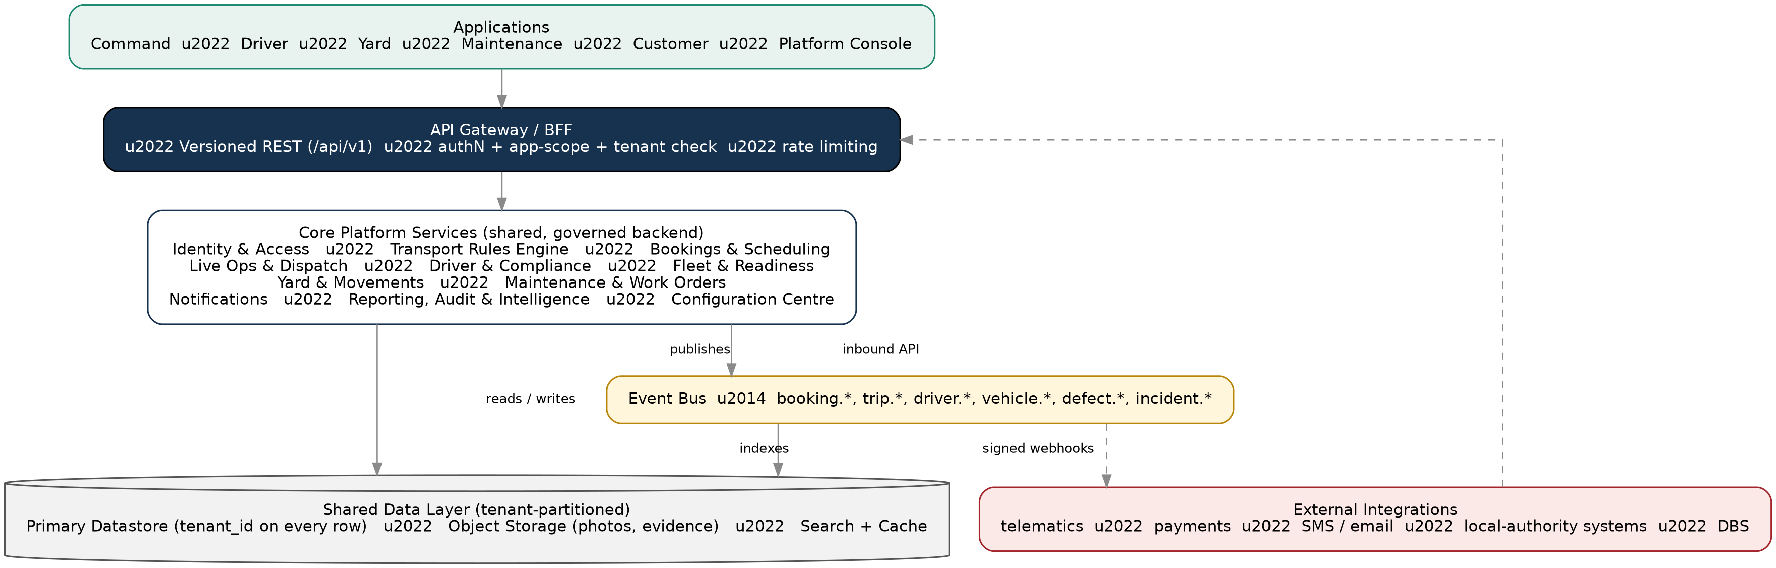
Figure 1. High-level system architecture — applications, gateway, core services, event bus, shared data layer, integrations.
1.1 Architectural Principles
- Shared backend, separate frontends. Command, Driver, Yard, Maintenance and Customer are independently releasable frontends. They share zero frontend code and 100% of business logic, which lives behind the API Gateway.
- Tenant isolation is structural, not incidental. Every tenant-owned row carries an immutable tenant_id. Isolation is enforced at query layer (ORM-level tenant scoping helpers that cannot be bypassed), at the API layer (gateway rejects any token/resource tenant mismatch), and, where the datastore supports it, at the database-policy layer (row-level security) as a defence-in-depth backstop — not the only control.
- Deny-by-default everywhere. Unknown roles, missing app scopes, expired sessions, inactive users and tenant mismatches are rejected by default; access must be explicitly granted, never implicitly inherited.
- Rules live in configuration, not code. Compliance thresholds, wheelchair policy, luggage limits and notification rules are data (see §5, §6), versioned and tenant-overridable, so a policy change is a configuration change, not a deployment.
- Every write is an event. Services publish domain events for every material state change; Notifications, Reporting/Audit and external webhook consumers all subscribe to the same event stream rather than being called synchronously and coupling services together.
1.2 Tenant Hierarchy
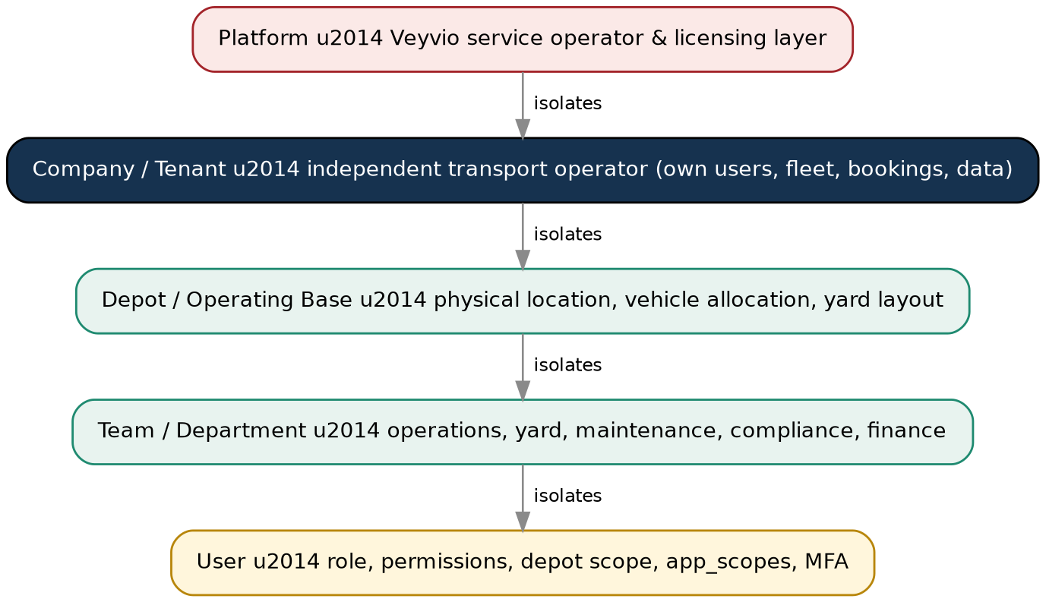
Figure 2. Tenant hierarchy — each level narrows scope and adds its own controls.
Platform administrators provision tenants but do not automatically inherit operational visibility into them (see §7). A Company/Tenant is the true data-isolation boundary; Depot and Team are scoping/organisational layers within it used for assignment, permissions and reporting, not separate security domains.
1.3 Service Boundaries
Ten core services sit behind the gateway. Each owns its own data and is the only writer to it; other services read via API or subscribe to its events — never by querying another service's tables directly.
Service | Owns | Primary consumers
Identity & Access | Users, roles, permissions, sessions, MFA, app scopes, API keys | Every other service (authZ checks)
Transport Rules Engine | Rule definitions, evaluation, overrides, explainability | Bookings, Driver & Compliance, Fleet & Readiness
Bookings & Scheduling | Bookings, recurrence templates, school routes, Dial-a-Ride requests | Live Ops & Dispatch, Notifications
Live Ops & Dispatch | Trips, assignments, transfers, exceptions, live status | Driver app, Command map/timeline
Driver & Compliance | Driver profiles, licences, CPC/MiDAS, DBS, duty-time ledger | Rules Engine, Live Ops & Dispatch
Fleet & Vehicle Readiness | Vehicles, PSVAR/MOT/PMI status, VOR state, equipment | Yard, Maintenance, Live Ops & Dispatch
Yard & Movements | Bay locations, checks, movements, keys, defect capture | Fleet & Vehicle Readiness, Maintenance
Maintenance & Work Orders | Work orders, parts, costs, return-to-service approvals | Fleet & Vehicle Readiness
Notifications | Templates, channels, delivery, preferences | Event Bus (subscriber only)
Reporting, Audit & Intelligence | Immutable audit log, analytics, exports | Event Bus (subscriber only)
1.4 Deployment and Environments
- Environments: dev → staging (production-like, synthetic tenants only) → production. No environment other than dev may contain mock or placeholder operational data — this directly closes the “Command running in hybrid mock mode” gap from the prior audit (see §7).
- Each core service is independently deployable behind the shared API contract; a service cannot ship a breaking change to a consumed endpoint without a version bump (§3.1) and a deprecation window.
- Feature flags and configuration (§5) are environment- and tenant-scoped, with production changes to high-risk configuration requiring an approval step.
2. Database Schema Blueprint
Every tenant-owned table below carries tenant_id as a mandatory, immutable, indexed column. Primary keys are UUIDs (not sequential integers) to avoid leaking record counts or enabling ID-guessing across tenants — this is also the first line of defence against the Broken Object-Level Authorization pattern discussed in §7.
2.1 Core Entities
Entity | Keys | Relationships | Indexes | Retention
tenant | id (PK) | — (root) | unique(id) | Retained for contract duration + 7 yrs (financial/audit)
depot | id (PK), tenant_id (FK) | belongs to tenant | idx(tenant_id) | As parent tenant
user_account | id (PK), tenant_id (FK), role_id (FK), depot_id (FK, nullable) | belongs to tenant; has role; scoped to depot(s) | idx(tenant_id, email) unique; idx(role_id) | Active + 7 yrs post-offboarding (employment record)
role | id (PK), tenant_id (FK, nullable for platform roles) | has many permissions; has many users | idx(tenant_id) | As parent tenant
driver | id (PK), tenant_id (FK), user_id (FK) | extends user_account; has many compliance_check | idx(tenant_id, user_id) unique; idx(licence_expiry); idx(dbs_expiry) | 7 yrs post-employment (PSV compliance record norm)
vehicle | id (PK), tenant_id (FK), depot_id (FK) | has many trip, defect, work_order, compliance_check | idx(tenant_id, registration) unique; idx(mot_expiry); idx(next_pmi_due) | Fleet record + 15 months minimum post-disposal (DVSA minimum)
passenger | id (PK), tenant_id (FK) | has many booking; has many guardian (self-referential) | idx(tenant_id); idx(safeguarding_flag) | Per tenant safeguarding/retention policy; special-category data — see §6
recurrence_template | id (PK), tenant_id (FK) | has many booking (generated instances) | idx(tenant_id, active) | As parent tenant
booking | id (PK), tenant_id (FK), passenger_id (FK), recurrence_id (FK, nullable) | generates trip; belongs to passenger | idx(tenant_id, requested_time); idx(status) | 7 yrs (contract/financial record)
route | id (PK), tenant_id (FK), school_id (FK, nullable) | has many stop; used by booking/trip | idx(tenant_id) | As parent tenant
trip | id (PK), tenant_id (FK), booking_id (FK), driver_id (FK), vehicle_id (FK) | planned/revised/actual states stored separately (never overwritten) | idx(tenant_id, planned_start); idx(driver_id); idx(vehicle_id) | 7 yrs (safety/compliance record)
defect | id (PK), tenant_id (FK), vehicle_id (FK), reported_by (FK), work_order_id (FK, nullable) | belongs to vehicle; may link to work_order | idx(tenant_id, status); idx(vehicle_id) | 15 months minimum (DVSA); recommend 7 yrs
work_order | id (PK), tenant_id (FK), vehicle_id (FK), defect_id (FK, nullable), technician_id (FK) | belongs to vehicle; may originate from defect | idx(tenant_id, status); idx(vehicle_id) | 15 months minimum (DVSA); recommend 7 yrs
incident | id (PK), tenant_id (FK), trip_id (FK, nullable), reported_by (FK) | may link to trip; has many action | idx(tenant_id, severity); idx(trip_id) | Per insurer/legal requirement, typically 7 yrs+
document | id (PK), tenant_id (FK), owner_type, owner_id, file_ref | polymorphic owner (driver, vehicle, passenger, tenant) | idx(tenant_id, owner_type, owner_id); idx(expiry_date) | Per document type; DBS certs not stored beyond legal minimum
rule_definition | id (PK), tenant_id (FK, nullable for platform defaults), version | referenced by compliance_check | idx(tenant_id, rule_type, effective_from) | All versions retained (audit trail of policy history)
compliance_check | id (PK), tenant_id (FK), subject_type, subject_id, rule_id (FK) | polymorphic subject (driver or vehicle) | idx(tenant_id, subject_type, subject_id); idx(checked_at) | As parent driver/vehicle record
notification | id (PK), tenant_id (FK), recipient_id (FK), template_id (FK) | belongs to recipient (user or passenger) | idx(tenant_id, status); idx(recipient_id) | 13 months (support/complaint window)
audit_log | id (PK), tenant_id (FK), actor_id (FK), resource_type, resource_id | append-only, immutable, no update/delete permitted | idx(tenant_id, resource_type, resource_id); idx(timestamp) | 7 yrs minimum; longer for safeguarding-related entries
event_outbox | id (PK), tenant_id (FK), event_name, version, payload | source of truth for event bus delivery (transactional outbox pattern) | idx(tenant_id, delivered); idx(event_name) | 90 days post-delivery, then archived
2.2 Schema Rules
- Soft delete only for tenant-facing entities (a deleted_at timestamp, never a hard DELETE) so audit history and referential integrity survive; hard deletion is a separate, permissioned, logged “purge” operation used only to satisfy a data-subject erasure request or contractual end-of-life, and is itself audit-logged before the record disappears.
- planned / revised / actual state columns on trip are never overwritten in place — each replanning event inserts a new revised-state row referencing the original, so the operational history described in the master blueprint's Live Operations section (§8.2) is queryable, not reconstructed from logs.
- Special-category data (safeguarding flags, DBS results, medical/behavioural notes, ethnicity/disability monitoring data) is held in narrower-access tables with field-level encryption at rest and a separate, smaller default role list — not simply a flagged column on a general-access table.
- Every schema migration is version-controlled with a paired rollback script and must pass a staging validation run against a production-shaped (synthetic) dataset before it is eligible for production deployment.
2.3 Validation and Audit Field Conventions
Every table in §2.1 carries the same standard audit block in addition to its own columns, so “who changed what, and when” never depends on remembering to add it per-entity:
Field | Type | Rule
id | UUID | Generated server-side; never client-supplied.
tenant_id | UUID (FK) | Immutable after insert; never updatable via API.
created_at / created_by | timestamp / FK user_account | Set once, server-side, on insert.
updated_at / updated_by | timestamp / FK user_account | Set on every write; drives optimistic-concurrency checks (If-Match / version).
deleted_at | timestamp, nullable | Soft delete only (§2.2); a non-null value excludes the row from all default queries.
schema_version | int | Row-level version marker so old rows can be migrated lazily rather than in one blocking pass.
Field-level validation is enforced server-side (never trusted from the client) and rejected requests return the machine-readable error shape from §3.9. Two entities illustrate the pattern at the depth every entity should reach before implementation:
vehicle — illustrative validation rules
- registration: required, unique per tenant, matches UK VRM format.
- seats: required, integer, 1–80.
- wheelchair_capacity: integer ≥ 0; cannot exceed seats.
- psvar_status: enum [fully_compliant, partially_compliant, non_compliant]; non_compliant blocks assignment to any route flagged school or rail_replacement from 2026-07-31 (Regulatory & Standards Addendum §C).
- pmi_interval_weeks: integer, 1–13; values above 6 require an attached Traffic Commissioner approval reference (§2.2 compliance data class).
- mot_expiry, next_pmi_due: required dates once status leaves onboarding_incomplete (§10.3); both drive document.expiring events.
driver — illustrative validation rules
- licence_category: required, enum matching DVLA categories relevant to PSV/D1 work.
- cpc_expiry: required only where the owning tenant's operating_basis = psv_standard (§5.2); null otherwise.
- midas_expiry: required where operating_basis ∈ {section_19, section_22, psv_restricted}; must be re-issued at 4-year intervals (Regulatory & Standards Addendum §B).
- dbs_type / dbs_expiry / barred_list_scope: required whenever the driver is eligible to be assigned to any route serving children or vulnerable adults; enforced by the Driver Eligibility Gate (§3.4), not by this table alone.
- duty_ledger entries: append-only; a rolling calculation, never a manually-editable total, so the 10-hour/11-hour/5.5-hour thresholds (Regulatory & Standards Addendum §B) cannot be edited around.
3. API Endpoint Catalogue
All endpoints are versioned under /api/v1, return JSON, and require a bearer token carrying tenant_id, app_scopes and role/permission claims (see §7). Every endpoint below is checked at the gateway for token validity, tenant match, app scope and permission before it reaches business logic. This catalogue shows representative endpoints per domain; the full OpenAPI document is the authoritative, exhaustive source and should be generated from the same schema definitions used here so the two never drift apart.
3.1 Identity & Access
Method | Route | Purpose | App scope | Permission
POST | /api/v1/auth/login | Authenticate, issue tokens (MFA step-up as required) | public | —
POST | /api/v1/auth/refresh | Rotate access token using refresh token | any | session valid
POST | /api/v1/auth/logout | Revoke current session | any | session valid
GET | /api/v1/users/me | Current user profile, roles, app scopes | any | self
POST | /api/v1/users | Create user and assign role/depot/app scopes | app.command | users.manage
PATCH | /api/v1/users/{id}/scopes | Grant/revoke application scopes | app.command | users.manage.scopes
POST | /api/v1/api-keys | Issue a scoped machine-to-machine API key | app.command | integrations.manage
3.2 Bookings & Scheduling
Method | Route | Purpose | App scope | Permission
POST | /api/v1/bookings | Create a booking (general, Dial-a-Ride or school route) | app.command, app.customer | bookings.create
GET | /api/v1/bookings/{id} | Retrieve booking detail | app.command, app.customer | bookings.read
POST | /api/v1/bookings/{id}/cancel | Cancel with reason code | app.command, app.customer | bookings.cancel
POST | /api/v1/recurrence-templates | Create a recurring transport template | app.command | bookings.manage
POST | /api/v1/recurrence-templates/{id}/regenerate | Regenerate future instances after a change | app.command | bookings.manage
POST | /api/v1/bookings/{id}/transfer | Move a job to another trip/driver/vehicle | app.command | dispatch.transfer
Example — create booking
POST /api/v1/bookings
Authorization: Bearer <token: tenant_id, app.command, bookings.create>
{
"passenger_id": "b7e1...",
"service_type": "dial_a_ride",
"pickup": { "address": "12 Elm St", "lat": 51.50, "lng": -0.12 },
"dropoff": { "address": "Riverside Clinic", "lat": 51.49, "lng": -0.10 },
"requested_time": "2026-08-04T09:15:00Z",
"mobility_requirements": ["wheelchair"],
"escort_required": false
}
201 Created
{ "id": "bk_9f2a", "status": "pending_allocation", "rule_evaluation": {
"wheelchair_capacity_check": "pass", "luggage_limit_check": "not_applicable" } }
3.3 Live Operations & Dispatch
Method | Route | Purpose | App scope | Permission
GET | /api/v1/trips | List trips (filter by date, driver, vehicle, status) | app.command, app.driver | trips.read
POST | /api/v1/trips/{id}/assign | Assign driver + vehicle (runs Eligibility + Readiness gates) | app.command | dispatch.assign
PATCH | /api/v1/trips/{id}/status | Driver-reported status update (started, at-stop, completed) | app.driver | trips.update.own
POST | /api/v1/trips/{id}/exceptions | Raise/acknowledge an operational exception | app.command, app.driver | trips.exception
Example — assign gate rejection
POST /api/v1/trips/tr_4471/assign
{ "driver_id": "drv_221", "vehicle_id": "veh_08" }
422 Unprocessable Entity
{ "error": "eligibility_gate_failed",
"failures": [
{ "gate": "driver.dbs", "reason": "enhanced_dbs_expired", "expired_on": "2026-06-30" },
{ "gate": "vehicle.psvar", "reason": "non_compliant_for_school_route",
"deadline": "2026-07-31" } ] }
3.4 Driver & Compliance
Method | Route | Purpose | App scope | Permission
GET | /api/v1/drivers/{id}/eligibility | Current eligibility-gate evaluation, explainable per rule | app.command, app.driver | drivers.read
PATCH | /api/v1/drivers/{id}/documents | Update licence/CPC/MiDAS/DBS records | app.command | drivers.compliance.manage
GET | /api/v1/drivers/{id}/duty-ledger | Rolling driving/duty hours against domestic or assimilated-rules thresholds | app.command, app.driver | drivers.read
3.5 Fleet & Vehicle Readiness
Method | Route | Purpose | App scope | Permission
GET | /api/v1/vehicles/{id}/readiness | Roadworthiness, legal compliance, maintenance, suitability, yard state | app.command, app.driver, app.yard | vehicles.read
POST | /api/v1/vehicles/{id}/vor | Set/clear Vehicle Off Road status with reason | app.command, app.yard, app.maintenance | vehicles.vor.manage
PATCH | /api/v1/vehicles/{id}/compliance | Update MOT/PSVAR/PMI-interval records | app.command, app.maintenance | vehicles.compliance.manage
3.6 Yard
Method | Route | Purpose | App scope | Permission
GET | /api/v1/yard/tasks | Tasks for a depot (checks, movements, defect follow-up) | app.yard | yard.tasks.read
POST | /api/v1/yard/checks | Submit a guided check result with photos | app.yard | yard.checks.submit
POST | /api/v1/defects | Report a defect (may auto-create linked work order) | app.yard, app.driver | defects.create
3.7 Maintenance
Method | Route | Purpose | App scope | Permission
GET | /api/v1/work-orders | List/filter work orders | app.maintenance | workorders.read
POST | /api/v1/work-orders/{id}/complete | Complete work order, trigger return-to-service approval | app.maintenance | workorders.complete
POST | /api/v1/work-orders/{id}/return-to-service | Approve return-to-service (clears VOR) | app.maintenance | vehicles.vor.manage
3.8 Documents, Notifications, Reporting, Administration
Method | Route | Purpose | App scope | Permission
POST | /api/v1/documents | Upload a document against a driver/vehicle/passenger/tenant | app.command, app.driver, app.maintenance | documents.create
GET | /api/v1/documents?expiring_within=30d | Documents expiring soon (feeds document.expiring event) | app.command | documents.read
GET | /api/v1/notifications/templates | List configured notification templates | app.command | config.notifications.read
GET | /api/v1/reports/compliance-summary | Tenant-wide compliance status export | app.command | reports.read
GET | /api/v1/audit-log | Immutable audit trail, filterable, read-only | app.command, app.platform_admin | audit.read
POST | /api/v1/tenants/{id}/support-access | Time-limited, approved platform-admin support session | app.platform_admin | platform.support_access
3.9 API Conventions
- Explicit versioning at /api/v1; breaking changes ship as /api/v2 with a published deprecation window for v1, never as an in-place behaviour change.
- Idempotency: all POST endpoints that create a resource accept an Idempotency-Key header; retried requests with the same key return the original result rather than creating duplicates — critical for offline-queued mobile writes (§12 of the master blueprint).
- Pagination via cursor (?cursor=...&limit=...) on all list endpoints; no unbounded result sets.
- Errors follow a single shape: { "error": "<machine_code>", "message": "<human text>", "details": [...] } so client apps can branch on error code without string matching.
- Every response is scoped to the caller's tenant_id and resource-ownership — an endpoint never accepts a client-supplied tenant_id; it is always derived from the authenticated token.
4. Event & Webhook Architecture
Services never call each other synchronously for side-effects. A service completes its own transaction, writes to its event_outbox table in the same database transaction (the transactional outbox pattern), and a relay process publishes from the outbox to the event bus — this guarantees an event is never lost or duplicated relative to the write that caused it.
Event | Producer | Consumers | Key payload fields
booking.created | Bookings & Scheduling | Notifications, Reporting, Rules Engine | booking_id, tenant_id, passenger_id, service_type, requested_time
booking.updated | Bookings & Scheduling | Notifications, Reporting | booking_id, tenant_id, changed_fields[]
trip.assigned | Live Ops & Dispatch | Driver app (push), Notifications, Reporting | trip_id, driver_id, vehicle_id, planned_start
trip.started | Live Ops & Dispatch | Command (map), Reporting | trip_id, actual_start, location
trip.completed | Live Ops & Dispatch | Reporting, Notifications, external webhooks | trip_id, actual_end, evidence_refs[]
driver.compliance_changed | Driver & Compliance | Rules Engine, Live Ops & Dispatch, Notifications | driver_id, changed_check, new_status, expiry
vehicle.readiness_changed | Fleet & Vehicle Readiness | Command, Driver app, Live Ops & Dispatch | vehicle_id, readiness_state, reason
vehicle.vor_changed | Fleet & Vehicle Readiness | Command, Yard, Live Ops & Dispatch, Notifications | vehicle_id, vor, reason, set_by
defect.reported | Yard / Driver | Maintenance, Fleet & Vehicle Readiness, Notifications | defect_id, vehicle_id, severity, photos[]
incident.created | Live Ops & Dispatch / Driver | Reporting, Notifications, external webhooks | incident_id, trip_id, severity, description
document.expiring | Reporting (scheduled scan) | Notifications | document_id, owner_type, owner_id, expiry_date, days_remaining
4.1 Event Contract Rules
- Every event carries name, version, tenant_id, produced_at, and a correlation_id linking it back to the API request that caused it.
- Consumers must be idempotent: processing the same event twice (at-least-once delivery) must not create duplicate bookings, notifications or financial records — consumers de-duplicate on event id.
- Ordering is guaranteed only within a single aggregate (e.g. all events for one trip_id arrive in order); cross-aggregate ordering is not guaranteed and must not be assumed.
- Retention: events are retained 90 days post-delivery in the outbox/dead-letter store for replay and debugging, then archived to cold storage.
4.2 Outbound Webhooks (external integrations)
- Payloads are signed (HMAC) with a per-tenant secret; timestamp included and validated on receipt to prevent replay.
- Delivery retries with exponential backoff; after the configured retry budget is exhausted, the event moves to a dead-letter queue visible in Command for manual replay.
- Every delivery attempt (success, failure, retry) is logged to the audit trail with response code and latency.
Example — webhook payload
POST https://tenant-endpoint.example/webhooks/veyvio
X-Veyvio-Signature: sha256=...
X-Veyvio-Timestamp: 1785000000
{
"event": "vehicle.vor_changed", "version": 1,
"tenant_id": "t_2291", "produced_at": "2026-07-24T08:12:00Z",
"data": { "vehicle_id": "veh_08", "vor": true,
"reason": "psvar_non_compliant_school_route", "set_by": "usr_44" } }
5. Configuration Centre Specification
The Configuration Centre is the tenant-scoped administration area where operational rules are set without a code deployment. Configuration is versioned, auditable and reversible, with a test/preview mode before anything goes live — the same discipline as a code release, applied to policy.
5.1 Booking Rules Configuration
- Luggage limits: per service type or vehicle class, in litres or item count; enforced at booking creation and re-checked at assignment.
- Recurrence and exceptions: term-time calendars, holiday exclusions, one-off cancellations that don't break the recurring pattern.
- Cancellation/no-show policy: notice windows, charge rules, passenger notification triggers.
- Multi-stop and shared-ride logic: maximum detour time, maximum co-passengers per vehicle class.
Example — booking rule config
{
"config_type": "booking_rules", "tenant_id": "t_2291", "version": 4,
"effective_from": "2026-08-01",
"luggage_limits": { "standard": { "max_items": 2 }, "dial_a_ride": { "max_items": 4 } },
"cancellation": { "notice_hours": 2, "no_show_charge": false },
"shared_ride": { "max_detour_minutes": 12, "max_copassengers": 6 }
}
5.2 Compliance Configuration
- Which Driver Eligibility Gate checks apply, driven by the tenant's Operating Basis (PSV Standard / Restricted / Section 19 / Section 22 — see the Regulatory & Standards Addendum): CPC required or MiDAS required, drivers'-hours rule set (domestic vs assimilated).
- PMI interval per vehicle (default 6 weeks, operator-adjustable with an approval record referencing the Traffic Commissioner authorisation).
- DBS/barred-list requirements by passenger type (children, vulnerable adults, general public).
5.3 Notification Configuration
- Channel per template (SMS, email, push, in-app) with tenant-level branding.
- Trigger mapping: which event(s) fire which template to which audience (e.g. document.expiring → email to the compliance manager 30/14/7 days out).
- Quiet hours and escalation: a critical alert (e.g. incident.created) bypasses quiet hours; routine reminders do not.
5.4 Workflow Configuration
- Approval chains for high-risk changes (e.g. extending a PMI interval, overriding a rules-engine block) — who must approve, and whether a reason is mandatory.
- Escalation rules for unacknowledged exceptions (late start, missed check-in) — time-to-escalate and next-in-line recipient.
- Test/preview mode: a configuration change can be evaluated against recent real data (read-only) before being made active, and every activation is versioned so it can be rolled back to the previous version in one action.
6. Transport Rules Library
Rules are data (rule_definition rows, §2.1), not application code, and every rule evaluation produces an explainable result — which rule passed, failed, or was overridden, and by whom. This is what lets the 422 example in §3.3 name the exact failing rule instead of a generic “assignment blocked.”
6.1 PSV / Operating-Basis Rules
Encodes the licensing distinctions in the Regulatory & Standards Addendum: which driver/vehicle checks are mandatory given the tenant's Operating Basis, and which passenger types a vehicle may legally carry (Section 19 = organisation members only, not the general public).
{
"rule_type": "operating_basis", "id": "rule_s19_passenger_scope",
"applies_when": { "operating_basis": "section_19" },
"condition": "booking.passenger.membership_status == 'member'",
"on_fail": { "action": "block", "reason": "s19_general_public_prohibited" },
"override": { "allowed": false }
}
6.2 Wheelchair and Accessibility Policy
- Vehicle-level: wheelchair_capacity, ramp/lift type, reference-wheelchair dimension limits (PSVAR Schedule 1) evaluated against the passenger's declared equipment.
- Booking-level: a wheelchair-user booking can only be matched to a vehicle whose PSVAR compliance status is “fully compliant” for school/rail-replacement work, or the assignment is blocked with the deadline reason shown in §3.3.
- Escort requirement: configurable per passenger profile or route (e.g. a school route may require a named escort in addition to the driver).
6.3 Luggage and Capacity Limits
Configured per service type in §5.1 and evaluated at both booking creation (early feedback to the booker) and trip assignment (final check against the specific vehicle), since the vehicle assigned may differ from the class assumed at booking time.
6.4 Overrides
- Every override requires: the permission to override that specific rule class, a free-text reason, and (where the rule is marked high-risk in configuration) a second-person approval before it takes effect.
- Overrides are never silent — they generate an audit_log entry and, for safety-critical rules (e.g. vehicle PSVAR/roadworthiness), a notification to the Compliance Manager role regardless of who performed the override.
7. Application Access Control
This chapter exists because of two specific gaps flagged in the prior audit: Command running in a hybrid mock-data mode, and weak tenant isolation. Both are closed the same way — by moving every access decision to the backend and making it structurally impossible to bypass from a client.
7.1 The Core Rule
Application access is enforced by the backend identity and authorisation layer, never by hiding a navigation item in the UI. Hiding a menu item stops a confused user; it does not stop a driver who manually types the Command URL, opens the app's network tab, or replays a captured API call. Every one of those paths must hit the same backend check and fail the same way.
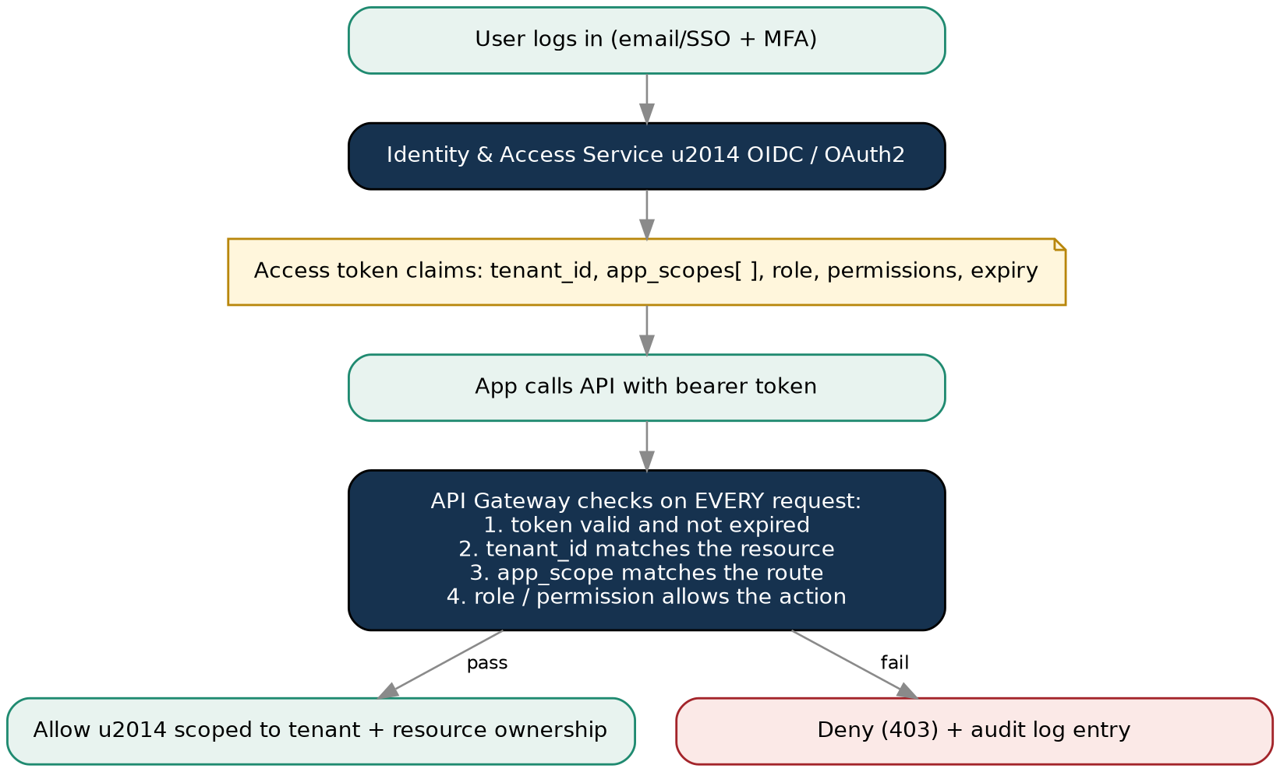
Figure 3. Every request — from any app, by any route — passes through the same four backend checks before it can act.
7.2 Application Scopes
A valid login proves who you are; it does not by itself grant access to any particular Veyvio application. Access to each application is a separate, explicit grant carried as an app_scope claim on the token:
Scope | Application | Notes
app.command | Command / Admin | Controllers, schedulers, managers, compliance, customer service, leadership
app.driver | Driver | Requires an active driver identity, employment/engagement status and required app scope — not granted by default to Command users
app.yard | Yard | Yard managers and depot operatives, invitation-only per depot
app.maintenance | Maintenance | Fleet engineers, workshop and maintenance coordinators
app.customer | Customer | Commissioners, schools, authorised bookers — constrained to their own tenant/customer scope
app.platform_admin | Platform Console | Veyvio platform staff only; does not grant tenant operational data access by default
7.3 Rules That Close the Audit Gaps
- A Driver-only user (app_scope = [app.driver]) is blocked from every Command/Admin, Yard, Maintenance and platform-administration route, API and data field, including by manually entering a URL or calling an endpoint directly. This is a gateway-level check on every request, not a client-side route guard.
- A Command/Admin user does not automatically receive Driver App access. Driver access requires an explicit driver identity, active employment/engagement status, the app.driver scope, and any device/compliance controls the tenant has configured — granting someone a Command role never silently grants driving duties.
- Yard, Maintenance and Customer users receive only the applications and functions required for their duties by default; any cross-application role (e.g. a Yard Manager who also dispatches) must be explicitly granted per user and shows up in access review reports, not inferred from job title.
- Platform administrators may manage tenants and licensing but do not automatically gain unrestricted access to tenant operational or personal data. Any privileged support access into a tenant's data is time-limited, requires approval, and is fully audited — see the /api/v1/tenants/{id}/support-access endpoint in §3.8.
- Staging and any non-production environment must not run against real tenant data, and Command must never fall back to mock or placeholder data in any environment reachable by a real user — if a service is unavailable, the correct behaviour is a visible error state, not silently-substituted fake data.
7.4 What Gets Checked on Every Protected Request
- Token valid, not expired, not revoked.
- tenant_id on the token matches the tenant_id of the resource being accessed — no endpoint trusts a client-supplied tenant identifier.
- app_scope on the token includes the scope required by the route being called.
- role/permission on the token authorises the specific action (read vs write vs delete) on this resource type.
- Resource ownership: for record-level actions, the caller's relationship to the specific record (not just their role) is checked — this is the Broken Object-Level Authorization defence from the OWASP API Security Top 10, referenced in the Regulatory & Standards Addendum.
7.5 Testing Requirement
- Every protected function ships with both a positive test (the intended role can do the thing) and a negative test (every other role, and an unauthenticated caller, cannot).
- Automated tests must include horizontal privilege-escalation attempts (User A accessing User B's data within the same tenant) and vertical privilege-escalation attempts (a lower-privilege role attempting a higher-privilege action), plus cross-tenant attempts (Tenant A's token used against Tenant B's resource IDs).
- Production release is blocked if any access-control test, tenant-isolation test, or the OWASP API Security Top 10 coverage matrix (Regulatory & Standards Addendum, §E) has a failing or unmapped row.
7.6 Permission Matrix
App scopes (§7.2) answer “can this user open this application at all”. The permission matrix below answers the finer-grained question — within an application they can open, what can this role actually do. This is the table every new role or new capability must be checked against before shipping; a capability with no row here is not implementation-ready per §9.
Role | Command — Bookings/Dispatch | Driver app | Yard / Fleet Readiness | Maintenance | Configuration Centre | Reporting / Audit
Company Owner | Full | — | — | — | — | Full (own tenant)
Director / Executive | Read + approve high-risk | — | — | — | — | Read
Operations Manager | Full | — | Read | — | — | Read + export
Dispatcher / Controller | Assign, transfer, exceptions | — | Read | — | — | Read (own scope)
Compliance Manager | Read; manage compliance rules | — | Read | Read | — | Read + export
Fleet Manager | Read | — | Manage readiness, VOR | Read; approve return-to-service | — | Read (fleet)
Yard Manager | — | — | Read; submit checks | Create defects | — | —
Maintenance User | — | — | Read (assigned vehicles) | Full (assigned work orders) | — | —
Driver / Escort | — | Own duties only | Read (assigned vehicle) | — | — | —
Customer / Booker | Create, read, cancel (own passengers) | — | — | — | — | —
Platform Admin | — | — | — | — | — | Platform-level only; tenant data via time-limited support access (§3.8)
“Full” means create/read/update/cancel within the role's tenant scope; every cell is still subject to the four backend checks in §7.4 — this table describes intent, the gateway enforces it.
8. Companion Application Blueprints
Each application below gets its own full implementation blueprint (personas, navigation, every screen and state, permissions, workflows, APIs consumed, offline behaviour, notifications, error states, acceptance criteria and test cases) as a separate document. What follows is the summary each full blueprint expands from — and every one of them must reference this specification as the source of shared rules rather than redefining them.
8.1 Veyvio Command / Admin
- Persona: Controllers, schedulers, managers, compliance, customer service, company leadership.
- App scope: app.command
- Core screens: Live map/timeline, scheduling board, booking wizard, driver & vehicle compliance dashboards, exception queue, reporting, Configuration Centre, audit log.
- Offline behaviour: Web-first; not offline-capable by design — depends on connected backend for live operational truth (master blueprint §2, “operational truth” principle).
- Key workflows: Assign trip (runs Eligibility + Readiness gates), handle exception, approve override, configure rules/notifications, review compliance summary, manage users and app scopes.
8.2 Veyvio Driver
- Persona: Drivers and escorts.
- App scope: app.driver
- Core screens: Home (next duty, vehicle, countdown), Trips (stop sequence, navigation), Vehicle Checks (pre-use/defect/end-of-duty), Messages, duty-time status.
- Offline behaviour: Full offline capability: pre-use checks, status updates and messages queue locally and sync with idempotency keys (§3.9) when connectivity returns; the app never blocks a driver from completing a duty because of a lost connection.
- Key workflows: Acknowledge duty, complete pre-use check, update trip status stop-by-stop, report a defect, close out shift.
8.3 Veyvio Yard
- Persona: Yard managers and depot operatives.
- App scope: app.yard
- Core screens: Task queue by depot/zone/bay, guided check workflow with photo capture, movement/keys/fuel-charge log, defect and VOR actions.
- Offline behaviour: Offline-capable for check submission and photo capture; queued submissions sync and re-run server-side validation on reconnect.
- Key workflows: Locate vehicle (QR/NFC scan), run guided check, log movement, raise defect → auto-linked work order, update readiness state.
8.4 Veyvio Maintenance
- Persona: Fleet engineers, workshop staff, maintenance coordinators.
- App scope: app.maintenance
- Core screens: Work order queue, defect detail, parts/cost capture, return-to-service approval.
- Offline behaviour: Web-first with mobile-friendly workshop views; offline photo/note capture with sync on reconnect.
- Key workflows: Triage defect → open work order, complete work, approve return-to-service (clears VOR via §3.7).
8.5 Veyvio Customer
- Persona: Commissioners, schools, organisations, authorised bookers.
- App scope: app.customer
- Core screens: Request/manage bookings, passenger roster (school context), documents, communications.
- Offline behaviour: Web portal; not offline-capable, constrained tenant/customer data scope enforced at every endpoint.
- Key workflows: Submit/manage booking requests, view trip status for their passengers only, exchange messages, manage passenger/guardian records within consent scope.
8.6 Platform Console
- Persona: Veyvio platform staff (internal only).
- App scope: app.platform_admin
- Core screens: Tenant provisioning, licensing/subscription management, platform feature flags, time-limited support-access requests and approvals.
- Offline behaviour: Web-only, strongly segregated internal control plane.
- Key workflows: Provision tenant, manage subscription, approve/monitor time-limited support access (§3.8), review platform-wide (not tenant-operational) metrics.
9. Platform Capability Matrix
A capability is not implementation-ready until its row below is complete and traceable end to end — app, owning service, API, data entities, roles/permissions, rule dependency and events. Use this table to catch duplicated logic, missing ownership and inconsistent permission checks before development starts, and extend it as new capabilities are added.
Capability | Apps | Owning service | Key API(s) | Data entities | Permission(s) | Rule dependency | Event(s)
Create booking | Command, Customer | Bookings & Scheduling | POST /bookings | booking, passenger, recurrence_template | bookings.create | Booking Rules (luggage, shared-ride) | booking.created
Assign driver + vehicle | Command | Live Ops & Dispatch | POST /trips/{id}/assign | trip, driver, vehicle | dispatch.assign | Driver Eligibility Gate, Vehicle Readiness Gate, Operating-Basis rules | trip.assigned
Update trip status | Driver, Command | Live Ops & Dispatch | PATCH /trips/{id}/status | trip | trips.update.own / trips.read | — | trip.started / trip.completed
Manage driver compliance | Command | Driver & Compliance | PATCH /drivers/{id}/documents | driver, document, compliance_check | drivers.compliance.manage | CPC/MiDAS/DBS rules (Regulatory Addendum §B) | driver.compliance_changed
Vehicle readiness check | Yard, Driver | Fleet & Vehicle Readiness / Yard | GET /vehicles/{id}/readiness, POST /yard/checks | vehicle, defect | vehicles.read, yard.checks.submit | Vehicle Readiness Gate, PSVAR rules | vehicle.readiness_changed
Set / clear VOR | Command, Yard, Maintenance | Fleet & Vehicle Readiness | POST /vehicles/{id}/vor | vehicle | vehicles.vor.manage | Vehicle Readiness Gate | vehicle.vor_changed
Report + resolve defect | Yard, Driver, Maintenance | Yard / Maintenance | POST /defects, POST /work-orders/{id}/complete | defect, work_order | defects.create, workorders.complete | — | defect.reported
Return to service | Maintenance | Maintenance & Work Orders | POST /work-orders/{id}/return-to-service | work_order, vehicle | vehicles.vor.manage | Vehicle Readiness Gate | vehicle.vor_changed
Configure booking/compliance rules | Command | Configuration Centre / Rules Engine | Configuration Centre UI → rule_definition writes | rule_definition | config.rules.manage | self (defines the rules) | — (config change, audited)
Document expiry tracking | Command (source), all apps (notified) | Reporting / Notifications | GET /documents?expiring_within= | document | documents.read | — | document.expiring
Grant application access | Command | Identity & Access | PATCH /users/{id}/scopes | user_account, role | users.manage.scopes | Application Access Control (§7) | — (audited)
Platform support access | Platform Console | Identity & Access | POST /tenants/{id}/support-access | user_account (approval) | platform.support_access | Application Access Control (§7) | — (audited)
9.1 Implementation Acceptance Criteria
- This specification, together with the OpenAPI catalogue it is generated alongside, must be reviewed before production implementation of any capability begins.
- Every protected function has positive and negative authorisation tests (§7.5), including cross-application and cross-tenant attempts.
- Configuration changes, rule decisions, overrides, API-key use and privileged access are fully auditable via the audit_log entity (§2.1).
- All six applications call these same governed backend services rather than implementing competing copies of business logic — any companion blueprint that redefines shared logic differently from this document is wrong and must be corrected here first.
- Production release is blocked when critical access-control, tenant-isolation, migration, backup-restore or API-contract tests fail.
10. Core Workflows
Four workflows cover the operational spine of the platform. Each diagram is the single source of truth for that process — every screen in every companion blueprint that touches this process should match the states shown here exactly, so the process is unambiguous across apps rather than each app inventing its own version.
10.1 New Booking → Trip Completion
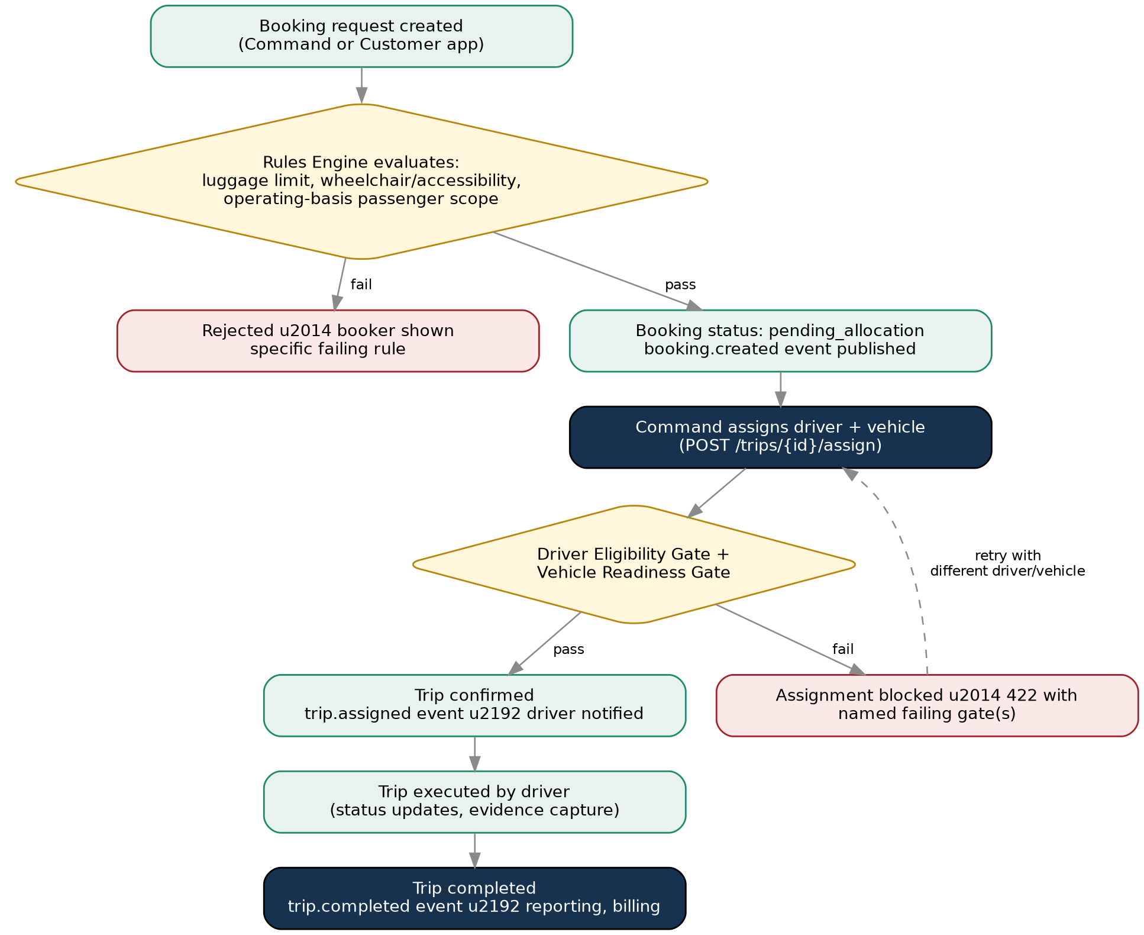
Figure 4. A booking is never assigned without passing both the Rules Engine and the Eligibility/Readiness gates — and a gate failure always names the specific rule, not a generic block.
10.2 Defect Lifecycle
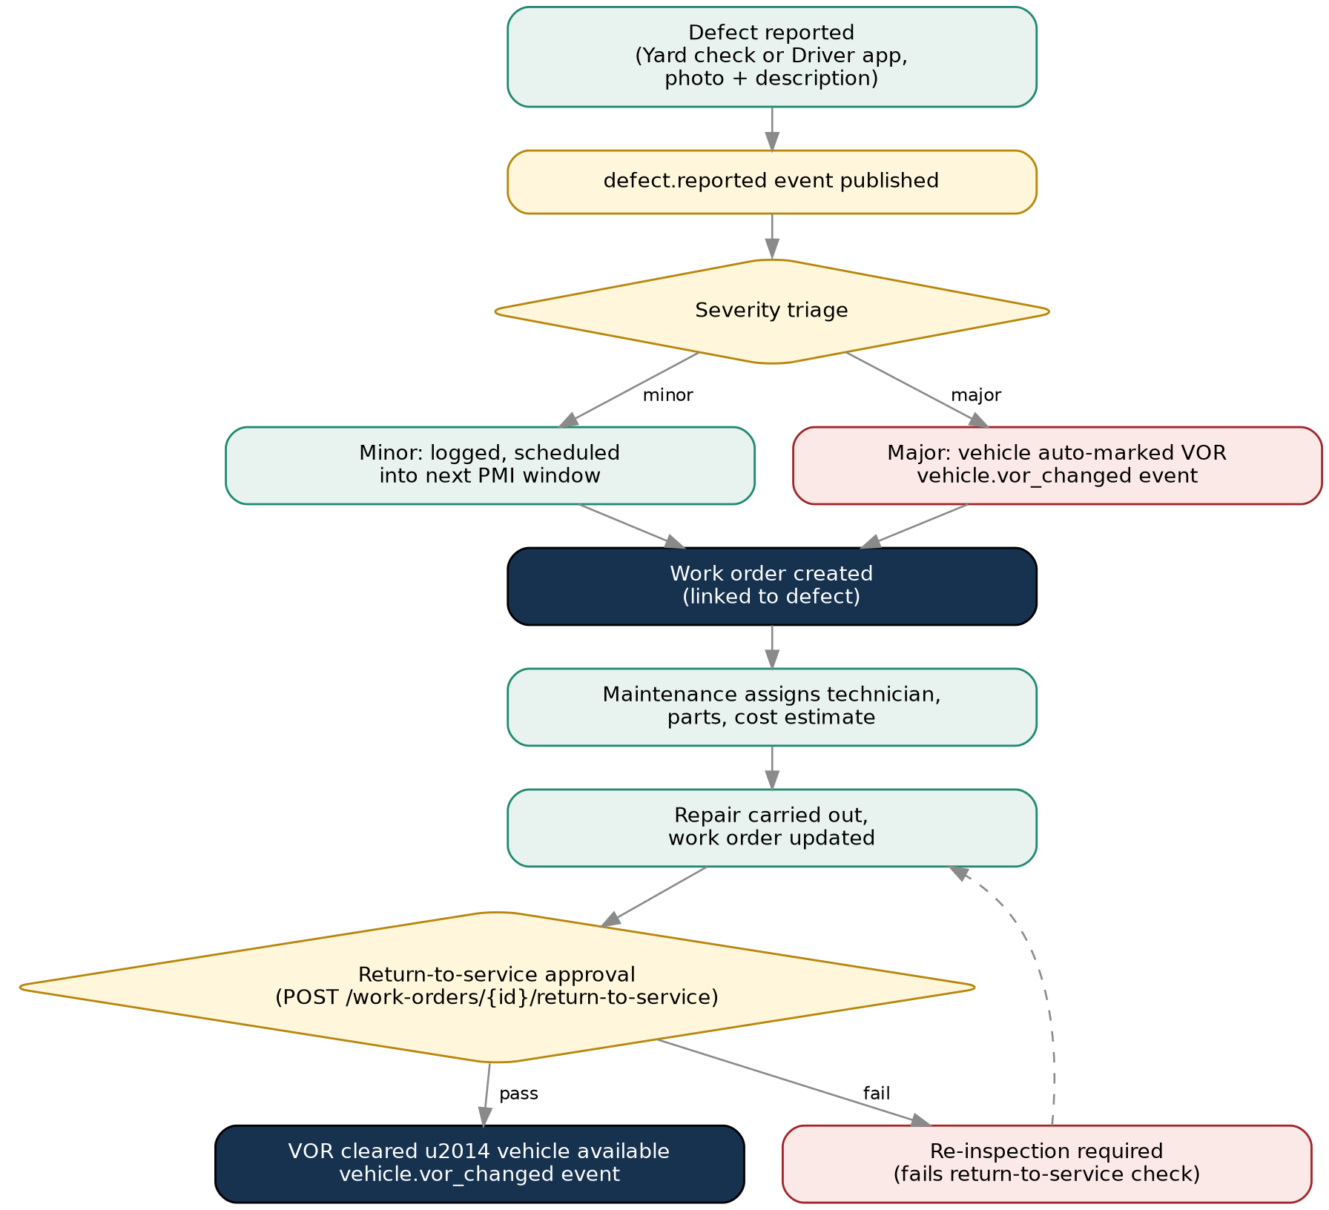
Figure 5. Severity triage decides whether VOR is automatic; return-to-service is a gate in its own right, not just “work order marked complete”.
10.3 Vehicle Onboarding
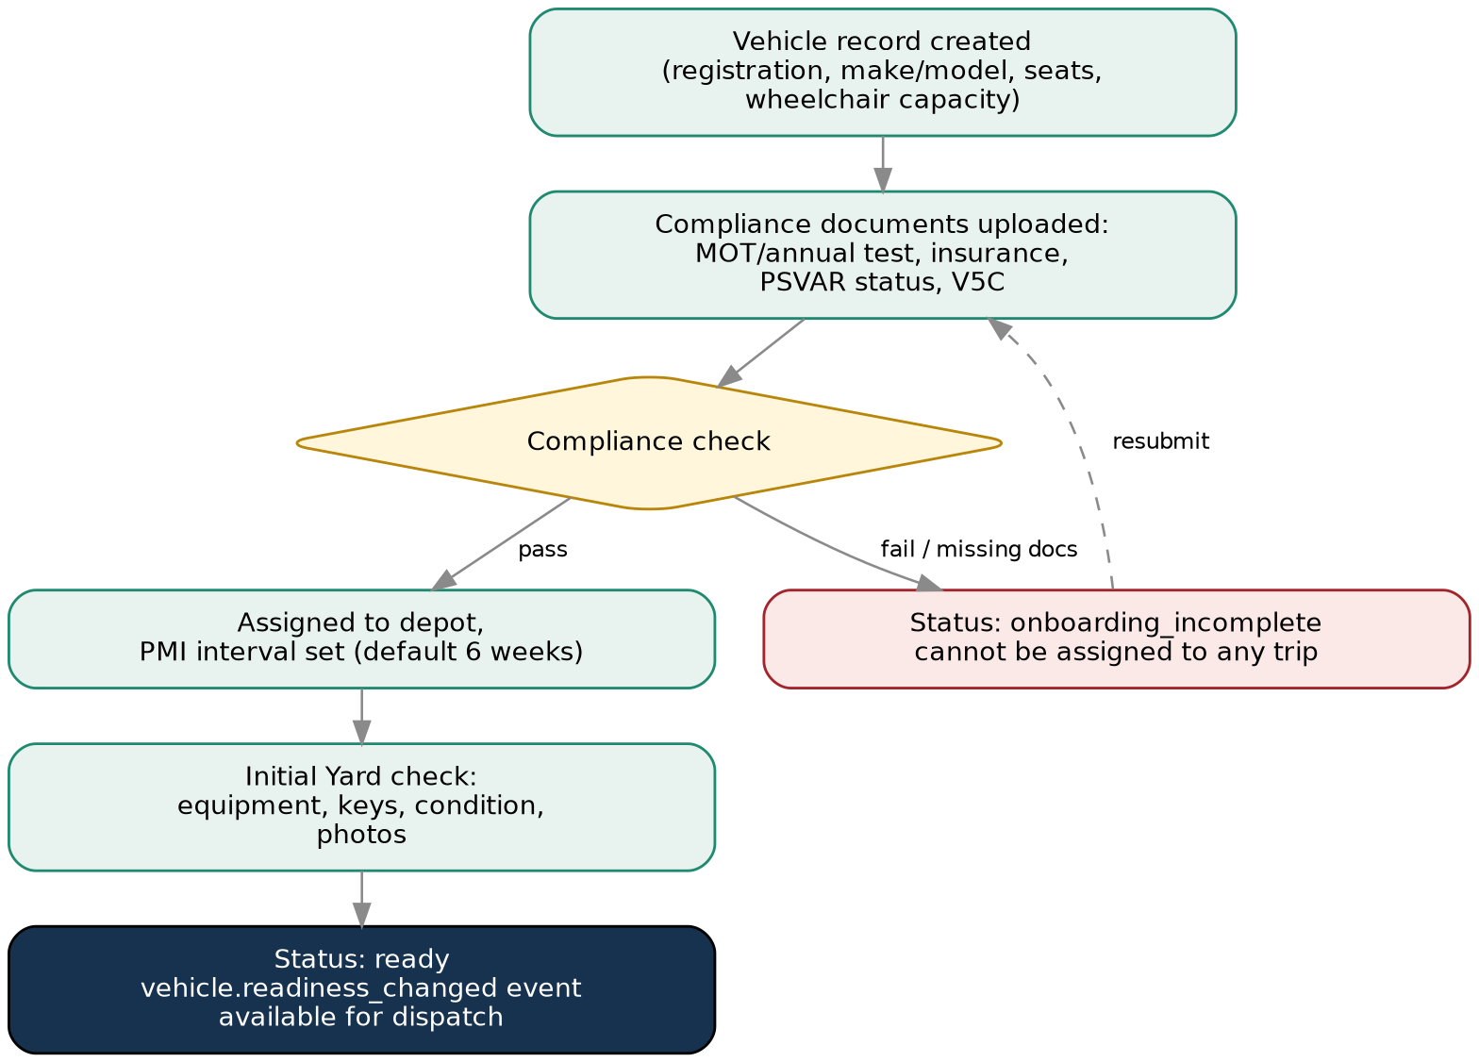
Figure 6. A vehicle cannot be dispatched until documents, depot assignment and an initial Yard check are all complete — onboarding_incomplete is a hard block, not a warning.
10.4 Incident Response
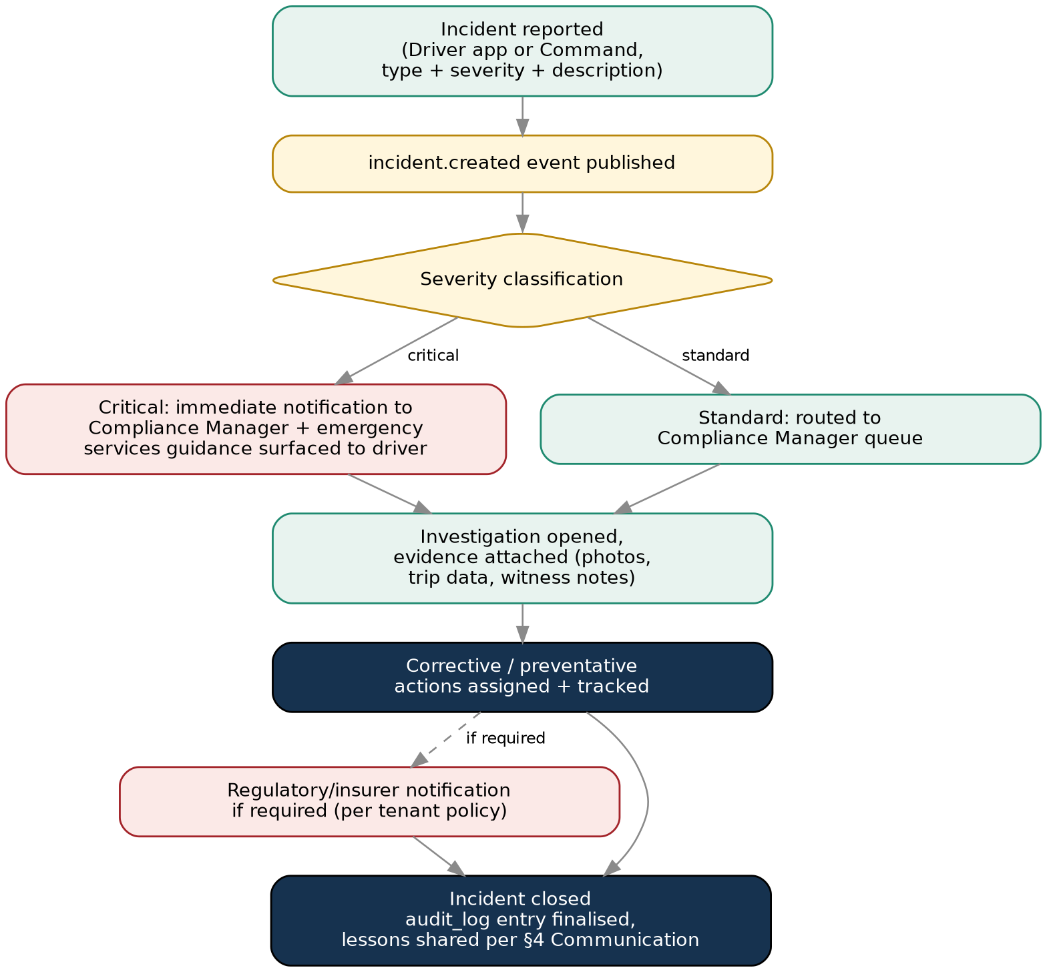
Figure 7. Critical incidents notify the Compliance Manager immediately, in parallel with driver-facing safety guidance — investigation never blocks the immediate response.
10.5 Workflow Conventions
- Every workflow above is implemented as an explicit state machine, not inferred from a combination of boolean flags — the current state is always one named value (e.g. trip.status ∈ {pending_allocation, assigned, in_progress, completed, cancelled}), queryable directly.
- Every state transition publishes the corresponding event from §4, so Notifications and Reporting stay correct without being hardcoded into the workflow logic itself.
- Dashed lines in the diagrams (retry/reopen loops) are the only transitions that can move a record backward through the process; every other transition is one-directional and logged.
VEYVIO
Vehicle Ecosystem, Yard Visibility and Intelligent Operations
PRODUCTION READINESS REQUIREMENTS
Hard rules and backend changes required before Veyvio is production-ready
Version 1.0, 24 July 2026 — these are gates, not recommendations
Status of This Document
Every rule below is a hard requirement, not a preference. None of them describe a new feature — they are the enforcement of decisions already made elsewhere in this blueprint (the gates, the tenant model, the rules engine, the audit trail). Nothing in this section is optional, and “we'll tighten it up after launch” is not an acceptable answer for any item marked as a stop-ship gate.
These 17 rules consolidate requirements that already exist, scattered, across the Master Blueprint, the Technical Implementation Specification and the Platform Principles into a single pre-production checklist. Where a rule restates something already specified elsewhere, that's deliberate — this document is the one place engineering, security review and release sign-off should look to confirm all of it is actually true of the running system, not just true on paper.
Cross-references to § numbers below point to the Technical Implementation Specification unless stated otherwise.
1. Backend Access Must Be Deny-by-Default
A successful login proves identity only. It must never automatically grant access to every Veyvio application.
Required application scopes
app.command
app.driver
app.yard
app.maintenance
app.customer
app.platform_admin
Every protected request must check
- 1. Is the session valid?
- 2. Does the user belong to this tenant?
- 3. Does the user have access to this application (app scope)?
- 4. Do they have permission for this specific action?
- 5. Are they allowed to access this particular record?
A driver holding only app.driver must receive a backend 403 Forbidden on any attempt to reach Command, Yard, Maintenance or Platform APIs — including by manually entering the URL or calling the API directly. Command users must not automatically receive Driver access either. Both directions of this are stop-ship tests (§17).
2. Tenant Isolation Must Be Structural
Every company-owned database record carries an immutable tenant_id. Isolation is enforced at every layer, not just one:
Layer | Requirement
API gateway | Rejects any token/resource tenant mismatch before the request reaches business logic
Backend services | Every query and command is scoped by the caller's tenant_id, never client-supplied
Database queries | tenant_id is part of every query predicate on tenant-owned tables
Foreign keys | Cross-references stay within the same tenant; no FK can point across tenants
File storage | Tenant-scoped storage paths (§13)
Cache keys | Tenant_id is part of every cache key; no shared cache entry across tenants
Search indexes | Search queries are pre-filtered to the caller's tenant before execution
Notifications | Recipients and content resolved only within the sending tenant
Reports and analytics | Aggregations never span tenants unless explicitly platform-level and permissioned
Background jobs | Every job carries and enforces the tenant_id it was scheduled for
The server compares the tenant in the user's access token with the tenant owning the requested resource; a mismatch is rejected before the business operation runs. Where the datastore supports it, row-level security is an additional safeguard — defence in depth, not the only control.
No production release proceeds while any cross-tenant create, read, update, delete, search, file-access, notification or analytics test can fail. This is a stop-ship gate (§17).
3. Remove All Mock and Fallback Production Behaviour
Production must never silently substitute:
- Mock drivers
- Mock vehicles
- Example bookings
- Placeholder dashboard figures
- Fake compliance information
- Seeded live operational data
- Default authentication secrets
When the backend is unavailable, the application shows an honest service or connectivity error — never demonstration data presented as live operational truth.
This blueprint specifically identifies removing mock-data paths and hybrid Command behaviour as a current hardening priority, not a future one.
4. Rotate and Secure Every Credential
Must be rotated
Credential
Supabase keys
Database passwords
JWT secrets
SMTP credentials
Stripe credentials
Mapping provider keys
SMS provider keys
OAuth client secrets
Third-party integration keys
Must be removed from
- Git repositories
- Old ZIP archives
- Environment files included in backups
- Mobile application bundles
- Browser JavaScript
- Logs
- Documentation and screenshots
Secrets belong in a managed secrets vault. Default or fallback JWT secrets must be eliminated completely — there is no safe default secret.
5. Centralise All Business Rules
Command, Driver, Yard, Maintenance, Customer and the website must not maintain separate versions of the same operational rule. Every app calls the same backend Rules Engine and receives the same decision.
Rules that belong in the Rules Engine
Rule domain
Driver licence validity
Driver training requirements
DBS or safeguarding status
CPC or MiDAS requirements
Driver hours and rest
Vehicle VOR status
MOT and PMI deadlines
Open safety defects
Wheelchair capacity
Escort requirements
Passenger assistance requirements
Luggage limits
Vehicle class and equipment requirements
Customer or contract-specific restrictions
Rules must be configurable, versioned, tenant-scoped, testable and auditable (Technical Implementation Specification §6).
6. Safety Rules Must Be Hard Gates
Important safety and compliance rules cannot simply show a yellow warning. The backend blocks the action when required:
- An ineligible driver cannot be assigned.
- A VOR vehicle cannot be dispatched.
- A vehicle with an unresolved critical defect cannot be released.
- A vehicle with incomplete onboarding cannot enter operational service.
- A wheelchair booking cannot be assigned to an unsuitable vehicle.
- A school service cannot proceed without a required escort.
- A driver who has exceeded permitted hours cannot receive an incompatible duty.
The assignment endpoint must call both the Driver Eligibility Gate and the Vehicle Readiness Gate. The booking or trip assignment is only committed if both pass — not one, not “pass with a warning.”
7. Overrides Must Never Be Silent
An override requires all of the following:
- A specific override permission
- A written reason
- The affected rule
- The person performing the override
- Date and time
- Original result
- Overridden result
- Expiry or applicable period
- Second-person approval when the rule is high-risk
Safety-critical overrides automatically notify the Compliance Manager.
Being a Company Owner or Administrator does not mean being able to silently bypass safety controls — the override requirements above apply regardless of seniority.
8. Implement Explicit State Machines
Backend workflows are not inferred from several unrelated boolean fields. Each workflow has one status field with a fixed set of valid values.
Trip status (example)
draft
pending_allocation
assigned
published
acknowledged
in_progress
completed
cancelled
Defect status (example)
reported
triaged
deferred
work_ordered
repaired
verified
closed
Only approved transitions are accepted. Every transition:
- Checks permission
- Checks prerequisite rules
- Records who performed it
- Records the reason where required
- Produces an audit event
- Publishes the corresponding domain event
Vehicle return-to-service is a separate, controlled transition — never merely the automatic result of marking a work order complete. (This is the exact scenario walked through in the Platform Principles worked example.)
9. Every Material Write Must Produce an Event
booking.created
booking.updated
trip.assigned
trip.started
trip.completed
driver.compliance_changed
vehicle.readiness_changed
defect.reported
vehicle.vor_changed
incident.created
document.expiring
Notifications, reporting, audit processing and external integrations subscribe to these events — individual modules do not each implement their own separate notification logic.
Event consumers must be idempotent so that retries do not create duplicate notifications, bookings or records.
10. Build an Immutable Audit Service
The backend creates an audit record for every sensitive or material action:
Audited action
Login success and failure
Denied access
Application access changes
Role and permission changes
Record creation and modification
Driver or vehicle assignment
Compliance decisions
Rule overrides
VOR changes
Return-to-service approvals
API-key creation and use
Data exports
Audit-pack generation
Support access
Configuration changes
Each audit record captures
- Tenant
- Actor
- Role
- Application
- Action
- Entity and record ID
- Before-and-after summary
- Timestamp
- Device or IP context
- Reason
- Correlation ID
Audit records are append-only. Normal administrators cannot edit or silently delete them — no exceptions for seniority, matching Platform Principle 1.
11. Replace Broad Roles With Specific Permissions
Do not rely only on labels such as “Admin”, “Driver” or “Manager.” Use granular permissions:
bookings.create
bookings.read
dispatch.assign
trips.update.own
drivers.compliance.manage
vehicles.read
vehicles.vor.manage
yard.checks.submit
workorders.complete
config.rules.manage
users.manage.scopes
platform.support_access
A role is a configurable collection of permissions. Context checks then further restrict access by tenant, depot, customer, ownership, assignment and record sensitivity.
12. API Boundary Validation
Every API endpoint validates:
Check
Authentication
Application scope
Tenant scope
Permission
Record ownership or assignment
Request schema
Allowed state transition
Relevant business rules
Rate limit
Concurrency version
API conventions
- /api/v1 versioning
- Consistent error codes
- Correlation IDs
- Cursor pagination
- Server-side filtering
- Request-size limits
- Idempotency keys
- Optimistic concurrency
Safety-critical commands remain immediately consistent and transactional. Notifications, reporting and integrations may use asynchronous events — that split is deliberate, not a shortcut.
13. Secure File and Document Access
Operational files must not live in publicly accessible storage. The backend:
- Stores files in tenant-scoped paths
- Validates content type and file signature
- Scans uploads where appropriate
- Uses short-lived signed download links
- Rechecks tenant and permission before generating links
- Records uploads, views, downloads, replacements and deletions
- Applies retention rules
- Prevents one tenant from guessing another tenant's storage path
Sensitive driver, passenger, DBS, safeguarding and incident documents need additional field- and purpose-level restrictions beyond standard file access controls.
14. Secure API Keys and Integrations
API keys are only for authorised machine-to-machine integrations. Each key carries:
Metadata field
Tenant
Integration name
Owner
Environment
Scopes
Creation date
Expiry or review date
Last-used timestamp
Revocation status
The secret is displayed once, stored securely, and never returned again. Supported: rotation, revocation, expiry, usage monitoring, environment separation, optional IP restrictions, scoped permissions, emergency disablement.
Production credentials must never work in sandbox or staging.
15. Offline Commands Must Be Safely Revalidated
Driver and Yard apps may work offline, but offline operation must never bypass server rules.
Offline writes include
- User ID
- Tenant ID
- Device ID
- Local timestamp
- Idempotency key
- Record version
- Attachments
- Intended command
On reconnect, the backend revalidates
- Session and membership
- Application access
- Permission
- Record state
- Business rules
- Conflicts
- Tenant ownership
The user is shown whether each action is pending, synchronised, failed, or requires manual resolution — never a silent success or a silent drop.
16. Privileged Support Access Must Be Temporary
Veyvio platform staff do not automatically have unrestricted access to tenant information. Support access requires:
- Explicit tenant or authorised approval
- A purpose
- Defined duration
- Restricted permissions
- Visible support-access banner
- Automatic expiry
- Full audit history
Platform administration and tenant operational access remain separate roles — provisioning a tenant is not the same grant as seeing its operational data.
17. Production Release Must Have Stop-Ship Tests
The release pipeline blocks deployment when any critical test fails:
Stop-ship test
Driver accessing Command
Command user accessing Driver without explicit scope
One tenant accessing another tenant's records
Cross-tenant file download attempts
Horizontal privilege escalation
Vertical privilege escalation
Expired or revoked token use
Missing scope
Inactive user
API-contract failures
Migration failures
Backup and restoration failures
Secret scanning failures
Every protected function needs both a positive test (the intended role can do the thing) and a negative test (every other role, and an unauthenticated caller, cannot).
Recommended Implementation Order
The safest order to close these out — each step reduces the risk of the ones that follow, rather than all seventeen being tackled in parallel:
- 1. Rotate credentials and remove exposed secrets.
- 2. Remove mock and fallback production data.
- 3. Add immutable tenant_id enforcement everywhere.
- 4. Introduce backend application scopes.
- 5. Add granular permissions and deny-by-default middleware.
- 6. Add database-level tenant protection.
- 7. Centralise Driver Eligibility and Vehicle Readiness gates.
- 8. Implement explicit workflow state machines.
- 9. Add the immutable audit service.
- 10. Add domain events and the central notification service.
- 11. Secure storage and documents.
- 12. Secure API credentials and webhooks.
- 13. Add offline-command revalidation.
- 14. Build the full cross-tenant and cross-role security test suite.
- 15. Block production releases when those tests fail.
This order is itself a gate: step 15 (block releases on test failure) only means something once steps 1–14 exist for it to test. Don't build the stop-ship gate before there's anything real behind it to enforce.

