PRODUCT AND TECHNICAL SPECIFICATION
Veyvio Cost Control
Master Blueprint
Authoritative product, experience, data and engineering plan
SCOPE DECISION
Veyvio is a cost-only platform. It captures, validates, allocates, forecasts and controls costs against approved budgets. It does not manage bookings, dispatch, income, sales, payroll processing or unrelated operations.

Version 1.2
Prepared 28 July 2026
Status: Master product blueprint

Document purpose
This document consolidates the Veyvio product discussion into one consistent specification. Where earlier ideas included broader finance or operational features, this blueprint applies the final product decision: only information required to identify, verify, allocate, approve, forecast, explain or reduce a cost belongs in Veyvio.

Contents
- Executive product definition
- Scope and boundaries
- Product principles and success measures
- Users and permissions
- Cost model and terminology
- Cost categories and allocation
- Page-by-page product specification
- End-to-end cost workflows
- Budget and forecasting engine
- Decision-support and cost review
- Data model and integrations
- Technical architecture
- Financial correctness controls
- AI architecture and safeguards
- Security, privacy and auditability
- UI/UX and visual design system
- Reports and management information
- Testing and acceptance strategy
- Delivery roadmap
- Risks, decisions and open definitions

How to read this blueprint
- Product sections define what users can see and do.
- Financial sections define how amounts are classified and calculated.
- Workflow sections define validation, approval, correction and audit behaviour.
- Technical sections define how the application should be implemented safely.
- The exclusions section overrides any conflicting earlier concept.

1. Executive product definition
PRODUCT PROMISE
Know exactly what has been spent, what is committed, what is expected and whether the CEC budget will hold.

Veyvio is a cost intelligence and budget-control platform. It brings cost data from fuel cards, supplier invoices, bank transactions, payroll summaries, recurring contracts and approved manual entries into a single validated cost record. It then allocates those costs to the correct budget, category, vehicle, department, contract or cost centre.
The product's value is not merely showing historical expenditure. Veyvio must identify what changed, forecast the final cost, detect unsupported or unusual expenditure, show the cause of budget variance and prepare controlled cost decisions.

Core questions Veyvio answers
- How much has been spent?
- How much expenditure is already committed?
- What additional costs are expected?
- What is the projected final cost?
- How much approved budget remains?
- Which categories, vehicles, departments or suppliers are over budget?
- Why did a cost change?
- Which costs are missing evidence or require review?
- What action could reduce or contain the projected overspend?

North-star outcome
The primary outcome is cost under control: the value of verified costs, avoided duplicate or unsupported expenditure, and forecast overspend identified early enough for management action.

2. Scope and boundaries
In scope | Out of scope
Capture and import costs | Booking and job scheduling
Cost validation and duplicate detection | Dispatch and route management
Cost categorisation and allocation | Customer relationship management
Fuel, vehicle and maintenance costs | Income, sales and profitability
Wage-cost summaries | Payroll calculation or submission
Actual, committed and forecast costs | Customer invoicing and debt collection
CEC and other budget control | Employee performance management
Supplier cost analysis | Live vehicle tracking
Cost forecasting and scenarios | Full MOT, inspection or workshop management
Cost decisions and approvals | Autonomous purchasing or payments
Reports and audit history | General operational management

The relevance test
ADMISSION RULE
A field, page or workflow belongs in Veyvio only when it materially improves the capture, accuracy, validation, allocation, forecasting, approval, explanation or reduction of a cost.

For example, an MOT date may be stored to forecast the next MOT cost. Veyvio does not need the wider operational detail required to manage the MOT process. A vehicle identifier may be stored to allocate fuel and maintenance costs, but Veyvio does not need to dispatch that vehicle.

3. Product principles and success measures
Principle | Meaning
Cost only | Every capability must serve cost accuracy or cost control.
One cost truth | All pages and reports use the same validated canonical cost records.
Explain every amount | Users can inspect source, status, allocation, formula and change history.
AI explains; rules calculate | Authoritative amounts are produced by deterministic, versioned services.
No silent corrections | Changes create new versions and preserve the previous record.
Approval before consequence | Budget changes, overrides and external actions require authority.
Uncertainty is visible | Forecast and estimated costs are never presented as actual.
Last valid state protection | Failed imports or calculations cannot replace trusted results.

Success measures
- Time from connection or upload to the first reconciled cost view.
- Percentage of costs automatically categorised correctly.
- Percentage of costs fully allocated to a budget and cost centre.
- Duplicate or unsupported cost value detected.
- Forecast final-cost accuracy.
- Budget variance identified before the end of the reporting period.
- Time required to complete monthly cost reporting.
- Percentage of cost-review recommendations resolved.

4. Users and permissions
Role | Permitted activities | Restricted activities
Organisation owner | All cost, budget, team and security administration | None within organisation policy
Finance manager | Validate costs, manage forecasts, approve reviews and reports | Organisation closure and ownership transfer
Budget owner | View and manage assigned budgets; approve permitted changes | Other budgets and security settings
Cost reviewer | Review allocations, evidence and exceptions | Budget baseline and user administration
Accountant/auditor | Read records, sources, corrections and exports | Operational changes unless separately granted
Read only | View approved reports and permitted cost areas | Edits, approvals and exports not expressly granted

Permissions must be enforced on the server. Hiding an interface control is not an authorisation mechanism. Sensitive wage data and supplier banking information require more restrictive permissions than aggregated cost totals.

5. Cost model and terminology
Term | Definition
Approved budget | The formally authorised cost envelope for a defined scope and period.
Actual cost | A cost already incurred and supported by a validated transaction, invoice or approved summary.
Committed cost | A future amount the organisation is contractually or operationally obligated to pay.
Forecast cost | An expected future cost that is not yet committed.
Estimated cost | A provisional amount with explicit uncertainty and a recorded estimation method.
Contingency | Approved budget reserved for defined uncertainty.
Available budget | Approved budget less actual and committed costs.
Projected remaining budget | Approved budget less actual, committed and forecast costs.
Projected final cost | Actual plus committed plus forecast costs, without double counting.
Variance | Difference between budget or baseline and actual or forecast cost.

Authoritative budget equations
AVAILABLE BUDGET
Approved budget - actual costs - committed costs = available budget

PROJECTED REMAINING BUDGET
Approved budget - actual costs - committed costs - forecast costs = projected remaining budget

PROJECTED FINAL COST
Actual costs + committed costs + forecast costs = projected final cost

A single economic cost may occupy only one lifecycle status at a time. When a commitment becomes actual, the commitment is converted or linked to the actual record; it is not added again.

6. Cost categories and allocation
Category | Included costs
Fuel | Fuel-card and cash fuel purchases, electricity charging, AdBlue, VAT and applicable fees
Vehicle ownership | Purchase, lease, finance, interest, insurance, tax, depreciation and disposal
Maintenance | MOT, servicing, repairs, inspections, parts, tyres, labour, recovery and replacement vehicle
Wages | Approved payroll totals, basic wages, overtime, employer costs, pensions, allowances and contractors
Premises | Rent, utilities, rates, security, cleaning and property services
Technology | Software, devices, communications, support and subscriptions
Professional | Accountancy, legal, consulting, audit and other professional services
Administration | Banking, office supplies, training, licences, uniforms and general overhead
Exceptional | Accidents, claims, penalties, emergency expenditure and material one-time costs

Allocation dimensions
- CEC or other budget
- Cost category and subcategory
- Cost centre or department
- Vehicle, where relevant
- Supplier
- Contract or funding code, where relevant
- Accounting period
- Location or depot, only when required for cost analysis
A cost may be split across allocation dimensions. Split rules must total exactly 100 percent or the complete monetary amount before approval.

7. Page-by-page product specification
Page | Purpose | Primary action
Home | Total cost position, CEC budget, actual/committed/forecast totals, projected remaining budget, variance, major exceptions and data health. | Open a cost, budget variance, review item or report.
All costs | Searchable cost ledger with filters, status, source, allocation, evidence and review state. | Inspect, split, reclassify, correct or approve a cost.
Fuel | Fuel spend, litres, price per litre, vehicle allocation, cost per mile, budget variance and anomalies. | Review unusual or incomplete fuel costs.
Vehicles | Cost profile only: finance, fuel, insurance, tax, maintenance and total cost by vehicle. | Compare cost trends and open underlying costs.
Maintenance | MOT, service, repair, inspection, tyre, parts, recovery and related cost totals. | Review recurring, repeated or unplanned costs.
Wage costs | Approved wage-cost summaries, overtime, employer costs, department and budget allocation. | Review variance or import differences; no payroll processing.
Operating costs | Premises, technology, professional, administrative and exceptional costs. | Review supplier, category and recurring-cost trends.
Budgets | Approved, actual, committed, forecast, projected final and remaining amounts. | Open budget, request revision, reallocation or contingency use.
CEC budget | Dedicated view of the CEC hierarchy, categories, variances and forecast final cost. | Drill into a category, owner or period.
Forecast | Future cost profile with baseline, confidence, assumptions and version history. | Change an assumption or compare versions.
Commitments | Future contractual and approved expenditure not yet actual. | Convert, cancel with authority, or link to an actual cost.
Suppliers | Spend by supplier, recurring commitments, price changes and document completeness. | Inspect cost history and prepare a supplier review.
Cost reviews | Exceptions, duplicates, missing evidence, allocation issues and recommended actions. | Approve, reject, correct, snooze or assign.
Reports | Budget, category, vehicle, fuel, maintenance, wages, supplier and audit reports. | Select period, version, export or schedule.
Imports | Connection health, upload status, validation, reconciliation and quarantine. | Resolve failed or incomplete imports.
Settings | Organisation, cost taxonomy, budgets, permissions, integrations, security and retention. | Controlled administrative changes.

Home page hierarchy
- Show approved CEC budget, actual cost, committed cost, forecast cost, projected final cost and projected remaining budget.
- Show the largest variances and explain what changed since the last valid snapshot.
- Show no more than one primary cost-control recommendation.
- Show costs awaiting review, missing evidence and unresolved reconciliation issues.
- Show the last successful data refresh and the age of every important result.

Cost detail page
- Supplier, description, date, net amount, VAT, gross amount and currency.
- Actual, committed, forecast or estimated status.
- Category, budget, cost centre, vehicle and other approved allocations.
- Original source and supporting document.
- Duplicate, anomaly and reconciliation checks.
- Approval, correction and version history.
- Related commitment or actual cost, preventing double counting.

Cost-only vehicle page
The vehicle page contains no dispatch, booking, driver-performance or route-management functionality. It exists to aggregate vehicle-attributable costs and support comparisons.
- Lease and finance cost
- Fuel cost
- Insurance and vehicle tax
- MOT, service, repair, inspection, tyres and recovery
- Total cost, cost per month and cost per mile where mileage is available
- Budget and forecast variance
- Documents supporting vehicle costs

8. End-to-end cost workflows

8.1 Cost ingestion
- Receive a cost from a fuel card, supplier invoice, bank feed, payroll summary, recurring contract or authorised manual entry.
- Store the original source payload without modification.
- Validate required fields, amount, date, currency and source identity.
- Normalise the record into the canonical cost format.
- Detect exact and probable duplicates.
- Match supplier, cost category, budget and relevant allocation dimensions.
- Validate evidence and reconcile the cost with its source.
- Quarantine any incomplete, inconsistent or unsupported record.
- Commit only validated records to the canonical cost ledger.
- Create a new financial snapshot and recalculate budgets and forecasts.
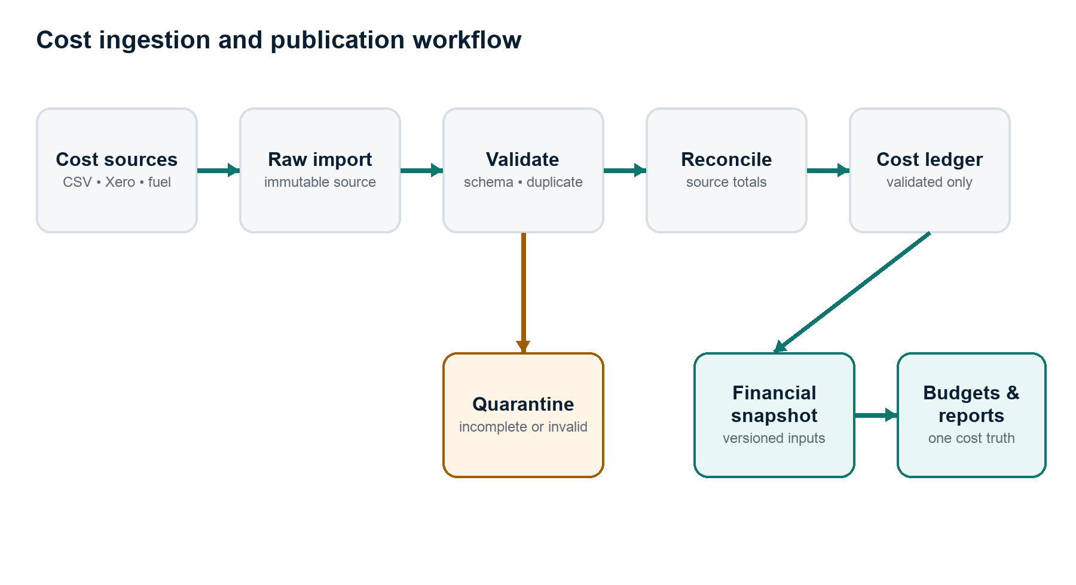
Figure 1. Only validated and reconciled costs reach the canonical ledger and published financial snapshot.

8.2 Cost review
- Open the review item with its cause, evidence and affected totals.
- Inspect source data and any suggested category or allocation.
- Correct, split, approve, reject or request evidence according to permission.
- Validate that allocation totals match the complete cost.
- Preserve the imported and previous versions.
- Write an immutable audit event identifying actor, time, reason and before/after state.
- Recalculate affected budgets, forecasts and reports.

8.3 Correction
Actual cost records are never silently overwritten. If the source system owns the record, the correction is made there and imported as a new source version. If Veyvio owns the manual record, an authorised correcting version is created with a mandatory reason.

8.4 Commitment conversion
- Identify the approved commitment.
- Import or record the actual supplier cost.
- Match actual and committed records using supplier, reference, date and amount.
- Confirm full or partial conversion.
- Reduce or close the remaining commitment.
- Record the actual cost once and preserve the linkage.
- Recalculate the projected final cost without double counting.
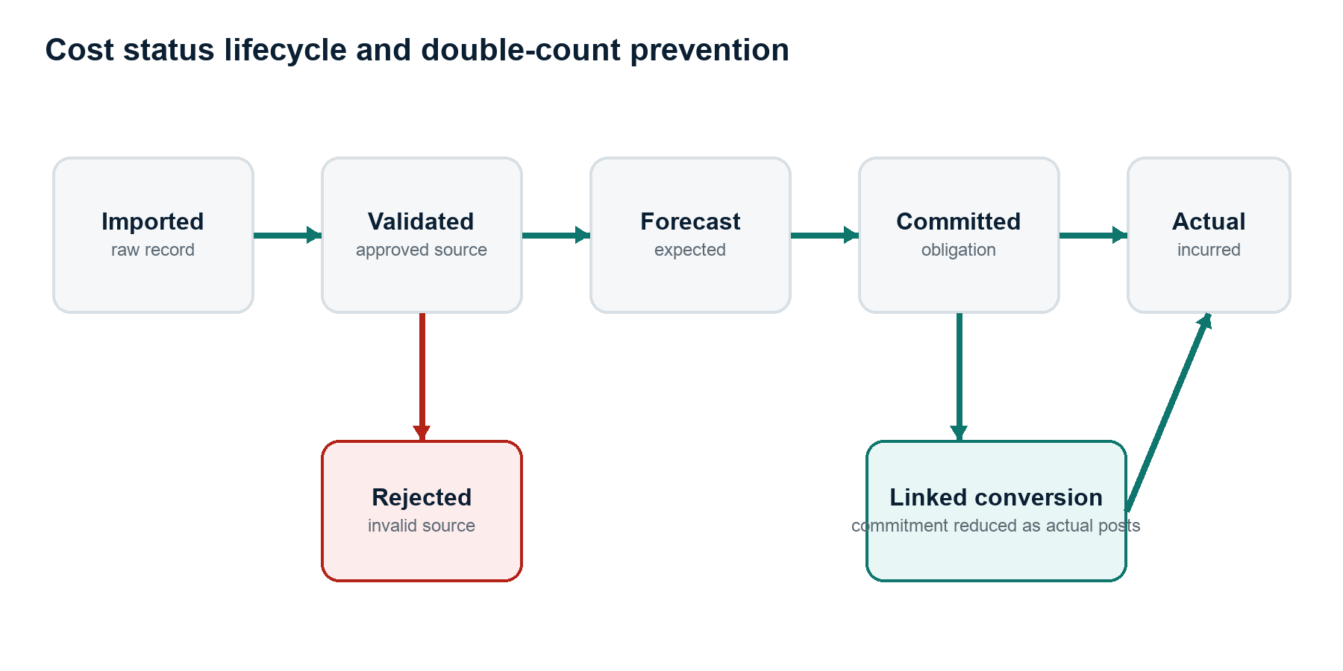
Figure 2. Cost status transitions preserve one economic cost as forecast expenditure becomes committed and then actual.

8.5 Budget revision
- A budget owner creates a change request with amount, category, period and reason.
- Veyvio previews affected available and projected remaining budget.
- The authorised approver accepts or rejects the request.
- The original approved baseline remains immutable.
- An approved revision creates a new budget version.
- Reports can compare original, revised and current forecast values.

8.6 Import failure
- Keep the last valid cost snapshot available.
- Do not publish partial or unreconciled totals as current.
- Classify connection, authentication, schema, duplication and reconciliation failures.
- Retry temporary failures safely and idempotently.
- Quarantine structurally changed or invalid source data.
- Notify the responsible user and show exactly what is stale.

9. Budget and forecasting engine

Budget hierarchy
The data model must support organisation, financial year, CEC/programme budget, cost category, cost centre, vehicle and other approved allocation levels. The hierarchy is configurable so CEC terminology is not hard-coded until its formal meaning and structure are confirmed.

Forecast inputs
- Validated historical actual costs
- Open commitments
- Recurring contracts and subscriptions
- Known renewal dates
- Approved purchase plans
- Seasonal cost patterns
- Rolling averages
- Manual assumptions with owner and expiry date
- Expected MOT, service or inspection costs where dates are available

Forecast outputs
- Monthly and period cost forecast
- Forecast by category, budget, cost centre, supplier and vehicle
- Projected final cost
- Projected remaining budget
- First expected overspend period
- Base, lower and upper ranges
- Assumptions and confidence
- Difference from the previous forecast version
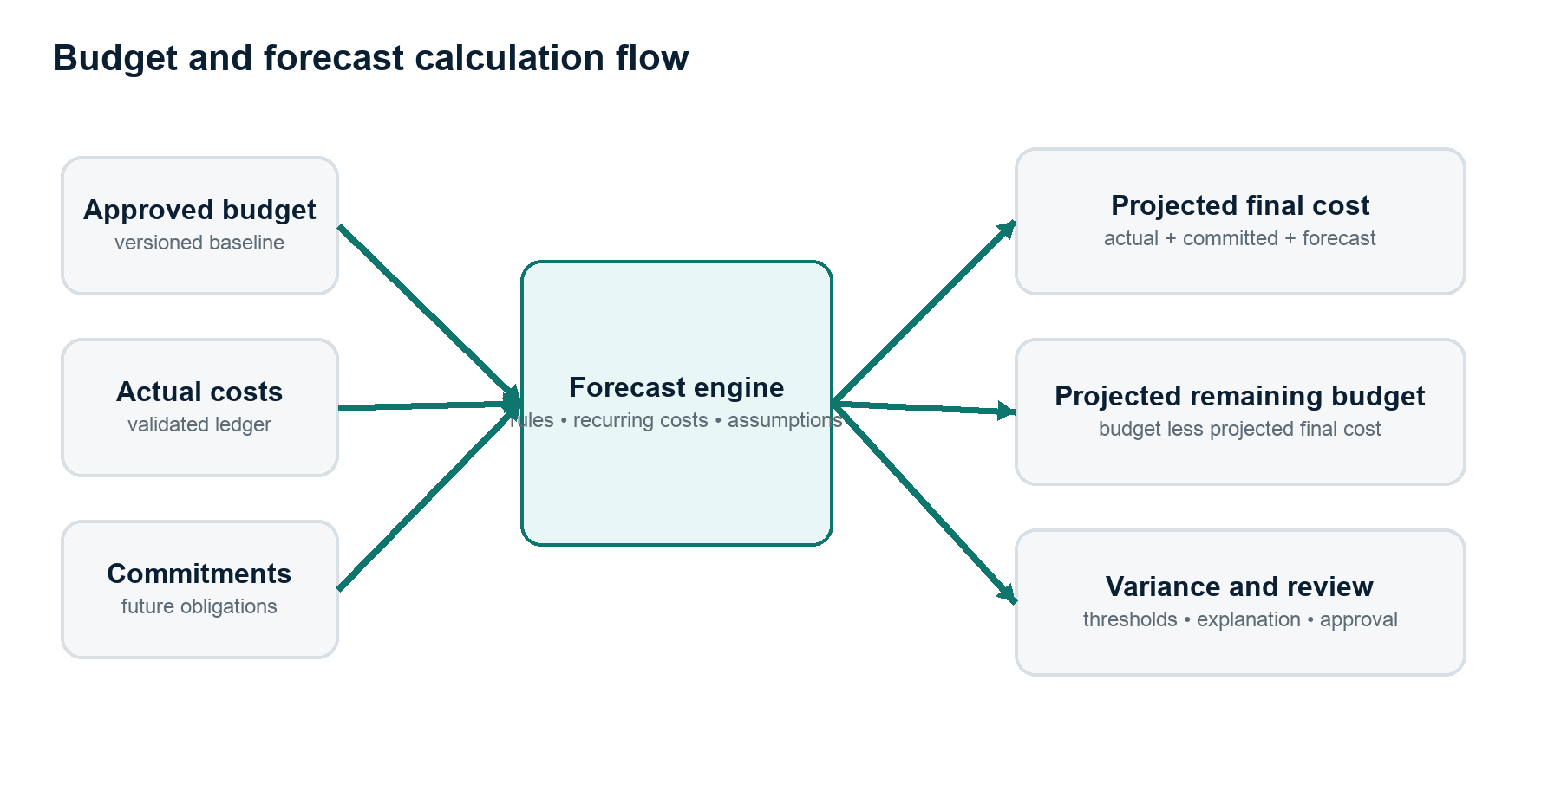
Figure 3. The forecast engine combines the approved baseline with actual, committed and expected costs.

Forecast versioning
Every published forecast is an immutable version with its calculation time, data snapshot, formula version, assumptions and author. A changed assumption creates a new forecast version; it does not rewrite history.

10. Decision-support and cost review
Recommendations must remain cost-specific. Veyvio may identify and prepare a review, but must not autonomously cancel a supplier contract, reject an employee cost, alter an approved budget or initiate a payment.
Signal | Permitted recommendation
Probable duplicate cost | Review and reject or link the duplicate.
Fuel cost above expected range | Inspect vehicle, supplier, mileage or missing evidence.
Maintenance forecast above budget | Review timing, quotation, contingency or budget revision.
Recurring supplier cost increased | Prepare supplier-price review.
Overtime cost rising | Review overtime expenditure with the authorised manager.
Cost assigned to wrong budget | Prepare reallocation with evidence.
Projected CEC overspend | Model reduction, reallocation, contingency or approved budget revision.
Unsupported cost | Request evidence or place the cost in review.

Recommendation contents
- Issue and affected cost
- Evidence and source records
- Budgeted, actual and projected amounts
- Variance and forecast effect
- Suggested review action
- Confidence and limitations
- Responsible person and required approval
- Outcome and measured cost effect

11. Data model and integrations

Core entities
Domain | Entities
Identity | User, organisation, membership, role, permission and approval policy
Cost | Cost record, cost version, cost line, category, allocation, evidence and correction
Source | Integration, connection, import, raw record, staging record, sync run and quarantine item
Budget | Budget, budget version, budget line, transfer, contingency and change request
Forecast | Forecast, forecast version, assumption, recurring rule and forecast line
Reference | Supplier, vehicle, cost centre, department, contract/funding code and accounting period
Control | Review item, recommendation, approval, action, outcome and audit event
Reporting | Financial snapshot, report definition, export and schedule

Canonical cost record
- Stable cost ID and version
- Supplier or payee
- Description and reference
- Transaction and accounting dates
- Net, VAT and gross amounts
- Currency and exchange-rate source where applicable
- Actual, committed, forecast or estimated status
- Category and subcategory
- Budget and allocation splits
- Source record and source lineage
- Supporting evidence
- Validation and reconciliation state
- Created, approved and corrected metadata

Initial integrations
Priority | Integration | Purpose
1 | CSV import | Validate cost model using bank, fuel-card, supplier and payroll-summary files.
2 | Xero | Import approved accounting costs, suppliers, tax values and source references.
3 | Fuel-card provider | Import detailed fuel transactions and card references.
4 | Bank/Open Banking partner | Support payment reconciliation through an authorised provider.
5 | Payroll provider summary | Import approved aggregate or permitted wage-cost results.

The MVP should begin with CSV and Xero rather than direct payment initiation. Veyvio does not need authority to move money to provide cost-control value.

12. Technical architecture
ARCHITECTURE RECOMMENDATION
Begin with a modular monolith, explicit domain boundaries and PostgreSQL. Split services only when scale, isolation or regulatory requirements justify the operational cost.

Logical modules
- Identity and organisations
- Cost ledger
- Imports and reconciliation
- Categories and allocations
- Budgets
- Forecasting
- Cost reviews and approvals
- Reporting and exports
- AI explanation orchestrator
- Notifications
- Audit and compliance

Recommended technology direction
Layer | Recommended starting point
Web application | React with Next.js and TypeScript
Application API | TypeScript service layer with modular domain boundaries
Database | PostgreSQL with strong constraints and transactional updates
Background work | Durable job queue for imports, forecasts, reports and notifications
File storage | Encrypted object storage for source files and evidence
Observability | Structured logs, metrics, tracing and calculation identifiers
Deployment | Managed cloud, infrastructure as code, separate development/staging/production
AI | Provider abstraction using structured tools and deterministic financial services

System flow
- External cost sources enter the raw immutable data zone.
- Validation and reconciliation services produce canonical cost records.
- A versioned financial snapshot freezes the trusted calculation input.
- Budget and forecasting engines calculate deterministic outputs.
- Home, cost pages, reports and AI explanations read the same stored outputs.
- Approved corrections create new records and restart the controlled calculation flow.
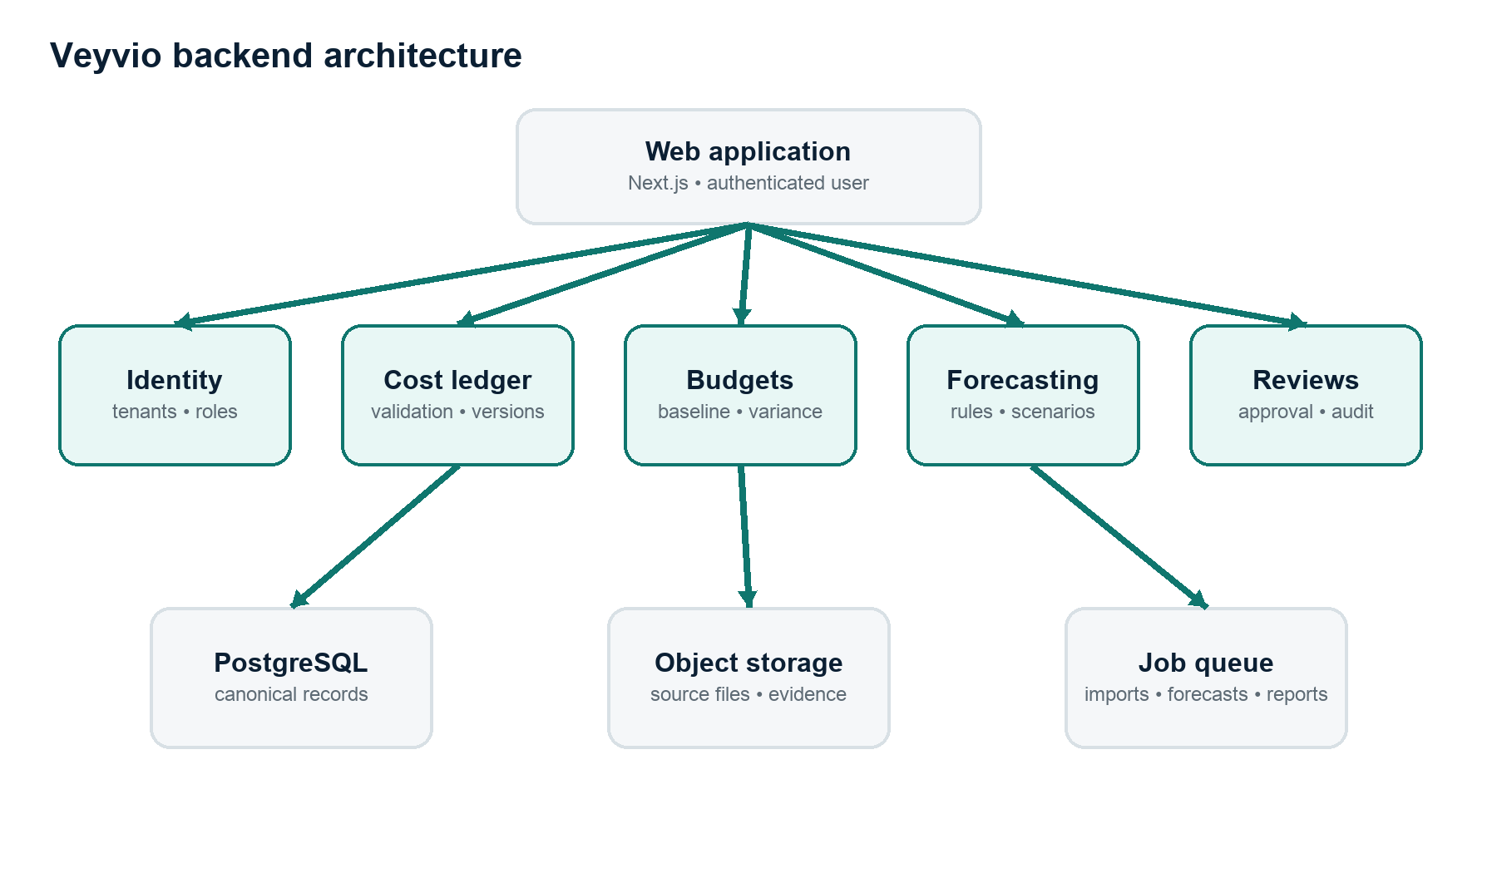
Figure 4. Modular-monolith backend with explicit domains and shared trusted infrastructure.

12.1 Backend domain boundaries
Backend module | Owns | Must not own
Identity | Users, organisations, memberships, roles, sessions and approval authority | Cost amounts or budget calculations
Cost ledger | Canonical costs, versions, lines, categories, allocation and correction | Forecast assumptions or user sessions
Imports | Connections, raw payloads, mapping, staging, validation, reconciliation and quarantine | Published financial totals
Budgets | Budget hierarchy, baselines, versions, lines, transfers and change requests | Source-system connection tokens
Forecasting | Rules, recurring costs, assumptions, runs, versions and forecast lines | Mutation of canonical actual costs
Reviews | Exceptions, recommendations, assignment, approval, decisions and outcomes | Independent financial calculations
Reporting | Report definitions, dataset snapshots, exports and schedules | Alternative copies of financial formulas
Audit | Append-only material events and security evidence | Mutable business state

12.2 Backend database requirements
PostgreSQL should be the authoritative transactional database. Every business table must include organisation ownership, stable identifiers, creation metadata and a concurrency strategy. Monetary values should use fixed-precision decimal or integer minor units; binary floating-point values are prohibited for authoritative amounts.
Requirement | Implementation rule
Tenant isolation | Every tenant-owned row carries organisation_id; repository and policy layers require it on every query.
Money | Store amount_minor plus ISO currency, or a fixed NUMERIC scale with a documented rounding policy.
Time | Store UTC timestamps; retain the organisation time zone for reporting-period boundaries.
Identifiers | Use non-sequential externally safe IDs; retain provider IDs under unique source constraints.
Versioning | Immutable version tables reference a stable parent record and monotonically increasing version.
Soft deletion | Use lifecycle status for financial records; never physically delete records needed for audit.
Optimistic locking | Use version counters or updated_at checks on editable configuration and review items.
Constraints | Enforce status transitions, non-null currency, allocation totals and unique import keys in the database.

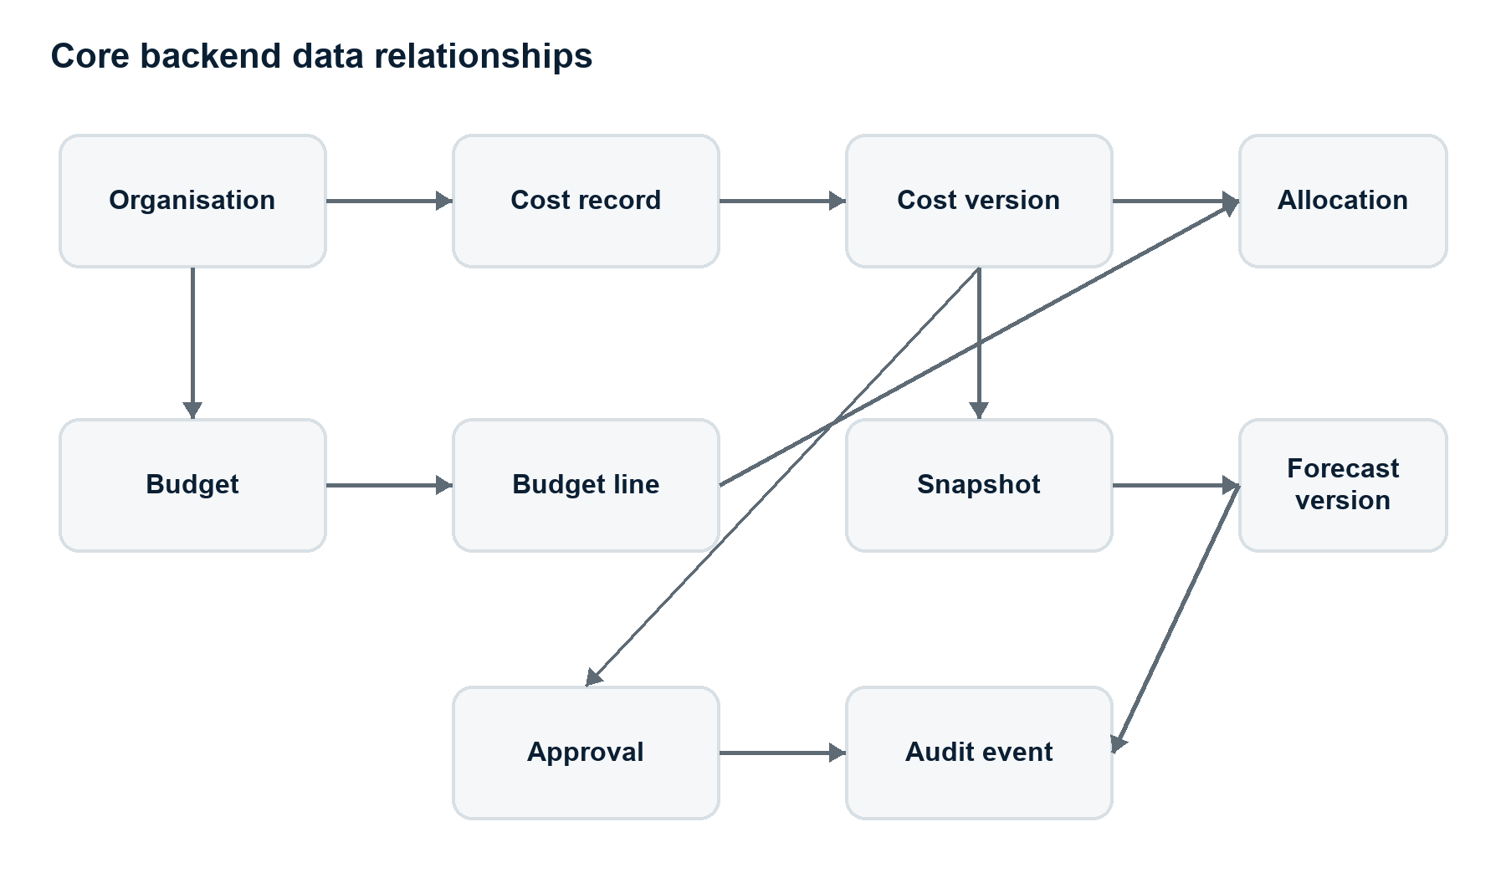
Figure 5. Core relationships between costs, budgets, snapshots, forecasts, approvals and audit records.

12.3 Minimum backend tables
Table group | Minimum tables
Organisation | organisations, users, memberships, roles, role_permissions, sessions
Cost ledger | cost_records, cost_versions, cost_lines, cost_categories, cost_allocations, cost_evidence
Reference | suppliers, vehicles, cost_centres, departments, accounting_periods, funding_codes
Imports | integration_connections, sync_runs, raw_import_records, staging_costs, import_mappings, quarantine_items
Budgets | budgets, budget_versions, budget_lines, budget_transfers, budget_change_requests
Forecasts | forecast_runs, forecast_versions, forecast_lines, recurring_rules, assumptions
Control | review_items, recommendations, approvals, approval_steps, actions, outcomes
Reporting | financial_snapshots, report_definitions, report_exports, report_schedules
Audit | audit_events, security_events and outbox_events

12.4 Cost-ledger transaction model
- Begin one database transaction after raw source data has passed structural validation.
- Acquire or verify the organisation and source-record idempotency key.
- Create or update the stable cost record and append a new immutable cost version.
- Write cost lines, evidence references and allocations against that version.
- Validate that allocation amounts exactly equal the cost amount.
- Write the audit event and outbox event inside the same database transaction.
- Commit once; publish asynchronous work from the outbox after the transaction succeeds.
The transactional outbox prevents a cost from being committed without the corresponding budget-recalculation or audit event. Consumers must remain idempotent because event delivery may occur more than once.

12.5 API surface
API group | Representative operations
Session | Sign in, sign out, refresh session, multi-factor challenge and current-user context
Organisations | Read organisation, switch context, list memberships and manage permitted settings
Costs | List, read, create manual draft, split, reclassify, submit correction and inspect versions
Evidence | Request secure upload, attach evidence, list metadata and obtain expiring download link
Budgets | List, read, create draft, submit change, approve change and compare versions
Forecasts | Run preview, publish version, compare versions and inspect assumptions
Reviews | List queue, assign, approve, reject, snooze, request evidence and record outcome
Imports | Create upload, preview mapping, confirm mapping, view sync, retry and resolve quarantine
Reports | Run report, inspect generation status, download export and manage schedules
Audit | Read permitted audit history and export an evidence package

API contract rules
- All organisation-scoped requests derive the tenant from authenticated membership, never from an unchecked client header.
- Mutating endpoints accept an idempotency key and return the authoritative resulting version.
- Amounts use explicit currency and string or integer representations that cannot lose precision.
- Errors use stable codes, human-readable messages and field-level details.
- List endpoints use cursor pagination and deterministic ordering.
- Conditional updates use an expected version to prevent silent overwrites.
- Consequential endpoints return an approval requirement rather than bypassing policy.

12.6 Background jobs and event processing
Job | Trigger | Correctness requirement
Import sync | Schedule or authorised manual request | Provider cursor, idempotent records and resumable batches
File parse | Completed secure upload | Checksum, parser version and quarantined invalid rows
Reconciliation | Validated staging batch | Source totals must match before publication
Snapshot build | Ledger or budget change | Consistent transaction boundary and deterministic input set
Forecast run | New snapshot or changed assumption | Pinned formula and assumption versions
Review detection | New published snapshot | Stable rules and deduplicated open review items
Report generation | User or schedule | Pinned snapshot/version and immutable export metadata
Notification | Approved domain event | Recipient permission check and delivery status
Retention | Policy schedule | Legal holds, audit preservation and deletion evidence

12.7 Domain events
- cost.imported
- cost.validated
- cost.quarantined
- cost.corrected
- cost.status_changed
- commitment.converted
- budget.version_approved
- snapshot.published
- forecast.published
- review.created
- approval.completed
- report.generated
- integration.degraded
Events contain identifiers and version references rather than unrestricted sensitive payloads. Consumers fetch authorised detail when needed. Event schemas are versioned and backward-compatible.

12.8 Validation and financial rules service
- Currency and rounding rules
- VAT and gross/net consistency
- Actual, committed, forecast and estimated status transitions
- Duplicate detection and provider idempotency
- Allocation equality and permitted allocation dimensions
- Accounting-period openness
- Budget ownership and approval threshold
- Commitment-to-actual conversion
- Formula-version selection
Rules should be pure, deterministic functions where possible. Each calculation stores the rule-set version so historical results remain reproducible after future rule changes.

12.9 Integration adapter contract
Every external provider must sit behind a common adapter boundary. The domain layer should not contain Xero, bank or fuel-card-specific field names.
Adapter capability | Required behaviour
Authorise | Obtain and securely store the minimum provider permissions.
Refresh | Refresh credentials before expiry and surface reauthorisation requirements.
Discover | List accessible organisations, accounts or card programmes.
Sync | Read incrementally using provider cursors or time windows.
Normalise | Map provider data to the staging schema without losing the raw payload.
Rate limiting | Respect provider limits with bounded retry and jitter.
Webhook | Verify signature, store event and process idempotently.
Health | Expose last success, last error, cursor, lag and permission state.

12.10 Authentication and authorisation
- Use a proven identity provider or security-reviewed authentication library.
- Short-lived authenticated sessions with secure, HTTP-only and same-site cookies.
- Multi-factor authentication for owners, finance managers and approvers.
- Server-side organisation membership and permission evaluation on every request.
- Step-up authentication for exports, connection changes and high-value approvals.
- Approval policies support thresholds, categories and segregation of duties.
- The person submitting a controlled change cannot approve it when policy requires separation.

12.11 File and evidence storage
- Use private encrypted object storage; never expose permanent public URLs.
- Store checksum, media type, byte size, uploader, source and retention classification.
- Scan uploads before parsing or download.
- Generate short-lived signed upload and download URLs.
- Link evidence to a specific cost version so a later correction does not rewrite historical evidence.
- Preserve original source files independently from generated reports.

12.12 Observability and operational controls
Area | Required telemetry
Requests | Request ID, organisation-safe context, route, status, latency and error code
Imports | Provider, cursor, rows read, rows accepted, rows quarantined and reconciliation difference
Calculations | Calculation ID, snapshot, formula version, duration and consistency result
Jobs | Queue delay, attempt, completion, failure, dead-letter and idempotency outcome
Security | Authentication changes, denied actions, exports, role changes and sensitive reads
Business health | Unallocated cost value, stale integrations, forecast age and open critical reviews

Logs must not contain full bank details, wage records, access tokens, source documents or unrestricted supplier information. Operational identifiers should permit investigation without exposing the underlying sensitive content.

12.13 Deployment and environments
- Separate development, staging and production accounts and databases.
- Infrastructure defined through reviewed code.
- Private database and object-storage access; public traffic terminates at a protected application edge.
- Secrets stored in a managed secret service and rotated.
- Automated migrations with forward and backward compatibility during rollout.
- Feature flags for high-risk calculation or integration changes.
- Blue/green or rolling deployments with health checks and rapid rollback.
- Production data is never copied into lower environments without approved anonymisation.

12.14 Backup, recovery and retention
- Point-in-time database recovery and encrypted cross-location backups.
- Object-storage versioning for evidence and imports.
- Documented recovery time and recovery point objectives.
- Routine restore tests, not merely successful backup jobs.
- Retention policies by raw import, evidence, cost record, report and audit event.
- Legal hold and investigation override before automated deletion.
- Deletion produces an auditable record without retaining prohibited content.

12.15 Initial service-level targets
Measure | Initial target
Interactive API availability | 99.9 percent monthly, excluding announced maintenance
Normal read latency | 95th percentile below 500 ms for common authenticated reads
Cost mutation latency | 95th percentile below 1 second, excluding external provider work
Forecast publication | Within 5 minutes of a normal validated snapshot
Import freshness | Provider-specific; visible last-success time and defined stale threshold
Recovery point | No more than 15 minutes for primary transactional data
Recovery time | Restore core read access within 4 hours for an initial production service

Targets are product requirements to validate during load and recovery testing. They are not customer commitments until operating evidence supports them.

12.16 Detailed architecture diagram pack
The following full-page diagrams provide the implementation-level workflows requested for engineering and product review. They use explicit processing stages, decision points, labelled branches and resulting system actions.
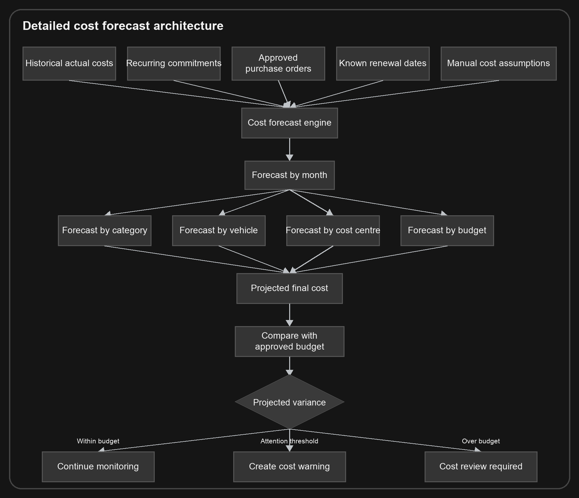
Figure 6. Detailed forecast architecture from cost inputs through budget-variance outcomes.

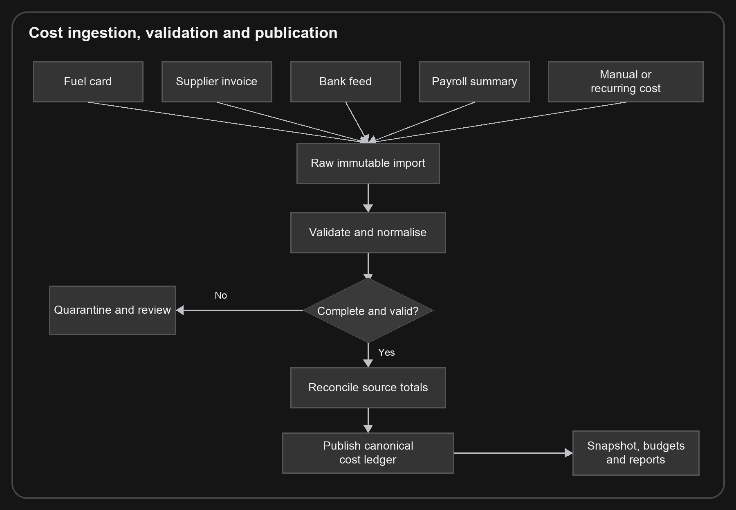
Figure 7. Detailed cost ingestion, validation, quarantine and publication workflow.

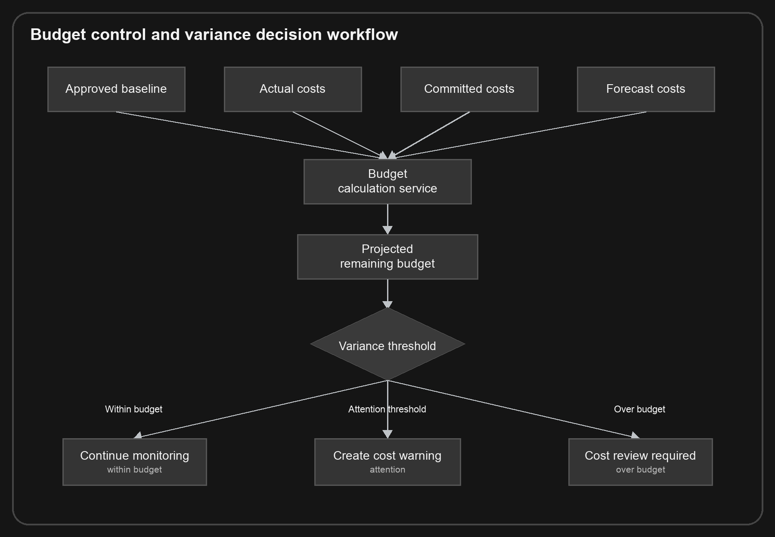
Figure 8. Budget calculation and threshold decision architecture.

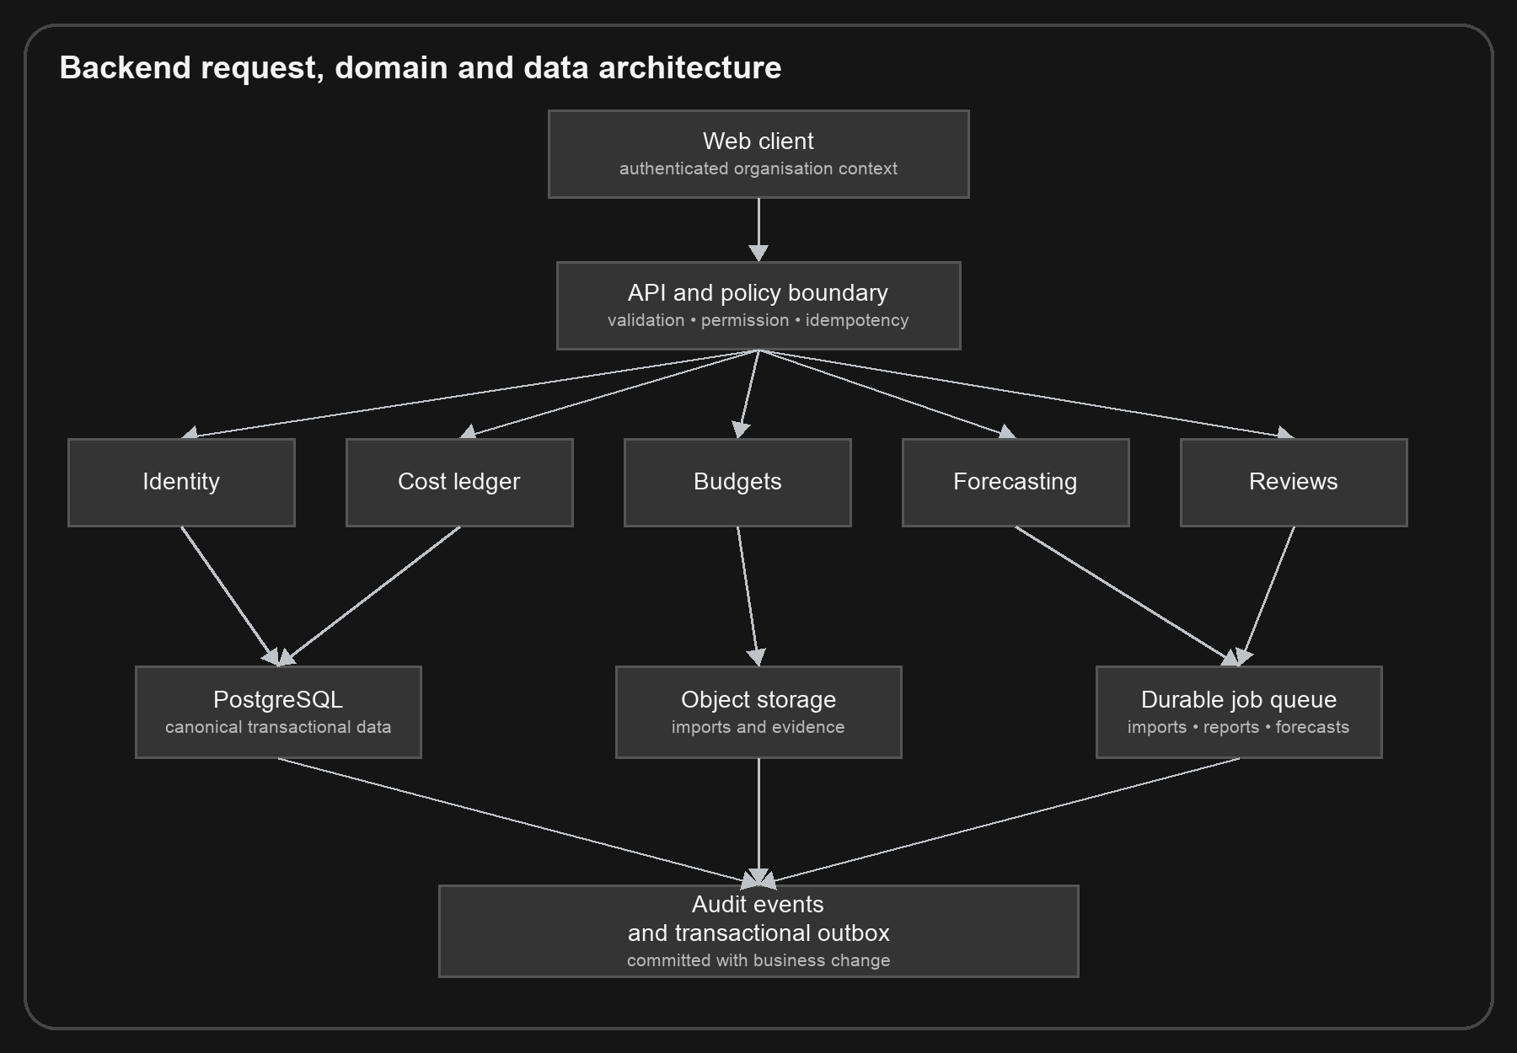
Figure 9. Backend request, domain, persistence, queue and audit architecture.

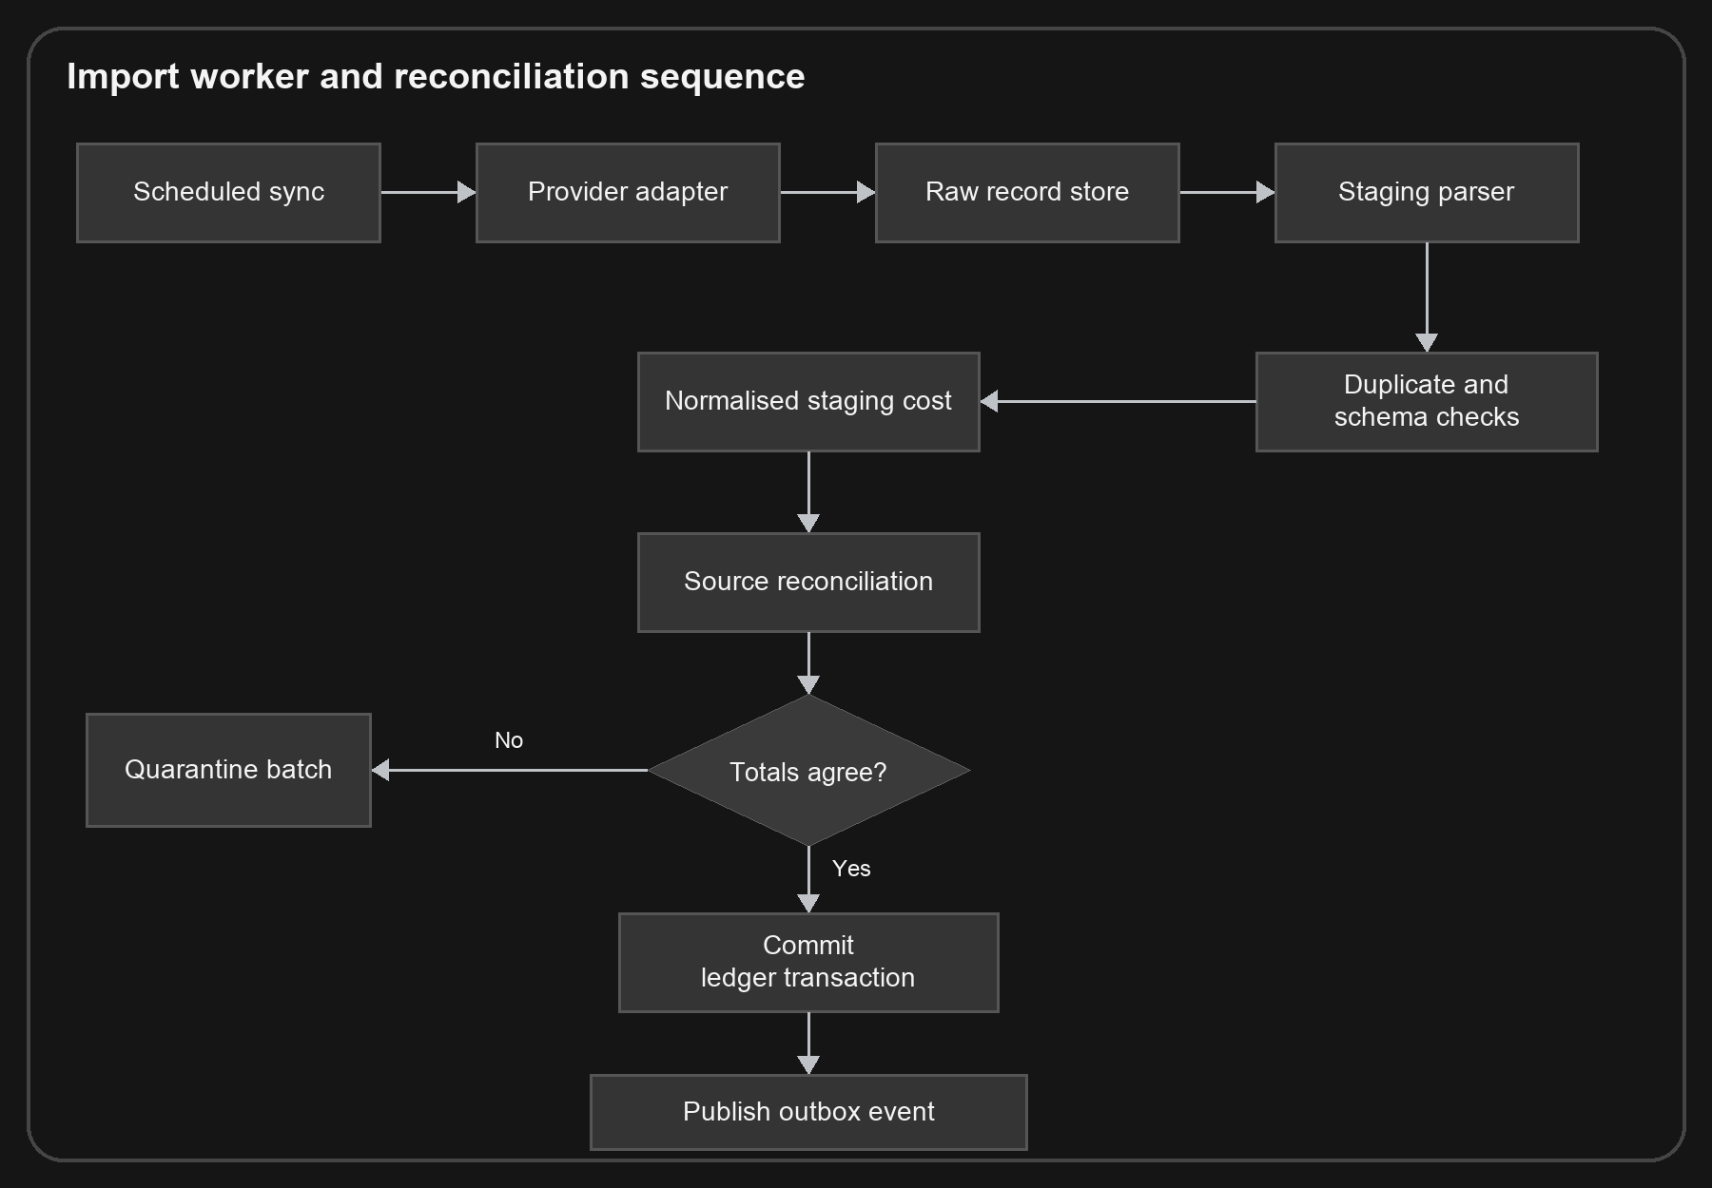
Figure 10. Import worker, parsing, duplicate detection and reconciliation sequence.

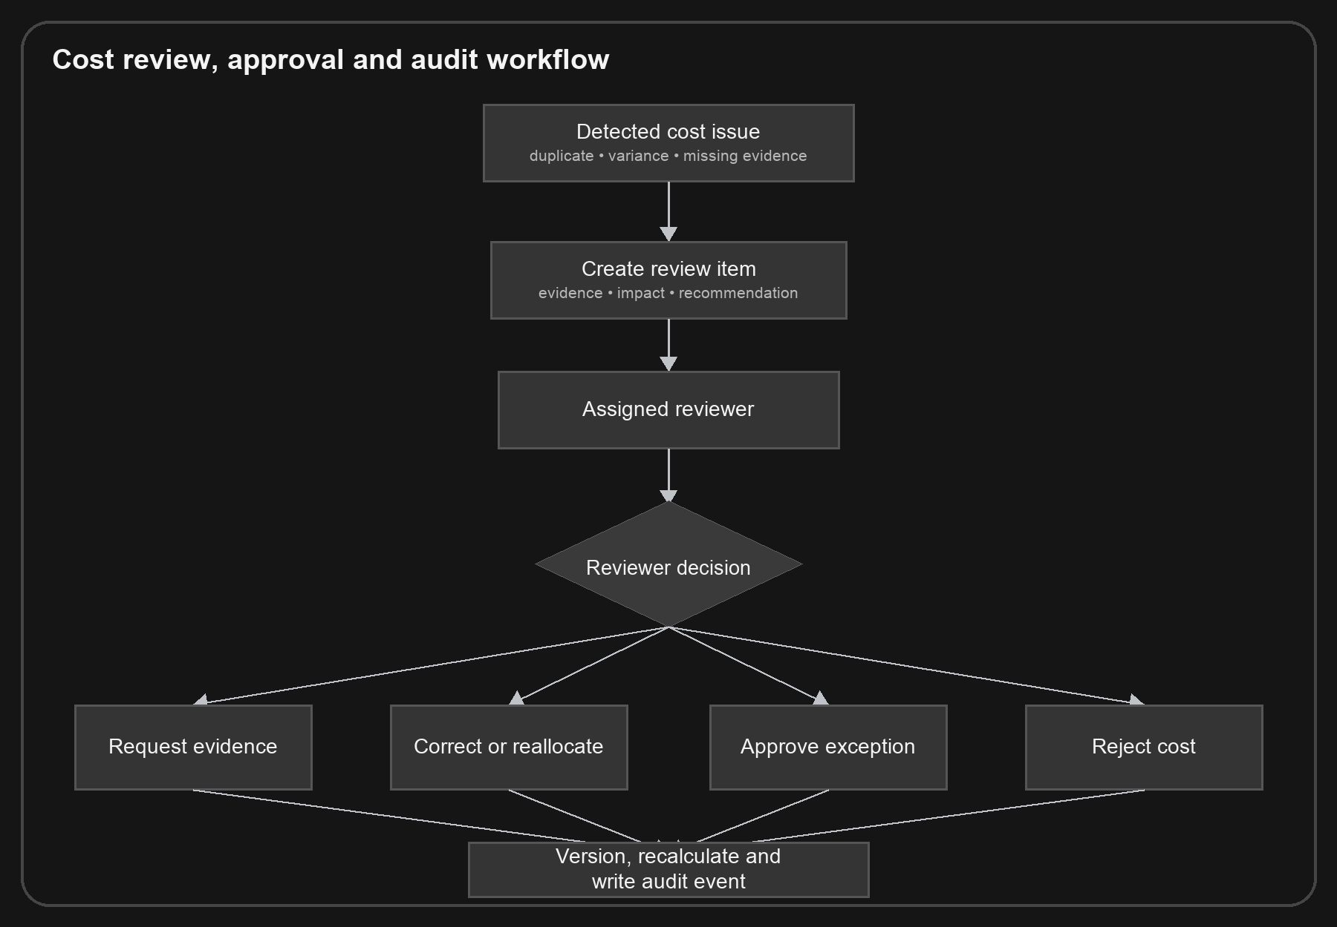
Figure 11. Cost review, approval, correction and audit workflow.

13. Financial correctness controls
Control | Requirement
Database constraints | Amounts, currency, status transitions and allocation totals are validated at persistence.
Idempotency | Repeated imports or provider callbacks cannot create duplicate costs.
Reconciliation | Source totals and imported totals must agree before publication.
Lineage | Every displayed amount links to source records and transformations.
Versioning | Costs, budgets, assumptions, forecasts and formulas preserve history.
Double-count prevention | Commitment-to-actual links enforce one economic cost.
Balanced allocation | Split allocations must equal the complete amount.
Last valid snapshot | Failed calculations do not replace trusted results.
Independent recalculation | Critical totals can be reproduced from the stored snapshot.
Immutable audit | Material actions record actor, authority, time, reason and result.

Calculation identity
Every authoritative amount should carry an internal calculation ID linking the result to its input snapshot, formula version, calculation time and consistency-check outcome. Support and audit teams must be able to reproduce the result exactly.

14. AI architecture and safeguards
The AI assistant is a controlled explanation and workflow-preparation layer. It does not own the cost ledger, calculate authoritative totals independently or write directly to financial records.
- Authenticate the user and organisation.
- Classify the request and check permission.
- Retrieve only authorised validated data.
- Call deterministic budget, cost or forecast tools.
- Generate a plain-language explanation.
- Validate every stated amount against tool output.
- Attach sources, assumptions and confidence.
- Return a draft cost review or change request for approval when appropriate.
- Prompt and model versioning
- Structured tool outputs
- Financial-amount validation
- Prompt-injection protection for imported documents
- Evaluation datasets with known cost answers
- Cost and latency controls
- Safe failure when data is incomplete
- No autonomous purchasing, payment or budget change

15. Security, privacy and auditability
- Encryption in transit and at rest
- Strong tenant isolation
- Role-based and attribute-based access where necessary
- Multi-factor authentication for privileged users
- Secret and integration-token management
- Immutable audit trails
- Data minimisation and defined retention
- Backup, restoration and incident-response testing
- Restricted access to wage and supplier-sensitive data
- Secure evidence downloads and expiring export links
- UK GDPR-aligned data subject and deletion workflows
- Professional security review and penetration testing before production launch
If Open Banking data is introduced, Veyvio should use an authorised partner initially and obtain specialist legal advice on the regulatory perimeter. Payment initiation is outside the cost-control MVP.

16. UI/UX and visual design system
EXPERIENCE PRINCIPLE
Calm financial confidence: serious, precise and transparent, without looking like a traditional bank or a trading platform.

Brand palette
Token | Hex | Use
Veyvio Midnight | #0B1F33 | Navigation, brand and primary text
Veyvio Teal | #0F766E | Primary actions and interactive emphasis
Veyvio Mint | #2DD4BF | Focus, highlights and selected chart points
Cloud | #F5F7F9 | Application background
White | #FFFFFF | Primary surfaces
Ink | #102130 | Main content text
Slate | #5E6B75 | Secondary text
Mist | #D8E0E5 | Borders and separators
Healthy | #16794B | Confirmed and reconciled status
Attention | #A15C00 | Cost requiring review
Critical | #B42318 | Blocking error or material overspend
Information | #1D4ED8 | Neutral explanation

Colour rules
- Colour communicates status, not simply positive or negative arithmetic.
- Every status also uses text and an icon or line style.
- Forecast values use a distinct line or label from actual values.
- Mint is paired with dark Midnight text rather than white.
- Critical red is reserved for errors, blocking conditions and material cost risk.

Typography and numbers
- Use Inter in the application, with regular and medium weights.
- Use tabular numerals for monetary values.
- Right-align numerical table columns.
- Show exact values where a decision depends on the amount.
- Use an unambiguous date such as 28 Jul 2026.
- Always show currency and label actual, committed, forecast and estimated values.

Application navigation
- Home
- Costs: All costs, Fuel, Vehicles, Maintenance, Wage costs and Operating costs
- Budgets: CEC budget, Other budgets and Budget changes
- Forecast
- Commitments
- Suppliers
- Cost reviews
- Reports
- Imports
- Settings

Interaction rules
- One dominant decision per page.
- Sources and calculations are inspectable without losing context.
- Large changes receive a preview and explicit confirmation.
- A blocking data issue identifies what is unavailable and how to resolve it.
- Tables become labelled rows on narrow screens.
- Desktop is optimised for analysis; mobile is optimised for review and approval.
- Target WCAG 2.2 AA and never rely on colour alone.

17. Reports and management information
Report | Core contents
CEC budget | Approved, revised, actual, committed, forecast, projected final and remaining amounts
Budget variance | Variance by period, category, cost centre, vehicle and owner
Monthly costs | Period totals, changes, exceptions and forecast
Fuel costs | Spend, litres, price per litre, cost per mile, allocation and anomalies
Vehicle costs | Finance, fuel, maintenance, insurance, tax and total cost
Maintenance costs | MOT, service, repair, inspection, tyres, parts and unplanned cost
Wage costs | Approved wage totals, overtime, employer cost and budget variance
Supplier spend | Supplier total, recurring cost, price change and evidence completeness
Exceptional costs | Material one-time or unusual costs
Forecast final cost | Projected cost, remaining budget, range and assumptions
Missing evidence | Costs lacking required source documents or approval
Corrections and audit | Record versions, reasons, actors, approvals and calculation effects

Every export must state organisation, reporting period, currency, data-through time, financial snapshot, budget version, forecast version and whether amounts are actual, committed, forecast or estimated.

18. Testing and acceptance strategy

Test layers
- Unit tests for formulas, status transitions and allocation rules
- Property-based tests for rounding, splitting and lifecycle conversions
- Golden financial datasets verified by a qualified finance professional
- Integration contract tests for Xero, fuel-card and bank sources
- Reconciliation tests against source totals
- End-to-end tests for every critical workflow
- Tenant-isolation and permission tests
- Forecast backtesting
- AI evaluation against known tool outputs
- Accessibility, performance, security and recovery testing

Critical acceptance scenarios
- The same source record imported repeatedly produces one cost.
- A commitment converted to actual does not increase projected final cost twice.
- A split allocation cannot save unless its parts equal the complete amount.
- An invalid import cannot replace the last valid snapshot.
- A correction preserves the original value and complete history.
- All pages and exports show the same amount for the same snapshot and version.
- A user without permission cannot change a cost by calling the API directly.
- AI cannot display an amount that differs from the deterministic tool result.
- A budget revision preserves the original approved baseline.
- Currency, VAT and rounding rules produce reproducible totals.

19. Delivery roadmap
Phase | Outcome | Included capabilities
0. Definition | Financial model and scope validated | CEC definition, category taxonomy, worked examples, user interviews and clickable prototype
1. Foundation | Trusted cost ledger | Identity, organisation, CSV import, canonical cost model, validation, categories, allocations and audit
2. Budget control | CEC budget position visible | Budget hierarchy, actual and committed costs, variance, Home and core reports
3. Cost intelligence | Future cost and exceptions visible | Forecasting, recurring costs, duplicate detection, cost review and evidence
4. Integrations | Reduced manual handling | Xero, fuel-card provider, bank reconciliation partner and payroll summaries
5. Decision support | Management can act earlier | Cost scenarios, recommendations, approval workflows and AI explanations
6. Scale | Portfolio-grade product | Multiple entities, advanced permissions, accountant/auditor experience and operational hardening

MVP definition
- Organisation and role management
- CSV cost imports
- Canonical cost ledger
- Cost categories and allocation
- Fuel, vehicle, maintenance, wage-summary and operating-cost views
- CEC budget
- Actual, committed and forecast statuses
- Basic recurring-cost forecast
- Cost review queue
- Budget versus actual report
- Immutable audit trail

Explicitly deferred
- Payment initiation
- Direct payroll processing
- Native mobile applications
- Complex multi-currency consolidation
- Autonomous supplier or purchasing actions
- Direct regulatory registration for Open Banking
- Any booking, dispatch, income, sales or operational management capability

20. Risks, decisions and open definitions
Risk | Mitigation
Poor source data | Staging, quarantine, reconciliation, data-health indicators and correction workflow
Double counting | Enforced lifecycle links between commitments and actual costs
Conflicting totals | Shared stored snapshots and central calculation services
Forecast mistrust | Versioned assumptions, ranges, backtesting and explainability
Scope expansion | Apply the cost relevance test to every proposed capability
AI error | Deterministic tools, amount validation and no direct ledger writes
Sensitive wage data | Restricted roles, minimised data and full audit
Integration instability | Idempotency, retries, quarantine and last-valid-state protection
Regulatory exposure | Avoid payment initiation in MVP and use authorised partners
Overbuilding | Validate CSV-led MVP and CEC reporting before advanced integrations

Decisions locked by this document
- Veyvio is cost-only.
- CEC and other budget control is the centre of the product.
- Income and profitability are excluded.
- Booking, scheduling, dispatch and routes are excluded.
- Payroll processing is excluded; approved wage-cost summaries are included.
- MOT, service and inspection information is included only to capture or forecast cost.
- The MVP uses a modular monolith and a canonical cost ledger.
- AI explains and prepares; deterministic services calculate.
- No external consequential action occurs without authorised approval.

Open definitions to confirm
- The full meaning, ownership and formal structure of the CEC budget.
- The required CEC cost codes and reporting periods.
- The initial organisations, vehicles and cost centres in scope.
- The exact fuel-card and accounting providers.
- Whether wage costs may be stored individually or only in approved aggregates.
- VAT, currency and financial-year requirements.
- Approval thresholds and segregation-of-duties rules.
- Required report formats and external recipients.

Final product statement
The strength of Veyvio will come from focus. It should not attempt to operate the business. It should provide one accurate, explainable and auditable view of cost so the business can control expenditure with confidence.
VEYVIO
A trusted cost-control platform that captures every cost, validates and allocates it, compares it with the CEC budget, forecasts the final position and shows where authorised action is needed.

