Following the Money: A Reproducible Analysis of Campaign Finance Reports in the 2017 San Antonio,TX Mayoral Race

Larkin O'Hern

January 19, 2017

### Purpose

While there is plenty of attention on the impact of political contributions on state and national elections, there is a dearth of coverage for local races. My goal is to develop a reproducible analysis that can be quickly re-run as new reports become available and can be used for races across the state of Texas.

### The Data

I'm using the ongoing 2017 San Antonio mayoral race to develop the analysis. The campaign finance reports are available here:(get web link later). The first report I analyzed was released **2017-01-02**. At that time there were **3** candidates: **IVY TAYLOR**, **Juan Manuel Medina** and **Ronald Nirenberg**. The report included data on **1627** contributions from **1596** individual contributors and **31** Political Action Committees worth **$470338.06** recorded between **2016-07-01** and **2016-12-31**.

### PACs vs. Individuals (Families?)

|  |  |  |  |  |  |  |
| --- | --- | --- | --- | --- | --- | --- |
| contact_type | total | mean | median | mode | max | min |
| INDV | 449,038 | 281 | 100 | 5.06 | 1,000 | 5 |
| PAC | 21,300 | 687 | 500 | 1,000.00 | 1,000 | 100 |

Individual donors outspent PACs **$ 449038.06** to **$21300** but the average PAC gave significantly more- **$687.097** to **$281.352** (mean) and **$687.097** to **$281.352** (median). The most common individual contribution was **$5.06** while the most common PAC contribution was **$1000**. See Appendix A for a list of all PAC contributions.

Add family stuff here....

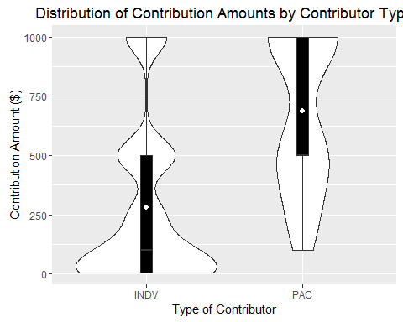

There is much greater variation in the size of individual contributions, especially at the low end while PAC giving was more uniform. The graph is a bit misleading as individual contributors vastly outnumber PACs in this report.

## The Candidates

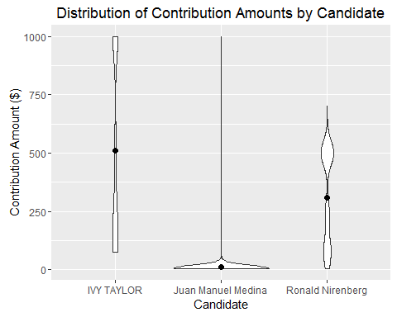

|  |  |  |  |  |  |  |  |
| --- | --- | --- | --- | --- | --- | --- | --- |
| candidate | total | n | mean | median | mode | max | min |
| IVY TAYLOR | 321,531 | 632 | 508.8 | 375.00 | 1,000.00 | 1,000 | 75 |
| Ronald Nirenberg | 143,356 | 464 | 309.0 | 250.00 | 500.00 | 700 | 5 |
| Juan Manuel Medina | 5,451 | 531 | 10.3 | 5.06 | 5.06 | 1,000 | 5 |

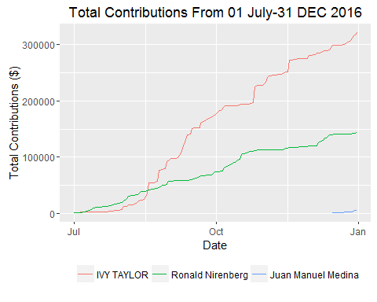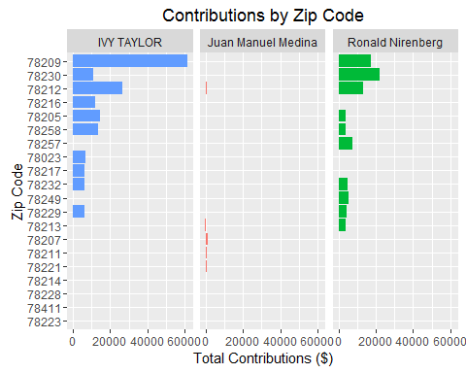

*Total Out of State Donations:*

|  |  |  |  |  |
| --- | --- | --- | --- | --- |
| candidate | contact_type | total | mean | n |
| IVY TAYLOR | INDV | 16,300.0 | 815.00 | 20 |
| Ronald Nirenberg | INDV | 1,530.0 | 139.09 | 11 |
| IVY TAYLOR | PAC | 1,250.0 | 625.00 | 2 |
| Ronald Nirenberg | PAC | 100.0 | 100.00 | 1 |
| Juan Manuel Medina | INDV | 40.5 | 5.06 | 8 |

*Out of State Donations By State:*

|  |  |  |  |  |
| --- | --- | --- | --- | --- |
| candidate | state | total | mean | n |
| IVY TAYLOR | FL | 6,000.0 | 1,000.00 | 6 |
| IVY TAYLOR | KS | 2,000.0 | 1,000.00 | 2 |
| IVY TAYLOR | AZ | 1,500.0 | 750.00 | 2 |
| IVY TAYLOR | AL | 1,000.0 | 1,000.00 | 1 |
| IVY TAYLOR | CO | 1,000.0 | 1,000.00 | 1 |
| IVY TAYLOR | DC | 1,000.0 | 1,000.00 | 1 |
| IVY TAYLOR | IL | 1,000.0 | 1,000.00 | 1 |
| IVY TAYLOR | NE | 1,000.0 | 1,000.00 | 1 |
| IVY TAYLOR | VA | 1,000.0 | 1,000.00 | 1 |
| IVY TAYLOR | VI | 1,000.0 | 1,000.00 | 1 |
| Ronald Nirenberg | CA | 650.0 | 216.67 | 3 |
| IVY TAYLOR | TN | 500.0 | 500.00 | 1 |
| Ronald Nirenberg | PA | 450.0 | 225.00 | 2 |
| IVY TAYLOR | MO | 250.0 | 250.00 | 1 |
| IVY TAYLOR | NC | 200.0 | 100.00 | 2 |
| Ronald Nirenberg | NA | 200.0 | 200.00 | 1 |
| Ronald Nirenberg | DC | 125.0 | 41.67 | 3 |
| IVY TAYLOR | NY | 100.0 | 100.00 | 1 |
| Ronald Nirenberg | MA | 100.0 | 100.00 | 1 |
| Ronald Nirenberg | NJ | 100.0 | 100.00 | 1 |
| Juan Manuel Medina | CA | 30.4 | 5.06 | 6 |
| Juan Manuel Medina | NE | 10.1 | 5.06 | 2 |
| Ronald Nirenberg | WA | 5.0 | 5.00 | 1 |

Mayor Ivy has raised significantly more than her opponents both locally and out of state. She has not only received more contributions, but her average contribution value is $200 greater than the either other candidate. As you can see if the table below she is killing it with max level donors ($1000) especially PACs.

|  |  |  |
| --- | --- | --- |
| candidate | contact_type | maxers |
| IVY TAYLOR | INDV | 210 |
| IVY TAYLOR | PAC | 15 |
| Juan Manuel Medina | INDV | 1 |

|  |  |
| --- | --- |
| candidate | pac_contributors |
| IVY TAYLOR | 24 |
| Ronald Nirenberg | 7 |

### Contributions by Type (Monetary vs. In-Kind)

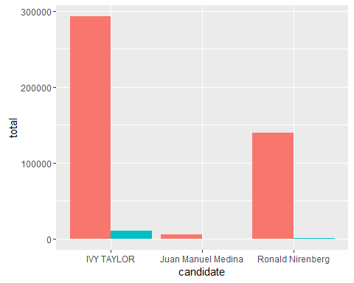

|  |  |  |  |  |  |
| --- | --- | --- | --- | --- | --- |
| candidate | contact_type | contrib_type | total | mean | n |
| IVY TAYLOR | INDV | Monetary Political Contributions | 293,109 | 497.64 | 589 |
| IVY TAYLOR | INDV | Non-Monetary (In-Kind) Political Contributions | 9,972 | 524.85 | 19 |
| IVY TAYLOR | PAC | Monetary Political Contributions | 17,450 | 758.70 | 23 |
| IVY TAYLOR | PAC | Non-Monetary (In-Kind) Political Contributions | 1,000 | 1,000.00 | 1 |
| Juan Manuel Medina | INDV | Monetary Political Contributions | 5,215 | 9.84 | 530 |
| Juan Manuel Medina | INDV | Non-Monetary (In-Kind) Political Contributions | 236 | 236.00 | 1 |
| Ronald Nirenberg | INDV | Monetary Political Contributions | 139,304 | 306.16 | 455 |
| Ronald Nirenberg | INDV | Non-Monetary (In-Kind) Political Contributions | 1,202 | 600.90 | 2 |
| Ronald Nirenberg | PAC | Monetary Political Contributions | 2,850 | 407.14 | 7 |

In-kind contributions appear insignificant compared to monetary contributions, though Mayor Ivy has received nearly $11,000 worth of in-kind contributions.

## Appendix A-PAC Contributions

|  |  |  |
| --- | --- | --- |
| last_name | amount | candidate |
| HNTB PAC | 1,000 | IVY TAYLOR |
| THE BOEING POLITICAL ACTION COMMITTEE | 1,000 | IVY TAYLOR |
| ACROSS THE TRACK PAC | 1,000 | IVY TAYLOR |
| CDS MUERY PAC | 1,000 | IVY TAYLOR |
| CP & Y INC. PAC | 1,000 | IVY TAYLOR |
| DAVIDSON TROILO REAM & GAZA COMMITTEE | 1,000 | IVY TAYLOR |
| IBC State Political Action Committee | 1,000 | IVY TAYLOR |
| KEVIN WOLFF CAMPAIGN | 1,000 | IVY TAYLOR |
| NORTON ROSE FULBRIGHT US LLP TEXAS COMMITTEE | 1,000 | IVY TAYLOR |
| NUSTAR PAC | 1,000 | IVY TAYLOR |
| PSCO PAC | 1,000 | IVY TAYLOR |
| SAN ANTONIO RESTAURANT ASSOCIATION PAC | 1,000 | IVY TAYLOR |
| TEXAS AUTOMOBILE DEALERS ASSOCIATION PAC | 1,000 | IVY TAYLOR |
| RABA-KISTNER PAC INC. | 1,000 | IVY TAYLOR |
| VALERO ENERGY CORPORATION POLITICAL ACTION COMMITTEEÂ | 1,000 | IVY TAYLOR |
| FREESE AND NICHOLS PAC | 500 | IVY TAYLOR |
| FRIENDS FOR NELSON W. WOLFF | 500 | IVY TAYLOR |
| LAN-PAC | 500 | IVY TAYLOR |
| SAHLA PAC | 500 | IVY TAYLOR |
| TEXAS TAXI POLITICAL ACTION COMMITTEE | 500 | IVY TAYLOR |
| CADENCE BANK NA PAC | 250 | IVY TAYLOR |
| FREESE AND NICHOLS PAC | 250 | IVY TAYLOR |
| FRIENDS FOR NELSON W. WOLFF | 250 | IVY TAYLOR |
| RJ RIVERA ASSOCIATES PAC | 200 | IVY TAYLOR |
| RJ Rivera Associates PAC | 500 | Ronald Nirenberg |
| PSCO PAC | 500 | Ronald Nirenberg |
| Cobb Fendley PAC | 500 | Ronald Nirenberg |
| Davidson Troilo Reams & Garza A Professional Corporation Committee for Civic Awareness | 500 | Ronald Nirenberg |
| S A Apartment Association PAC | 500 | Ronald Nirenberg |
| RPS Klotz PAC | 250 | Ronald Nirenberg |
| Environment America Voter Action | 100 | Ronald Nirenberg |