Deliverable 3: Predictive Model Development and Performance Evaluation
Project MAI643

1. Project Title and Team Members
Project Title: Machine Learning-Driven Risk Stratification for Stroke Using Clinical and Lifestyle Factors
- Larkou Kostantinos
- Rodosthenous Ioannis
- Tamboutsiaris Petros

2. Revisions from Previous Deliverable
No changes were made to the raw dataset or the base preprocessing assumptions from Deliverable 2. The main revision in Deliverable 3 is methodological: preprocessing was embedded directly inside cross-validation and GridSearchCV pipelines so that imputation, encoding, scaling, SMOTE, and PCA are learned only from training folds. This avoids data leakage during model selection and tuning.
AdaBoost was also added to the candidate algorithms in response to the previous feedback suggesting that a boosting method should be tested.

3. Model Evaluation Metrics
The stroke class is highly imbalanced: 249 positive cases out of 5110 total observations (4.87%). Because of that, accuracy alone is not a reliable metric. A model can appear strong by predicting the majority class while failing to detect actual stroke cases.
- Accuracy: reported for completeness and for comparison with prior studies.
- Balanced Accuracy: used as the main selection metric because it weights both classes equally.
- Precision: shows how many predicted stroke cases are truly stroke cases.
- Recall (Sensitivity): important in screening because missed stroke cases are costly.
- Weighted F1-score: summarizes global classification quality under class imbalance.
Balanced accuracy was used as the primary optimization criterion during model selection and hyperparameter tuning, while recall and weighted F1-score were used as secondary checks.

4. Initial Model Experimentation

Experimental Setup
- Dataset after preparation: 5110 rows and 10 predictive variables after dropping the identifier.
- Train/test split: 80/20 stratified split (4088 train, 1022 test).
- Cross-validation: 5-fold stratified cross-validation on the training split.
- Candidate models: Logistic Regression, K-Nearest Neighbors, Random Forest, Support Vector Machine, AdaBoost.

Preprocessed Dataset Versions
Version | Preprocessing steps
V1 | Median imputation (numerical), most-frequent imputation (categorical), one-hot encoding
V2 | V1 plus standard scaling for numerical features
V3 | V2 plus SMOTE applied on the training fold only
V4 | V3 plus PCA retaining 95% explained variance

Initial Cross-Validation Results by Model
model | Accuracy | Balanced Accuracy | Precision | Recall | Weighted F1
LogisticRegression | 0.8466 | 0.6291 | 0.0665 | 0.3882 | 0.8713
AdaBoost | 0.8321 | 0.6197 | 0.0599 | 0.3845 | 0.8609
SVM | 0.8681 | 0.5868 | 0.0607 | 0.2751 | 0.8851
KNN | 0.8795 | 0.5575 | 0.1214 | 0.2008 | 0.8929
RandomForest | 0.9305 | 0.5194 | 0.1851 | 0.0640 | 0.9198

Initial Cross-Validation Results by Dataset Version
Dataset Version | Accuracy | Balanced Accuracy | Precision | Recall | Weighted F1
V4 | 0.7830 | 0.6742 | 0.1201 | 0.5537 | 0.8386
V3 | 0.8018 | 0.6507 | 0.1131 | 0.4833 | 0.8501
V1 | 0.9502 | 0.5028 | 0.0790 | 0.0071 | 0.9276
V2 | 0.9504 | 0.5024 | 0.0827 | 0.0060 | 0.9276

The initial experiments show that the highest-accuracy pipelines (V1 and V2) are misleading. They achieve roughly 95% accuracy while almost completely failing to identify stroke cases. The SMOTE-based versions (V3 and V4) substantially improve recall and balanced accuracy, which is more appropriate for stroke-risk screening.
For the same reason, model selection did not rely on accuracy alone. Logistic Regression and AdaBoost produced the most defensible class-sensitive behavior, while Random Forest and KNN mainly benefited from the class imbalance.
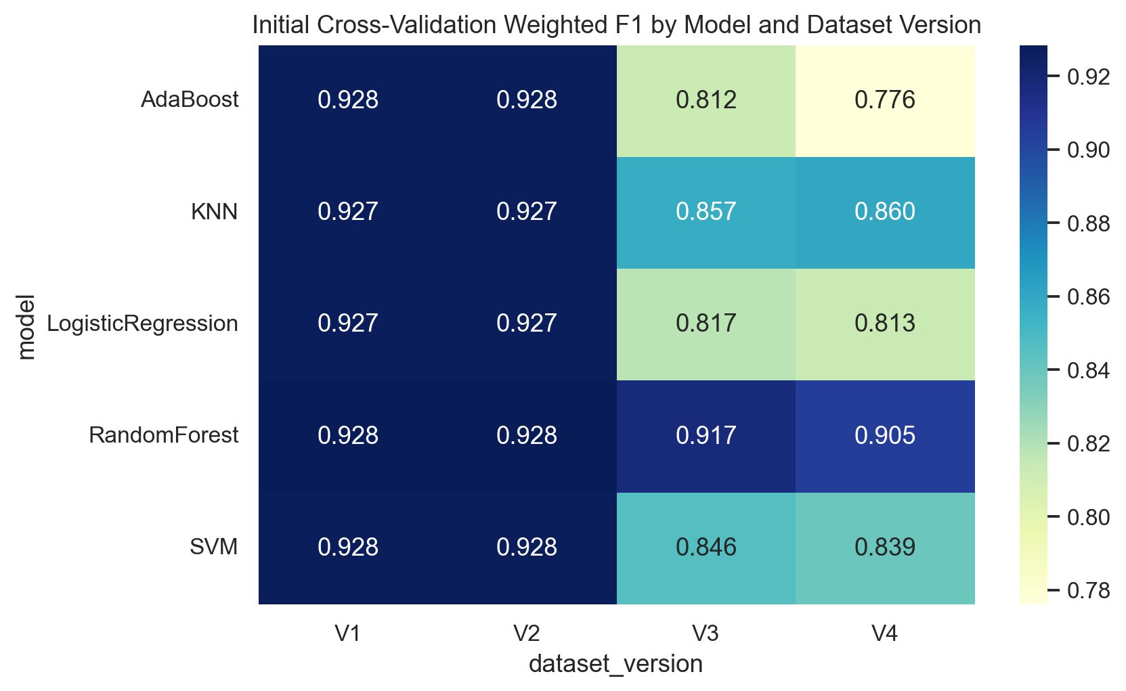
Figure 1. Initial cross-validation weighted F1-score heatmap.
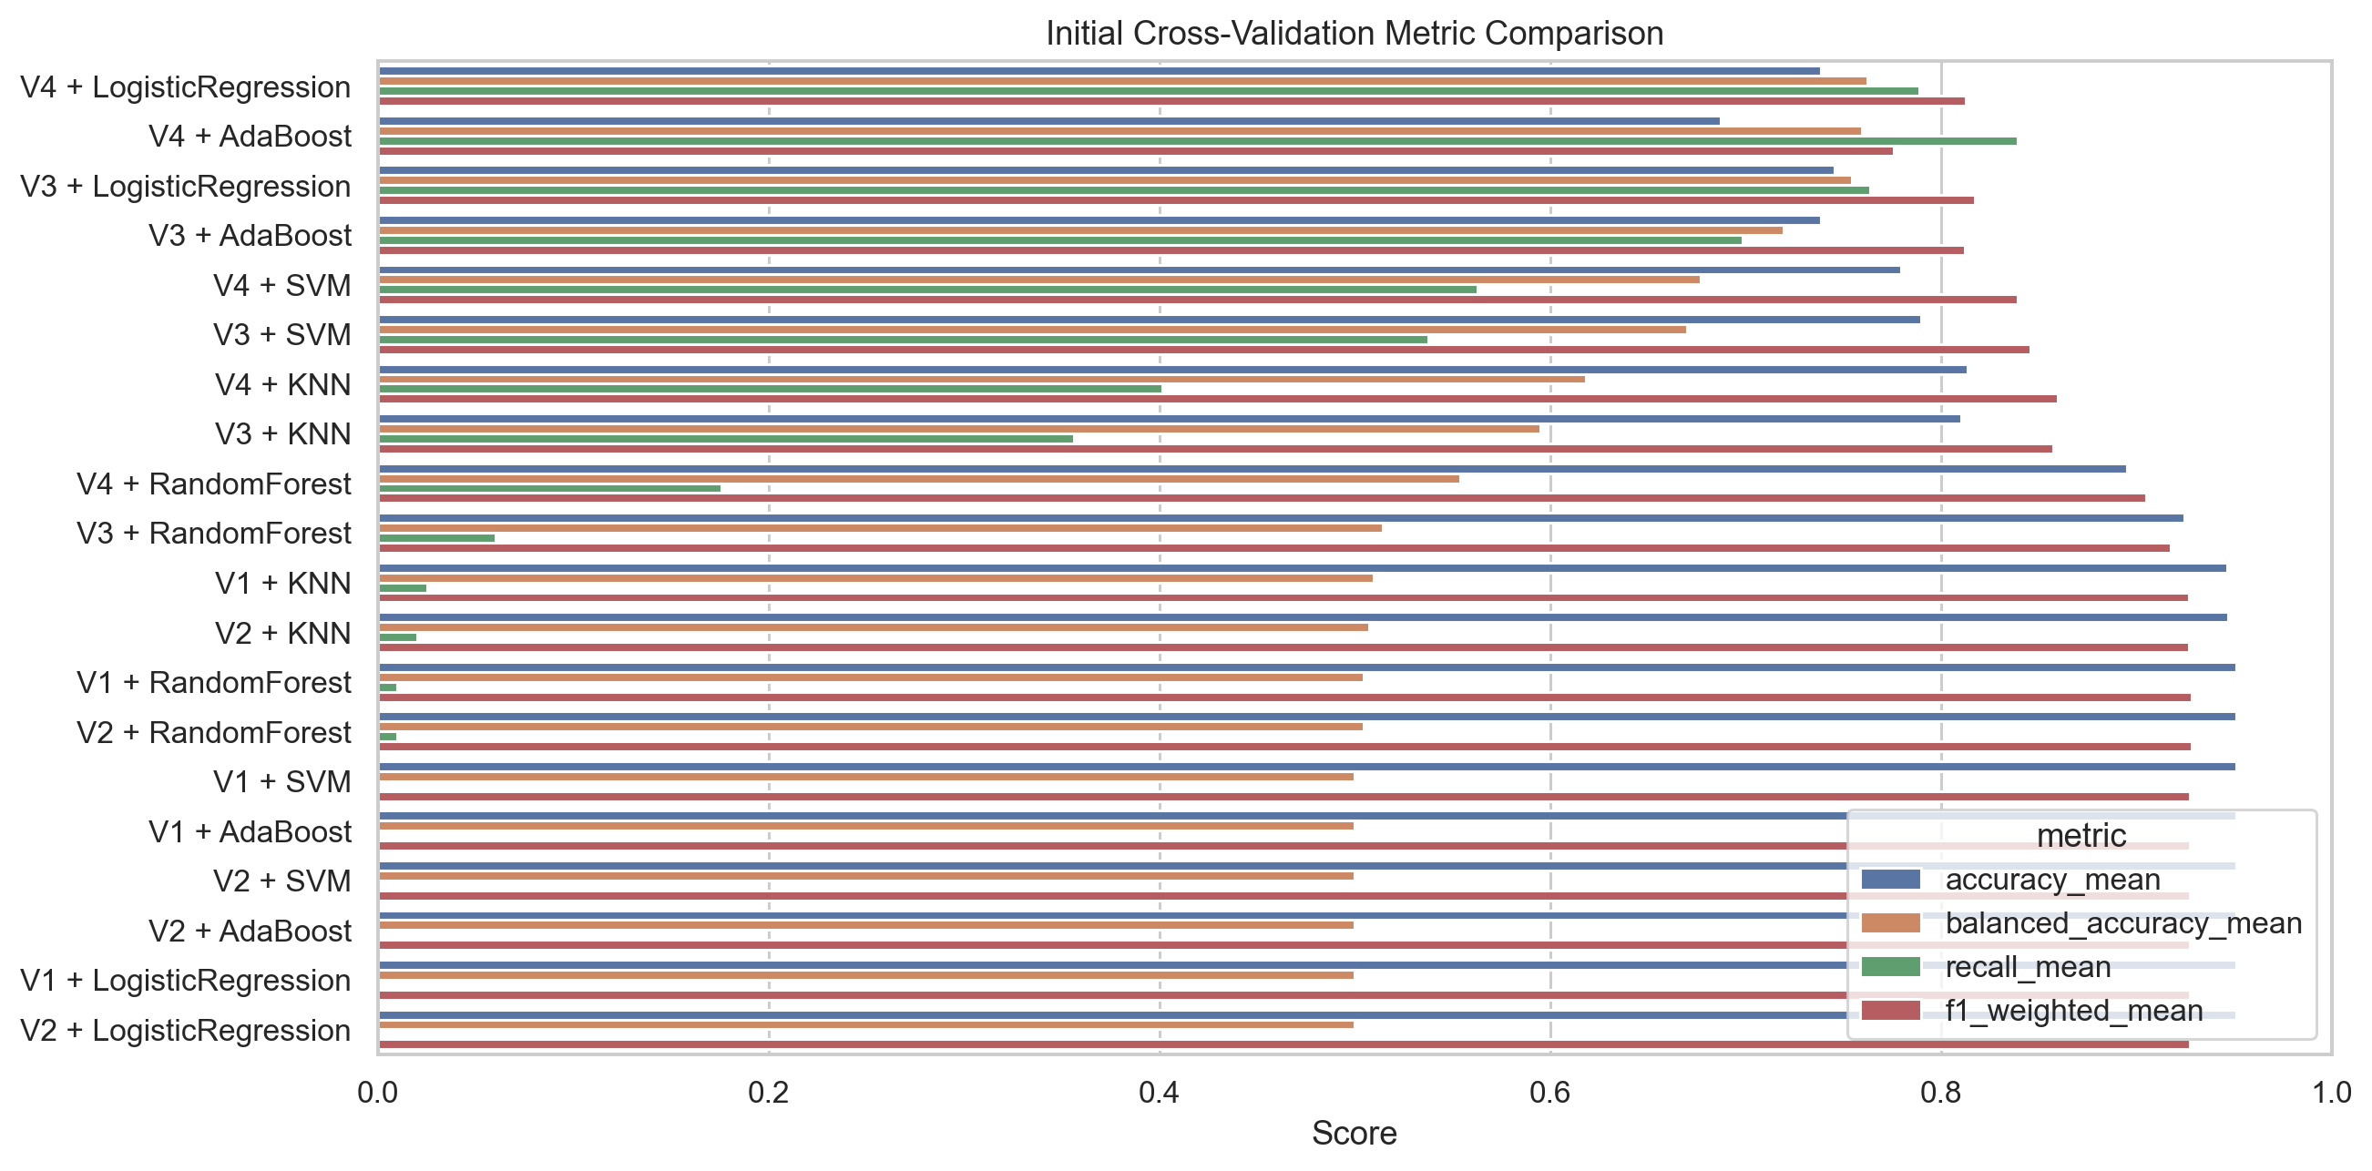
Figure 2. Initial cross-validation metric comparison across model/version combinations.

5. Selection of Best-Performing Models and Pre-Processed Datasets
- Selected models: LogisticRegression, AdaBoost
- Selected dataset versions: V4, V3
Selection was based primarily on balanced accuracy and stroke recall rather than on raw accuracy. This is more defensible for an imbalanced medical dataset where failing to detect positive cases is a serious error.

6. Pipeline Definition

Pipeline for V3
- Median imputation for numerical features
- Standard scaling for numerical features
- Most-frequent imputation for categorical features
- One-hot encoding for categorical features
- SMOTE applied inside each training fold
- Classifier (Logistic Regression or AdaBoost)

Pipeline for V4
- Same preprocessing as V3
- PCA retaining 95% explained variance
- Classifier (Logistic Regression or AdaBoost)
This structure ensures that all transformations are estimated strictly from the training data inside each GridSearchCV split.

7. Hyperparameter Tuning
GridSearchCV with 5 stratified folds was applied to the four finalist combinations: V4 + Logistic Regression, V4 + AdaBoost, V3 + Logistic Regression, and V3 + AdaBoost.
Logistic Regression grid:
- C: [0.1, 1.0, 5.0, 10.0]
- solver: ["liblinear", "lbfgs"]
- class_weight: [None, "balanced"]
AdaBoost grid:
- n_estimators: [50, 100, 200]
- learning_rate: [0.5, 1.0, 1.5]
Balanced accuracy was used for GridSearchCV refitting, while recall, precision, and weighted F1-score were also tracked.

8. Final Model Evaluation

Tuned Finalist Results on the Held-Out Test Split
Combination | Accuracy | Balanced Accuracy | Precision | Recall | Weighted F1 | Macro F1
V4_LogisticRegression | 0.7524 | 0.7750 | 0.1413 | 0.8000 | 0.8222 | 0.5462
V3_LogisticRegression | 0.7515 | 0.7745 | 0.1408 | 0.8000 | 0.8215 | 0.5455
V3_AdaBoost | 0.7025 | 0.7677 | 0.1243 | 0.8400 | 0.7871 | 0.5165
V4_AdaBoost | 0.7299 | 0.7632 | 0.1307 | 0.8000 | 0.8066 | 0.5306

Best-Performing Model
- Dataset version: V4
- Classifier: LogisticRegression
- Best parameters: {"classifier__C": 5.0, "classifier__class_weight": null, "classifier__solver": "lbfgs"}
The best final model was V4_LogisticRegression. It achieved accuracy 0.7524, balanced accuracy 0.7750, precision 0.1413, recall 0.8000, and weighted F1-score 0.8222 on the held-out test split.

Best Model Confusion Matrix
Actual / Predicted | No Stroke | Stroke
No Stroke | 729 | 243
Stroke | 10 | 40

The best model correctly identified 40 of the 50 stroke cases in the test split, corresponding to recall 0.80. The main trade-off is low precision, which means that many non-stroke patients are flagged as possible stroke cases. For screening support, this trade-off is generally preferable to a high-accuracy model that misses most positive cases.
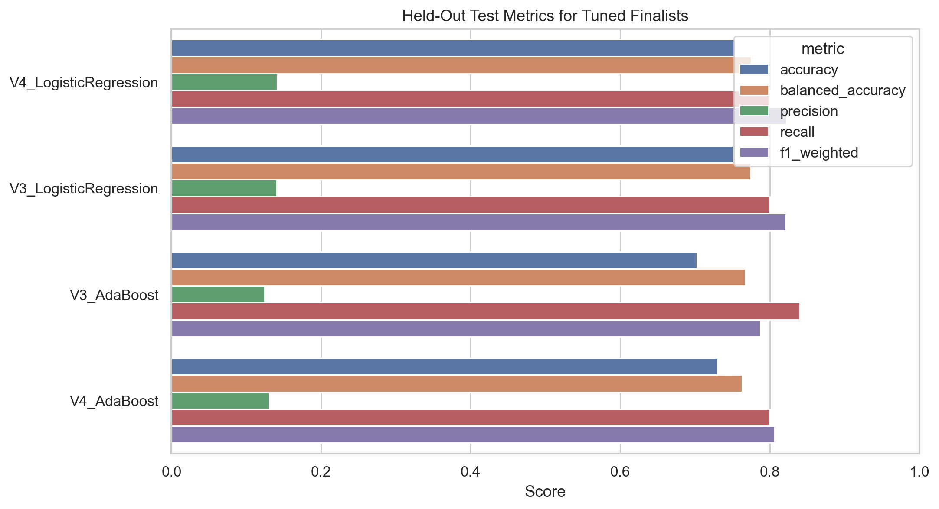
Figure 3. Held-out test metrics for the tuned finalist models.
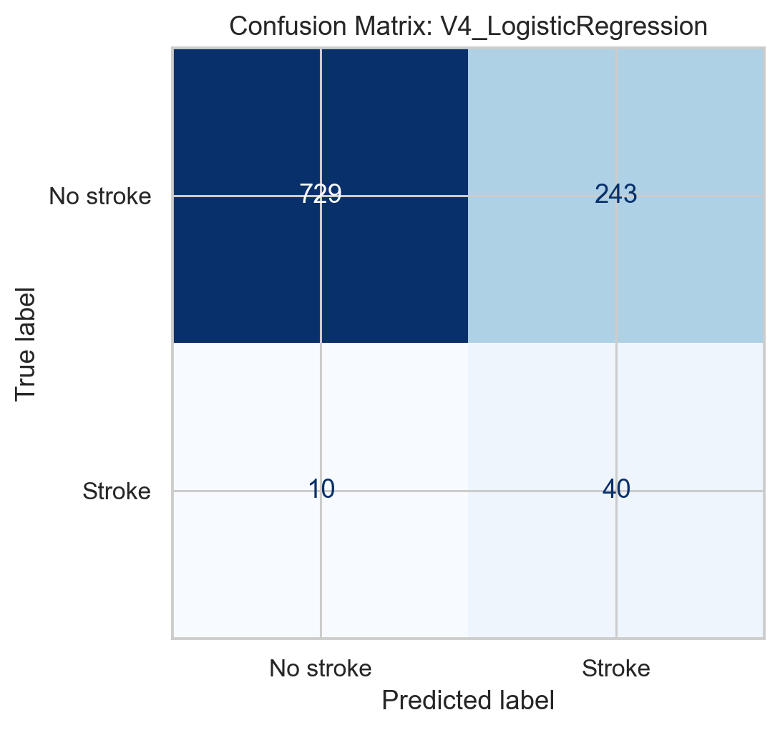
Figure 4. Confusion matrix for V4 + Logistic Regression.
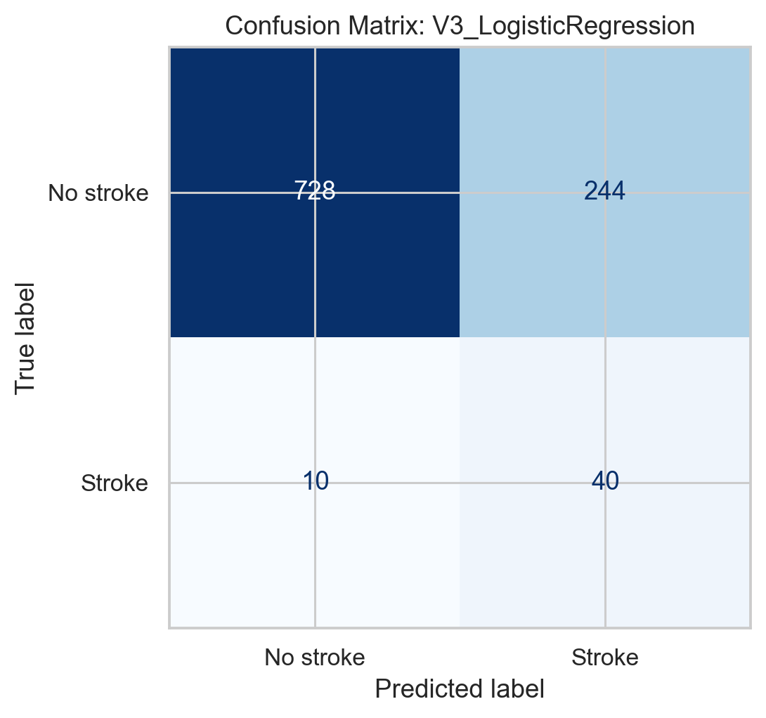
Figure 5. Confusion matrix for V3 + Logistic Regression.
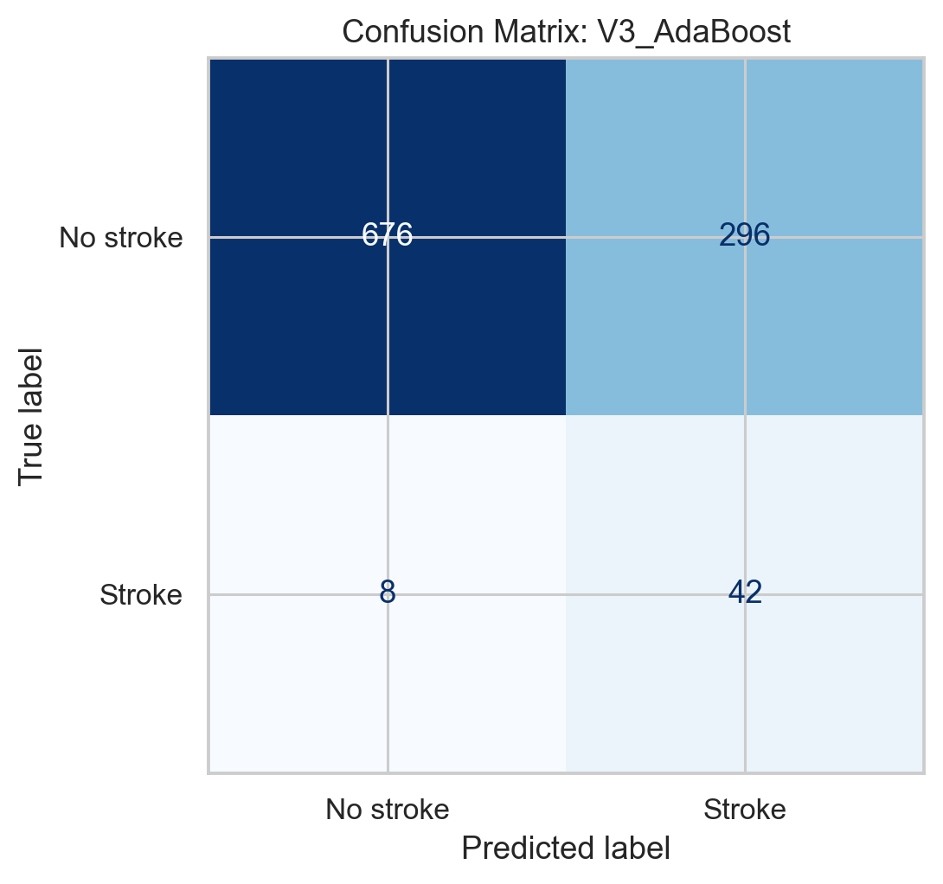
Figure 6. Confusion matrix for V3 + AdaBoost.
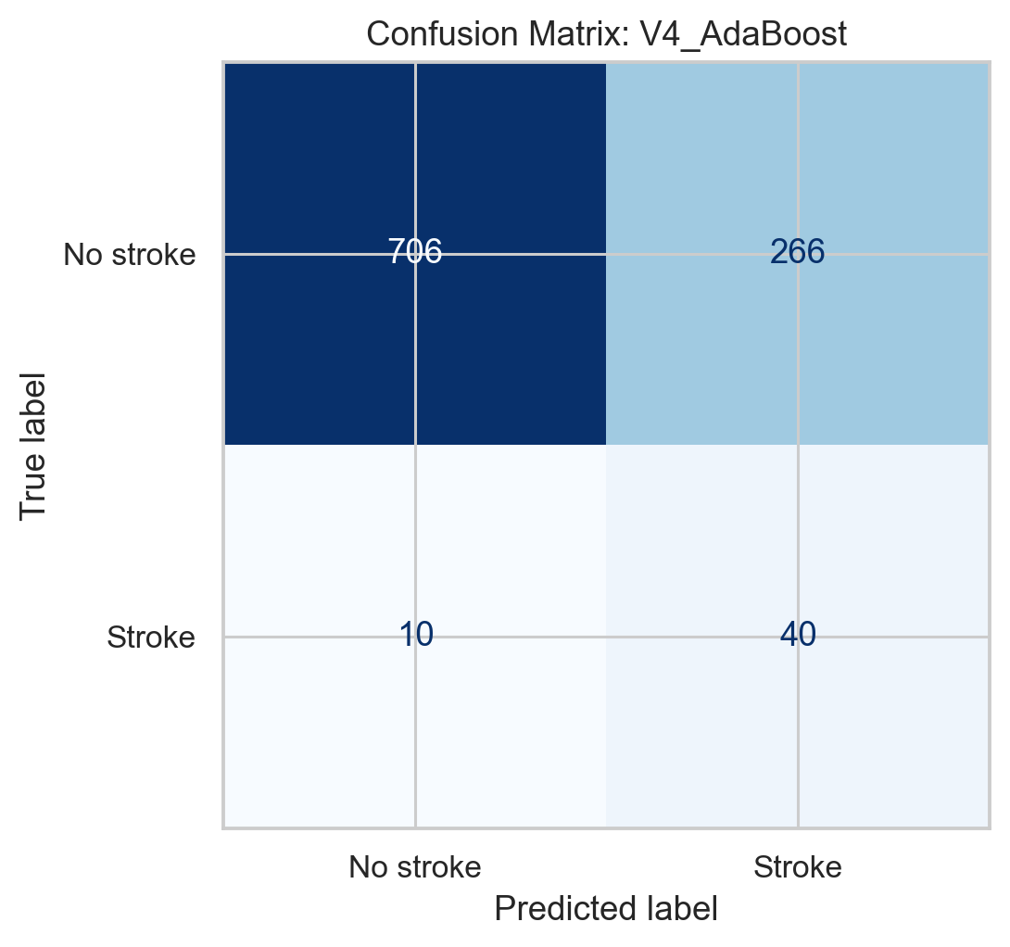
Figure 7. Confusion matrix for V4 + AdaBoost.

9. Discussion

Key Findings
- Accuracy was not a reliable selection metric for this dataset. Versions V1 and V2 achieved about 95% accuracy while nearly failing to detect stroke cases.
- SMOTE-based preprocessing (V3 and V4) materially improved recall and balanced accuracy, making these versions more suitable for medical screening.
- Logistic Regression was the most stable final model. It matched AdaBoost on recall for the final winner while providing the strongest balance of metrics overall.
- PCA did not degrade performance. V4 + Logistic Regression slightly outperformed the V3 version, suggesting that dimensionality reduction can be used without harming discrimination.

Comparison with Literature
Study | Dataset / setup | Best model | Reported result | Comparison
Dritsas and Trigka (2022) | Same Kaggle stroke dataset; balanced setting with ensemble methods | Stacking ensemble | Precision 0.974, Recall 0.974, F-measure 0.974, Accuracy 0.98 | Much higher headline performance, but their evaluation was carried out on a balanced dataset rather than the original imbalanced distribution.
Rakshit and Shrestha (2021) | Kaggle stroke dataset; accuracy-focused comparison | Decision Tree | Accuracy 100% | This is far above the present results and likely reflects different evaluation choices or leakage risk; our experiments show that accuracy alone is misleading on this dataset.
This work | Same Kaggle stroke dataset; preprocessing inside CV and GridSearchCV; held-out imbalanced test split | V4 + Logistic Regression | Balanced Accuracy 0.775, Recall 0.80, Precision 0.141, Weighted F1 0.822 | Lower raw accuracy, but explicitly optimized to detect stroke cases under a stricter leakage-controlled setup.

Domain-Specific Validation
Deliverable 2 showed that age, average glucose level, BMI, hypertension, heart disease, and smoking-related lifestyle variables contain clinically meaningful signal. The final model uses the full structured feature set after preprocessing, which is consistent with the medical literature on stroke-risk stratification.
The resulting system should be treated as a risk stratification aid rather than a diagnostic tool. Its value lies in sensitivity and early flagging for further clinical review.

Study Limitations
- The dataset is relatively small and strongly imbalanced, with only 249 positive stroke cases.
- The data come from a public secondary source rather than a hospital-specific clinical registry, so external validity is limited.
- The final model has high recall but low precision, creating many false positives that would require clinical follow-up.
- PCA improves predictive behavior slightly but reduces interpretability of the transformed feature space.
- Literature comparisons are imperfect because different studies use different balancing strategies, split protocols, and reporting conventions.

References
- Chawla, N.V., Bowyer, K.W., Hall, L.O. and Kegelmeyer, W.P. (2002). SMOTE: Synthetic Minority Over-sampling Technique. Journal of Artificial Intelligence Research, 16, 321-357.
- Fedesoriano (2021). Stroke Prediction Dataset. Kaggle. https://www.kaggle.com/datasets/fedesoriano/stroke-prediction-dataset
- Dritsas, E. and Trigka, M. (2022). Stroke Risk Prediction with Machine Learning Techniques. Sensors, 22(13), 4670. https://doi.org/10.3390/s22134670
- Rakshit, T. and Shrestha, A. (2021). Comparative Analysis and Implementation of Heart Stroke Prediction using Various Machine Learning Techniques. IJERT. https://www.ijert.org/comparative-analysis-and-implementation-of-heart-stroke-prediction-using-various-machine-learning-techniques
- Pedregosa, F. et al. (2011). Scikit-learn: Machine Learning in Python. Journal of Machine Learning Research, 12, 2825-2830.
- Powers, W.J. et al. (2019). Guidelines for the Early Management of Acute Ischemic Stroke. Stroke, 50(12), e344-e418.

