Deliverable 2: Data Exploration and Pre-processing

1. Project Title and Team Members
Project Title: Machine Learning-Driven Risk Stratification for Stroke Using Clinical and Lifestyle Factors
Team Members: Larkou Kostantinos, Rodosthenous Ioannis, Tamboutsiaris Petros

2. Data Understanding
The Stroke Prediction dataset (Kaggle, fedesoriano) contains 5,110 rows and 12 columns. The target variable is stroke (0: no stroke, 1: stroke).
Data quality checks found 0 duplicate rows and 201 missing values in bmi (no other feature has missing values).
Target distribution is highly imbalanced: class 0 = 4,861 (95.13%), class 1 = 249 (4.87%).
Feature dictionary with data types:
Feature | Dtype | Feature Type | Unique Values
id | int64 | Numerical | 5110
gender | str | Categorical | 3
age | float64 | Numerical | 104
hypertension | int64 | Binary | 2
heart_disease | int64 | Binary | 2
ever_married | str | Categorical | 2
work_type | str | Categorical | 5
Residence_type | str | Categorical | 2
avg_glucose_level | float64 | Numerical | 3979
bmi | float64 | Numerical | 418
smoking_status | str | Categorical | 4
stroke | int64 | Binary Target | 2

3. Exploratory Data Analysis (EDA)
EDA was conducted using univariate and bivariate visualizations for both numerical and categorical variables. Numerical plots were generated for age, avg_glucose_level, and bmi, and categorical plots were generated for gender, work_type, smoking_status, ever_married, and Residence_type.
Stroke cases are rare (4.87%), confirming severe class imbalance and the need for imbalance-aware preprocessing.
Key numerical findings: mean age is higher in stroke cases (67.73) than non-stroke cases (41.97); mean avg_glucose_level is higher in stroke cases (132.54) than non-stroke cases (104.80); mean bmi is slightly higher in stroke cases (30.47) than non-stroke cases (28.82).
Correlation with stroke is strongest for age (0.245), followed by heart_disease (0.135), avg_glucose_level (0.132), and hypertension (0.128).
Figure: Target class distribution
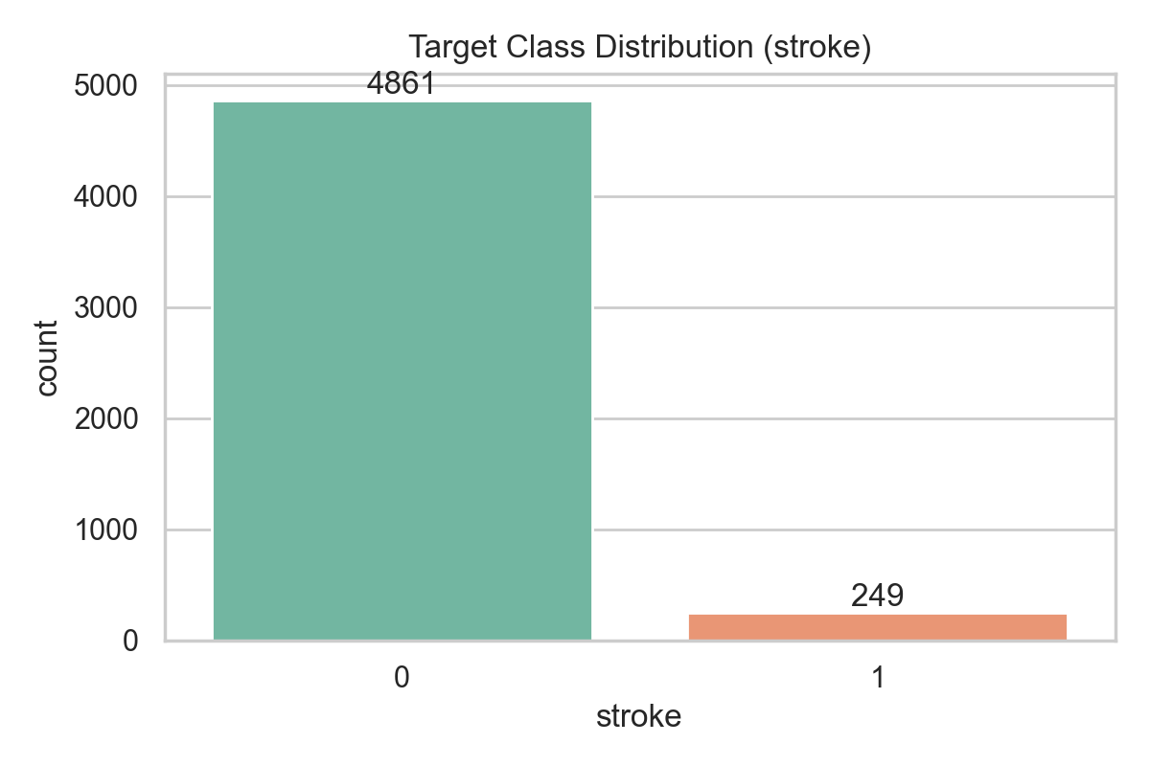
Figure: Histogram of avg_glucose_level
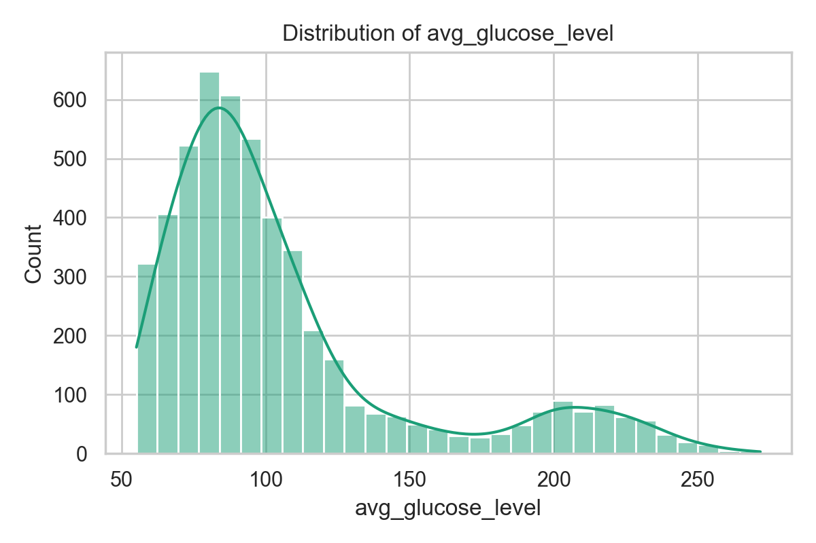
Figure: Avg glucose by stroke status
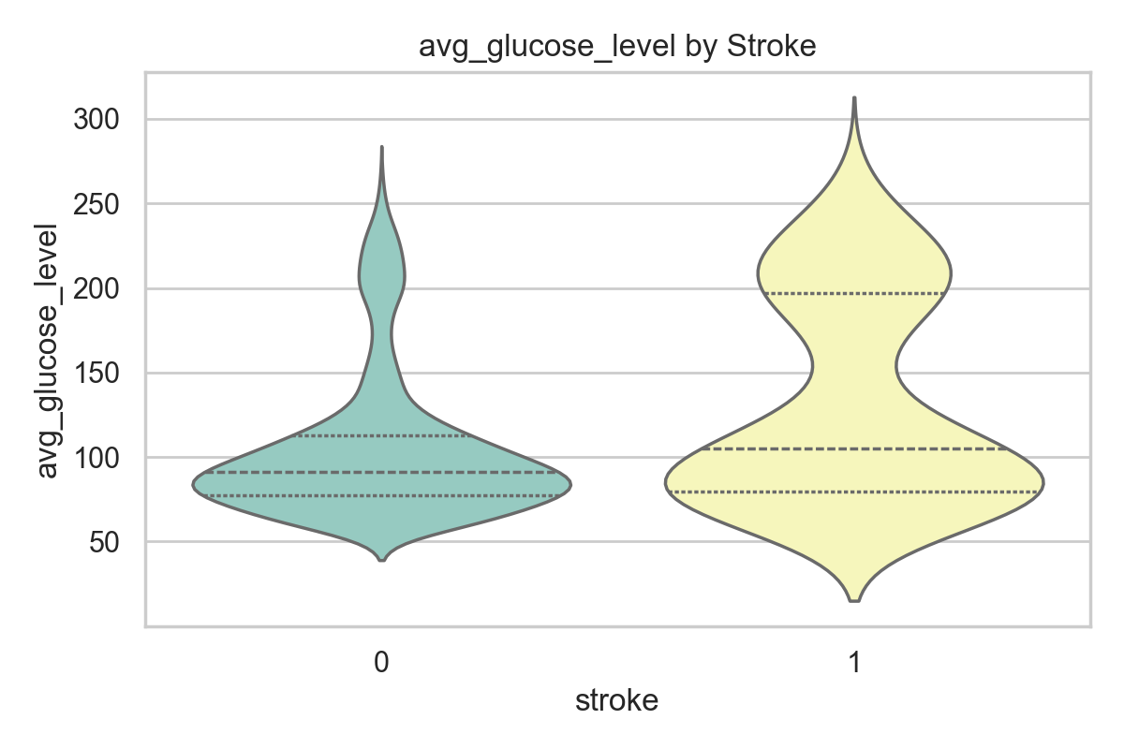
Figure: Correlation heatmap
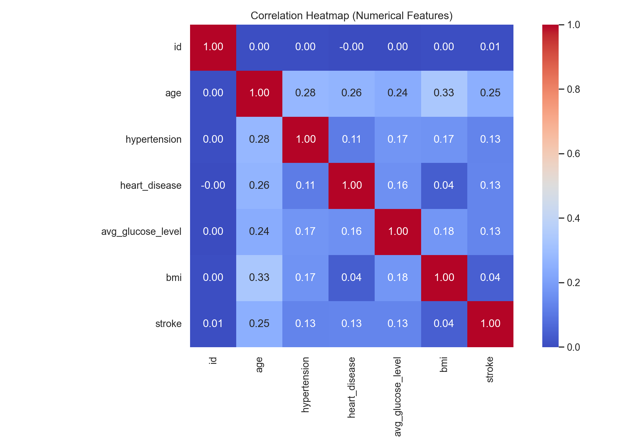

4. Data Pre-processing
- Drop the identifier column (id) before modeling because it has no clinical predictive value.
- Impute missing numerical values (especially bmi) using median strategy; impute categorical values using most frequent category.
- Encode categorical features using one-hot encoding to avoid artificial ordinal relationships.
- Scale numerical features with StandardScaler for scale-sensitive algorithms (KNN, SVM, Logistic Regression).
- Apply SMOTE on the training split only to address class imbalance and avoid data leakage.
- Test PCA as an experimental feature extraction step in one dataset version.

5. Pre-processed Dataset Versions
Version | Core Preprocessing | Scaling | Imbalance | Feature Reduction | Purpose
V1 | Median/Most-frequent imputation + One-Hot Encoding | No | No | No | Baseline pipeline
V2 | Same as V1 | StandardScaler | No | No | Assess scaling impact
V3 | Same as V2 | StandardScaler | SMOTE (train only) | No | Address class imbalance
V4 | Same as V3 | StandardScaler | SMOTE (train only) | PCA (95% variance) | Assess dimensionality reduction

6. Selected Machine Learning Algorithms
Logistic Regression: Interpretable binary baseline with probabilistic outputs useful for clinical communication.
K-Nearest Neighbors: Distance-based method that is useful for testing the value of scaling and local neighborhood patterns.
Random Forest: Captures nonlinear interactions and provides robust performance on tabular clinical data.
Support Vector Machine: Strong classifier for complex boundaries, typically effective after scaling.

7. References
- Fedesoriano. Stroke Prediction Dataset. Kaggle.
- Deo, R. C. (2015). Machine learning in medicine. Circulation.
- Chawla, N. V., et al. (2002). SMOTE: Synthetic Minority Over-sampling Technique. Journal of AI Research.
- Pedregosa, F., et al. (2011). Scikit-learn: Machine Learning in Python. JMLR.
- Powers, W. J., et al. (2019). Guidelines for the Early Management of Acute Ischemic Stroke.
- Rajkomar, A., Dean, J., & Kohane, I. (2019). Machine learning in medicine. New England Journal of Medicine.

