Industry Analysis

Industry Value Chain and Waterfall chart

Industry Value Chain
Operations and Investment Management
Customer Hotline
Admin Operation
Finance Operation
17.09% of the total revenue
Servicing
Drive thru services
Delivery
Kid’s Party Celebration
24 hours fast food restaurant
8.55% of the total revenue

Marketing
TV Commercials & Billboard Ads
CSR Programs
6.22% of the cost
Resources
Hiring Employees
Licensing and Permits
Property Plant and Equipment
Inventories
58.14% of the total revenue
Distribution Channels
Acquiring clients through franchised marketing.
8.70% of the cost
Membership
The remaining 1.03% is distributed to consumer clients.

Waterfall Chart

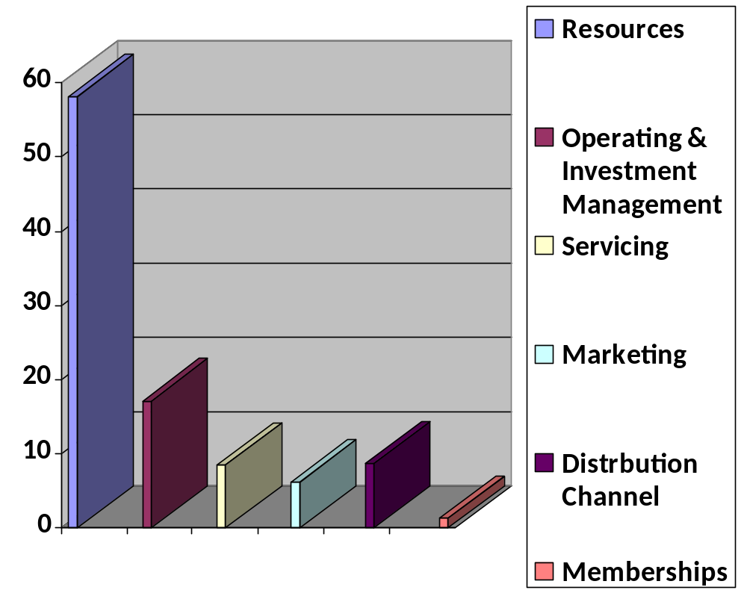

Industry value chain analysis

Resources
The first step in the fast food industry value chain is to attain the essential license and permits to open up the business which consists a business license, food handler’s permit, certificate of occupancy, music license, sign permit and employer identification number. Furniture & fixtures and PPE are two major resources that a fast food restaurant should obtain. This industry is allotted to 58.14% of the cost and is considered to be the costliest category in the value chain.

Operations and Investment Management
The second step is the operations and investment management which conducts the circulation of administrative & financing departments. This stage signifies how well the management is sustained in order for the company to be profitable. It composes of the administration services, finance operations and customer hotline service. 17.09% of the total cost is designated for this phase.

Servicing
Fast Food Industry offers 4 various services to achieve customer satisfaction. These 4 services are Drive thru, Birthday party celebration, Food Delivery and a 24/7 fast food chain. This step is allocated for approximately 8.55% of the total cost.

Marketing
This connotes to TV commercials, billboard ads and newspaper advertisement to promote their product and services. This phase aids the company’s reputation which will attract customers. 6.22% of the total revenue is allotted for this step.

Distribution channels
The Four Fast Food Industry’s distribution channel is to create a program where investors, businessmen and the like could franchise its restaurant which could benefit their prominence and it could also support the company’s growth in the community. This step accounts to 8.70% of the total cost.

Key findings and insights
Jollibee Food Corp (JFC), the largest Asian foodservice company, continued to lead the fast food industry in 2017, with each of its brands also leading in their respective categories. The group recorded double-digit value sales growth over much of the review period, driven by an acceleration of its store network expansion. McDonald’s was the second-ranked brand within fast food in 2017, positioned behind Jollibee. McDonald’s posted strong value sales growth in 2017 thanks to its continuous opening of new restaurants, the renovation of existing restaurants, new product launches and consistent marketing and promotion of its core menu.

Relevance to the firm
To further elevate customer satisfaction, fast food players recognize the growing consumer group of millennials, especially those coming from the emerging middle class. The increasingly on-the-go lifestyles of millennials are a huge opportunity for fast food players to further highlight their strength in terms of convenience compared to other types of foodservice.

