Product
1.Product层面

Define Target Audience
North Star Metric

2. Feature层面

Measuring Impact:
when measuring impact, it’s a good tactic to define 3 metrics: 2 metrics that measure success and 1 metric that does not worsen.

When answering this product sense interview question, we can assume that with a new search toolbar, Quora wants to increase its click rate and the number of returning visitors, but at the same time, it doesn’t want the time it takes to find a piece of information to increase.

3. Metric层面

Machine Learning
1. SVM
2. XGBoost
3. KMeans
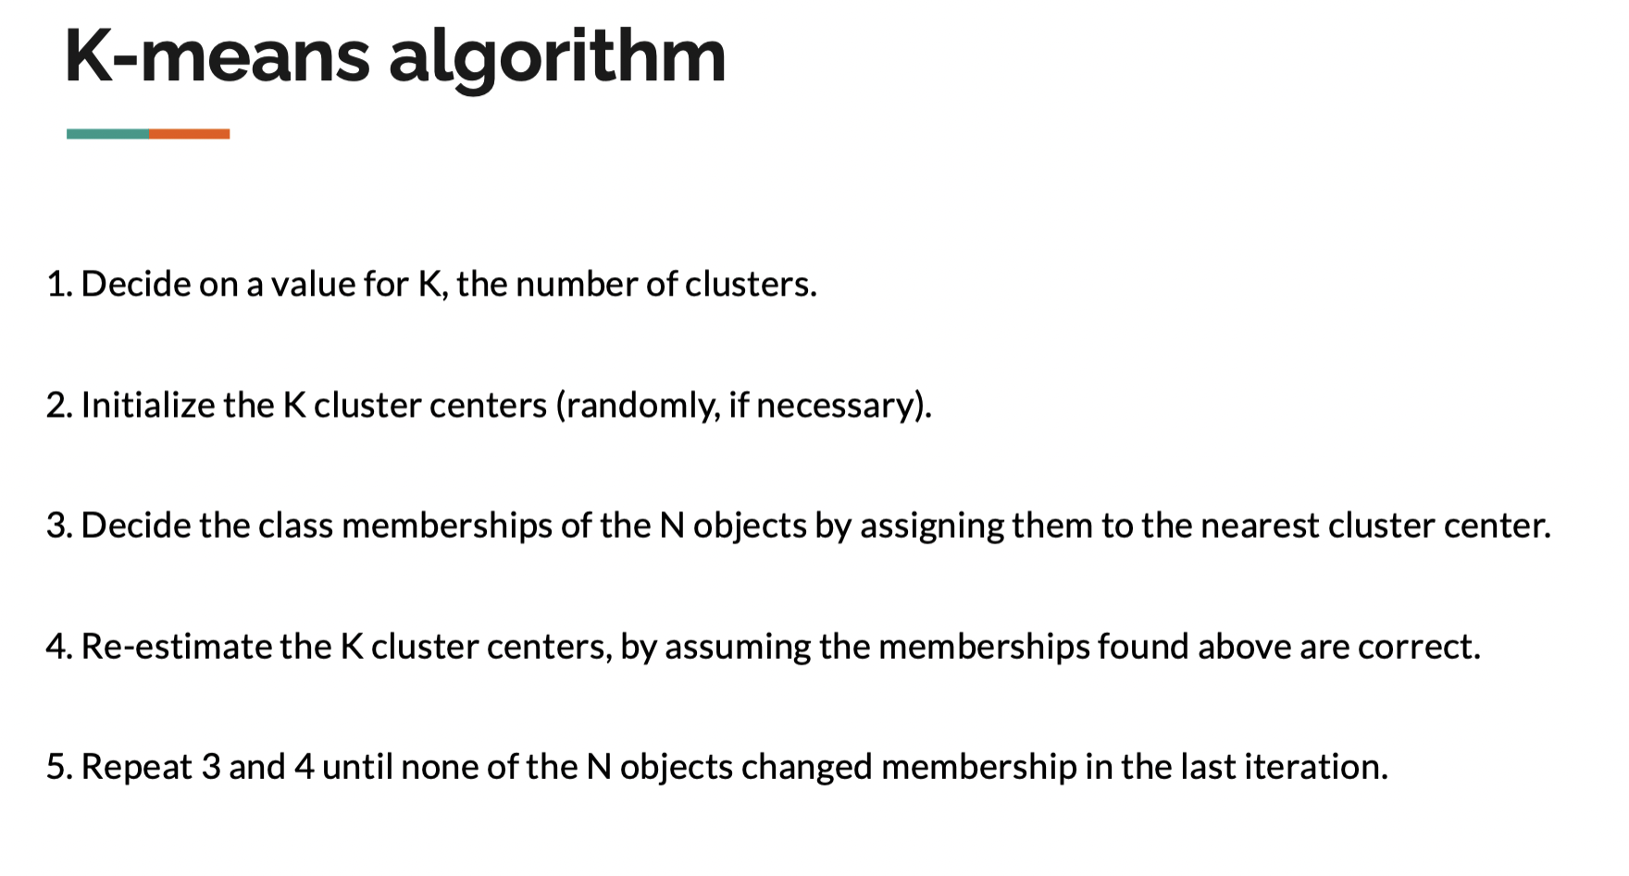

4. Deep Learning

CNN:
卷积：周围像素点对当前像素点的影响，g函数 (kernel) 规定了如何影响
CNN中卷积核 (kernel) 旋转180度才是g函数
Sum over x: (f(x) * g(t-x))
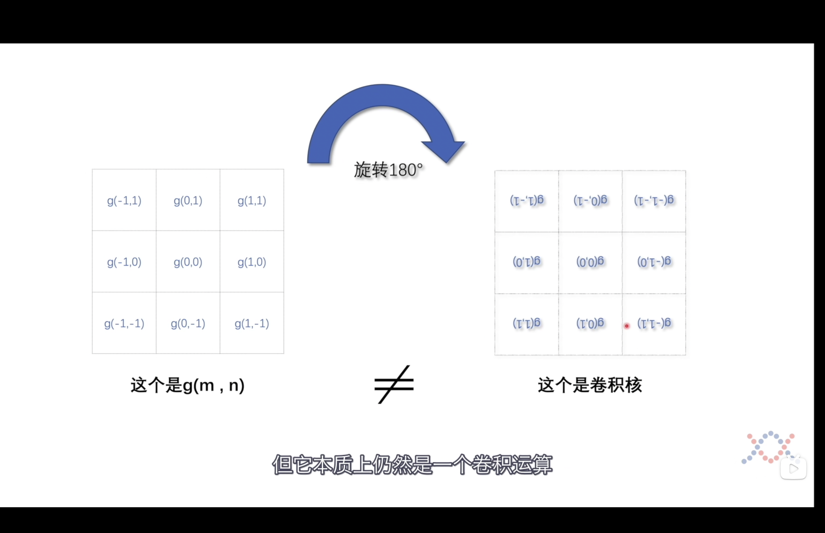
不同的卷积核：
Horizontal filter and Vertical filter
这样的卷积核

线性模型和非线性模型的区别：
a. 线性模型可以用曲线拟合样本，线性模型可以是用曲线拟合样本，但是分类的决策边界一定是直线的，例如logistics模型（广义线性模型，将线性函数进行了一次映射）。
b. 区分是否为线性模型，主要是看一个乘法式子中自变量x前的系数w，如果w只影响一个x，那么此模型为线性模型。或者判断决策边界是否是线性的

Deterministic algorithm
A deterministic algorithm is that in which output does not change on different runs. PCA would give the same result if we run again, but not k-means.

4. 其他重要知识

AARRR
A (Acquisition) A (Activation) R (Retention) R (Referral) R (Revenue)

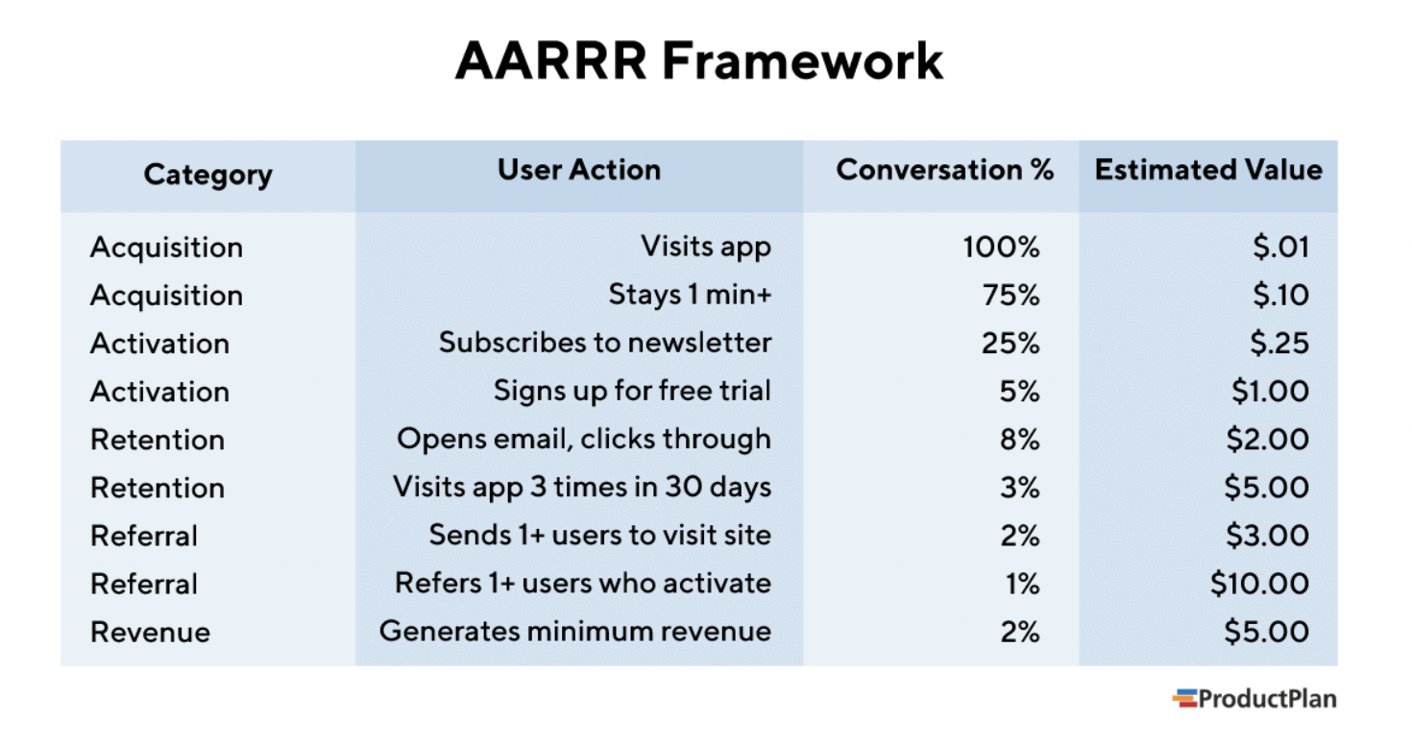

SQL

Algorithms

