Marketing research for Remember Together at
Virtual-memorials.net
- Virtual memorials is

Elements worth doing learned
- Create strong/beautiful sales page. Benefits to focus on:
  - Remembering/paying tribute. Togetherness with the online memorial.
  - Memorial “tour” showing ease of putting one together. Simple, modular interface to add photos, etc.
  - Features emphasis: Easy, permanent, safety of memorial data (regular backups/multiple sites), privacy (no info given to 3rd parties)
  - Pre-planning, caregiving, end-of-life, bereavement – help in all stages?

Pricing structures
  - YourTribute (b2 consumer):
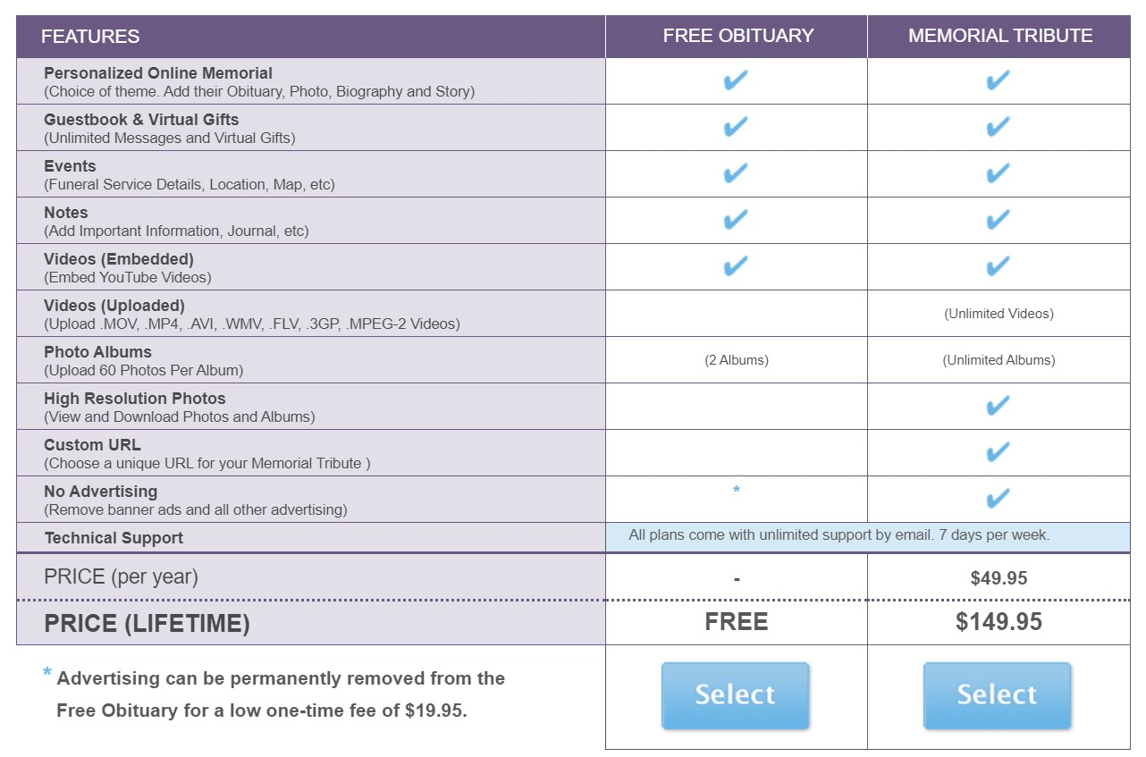

Competitor research
- YourTribute.com:
  - Great front page very pretty
    - Pay tribute with an online memorial
    - Find a memorial – Create memorial
  - Good structure
  - Actual memorials pretty ugly and dated looking
  - Cross-marketing links in menu – BRILLIANT do affiliates!
    - Pre-planning: funeral insurance, funeral planning, will and estate
    - Care-giving: home healthcare, assisted living, hospice and palliative care,
    - End-of-life: funeral arrangements, legal and financial, memorialization
    - Bereavement: Grief counseling, grief support, grief recovery
    - Expert blogs: Grief &Loss, Death and dying, Cargiving hospice, Our experts
    - Online memorials: Log in, tour and features, create a memorial, find a memorial
  - Pricing structure: http://memorial.yourtribute.com/pricing.aspx
    - Free obituary/pay for upgrade/ pay to remove ads

