UNITY PLATFORM
Consolidated Target Architecture

Target-state architecture for consolidating the legacy CVIS application estate into the Unity platform, incorporating the Business Orchestration Broker (BoB) as the Unity durable workflow control plane.
Status: Consolidated working architecture recommendation
Date: August 2026
Supersedes: Unity Architecture Modernization Blueprint (Updated) and BoB — Business Orchestration Broker Architecture

Contents

Part I. Platform overview

Core operating rule
Unity operating rule Business Enablement requests; Apigee protects APIs; A.M.I.E. interprets and selects; BoB coordinates; Kafka transports; reusable capability modules and approved executors perform the work; SQL and data services store and compute business data; integration adapters isolate CyberArk and other external systems; persistent data and artifact stores retain state that must survive container instances.

Recommended direction
Unity becomes the consolidated platform for the legacy CVIS application estate. Business Enablement is the governed human interaction surface. A.M.I.E. provides intelligent intake, canonicalization, cleanup, enrichment-assisted decisioning and routing. BoB (the Business Orchestration Broker) composes reusable capabilities into durable, active-active workflows. Kafka is the sole internal command and event backbone. Reusable capability services and approved executors perform the work. Canonical adapters isolate every external product. OpenShift Container Platform provides container execution and resiliency across four data centers.
Bulk Excel and CSV requests are accepted through a schema-driven web experience with governed field mapping, validation and correction. RabbitMQ is out of scope. Legacy application names are migration inputs, not automatic target services.

Document purpose
This document consolidates two prior working papers into a single Unity platform architecture:
- The Unity Architecture Modernization Blueprint, which established Unity as the platform, corrected earlier BoB-centric framing, and added Business Enablement, reusable capability derivation, storage, scheduling, API testability and four-data-center deployment.
- The BoB (Business Orchestration Broker) Architecture, which established the durable active-active orchestration model, the 42-item application inventory evidence, SQL and reporting evidence, bulk intake and mapping design, Kafka contracts, adapter architecture, product evaluation and migration roadmap.
Unity is the subject of this document. BoB is described here as one component of Unity — its durable workflow control plane — rather than as the whole system. Where the two source documents conflicted, the conflict is resolved in the body of this document and recorded in Appendix D.

Decision precedence The Unity platform framing supersedes conflicting concepts in the earlier BoB paper and in the original architecture PDFs. Kafka is the only enterprise messaging backbone; RabbitMQ is excluded. Legacy business domains are workflow families and migration inputs, not automatic target microservices. Earlier diagrams and inventories remain valid as discovery evidence rather than as approved target architecture.

Executive decisions
The table below merges the executive decisions from both source documents into one register. Where the two papers stated the same decision at different levels of detail, the more specific statement is retained.
Decision | Recommendation | Why it matters
Platform shape | Unity is the platform. Business Enablement, A.M.I.E., BoB, Kafka and reusable capabilities are peer architectural concerns with separated decision routing, workflow orchestration and business execution. | Prevents a monolithic engine and stops any one component being treated as the whole system. Policy, coordination and side effects stay independently governable.
Business interaction | Users operate through Business Enablement. Approved systems may use governed APIs and, later, MCP integration where approved. | Keeps internal runtime infrastructure hidden from users and partners.
Decision routing | A.M.I.E. owns configurable intake, validation, canonicalization, cleanup, enrichment-assisted decisioning, classification and routing. | Keeps policy decisions separate from process state and side effects.
Workflow orchestration | BoB owns durable workflow composition, state, timers, retries, approvals, fan-out/fan-in, compensation, recovery and completion. | Prevents business workflows from being reimplemented inside individual applications.
Workflow model | Versioned, composable workflows built from reusable modules and subprocesses; each instance pinned to explicit versions. | Enables small process variations without duplicating integrations or business logic.
Execution model | BoB workflows compose reusable capability modules. Worker Deployments handle service tasks; OpenShift Jobs handle heavy finite batch work. | Avoids recreating 30+ applications as 30+ microservices and matches isolation and scaling to task type.
Durability | Persist workflow history, timers, leases and commands outside pods. | Any OpenShift pod may fail or restart without losing process state.
Messaging | Kafka is the only internal asynchronous command and event boundary, used with a transactional outbox. It is not the workflow-state database. RabbitMQ is removed. | One governed messaging model; decoupling, eventing and scalable work distribution without database/message dual-write loss.
Bulk intake | Provide Excel/CSV upload, field mapping, validation, correction and result dashboards as a governed experience. | Replaces manual interpretation and console-driven bulk execution.
CyberArk | CyberArk technical access is centralized behind the CyberArk Integration Service and version-isolated adapters. | Avoids duplicated authentication, API handling and vendor-specific logic across workloads.
Storage | Use durable application and state databases plus enterprise persistent file and artifact storage where workloads require files. | Pods remain disposable while workflow data and files survive restarts and failover.
Scheduling | AutoSys provides enterprise scheduling and timed triggers; it does not own Unity business orchestration. | BoB remains the process coordinator.
Availability | Run APIs, A.M.I.E., BoB services, Kafka consumers and eligible workers active-active across the four-data-center OCP topology. | A pod or site loss does not lose, strand or duplicate a business job.
Deployment | Unity runs on OCP across four data centers: Sterling, Manassas, Garland and Lewisville. | Supports intra-region failover first and cross-region failover when a region is unavailable.
Product strategy | Evaluate a supported BPMN or durable workflow engine before implementing a custom engine. | State recovery, versioning, timers and operations are costly to build correctly.

Business value proposition
Why Unity exists Unity turns recurring business-process patterns into governed, reusable building blocks. New requests should normally be satisfied by configuring A.M.I.E., composing BoB workflows and reusing existing capability modules — not by creating another console application, one-off script or tightly coupled service. New code is expected primarily when a genuinely new reusable capability, integration, data transformation or security boundary is introduced.

Business outcome | Unity mechanism | Measure of value
Faster delivery | Compose approved modules, subprocesses, workflows, forms, mappings, rules and integrations. | Lead time from approved request to production workflow.
Less custom development | Reuse generic capabilities and configuration-driven mappings instead of new console applications. | Percentage of changes delivered without a new service or worker release.
Consistent controls | Platform-level authentication, authorization, approvals, audit, retry, observability, failure handling and recovery. | Reduction in duplicated control logic and audit findings.
Safer change | Version definitions and modules; run tests and controlled promotion before adoption. | Change failure rate and rollback frequency.
Operational visibility | One governed status, history and recovery experience across SQL, OCP capabilities, adapters and candidate execution paths. | Mean time to identify and recover failed work.
Adaptability | Change routing or workflow composition, and swap or add process steps, without rebuilding integrations. | Reuse rate of published modules, subprocesses and workflows.

Scope
- Business Enablement web interface for operation forms, Excel/CSV upload, mapping, correction, submission, dashboards, scheduling configuration and administration.
- A.M.I.E. intake, data interpretation, canonicalization, cleanup, enrichment, decision routing and rule governance.
- BoB reusable workflow and module catalog, durable active-active workflow execution, human tasks and operations console.
- Kafka-only command, result, event, audit, recovery and outbox contracts.
- Reusable Unity capability families and the legacy capability domains they replace, including account lifecycle, safe management, account import, cleanup and ESAR.
- CyberArk, Active Directory, EVD, QTSDataDB, reporting, ServiceNow and later data-source adapters.
- Four-data-center OCP deployment, load balancing, firewall boundaries, shared storage, resiliency, security, observability, API testability, migration and acceptance criteria.
- Future connector and MCP-enabled modules where governed access and deterministic contracts make them appropriate.

1. Current state and modernization objective
The legacy estate is fragmented across console applications, scheduled utilities, CSV-driven processes, SQL and reporting logic, and partially adopted services. Many applications perform similar core operations with different input, enrichment, validation, scheduling and reporting needs. This has produced duplicated CyberArk integration logic, repeated data and file handling, inconsistent execution patterns and fragmented operational visibility.
ExtractReconcileUpdate.sln contains multiple capabilities with inconsistent execution patterns, shared dependencies and limited end-to-end observability. The Business Enablement website is intended to become the supported interaction and orchestration surface, while services remain responsible for execution.
The modernization objective is not to containerize each legacy application. Unity replaces the application-per-function model with a common interaction surface, intelligent routing, durable workflows, reusable capabilities, governed integrations and platform-provided non-functional controls.

1.1 Application inventory evidence
The modernization workbook identifies 42 applications, tools, DLLs, scripts, services and shared components. Twenty-seven are marked active, nine inactive and six require confirmation. Thirty-one interact with the CyberArk API. Ten are Phase 1 candidates, 15 are explicitly marked for consolidation into Unity, and eight are marked for retirement.
The "30+ applications" figure used elsewhere in this document refers to the active and confirmation-pending population within that 42-item inventory. The inventory confirms that the target unit of modernization is the reusable business capability, not one container or microservice per legacy executable.

1.2 Legacy capability domains
The inventory groups naturally into the domains below. These are business domains and workflow families used to organize migration analysis. They are not, by themselves, target deployable services; see section 10.
Legacy capability domain | Representative inventory items | Target treatment
Import and onboarding | PersonalAccountImport, PersonalAccountImportService, ServiceAccountImportConsole, iSeriesAccountImport, eSAR bulk import. | Bulk-intake workflows, mapping profiles, reusable validation and approved execution modules.
Lifecycle and password operations | PersonalAccountDelete, eSARMoveAccounts, ReconcileAccounts, RotatePasswords, NHA disabled-account cleanup. | BoB workflows with fail-closed rules, idempotent tasks and adapter-based side effects.
Safe governance | vopSafeCreate, SafePermissionUpdate, SafeAndAccountValidationService and validation bypass. | Reusable safe, membership, validation, approval and exception modules.
Hygiene and compliance | AccountCheck, SafeName/PolicyID discrepancies, Maturity Model Evaluation, Policy Baseline Drift. | Scheduled or uploaded data workflows with A.M.I.E. rules and auditable outcomes.
Reporting and data movement | EVD SQL, iSeries reporting, ACT Code, eSAR data table update. | Read-optimized SQL and OCP batch modules behind controlled contracts.
Adapters and exceptions | IESEPVAPI, ServiceNow DLL, RSA bypass, PSM monitor, vault maintenance. | Discover callers; replace direct coupling with adapters or retain approved exceptions temporarily.

1.3 Observed legacy characteristics
- Console and batch entry points with direct or scheduled invocation.
- Business rules embedded in executables, scripts, SQL and procedural orchestration.
- Direct CyberArk calls with vendor-specific DTO and error behavior distributed across workloads.
- CSV import/export and batch reconciliation behavior.
- Shared database tables and reporting logic, including CA_EPV_REPORTING and PolicyDriftEval data.
- Manual troubleshooting through logs, SQL queries and reruns.
- Deletion and security guardrails that must fail closed and survive modernization.

1.4 Legacy SQL and reporting evidence
The supplied SQL evidence shows a policy-drift reporting process that parses execution identifiers and report dates, compares CA reporting policy identifiers with PolicyDriftEval results, computes processed, excluded, drift and missing-baseline counts, parses log events, classifies special-character mutations and deletion conditions, and writes to or queries a broad CA_EPV_REPORTING schema. This should be treated as a business capability with explicit contracts, not lifted into a container unchanged.

Migration implication Extract the SQL behavior into documented inputs, outputs, classifications, guardrails and reporting events. Large diagnostic queries may remain read-optimized SQL initially, but workflow state and business decisions must not depend on an interactive query session.

1.5 Migration principle
Compose before creating A legacy application is decomposed into its business workflow, reusable operations, integrations, data and file behaviors, unique rules, guardrails and outputs. Repeated operations become reusable capability modules. Unique behavior remains workflow-specific, or becomes a specialized module only where justified.

2. Architecture principles
These principles are binding design constraints for Unity. They combine the principles stated in both source documents.
- The router chooses; it does not execute. A.M.I.E. validates, cleanses, normalizes and enriches requests, evaluates policy, and returns destination, workflow, matched rule, priority and reason. It does not own long-running process state or privileged side effects.
- The workflow engine coordinates; modules execute. BoB persists state, waits, schedules, retries, compensates and requests work. Capability workers perform side effects.
- Enrichment is a shared capability. It may be used by A.M.I.E. before routing and by BoB workflows during execution; it is not embedded exclusively inside either.
- Kafka is the messaging backbone. Commands, results, status, audit, replay and dead-letter handling use governed Kafka contracts. RabbitMQ is not part of the target.
- Compose before cloning. Reference reusable versioned modules and subprocesses; create new code only for genuinely new capabilities, and clone only when a process is intended to diverge permanently.
- Pods are disposable. No correctness-critical state lives only in container memory or an ephemeral filesystem.
- Active-active is a correctness property. Multiple replicas may accept, schedule and consume work concurrently without requiring pod affinity or in-memory ownership.
- At-least-once delivery is explicit. Workers are idempotent, mutating commands carry idempotency keys, and duplicate delivery is expected and safe.
- Legacy behavior is evidence. Inputs, outputs, side effects, failure behavior and guardrails are captured and parity-tested before cutover.
- Vendor access is centralized. CyberArk authentication, token lifecycle, API versions, DTOs, mapping and error translation stay behind one integration boundary.
- External formats stop at adapters. Core workflows exchange canonical internal models; vendor version changes are handled by mapping adapters.
- Files are artifacts, not workflow state. Large CSV, ZIP, report and processing files live in durable enterprise storage and are referenced by identifier or path.
- Everything is versioned and governed. Rules, workflows, modules, forms, APIs, schemas, mappings and migrations have explicit versions and ownership.
- NFRs are platform capabilities inherited by new Unity functions rather than rebuilt in each migrated application.

3. Target logical architecture

3.1 Responsibility model
The table below is the authoritative component responsibility model for Unity. It merges the component tables from both source documents, retaining the Unity naming for the interaction surface and the BoB paper's treatment of SQL, adapters and future connectors.
Component | Primary responsibility | Boundary
Business Enablement (Blazor UI) | Role-aware user experience, dashboards, operation forms, bulk/CSV intake and mapping, status and history, operational controls, scheduling configuration and administration. | Browser does not directly access Kafka, AutoSys, SQL, CyberArk or privileged backend infrastructure.
Business Enablement API (ASP.NET) | Server-side application boundary for authorization enforcement, website data, governed Unity submission, schedule requests, status retrieval and backend integration. | Does not become the workflow engine.
Apigee | Enterprise API gateway: north-south API security, policy, products, quotas, external versioning and routing. | No Unity business-routing or workflow semantics.
A.M.I.E. | Interpret, validate, cleanse, normalize, enrich and classify requests; select destination, workflow and internal routing using governed versioned rules. | No long-running workflow state and no privileged side effects.
BoB | Compose reusable modules and maintain durable workflow state, waits, timers, retries, approvals, fan-out/fan-in, compensation and recovery. | No vendor credentials, no arbitrary SQL execution and no direct arbitrary database logic.
Kafka | Sole internal durable command, result, status, event, audit and replay transport; integration decoupling. | Not authoritative workflow state; not a business wait mechanism. RabbitMQ excluded.
Reusable capability services | Perform generic execution functions used across workflows; Unity workers and OCP Jobs. SPEARS and CyberArk Flows are candidate paths where discovery proves a fit. | Do not own end-to-end business-process orchestration. All paths use versioned module contracts and report results to BoB through Kafka.
CyberArk Integration Service | Centralize CyberArk API authentication, token lifecycle, endpoint/version routing, DTO mapping, error translation, technical retry and telemetry. | Does not own business workflow sequencing.
SQL Server / data services | Existing business data, stored procedures, reporting and controlled execution adapters exposed through governed APIs. | BoB state uses a separately owned schema or store. No direct browser access.
Integration adapters | Map canonical internal requests to CyberArk and other external API versions and formats. | External DTOs, versions, secrets and tokens never leak into workflow contracts.
Data and storage | Persist application state, workflow state, governed business data and durable file/artifact content. | State ownership is explicit; pods do not become stores; storage does not make routing decisions.
OpenShift (OCP) | Container hosting, isolation, health, scaling, scheduling, placement, restart and platform recovery. | No business-process semantics.
Future connectors / MCP | Optional governed modules that retrieve or act on data from additional approved systems. | No dynamic access without allow-listed tools, schemas, authorization and audit.

3.2 Interaction pattern
Human users enter through Business Enablement. Approved system integrations may use governed APIs and, later, MCP where approved. Runtime work is internally message-driven. A request is accepted by a server-side API, represented as a canonical message, evaluated by A.M.I.E., routed to a BoB workflow, and executed through reusable capability modules. Results and events return asynchronously and are reflected in durable workflow state, reporting, notifications and dashboards.

Not a fixed pipeline Unity is not a fixed linear pipeline. A.M.I.E. and BoB may both use shared capabilities such as Enrichment when the decision or the workflow requires additional context, and results may fan out to logging, reporting, notification and audit consumers independently of the main workflow path.

3.3 Target architecture reference view
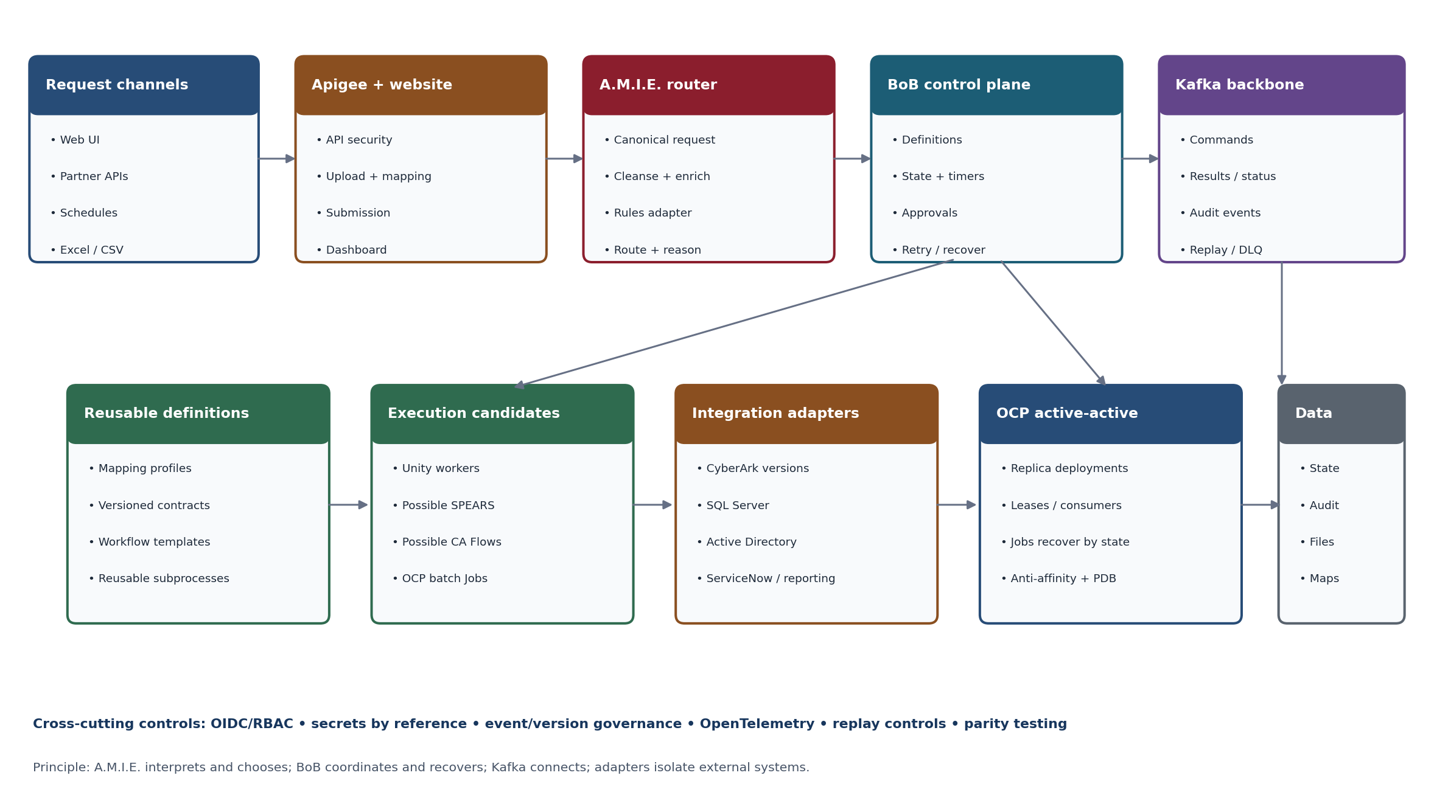
Figure 1. Recommended target architecture and responsibility boundaries.
Figure currency Figures 1 to 7 were produced for the BoB architecture paper. They remain accurate for responsibility boundaries, message flow, deployment shape and recovery behavior. Where a figure groups execution capabilities by legacy business domain, read it together with section 10: those groupings are workflow families and migration inputs, and the final capability service boundaries are a pending analysis output. Replacement Unity diagrams are listed in section 22.1.

Part II. Interaction, intake and decisioning

4. Business Enablement application architecture

4.1 Purpose
Business Enablement replaces much of the user-facing functionality currently spread across independent console applications. It is the governed human interface for initiating approved operations, uploading bulk data, configuring schedules and requests, reviewing status, managing approvals and corrections, and accessing role-appropriate dashboards and administrative functions.
Business Enablement is a governed orchestration surface, not an execution engine. It submits work to server-side APIs, configures approved workflows and mappings, displays validation and execution results, manages approvals, schedules approved runs and requests controlled recovery. It never publishes directly to Kafka and never calls CyberArk.

4.2 Application components
Component | Responsibility
Blazor Web UI | Role-aware dashboards, operation forms, CSV/Excel bulk upload and mapping, run history, status, reporting views, approvals and correction, schedule configuration and administrative experiences.
Business Enablement ASP.NET Web API | Server-side application boundary for authorization, website data, Unity submissions, artifact registration, schedule requests, status retrieval and backend integration.
Business Enablement Database | Website-owned configuration and application state. Schema is application-owned and separate from BoB workflow state.
Enterprise SSO / entitlements | Authentication and authorization integration. The exact entitlement interface remains an enterprise integration decision.
Apigee | Required API onboarding and governance for exposed Unity APIs.
Breakglass / privileged controls | Restricted functions require explicit entitlement, audit and enterprise security controls. Implementation details remain to be confirmed.

4.3 Website boundaries
- The browser does not publish directly to Kafka.
- The browser does not configure or invoke AutoSys directly.
- The browser does not call CyberArk or EPV directly.
- The browser does not directly access application databases or SQL.
- All privileged and backend actions pass through governed server-side APIs and Unity runtime boundaries.

4.4 Bulk upload and mapping experience
The bulk mapping studio turns varied Excel and CSV layouts into canonical business requests without code changes. It is the governed replacement for console-driven bulk execution and manual interpretation of spreadsheets.
- Upload an approved Excel or CSV file and scan it before processing.
- Select a workflow and a versioned target schema.
- Auto-detect headers, delimiter, encoding, worksheet and basic data types.
- Map source columns to canonical fields; apply approved transforms, defaults, lookups and validation rules.
- Preview normalized rows and show missing, ambiguous, rejected and duplicate records before submission.
- Save the mapping as a reusable, versioned profile scoped to an authorized business use.
- Create a parent BoB batch instance and child work items using an idempotent file fingerprint and row identity.
- Display totals and row-level outcomes: accepted, running, completed, failed, manual review, skipped and safely replayed.
- Export an error or correction file without exposing secrets or restricted values.

Artifact rule Large uploaded files and generated reports live in governed object storage. BoB persists metadata, checksums, schemas, mapping versions, row and work-item identities, and artifact references — not the only copy of a file inside a pod.

4.5 Bulk processing flow
The flow below makes validation and mapping visible before execution and makes each accepted row independently traceable and recoverable. The parent batch summarizes the business submission; row and item workflows carry their own idempotency and outcome evidence.
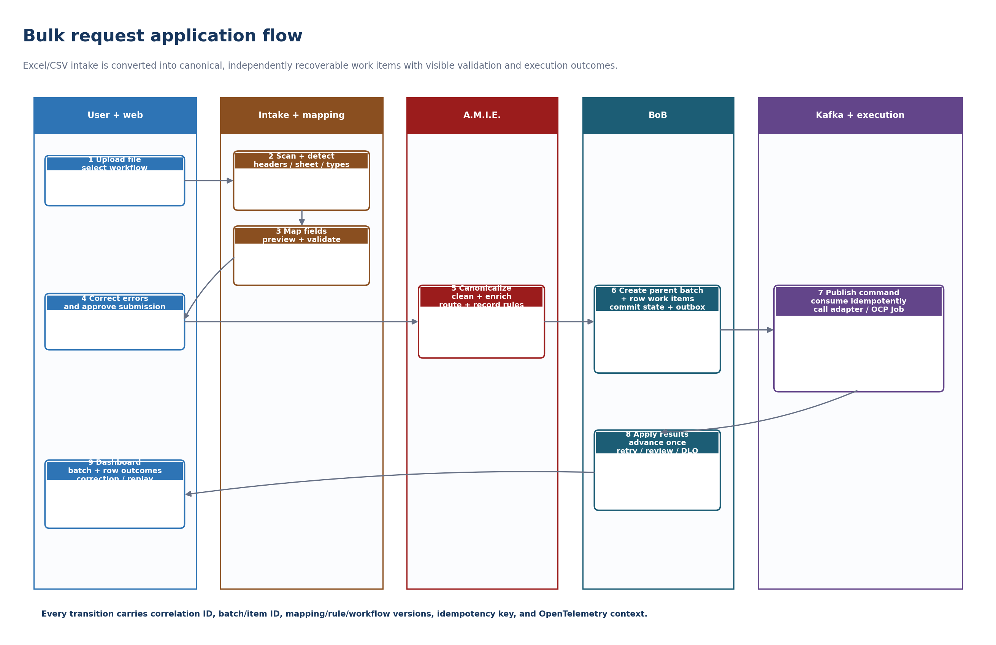
Figure 2. Excel/CSV bulk request application flow.

4.6 Secure intake boundary
- API gateway and rate limiting.
- OIDC for interactive users; OAuth2/JWT or mTLS for service callers.
- Strict request-type and JSON-schema validation.
- Correlation ID creation and propagation.
- Idempotency key enforcement for mutating requests.
- Sensitive-field masking before logs, events or workflow history.

4.7 Canonical request model
All intake paths — interactive forms, bulk rows, partner APIs and scheduled triggers — converge on one canonical request model before A.M.I.E. evaluates it.
Field | Purpose
requestId | Platform-generated request identity.
correlationId | End-to-end trace and business correlation.
clientId | Calling application or partner identity.
requestType | Stable business request classifier.
sourceSystem | Origin of the request.
idempotencyKey | Duplicate side-effect protection.
attributes | Schema-controlled, non-secret request data.
receivedAtUtc | Authoritative receipt timestamp.
tenant / policy context | Enrichment used for routing and authorization.

5. A.M.I.E. intelligent intake, rules and routing
A.M.I.E. is the intelligent intake and decision-routing layer. It validates and normalizes requests, determines whether additional context is required, applies governed and versioned rules, and selects the appropriate destination, workflow and internal routing or topic information. It does not execute the business process itself.

5.1 A.M.I.E. deployable concerns
- Runtime Kafka consumer and message intake.
- Canonicalization, validation, cleansing and normalization.
- Rules and decision-router runtime.
- Enrichment request and response interaction when routing cannot be decided from the original request alone.
- Kafka publication of routing decisions, commands and events.
- Management and configuration API.
- Persistent A.M.I.E. Rules and Configuration Store for rule definitions, versions, mappings, enrichment definitions, effective dates, approvals and audit history.

5.2 Decision router and rules
The decision router applies versioned rules through an adapter interface so the underlying rules product can change without altering intake or workflow contracts. The routing result contains destination, workflow key, matched rule ID, reason, priority and rule-set version. An unmatched request goes to manual review rather than silently selecting a default execution path.
Responsibility | Owned by the router?
Validate and normalize request | Yes
Cleanse and enrich request metadata | Yes
Select destination, workflow and topic | Yes
Record matched rule, reason, priority and rule-set version | Yes
Execute CyberArk, AD or database operation | No
Track multi-step process state | No
Compensate a partially completed process | No

5.3 Enrichment interaction
Enrichment is not embedded exclusively inside A.M.I.E. A.M.I.E. may request enrichment to clean or complete a request before routing. A BoB workflow may independently request enrichment later to obtain context required for an execution step. The same governed capability supports Active Directory, database, EVD, CyberArk metadata and other approved enterprise data sources.

Part III. BoB — the Unity workflow control plane

6. BoB reusable workflow platform
BoB is Unity's durable workflow control plane and the named business orchestration layer. It brokers reusable business capabilities into durable end-to-end processes without absorbing the implementation of those capabilities. BoB owns process composition and execution state; A.M.I.E. owns request classification and routing policy.
BoB is a component of Unity, not a synonym for it. Business Enablement, A.M.I.E., Kafka, the reusable capability services and the platform layer are peer concerns described elsewhere in this document.

6.1 Configuration-first delivery model
The platform should make the cheapest safe kind of change the normal path. A business variation that changes sequence, conditions, mappings, approvals, schedules or module parameters should not require a new application. Development is required only when the business asks for a genuinely new capability, integration, data transformation or security boundary.
Change requested | Expected delivery mechanism | Code required?
Change sequence or omit an optional step | Publish a new versioned workflow definition. | No
Change approval role or threshold | Update policy and form configuration. | Usually no
Map a different input field | Update the schema-controlled input mapping or mapping profile. | No
Schedule or batch an existing process | Configure the trigger and execution policy. | No
Create a business variant from an approved template | Compose or reference existing modules. | No
Add a new reusable data operation or stored-procedure operation | Publish a governed capability module or SQL capability adapter. | Small, controlled change
Integrate a new external system | Implement and certify a new module or adapter. | Yes
Introduce new privileged behavior | Implement with security review and explicit guardrails. | Yes

6.2 Workflow definition model
A workflow definition is an immutable, versioned graph of reusable steps. Each running instance is pinned to its definition and module versions. Definitions may include service tasks, human tasks, durable timers, conditions, parallel branches, fan-out and fan-in, subprocesses, batch jobs, compensations, and completion and failure events.
Element | Required metadata
Workflow | Key, semantic version, owner, description, input/output schema, SLA, sensitivity, retention.
Step | Module reference, input mapping, output mapping, timeout, retry class, failure path.
Condition | Named decision with testable expressions and a default or manual-review branch.
Human task | Role/entitlement, form schema, due date, escalation, decision values.
Timer | Durable deadline, timezone policy, late-fire behavior.
Compensation | Explicit undo or reconciliation action with its own idempotency key.

6.3 Module catalog
The module catalog is the reuse mechanism. Each module exposes a stable canonical contract, generates a configuration form from its schema, identifies its owning executor, and defines operational defaults, security classification, idempotency and retry behavior, version and lifecycle.
Examples include Parse Tabular File, Apply Mapping Profile, Validate Identity, Validate AD Identity, Create CyberArk Safe, Add Safe Members, Reconcile Account, Rotate Password, Acquire File, Parse CSV, Submit OpenShift Job, Wait for Approval, Request Enrichment, Publish Report, Send Notification and Open ServiceNow Ticket. These are module examples, not commitments to a separate microservice for every action.
Catalog field | Example
Module key / version | cyberark.safe.create / 2.1.0
Input schema | safeName, managingCPM, retentionDays
Output schema | safeId, createdAtUtc
Executor | unity-worker:create-safe; candidate SPEARS/Flow binding after discovery
Reliability | 2-minute timeout; standard API retry; idempotent create
Security | security-process-designer; secret reference only
Lifecycle | Draft → Reviewed → Approved → Published → Deprecated

6.4 Reuse and cloning rules
Mechanism | Use when | Upgrade behavior
Reference module | A single technical or business action is shared. | Consumer adopts a selected version range or pins an exact version.
Call subprocess | Several steps form a reusable business capability. | Parent explicitly selects a published subprocess version.
Template | Designers need a recommended starting structure. | Copy is expected; provenance remains visible.
Clone workflow | The new process will intentionally evolve independently. | No automatic inheritance after clone.

Governance rule Never change the meaning of a published version. Publish a new version, run compatibility checks, and migrate only eligible in-flight instances through an explicit, audited operation.

6.5 BoB product capability model
BoB aspect | Purpose | Initial capability
Process designer | Visually assemble steps, conditions, branches, approvals and subprocesses. | Curated node palette; validation; draft, save and compare.
Module catalog | Discover reusable Unity, SQL, CyberArk, notification, approval and batch capabilities, plus candidate SPEARS/Flow paths. | Search, schemas, ownership, versions, examples and lifecycle.
Definition registry | Govern immutable workflow versions and promotion between environments. | Draft, review, approve, publish and deprecate with dependency impact analysis.
Runtime | Execute durable workflows independent of pod lifecycle. | State, history, tasks, timers, signals, retries and cancellation.
Human work | Support approvals, manual review, correction and escalation. | Role-based inbox, forms, due dates, comments and evidence.
Batch and scheduling | Trigger reusable processes for CSV and scheduled work. | Schedules start BoB; OCP Jobs run finite heavy tasks.
Bulk mapping studio | Turn varied Excel/CSV layouts into canonical business requests. | Header detection, reusable mapping profiles, preview, validation, row corrections and error export.
Operations console | Find, understand and safely recover executions. | Search, timeline, retry-safe task, pause, resume, cancel and replay request.
Governance and analytics | Demonstrate reuse, control, performance and business value. | Audit, version history, SLA metrics, reuse and lead-time reporting.

6.6 Future enrichment and MCP-enabled modules
The initial platform should not depend on autonomous data discovery. It should, however, reserve a governed connector contract so later modules can retrieve reference data from approved systems and reduce manual file preparation. An MCP-enabled module may be appropriate when an approved MCP server provides a narrow, authenticated tool with stable schemas and complete audit evidence. BoB still controls when the module runs; A.M.I.E. and deterministic rules remain authoritative for validation and routing; the MCP interaction is treated as an external adapter call, not an unrestricted agent.
- Allow-list server, tool, operation and data scope per module version.
- Validate returned data against a canonical schema before it enters workflow state.
- Record tool identity, request correlation, response hash, policy and rule version, and outcome.
- Require human review for ambiguous or high-impact enrichment.
- Keep credentials and raw sensitive responses outside workflow definitions and Kafka payloads.

7. BoB durable runtime and state model
The engine is an active-active control plane. Multiple API, scheduler, dispatcher and worker replicas may run concurrently across OCP nodes, zones or data centers, while correctness state is stored in durable services. A crashed pod does not own a process: another replica acquires an expired lease or Kafka partition and continues from persisted history without restarting the entire batch.

7.1 Core persistent records
Record | Purpose
Workflow definition | Immutable executable process model and metadata.
Workflow instance | Definition version, business key, status, timestamps, tenant and current revision.
Event history | Append-only process facts used for audit and deterministic recovery.
Task | Pending work, queue, lease owner and expiry, attempt, heartbeat and result reference.
Timer | Durable due time and timer-fired status.
Signal / approval | External event or human decision correlated to a workflow instance.
Outbox | Commands and events committed atomically with state changes.
Mapping profile | Versioned source-to-canonical mapping, transforms, validation and authorization scope.
Batch / row item | File fingerprint, row identity, parent workflow, current state and outcome reference.
Artifact reference | Pointer to durable file or object storage for CSVs, ZIPs, correction files, reports or logs.

7.2 State transitions
- Use optimistic concurrency on every instance transition.
- Commit the instance update, the history event and the outbox record in one transaction.
- Publish outbox records asynchronously and mark them published only after broker acknowledgement.
- Claim tasks with expiring leases and heartbeats; never permanent locks.
- Treat task completion as idempotent by workflow instance, step, attempt and command identity.
- Persist waits and timers; never hold a request thread or pod while waiting.

7.3 Delivery semantics
Reliability position The platform provides durable at-least-once task delivery. Exactly-once business effects are achieved only where the target supports idempotency or an atomic uniqueness constraint. Otherwise the workflow uses reconciliation or compensation.

8. BoB runtime product decision
BoB is the Unity platform concept and the platform name; the underlying durable workflow runtime remains a product decision. The source material does not settle whether that runtime is custom-built or adopted. The BoB UI, contracts and module catalog may remain organization-specific while a proven engine supplies durable execution semantics.
The product evaluation should occur after the legacy and capability decomposition establishes actual workflow requirements. Candidate evaluation should include durable state recovery, human tasks, timers, fan-out and fan-in, version migration, audit, .NET and Kafka integration, OCP operations, licensing and support, and the authoring experience.
Option | Strengths for this use case | Primary concern | Fit
Camunda 8 self-managed | Visual BPMN, human tasks, reusable called processes, operations UI, supported OpenShift deployment path. | Operational footprint, licensing and platform dependencies. | Leading candidate
Temporal | Strong durable code-based orchestration, retries, timers, signals, child workflows and worker model. | Business-user visual authoring requires a custom layer; deterministic-code constraints. | Strong developer-led option
Flowable | BPMN and human-task orientation with a Java/RDBMS deployment model. | Validate scale, support, UI and enterprise requirements. | Evaluation candidate
Argo Workflows | Excellent Kubernetes-native batch and container execution and templates. | Not primarily a long-lived human or business-process platform. | Execution layer only
Custom .NET engine | Maximum control over contracts and UI. | High correctness and operational burden: versioning, timers, recovery, migrations, UI and tooling. | Only with compelling constraints

Decision gate Prototype the CyberArk onboarding slice on the top two candidates. Score process authoring, module reuse, OCP operations, state recovery, human tasks, version migration, audit, licensing and integration with .NET and Kafka before committing.

Part IV. Messaging, capabilities and integration

9. Kafka command and event architecture
Kafka is Unity's internal asynchronous integration boundary and the sole target messaging backbone. Commands request an action; results and events report observed outcomes. Workflow state remains authoritative in BoB's durable store and is projected to Kafka for executors, integrations, dashboards, audit and analytics. RabbitMQ and legacy or custom queue implementations are removed from the target design. Kafka is not exposed directly to end users.

Kafka-only decision Do not recreate RabbitMQ semantics implicitly inside another component. Use consumer groups for competing execution, partition keys for required ordering, retry topics for delayed attempts, dead-letter topics for terminal transport failures, and BoB timers and state for business waits and recovery.

9.1 Runtime pattern
- Approved server-side APIs and enterprise triggers publish governed intake messages.
- A.M.I.E. consumes applicable intake and routing messages, applies rules, and publishes routing decisions or work requests.
- BoB consumes workflow-start and continuation messages and publishes capability commands as required by the workflow definition.
- Capability workers consume commands, execute idempotently through adapters, and publish standardized results and events.
- BoB advances authoritative workflow state once; duplicate or late results are recorded and ignored or reconciled according to step policy.
- Operational events may independently feed logging, reporting, notification or audit consumers without failing the main workflow, unless the workflow explicitly classifies the condition as blocking.

9.2 Provisional topic families
The topic families below were defined against the legacy business groupings and are retained as a provisional working set. They are sufficient to build the first vertical slice.
Topic | Owner / purpose
unity.routing.requests | Optional intake stream for asynchronous sources.
unity.cyberark.account.requests | Account lifecycle commands.
unity.cyberark.safe.requests | Safe management commands.
unity.cyberark.import.requests | Account import commands.
unity.cyberark.cleanup.requests | Account cleanup commands.
unity.cyberark.esar.requests | ESAR commands.
unity.manualreview.requests | Requests requiring human classification or recovery.
unity.deadletter.requests | Unprocessable messages with reason and diagnostics.
unity.workflow.status.v1 | Normalized workflow lifecycle events.

Topic taxonomy is pending These topic families are organized around legacy business groupings. The final taxonomy must be revisited once the reusable capability analysis in section 10 determines the actual execution boundaries. Topic ownership, schema compatibility, retention, replay authority, partitioning and data classification remain governed architecture decisions.

9.3 Event envelope
- eventId, eventType, eventVersion, occurredAtUtc.
- correlationId, causationId, requestId, workflowInstanceId.
- sourceSystem, producer, tenant and client context.
- definitionKey and version, moduleKey and version, matchedRuleId and ruleSetVersion.
- Payload schema reference and non-secret payload.
- traceparent / OpenTelemetry context.

9.4 Partitioning and retention
Use the workflow instance ID or a stable business key as the Kafka key when ordering is required within a process. Define retention by event class: short-lived commands, longer-lived status and audit events, compacted reference topics, and separately governed dead-letter data. Replay must be entitlement-controlled and must create a new audited replay attempt rather than mutating history.

9.5 End-to-end Kafka flow
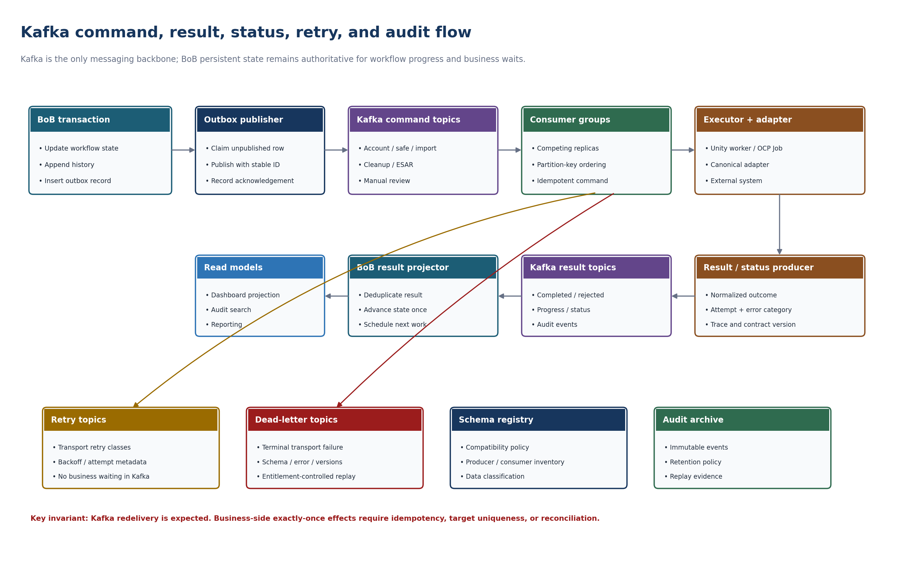
Figure 3. Kafka command, result, status, retry and audit flow.

10. Reusable Unity capability architecture
Legacy business groupings such as Account Lifecycle, Safe Management, Account Import, Cleanup and ESAR remain useful as business domains and workflow families, but they are not automatically target deployable services. The target service boundaries must be derived from repeated technical capabilities observed across the application estate.

10.1 Capability derivation rule
Architecture rule A business domain is not automatically a microservice. A target capability service is justified by repeated operations, common dependencies, shared execution characteristics, shared security and operational controls, and a coherent reason to change together.

10.2 Working capability families
These are the candidate reusable capability families derived from the estate. Final taxonomy depends on the decomposition analysis in section 19.
Capability family | Purpose / candidate functions | Status
Enrichment Service | Obtain and normalize context from AD, governed data APIs, EVD, CyberArk metadata and other approved sources. Available to both A.M.I.E. and BoB workflows. | Strong candidate
CyberArk Integration | Centralized EPV/CyberArk API boundary for accounts, safes, members, platforms and policies, password and reconcile, and other vendor operations. | Strong candidate
Data Services | Governed database reads and writes, lookups, controlled procedures, reporting-table population and data operations exposed through APIs. | Strong candidate
File Acquisition | Retrieve, upload, download, stage, move and verify files and artifacts. | Strong candidate
File Processing | CSV and Excel parsing and generation, ZIP extraction, validation, transformation, split and merge, and artifact generation. | Strong candidate
Batch Processing | Reusable high-volume or parallel execution behavior, if cross-application analysis proves a coherent service boundary. | Validate
Reporting Service | Reusable report, projection and dashboard data generation where behavior is broader than simple data operations. | Validate
Notification Service | Email and event-driven completion, warning and failure notifications with templates. | Strong candidate

10.3 Legacy domain grouping as migration input
The grouping below was produced from the legacy inventory and remains the working migration map. It is an input to the capability derivation in section 10.2 and to the topic taxonomy in section 9.2 — not a commitment to five target services.
Legacy capability domain | Legacy operations grouped for migration | Provisional command topic | Candidate execution path
Account Lifecycle | ActivateAccount; PasswordUpdate; RotatePasswords; ReconcileAccounts | unity.cyberark.account.requests | Unity worker; assess SPEARS or CyberArk Flow where suitable.
Safe Management | SafePermissionUpdate; SafeAndAccountValidationService; validation bypass; vopSafeCreate | unity.cyberark.safe.requests | Unity/CyberArk adapter; assess CyberArk Flow.
Account Import | PersonalAccountImport; PersonalAccountImportService; ServiceAccountImport; iSeriesAccountImport | unity.cyberark.import.requests | OCP batch worker; assess SPEARS for repeatable execution.
Account Cleanup | PersonalAccountDelete; NHADisabledAccountDeleteService; BAUAccountDelete | unity.cyberark.cleanup.requests | Unity worker with fail-closed controls; further discovery required.
ESAR | eSARImport; eSARImportService; eSARMoveAccounts; eSARDeleteService | unity.cyberark.esar.requests | OCP batch worker or SPEARS candidate after dependency discovery.

Discovery status SPEARS and CyberArk Flows are potential execution mechanisms, not default destinations. Each candidate must be evaluated for supported operations, bulk behavior, idempotency, observability, security boundary, failure recovery, throughput, licensing and lifecycle ownership before it is bound to a BoB module. SPEARSBoard and CyberArk Flows should remain small integration references until concrete requirements exist.

10.4 CyberArk integration boundary
Many Unity workflows are CyberArk-related. BoB determines the sequence and business semantics; the CyberArk Integration Service performs the governed technical interaction with EPV and the CyberArk API.
Capability modules own workflow semantics, validation, result classification and legacy parity. The adapter boundary exposes a versioned internal capability contract independent of CyberArk DTOs. Version-specific adapters own authentication, token lifecycle, endpoint and version routing, request and response mapping, direct REST or approved Flow calls, technical retry and circuit behavior, error translation and CyberArk-specific telemetry.
A CyberArk upgrade should normally require an adapter mapping change, not a BoB workflow or A.M.I.E. contract change. Future CyberArk Flows integration can be introduced behind the same integration boundary or as an additional governed adapter without rewriting the business workflow. Credentials and tokens never appear in workflow variables or Kafka events.
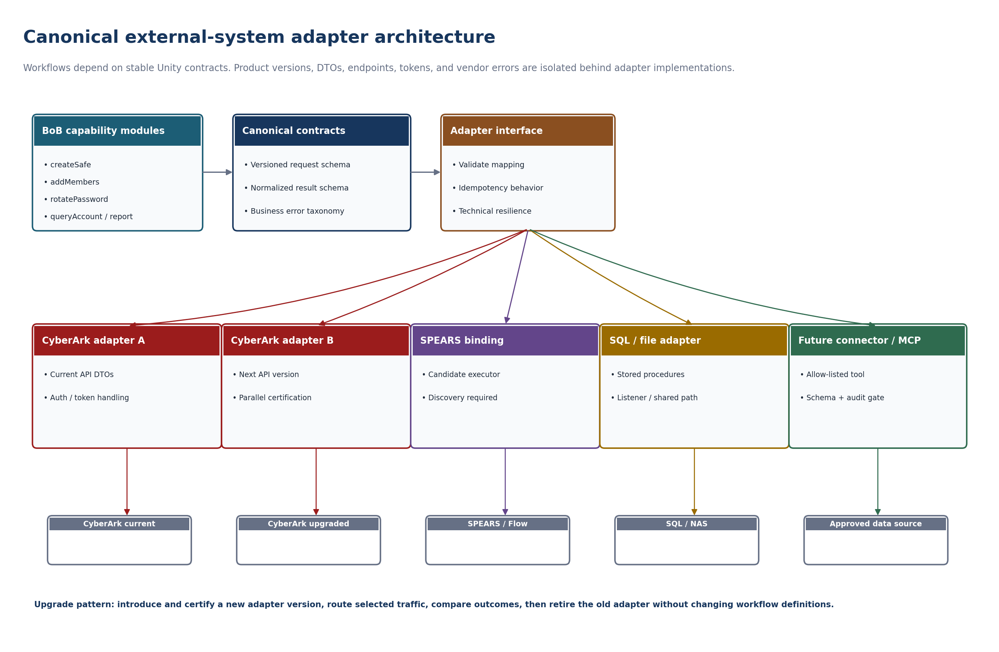
Figure 4. Canonical external-system adapter architecture.

10.5 Deletion guardrails
Fail-closed requirement Account deletion proceeds only after all documented safety preconditions succeed. Ambiguous identity, failed Active Directory lookup, unexpected safe naming, incomplete data or unavailable dependencies route to manual review; they do not default to deletion.

10.6 Reporting and policy-drift module
The legacy SQL policy-drift logic should become a batch-capable module with a canonical execution ID, report date, source snapshot, policy counts, classification counts, exclusion reasons and a report artifact. Its diagnostic parsing may be implemented in a reporting worker or an OpenShift Job, while state, retries and completion remain controlled by the workflow engine.

11. Scheduling and AutoSys integration
AutoSys is the enterprise scheduler for configured timed activity. It does not own multi-step Unity business process state. At the configured time, AutoSys causes a governed Unity trigger or request to be produced; A.M.I.E. evaluates the request and routes it to the appropriate BoB workflow.
Business Enablement may provide authorized configuration and management experiences for schedules, but users do not directly interact with AutoSys runtime internals. An OpenShift CronJob may be used only to trigger a workflow where a platform-internal schedule is appropriate and AutoSys is not the correct owner; a CronJob never owns multi-step process state.

Part V. Data, storage and platform

12. Data, database and storage architecture

12.1 Persistent databases
Business Enablement, A.M.I.E. and BoB have distinct persistence concerns. Business Enablement owns website and application state. A.M.I.E. requires durable rules, configuration and governance data. BoB requires durable workflow state, history, timers, tasks and outbox, in a separately owned schema or store. Additional capability services receive their own persistent store only where independent state ownership is justified; a web service does not automatically require its own database.

12.2 Governed database access and SQL Server
SQL Server holds existing business data, stored procedures and reporting. It remains a legitimate part of the target for business data and read-optimized reporting, accessed through governed contracts rather than ad hoc connections from workloads.
Appropriate application and data functions are exposed through governed ASP.NET Web APIs so that functional and regression automation can exercise supported contracts. APIs are onboarded to Apigee according to enterprise standards. Direct browser-to-database access is prohibited, and BoB does not execute arbitrary SQL.

12.3 Persistent file and artifact storage
Unity requires durable enterprise storage for workloads that process CSVs, Excel files, ZIPs, reports, exports and other artifacts. This design distinguishes shared and persistent file storage from object and artifact storage without selecting a specific enterprise product. Containers receive mounted or API-accessible storage according to the approved OCP storage pattern. Kafka messages and BoB state carry artifact references rather than large file payloads.
Storage class | Examples | Architecture requirement
Application/state databases | Business Enablement state, A.M.I.E. rules and configuration, BoB workflow state | HA, backup, recovery, replication and access only through owned service boundaries.
Persistent/shared file storage | Uploads, ZIP processing, working directories, staged files, legacy shared-drive batch inputs and outputs | Survives pod and node failure; mountable by approved workloads where required.
Object/artifact storage | Reports, exports, correction files, long-lived artifacts, large outputs | Durable referenceable artifacts; exact enterprise technology to be confirmed.

Shared-drive rule Legacy batch modules may use an approved shared network drive through a stable SMB, NFS or NAS endpoint when required. The share may stage inputs and outputs, but it must not be the sole owner of workflow progress, locks, retry state or audit history. Availability, cross-site replication, path conventions, permissions, malware scanning and outage behavior require infrastructure confirmation.

13. OpenShift deployment architecture
OpenShift Container Platform is the hosting and execution foundation. Business Enablement, A.M.I.E., BoB and reusable capability services run as independently deployable and scalable container workloads. Kubernetes and OpenShift resource types such as Job are implementation details and should not be presented as business architecture components in diagrams — label the Unity business capability, not "OCP Job".

13.1 Workload types
OCP workload | Use
Deployment | Long-running APIs and consumers: Business Enablement API, A.M.I.E. runtime and API, BoB runtime and API, workflow gateways, schedulers, outbox publishers, Kafka consumers, integration services and background workers.
Job | Finite processing workloads: batch import, file processing, reconciliation, report generation, policy-drift analysis and high-isolation tasks.
CronJob | Only to trigger a workflow on a schedule where AutoSys is not the correct owner. Never owns multi-step process state.
Stateful operator-managed service | PostgreSQL, Kafka, search or secondary stores, and chosen engine dependencies, provided and operated according to enterprise platform standards.
Optional Argo Workflow | Complex container-native batch DAGs behind a reusable workflow module; not the primary business-process control plane.

13.2 Pod and platform controls
- Run containers with restricted SCC-compatible security contexts and non-root images.
- Run at least two eligible replicas for web/API, A.M.I.E., BoB control-plane services, outbox publishers and Kafka consumers, subject to the quantified NFRs.
- Spread replicas with topology constraints or anti-affinity; protect quorum-sensitive disruptions with PodDisruptionBudgets.
- Use separate service accounts and network policies for each capability boundary.
- Keep sessions, mappings, workflow progress, timers and job ownership out of pod memory; use shared durable stores, Kafka offsets and expiring leases.
- Use readiness for traffic eligibility and liveness only for unrecoverable process failure.
- Use Horizontal Pod Autoscaling on Kafka lag, BoB task backlog, batch backlog or CPU as appropriate; exact replica counts require sizing.
- Store large artifacts in object storage; mount persistent volumes only when the component requires them.
- Use OpenShift Routes for HTTP UI and API exposure; use approved ingress configuration for gRPC-based engines.

13.3 Container and namespace view
The container view separates independently scalable concerns. Web, intake, A.M.I.E., BoB, execution, integration, human-work and operations components run as replicated Deployments where appropriate. Finite heavy batch work runs as OCP Jobs. Durable workflow state, files, messages, mappings and audit evidence remain outside individual containers.
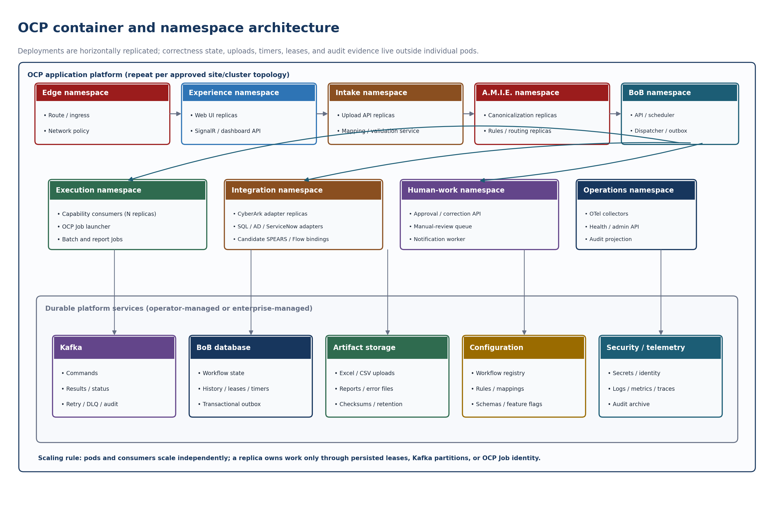
Figure 5. OCP container and namespace architecture.

14. Four-data-center resiliency architecture
Unity is deployed across four data centers organized into two regions. Virginia contains Sterling and Manassas. Texas contains Garland and Lewisville. Each data center has an OCP cluster. The target resiliency model is intra-region failover first, and cross-region failover if the region is unavailable.
Region | Data center | Platform role
Virginia | Sterling | OCP cluster hosting Unity workloads; participates in regional failover.
Virginia | Manassas | OCP cluster hosting Unity workloads; failover peer for Sterling.
Texas | Garland | OCP cluster hosting Unity workloads; participates in regional failover.
Texas | Lewisville | OCP cluster hosting Unity workloads; failover peer for Garland.

14.1 Traffic and failover
Enterprise DNS and global traffic management, WAF and DDoS protection, Apigee, and SSO and entitlement services form the enterprise access and edge layer in front of Unity. Exact enterprise products and traffic-routing implementation are infrastructure-owned. The architecture requirement is that traffic can be directed to a healthy data center, fail within the current region when a data center is unavailable, and fail to the alternate region when the region is unavailable.
Unity application services reach enterprise SQL through a stable clustered listener or virtual name. The SQL platform can fail over between data centers without applications selecting a database node directly. Applications use stable service endpoints for SQL, Kafka, object storage and shared files rather than node- or data-center-specific addresses.
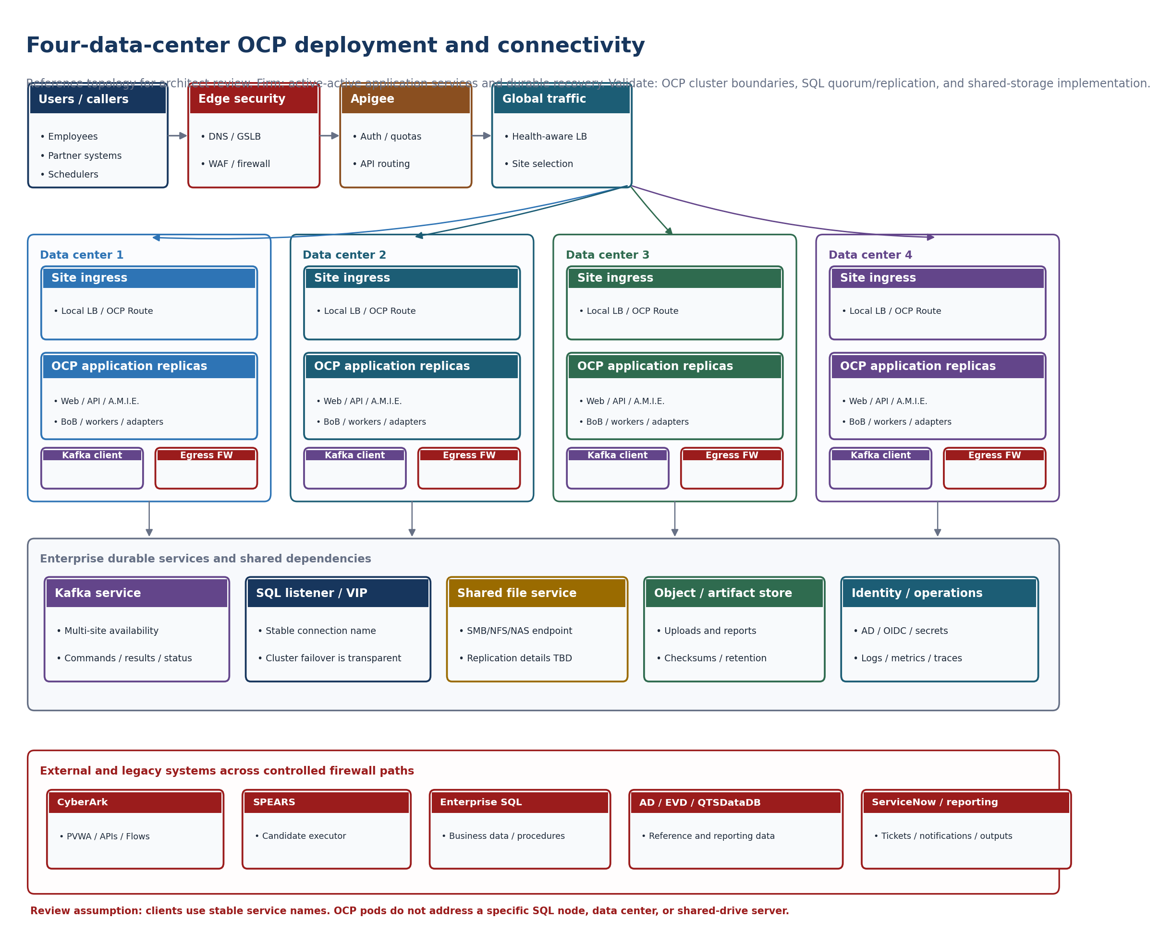
Figure 6. Four-data-center OCP deployment and connectivity reference view.
Infrastructure validation boundary The four-data-center view is a review assumption, not a confirmed description of SQL quorum, replication, witness, storage or failback behavior. Confirm whether there is one OCP cluster per data center or another pairing; which sites receive active traffic; the SQL listener, quorum, replication and failback model; Kafka site topology; shared-file replication; and the required firewall zones and flows. The diagram deliberately uses stable service endpoints instead of invented server or cluster names.

14.2 State continuity
Application databases, BoB workflow state, A.M.I.E. configuration, Kafka data where applicable, and persistent file and artifact storage must meet the defined regional recovery objectives. Exact database clustering and replication, Kafka physical topology and storage replication technologies remain enterprise infrastructure decisions. Broker replay is not a substitute for authoritative workflow-state backup.

14.3 Active-active recovery behavior
- A request is committed with its canonical payload reference, mapping and rule versions, workflow state, and outbox record.
- A Kafka command is published with a stable command ID, workflow and step identity, idempotency key and partition key.
- One consumer-group member processes the command; duplicate delivery remains safe by contract.
- If the consumer pod dies before acknowledgement, Kafka redelivers after group rebalance.
- If a BoB scheduler or worker pod dies while holding a task, its lease expires and another replica claims the persisted task.
- For an OCP Job failure or eviction, BoB creates or observes a replacement attempt from durable state rather than relying on the failed pod filesystem.
- The result event advances BoB once; duplicate or late results are recorded and ignored or reconciled according to step policy.
- Operators see the full timeline, file and row outcomes, attempts, errors and permitted recovery actions on the dashboard.
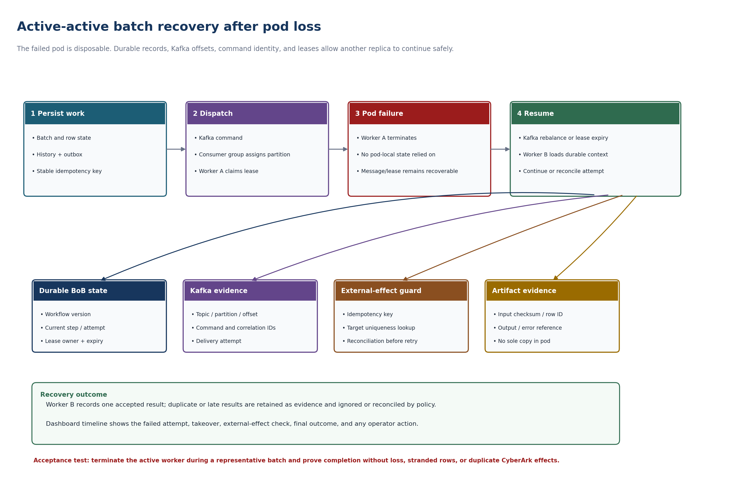
Figure 7. Active-active batch recovery after pod loss.

14.4 State and disaster recovery
Define recovery point and recovery time objectives for workflow state, event history, rules, definitions and object artifacts. Back up the authoritative workflow database and configuration repositories; broker replay is not a substitute for workflow-state backup. Test restoration with in-flight timers, approvals and leased tasks.

NFR dependency The architecture fixes the active-active correctness model now. The forthcoming NFRs must quantify replica counts, availability, failover time, RTO and RPO, file and row volumes, throughput and latency, retention, maximum recovery concurrency, dependency-degradation behavior and regional disaster-recovery expectations.

Part VI. Cross-cutting platform concerns

15. Security, entitlements and governance

15.1 Authentication and authorization
- Entra ID / OIDC and enterprise SSO for interactive users.
- OAuth2 client credentials with JWT, or mTLS, for external and internal service callers.
- Entitlement-backed authorization for execute, approve, administer, replay, DLQ access, log access, configuration and privileged functions.
- Four-eyes approval for production workflow, module and routing-rule publication where required.
- Separate design-time privileges from runtime service identities.

15.2 Sensitive data
- Store secret references, not credentials, in workflow definitions, workflow variables, Kafka messages and the UI.
- Retrieve short-lived credentials in the integration worker at execution time.
- Classify workflow variables and redact sensitive fields from history, logs, Kafka and UI.
- Encrypt state, artifacts, broker traffic and database connections according to enterprise standards.
- Define variable and artifact retention by data classification.

15.3 Governance lifecycle
Artifact | Required controls
Routing rule | Owner, version, test cases, approval, effective date, rollback, audit history.
Workflow | Owner, semantic version, compatibility policy, review, publish approval, deprecation.
Module | Contract tests, security review, idempotency statement, operational defaults, supported versions.
Mapping profile | Owner, version, authorization scope, validation rules, approval and retention.
Event / API schema | Registry identity, compatibility mode, classification, producer and consumer inventory.
Replay | Reason, approver, original event reference, new attempt identity, result evidence.

16. Observability, operations and NFR inheritance
Unity centralizes cross-cutting non-functional behavior so that migrated and newly configured functions inherit platform controls instead of reimplementing them.

16.1 Platform-provided NFR capabilities
- Authentication and authorization.
- Correlation IDs and distributed tracing.
- Structured logging and Splunk integration.
- OpenTelemetry metrics and traces where approved.
- Health and readiness probes and operational monitoring.
- Idempotency, bounded retry, DLQ and recovery, and reconciliation patterns.
- Audit history and version provenance.
- Horizontal scaling and container recovery.
- Secrets management and network and security policy.
- Backup, restore, RPO/RTO and disaster-recovery testing.
- API governance through Apigee.
- Controlled release and promotion through enterprise CI/CD and GitOps standards.

16.2 Required telemetry context
Every log, safe metric dimension and trace should carry the applicable correlationId, requestId, workflowInstanceId, idempotencyKey, clientId, sourceSystem, requestType, destination, workflow and version, module and version, matchedRuleId, ruleSetVersion, Kafka topic, partition and offset, consumer name, attempt, workflow status and error category.

16.3 Operational dashboards
- Intake volume and validation failures by request type.
- Rule-match distribution and rule-evaluation latency.
- Manual-review rate and aging.
- DLQ volume, age and replay outcomes.
- Kafka publish failures and consumer lag by workflow.
- Workflow success and failure, step latency and end-to-end latency.
- Timer backlog, leased-task age and retry volume.
- CyberArk, AD, EVD, QTSDataDB, ServiceNow and reporting dependency health.
- OpenShift Job duration, failure, eviction and resource utilization.

16.4 Operator controls
- Search by business key, request ID, correlation ID or workflow instance ID.
- View immutable event history and current projected state.
- Pause, resume, cancel, retry a safe task, or request replay according to entitlement.
- Inspect human-task ownership, due dates and escalation.
- Compare the workflow, rule and module versions active for an execution.
- Export audit evidence without exposing secrets.

16.5 Outcome classification
Capability execution must distinguish workflow-blocking failures from item-level warnings and non-blocking failures. A record-level exception may produce logging, an event and a later notification while the parent workflow continues. The standardized result contract and the exact status taxonomy remain to be finalized during capability design.

17. Resiliency and failure handling
Failure | Platform behavior
Transient dependency error | Bounded exponential retry with jitter; preserve correlation and attempt.
Business rejection | Complete the task with an explicit business outcome; follow the modeled alternate path.
Worker or pod lost | Lease expires; the task becomes claimable by another worker.
Unknown request or no matching rule | Route to manual review with matchedRuleId = none and a reason.
Poisoned message | Move to DLQ with error category, correlation, and schema, rule and workflow versions.
Partial external side effect | Reconcile via idempotency lookup; compensate only when an explicit safe action exists.
Workflow definition defect | Suspend affected instances; deploy a new version; migrate only through an audited plan.
Engine outage | Resume from persistent history and timers after service recovery.

18. API architecture and testability
All appropriate Unity application functions must be accessible through governed APIs to support functional, automated and regression testing. ASP.NET Web API is the standard application API technology identified for Unity. Exposed APIs are onboarded to Apigee. HyperExecute-based test automation can invoke supported API contracts from its separate test repository without depending on internal pod implementation.
- Business Enablement API is independently testable.
- A.M.I.E. management and configuration APIs and supported intake contracts are independently testable.
- BoB management, status and workflow contracts are independently testable.
- Capability and data APIs expose supported testable operations where appropriate.
- Test automation validates behavior, authorization, idempotency, failure handling, recovery and regression parity.

Part VII. Migration, acceptance and decisions

19. Migration and capability discovery
The legacy applications are decomposed into workflows and reusable capabilities rather than mapped one-for-one to replacement services. The capability analysis is a required architecture input because it determines the final service and module boundaries, the Kafka topic taxonomy, migration sequencing and reuse metrics.

19.1 Application decomposition
For each legacy application capture | Purpose
Business purpose / workflow | Identifies the process Unity must preserve.
Trigger / intake | User, API, CSV, schedule, message or other source.
Command-line arguments and invocation | Captures how the legacy executable is actually run today.
Inputs / outputs | Defines contracts and artifacts.
Business rules / guardrails | Preserves behavior and fail-closed controls.
CyberArk operations | Identifies reusable vendor-facing functions.
AD / DB / EVD / other integrations | Identifies enrichment and integration needs.
File operations | Identifies acquisition, parsing, ZIP/CSV and artifact behavior.
Reporting / notifications | Identifies common output capabilities.
Scheduling / volume / parallelism | Determines execution and scaling patterns.
Unique logic | Determines whether a specialized module is required.

19.2 Target mapping
Each legacy application receives a disposition such as: retire and replace with a BoB workflow; replace with a scheduled workflow; refactor repeated logic into a reusable capability; retain temporarily; or implement a specialized module. Parity tests are required before cutover for inputs, outputs, side effects, security guardrails and reporting behavior.

19.3 Migration roadmap
Phase | Outcome | Exit evidence
0. Legacy capability assessment | Inventory commands, arguments, inputs and outputs, DB/file/API dependencies, schedules, reports, rules and guardrails. | Approved migration matrix and parity-test catalog.
1. Platform MVP | Intake → normalize → route → outbox/Kafka → durable workflow → one account-lifecycle worker. | Crash/restart, duplicate delivery, timer, retry, audit and manual-review tests pass.
2. Account lifecycle | Activate, password update, rotate and reconcile modules. | Shadow comparison and feature-flag cutover.
3. Safe management | Safe permission, validation, bypass and create modules. | Security review and contract tests.
4. Import and cleanup | Personal, service and iSeries imports and deletion services. | CSV parity and fail-closed deletion evidence.
5. ESAR and specialized support | ESAR flows, reporting, policy drift and remaining utilities. | Operational readiness and runbooks.
6. Decommission | Parallel run, compare, correct gaps, cut over, retain rollback evidence. | Legacy invocation disabled by capability.

19.4 Recommended first vertical slice
- Upload one representative Excel or CSV file through the Business Enablement interface.
- Map source columns to canonical required fields; preview transformations, validation failures and warnings; save the approved mapping profile.
- A.M.I.E. cleans, enriches, classifies and selects the onboarding workflow and rule versions.
- BoB creates a durable parent batch plus independently traceable row and item workflows.
- BoB publishes versioned commands through the transactional outbox to Kafka.
- An approved Unity worker executes the slice; evaluate SPEARS or a CyberArk Flow only as a discovery alternative.
- The worker calls CyberArk only through the canonical adapter contract and emits normalized results.
- Force termination of the active consumer or worker pod; another replica resumes from durable state without duplicate external effects.
- The dashboard shows batch totals, per-row outcomes, errors, attempts, audit history and permitted correction and replay actions.
- Submit a second source layout using the saved mapping profile without changing workflow or integration code.

20. Acceptance criteria

20.1 Platform
- Business Enablement provides the governed human interaction surface and does not expose internal brokers or privileged systems directly.
- Intake accepts, authenticates, validates, normalizes and correlates supported requests.
- The web UI uploads Excel and CSV files, maps custom columns to canonical fields, previews validation and transformation results, and stores versioned mapping profiles.
- A.M.I.E. records cleanup, enrichment, classification, routing and rule versions for every submitted batch and item, and returns governed routing decisions without executing the end-to-end business process.
- The router returns destination, workflow, matched rule, reason, priority and rule-set version without executing business work.
- Kafka is the only target messaging backbone; RabbitMQ is absent from deployed target components and contracts.
- Kafka command and event contracts are versioned, governed and decoupled from authoritative workflow state.
- BoB workflow state survives deletion of any individual application pod, a controlled engine restart, and can resume waits, timers and tasks.
- After a worker or consumer pod failure, another replica resumes eligible work without duplicate external effects.
- The outbox prevents lost commands between state commit and Kafka publication.
- Manual review and dead-letter paths are implemented and entitlement protected.
- Reusable capability modules can be composed into multiple workflows without duplicating integration logic.
- CyberArk operations are routed through the centralized integration boundary.
- Persistent files and artifacts survive container instances and are referenced rather than embedded in workflow state or messages.
- Applications use stable SQL, Kafka, object-storage and shared-file service endpoints rather than node- or data-center-specific addresses.
- Unity workloads can be deployed across Sterling, Manassas, Garland and Lewisville with defined intra-region and cross-region recovery behavior.
- A controlled site or dependency failover test demonstrates the agreed RTO and RPO once the four-data-center topology is confirmed.
- OpenTelemetry connects file intake and mapping, A.M.I.E. interpretation, routing, Kafka, workflow, worker, adapter and result.
- APIs are governable through Apigee and support functional and regression automation.

20.2 Reuse and authoring
- A designer can assemble a second onboarding variant without changing the engine or the CyberArk worker.
- The UI renders module configuration from versioned schemas.
- Published definitions and modules are immutable; new behavior uses new versions.
- Referenced modules and subprocesses remain distinguishable from cloned content.
- Impact analysis lists consumers before a module or event version is deprecated.

20.3 Migration
- Every console application maps to a capability domain and a target module or service.
- Inputs, outputs, rules, side effects, dependencies and schedules are documented.
- Parity tests exist before cutover, including SQL and report totals and deletion guardrails.
- Direct CyberArk calls are removed from capability services where the integration boundary applies.
- Feature flags support shadow mode, controlled cutover and rollback evidence.
- Legacy applications have documented parity evidence before retirement.

21. Architecture decision record register
The two source documents maintained separate ADR lists with overlapping content and conflicting numbering. The register below is the single authoritative list. The "Source" column records the origin so earlier references can be traced.
ADR | Decision | Source
ADR-001 | Use a separate A.M.I.E. decision-router pattern. | Both
ADR-002 | Adopt canonical internal request, message and result models. | Both
ADR-003 | Use Kafka as the only internal durable command and event backbone; exclude RabbitMQ. | Both
ADR-004 | Abstract the rules engine behind a governed adapter and configuration model. | Both
ADR-005 | Decompose legacy applications into BoB workflows and reusable capabilities rather than grouping legacy applications into target services. | Unity; supersedes BoB ADR-006
ADR-006 | Use a transactional outbox where a state change and message publication require atomic durability. | Both
ADR-007 | Adopt end-to-end correlation and OpenTelemetry telemetry. | Both
ADR-008 | Host Unity workloads on OpenShift and run eligible application services active-active. | Both
ADR-009 | Use versioned API, command and event contracts. | Both
ADR-010 | Govern rules, mappings, workflows and modules through explicit lifecycle and version controls. | Both
ADR-011 | Route CyberArk technical operations through the centralized, version-isolated integration boundary. | Both
ADR-012 | Keep Business Enablement a governed interaction surface, not the workflow execution engine. | Both
ADR-013 | Preserve legacy behavior through parity tests. | Both
ADR-014 | Select a supported durable workflow runtime after requirements validation. | Both
ADR-015 | Use at-least-once delivery with idempotent workers. | Both
ADR-016 | Treat finite container execution, including OpenShift Jobs, as an implementation pattern for isolated batch work rather than a business architecture component. | Both
ADR-017 | Define an explicit workflow and module in-flight version migration policy. | Both
ADR-018 | Treat Enrichment as a reusable capability available to both A.M.I.E. and BoB workflows. | Unity
ADR-019 | Use enterprise persistent file and artifact storage for workloads requiring durable files. | Unity
ADR-020 | Use AutoSys for enterprise timed triggers while BoB owns business workflow orchestration. | Unity
ADR-021 | Deploy Unity across four OCP data centers with intra-region then cross-region failover. | Unity
ADR-022 | Use governed, versioned Excel and CSV mapping profiles. | BoB
ADR-023 | Use stable service listeners and endpoints instead of node- or data-center-specific addresses. | BoB
ADR-024 | Keep shared-file staging separate from authoritative workflow state. | BoB
ADR-025 | Treat SPEARS and CyberArk Flows as discovery candidates, not default executors. | BoB
ADR-026 | Govern future data-source connector and MCP-enabled modules. | BoB
Superseded | BoB ADR-006, "Group legacy applications by business capability," is superseded by ADR-005. Legacy domain groupings remain valid as workflow families and migration inputs only. | BoB

22. Remaining architecture work, open decisions and risks
The conceptual Unity architecture is sufficiently defined to continue the high-level design and implementation planning. The items below remain necessary to convert the working architecture into an implementation-ready design. Items marked "analysis required" are work the Unity team can perform from the legacy estate; items marked "enterprise decision" require platform, security or infrastructure confirmation.
# | Remaining item | Type | Required outcome
1 | Legacy application decomposition | Analysis required | Application-to-workflow-to-capability matrix covering inputs, outputs, integrations, files, rules, schedules, volumes, guardrails and unique logic across the 42-item inventory.
2 | Final reusable capability taxonomy | Analysis required | Confirm service and module boundaries; validate Batch Processing and Reporting as services versus execution or module patterns.
3 | Kafka topic and schema taxonomy | Architecture follow-up | Align topics with final capability and execution boundaries; define ownership, schema registry, compatibility, retention, partitioning, replay authority and DLQ policy.
4 | BoB runtime product | Product / enterprise decision | Evaluate durable workflow candidates against proven requirements and enterprise support and licensing.
5 | A.M.I.E. rules product and configuration persistence | Product / architecture decision | Confirm the rules technology — including whether Microsoft RulesEngine has adequate lifecycle and support or an alternative is selected behind the adapter — plus rule-store implementation, governance and promotion model.
6 | Business Enablement entitlements integration | Enterprise decision | Confirm enterprise entitlement APIs and groups, role mapping and the breakglass pattern.
7 | Four-data-center traffic topology | Enterprise infrastructure decision | Confirm cluster boundaries, active sites, GTM/GSLB/DNS, local load balancers, OCP Routes, ingress ownership, health checks, draining, active/active behavior, automated failover and failback.
8 | Database HA/DR topology | Enterprise infrastructure decision | Confirm listener/VIP, database engine and edition, cluster and replication model, quorum and witness placement, synchronous or asynchronous replicas, eligible failover sites, storage, backup, RPO/RTO and cross-region recovery.
9 | Kafka physical topology | Enterprise infrastructure decision | Confirm whether Kafka is regional or global, broker and schema-registry placement, replication, and behavior during broker, availability-zone or data-center loss.
10 | Persistent file and object storage | Enterprise infrastructure decision | Confirm the OCP-supported shared storage and object storage products, stable endpoint names, access modes, cross-site replication, locking semantics, capacity, permissions, malware scanning, retention, backup and restore.
11 | Capacity and pod sizing | Performance analysis | Estimate request rates, bulk volumes, file sizes, concurrency and resource profiles; derive autoscaling and minimum replica requirements.
12 | API inventory and Apigee onboarding | Architecture / implementation | Define exposed APIs, ownership, security, versioning and test contracts.
13 | HyperExecute test architecture | Implementation / NFR | Define functional and regression suites, environment connectivity, test data, API coverage and evidence.
14 | Legacy SQL and reporting ownership | Analysis required | Determine which SQL remains as governed data and reporting behavior and which logic moves into reusable versioned modules.
15 | Workflow and module in-flight migration | Architecture decision | Define the compatibility policy for running workflows when definitions or modules are upgraded, and which upgrades require completion on the original version.
16 | Data classification and retention | Security decision | Classify request fields, workflow variables, events and artifacts; define masking, persistence, indexing, publication and retention.
17 | Firewall and network zoning | Enterprise infrastructure decision | Confirm user, ingress, application, data, privileged-integration and management zones plus the permitted source, destination, port, protocol, TLS/mTLS, DNS and proxy/egress matrix.
18 | Authoring audience | Governance decision | Determine which process changes business designers may publish versus which remain developer-owned.
19 | Batch orchestration thresholds | Architecture decision | Define thresholds for using a long-running Kafka consumer, a direct OCP Job, or an optional Argo-backed complex batch workflow.
20 | Bulk mapping policy | Architecture / governance | Set supported Excel and CSV formats, file and row limits, transformation policy, profile ownership, error-correction flow and artifact retention.
21 | Future connectors and MCP governance | Security / architecture decision | Define the trust boundary, approval process, tool allow-listing, data minimization, runtime isolation, human confirmation and audit requirements.
22 | SPEARS and CyberArk Flows discovery | Discovery | Discover supported operations, idempotency, bulk limits, observability, security, ownership, licensing and lifecycle before assigning execution. Keep SPEARSBoard and CyberArk Flows as small future integration points until concrete contracts exist.

22.1 Immediate next deliverables
- Complete the legacy application and capability matrix using the ApplicationDetails inventory.
- Use that matrix to finalize the reusable capability families and the module catalog.
- Revise Kafka topics and contracts based on the final capability boundaries.
- Produce the logical Unity architecture diagram, the Business Enablement diagram, the A.M.I.E./BoB component diagram, the storage and data diagram, and the four-data-center OCP deployment diagram.
- Confirm the infrastructure-owned decisions for database, Kafka, storage, traffic management and entitlements.
- Use the resulting requirements to evaluate the BoB runtime product and produce implementation sizing.

22.2 Infrastructure architecture review agenda
- Confirm whether the four data centers contain independent OCP clusters, paired clusters or another shared control-plane arrangement.
- Identify which data centers accept active user and batch traffic and how GSLB, local load balancers, Apigee, OCP Routes, health checks, draining and failback interact.
- Document the SQL listener or VIP and the actual cluster topology, including quorum or witness placement, replica modes, backups, failover authority, RTO and RPO.
- Identify where Kafka brokers, the schema registry and operators run, and the behavior during broker, availability-zone or data-center loss.
- Confirm the enterprise shared-drive and object-storage products, stable endpoint names, cross-site replication, locking semantics, capacity, retention, scanning and restore processes.
- Review firewall and network-policy boundaries and produce the approved source, destination, port, protocol, TLS/mTLS, DNS and proxy/egress matrix.
- Identify external-system locality and availability for CyberArk, SPEARS, AD, EVD, QTSDataDB, ServiceNow and reporting services.
- Agree the infrastructure failure tests: pod loss, node loss, OCP cluster loss, Kafka rebalance, SQL failover, storage outage, external timeout and controlled failback.

22.3 Current confidence
Area | Assessment
Unity platform concept and responsibility boundaries | Strong / ready to document
Business Enablement role and boundaries | Strong; entitlement details pending
Bulk intake and mapping design | Strong; format, limit and retention policy pending
A.M.I.E. role | Strong; rules product and configuration-store implementation pending
BoB orchestration and durable state model | Strong; runtime product pending
Reusable capability model | Direction strong; final taxonomy depends on the application decomposition
CyberArk integration boundary | Strong
Kafka logical role | Strong; final topic and physical topology pending
Storage requirements | Strong; enterprise product and topology pending
Four-data-center logical resiliency | Strong; exact traffic and data replication mechanics pending
Active-active correctness model | Strong; replica counts and quantified NFRs pending
NFR and testability model | Strong; detailed test and sizing implementation pending
SPEARS and CyberArk Flows | Unresolved; discovery required before any execution binding

Appendix A. Responsibility map
Layer | Owns | Must not own
Business Enablement (web/UI) | User experience, submission, Excel/CSV upload, field mapping, preview, correction, dashboards, configuration, status, approvals and approved operations. | Privileged CyberArk execution, secrets, broker internals, workflow state.
Intake API | Authentication, file and schema validation, artifact registration, idempotency and correlation. | Multi-step workflow state or destination side effects.
A.M.I.E. | Intake canonicalization, data interpretation, cleanup, enrichment, policy evaluation, and destination and workflow selection. | Long-running workflow execution, business workflow execution or vendor side effects.
BoB | Durable state, parent-batch and row/item tracking, sequencing, waits, timers, retries, approvals, fan-out/fan-in, compensation and recovery. | Vendor credentials, domain-specific API mapping or arbitrary integration implementation.
Capability module / worker | Reusable execution semantics, business task rules and standardized results. | End-to-end business-process ownership; shared vendor auth, token and version handling.
Integration service / adapter | Vendor and system API isolation, canonical-to-vendor mapping, vendor-version isolation, authentication and technical resilience. | Business workflow sequencing or end-to-end process ownership.
Kafka | Durable command, result, status, event, audit and replay transport. | Authoritative workflow state or business waits.
OpenShift | Active-active container scheduling, isolation, scaling, placement, restart and platform health. | Business-process semantics.
Persistent storage | Durable state, files and artifacts according to explicit ownership. | Business routing or orchestration decisions.

Appendix B. Example composition pattern: CyberArk onboarding
A CyberArk onboarding workflow illustrates the architecture without defining a dedicated "Account Lifecycle Service."
- Business Enablement or an approved system submits a governed request, either as a single form submission or as a mapped row from a bulk upload.
- A.M.I.E. validates and normalizes the request and requests enrichment if routing context is incomplete.
- A.M.I.E. selects the onboarding workflow and publishes the routing decision or work request.
- BoB starts the versioned workflow and maintains durable state.
- The workflow composes reusable modules; the CyberArk Integration Service performs the technical EPV and CyberArk API operations.
- Capability results and events return through Kafka; BoB advances, waits, retries or completes according to the workflow definition.
- Business Enablement displays authorized status, history and resulting reports.

The composed step sequence is:
- Validate the canonical request and authorization.
- Evaluate onboarding policy and select the workflow version.
- Validate employee or service identity through an approved abstraction.
- Create a manual approval task when policy requires it.
- Create or locate the CyberArk safe through the integration service.
- Assign members and roles.
- Verify the resulting access.
- Generate the report and audit event.
- Notify the requester and complete the workflow.

Variation example A second onboarding workflow can reuse steps 1, 3, 5, 6, 7, 8 and 9 while replacing manager approval with security approval and inserting a mandatory training check. No CyberArk integration code is duplicated and no new service is created.

Appendix C. Source consolidation and decision precedence
This document consolidates the Unity Architecture Modernization Blueprint and the BoB (Business Orchestration Broker) Architecture. Those papers in turn consolidated the A.M.I.E. and BoB screenshots, the CVIS Unity Modernization Recovery Template application inventory, two early architecture PDFs and the SQL and reporting screenshots.
The workbook inventory contains 42 applications and establishes the migration population, CyberArk dependencies, candidate sequencing, consolidation opportunities and retirement candidates. Duplicate screenshots were consolidated rather than repeated.
The early PDFs represent the earliest architectural exploration. Their RabbitMQ, dynamic resolver and differing website assumptions are retained only as discovery history where they conflict with later decisions. The authoritative direction is: Unity as the platform; Kafka only; governed web-based Excel and CSV intake and mapping; A.M.I.E. interpretation and policy routing; BoB durable orchestration; reusable capability derivation; active-active OCP execution across four data centers; and canonical external-system adapters.
Where this document goes beyond transcription — particularly the mapping studio, the reusable module catalog, the durable active-active state model, the OCP workload split, the workflow-product decision, candidate SPEARS and CyberArk Flow execution, future connector and MCP governance, and the compose-before-clone policy — the content is an architecture recommendation derived from the stated platform goals and constraints. These items remain subject to product discovery and the forthcoming quantified NFRs.

Appendix D. Conflict resolution log
The two source documents disagreed in the areas below. Each conflict is resolved here so that no reader has to reconcile them independently.
Topic | Unity blueprint position | BoB paper position | Resolution in this document
Target service boundaries | Legacy business domains are not automatically target services; derive capability services from repeated technical operations. | Group legacy applications by business capability into Account Lifecycle, Safe Management, Import, Cleanup and ESAR services. | Unity position adopted (ADR-005). The BoB grouping is retained in section 10.3 as a migration map and workflow-family view, not as a service commitment.
Kafka topic taxonomy | Topic families must be revisited after the capability analysis. | Defined unity.cyberark.* topic families as the target set. | The BoB topics are retained as a provisional working set (section 9.2) sufficient for the first vertical slice, explicitly marked pending the capability analysis.
Application count | Refers to a 30+ legacy application estate. | Refers to a 42-item inventory: 27 active, 9 inactive, 6 to confirm. | Both are stated in section 1.1. The inventory population is 42 items; "30+" refers to the active and confirmation-pending applications within it.
Data-center model | Four named data centers in two regions; intra-region then cross-region failover. | Four data centers, active-active, exact topology to be validated. | The named topology and the failover order are adopted. Active-active is retained as a correctness property of the runtime, with the topology still subject to infrastructure confirmation.
Scheduling | AutoSys is the enterprise scheduler and does not own process state. | OCP CronJob triggers workflows on a schedule. | AutoSys is the enterprise scheduler. CronJob is a platform-internal exception used only to trigger a workflow where AutoSys is not the correct owner (section 11).
Interaction surface | Named Business Enablement, with Blazor UI, ASP.NET Web API and its own database. | Referred to generically as the business website and API. | Unity naming and technology stack adopted throughout; the BoB bulk mapping and intake detail is retained under Business Enablement (sections 4.4 to 4.7).
SQL Server | Emphasizes Data Services capability and governed API access. | Treats SQL Server as a first-class component with stored procedures and reporting. | Both retained in section 12.2: SQL Server holds business data and reporting, reached through governed APIs and capability adapters rather than ad hoc connections.
ADR numbering | ADR-001 to ADR-021. | ADR-001 to ADR-022 with different numbering. | A single register in section 21 uses the Unity numbering, extends it to ADR-026 for BoB-only decisions, and records the one superseded decision.
MCP integration | Mentioned only as a future possibility for approved system access. | Full governance model for MCP-enabled modules. | The BoB governance model is retained in full (section 6.6) and referenced from the executive decisions as a future capability.

