EE412 Foundation of Big Data Analytics, Fall 2023

HW3

Name: 권혁태

Student ID: 20180036

Discussion Group (People with whom you discussed ideas used in your answers):

On-line or hardcopy documents used as part of your answers:

## Answer to Problem 1

1. Solve following problems

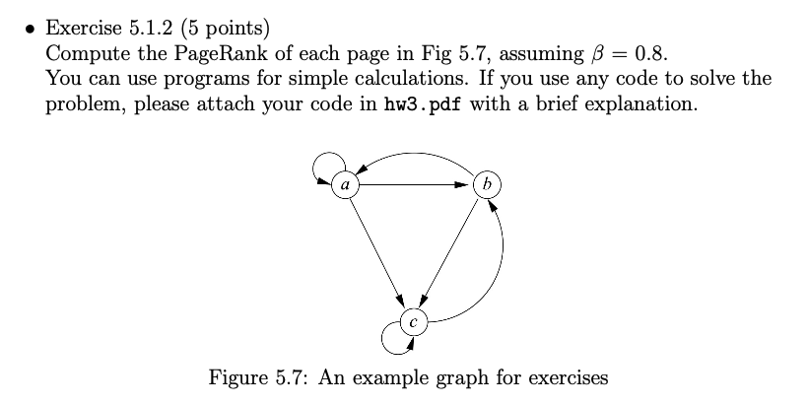

a: 0.25925926

b: 0.30864198

c: 0.43209877

def matrix_multiply(matrix_a, matrix_b):

*# Check if the matrices can be multiplied*

*if* len(matrix_a[0]) != len(matrix_b):

*raise* ValueError("Matrices cannot be multiplied. Inner dimensions must match.")

*# Initialize the result matrix with zeros*

result = [[0 *for* _ *in* range(len(matrix_b[0]))] *for* _ *in* range(len(matrix_a))]

*# Perform matrix multiplication*

*for* i *in* range(len(matrix_a)):

*for* j *in* range(len(matrix_b[0])):

*for* k *in* range(len(matrix_b)):

result[i][j] += matrix_a[i][k] * matrix_b[k][j]

*return* result

def power_iteration(beta, matrix,random_walk,num_iterations):

n = len(matrix)

v = []

*for* i *in* range(n):

v.append([1/n])

*for* i *in* range(num_iterations):

computed_matrix = matrix_multiply(matrix, v)

pageRank = []

*for* i *in* range(n):

pageRank.append([beta * computed_matrix[i][0] + (1-beta) * random_walk[i][0]])

v = pageRank

*return* v

beta = 0.8

M = [[1/3, 1/2, 0],

[1/3, 0, 1/2],

[1/3, 1/2, 1/2]]

random = [[1/3],[1/3],[1/3]]

pageRank = power_iteration(0.8, M, random, 100);

print(pageRank)

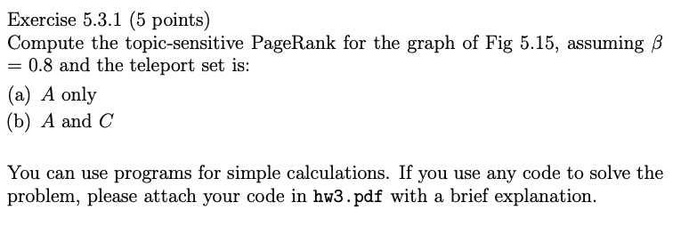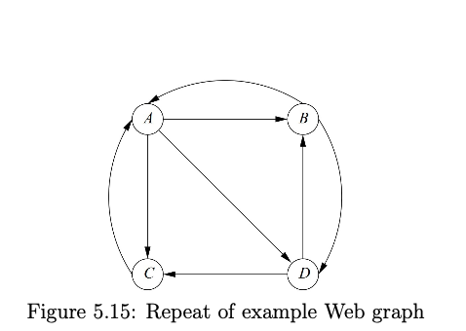

1. A only

A: 0.42857143

B: 0.19047619

C: 0.19047619

D: 0.19047619

def matrix_multiply(matrix_a, matrix_b):

*# Check if the matrices can be multiplied*

*if* len(matrix_a[0]) != len(matrix_b):

*raise* ValueError("Matrices cannot be multiplied. Inner dimensions must match.")

*# Initialize the result matrix with zeros*

result = [[0 *for* _ *in* range(len(matrix_b[0]))] *for* _ *in* range(len(matrix_a))]

*# Perform matrix multiplication*

*for* i *in* range(len(matrix_a)):

*for* j *in* range(len(matrix_b[0])):

*for* k *in* range(len(matrix_b)):

result[i][j] += matrix_a[i][k] * matrix_b[k][j]

*return* result

def power_iteration(beta, matrix,random_walk,num_iterations):

n = len(matrix)

v = []

*for* i *in* range(n):

v.append([1/n])

*for* i *in* range(num_iterations):

computed_matrix = matrix_multiply(matrix, v)

pageRank = []

*for* i *in* range(n):

pageRank.append([beta * computed_matrix[i][0] + (1-beta) * random_walk[i][0]])

v = pageRank

*return* v

beta = 0.8

M = ([[0, 1/2, 1,0 ],

[1/3, 0, 0, 1/2],

[1/3, 0, 0, 1/2],

[1/3, 1/2,0 ,0]]

random = [[1],[0],[0],[0]]

pageRank = power_iteration(0.8, M, random, 100);

print(pageRank)

1. A and C

A: 0.38571429

B: 0.17142857

C: 0.27142857

D: 0.17142857

def matrix_multiply(matrix_a, matrix_b):

*# Check if the matrices can be multiplied*

*if* len(matrix_a[0]) != len(matrix_b):

*raise* ValueError("Matrices cannot be multiplied. Inner dimensions must match.")

*# Initialize the result matrix with zeros*

result = [[0 *for* _ *in* range(len(matrix_b[0]))] *for* _ *in* range(len(matrix_a))]

*# Perform matrix multiplication*

*for* i *in* range(len(matrix_a)):

*for* j *in* range(len(matrix_b[0])):

*for* k *in* range(len(matrix_b)):

result[i][j] += matrix_a[i][k] * matrix_b[k][j]

*return* result

def power_iteration(beta, matrix,random_walk,num_iterations):

n = len(matrix)

v = []

*for* i *in* range(n):

v.append([1/n])

*for* i *in* range(num_iterations):

computed_matrix = matrix_multiply(matrix, v)

pageRank = []

*for* i *in* range(n):

pageRank.append([beta * computed_matrix[i][0] + (1-beta) * random_walk[i][0]])

v = pageRank

*return* v

beta = 0.8

M = [[0, 1/2, 1,0 ],

[1/3, 0, 0, 1/2],

[1/3, 0, 0, 1/2],

[1/3, 1/2,0 ,0]]

random = [[1/2],

[0],

[1/2],

[0]]

pageRank = power_iteration(0.8, M, random, 50);

print(pageRank)

## Answer to Problem 2

