WEEK 4 DRAFT — DESK-BASED REVIEW, NOT YET PRACTITIONER-VALIDATED
Ribble Catchment: Five Candidate NFM Sites
READ THIS BEFORE ANYTHING ELSE
Every polygon in this document is a SCREENING AREA showing where public data suggests further investigation may be worthwhile. None of them are proposed construction boundaries, engineering designs, or confirmed project sites - see docs/screening_methodology.md for what each score does and doesn't claim.

HOW THESE FIVE WERE CHOSEN
From 35 modelled candidates, these five combine a strong or moderate composite score, rank stability across four alternative weightings, and catchment-wide geographic spread — after screening out oversized ‘Investigation Zones’ (≥ 1,000ha) and checking every candidate against SSSI, SAC and Scheduled Monument boundaries. One (C23) is kept specifically because it flags a real statutory constraint, not despite it. Full reasoning, including which higher-ranked candidates were set aside and why, is in docs/week4_manual_review.md.

1. Catchment overview
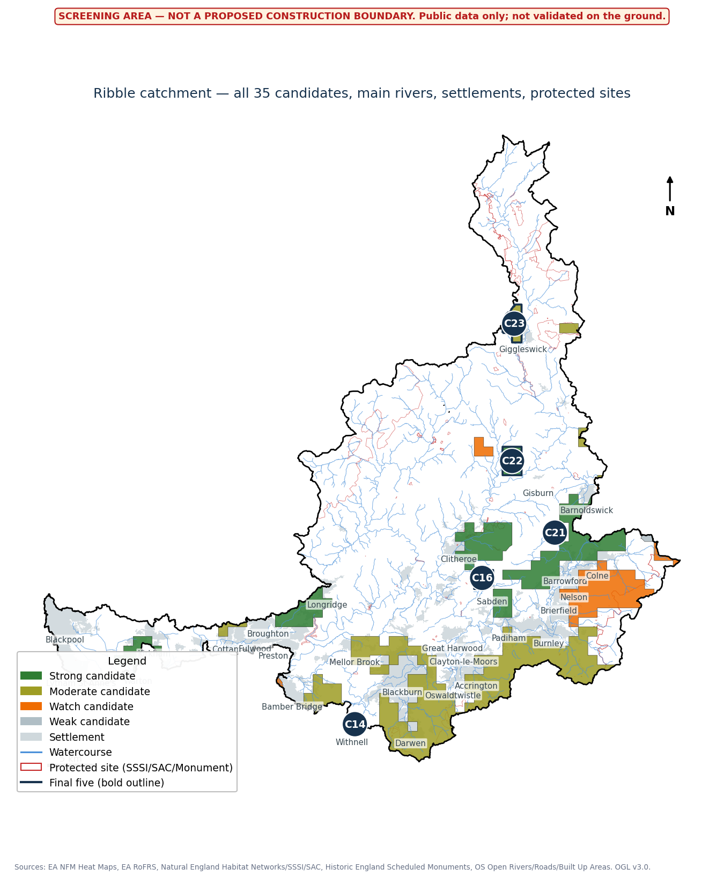
All 35 screened candidates, banded by composite score, with main rivers and settlements for context. The final five are outlined in navy.

2. Opportunity-gap map
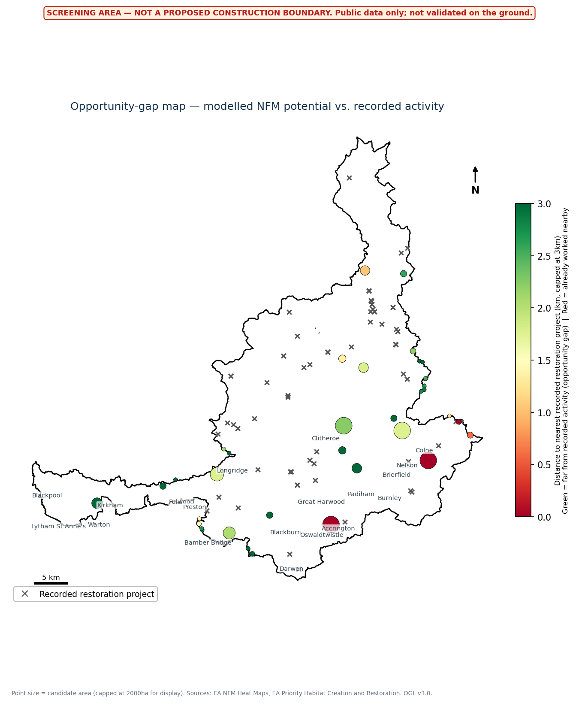
Modelled NFM potential (point size) against distance to the nearest recorded restoration project (colour). Green points are furthest from any recorded activity — the strongest 'gap' candidates.

3. Site cards

Site 1 — Candidate C16
Strong candidate | 300 ha | Rank 1 of 35 | Flood-risk context: High
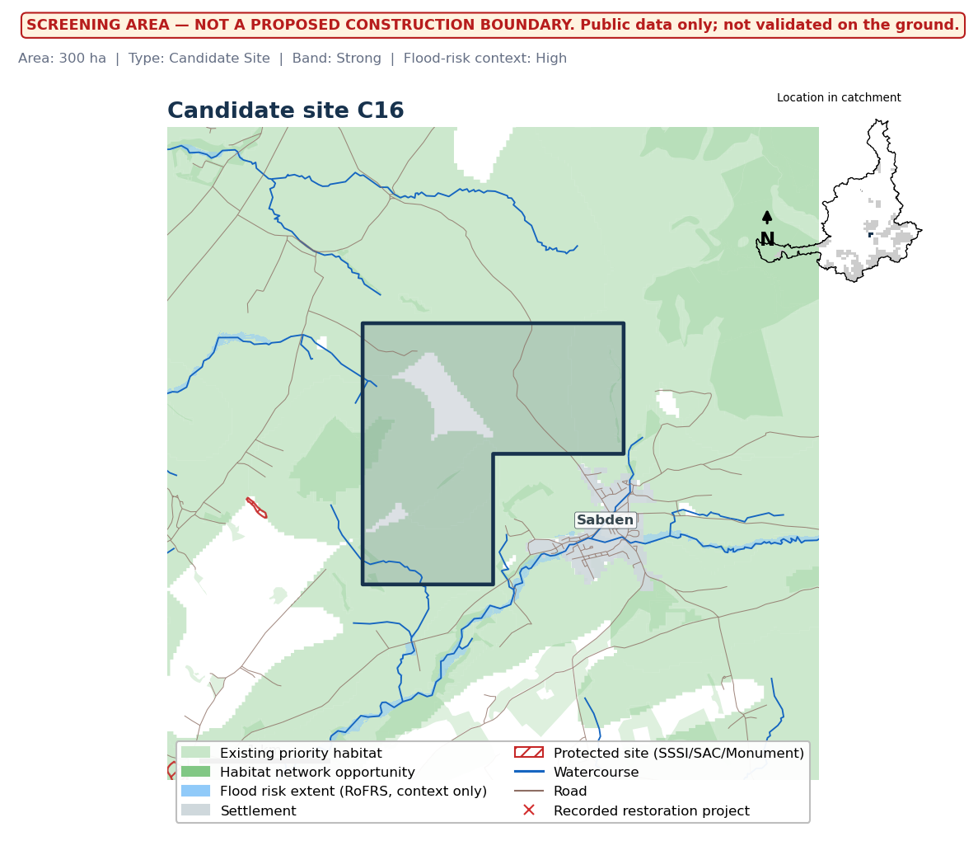

Evidence
LOCATION | Near Sabden, Ribble catchment (0.08km away)
INTERVENTIONS TO INVESTIGATE | Wet woodland or habitat expansion; runoff storage / leaky barriers
NEARBY COMMUNITY EXPOSURE | Nearest settlement: Sabden, 0.08km away. 16 settlements within 5km.
HABITAT VALUE | 93% overlaps a mapped habitat-network opportunity zone; nearest existing priority habitat 0.00km away.
RECORDED ACTIVITY | Nearest recorded restoration project is 2.98km away - no known nearby activity in the EA register.
CONSTRAINTS | No settlement or protected-site overlap; low road density.
CONFIDENCE (FLOOD-RISK CONTEXT ONLY) | High
RECOMMENDED NEXT CHECK | Practitioner walkover to confirm land use, ownership and access.

Site 2 — Candidate C21
Strong candidate | 187 ha | Rank 6 of 35 | Flood-risk context: High
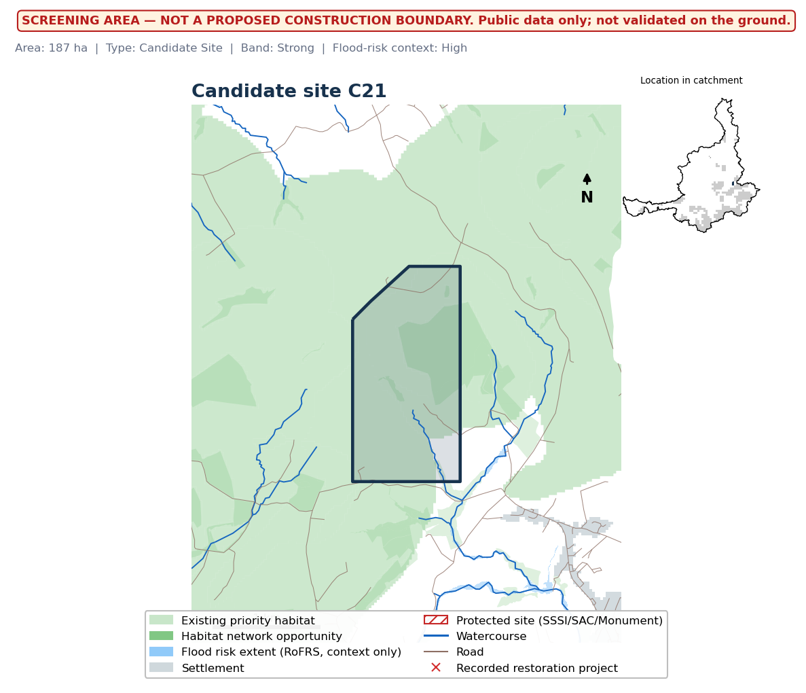

Evidence
LOCATION | Near Barrowford, Ribble catchment (0.50km away)
INTERVENTIONS TO INVESTIGATE | Wet woodland or habitat expansion; runoff storage / leaky barriers
NEARBY COMMUNITY EXPOSURE | Nearest settlement: Barrowford, 0.50km away. 8 settlements within 5km.
HABITAT VALUE | 94% overlaps a mapped habitat-network opportunity zone; nearest existing priority habitat 0.00km away.
RECORDED ACTIVITY | Nearest recorded restoration project is 5.02km away - no known nearby activity in the EA register.
CONSTRAINTS | No settlement or protected-site overlap; low road density.
CONFIDENCE (FLOOD-RISK CONTEXT ONLY) | High
RECOMMENDED NEXT CHECK | Practitioner walkover to confirm land use, ownership and access.

Site 3 — Candidate C14
Strong candidate | 62 ha | Rank 7 of 35 | Flood-risk context: High
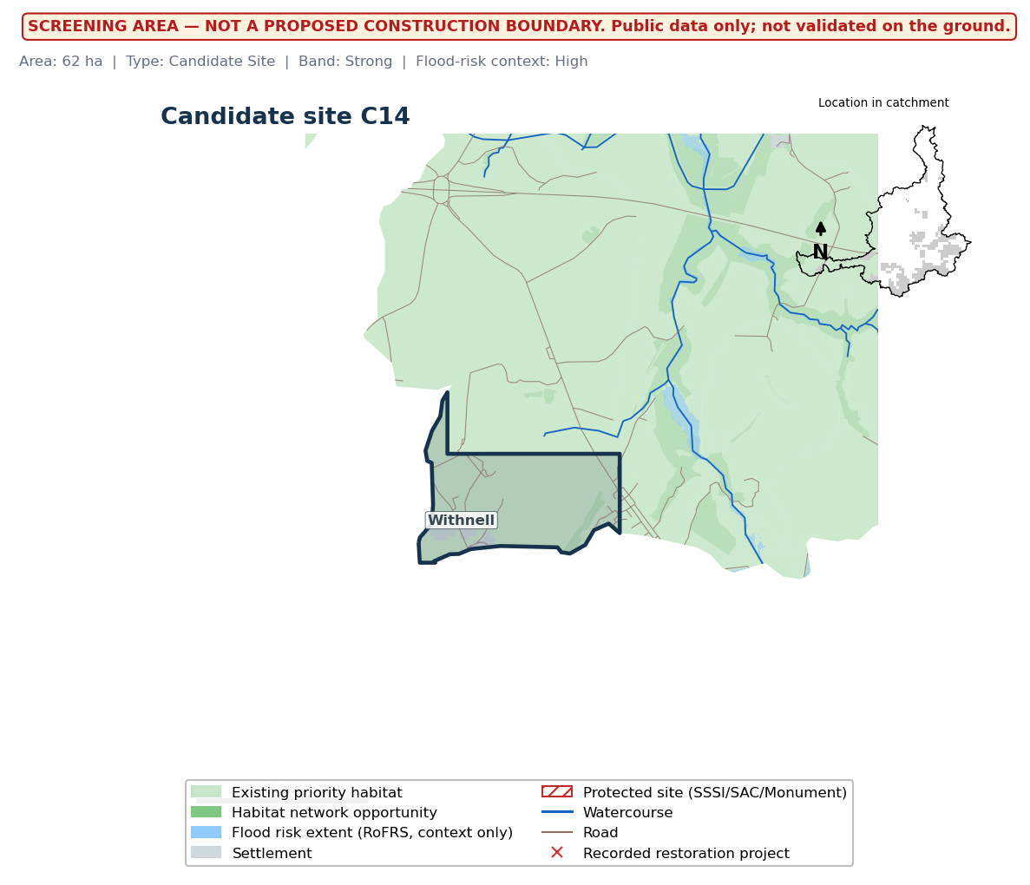

Evidence
LOCATION | Near Withnell, Ribble catchment (0.00km away)
INTERVENTIONS TO INVESTIGATE | Wet woodland or habitat expansion; runoff storage / leaky barriers
NEARBY COMMUNITY EXPOSURE | Nearest settlement: Withnell, 0.00km away. 6 settlements within 5km.
HABITAT VALUE | 100% overlaps a mapped habitat-network opportunity zone; nearest existing priority habitat 0.00km away.
RECORDED ACTIVITY | Nearest recorded restoration project is 4.98km away - no known nearby activity in the EA register.
CONSTRAINTS | 6% overlaps mapped settlement extent; road density 4.7km/km2.
CONFIDENCE (FLOOD-RISK CONTEXT ONLY) | High
RECOMMENDED NEXT CHECK | Practitioner walkover to confirm land use, ownership and access.

Site 4 — Candidate C22
Strong candidate | 600 ha | Rank 9 of 35 | Flood-risk context: High
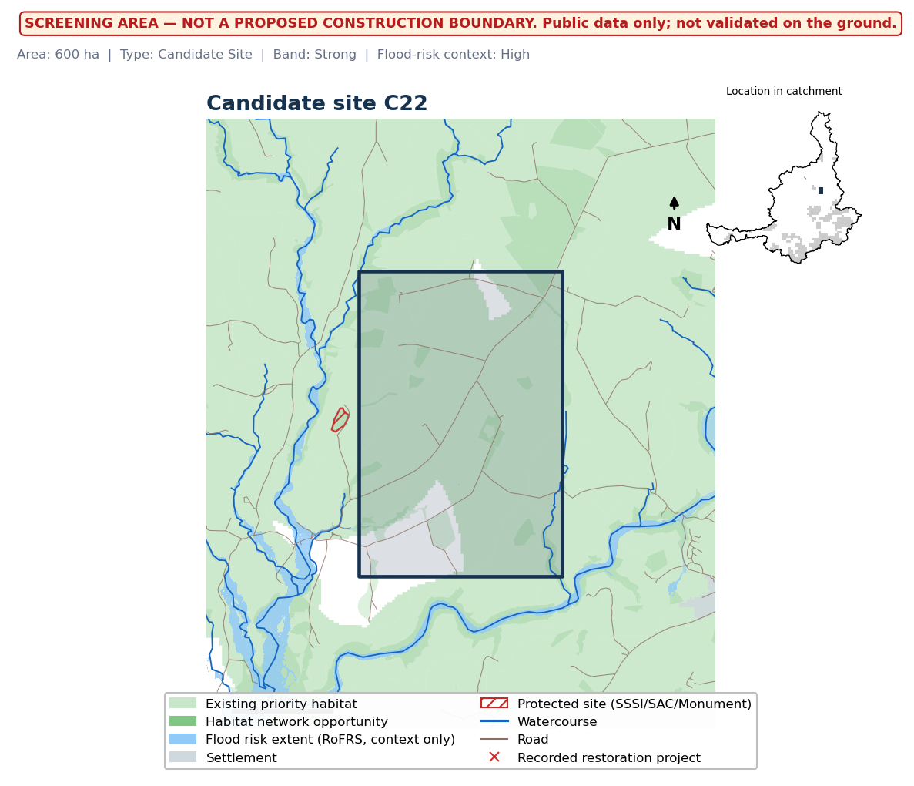

Evidence
LOCATION | Near Gisburn, Ribble catchment (1.18km away)
INTERVENTIONS TO INVESTIGATE | Wet woodland or habitat expansion; runoff storage / leaky barriers
NEARBY COMMUNITY EXPOSURE | Nearest settlement: Gisburn, 1.18km away. 3 settlements within 5km.
HABITAT VALUE | 88% overlaps a mapped habitat-network opportunity zone; nearest existing priority habitat 0.00km away.
RECORDED ACTIVITY | Nearest recorded restoration project is 1.79km away - no known nearby activity in the EA register.
CONSTRAINTS | No settlement or protected-site overlap; low road density.
CONFIDENCE (FLOOD-RISK CONTEXT ONLY) | High
RECOMMENDED NEXT CHECK | Practitioner walkover to confirm land use, ownership and access.

Site 5 — Candidate C23
Moderate candidate | 571 ha | Rank 13 of 35 | Flood-risk context: High
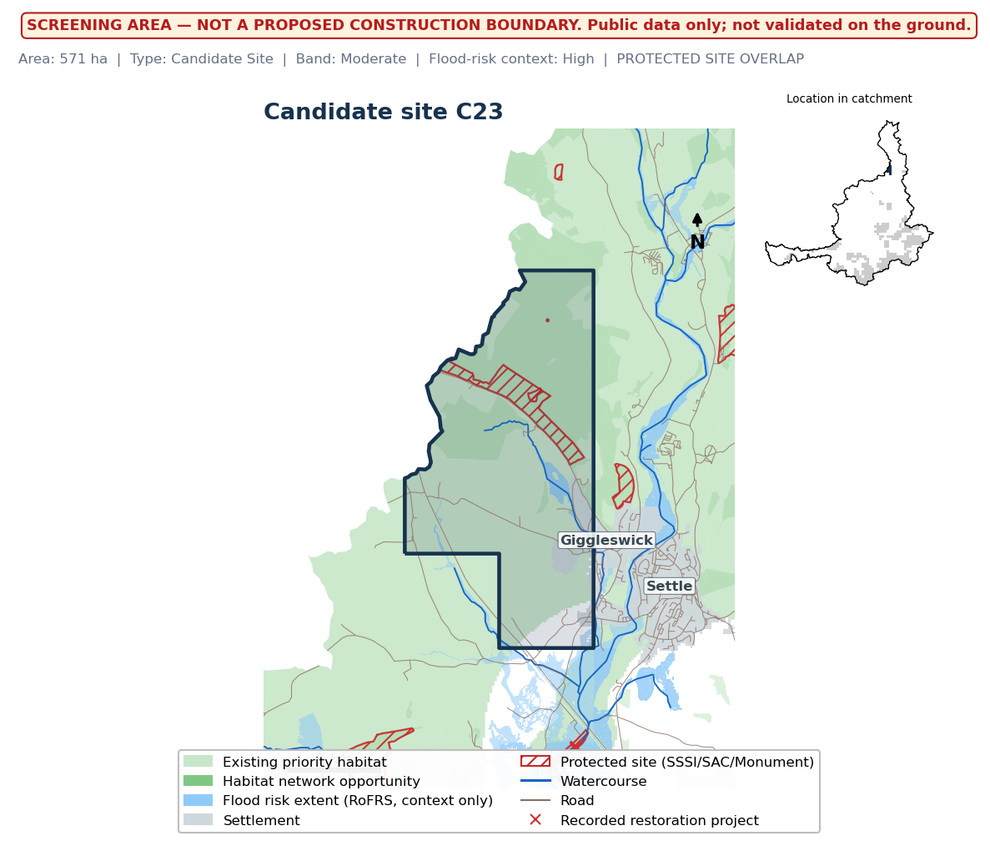

Evidence
LOCATION | Near Giggleswick, Ribble catchment (0.00km away)
INTERVENTIONS TO INVESTIGATE | Floodplain reconnection / rewetting; wet woodland or habitat expansion; runoff storage / leaky barriers
NEARBY COMMUNITY EXPOSURE | Nearest settlement: Giggleswick, 0.00km away. 3 settlements within 5km.
HABITAT VALUE | 95% overlaps a mapped habitat-network opportunity zone; nearest existing priority habitat 0.00km away.
RECORDED ACTIVITY | Nearest recorded restoration project is 1.05km away - no known nearby activity in the EA register.
CONSTRAINTS | PROTECTED SITE: Giggleswick Scar and Kinsey Cave SSSI; Kinsey Cave, Giggleswick Scar (+1 more - see docs/week4_manual_review.md) - likely needs consent.
CONFIDENCE (FLOOD-RISK CONTEXT ONLY) | High
RECOMMENDED NEXT CHECK | Practitioner walkover to confirm land use, ownership and access.

