RIBBLE CATCHMENT — NATURAL FLOOD MANAGEMENT SCREENING
Five candidate sites from a data-led screening exercise
A screening tool, not a proposal — every polygon is a SCREENING AREA, not a proposed construction boundary.
I've combined EA NFM Heat Maps, flood-risk and recorded-flooding data, Natural England habitat/SSSI/SAC layers, Historic England Scheduled Monuments, and OS settlement/river data to screen the catchment for strong modelled NFM potential with little recorded delivery — genuine gaps, not sites already known, worked, or statutorily constrained.  What I'd value from you  - Do these five reflect real conditions, or is there unrecorded activity/constraints public data wouldn't show?  - Any location you'd expect flagged that isn't here?  - Does C23's SSSI/Monument overlap rule it out, or is a smaller area within it still feasible? | 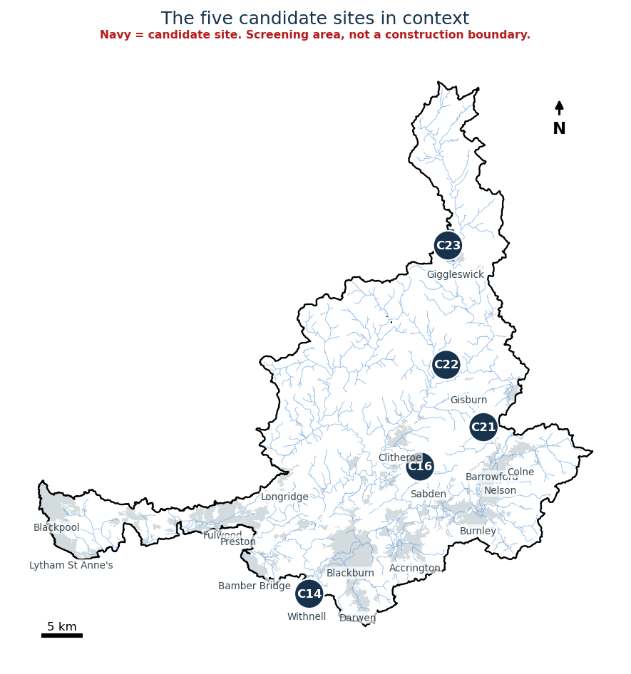

Five candidates, chosen for strength and catchment-wide spread
Site | Nearest place | Area | Note
C16 | Sabden | 300 ha | Top-ranked; no settlement or protected-site overlap; strong habitat-network overlap
C21 | Barrowford | 187 ha | Clean, no visible constraints
C14 | Withnell | 62 ha | Only strong candidate outside the Clitheroe/Pendle cluster
C22 | Gisburn | 600 ha | Clean, but rank is less stable across alternative weightings than the others
C23 | Giggleswick | 571 ha | Only credible candidate near the upper catchment - overlaps two SSSIs and a scheduled monument, likely needs consent. Kept deliberately, not hidden
This narrows the search and makes uncertainty visible; it doesn't claim these are ready for investment or that public data is complete. Happy to talk through the maps, or take feedback by email.

