Larry Schultheis

CMPSC 441

Lab 4

Part 1:

1. The breadth-first search turtle considers 28 potential nodes to expand.
2. The actual length of this path is 9 nodes long
3. The depth-first search turtle considers 14 potential nodes to expand
4. The actual length of the path is 9 nodes long
5. There is no uniform cost search turtle because the cost for each step is the same in this problem. If the cost is the same for each step cost, then this search is equivalent to breadth-first search
6. The depth-limited search (limit = 8) turtle considers 14 potential nodes to expand
7. Iterative deepening search is simply a depth-limited search run in a loop increasing the depth by 1 each time. In this case, there is no iterative-deepening search because it would be equivalent to running the depth-limited searches.
8. The iterative deepening search turtle would have to consider 28 potential nodes to expand. In this case, it would be equivalent to the breadth-first search in that aspect.
9. The A\* turtle considers 14 potential nodes to expand
10. The actual length of this path is 9 nodes long

Part 2:

1. BFS: 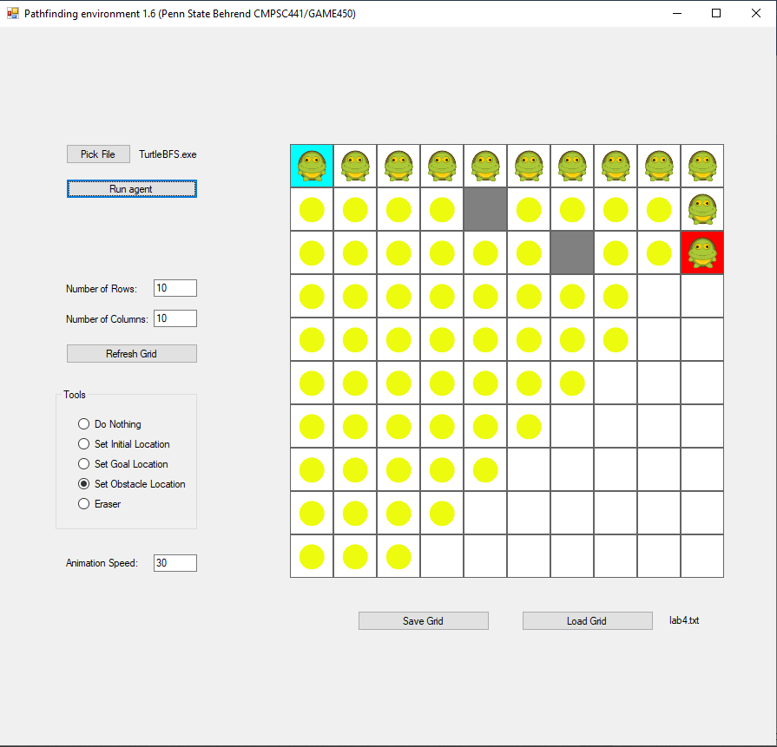

DFS: 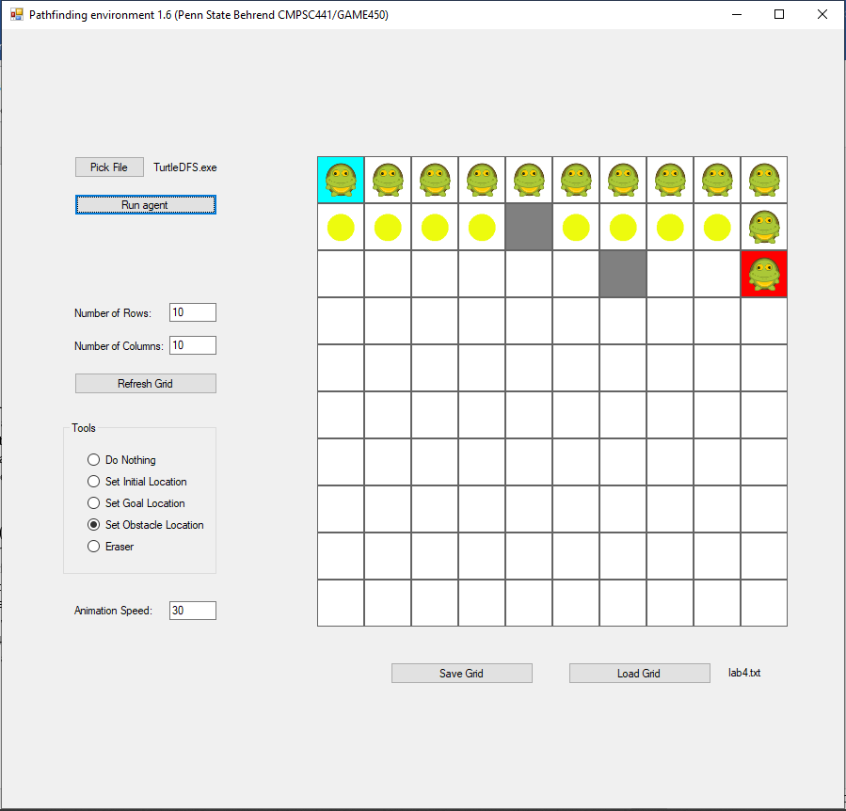

1. BFS: 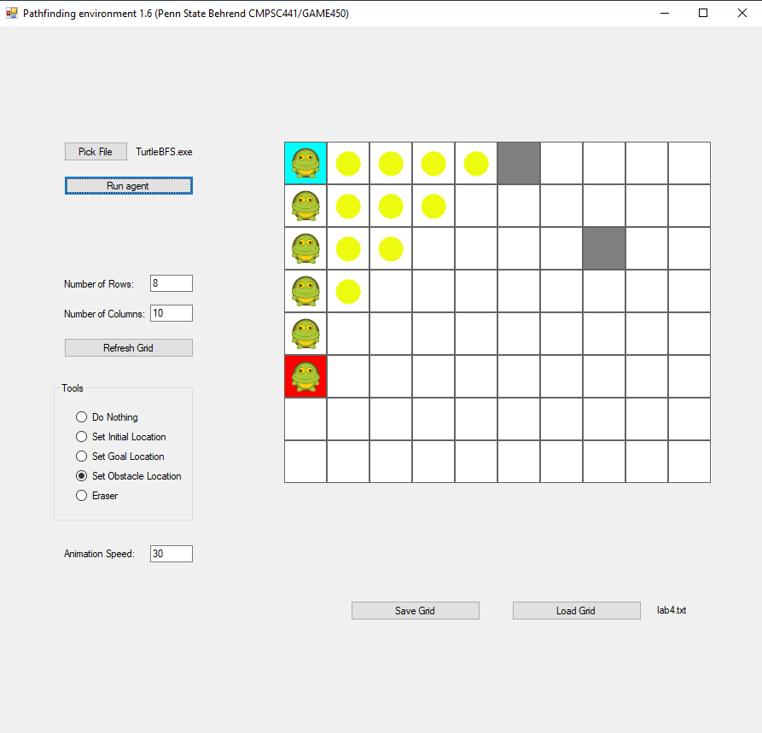

DFS: 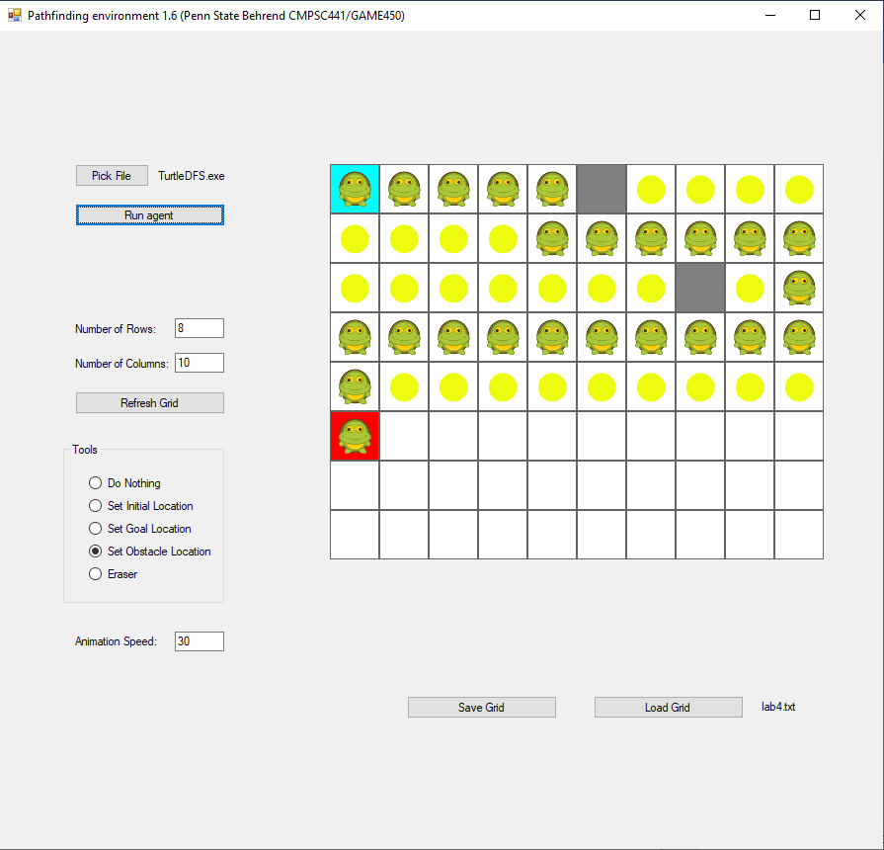

1. BFS: 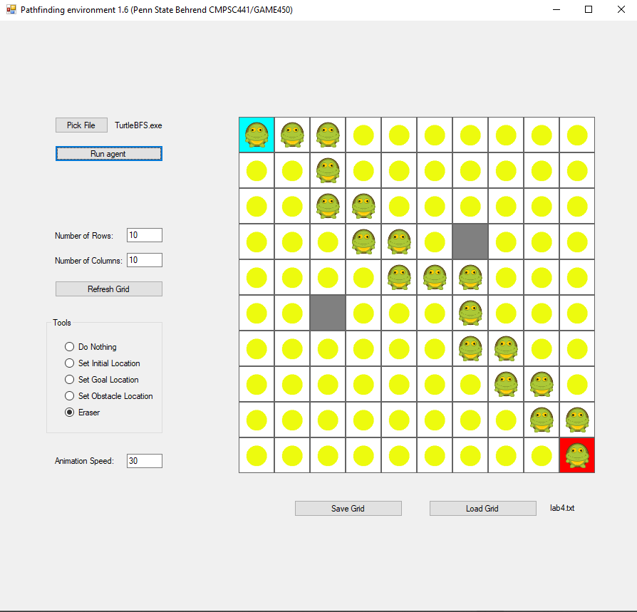

DFS: 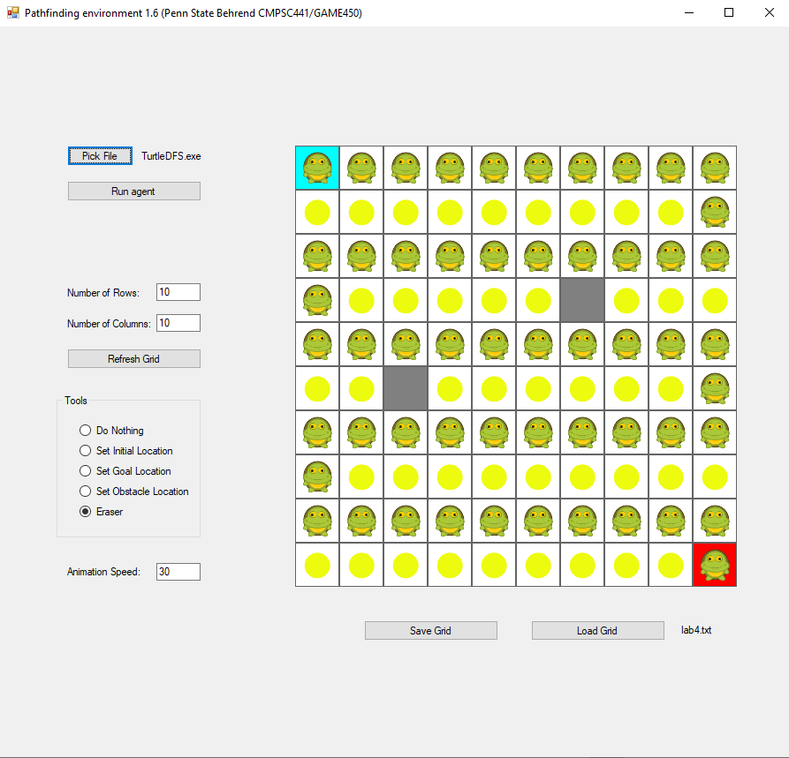

1. DFS Optimal solution:
2. DFS non-optimal solution: 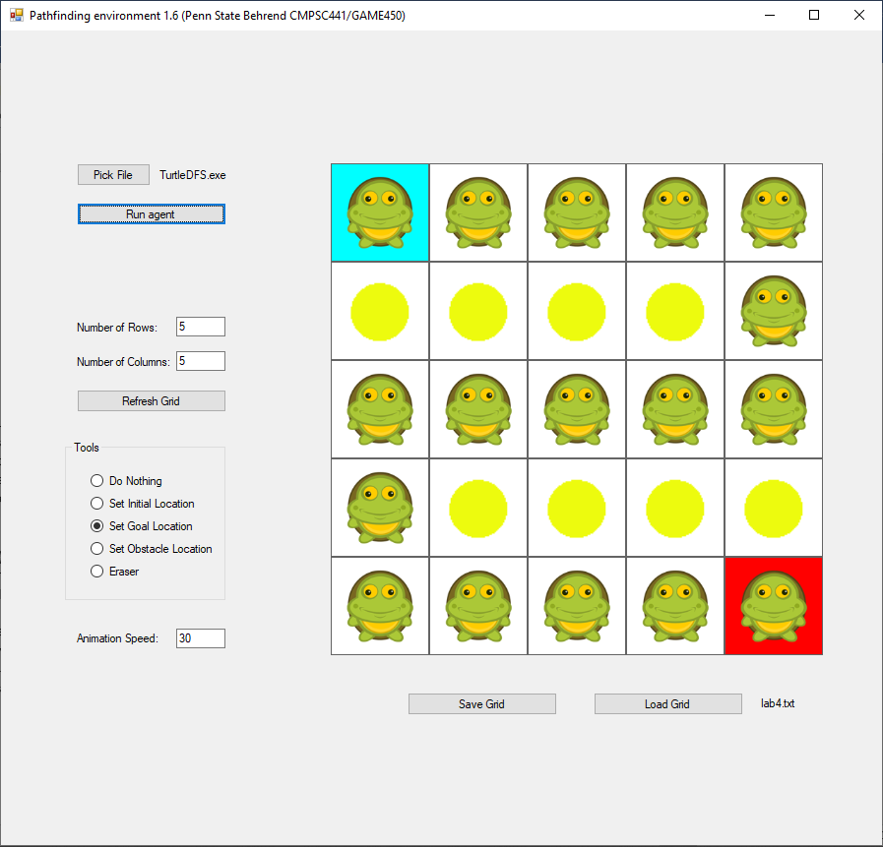
3. DFS: 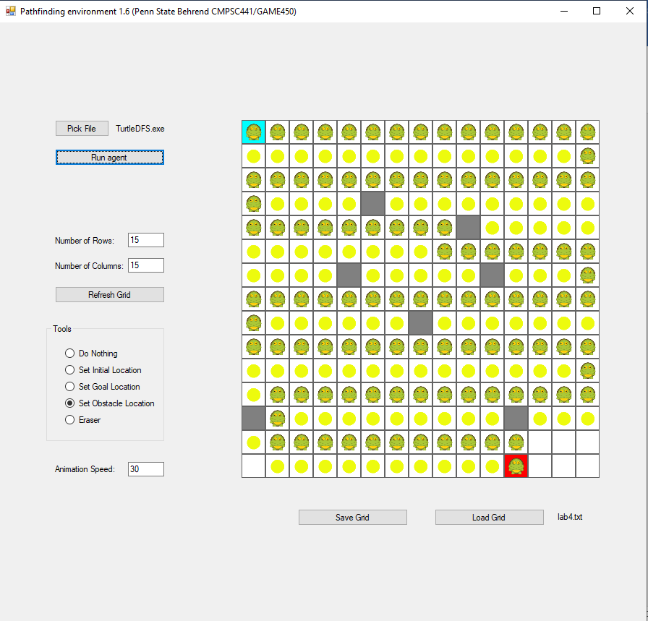

A\*: 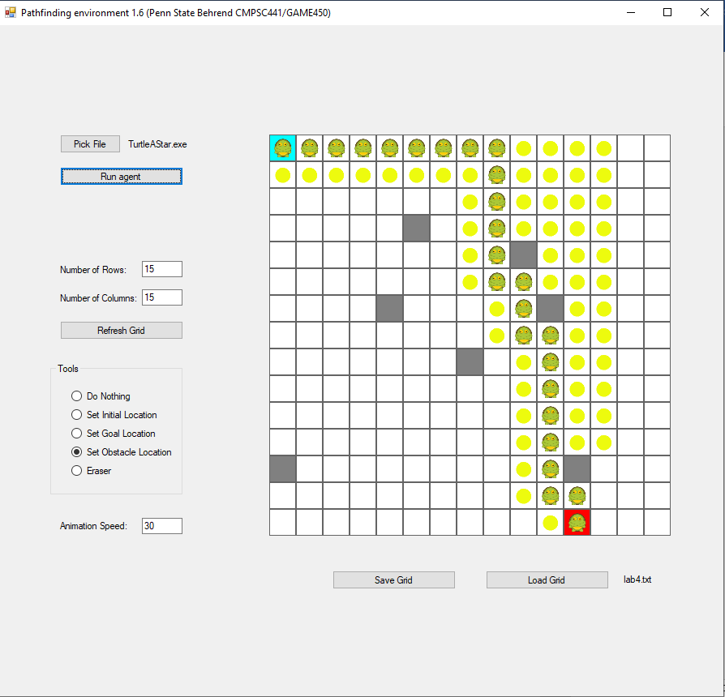

1. DFS: 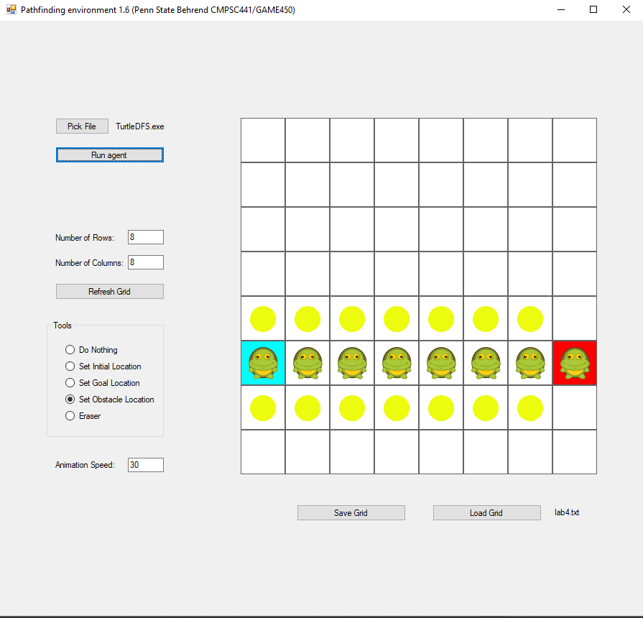

A\*: 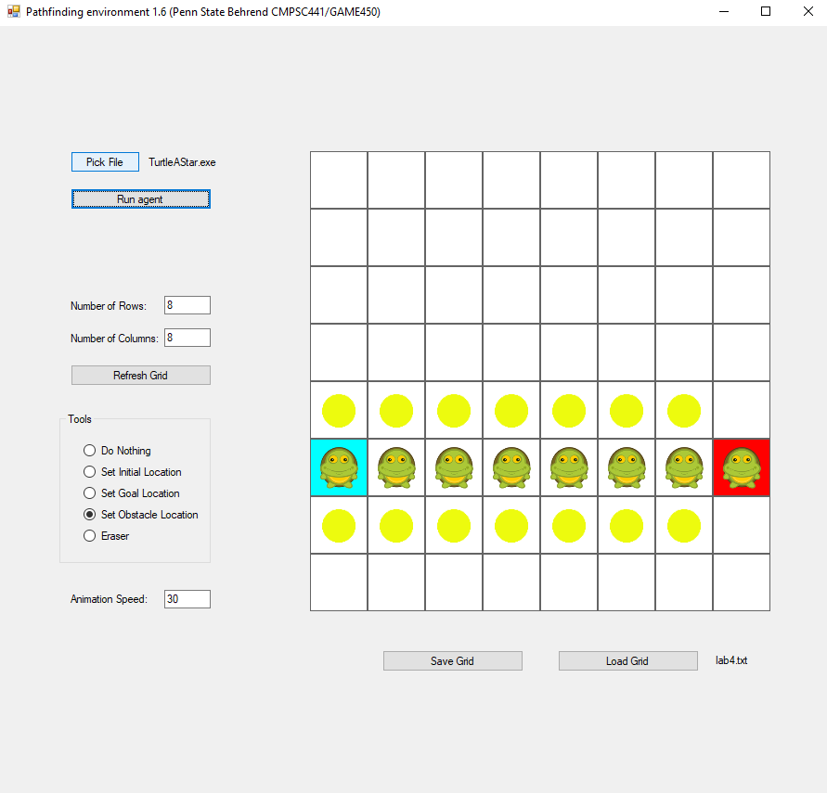

1. DFS: 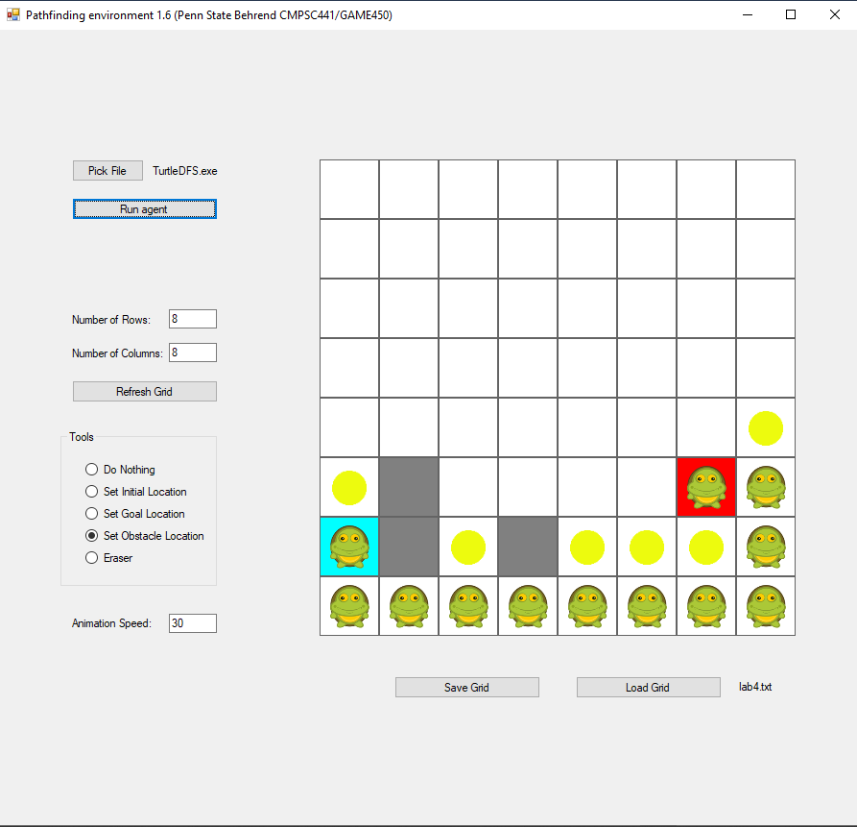

A\*: 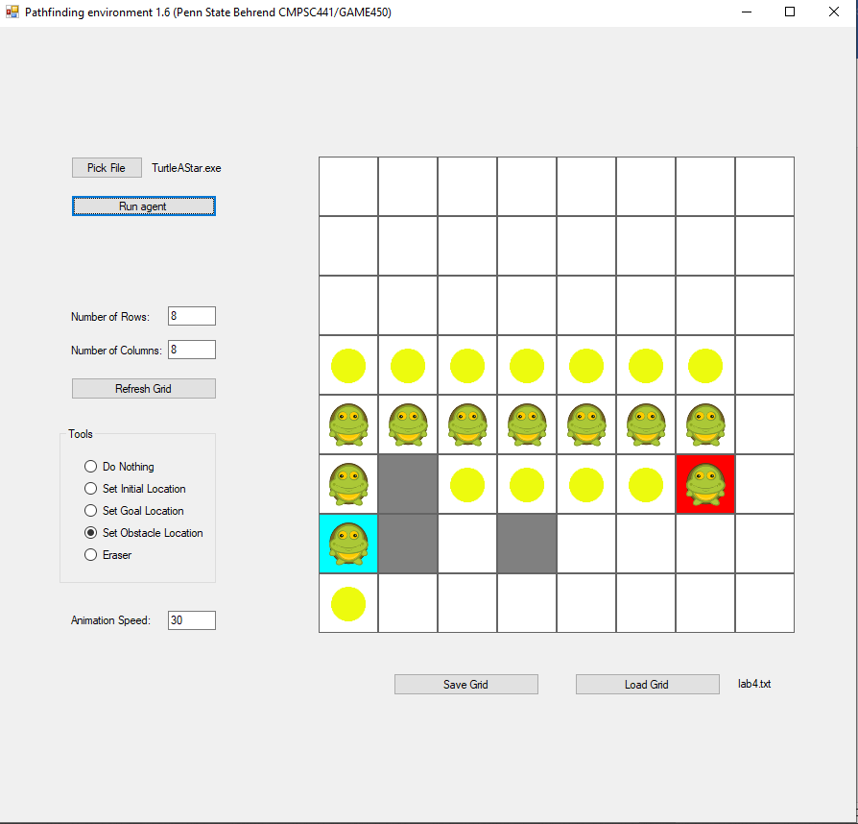

1. DL (6): 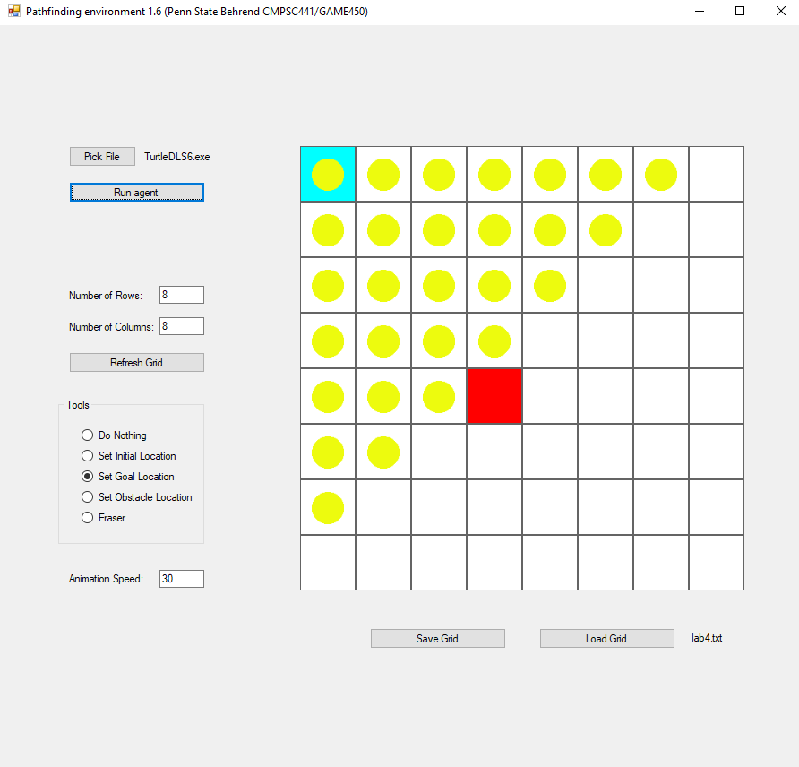

DL (7): 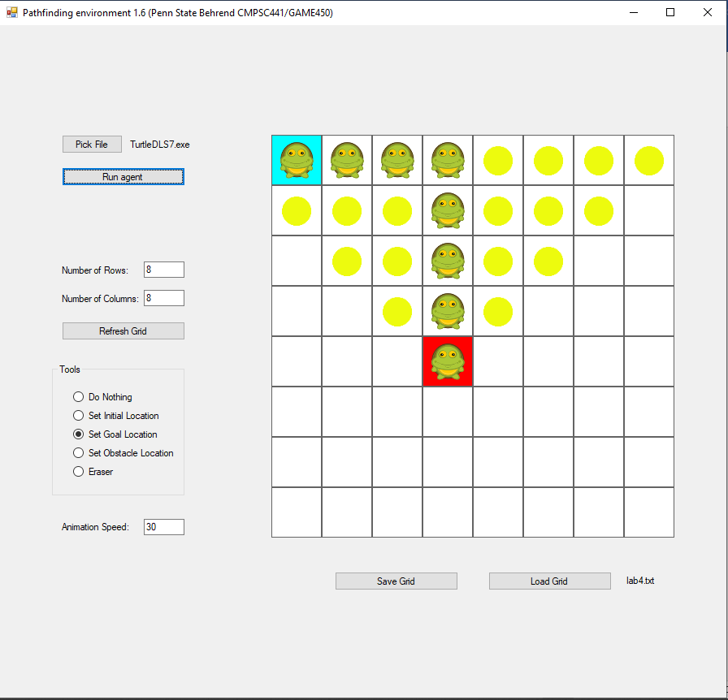

1. DL (8): 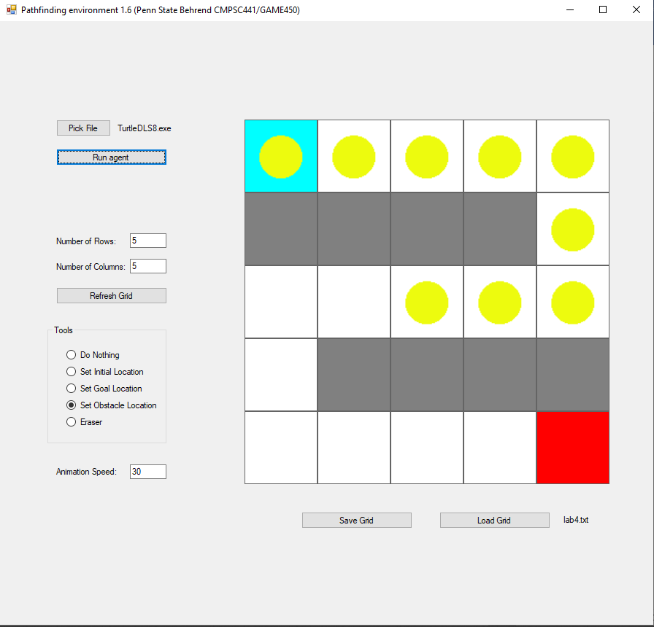

DFS (Proof that solution exists): 