**MidiOrganize: Physical connections. June 2024**

Prerequisites: A PC digital analog workstation (such as Reaper), a standalone Midi sound module

(tone generator) such as Yamaha MU15, and (optional) audio mixer.

Notice MidiOrganize is not a VST and you need an external Midi device (tone generator) to play your midi loops.

In this example, I am using a Yamaha MU15 tone generator to play my DAW Midi.

This document describes how to use MidiOrganize with your preferred digital analog workstation (DAW) such as ProTools, Reaper, Cubase, ….

The examples shown below describe MidiOrganize with Reaper. ProTools and Cubase follow the same basic process.

This document assumes you have already installed and configured your DAW and MidiOrganize.

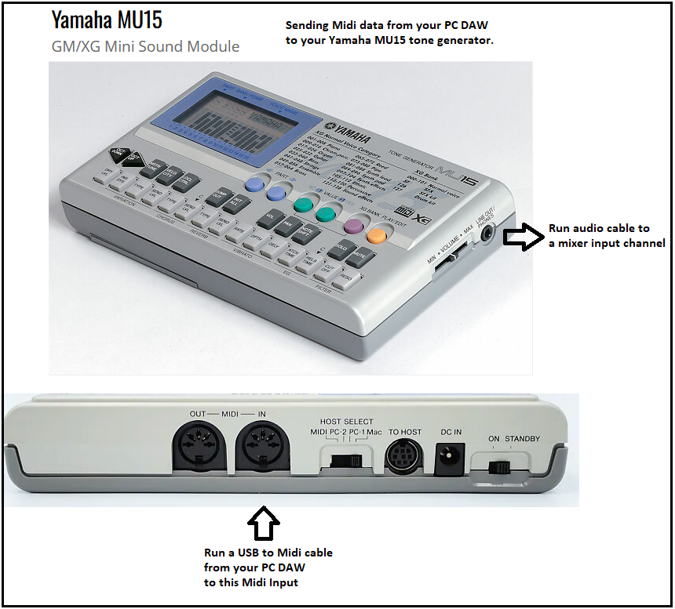

Connect your tone generator (MU15) Midi to your PC as described above ([using Midi to USB cable](https://www.amazon.com/FORE-Interface-Converter-Adapter-Laptop/dp/B0719V8MX1/ref=sr_1_4_sspa?crid=3DTUQPZF5B87A&dib=eyJ2IjoiMSJ9.ms3hKkHNewBET-HWusmgZsd9x2H9Io3ivu5LSOvPh9JbO6c0PPp9ezWweSed3XGYYAYcKSECQJJa3PSut9V6sfuJJuebI9AVbjlXFZPeKlrnhVUFcO1g0JS16Vmq8gKi-qiBdgnde86x7iGbn35zH_nVdD8JCIBiZ4N1S4-GMcMXg3CNUk1XCdiy2U3GAAv5NTYgaaKAdBZz2TFWGOlDGeMMtqnprf8twVi0U1Aday4FjJVDS2RTPIKfczAgpETjP9X_5e03nP7g3t13en3uIvCirArUdUrCWeywbt6ZmFI.UZXhf_R_ytnDJEAA-KUEeK5Spo-SZkfGvO4tE6EzfSY&dib_tag=se&keywords=usb%2Bto%2Bmidi%2Bcable&qid=1718235823&sprefix=usb%2Bto%2Bmidi%2Bcable%2Caps%2C160&sr=8-4-spons&sp_csd=d2lkZ2V0TmFtZT1zcF9hdGY&th=1)).

Connect your tone generator (MU15) audio to your mixer (or PC) as described above ([using 3.5mm audio cable](https://www.amazon.com/Amazon-Basics-Speaker-Subwoofer-Gold-Plated/dp/B00NO73MUQ/ref=sr_1_1_ffob_sspa?dib=eyJ2IjoiMSJ9.3cDaCB2W8r3aFG9qdbmJQjHL26IoUxn56dXyO4uO1LpSkrSSGPDC1JaeMYyZQZFqSnjAFa3_RSQYxWRc2IlAs_P0Lonh_VUiOX_36DkXvAuSSWkC-Zpe1zyxWOAOemjs5u2vmtwssSYIkQANsWUhVGkRmPNvkdS_DeNUj46o-44mWd5-j61NlOMisD5sG8e0l8h4MmZLMMJ7lAdXACk872rUREYRv2PEL02cUsi8Ez8.0I6dYsP9S7giG38ZkdSKsIJvx3ZDPe_1OHB_n2pt46o&dib_tag=se&hvadid=570527005189&hvdev=c&hvlocphy=9032737&hvnetw=g&hvqmt=e&hvrand=16943092840632533348&hvtargid=kwd-52137146&hydadcr=4996_13189554&keywords=3.5mm%2Baudio%2Bcable&qid=1718235761&sr=8-1-spons&sp_csd=d2lkZ2V0TmFtZT1zcF9hdGY&th=1))

** Be aware that cheap midi cables typically do not support midi SYSEX commands (are best to avoid).

**Step 1: Start MidiOrganize**

My MidiOrganize screen looks like this: Notice in pane 4, I selected a midi drum loop (Verse.mid) to use in my Reper project.

If you want to preview the midi file before dragging into Reaper, drag the midi file into the MidiOrganize embedded Windows Media Player in the bottom left corner of the screen below. The midi will play using windows MidiMapper. Your playback options are limited, but the local Media Player will give you a good sense of the midi file sound.

Next, start Reaper and setup Reaper to receive the Midi track Verse.mid (as shown on next page).

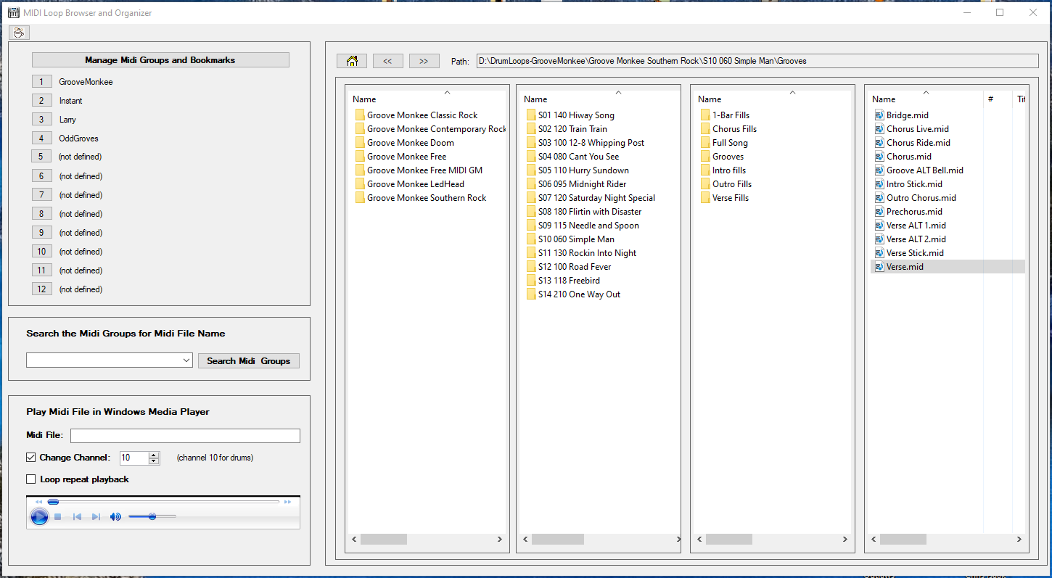

**Step 2: Start your DAW and create a new Midi track**

My Reaper screens looks like this: See arrows and numbers in the screenshot below.

**Step 2.1:** Under menu ‘Options’ > ‘Preferences’, select the midi cable (USB Midi Interface) connected to your drum machine / Yamaha MU15 tone generator.

**Step 2.2:** Go to menu ‘Insert’ and select option ‘Insert (midi) Track’. Track 6 is created. Name your track. I use MO1 to identify MidiOrganize track 1.

**Step 2.3:** Drag ‘Verse.mid’ from MidiOrganize (shown on previous page) on to Reaper Track 6. The midi track will appear as shown below.

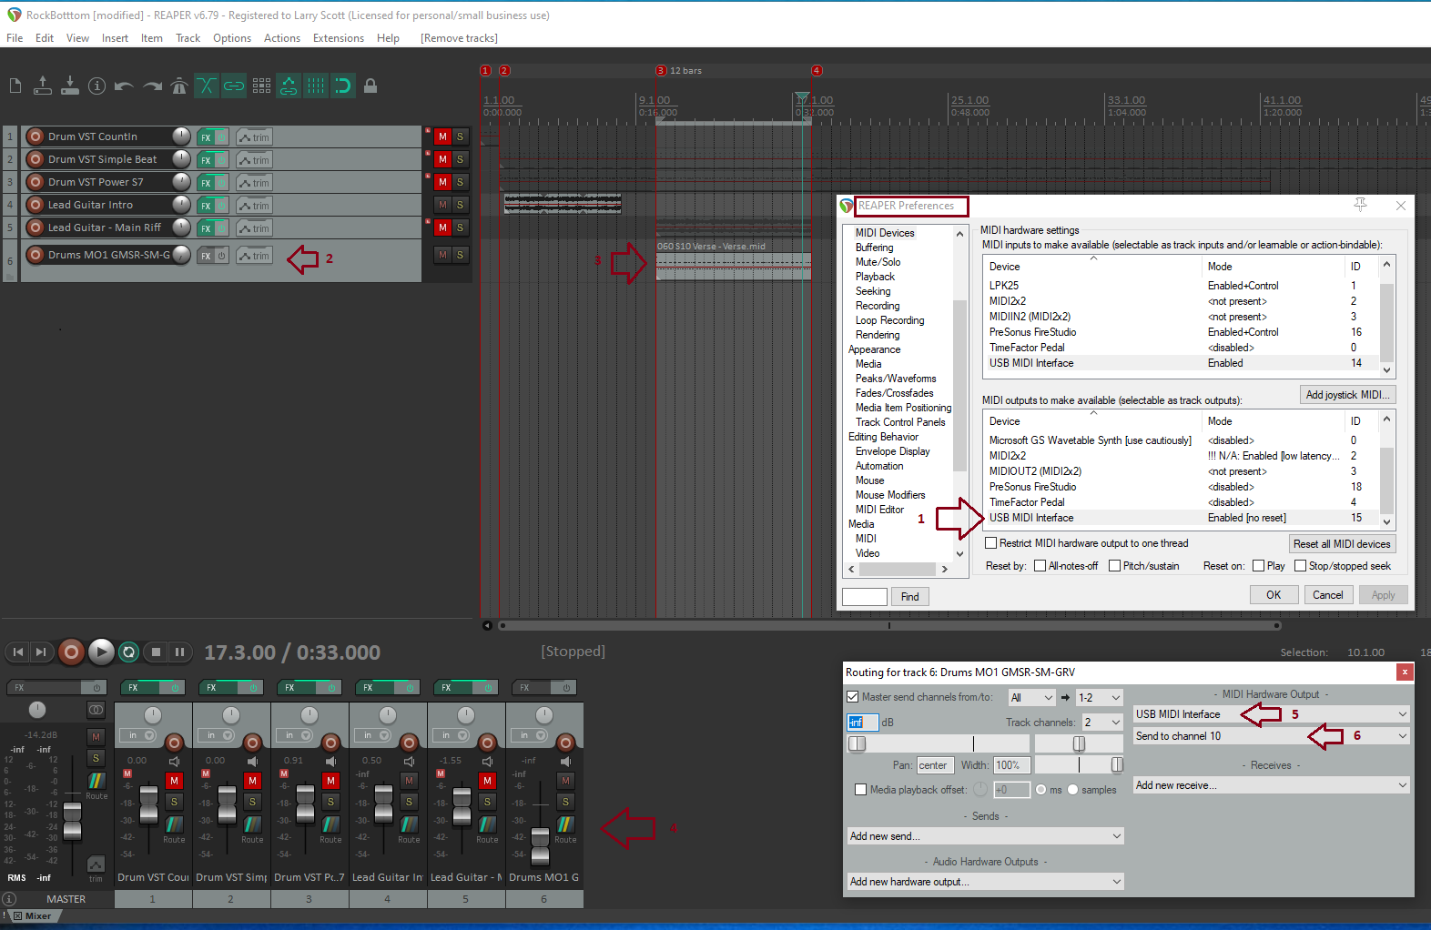

**Step 2.4:** Press the ‘routing’ button in the mixer track 6 control to show the ‘Routing for tack 6’ dialog box shown immediately above.

**Step 2.5:** Under Midi Hardware Output, select the midi interface (cable) attached to your Yamaha MU15 tone generator.

When the midi file is played, it will sent Reaper’s midi data to the ‘USB Midi Interface’ cable connected to your Yamaha MU15 tone generator.

**Step 2.6:**  If you are playing a drum patch, select ‘Send to channel 10’. Channel 10 is the midi standard channel for drums.

**Step 2.7:**  Press the PLAY button in the Reaper transport bar. Your Reaper project audio will be sent to your mixer channel 1 and the drum midi will be sent to your Yamaha MU15 tone generator, heard on your mixer channel 2.

**3: Optional: Recording your Midi for a final mix:**

The above setup is good for live performances and practice sessions but how about when you want to record the Midi drums to add to your final mix?

The steps are pretty simple.

**Step 3.1:** In Reaper, create an AUDIO (not midi track). See track 7 below

**Step 3.2:** In the new audio track, press the red record button to record the midi drum audio

**Step 3.3:** Select the mixer channel connected to your Yamaha MU15. In the example below, I selected my StudioLive stereo mixer channels 13 & 14.

**Step 3.4**: Press the record button on your transport control. The Repear project will simultaneously play and record your midi drums.

(while recrding, you do not need to be playing or recording an instrument. This process is just to record your drums, converted from Midi to audio)

**Step 3.5:** You now have a track recording of your midi drums!

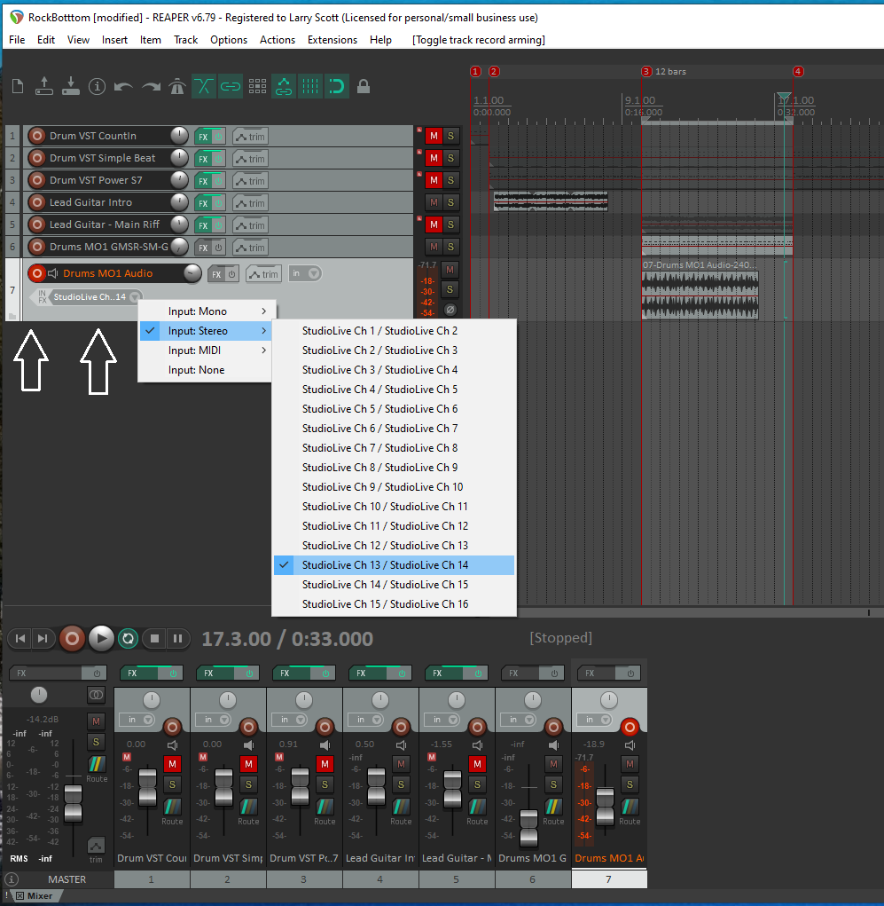

**THE END!**

**Email** [**lscottae@gmail.com**](mailto:lscottae@gmail.com) **for any clarification, corrections, or enhancement requests.**