Pre lab 4

*(1)*

*xcorr(x,y)* function in matlab has a functionality of cross correlation in matlab. Thus, I will use the function and not really writing my own. In case you insist, here is my code:

function [r,m,peak] = crosscorr(x1,x2)

%do the cross-correlation

r = xcorr(x1,x2);

%finding the peak

[M, Idx] = max(r);

peak = Idx;

%returning value of m

m = r;

end

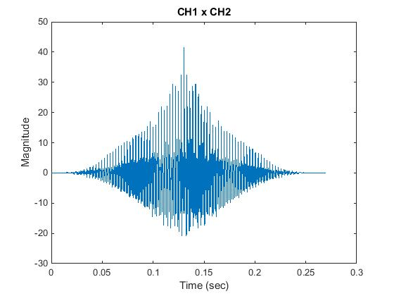

*(2)*

close all

clear all

[x,fs,nbits]= wavread('taxi_honk.wav')

X = xcorr(x(:,1), x(:,2));

t = linspace(0,0.27,length(X));

figure

plot(t,X);

title('CH1 x CH2');

ylabel('Magnitude');

xlabel('Time (sec)');

*(3)*

 \frac{a}{\sin A} \,=\, \frac{b}{\sin B} \,=\, \frac{c}{\sin C} \,=\, D \!

(Just in case: c^2 = a^2 + b^2 - 2ab\cos\gamma\, )