Laboratory 3 Assignment

ANALOG FILTERS: TEMPORAL AND FREQUENCY
CIRCUIT ANALYSIS

Lab Dates: Weeks 5 and 6

Lab Report Due Date: At the beginning of the lab on February 16th for Tuesday session.

Bring to Lab: Scope probes

1. Introduction

This lab will introduce you to analog filtering, passing continuous-time signals through physical electrical elements. The lab also provides linkage between the theoretical Fourier analysis you studied in ECE351 and physical waveforms and electronics. You will build two second-order passive filter circuits (one low-pass and one high-pass) from two resistor (R) elements and two capacitor (C) elements. You will then perform in-lab measurements of the frequency response of each filter (sinusoidal inputs) and the temporal response of each filter to periodic pulse waveforms (square-wave inputs) for three different periods. The frequency response and square-wave response measurements will then be compared to the theoretical responses obtained using Fourier analysis mathematics. Your measured and theoretical responses should be identical to within measurement precision and element value tolerances.

2. Objectives

2.1 Characterize the low-pass and high-pass filter systems as both temporal domain DEs and as
frequency domain responses using Fourier mathematical analysis.
2.2 Measure and save the actual responses of filters constructed from lab-built circuit elements.
2.2 Validate that each filter frequency response analysis matches the frequency measurements.
2.3 Validate that each filter temporal response analysis matches the periodic signal measure-
ments.

3. References

Course text sections: 3.2 – Frequency response, 3.5 – Square-wave Fourier series and partial-sum (truncated) FS approximations, 4.3 – Convolution with mixtures of periodic (input square-wave) and non-periodic (filter impulse response) signals [especially Eq. 4.10], Appendix C.7 Properties of Fourier representations [particularly the differentiation-in-time property].

4. Pre-Lab Tasks ( 1 point )

Read and familiarize yourself with this entire assignment prior to start of lab!

Show your TA your results of these pre-lab tasks at the start of this lab assignment to receive 1 point of your total lab score.

You will be constructing in the lab the electrical circuits shown in Figures 4.1 and 4.2, consisting of two capacitors and  and two resistors  and . The input source voltage, a signal labeled 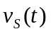, is applied to the filter circuits by the Tektronix signal function generator, and the resultant output voltage across the capacitor, a signal labeled 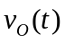, is observed. The ground reference for these circuits is considered to be the negative (-) line at the bottom of each circuit.

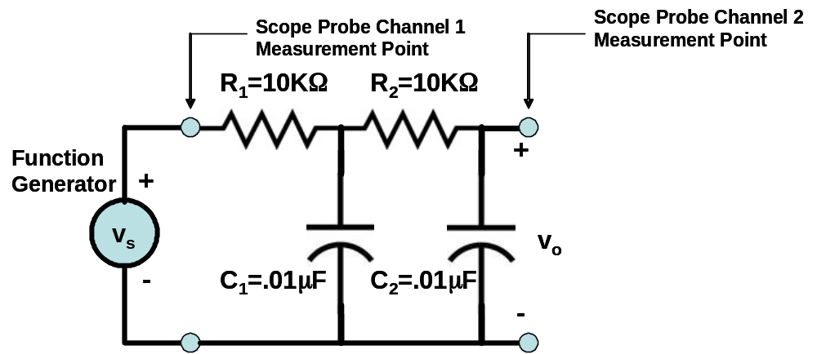

Figure 4.1 Schematic of low-pass filter and experiment setup to be constructed in the lab.

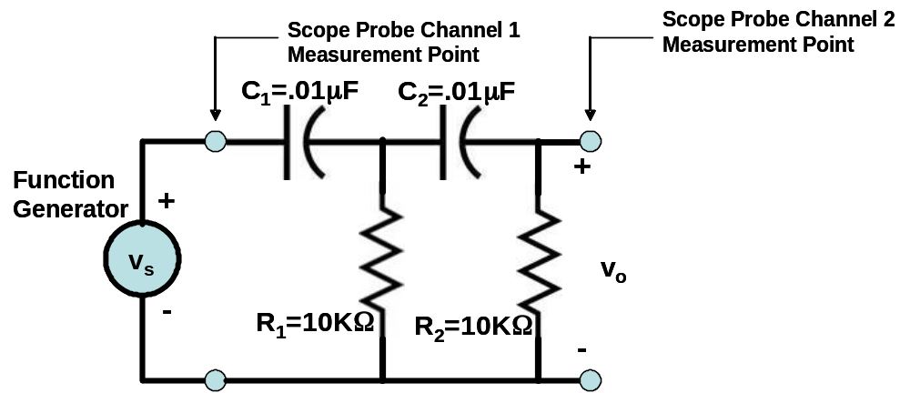

Figure 4.2 Schematic of high-pass filter and experiment setup to be constructed in the lab.

4.1 Task: Determine Differential Equation Expressions

Determine the mathematical expressions of the second-order differential equation (DE) that relates the input source voltage and the output voltage for both the low-pass filter (Figure 4.1) and the high-pass filter (Figure 4.2). The constant coefficients of the DE should be expressed (1) algebraically in terms of generic , , and variables (that is, unspecified values) and then (2) numerically in terms of the actual element values shown in Figures 4.1 and 4.2.

4.2 Task: Determine Filter Frequency Responses

Determine the frequency responses of both the low-pass and high-pass filters. Let 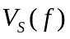and 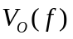be the Fourier transforms of the input and output voltages, respectively, expressed as a function of cyclic frequency f (cycles/sec, Hz). To determine the frequency response of either filter, a mathematical expression for the filter transfer function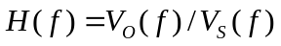, formulated as a ratio of second-order polynomials of the form 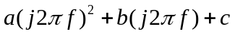, must first be found. This is obtained by applying the differentiation-in-time Fourier property to each of the two DEs you formulated in Task 4.1. From your 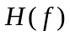 expressions, you are to generate plots similar to those of Figures 4.3 and 4.4.
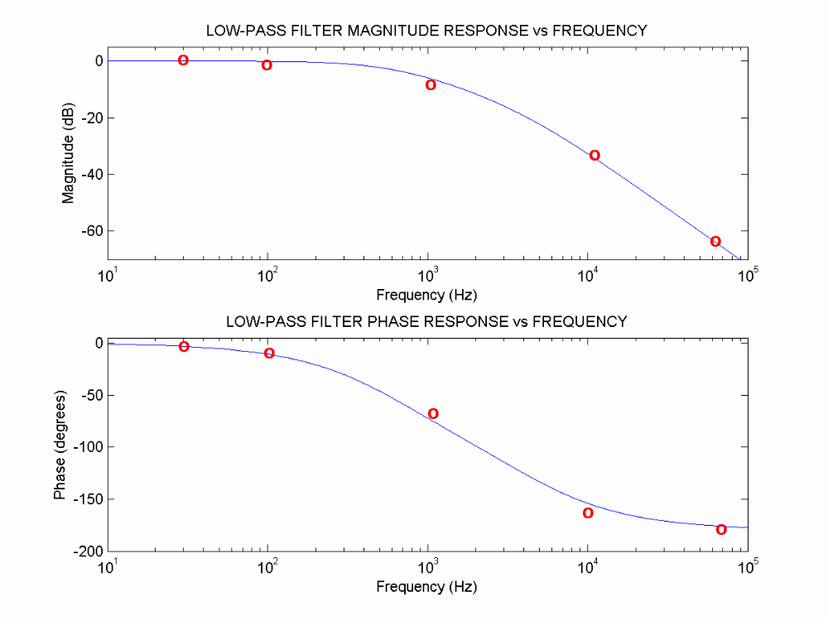

4.3 Task: Plot Frequency Responses

Figure 4.3 Magnitude and phase frequency response plots for the low-pass filter. Blue line: theoretical response determined from the H(f) of Task 4.2. Red circles: typical measured responses from lab measurements.

Because is a complex-valued function, a filter’s frequency response is normally plotted in polar format, that is, in terms of a two-plot magnitude frequency response 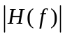 and phase frequency response , both as functions of f in Hz [see Matlab’s abs and angle functions, respectively]. Also, rather than use linear magnitude units, traditionally the magnitude frequency response is plotted in deciBel (dB) units, obtained by computing 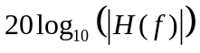. The use of dB plotting originated in the telephone industry in the 1930s to measure an analog telephone circuit’s logarithmic selectivity to audio signal power transfer. Using Matlab-produced graphics, plot the magnitude (in dB) and phase (in degrees) frequency responses of both (a) the low-pass filter circuit response and (b) the high-pass filter circuits. The plots should plot the horizontal frequency axis as a function of 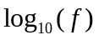, rather than as a function of f [see Matlab’s semilogx function] over the frequency range 10 Hz – 100 KHz.
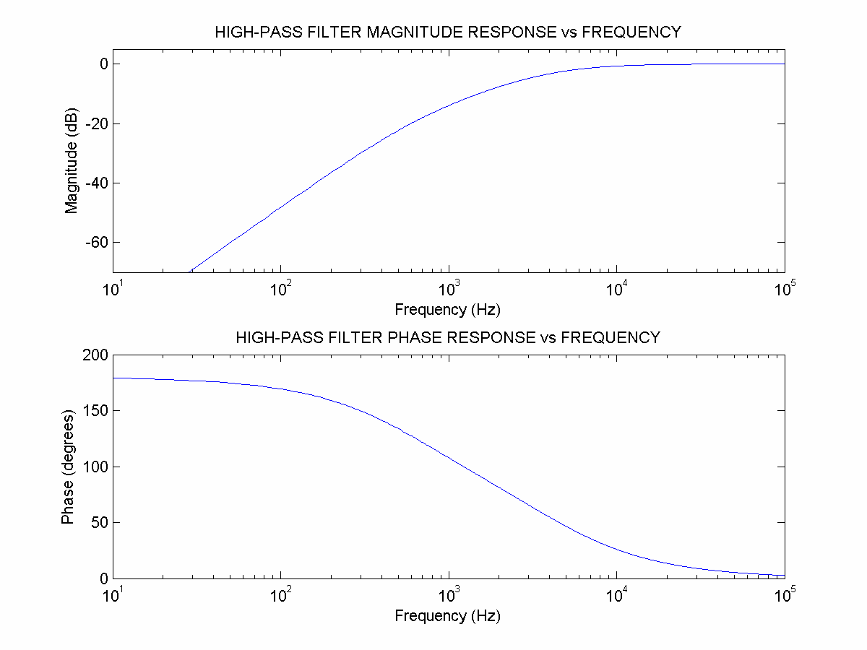

Figure 4.4 Magnitude and phase frequency response plots for the high-pass filter.

5. Lab Tasks/Experiments

You will be provided a kit of two resistors, two capacitors, and a prototyping plug board to configure as either the low-pass circuit indicated in schematic 4.1 or the high-pass circuit indicated in schematic 4.2. The kit components should be returned to the TA at the end of each lab.

5.1 Task: Measure Filter Frequency Responses.

Perform any pre-measurement calibration needed to verify that both oscilloscope channels match and accurately reflect the voltage levels being measured (see your TA for this procedure, or use the calibration procedure within the on-line oscilloscope user manual). Using both oscilloscope channels and a 3V peak-to-peak sinusoidal waveform of the designated range of frequencies cited below from the function generator as input , you will use two probes to simultaneously display the generator input sinusoidal waveform and the filter output sinusoidal response waveform (trigger on channel 1). From these displays, record in your lab notes for each frequency that is measured (a) the peak-to-peak amplitude of the input (should stay constant at 3V) and the peak-to-peak amplitude of the output and (b) the time shift between zero crossings of the input (channel 1) sinusoid and the output (channel 2) sinusoid, as shown in Figure 5.1. The relative phase may be determined by noting the time difference between a zero crossing of the input waveform and the delayed zero crossing of the output waveform. Have your TA show you how to use the scope features to make this differential time measurement . Assuming the generated frequency is f Hz, the conversion of the differential time measurement into phase in degrees is obtained by computing the product (360 degrees/cycle)( f cycles/sec)(sec). Note: if the output response phase lags the input, phase is negative (-); if it leads, the phase is positive (+).
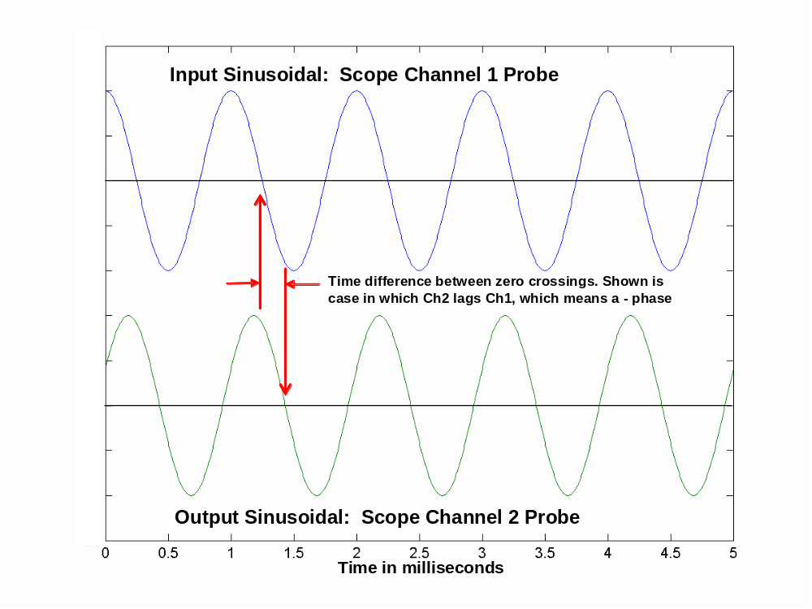

Figure 5.1 Scheme to measure the phase response at each sinusoidal frequency tested. Shown is the case in which the output phase (sinusoidal time delay) lags the input sinusoidal test signal.

Perform frequency amplitude/phase response measurements for both the low-pass filter circuit and the high-pass filter circuit at the following frequencies in Hz: 10, 100, 200, 400, 700, 1 KHz, 2 KHz, 4 KHz, 7 KHz, 10 KHz, 30 KHz, 70 KHz. Spot check that your measurements are comparable to the results that you derived in Task 4.2 before leaving the lab. Specifically, compute and compare to the magnitude plot and similarly compare the estimated phase in degrees with the phase plot.
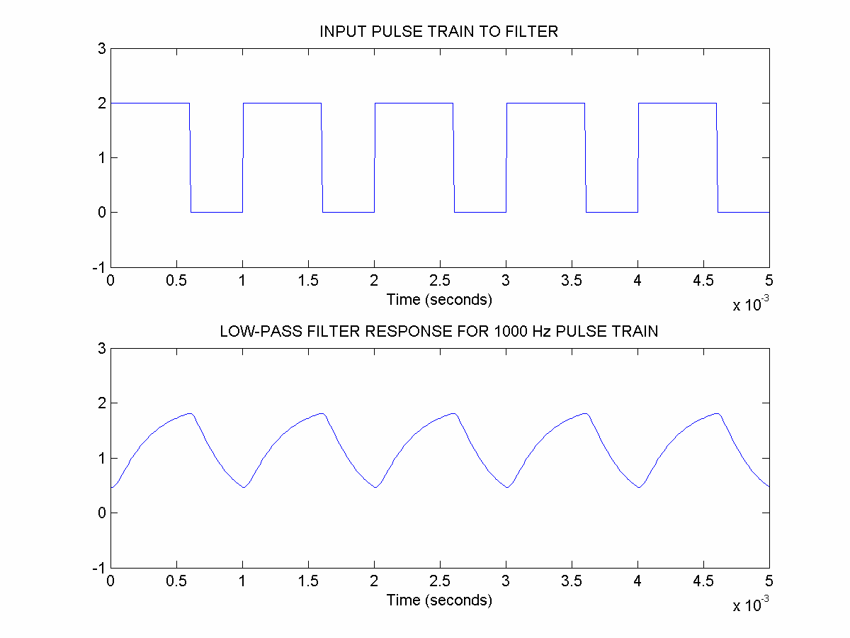

Figure 5.2 Low-pass filter response to an input square-wave of 1000 Hz rate. Top plot is the signal generator output (Channel 1 scope probe); bottom plot is the filter response (Channel 2 scope probe).

5.2 Task: Measure Temporal Responses to Periodic Signals (Square-waves).

In this task, you will measure the effect of the low-pass and high-pass filters on square-waves of three different periodicities. Using both oscilloscope channels (two probes) and a generated 2V zero-to-peak (that is, uni-polar) pulse train (square-wave) from the function generator, set up a dual display that shows about 5 periods of the input pulse train and the corresponding output response of the filter (trigger off channel 1). A duty cycle of 60% should be used (pulse high at 2V for 60% of period and low at 0V for 40% of the period). Using Excel for acquisition on the lab computers and the procedures you experienced from Lab Assignment 1 (see also Appendix of this assignment) that ensure good fidelity of the captured waveforms, you will transfer the measured scope waveform data for three different periodic square-wave cases into separate files in your server space for later post-lab analysis. Obtain and record the input and output waveform responses for three pulse train waveform fundamental frequencies 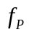of 100 Hz, 1 KHz, and 10 KHz , respectively (decade spacings). Make these measurements for both the low-pass filter and high-pass filter circuits. The periods 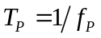are the reciprocals of the fundamental frequencies.

The saved waveform pairs (channels 1 and 2) will be compared to the mathematically-generated responses to be computed as part of the post-lab analysis tasking. Figures 5.2 and 5.3 show waveform plots for two cases of the six square-wave cases you will be measuring in this task. These illustrate the type of Matlab-generated graphics that is expected in the final report.

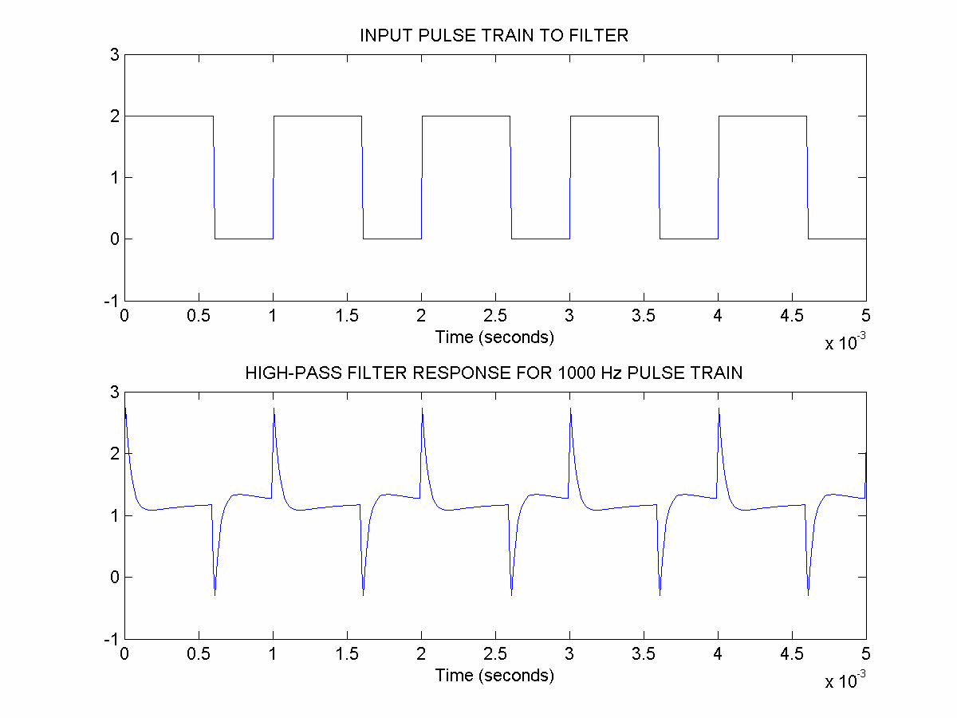

Figure 5.3 High-pass filter response to an input square-wave of 1000 Hz rate. Top plot is the signal generator output (Channel 1 scope probe); bottom plot is the filter response (Channel 2 scope probe).

6. Post-Lab Tasks

6.1 Task: Compare Analytical and Measured Frequency Responses.

Create for inclusion in your lab report a Matlab-generated overlay plot in which your measured magnitude and phase frequency responses are overlaid as measurement circle markers onto the analytically-determined magnitude and phase response plots you created in Task 4.3 (see an example in Figure 4.3). Investigate in Matlab the use of hold on when a plot axis is to be held for re-use, and the role of markers, as in plot(f,x,’ro’) which produces red marker circles.

Question: What is the middle frequency of the transition band that you obtained with your measurements in both the low-pass filter and high-pass filter cases? Is it coincidence that they are nearly the same, given the form of the transfer function in each case?

Question: Are your mathematical and measured frequency responses identical/similar, as expected? If not similar in all frequency regions, can you provide possible reasons why they differ?

6.2 Task: Compare Analytical and Measured Periodic Waveform Temporal Responses.

From text section 4.3 on mixed signals, a periodic signal input convolved with a non-periodic signal produces an ouput signal that is periodic with the same period as the input. If 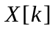 is a Fourier-series coefficient of the input, then the output also has a Fourier series with coefficients 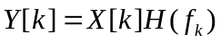, in which is the transfer function (Fourier transform of filter impulse response) developed in Task 4.2. [ What is the value of 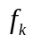in Hz for each of the three square-wave cases? ] Text section 3.5 develops the Fourier series representation for an input square-wave. Thus, we can mathematically predict a filter’s temporal response to a square wave by computing the response as a Fourier series reconstruction using a partial-sum (truncated) exponential series approximation:
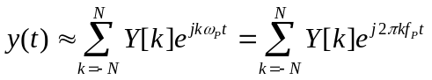
Here, the number of harmonics N is an approximation variable that must be selected. Select N such that harmonic frequencies only up to 100 KHz are used (exception: the high-pass filter for the 100 Hz square-wave will need to use harmonics up to 1 MHz). Generate dual plots of each partial-sum approximation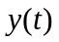, covering 5 periods of the each filter’s waveform responses to the three square-wave cases, and the corresponding input pulse train waveform. These should be similar to Figures 5.2 and 5.3. Generate similar dual plots using the actual measured 2-channel responses that you saved in Task 5.2, and then compare with the mathematical approximations.

Question: Are the mathematical and measured temporal responses to square-waves similar, as is expected, or dissimilar? If dissimilar, can you provide an explanation why?

Question: Provide an explanation as to why the low-pass (high-pass) filter responses for the 3 cases differ so dramatically, based on how the harmonics are passed or attenuated by the filter. Why is the low-pass filter response for the 10 KHz square-wave roughly a DC-like voltage? Why does the high-pass filter response for the 100 Hz square-wave look like RC time constant responses on each edge of the pulse? Suggestion: create a graphic of the harmonic frequency locations for each of the three input pulse trains overlaid onto a plot of the low-pass (or high-pass) filter frequency magnitude and phase responses, and note which harmonics are within the passband of the filter, which harmonics are in the transition region, and which harmonics are within the attenuation region of the filter’s frequency response.

7. Lab Report

Use the lab report format our TA e-mailed to the class list.

8. Extra Credit ( up to 1 point )

The schematics indicated in Figures 4.1 and 4.2 for the low-pass filter and high-pass filter circuits do not accurately characterize the true measurement situation. Both the signal function generator and the measuring scope probes have impedances that could potentially affect the quality of your section 5 task measurements, but were neglected in the pre-lab analysis schematics. Figure 8.1 indicates a more accurate characterization of your experimental setup for the low-pass filter case. The signal function generator can be characterized as having effectively a 50Ω source impedance. The scope probe (P2100 series) can be characterized by a passive parallel combination of a resistor and a capacitor. In the 1X setting, typical values of these are 1MΩ and 110 pF; in the 10X setting, typical values are 10MΩ and 17 pF. Here pF stands for pico-farads (pico is 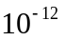), in contrast to μF, or micro-farads (micro is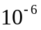).
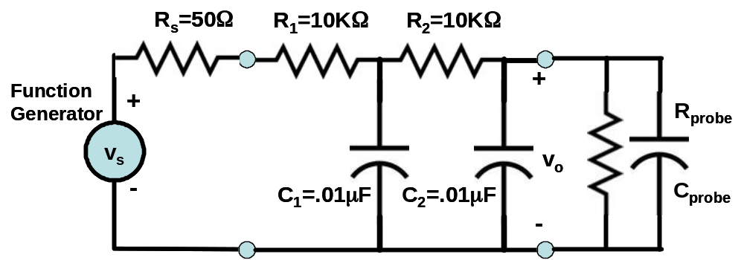

Figure 8.1 Schematic of experimental low-pass filter that more accurately accounts for function generator and scope probe impedances.

Task 8.1 Find the mathematical form of H(f), which is now a third-order transfer function, for the modified low-pass filter schematic of Figure 8.1

Task 8.2 Overlay a plot of the modified H(f) magnitude and phase frequency responses onto the H(f) magnitude and phase frequency response plots generated in Pre-Lab Task 4.2.

Question: Is the impact of an accurate schematic negligible or not, based on your observations in Task 8.2. Is the difference observable in the saved quantized oscilloscope waveforms?

