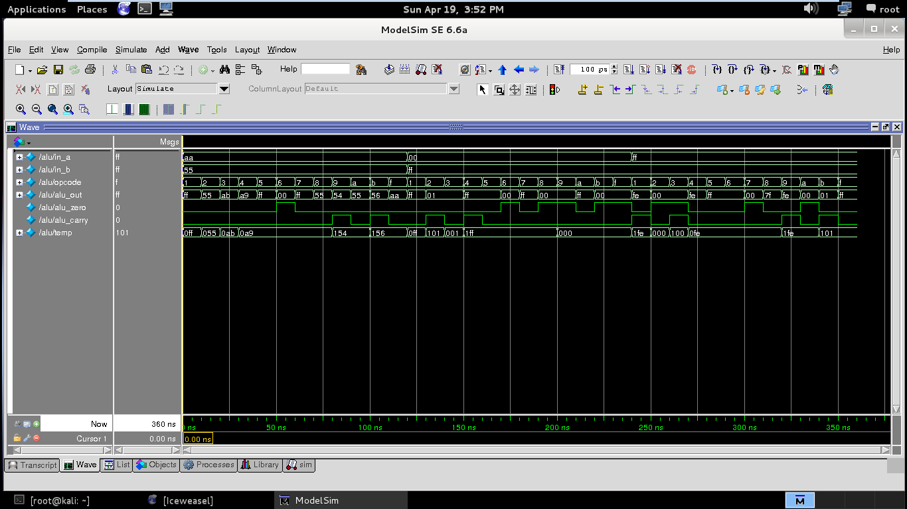

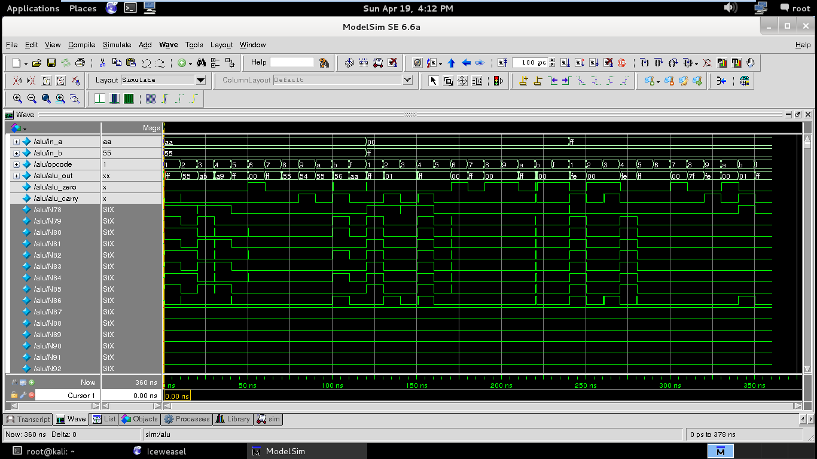

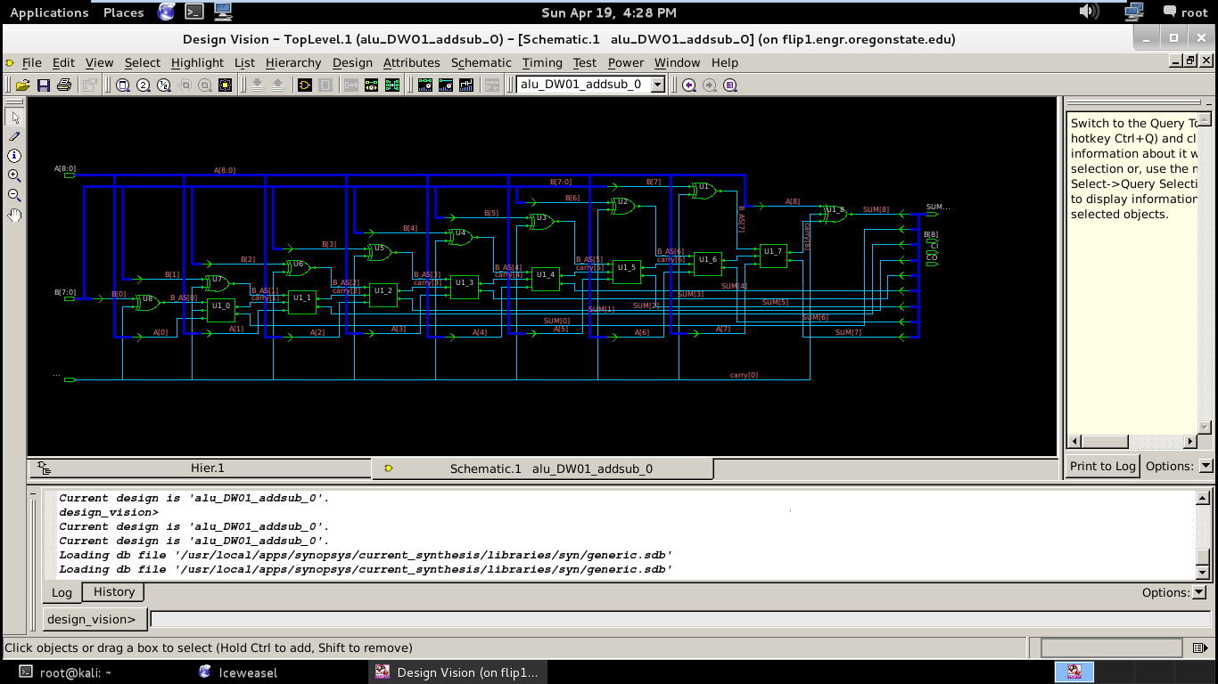

module alu(

input [7:0] in_a , //input a

input [7:0] in_b , //input b

input [3:0] opcode , //opcode input

output reg [7:0] alu_out , //alu output

output reg alu_zero , //logic '1' when alu_output [7:0] is all zeros

output reg alu_carry //indicates a carry out from ALU

);

//Declaration of OP code macro

//c_ to mark the identifier as a const

parameter c_add = 4'h1;

parameter c_sub = 4'h2;

parameter c_inc = 4'h3;

parameter c_dec = 4'h4;

parameter c_or = 4'h5;

parameter c_and = 4'h6;

parameter c_xor = 4'h7;

parameter c_shr = 4'h8;

parameter c_shl = 4'h9;

parameter c_onescomp = 4'hA;

parameter c_twoscomp = 4'hB;

//Creating a temporary wire

reg [8:0] temp;

always_comb

case (opcode)

c_add : begin

temp = in_a + in_b;

alu_out[7:0] = temp[7:0];

alu_carry = temp[8];

end

c_sub : begin

temp = in_a - in_b;

alu_out[7:0] = temp[7:0];

alu_carry = temp[8];

end

c_inc : begin

temp = in_a + 1;

alu_out[7:0] = temp[7:0];

alu_carry = temp[8];

end

c_dec : begin

temp = in_a - 1;

alu_out[7:0] = temp[7:0];

alu_carry = temp[8];

end

c_or : begin

alu_out[7:0] = in_a | in_b;

alu_carry = 0;

end

c_and : begin

alu_out[7:0] = in_a & in_b;

alu_carry = 0;

end

c_xor : begin

alu_out[7:0] = in_a ^ in_b;

alu_carry = 0;

end

c_shr : begin

alu_out[7:0] = in_a[7:0]>>1;

alu_carry = 0;

end

c_shl : begin

temp = in_a[7:0]<<1;

alu_out[7:0] = temp[7:0];

alu_carry = temp[8];

end

c_onescomp:begin

alu_out = ~in_a;

alu_carry = 0;

end

c_twoscomp:begin

temp = ~in_a + 1'b1;

alu_out = temp[7:0];

alu_carry = temp[8];

end

default:begin

alu_out = in_a;

alu_carry = 0;

end

endcase

assign alu_zero = !alu_out;

endmodule

